

Strategic Management (LCMB7003)

Strategic Analysis of (MARK & SPENCER)


Student name: SIDDHI RAUT
Student Number: 2210107
Submission Date: 01/09/2023

Table of Contents
Introduction 2
MARK & SPENCER Background 2
MARK & SPENCER’s Mission and Objectives 2
Macro-Environment Analysis 2
PESTEL Analysis 2
Micro-Environment Analysis 2
Industry Life Cycle 2
Porter’s Industry Five Forces Analysis 2
Internal Analysis 3
MARK & SPENCER’s Strategic Resources and Capabilities 3
Value Chain Analysis 3
Primary Activities 3
Secondary Activities 3
VRIO Analysis of Distinctive Resources and Capabilities 3
SWOT Analysis 3
Strategies to Sustain Competitive Advantage 4
Growth Strategies 4
Green Strategy and CSR 4
Conclusion 4
Recommendation 4
References 4
Appendix 5
Appendix 1: 5
Appendix 2: 5

Introduction
Marks and Spencer Overview:
Marks & Spencer, often abbreviated as M&S, is a pillar of British retail history and a worldwide recognised brand. The firm, which was founded over a century ago, has knitted its presence into the fabric of the retail scene, becoming associated with quality, dependability, and a dedication to servicing its consumers. Marks & Spencer has established itself as a retail sector leader with a varied selection of items, a rich heritage, and a strategic approach to business.

Marks & Spencer originated as a market stand in Leeds, England in 1884, founded by Michael Marks and subsequently joined by Thomas Spencer. From these modest origins, the firm set out on a path that would see it grow into an international retailing behemoth with a significant presence in a variety of regions. Throughout its history, Marks & Spencer has focused on providing high-quality items that meet a wide range of customer demands, from apparel and food to home goods.
The company's success has been fueled by its dedication to innovation and client satisfaction. Marks & Spencer has continuously adapted to evolving customer behaviours and tastes, from pioneering the notion of 'St. Michael' quality standards to offering self-service shopping in the UK. Its focus on customer service and attention to detail has won it a devoted following.
Marks & Spencer's impact goes beyond the realm of commerce. It has influenced British culture and fashion trends, and its unique logo has become a symbol of dependable and fashionable items. The corporation has worked to match its operations with growing social ideals as part of its commitment to sustainability and ethical practises.
In this research, we will look further into Marks & Spencer's different elements, including its history, company operations, financial performance, marketing tactics, industry competitiveness, and initiatives towards sustainability. By exploring these aspects, we want to give a thorough picture of Marks & Spencer's position in retail and its long-term influence on customers and marketplaces throughout the globe.

MARK & SPENCER Background
Marks & Spencer's History:

Marks & Spencer (M&S) is a British multinational retailer that, from its founding, has made an indelible influence on the retail business. Michael Marks, a Polish immigrant, founded the firm in 1884 by opening a market booth in Leeds, England. His philosophy of supplying high-quality items at reasonable rates rapidly gained momentum, and in 1894, he formed a company with former cashier Thomas Spencer. This agreement officially established Marks & Spencer as we know it today.

M&S initially concentrated on offering a wide range of products, from home goods to clothes, all of which were noted for their constant quality and value. One of the watershed points in the company's history occurred in 1928, when M&S launched the "St. Michael" brand as a mark of their dedication to providing high-quality goods. This decision not only cemented M&S's reputation for dependability, but also lay the groundwork for future expansion.

Marks & Spencer has continued to develop and adapt to shifting customer demands throughout the years. They pioneered "cash and carry" shopping in the 1930s, allowing consumers to purchase things straight off the shelves. This notion was groundbreaking at the time, and it helped to shape the contemporary shopping experience we know today.

In the years that followed, M&S's apparel selections grew in popularity, becoming associated with British style and quality. Customers anxiously anticipated the company's apparel ranges as it became a fashion industry pioneer. This reputation for trendy and trustworthy apparel aided M&S's rise to prominence in the UK and globally.

The company's dedication to ethical and responsible business practises was also clear. M&S started to concentrate on ethical product procurement and developing strong ties with suppliers in the 1950s. This commitment to ethical sourcing cemented its position as a firm concerned with more than simply profits.

M&S extended its goods and entered new areas as the retail environment changed. It launched its food section, which has since become a cornerstone of the company and is recognised for producing high-quality, creative food items. Because of the company's dedication to sustainability and environmental responsibility, eco-friendly initiatives and sustainable sourcing practises have been implemented.

M&S, on the other hand, has had its share of difficulties. The growth of e-commerce and changing customer habits presented challenges for the corporation, resulting in changes to its business plans and operations. As a result, M&S has been attempting to improve its digital presence while remaining committed to quality and customer service.

Finally, Marks & Spencer has a history of innovation, excellence, and flexibility. From its humble beginnings as a market stall to its current position as a worldwide retail behemoth, the company's story demonstrates its steadfast dedication to supplying consumers with dependable items while remaining loyal to its principles.

MARK & SPENCER’s Mission and Objectives
Mission Statement:
Marks & Spencer's purpose is to be recognised as a leading retailer that continuously provides its consumers with high-quality, innovative, and sustainable items. The company's mission is to create a great shopping experience while adhering to ethical and environmental standards, so enhancing the lives of its customers, workers, and the communities it serves.
Key Objectives:
1. Provide High-Quality Products:
One of the primary goals of Marks & Spencer is to produce high-quality items. This dedication to excellence extends across all product categories, from apparel and food to home furnishings. M&S strives to maintain its reputation as a reputable and well-crafted retailer.

2. Ethical and Sustainable Practises:
Marks & Spencer puts a high value on sustainability and ethical business practises. The company's goal is to decrease its environmental impact via sustainable procurement, waste reduction, and promotion of eco-friendly projects. It aspires to be a retail sector leader in responsible business practises.

3. Customer Satisfaction:
M&S's primary goal is customer happiness. The company's goal is to provide an amazing shopping experience that meets and surpasses the expectations of its customers. This involves giving exceptional customer service, a varied and relevant product assortment, and a user-friendly and convenient purchasing experience.

4. Adaptation and Innovation:
M&S recognises the significance of innovation and flexibility in a continually changing retail sector. The company's goal is to keep ahead of industry trends and technical breakthroughs in order to remain relevant and attractive to clients of all demographics.

5. Employee Engagement and Well-Being:
M&S regards its personnel as critical elements to the company's success. The company's goal is to provide a healthy and welcoming work environment that encourages employee well-being, professional development, and possibilities for advancement. Employee involvement is seen as critical for providing outstanding customer service.

6. Global Expansion and Reach:
While headquartered in the United Kingdom, Marks & Spencer has a worldwide outlook. The company's goal is to expand its worldwide footprint and enter new markets while adhering to its commitment to quality and sustainability throughout many areas.

7. Financial Performance:
Financial success is an important goal for Marks & Spencer, as it is for any firm. The company's goal is to achieve long-term profitability by successfully controlling expenses, optimising operations, and making strategic investments that are consistent with its purpose and values.

8. Community Engagement:
M&S recognises its responsibilities to the communities in which it works. One goal is to actively connect with and positively contribute to local communities via activities such as philanthropic giving, support for social causes, and attempts to generate job possibilities.

9.Digital Transformation:
M&S aspires to improve its digital presence and skills in the digital era. The company's goal is to create a unified online shopping experience, new digital services, and omnichannel solutions that meet the needs of contemporary consumers.

In summary, Marks & Spencer's purpose and goals are centred on providing quality, sustainability, customer happiness, innovation, and responsible business practises. By following these values, the firm hopes to not only prosper in the retail market but also to have a constructive influence on society and the environment.

Macro-Environment Analysis ( Diagram)

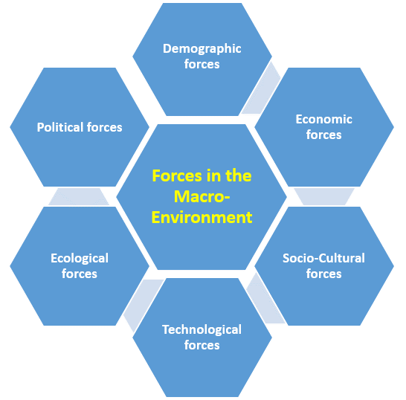

Macro-Environment Analysis
A macro-environment study is investigating external elements that might have an impact on a company's operations, plans, and overall success. These elements, in the case of Marks & Spencer (M&S), include political, economic, social, technical, environmental, and legal effects, which are often summarised using the PESTEL framework. Let's take a closer look at each of these aspects to see how they affect M&S:

1. Political Factors:
- Trade Policies: International trade treaties and tariffs may have an impact on M&S's worldwide supply chain and market growth initiatives.
- Regulations and Standards: Regulatory changes affecting product safety, labelling, and labour practises may have an effect on M&S's operations and reputation.
- Political Stability: Political unrest in some markets might jeopardise M&S's operations and investments.

2. Economic Factors:
- Economic Growth: Consumer spending and buying power are influenced by economic circumstances in important markets, impacting M&S's sales.
- Inflation and Currency Fluctuations: Currency fluctuations and inflation rates may have an influence on the cost of purchasing materials and goods.
- Income Levels: Consumer tastes and buying behaviour are influenced by disposable income levels, which impact M&S's product demand.

3.Social Factors :
- Changing Demographics: Changes in population age, economic distribution, and family structures may all have an effect on M&S's product preferences and target audience.
- Lifestyle Trends: Shifting customer tastes for sustainable, healthful, and ethically based items may cause M&S's offers to evolve.
Cultural norms and values may have an impact on product design, marketing methods, and customer perception.

4. Technological Factors:
- Digitalization: As technology advances, M&S must engage in e-commerce, digital marketing, and seamless online experiences.
- Automation and Supply Chain: Technological innovations have the potential to optimise supply chain operations, cut costs, and increase efficiency.

5. Environmental Factors:
- Sustainability Concerns: As people become more conscious of environmental concerns, there is a greater demand for eco-friendly goods and ethical business practises, encouraging M&S to prioritise sustainable sourcing and decreased environmental effect.
- Climate Change Risks: Climate-related supply chain disruptions, such as severe weather occurrences, may have an effect on M&S's operations.

6. Legal Factors:
- Regulations and Compliance: M&S's operations and plans are influenced by legal obligations in areas such as labour practises, data protection, and product safety.
- Intellectual Property: Maintaining M&S's brand image and avoiding intellectual property infringements require the protection of trademarks and patents.

It is vital to recognise that these aspects are linked and might provide M&S with significant problems and possibilities. M&S can anticipate possible hazards and develop plans to capitalise on emerging trends by analysing the macro-environment. Furthermore, the company's dedication to sustainability and ethical business practises positions it well to address social and environmental problems while staying competitive in a constantly changing global context.

PESTEL Analysis ( Diagram)
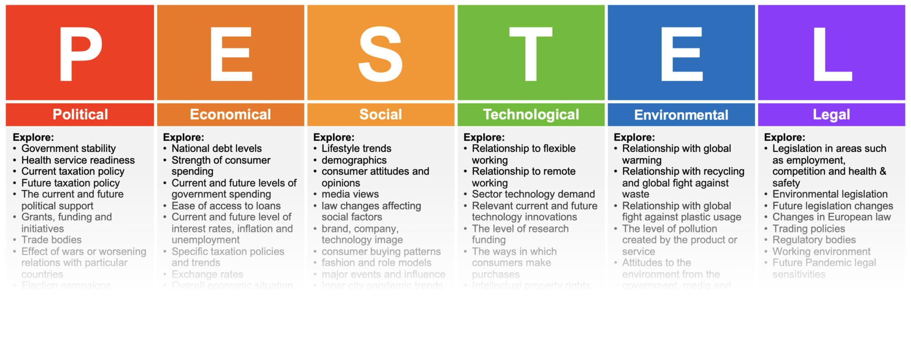

PESTEL Analysis
A PESTEL study looks at the macro-environmental elements that may have an influence on the business operations and strategy of an organisation. Perform a PESTEL study for Marks & Spencer as follows:
1. Political Factor:
- Trade Agreements: The supply chain and distribution of M&S may be impacted by changes to trade agreements, such as the effect of Brexit on UK-EU trade.
- Political Stability: M&S's global operations and growth ambitions may be affected by political unrest in important markets.
- Regulatory Changes: M&S's compliance initiatives and operating expenses may be impacted by changing legislation on product safety, labelling, and labour practises.

2. Economic Factors:
- Economic Growth: Economic upswings or downturns may have an impact on consumer spending on M&S items, which may have an effect on revenue and profitability.
- Inflation and Exchange Rates: Changes in inflation and currency values may have an impact on the price of acquiring materials and on global commerce.
- Consumer Income Levels: The demand for M&S's goods may change depending on changes in consumer disposable income levels.

3. Social Factors:
- Demographic Changes: The target market and product preferences of M&S are impacted by changes in the population's age composition and growth.
- Lifestyle Trends: M&S's product offers and customer choices are impacted by the growing focus on health, sustainability, and ethical consumerism.
- Cultural norms: In a number of foreign marketplaces, cultural variations affect customer behaviour and marketing tactics.

4. Technological Factors:
Digitalization: As a result of the influence that technological improvements are having on how consumers purchase, M&S has improved its e-commerce capabilities and digital marketing techniques.
- Automation and Supply Chain: For M&S, technological advancements may improve the effectiveness of the supply chain, inventory control, and logistics.

5. Environmental Factor:
Growing customer knowledge of environmental concerns necessitates M&S to adopt sustainable business practises.
- Climate Change Impacts: M&S has to handle possible supply chain and operational interruptions brought on by climate-related occurrences.

6. Legal Factors:
- Regulatory Compliance: Maintaining M&S's business operations necessitates observing legal obligations in domains including labour legislation, data protection, and product safety.
- Intellectual Property Protection: Protecting copyrights, patents, and trademarks bolsters M&S's efforts to innovate and build its brand.

By examining these variables, Marks & Spencer may learn more about the outside influences that could have an effect on its company and create plans to deal with obstacles and grasp opportunities. M&S can adapt its operations to the changing environment, maintain the reputation of its brand, and guarantee ongoing development by taking a balanced approach to the PESTEL variables.

Micro-Environment Analysis ( Diagram)

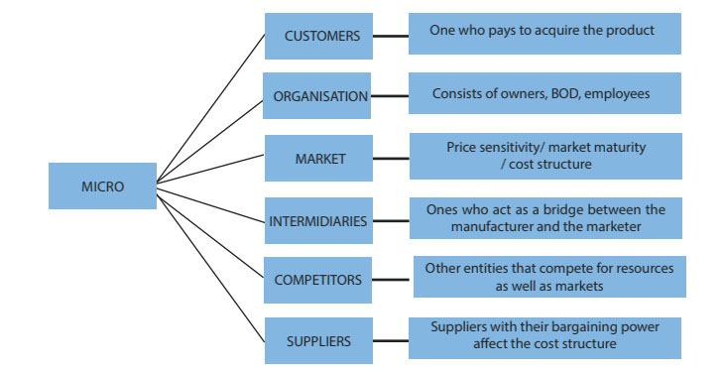

Micro-Environment Analysis
The precise elements that have a direct impact on a company's operations, competitiveness, and relationships with its stakeholders are the subject of a microenvironment study. Let's examine the Marks & Spencer microenvironment:

1. Customers:
Consumer Preferences:
M&S's product offers and marketing tactics are informed by an understanding of consumer preferences for product quality, style, and sustainability.
- Demographics: Knowing your target market's age, income, and geography enables you to better focus your marketing efforts.

2. Competitors:
By identifying both direct and indirect rivals in the retail sector, M&S can assess its market positioning and create strategies to set itself apart.
- Competitive Advantage: Determining M&S's strengths and shortcomings in comparison to rivals helps the company create and maintain a competitive advantage.

3. Suppliers:
- Strong supplier connections promote timely and dependable procurement of resources, which affects the availability and quality of M&S's products.
- Supplier Diversity: Examining sustainability and supplier diversity policies is consistent with M&S's beliefs and may enhance the company's reputation.

4. Retail Partners and Distributors:
- Distribution Channels: Working together with distributors and retailers guarantees that M&S's goods successfully reach the target markets.
- Relationships with Retailers: Building solid alliances with retailers helps increase M&S's product exposure and shelf space.

5. Internal Stakeholders:
- Employees: Dedicated workers help businesses run smoothly and provide exceptional customer service.
- Management: The management team's ability to make wise decisions and plan strategically is essential to M&S's overall success.

6. Investors and Shareholders :
- Shareholder Expectations: Retaining investor trust depends on meeting or surpassing shareholder expectations for profitability and growth.
Strong financial performance increases shareholder value and provides funding for M&S's strategic activities.

7. Media and Public Perception:
- Brand Reputation: Controlling media attention and public perception is essential for upholding M&S's brand reputation and retaining consumer trust.
- Crisis management: Effective crisis management may protect a company's reputation and preserve stakeholder trust.

8. The legal and regulatory environment :
- Compliance: By abiding by all applicable rules and regulations, M&S is able to stay out of trouble with the law and preserve its reputation for moral behaviour.
- Consumer Protection: Upholding M&S's dedication to client happiness and trust by abiding with consumer protection legislation.

9. Local Communities
- Community Engagement: Promoting connections and brand loyalty by supporting regional communities via activities like philanthropic programmes.
- Environmental Impact: How the public views M&S's environmental policies may affect how the public views the brand and its popularity.

Marks & Spencer can better communicate with consumers, avoid competition, work with stakeholders, and align operations with shifting market dynamics by analysing the micro-environment. Understanding these particular effects will help M&S make choices that will improve performance and maintain its place in the market.

Industry Life Cycle
The phrase "industry life cycle" refers to the numerous phases that a certain industry experiences through time, from its infancy to its maturity and, in some circumstances, decline. Let's examine Marks & Spencer's (M&S) role in the industrial life cycle:
1. Introduction
The corporation introduces its goods and services to the market during this phase. The introduction phase of M&S began with the company's humble beginnings as a market stand in 1884. The business immediately established a reputation for providing high-quality products at reasonable prices, laying the groundwork for its future expansion.
2. Growth:
Marks & Spencer expanded significantly during the course of the 20th century. The company's success was facilitated by the launch of its "St. Michael" brand, diversification into new product categories, and emphasis on client happiness. M&S expanded its reach and gathered a devoted following of customers as it rose to prominence both in the UK and abroad.
3.Maturity:
Over the course of many decades, M&S matured and cemented its position as a leading retailer. The brand's cuisine selection, apparel lines, and reputation for excellence all gained widespread recognition. This stage was characterised by ongoing expansion, streamlining of operating procedures, and an emphasis on preserving client loyalty.
4. Saturation:
M&S has recently had to deal with difficulties brought on by customer choice changes and market saturation. The old business model of M&S faced difficulties from increased competition from fast-fashion companies, e-commerce platforms, and shifting consumer trends. The business had to adjust to changing customer needs and the digital revolution.

5. Decline or Renewal:
It is possible to think of the present phase of the M&S industry life cycle as a time of regeneration. To stay relevant in a changing retail environment, the firm realised it needed to update its tactics. To adapt to shifting customer attitudes, M&S has been attempting to improve its internet presence, hone its product offers, and place an emphasis on sustainability.

It's vital to keep in mind that the industry life cycle is not linear and that businesses may pass through several stages more than once. Since the inception and growth stages of M&S's business happened many years ago, the firm has gone through phases of maturity and faced difficulties related to market saturation and shifting market dynamics. The present emphasis on rejuvenation is a reflection of M&S's efforts to resurrect its brand and catch up with modern trends.
As with any research, it's important to keep in mind that industry life cycle phases are not always absolute, and businesses may display traits from many stages at once. The progression of M&S through these phases emphasises how important adaptability, innovation, and strategy evolution are for preserving relevance and competitiveness in a fluid market context.

Porter’s Five Forces Analysis ( Diagram)
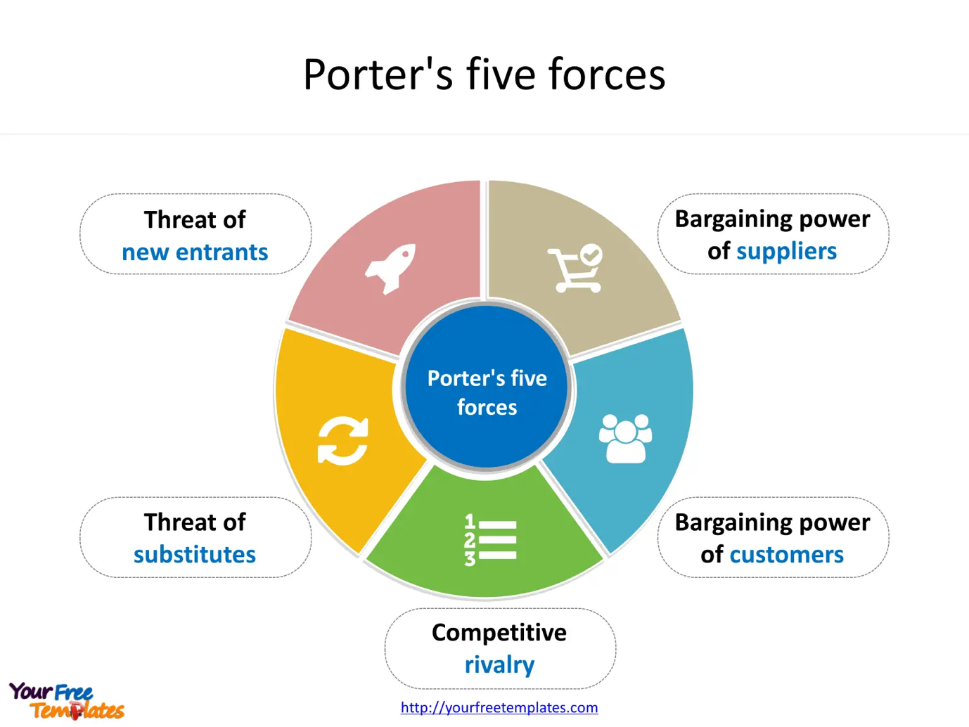

Porter’s Industry Five Forces Analysis
The Porter's Five Forces analysis is a methodology for evaluating an industry's level of competitiveness and attractiveness. Let's examine Marks & Spencer using Porter's Five Forces analysis:
1. The Threat of New Entrants:
The retail sector faces a modest threat from new entrants, particularly in the food and apparel industries. The entrance hurdles are not insurmountable, yet they might still be difficult to overcome:
- Economies of scale: Long-standing merchants like M&S profit from economies of scale, making it difficult for competitors to match their cost-savings capabilities.
- Brand Loyalty: M&S has a devoted client base that has been developed over many years, making it difficult for new competitors to immediately capture market share.
- Capital Needs: Setting up a retail enterprise takes a large sum of money for the store's setup, inventory, and marketing.
- Distribution Network: New entrants must mimic the supply chains and distribution networks that already-existing merchants have in place.

2. Suppliers' Bargaining Power:
In the retail sector, suppliers have a considerable amount of negotiating leverage, however this might vary depending on the individual product categories:
- Clothing Suppliers: M&S has some negotiating sway over clothing suppliers due to its size and reputation, although supplier diversification and fashion trends may also play a role.
- Food Suppliers: M&S may have an edge in negotiations with food suppliers that share its commitment to quality and sustainability.

3. Buyers' Bargaining Power:
Because of their price sensitivity and changing tastes, customers have a big effect on M&S:
- Strong buying power: Customers have many options available to them in the retail sector, providing them the freedom to move to rivals.
- Price Sensitivity: Price sensitivity among consumers may result in fierce competition and pressure on M&S to provide competitive prices.
- Changing Preferences: M&S must modify its offers in response to shifting customer preferences for sustainability and moral behaviour.

4. Threat of Substitute Goods or Services:
Due to the availability of replacement goods and shopping options, the danger of substitutes is rather significant in the retail sector:
- Substitutes: Customers might be drawn away from conventional brick-and-mortar businesses like M&S by fast-fashion companies, online shopping platforms, and alternative retail channels.
- E-Commerce: The expansion of e-commerce offers customers practical alternatives for traditional retail establishments.

5. Competitive Rivalry Within the Industry: Strong competition exists among current brick-and-mortar and internet retailers:
- Intense Competition: There are many businesses vying for market share and customers' attention in the congested retail sector.
- Differentiation: M&S must distinguish itself by product quality, brand repute, and sustainable practises in order to stand out.

In conclusion, Marks & Spencer faces difficulties from new competitors, shifting customer preferences, internet shopping, and alternative retail outlets in its competitive landscape. M&S must concentrate on growing and exploiting brand loyalty, strengthening its online presence, and adjusting to shifting market trends if it wants to keep its position.

Internal Analysis
A company's internal resources, capacities, and operations are analysed internally to determine their strengths and shortcomings. Let's do a Marks & Spencer (M&S) internal analysis:

1. Strengths
• Brand Reputation :
M&S has a powerful brand that stands for excellence, dependability, and British tradition. Customers' confidence and loyalty have been earned as a result of its lengthy history of providing high-quality items.

- Diverse Product Offering: M&S sells a variety of commodities, such as apparel, food, household items, and more. By diversifying, the business is able to appeal to a wider client base.

Innovation and quality: M&S stands apart due to its dedication to product innovation and quality. It often emphasises high-quality materials, workmanship, and distinctive goods in its apparel lines and cuisine offers.
- Sustainable Development Initiatives With an emphasis on waste reduction, ethical sourcing, and environmentally friendly practises, the organisation has achieved considerable advancements in sustainability. This suits the tastes of contemporary consumers.
- Strong Employee Culture: M&S places a strong focus on employee happiness and engagement, which fosters a motivated staff that can improve both customer satisfaction and operational effectiveness.
- Global Presence: With a presence in many nations, M&S has a worldwide reach that enables it to access a variety of markets and customer groups.

2. weaknesses
Digital Transformation M&S has been attempting to improve its online visibility, but it confronts competition from e-commerce behemoths and must constantly develop new online services.

Supply chain complexity is a factor. Due to the company's varied product line and global operations, managing costs and operating efficiently may face difficulties due to the complexity of the supply chain.

- Fashion Trend Sensitivity: To remain relevant, M&S's clothes company may need to adopt agile techniques due to how quickly fashion trends change.

- Operating Expenses: Higher operating expenses may be incurred as a result of maintaining the high standards for quality and sustainability, which may affect price competitiveness.

- Contest: M&S must constantly work to stand out in the extremely competitive retail market, which includes both conventional and internet businesses.

3.Core competencies include:

- Quality Assurance: A major strength and differentiator for M&S has been its constant emphasis on producing high-quality goods across a range of categories.

- Sustainable Business Practises: The business has established itself as a pioneer in ethical retail practises thanks to its dedication to sustainability and responsible sourcing.

- Customer Relationship: M&S's long-standing, solid customer connections are a key component of customer loyalty and repeat business.

4. Unique Selling Proposition:

M&S's blend of legacy, quality, and sustainability serves as its key differentiator. It provides goods that appeal to buyers who value dependability, British history, and moral decisions.

5. Resource Allocation:

M&S should think about devoting funds to: - Improve its online visibility and shopping experience.
- Be innovative in product creation all the time to keep up with customer needs and vogue trends.
- Improve supply chain management to reduce costs and increase effectiveness.
- To keep a committed staff, make investments in employee engagement and development.
M&S's operations are solidly supported by its strengths in the areas of brand reputation, product quality, sustainability, and staff culture. The firm may overcome obstacles and maintain its competitive edge in the changing retail environment by addressing weaknesses and using key capabilities.

Mark & Spencer’s Strategic Resources and Capabilities
The distinctive assets, skills, and talents that Marks & Spencer uses to accomplish its business goals and create a competitive edge in the retail sector are known as its strategic resources and capabilities. Let's examine a few of these tactical tools and abilities:
1.Brand Reputation and Heritage:
- Customers are loyal to and trust M&S because of its lengthy history and solid brand reputation.
- The company has a distinct market position since the brand is linked to excellence, dependability, and British history.

2. Quality Assurance:
M&S stands apart from rivals due to its dedication to providing high-quality items.
- Quality assurance procedures guarantee that goods live up to consumer expectations and uphold a company's image.

3. Diverse Product Portfolio:
M&S's extensive product line, which includes apparel, food, home items, and more, enables the business to meet the needs of different client categories and preferences.

4. Sustainability Initiatives :
- M&S's emphasis on sustainability and moral behaviour is in line with customer desires for environmentally friendly goods.
- Sustainability programmes help the organisation build a reputation for ethical corporate conduct.

5. Customer Relationships:
Strong customer ties that M&S has developed over decades are what encourage client loyalty and repeat business.
- M&S can efficiently customise its offers by being aware of the demands and preferences of its customers.

6. Supply Chain Management:
A strong supply chain management system enables prompt product delivery and effective inventory control.
- Reliable sourcing and quality control are aided by strong ties with suppliers.

7. Innovation and design:
- M&S is able to keep ahead of customer tastes and fashion trends because to its capacity to innovate in product design and development.
- Design knowledge helps to produce distinctive and attractive goods.

8.Employee Engagement and Culture:
- M&S's focus on employee happiness and engagement results in an engaged workforce.
- Workplace culture affects the effectiveness of operations and the quality of client service.

9. International Presence:
M&S's worldwide network enables it to access a variety of markets and clientele.
- International business activities help provide prospects for development and income diversification.

10. E-commerce and Digital Initiatives:
M&S is adapting to shifting customer habits by improving its online visibility and shopping experience.
- Digital activities aid multichannel marketing plans and expand client reach.

11. Corporate Social Responsibility (CSR): M&S's CSR programmes, such as sustainability and community participation, help to build a favourable reputation for the company.

Together, these strategic assets and competencies provide M&S the edge it needs to stand out in the retail sector and meet changing consumer demands. M&S seeks to keep its competitive edge and maintain its position as a respectable and forward-thinking retail brand by using these assets and continuously adjusting to market developments.

Value Chain Analysis
Value Chain Analysis is a framework that aids in the analysis of a company's operations and procedures to comprehend how it provides value for clients and eventually results in a competitive advantage. Let's use Marks & Spencer as our case study for the value chain analysis:

1. Inbound Logistics:
Sourcing: M&S purchases goods from a variety of vendors, putting a premium on quality and sustainability.
- Supplier Relationships Goods will be delivered consistently and on schedule if you maintain solid ties with your suppliers.

2. Operations:
Quality Control: M&S places a strong emphasis on quality assurance throughout its manufacturing procedures to guarantee that goods satisfy high standards.
- Product Design: M&S benefits from innovation in product design to provide distinctive and alluring products, particularly in the apparel categories.

3. Outbound Logistics:
Distribution: M&S effectively controls its distribution network to make sure that goods arrive to shops and consumers on schedule.
- Retail Partnerships: Working with retailers guarantees that items are accessible to consumers through a variety of channels.

4. Marketing and Sales:
Brand Image: M&S's solid brand image and tradition serve as major marketing catalysts.
- Customer Engagement: Marketing initiatives are focused on interacting with consumers via a variety of channels while advancing sustainability and quality.

5. Customer Service:
Customer connections:Excellent Customer Service and Support: M&S's long-standing customer connections are fostered through excellent customer service and support.
- Comments and Improvement: M&S consistently enhances its goods and services based on user input.

6. Procurement:
Supplier Selection: M&S carefully chooses suppliers based on their product quality, ethical business conduct, and compatibility with sustainability objectives.
- Talking points: Obtaining advantageous conditions from suppliers helps in cost optimisation and guarantees a steady supply.

7.Technology and Innovation:
Digital Presence: M&S's investment in technology improves its e-commerce capabilities and digital consumer experience.
- Product Innovation: M&S maintains its competitiveness by consistently introducing new products and services.

8. Human Resources:
Employee Development: M&S's focus on worker happiness and growth helps to foster a motivated workforce.
- Training: Continuing education enables staff to provide superior customer service and maintain operational effectiveness.

9. Firm infrastructure:
Global Presence: M&S's foreign businesses provide a solid foundation for growth and revenue diversification.
- Corporate Culture: M&S's corporate culture promotes creativity, environmental responsibility, and moral behaviour.
M&S adds value for its customers by placing a strong focus on quality, sustainability, innovation, and partnerships with them. The company's value chain operations are intertwined, and their efficient management helps it maintain a competitive edge in the retail sector. M&S seeks to improve its value offer and hold onto its position as a dependable and forward-thinking retailer by continuously optimising these efforts and adapting to shifting customer preferences.

Primary Activities
The crucial operational stages involved in developing, promoting, and providing clients with goods are Marks & Spencer's (M&S) main operations. These actions are crucial for creating money for the organisation since they immediately impact the value chain. Let's examine M&S's main activities:
1. Inbound Logistics
- Sourcing and Procurement: Clothing, food, and household items are just a few of the many things that M&S purchases from different vendors. This entails choosing suppliers who adhere to high standards of quality, sustainability, and moral behaviour.
• Supply Chain Management: The business controls its supply chain to make sure that supplies and goods arrive to its distribution centres and retail locations on schedule.

2. Operations:
Product Manufacturing and Assembly: To generate the finished goods for its apparel lines and certain other items, M&S uses manufacturing or assembly procedures.
• Quality Control To retain its standing as a manufacturer of high-quality goods, M&S places a strong emphasis on quality control throughout the whole manufacturing process.
- Packaging: The products are properly wrapped for display and shipping, complementing the brand's image.

3. Outbound Logistics:
Distribution: M&S effectively runs its distribution network to get goods from its distribution centres to shops and, in the case of e-commerce, right to consumers' front doors.
- Retail Partnerships: By working with retail partners, we can make sure that our items are accessible via a variety of channels, including standalone M&S shops and other retailers.

4. Marketing and Sales:
Branding and Promotion:M&S's solid brand recognition and history are important factors in its marketing initiatives. Through a variety of marketing methods, the corporation advertises its goods.
- Advertising and Communication: To interact with consumers and market its goods, M&S use advertising, social media, and other communication techniques.
- Customer Engagement:The business places a strong emphasis on keeping consumers engaged via individualised experiences, loyalty schemes, and exclusive deals.

5. Customer Service:
Customer help: M&S offers customer help through a variety of channels, resolving questions, issues, and comments to guarantee a great customer experience.
- *Returns and Exchanges*: The business makes hassle-free returns and exchanges possible, which increases customer happiness.

The capacity of M&S to efficiently develop, distribute, and market its goods is influenced by these core operations, which are interrelated. M&S hopes to provide high-quality items to clients, uphold enduring customer connections, and preserve competitiveness in the retail sector by managing these operations effectively.

Secondary Activities
Marks & Spencer's (M&S) secondary activities support the core activities by providing the required infrastructure, resources, and procedures to enable the smooth running of the company's operations. These actions are critical for establishing a productive and efficient corporate environment. Let's look into M&S's supplementary activities:

1. Firm Infrastructure:
- Global Presence: M&S's worldwide activities and presence provide the groundwork for future growth and revenue diversification.
- Corporate Culture:The corporate culture of M&S promotes innovation, sustainability, and ethical practises, influencing decision-making and staff behaviour.

2. Human Resources:
- Recruitment and Selection:M&S recruits and chooses personnel based on skills, values, and cultural fit.
- Training and Development:Ongoing training programmes ensure that staff have the skills they need to provide exceptional customer service and efficiently execute their responsibilities.
- Employee Well-being: To develop a motivated and engaged workforce, M&S prioritises employee well-being.

3. Technology and Innovation:
M&S invests in technology to improve its e-commerce capabilities, digital marketing, and online consumer experience.
- Product Development: Continuous innovation in product design and offers assists M&S in remaining competitive and meeting evolving customer demands.

4. Procurement:
- Supplier Management: M&S monitors supplier relationships to guarantee consistent sourcing, ethical practises, and quality assurance.
- Bargaining: Negotiating favourable terms with suppliers aids in cost optimisation and assures a consistent supply of materials and goods.

5 Regulatory and Legal Affairs:
- conformity: M&S guarantees conformity with applicable laws, regulations, and industry standards, while promoting ethical business practises.
- Intellectual Property: It is critical to protect trademarks, patents, and copyrights in order to retain brand image and innovation.

6. Corporate Social Responsibility (CSR):
- Sustainability Initiatives: M&S's dedication to sustainability, ethical sourcing, and environmental practises adds to the company's favourable image.
- Community Engagement:Participation in philanthropic programmes and community projects displays the company's social responsibility.

7. Product Development:
- Research and Development: M&S spends in R&D to produce new goods and enhance old ones while keeping ahead of customer trends.

8. Financial Management:
- Budgeting and Financial Planning: M&S manages its finances strategically in order to efficiently allocate resources and accomplish corporate goals.
- Cost Control:Efficient cost management enables the organisation to sustain profitability while maintaining competitive pricing.

By providing the required resources, procedures, and infrastructure, these secondary operations together support M&S's main activities. Effective management of these tasks guarantees that the firm can continue to offer high-quality items, retain customer connections, and compete in the retail sector.

VRIO Analysis of Distinctive Resources and Capabilities
The VRIO methodology evaluates a company's resources and capabilities in terms of Value, Rarity, Imitability, and Organisational Support. Let us apply the VRIO analysis to the unique resources and skills of Marks & Spencer (M&S):
1. Reputation and Heritage of the Brand:
M&S's brand reputation and legacy are valuable because they contribute to consumer trust, loyalty, and good product quality perceptions.
Rarity: The brand's lengthy history and reputation are unique and difficult for rivals to replicate.
While other businesses may attempt to construct their own brands, replicating M&S's existing tradition and reputation would be difficult.
M&S has spent decades investing in protecting and cultivating its brand name, exhibiting strong organisational support.

2. Initiatives for Sustainability:
M&S's sustainability initiatives are in line with rising customer demand for environmentally friendly goods and ethical business practises.
Rarity: While sustainability is becoming increasingly prevalent, M&S stands apart for its broad commitment to ethical sourcing and environmental practises.
Imitability: To replicate M&S's sustainability programmes, considerable investment and a commitment to change are required.
M&S's emphasis on sustainability reflects a strategic commitment backed up by organisational measures.

3. Diverse Product Portfolio :
M&S's diverse product offering appeals to a broad variety of client categories and tastes, expanding its market reach.
Rarity: While having a varied portfolio is not uncommon, M&S's mix of apparel, food, and home items under one brand is distinctive.
Competitors may mimic a varied portfolio, but reaching the same level of brand awareness and trust across categories is difficult.
M&S's capacity to handle many product categories requires good organisational cooperation.

4. Quality assurance:
Value: M&S's focus on quality adds to customer happiness and loyalty, which is consistent with the company's reputation for dependable goods.
Rarity: Maintaining continuous high quality is difficult since it requires stringent quality control and operational excellence.
Imitability: To achieve M&S's level of quality assurance, large investments in procedures and resources are required.
Quality assurance is a crucial component of M&S's operations, demonstrating strong organisational commitment.
According to the VRIO research, Marks & Spencer has a competitive advantage due to its unique resources and competencies, such as its brand recognition, sustainability efforts, wide product selection, and quality assurance. These resources are valuable, uncommon, difficult to replicate, and well supported by the organisation. M&S can distinguish itself in the retail business and generate value for its consumers by using these assets.

SWOT Analysis (Diagram)

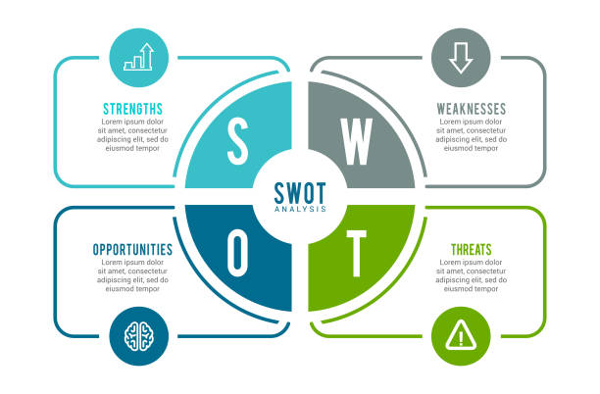

SWOT Analysis
A SWOT analysis assesses a company's strengths, weaknesses, opportunities, and threats. Marks & Spencer (M&S)'s SWOT analysis is as follows:
Strengths.
1. Strong Brand Reputation: M&S is recognised for quality and dependability, which contributes to a loyal consumer base and strong brand impression.
2. Diverse Product Portfolio: To meet the demands of its customers, the firm provides a diverse product portfolio that includes apparel, food, and home items.
3. Sustainability Commitment: M&S's emphasis on sustainability and ethical practises matches with current customer expectations and strengthens the company's reputation.
4. Customer Loyalty: Repeat business and customer loyalty are influenced by long-standing customer connections and brand trust.
5. International Presence:With a presence in several countries, M&S has a worldwide reach that allows it to tap into a variety of markets.
6. Innovative Design: The company's emphasis on innovation and design enables it to generate distinctive and attractive items, notably in the apparel line.

Weaknesses:
1. Digital Transformation:M&S has struggled to adapt to digital retail trends, which may have an effect on its competitiveness in online channels.
2. Fashion Trend Sensitivity: Because the garment industry is vulnerable to swiftly shifting fashion trends, staying relevant requires adaptability.
3. operating expenditures: Upholding high quality and sustainability standards may need greater operating expenditures.
4. Supply Chain Complexity: The complexity of the supply chain for varied goods may provide cost management and efficiency difficulties.
5. Competition: M&S competes in a highly competitive retail business that includes both conventional and online competitors.

Opportunities:
1. E-Commerce Growth: By expanding and improving the company's e-commerce capabilities, it will be able to capitalise on the rising trend of online buying.
2. Sustainability Focus: M&S's sustainability activities are in line with rising customer demand for environmentally friendly and ethical goods.
3. International Expansion: Further expansion into new areas might provide prospects for development and diversification of income sources.
4. Food and Clothing Innovation: Continued product innovation may attract new consumers and distinguish M&S's goods.
5. Health and Wellness Trend: Taking advantage of the health and wellness trend by providing better dining alternatives and environmentally friendly clothes.
Threats:
1. Intense rivalry: M&S confronts rivalry from a variety of stores, including fast-fashion labels, e-commerce behemoths, and other conventional shops.
2. Evolving Consumer Preferences: Consumer preferences for convenience, sustainability, and internet shopping may all have an influence on M&S's sales.
3. Economic Conditions: Downturns in the economy and changes in consumer spending may have an impact on M&S's sales and profitability.
4. Online Retail Giants: The dominance of online retail giants may put M&S's online presence and consumer acquisition at risk.
5. Supply Chain Disruptions: Supply chain disruptions caused by causes such as geopolitical crises or natural catastrophes may have an effect on operations.

A SWOT analysis gives a complete picture of a company's internal strengths and weaknesses, as well as external opportunities and threats. M&S may use its strengths to capitalise on opportunities while addressing its shortcomings and risks to develop successful plans for long-term development.

Strategies to Sustain Competitive Advantage
Marks & Spencer (M&S) may use multiple strategies based on diverse strategic assessments, such as Porter's Generic Strategies, to maintain its competitive edge. Let's look at different techniques that M&S might employ:

1. Differentiation Strategy (Porter's Generic Strategy):
- Value-Added Products:** Maintain an emphasis on high-quality and distinctive product offerings that distinguish M&S from rivals. Highlight the brand's reputation for quality and longevity.
- inventive Design: Invest in inventive product design to develop attractive and unique items, particularly in the garment industry.
- Customer Experience: Improve in-store and online purchasing experiences by offering personalised service, simplicity of navigation, and convenience.

2. Cost Leadership Strategy (Porter's Generic Strategy):
- Operational Efficiency: To provide competitive pricing, streamline supply chain operations and minimise operational expenses while preserving quality.
- Lean Management Practises: Use lean management practises to reduce waste, optimise resources, and boost efficiency.
- Economies of Scale: Use M&S's size to negotiate better terms with suppliers and gain cost savings.

3. Focus Strategy (Porter's Generic Strategy):
- Niche Markets: Concentrate on niche client groups where M&S can deliver distinctive value, such as environmentally friendly and ethically sourced items.
- Localised Offerings:Tailor goods to individual local markets' tastes and demands, increasing relevance and consumer engagement.

4. Digital Transformation Strategy:
Invest in a user-friendly and strong e-commerce platform to capture online sales and successfully compete with digital-native rivals.
- Digital Marketing: Use focused digital marketing initiatives to reach out to and engage consumers through online channels.
- Data Analytics: Use data analytics to get insights into consumer behaviour, preferences, and trends, allowing for better decision-making.

5. Sustainability and Ethical Strategy:
- Sustainable Sourcing: In order to appeal to environmentally sensitive customers, strengthen commitment to sustainable sourcing and ethical practises across all product categories.
- Transparency: Communicate openly about M&S's environmental efforts and progress, fostering consumer confidence.
- Green Initiatives: Introduce more eco-friendly packaging and goods to meet rising customer demand for environmentally friendly options.

6. International Expansion Strategy:
- developing countries:** Focus on items that correspond with local tastes and requirements in developing countries.
- Adaptation: Tailor offerings to cultural variances, legal restrictions, and customer behaviour in different worldwide markets.
- Strategic Partnerships: Form strategic alliances with local merchants or distributors to help you enter new markets.

7. Continuous Innovation Strategy:
- R&D Investment: Invest in research and development to develop new and innovative goods across all product categories.
- Collaboration: To bring breakthrough ideas to market, collaborate with designers, suppliers, and technology partners.
- Trend Anticipation: To keep a competitive advantage in the fast-paced retail business, stay ahead of fashion and customer trends.

M&S may construct a multi-faceted strategy to maintaining its competitive edge by incorporating parts from other strategic studies, such as Porter's Generic Strategies. These strategies should complement the company's strengths, reduce weaknesses, capitalise on opportunities, and handle risks, eventually establishing M&S as a robust and inventive retail operator.

Growth Strategies
Certainly, let us investigate numerous Marks & Spencer (M&S) development plans employing various strategic analyses:

1. Market Penetration (Ansoff Matrix):
- Current Products, Current Markets:** By utilising its strong brand and consumer loyalty, M&S may concentrate on growing its market share in its current markets.
- Promotions and Loyalty Programmes:** To attract and keep consumers, use targeted marketing campaigns, discounts, and loyalty programmes.

2. Market Development (Ansoff Matrix):
Expand into new geographic regions where M&S is not currently present. Customise items to meet local tastes while keeping the brand's basic principles.
- International Franchising: Open franchised locations in new countries, collaborating with local firms to manage cultural and regulatory complexities.

3. Product Development (Ansoff Matrix):
Innovate by creating new product lines or variants within current categories, adapting to shifting customer preferences.
- Collaborations: Create limited-edition collections with designers, influencers, or celebrities to draw attention and appeal to certain target groups.

4. Diversification (Ansoff Matrix):
Invest in new and unrelated product categories or markets to lessen reliance on a single market.
- Digital-First Brands: Capitalise on the expansion of e-commerce by launching new digital-first brands that appeal to certain niches or trends.

5. International Expansion Strategy:
- Franchising:** Expand worldwide via franchising, enabling local partners to run shops while maintaining brand control.
- Joint Ventures: Work with local partners in international markets to share risks and capitalise on their knowledge.
- Wholly-Owned Subsidiaries: Form wholly-owned subsidiaries in areas where M&S want more direct control and brand promotion.

6. Entry Mode Strategies:
- Greenfield Investment:** Build new shops from the ground up in high-growth regions, allowing total control over operations and brand presence.
- Acquisitions: Purchase existing retail chains in desired areas to increase market share fast and profit from existing customer bases.
- Licencing: Licence the M&S brand to local merchants, enabling them to operate under the name while generating money and market presence for M&S.

7. E-Commerce and Digital Expansion:
- Online Marketplaces:** Collaborate with well-known online marketplaces to broaden your reach and tap into current consumer bases.
- Direct-to-Consumer: Invest in improving the company's e-commerce platform to provide consumers with a flawless online buying experience.
- Global Shipping: Provide worldwide shipping choices to consumers who live outside of typical geographic borders.

M&S can efficiently manage its expansion path, capitalise on possibilities, and diversify its income sources by using these growth tactics and adopting numerous strategic evaluations. The tactics adopted should be in line with the company's capabilities, market trends, and long-term goals.

Green Strategy and CSR
Marks & Spencer (M&S) has been aggressively pursuing a green strategy and participating in corporate social responsibility (CSR) activities to promote sustainability and ethical practises. Let's look at their green approach and CSR efforts:

Green Strategy:

M&S's green strategy focuses on reducing the environmental effect of its operations, goods, and supply chain. Among the key components of their green approach are:

1. Sustainable Sourcing: M&S prioritises purchasing materials and goods from suppliers that follow ethical and sustainable practises. This includes using ethically produced raw materials and using fair labour practises.

2. Reducing the Environmental Footprint:Across its activities, the corporation strives to decrease its carbon footprint, water use, and trash output. This includes energy-efficient lighting, trash reduction programmes, and prudent water management.

3. Circular Economy: M&S aspires to establish a circular economy by encouraging recycling and reusing resources. They encourage consumers to return unwanted items via their "Shwopping" project, diverting textiles from landfills.

4. Innovation in Packaging: The firm is committed to decreasing superfluous packaging and adopting sustainable packaging materials, with the goal of minimising environmental effect.

5. Ethical Farming and Animal Welfare: M&S promotes ethical farming practises in their food supply chain, focusing on animal welfare and appropriate agricultural techniques.

CSR Initiatives:

M&S's CSR programmes go beyond environmental sustainability to include social responsibility and community involvement:

1. Ethical business: M&S assures fair treatment and remuneration for employees in their supply chain by encouraging ethical business practises and supporting workers' rights.

2. Community Engagement: The corporation collaborates with local communities via philanthropic partnerships and community programmes, so contributing to social development and well-being.

3. Diversity and Inclusion: M&S is dedicated to developing diversity and inclusion in its workforce and supporting equality in all parts of its business.

4. Health and Well-Being: Customers are encouraged to live better lives by providing healthier food options and accurate nutritional information.

5. Employee Well-being: M&S prioritises employee well-being by providing a supportive work environment, training programmes, and career development possibilities.

Education and Awareness: Through campaigns and initiatives, the organisation develops consumer, employee, and stakeholder awareness of sustainable and ethical practises.

M&S's green strategy and CSR initiatives are in line with customer values and expectations for responsible business practises. These projects not only contribute to a great brand image, but they also solve global environmental and social concerns. M&S exhibits a commitment to creating a good effect beyond its bottom line by incorporating sustainability into its business strategy and actively interacting with communities.

Conclusion
Finally, Marks & Spencer (M&S) is a key participant in the retail business with a rich history, a strong brand reputation, and a dedication to sustainability and ethical practises. Throughout its history, M&S has faced several obstacles and opportunities, altering its strategy to stay relevant in a continuously changing market.
The company's emphasis on quality, creative product design, and diversified offers spanning clothes, food, and home items has led to its competitive edge. M&S's commitment to sustainability not only coincides with current customer expectations, but also reflects the company's care for environmental and social problems.
While M&S has always been linked with its physical shops, its attempts to improve its digital presence and embrace e-commerce demonstrate its readiness to adapt to changing customer behaviours. The company's strategy to worldwide development via various entrance techniques displays its strategic savvy in entering new markets while respecting local dynamics.
M&S's green strategy and CSR programmes demonstrate the company's commitment to being a responsible corporate citizen, campaigning for environmental protection, ethical trade, and community well-being. M&S attracts environmentally concerned clients while also contributing positively to society by incorporating sustainability and social responsibility into their operations.
As the retail market evolves, M&S's ability to innovate, adapt, and capitalise on possibilities will be critical in determining its future success. M&S is positioned to continue its path as a recognised and prominent brand in the global retail arena by utilising its strengths, resolving its shortcomings, and aligning tactics with evolving customer preferences.

Recommendation
Based on an examination of Marks & Spencer's (M&S) history, strategic resources, competitive environment, and sustainability activities, the following suggestions are made to the company:
1. Improve E-Commerce and Digital Presence:
- Increase your investment in improving the online buying experience in order to capitalise on the expanding trend of digital retail.
- Create a user-friendly website and mobile app with simple navigation, personalised suggestions, and quick checkout.
- Use digital marketing methods to reach a larger online audience and interact with consumers through social media and other online channels.

2. Innovation and Product Development: To preserve a competitive advantage, continue to invest in creative product design and development, particularly in the fashion market.
- Using agile design and production processes, anticipate and adapt to changing customer preferences and fashion trends.

3. International Expansion methods:
Prioritise international expansion in developing markets by emphasising customised product offers and localised methods.
- Consider joint ventures or collaborations with local shops to capitalise on their market experience and efficiently handle cultural subtleties.

4. Sustainability Integration:
- Expand the integration of sustainability practises across all business areas and product categories, demonstrating the company's commitment to ethical and environmentally friendly practises.
- Investigate novel approaches to reducing the environmental effect of operations, such as more sustainable packaging alternatives.

5. Customer Engagement and Loyalty:
Invest in strong customer connections by providing personalised experiences, loyalty programmes, and exceptional customer service.
- Collect and analyse consumer feedback to constantly enhance goods, services, and the shopping experience as a whole.

6. Empowerment and Training of Employees:
- Maintain a motivated and talented team by continuing to prioritise employee well-being, growth, and engagement.
- Provide continual training to personnel in order to improve customer service and product understanding.

7. Partnerships and Collaborations:
- Create limited-edition collections or special promotions with influencers, designers, and other companies to attract new consumer groups.

8. Monitoring and Adaptation: - Monitor market developments, rivals, and customer preferences on a regular basis to quickly modify tactics and remain ahead of the curve.

9. Transparent Communication:
Boost transparency in sharing sustainability efforts and social responsibility activities in order to establish confidence and connect with consumers.

10. Continuous Digital Transformation:
Adapt to digital developments by implementing technologies that improve customer interaction, simplify processes, and enable data-driven decision-making.

These suggestions are intended to assist M&S in capitalising on opportunities and minimising possible risks by leveraging its strengths, fixing its shortcomings, capitalising on opportunities, and mitigating potential dangers. M&S can prosper in the dynamic and competitive retail market by taking a customer-centric strategy, embracing innovation, and maintaining a strong commitment to sustainability and ethical practises.

References
Campbell, A. and Yeung, S., 1991. Creating a sense of mission. Long range planning, 24(4), pp.10-20.
Burt, S. and Carralero‐Encinas, J., 2000. The role of store image in retail internationalisation. International Marketing Review, 17(4/5), pp.433-453.
Pal, J., Medway, D. and Byrom, J., 2006. Analysing retail failure from an historical perspective: A case study of A. Goldberg & Sons plc. The Service Industries Journal, 26(5), pp.513-535.
Alexander, N., Quinn, B. and Cairns, P., 2005. International retail divestment activity. International Journal of Retail & Distribution Management, 33(1), pp.5-22.
Kuusela, E., 2019. Sustainability trends effecting modern business practices.
HUDSON, J., 2013. The Future of the Responsible Designer.
Warnaby, G. and Woodruffe, H., 1995. Cost effective differentiation: an application of strategic concepts to retailing. International Review of Retail, Distribution and Consumer Research, 5(3), pp.253-269.
Pal, J., Medway, D. and Byrom, J., 2006. Analysing retail failure from an historical perspective: A case study of A. Goldberg & Sons plc. The Service Industries Journal, 26(5), pp.513-535.
Jackson, P., Russell, P. and Ward, N., 2011. Brands in the making: a life history approach. Brands and branding geographies, pp.59-74.
Mellahi, K., Jackson, P. and Sparks, L., 2002. An exploratory study into failure in successful organizations: The case of Marks & Spencer. British journal of management, 13(1), pp.15-29.
Sim, S., Barry, M., Clift, R. and Cowell, S.J., 2007. The relative importance of transport in determining an appropriate sustainability strategy for food sourcing: A case study of fresh produce supply chains. The International Journal of Life Cycle Assessment, 12, pp.422-431.
Collis, D.J. and Montgomery, C.A., 1995. Competing on Resources: Strategy in the 1990s. Knowledge and strategy, 73(4), pp.25-40.
Warnaby, G. and Woodruffe, H., 1995. Cost effective differentiation: an application of strategic concepts to retailing. International Review of Retail, Distribution and Consumer Research, 5(3), pp.253-269.
Mellahi, K., Jackson, P. and Sparks, L., 2002. An exploratory study into failure in successful organizations: The case of Marks & Spencer. British journal of management, 13(1), pp.15-29.
Campbell, D.J., 2000, March. Legitimacy theory or managerial reality construction? Corporate social disclosure in Marks and Spencer Plc corporate reports, 1969–1997. In Accounting forum (Vol. 24, No. 1, pp. 80-100). Taylor & Francis.
Lang, M., 2005. Marks and Spencer-more questions than answers: an analysis of the Opinion delivered by Advocate General Maduro. EC Tax Rev., 14, p.95.
Collis, D.J. and Montgomery, C.A., 2008. Competing on resources. Harvard business review, 86(7/8), p.140.
Collis, D.J. and Montgomery, C.A., 1995. Competing on Resources: Strategy in the 1990s. Knowledge and strategy, 73(4), pp.25-40.
Kaleka, A., 2002. Resources and capabilities driving competitive advantage in export markets: guidelines for industrial exporters. Industrial marketing management, 31(3), pp.273-283.
Hendry, C. and Pettigrew, A., 1986. The practice of strategic human resource management. Personnel review, 15(5), pp.3-8.
Walters, D. and Rainbird, M., 2004. The demand chain as an integral component of the value chain. Journal of consumer marketing, 21(7), pp.465-475.
Storey, J., Emberson, C. and Reade, D., 2005. The barriers to customer responsive supply chain management. International Journal of Operations & Production Management, 25(3), pp.242-260.
Rieple, A. and Singh, R., 2010. A value chain analysis of the organic cotton industry: The case of UK retailers and Indian suppliers. Ecological Economics, 69(11), pp.2292-2302.
Shields, T.J. and Boyce, K.E., 2000. A study of evacuation from large retail stores. Fire safety journal, 35(1), pp.25-49.
Collis, D.J. and Montgomery, C.A., 2008. Competing on resources. Harvard business review, 86(7/8), p.140.
Burt, S.L., Mellahi, K., Jackson, T.P. and Sparks, L., 2002. Retail internationalization and retail failure: issues from the case of Marks and Spencer. The International Review of Retail, Distribution and Consumer Research, 12(2), pp.191-219.
Burt, S. and Gabbott, M., 1995. The elderly consumer and non‐food purchase behaviour. European Journal of Marketing, 29(2), pp.43-57.
Walters, D. and Rainbird, M., 2004. The demand chain as an integral component of the value chain. Journal of consumer marketing, 21(7), pp.465-475.
Campbell, D., Stonehouse, G. and Houston, B., 2003. The business organization: competences and activities. In Business Strategy (pp. 33-46). Routledge.
Gereffi, G. and Memedovic, O., 2003. The global apparel value chain: What prospects for upgrading by developing countries (pp. 2009-12). Vienna: United Nations Industrial Development Organization.
Munasinghe, M., Jayasinghe, P., Ralapanawe, V. and Gajanayake, A., 2016. Supply/value chain analysis of carbon and energy footprint of garment manufacturing in Sri Lanka. Sustainable Production and Consumption, 5, pp.51-64.
Oliver, S., 2001. Case 20 Marks & Spencer plc. Public Relations Cases, p.259.
Beránková, M., Marketingový mix společnosti Marks & Spencer.
Frederick, C.D., 1999. An International marketing case study (Doctoral dissertation, KDI School).
Collis, D.J. and Montgomery, C.A., 1995. Competing on Resources: Strategy in the 1990s. Knowledge and strategy, 73(4), pp.25-40.
Lewis, P. and Thomas, H., 1990. The linkage between strategy, strategic groups, and performance in the UK retail grocery industry. Strategic Management Journal, 11(5), pp.385-397.
Doyle, P., 1998. Radical strategies for profitable growth. European Management Journal, 16(3), pp.253-261.
Doyle, P., 1990. Building successful brands: the strategic options. Journal of consumer Marketing, 7(2), pp.5-20.
Nyame-Asiamah, F. and Ghulam, S., 2020. The relationship between CSR activity and sales growth in the UK retailing sector. Social Responsibility Journal, 16(3), pp.387-401.
Campbell, D.J., 2000, March. Legitimacy theory or managerial reality construction? Corporate social disclosure in Marks and Spencer Plc corporate reports, 1969–1997. In Accounting forum (Vol. 24, No. 1, pp. 80-100). Taylor & Francis.
Grayson, D., 2011. Embedding corporate responsibility and sustainability: Marks & Spencer. Journal of Management Development, 30(10), pp.1017-1026.

