sana arif
[Email address]
Abstract
[Draw your reader in with an engaging abstract. It is typically a short summary of the document.
When you’re ready to add your content, just click here and start typing.]
Digital skills and Research Methods (BMSW4003_BIRM) Student Name: Sana Arif Student number: (2116663) Lectures name: Yohan Mendis Research Report
[Document subtitle]

Abstract

Digital Skill is an efficient skill in modern world which determined the person can easily handle different type of digital Technology. Over all research is totally based on this. In this case research questions are developed which derives that how the research will proceed with different aspects of digital skills. Other Ethical consideration is also proposed in this research which deliver the different scientific standards which are maintained in this research during Method selection. This over all research maintains a simple structure for the brief Description of digital skill. Results are described for the explanation of the final outcomes from this research. Basic charts are designed which described the results more effectively about the different issues which are faced by the participants of the Digital Skill Learning process.

Table of Contents
Abstract 1
Introduction 3
Research Design 4
Research Question 4
Research Methodology 4
Ethical Considerations 4
Results 5
Discussion 6
Conclusion 7
Reference list 8
Appendices 9

Introduction

A digital skill involves the knowledge and ability of a person for determining information and needs from sources of digital technology. Collaborative learning is the approach which is an educational one of using the groups for enhancing learning by working together. Digital technologies are systems, electronic tools, resources and devices which process, or generate data. Examples which are known involve online games, social media, mobile phones. Digital learning is any kind of learning which uses technology. Using technology for collaborating at UWTSD can be done in a definite and clear-cut way. UWTSD has significantly invested in the infrastructure as well as embarked on a programme of ambitious regeneration for transforming the learner’s educational experience. Collaboration in digital literacy skills is using technology for effectively collaborating with each other for a particular purpose. Enabling knowledge co-construction, supporting communities as well as fostering peer learning is also done here.

Research Design

The project will be conducted using secondary data analysis which leads to qualitative research. Through this research researchers will collect several journals, online articles from internet for data collection and analysis

Research Question

The chosen questions of research are as follows:

Question 1: How technology developed over the years in the field of digital skills and research methods?

Question 2: What are the research methods that should be used in this project?

Question 3: How critically analyse the project?

Question 4: What are the ethical considerations of this project?

Research Methodology

The methods used in the research:
- The use of online as well as other technologies which are digital.
- Participant Observation.
- Interviews.
- Questionnaires.
- Experiments.

The questions which were asked above are the questions which need to be asked based on the research analysis and design based on the digital skills and help in making the research work better. While conducting interviews the questions which are asked are important in case of digital skills. The questions which were asked in this research are possible in case of conducting the digital skills and the questions which are relevant based on the subject are vital and all the questions are useful in this project. Recruiting through the advertisements of the newspaper, fliers and emails are done. Anyone who is spending time on a university campus will know, researchers are frequently recruiting the participants through advertisements and fliers. Sometimes, participation payment is involved as an incentive. This will make the questions of research clear and will be very useful in this case and makes the point relevant. Questions based on qualitative research often ask about personal experience, lived experience, stories. These keywords help in indicating that qualitative methods must be used. Secondly, questions based on qualitative research may be less specific. The research questions which were chosen are asked how participants can be recruited including the asked questions and any considerations which are ethical will be discussed based on the questions and above methods. Research methods which are digitally mediated refers to the online use as well as other digital technologies. This highlights the limitations as well as the advantages of digital research methods which are mediated as compared to other methods of research. The methods under research design are discussed here. Also, the advantages are compared with the methods which are face-to-face.

Ethical Considerations

Ethical considerations used which helps in maintaining the ethics and work culture of the work in such manner so that no issue arise while doing this project work. In this research, ethical work which needs to be done is based on the research that is designed for security, promoting trust, beware of any bias, ensuring there is any accountability and promoting an ethical culture. In this research on ethical skills these things are considered so that decisions which are taken are very accurate. These issues need to be addressed so that in research design and digital skills, no ethical considerations take place and the project work can be completed properly.

Results
The results are based on the questionnaires and interviews which are cognitive were utilised in two ways. Firstly, it was made sure that all the problems which are based on understanding and answering formulation were correlated before the tests of a survey pilot began. Before fielding the tests of the pilot, data that’s collected was used for evaluating as well as adjusting questions which surfaced as problematic in the interviews which are cognitive. Several mistakes in the spelling were corrected. Overall, things which appeared difficult for interpretation were also discussed here. For example, questions were modified for capturing someone’s knowledge to better do something rather than if they had completed it or not. For example, in mobile operation, the item which is an original one is devices by the Internet, this was the key to the approach, as well as which was echoed by interviewees who have told us they knew a way of doing many of the operations which were referenced in these parts but didn’t perform them just. In other items, some context or examples were added as this helped in the assistance with understanding of the participants of the question. For example, during the operation of Internet Browser, the item which is an original one was modified. Particularly within skills which are related with content, some of the item wording needs to be revised for making the questions easier to understand and they are also discussed in detail.

Discussion
The results which were discussed in the result section are based on research questions, questionnaires, and online interviews. Apart from this, online opportunities, informational benefits, academic grades, coping with the behaviours, miscellaneous benefits, online risks of harm are all discussed in this section. The results fit with the literature which have been involved in the introduction. The digital skills part is discussed here from the results and answers to the question is discussed here which is taken from the results part and the research question, methods and ethical considerations, questionnaire, etc. E.G., company reports have been discussed and covered as well as certain graphs, charts and tables are shown above for explaining them in detail in such a manner that all points have been mentioned clearly and have been shown properly and all things are discussed according to this thing based on the digital skills and other technologies which are required here, and this is also possible in making them clear and precise and making them relevant. All processes and methods have been performed on the results based on the discussion and all the technologies and methods have been properly given here that all of them have been clearly given and all have been processed on the method in such manner so that all of them have been added clearly and have been made proper as well as appropriate. All the points which are needed in this project have been mentioned and been included here giving them a proper definition and have been incorporated as well such as the interviews, questionnaire and all the other methodologies which are very necessary in this phase of discussion in a precise manner giving them accurate meaning and definition which shows that all of them have been made in a clear-cut way for examining this giving a definition and meaning as well which makes them very relevant and making them conducting the interviews, questionnaires, research questions, methods whilst giving them a proper meaning as well as making them relevant in such case.

Conclusion

Although many studies and research methods are applied on digital skills recently, this has proved tough in the case of drawing conclusions as the number of methodologies and definitions create challenges to compare findings of study. The initial research question is which it is inquired into the results of digital skills. It’s been found that most of the research on the results of digital skills concerns the range of opportunities online or threats that are encountered, leaving many things to be explored with respect to specific results like academic grades. Larger digital skills are connected to more opportunities which are online as well as benefits of the information, with few various findings by sex or gender. For other outcomes which are beneficial, the findings have been found which are mixed, with too fewer studies in case of drawing conclusions which are reliable. However, a fair research body also suggests that digital skills which are greater are connected, indirectly or directly, to exposure to risks which are online, although the problems for harm remain unclear. Although hereby+ not examined, this should also be noted here that results in one domain are not correlated necessarily with results in another, so more research is required which examines multiple results, as well as for designs of research which can go beyond correlations for examining relationships which are casual and all of them have been discussed in a relevant as well as an appropriate manner.

Reference list:

Ben Youssef, A., Dahmani, M. and Ragni, L., 2022. ICT use, digital skills and students’ academic performance: exploring the digital divide. Information, 13(3), p.129.
Djumalieva, J. and Sleeman, C., 2018. Which digital skills do you really need?. London. Recuperado de https://www. nesta. org. uk/report/which-digital-skills-do-you-really-need.
Edelsbrunner, S., Steiner, K., Schön, S., Ebner, M. and Leitner, P., 2022. Promoting Digital Skills for Austrian Employees through a MOOC: Results and Lessons Learned from Design and Implementation. Education Sciences, 12(2), p.89.
Hamad, F., Al-Fadel, M. and Fakhouri, H., 2021. The effect of librarians’ digital skills on technology acceptance in academic libraries in Jordan. Journal of Librarianship and Information Science, 53(4), pp.589-600.
Leshchenko, M., Tymchuk, L., Pavlenko, N. and Ruban, L., 2020. Democratic values and digital skills of students in higher educational establishments of Poland and Ukraine. Advanced Education, pp.105-115.
Livingstone, S., Mascheroni, G. and Stoilova, M., 2021. The outcomes of gaining digital skills for young people’s lives and wellbeing: A systematic evidence review. New media & society, p.14614448211043189.
Rodríguez Hoyos, C., Fueyo Gutiérrez, M.A. and Hevia Artime, I., 2021. The digital skills of teachers for innovating in university teaching. Pixel-Bit-Revista de Medios y Educación.
Rodríguez-de-Dios, I., van Oosten, J.M. and Igartua, J.J., 2018. A study of the relationship between parental mediation and adolescents’ digital skills, online risks and online opportunities. Computers in Human Behavior, 82, pp.186-198.
van Laar, E., van Deursen, A.J., van Dijk, J.A. and de Haan, J., 2020. Determinants of 21st-century skills and 21st-century digital skills for workers: A systematic literature review. Sage Open, 10(1), p.2158244019900176.
Van Laar, E., Van Deursen, A.J., Van Dijk, J.A. and De Haan, J., 2019. The sequential and conditional nature of 21st-century digital skills. International journal of communication, 13, p.26.

Appendices

Digital Skill Challenges

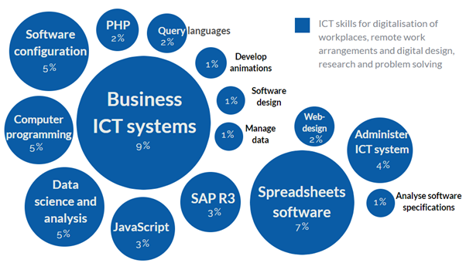

Skill Mapping
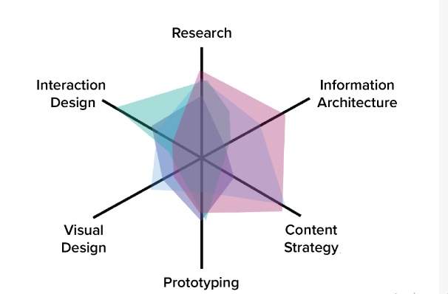

Digital Learning



