Managing Projects in the Organisation:
Intercity Removal

Student Name: Ionut Gabriel Artan
Student Id: 1817448
Module Tutor: Dan Hart
Table of Contents
Introduction 2
The objective of Project 3
Project management tool and techniques 3
Prince 2 4
Prince 2's advantages and disadvantages 4
Agile 4
Difference between Agile and Prince 2 4
Table 1: Difference between Agile and Prince 2 5
Project management plan 5
Benefits of project management in Intercity Removal 5
Characteristics of project managers of Intercity Removals 6
The hiring of candidates 6
Project sponsors 7
Stakeholder analysis 7
Project communication methods 8
Organisational structures to support projects 9
Project life cycle 10
Project time plan 10
Risk management techniques 13
Soft skills that are needed to manage the Intercity Removal’s project 14
Personal SWOT Analysis for Project Management 15
Self Assessment Plan 16
Conclusion 17
Reference list 19

Introduction
Project management is an approach that is used by various project operators to deliver goods and services successfully (Heagney, 2016). The Project Managers always tries to implement his project management skills to integrate his team members to successfully control the project operation. According to Hughes (2012), a project manager initiates the principal consultation about the task with his teammates during the implementation period, and afterwards, they present their viewpoint for designing each part of a project. A project manager then moved on to the design phase, at which the project was planned with the help of the project management, increasing the potential for completing the project on schedule. This planning process entails the development of project scope, time management, task scheduling, as well as the preparation of a budget at every point of the project. Several aspects are related to the project management techniques which are gathering knowledge, finding potential skills, using the right techniques to meet the project requirements (Leach, 2014). The current study is prepared to examine as well as prepare a project management plan for Intercity Removal, which is a renounce company in the UK marketplace. The company is involved with the removal and shifting of houses, office and furniture with the help of international shifting solutions. The company also provide a solution to store excess stock, office equipment, financial data and related materials.
After the Covid-19 pandemic period, all the business enterprises face some sort of challenges that need to address an urgent basis. The removal of the house, office and furniture is a modern concept that includes series of methods. The potential and efficient workforce, are involved within this type of business operation. Because of the pandemic period, they are suffered the most. Most of the employees are feeling worried about the failure of project operation. They are feeling demotivated and dissatisfied with the role of the key personals. Hence, The attrition rate of Intercity Removal increases rapidly. It is expected that the rightful use of to recover the entire business operation a strong project management method is needed. For this reason, the specified business sector is chosen to present this report.
The entire project management work includes all the relative aspects. For example, a comparison between two effective tools to manage overall project work and a significant project management plan. A project management time plan is also prepared to execute all the tasks. The start date of the entire project will be 5th May 2021 and the project work will finish on 3rd September 2021. A project manager is a responsible person who introduces the project management plan to restructure the chosen organisation. The project manager feels that it is necessary to deploy effective strategies to fulfil the needs of the clients. For the past six months, the company is failed to achieve client requirement. The staffs are also demotivated in this period. Hence, the attrition rate of the company increased. By the implementation of the overall idea which is discussed in this report, the project operators, existing employees and the end beneficiary particularly the customers will be benefited most. If the key personals are unable to implement the suggested project that the company will suffer most regarding executing their business operation. At present time, Intercity Removal is experiencing a lack of financial resources due to numerous lockdown period in the UK. Though, in recent time, the government is arranged a rapid vaccination program. Thus, the financial growth of the company depends on the implementation of the right policies. For these reasons, a new potential workforce is required who can effectively execute the business operation.
To develop the entire project management strategy, it is necessary to extract all the detailed information regarding the financial and operational details of the chosen sector. For this reason, an authentic source of information is required to complete the project work.

The objective of the Project
The current report focuses on the selected objective, which is described below;
1. To understand the project management process to enhance the performance of Intercity Removal.
2. To find out the best project management tool for executing the project.
3. Prepare an effective project management plan for Intercity Removal.
4. To find out various pitfalls of the formulated project and recommend an effective strategy to minimise the project management risk.

Project management tool and techniques
As mentioned by Meredith, Shafer and Mantel, (2017), a project manager must design the system using a variety of approaches and methods, which will aid in the development of project aspects that will contribute to a project's completion. A project management tool is needed for managing each task of a selected project in order to execute the project. This improved a number of aspects of the selected project since the resources gave visibility into the project phases that needed to be completed within a certain amount of time, as well as expanding the potential for high-quality project delivery. The project planning team's work was also made easier by these instruments, which improved the possibility of completing the project on schedule. The project manager should utilize Prince 2 system to design this project. Moreover, Developing the project risk assessment matrix and stakeholder engagement plan is a prime resource.

Prince 2
This approach is regarded as the single most valuable applied strategy or technique, as it necessitated the development of many aspects of the project, thus increasing the project's chances of completion (Watson, 2002). Prince 2 has a built-in feature for designing project aspects and managing work specifications in the United Kingdom. The specified project management framework was first introduced in 1996 and has since grown substantially to manage the projects. For a clearer interpretation of the project work, Prince 2 approach incorporates the 7 principles to develop the project. It further describes the duties and obligations of the project manager as well as his entire workforces (Roberts, 2011). This approach also includes the project life cycle to design various aspects of the specified project, as well as improving the mechanism used to achieve a high-quality project result.

Prince 2's advantages and disadvantages
Advantages:
1. Price 2 consist of a single standardised approach to manage a project.
2. This approach provides a comprehensive overview of the teammates' functions and duties in implementing the project.
2. Each level of the project's, project cost, schedule, and risk are updated in-depth that allowing for a deeper understanding of regarding project's formulation process.
Disadvantages:
1. Prince 2 isn't comprehensive enough to include the entire procurement management program.
2. When compared to a PMBOK Guideline, Prince 2 system is poorer because it does not rely on the different methods and approaches that can be used to enhance project development (Heagney, 2012).
3. Prince 2 does not emphasise the value of technical skills, despite the fact that they are needed for project management.
Prince 2 controls the scope of the project in order to consider modifications inside the project and it utilizes the change management methodology to improve each project aspect. As a result, the selected tool is being utilized for the development of this product, which would also assist the project manager to improve project management aspects.

Agile
Inside the information technology community, an agile methodology is used to improve all levels of the process, from problem analysis to the development of a project. Agile methodology was first implemented in the 20th century, and since then, it has changed the way people's perception manage a project (Maylor, 2010). Apart from the IT industry, this system is also utilised by various other sectors. The agile framework is mostly concerned with the project's value, and this is unconcerned with the project's quality or whether it is worthwhile for the business entity. All the project personal, Stakeholders and clients are also active in the project implementation process to identify potential risks, which adds to the friction between employees and stakeholders. The partners as well as the client planned to put in place the necessary improvements to make the project better. This escalated the dispute among teammates as a result of the project's strategic changes.
Agile methodology has utilized the iterative method, which is needed for software creation, although it is not necessary for the current project because the project work involved providing assistance to remove office equipment and houses to the UK based clients.

Difference between Agile and Prince 2
Agile | Prince 2
This approach is beneficial to project operators in terms of completing projects on schedule. | This approach is extremely beneficial to customers who need project planning services.
This approach focuses mostly on the production process, not on services. | This system is customer-centric.
This framework focuses the smaller teams on the project's growth. | This often focuses on the organization's senior managers (Papke-Shields and Boyer-Wright, 2017).
The development of the individual is the subject of this framework. | This approach also emphasises consumer benefits that assist the company.
This approach focuses on the project's objective. | This approach also believes in collaboration for project implementation and includes staff in the decision-making process.
This is regarded as having a more adaptable disposition when it comes to making improvements inside the organisation in order to improve the project. | This approach is thought to be the most prescriptive for the overall development of the project.

Table 1: Difference between Agile and Prince 2
As a result, as project manager, Prince2 is the right choice for implementing the current project and utilizing these approaches to refine the methodology has changed many aspects of this project. It expanded the flexibility for executing this project while maintaining the accuracy of a project's results, as well as the likelihood of implementing the process to the intended client. Communication strategy, Stakeholder analysis, and risk assessment plan are the project development methods that can be used in this project. This also aids in the development of the program, as well as the project manager's development of each project section.

Project management plan

Benefits of project management in Intercity Removal
By implementing the introduced project management strategy all the stakeholder and sponsors can integrate with each other to successfully conduct the project operation (Berkun, 2008). The company can improve its business portfolio and brand identity through the management strategy. The project manager introduces this project management technique to restore the financial growth rate which is negatively affected by the spreading of the Coronavirus in the global marketplace. This type of rightful strategy can improve coordination and cooperation between the teammates and eliminate organisational conflict that is developed due to dissatisfaction and discomfort within the employees during the lockdown period (Maylor, 2011).

Characteristics of project managers of Intercity Removals
As mentioned by Buttrick (2013), the project managers of Intercity Removals are critical thinker and he has the technical expertise to execute the business operation. He is responsible for providing information regarding entire the project work. The project manager is the prime candidate who introduces the project management scheme along with the board members. In previous time, companies faced various pitfalls regarding business operation. Though, the project manager introduces some fruitful strategies to resolve the raised challenges.

Hiring of candidates
The hiring of candidates is the foremost aspect to manage a project. Recruitment criteria are set by the project manager along with the board members of Intercity Removal. The recruitment process and talents are tabulated below for Intercity Removal’s project management.
Required Member | Skill | Number | Recruitment process
Team member | Problem-solving, Collaborative, Industry Knowledge, Good communication skill, Arrange teammates | 3 | By verifying the last 6 years portfolio.
Teammates | Technological knowledge, efficient and critical thinker, Industry Knowledge | 15 | By verifying the last 2 year’s portfolio
Accountant and financial executive | Organised, Adoptability, Industry Knowledge, Spreadsheet proficiency. | 2 | By verifying the last 2 years portfolio.
Table 2: Hiring of candidates

Project sponsors
The project sponsors are the key personals who is an integral part of the entire project work. The Intercity Removal seek helps from the two company to acquire knowledge and financial advantages to successful the entire project work. The sponsors of the project are tabulated below;
Sponsors | Activity | Due date | Note
RL Maynard | Investment | 13rd May | 50% of the total fund will be on 3rd May
Aitchison Safety | Provide technology | 4th May | -
Table 3: Details of project sponsors

Stakeholder analysis
Various stakeholders are involved with the management of Intercity Removals projects. The key stakeholders of the project are tabulated below;
Stakeholder Name/Title | Project Role
Project Operators | The project operators include the project manager, project owner and board of directors who are responsible for making a corporate decision for executing the business practice of Intercity Removals (Field and Keller, 1998).
Project sponsors | The project sponsors are responsible to assist the Intercity Removals to conduct better business practices.
Workforce | The workforce of Intercity Removals is liable for providing services and solution to its client to improve the company’s brand image.
Local authority | The local authority is responsible for regulating and restrict unfair practices which are conducted by various autonomous removal company in the UK marketplace.
End beneficiaries | The end beneficiaries are students, households and official delegates who can experience the removal services that are provided by Intercity Removals.
Table 4: Stakeholder identification and their role

Project communication methods
STAKEHOLDER | INFORMATION | METHOD | TIMING OR FREQUENCY | SENDER
Project Operators | Project-related information and updates | Email and verbal updates. | Daily reviewed the status. | Teammates
Project sponsors | Financial as well as technological information | Zoom and Google meets, Teams | Weekly basis | Project Manager
Workforce | Performance-related information | Email communication | Weekly basis | Project Manager
Local authority | Tax, regulation and business operation related information | Email | Monthly basis | Project Owner
End beneficiaries | Service-Related information | Telecalling, SMS and Email | Daily basis | Teammates and Telecalling executives
Table 5: Stakeholder communication plan

Organisational structures to support projects
The organisation structure of the Intercity Removals is a principal aspect to execute the project management. Hence, the organisational structure of Intercity Removals is presented below;

Flow Chart 1: organisational structure of Intercity Removal
(Source: Author)
The above flow chart is reflecting that the board member of Intercity Removals is a prime decision-maker for the company. Hence, it is necessary to develop management strategies from the initial consent of each of the board members. Hence, it is necessary as a project manager, introduce an effective plan in front of the broad members.

Project life cycle
The execution of the specified project is prepared in several stages. Each of the stages of the project life cycle is discussed below;
Phases | Characteristics
Initiation | At the initiation phase, the project personals identify several features of the project management; such as project objective, the opportunity of the project work, facility and its issues (Hinde, 2018).
Planning | At the planning phase, to manage a project a detailed analysis is required based on the project analysis. The project manager coordinates with all the stakeholders to prepare a project plan.
Implementation | It is an execution phase, the project progress needs to be monitor. The regular team meeting can be arranged via various communication tool.
Closure | At the closure stage, the concerned authority emphasis the delivery of the project work to its clients. The supplier and the other stakeholders also involved with the completion stage to release the offer services.
Table 6: Details of Project life cycle

Project time plan
It is necessary to develop the project time plan to achieve the client needs. For these reasons, a project management time plan is prepared to implement the formulated project. The time plan of the entire project work is tabulated below;
Task Name | Duration | Start | Finish
Managing Project of Intercity Removal | 88 days | Wed 05/05/21 | Fri 03/09/21
Initiation | 24 days | Wed 05/05/21 | Mon 07/06/21
Business case creation | 10 days | Wed 05/05/21 | Tue 18/05/21
Feasibility study | 7 days | Wed 19/05/21 | Thu 27/05/21
Creating project charter | 9 days | Wed 19/05/21 | Mon 31/05/21
Stakeholder identification | 3 days | Tue 01/06/21 | Thu 03/06/21
Assemble team | 2 days | Fri 04/06/21 | Mon 07/06/21
Planning | 26 days | Tue 08/06/21 | Tue 13/07/21
Extract all the details | 12 days | Tue 08/06/21 | Wed 23/06/21
Design a project plan | 14 days | Thu 24/06/21 | Tue 13/07/21
Implementation | 18 days | Wed 14/07/21 | Fri 06/08/21
Exploration | 4 days | Wed 14/07/21 | Mon 19/07/21
Installation | 6 days | Wed 14/07/21 | Wed 21/07/21
Initial Implementation | 8 days | Thu 22/07/21 | Mon 02/08/21
Full Implementation | 4 days | Tue 03/08/21 | Fri 06/08/21
Closure | 20 days | Mon 09/08/21 | Fri 03/09/21
Monitor | 10 days | Mon 09/08/21 | Fri 20/08/21
Verify | 5 days | Mon 09/08/21 | Fri 13/08/21
Closeout meeting | 2 days | Mon 23/08/21 | Tue 24/08/21
Documentation and close | 8 days | Wed 25/08/21 | Fri 03/09/21
Work Breakdown Structure
For understanding each stage of the selected project for delivering it successfully the below WBS prepared. The grand chart of the project also attaches in the below section.
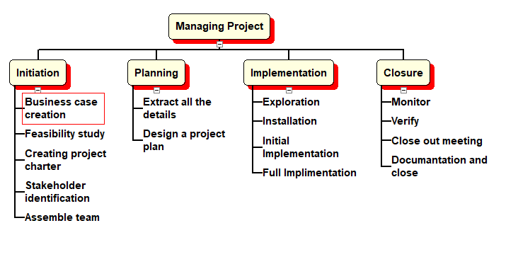
Figure 1: Work Breakdown Structure
(Source: Author)
Gantt chart
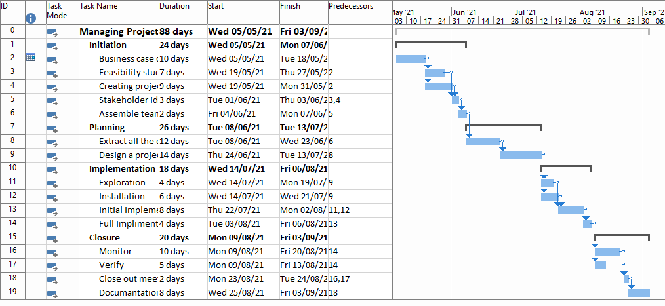
Figure 2: Gantt chart
(Source: Author)

Critical Path
The below image represents that most of the task is fall under the critical path. The red highlighted area in the image is showing the critical path of the selected project.
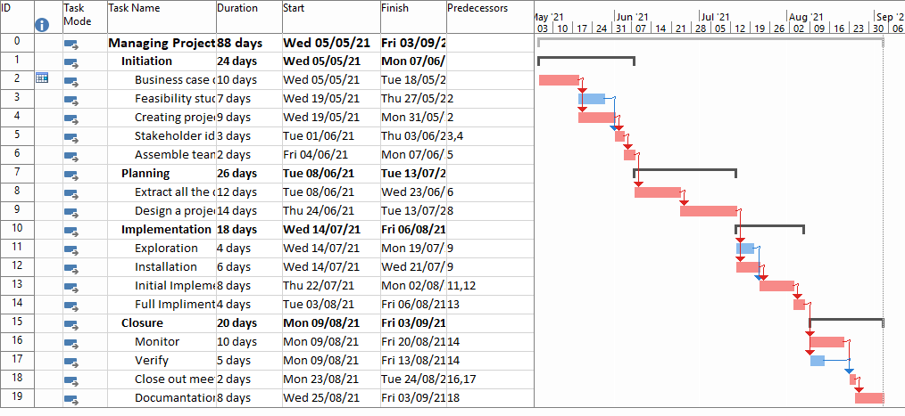
Figure 3: Critical Path
(Source: Author)

Risk management techniques
It is essential to identify various risks that are associated with project management (Rigby, Sutherland and Noble, 2018). The several types of risks are associated with Intercity Removal’s project management. Hence, in the current study, various types of risks are identified and appropriate solution also suggested in the below-presented table;

Risk Type | Cause | Effect | Impact Score | Probability score | Risk Score | Min  Cat. | Action taken | Status
Financial Risk | To implement the formulated project management techniques a huge amount of financial assistance is needed. Hence, the financial risk is also associated with the current project management. | If the concerned authority fails to manage a required fund, then overall project work will fail | 5 | 5 | 25 | Reduced | Need to find different sponsors to manage the required fund. | In progress
Organisational conflict | There is a minimal chance to arise organisation conflict due to implement a new work strategy. | The quality of the service will decrease. | 2 | 3 | 6 | Reduced | Need to enrol all the stakeholder to eliminate the conflict. | In progress
Communication | Ignorance of the project management technique is a root cause for arises this type of issues. | The lack of communication practice can hamper all the project work. | 4 | 3 | 12 | Reduced | The implementation of a new communication strategy can only be fruitful if all the stakeholder obeys the formulated strategy. | In progress
Performance risk | The performance risk arises when the majority of the workforce feel that they are not capable to perform their jobs. | The level of Performance decreased and leads to project failure | 2 | 1 | 2 | Reduced | Need to motivate the entire workforce by giving insights into the entire project management approaches. | In progress
Schedule Risk | Lack of management skill is a root cause for project rescheduling. | The cost of the project increases and the project success rate decreases. | 3 | 2 | 6 | Reduced | Need to recruit the right person who can manage the entire project work successfully. | In progress
Table 7: Risk assessments

Soft skills that are needed to manage the Intercity Removal’s project
Soft skill is can be considered as the prime feature that needs to develop before managing any type of project. The appropriate soft skills are listed below to manage Intercity Removal’s project work;
1. Critical thinking power is needed to execute the project work.
2. A significant problem-solving power is needed to successfully complete the project work.
3. Good communication skill is needed to manage the entire workforce.

Personal SWOT Analysis for Project Management
The Personal SWOT analysis is used to evaluate strengths, weaknesses, opportunities, and threats in order to self-developed for managing this project. This framework also helps to determine the factors that might affect project management and thereby improve the project dimension.
Strength  Track record  Skill Level  Process and System | Weakness  Knowledge gap  Maintain deadlines  Project Competing
Opportunities  Infrastructure and Technology development  Alter Customer nature  Innovation | Threats  Political Influence  Environmental Factors  Economy
Figure 1: Personal SWOT Analysis
(Source: Author)
Strength
The project manager's track record is regarded as an asset. The project planning process is influenced by the project manager's track record. Therefore, it is necessary to develop good knowledge to manage a project. Moreover, if the project manager is inexperienced in a project management job, he or she will not be familiar with the issues that may arise at the time of the project's implementation. The project manager's expertise is therefore essential for optimising project efficiency and developing various aspects of the project, and this is regarded as an integral part of the planning process. In order to build the project, a project manager must also oversee the process and procedure appropriately. If a project manager has prior experience in project management, he or she may be able to tackle any circumstance that might occur.
Weakness
The project manager has awareness problems that make it difficult for him to develop various aspects of the project as well as support the team as needed. This is a major deficiency that has an adverse effect on the project. The demand for designing similar projects is still competitive, which is seen as a drawback.
Opportunities
A project manager has learned a variety of skills, such as technical design and industrial development, which are often needed to complete this project. Changing consumer behaviour will broaden the complexity of a project in the future, as well as the scope of the project needed to announce a new project. This shift in consumer behaviour further expanded the potential for implementing new ideas, which necessitated the project manager's strategic thinking skills.
Threat
Political pressure to cancel contracts is a potential danger that the project manager is facing in recent times because as a project manager, it's the most frequent threat for the projects. In recent times the Covid-19 also hampered the implementation process and reduced the project's prospects of completion. The budgeting dilemma is another difficult and serious issue in the context of project management. The project manager was confronted with it repeatedly during the project's implementation.
The above personal SWOT analysis, here are the main strengths and disadvantages for designing the project's various aspects. This research is also essential for designing each project segment, as well as assisting each project manager in enhancing the various skills needed for project development.

Self-Assessment Plan
I want to provide some aspects of myself that were established in the SWOT framework of this self-assessment plan. This self-assessment plan has been planned on that framework. Firstly, I also need to collect more information in order to manage the project. moreover, I also need to enhance my communication skill to give more accurate details regarding project operation to the board members in order to complete the current project. The project implementation process must be completed on schedule. I have been responsible for designing each portion of the project, which has increased the accuracy of the outcome. Before presenting the budget proposal in front of senior management, I have to double-check the budget then compare it to other relevant projects in order to improve this part of the work. This broadens the range of options for competing in this dynamic environment. In order to improve the project, I still needed to establish good relationships with government personnel, which expanded the potential for minimising the political impact of the current project. I also need to take charge of the organisation's economy in order to include the budget plan, which was also needed for improving each project segment in order to deliver output to the existing clients.
Such qualities of mine must improve for me. That can make me a successful project manager who can oversee the whole project independently and provide high-quality results to the clients.

Conclusion
Plan management is a method used by multiple project operators to efficiently execute goods and services. The Project Manager attempts to use his professional skills to coordinate with his teammates in order to effectively monitor the project's process. In the current project report, many of the related considerations are used in the project management work. Consider a comparison of two important strategies for managing total project work and a comprehensive project management strategy. To complete all of the projects, a project management time schedule is also developed. Since it required the advancement of several elements of the project, the Prince 2 method is considered the most useful applicable method or tactic, since it increased the project's chances of execution. By using various tools project managers are enabled to develop new policies to address several issues. The overall study is focused on the contract a project management strategy of Intercity Removal to amplify its business operation. The entire study reflects that Prince 2 is a project management tool that is effective for the development of overall project work rather than the Agile framework. Though, it is suggested that if the firm is wanted to use Agile, that it will face some sort of issues such as; the method is not applicable for the attract customers it only focuses on team development. Though, the framework is effective if the firm manager considers hybrid project management techniques. Various business entities are using a combination of two project management tool. To experience advanced feature and minimise the pitfalls of agile. The waterfall techniques are also useful with combine to agile. Moreover, the current report also focuses on the development of the potentiality of the project manager. To execute the project work more efficiently. For this reason, a personal SWOT analysis is prepared to examine the potentiality level of the project manager. The skilful project manager can manage the overall project work efficiently. He can minimise and control every type of risk effect to fulfil the client's needs. Moreover, several skilful candidates are needed to formulate the project plan. Hence, the study focuses on the hiring of potential candidates with the help of portfolio verification techniques. Though, it is recommended that effective training is needed to enhance the potential level of the existing candidates. To implement the overall project, a huge amount of fund is needed. Hence the study emphasizes the selection of project sponsors. Moreover, to minimise the financial risk an effective budget allocation is needed. For this reason, an expert accountant and financial executive are needed. The recruitment process also includes the hiring of those candidates. To understand the roles and responsibility of each individual a stakeholder segmentation is needed to identify their needs in the project operation. To integrate all stakeholders a communication plan is also developed to provide information regarding the project work. It is also recommended that there has a certain type of risk regarding loss of project related information at the time of online communication. Hence, each and every stakeholder must be aware of the cyber-related challenges. The existing organisational structure is also beneficial for Intercity Removal to execute the formulated project management scenario. Though, strong management techniques must be implemented to improve the management scenario. Various threats are also related to the formulated project management scenario, which is also considered and identified in the risk assessment table to minimise the risk effect. Though, the decision-makers need to deploy a quality assessment team that can identify the potentiality of those risk. The preparation cause-effect diagram of a certain type of risk is also needed that did not consider in this current report work. Though, all the potential cause and effect is described in the risk assessment table.

Reference list
Berkun, S., (2008) Making things happen: Mastering project management. Sebastopol, CA: O'Reilly. https://www.usenix.org/system/files/login/articles/310-bookreviews0808.pdf
Buttrick, R., (2013) The project workout: The ultimate handbook of project and programme management. Pearson UK. https://books.google.com/books?hl=en&lr=&id=gaVcAgAAQBAJ&oi=fnd&pg=PT13&dq=Buttrick,+R.+(2009).+The+Project+Workout:+The+Ultimate++Handbook+of+Project+and+Programme+Management.+4th+ed.+Harlow,+England:+Financial+Times/Prentice+Hall.&ots=a1ADtQdAcc&sig=e7GDOdl6MJ1B4ixZ1ptDu2GAeOs
Field, M. and Keller, L. (1998) Project Management, London: Open University / Thomson Learning. https://www-dawsonera-com.ezproxy.uwtsd.ac.uk/abstract/9780273743521
Heagney, J. (2012) Fundamentals of project management. (Online) New York: American Management Association. https://www-dawsonera-com.ezproxy.uwtsd.ac.uk/abstract/9780814417492 (Accessed 25 July 2019)
Heagney, J., (2016) Fundamentals of project management. Amazon. https://www.etonline-digitallibrary.com/bitstream/123456789/64/1/4.pdf
Hinde, D., (2018) PRINCE2 Study Guide: 2017 Update. John Wiley & Sons. https://books.google.com/books?hl=en&lr=&id=D1ZaDwAAQBAJ&oi=fnd&pg=PP1&dq=Prince+2&ots=by7QDnEI8Y&sig=FrTAVJKhpI2KUr9lhOXaIOg9UhA
Hughes, R., (2012) Project management for IT-related projects. BCS Learning and Development. https://research.brighton.ac.uk/en/publications/project-management-for-it-related-projects-2nd-edition
Leach, L.P., (2014) Critical chain project management. Artech House. https://kniga.biz.ua/pdf/1342-Vovremya.pdf
Maylor, H. (2010) Project management (4th ed.). Harlow: Financial Times Prentice Hall. https://www-dawsonera-com.ezproxy.uwtsd.ac.uk/abstract/9780273743521 (Accessed 25 July 2019)
Maylor, H. (2011) Project Management. 4th ed. Harlow, England: FT Prentice Hall. https://www-dawsonera-com.ezproxy.uwtsd.ac.uk/abstract/9780273743521 (Accessed 25 July 2019)
Meredith, J.R., Shafer, S.M. and Mantel Jr, S.J., (2017) Project management: a strategic managerial approach. John Wiley & Sons. https://www.academia.edu/download/30240879/42a8009c3d9c5.pdf
Papke-Shields, K.E. and Boyer-Wright, K.M., (2017) Strategic planning characteristics applied to project management. International Journal of Project Management, 35(2), pp.169-179. https://fardapaper.ir/mohavaha/uploads/2017/10/papkeshields2017.pdf
Rigby, D.K., Sutherland, J. and Noble, A., (2018) Agile at scale. Harvard Business Review, 96(3), pp.88-96. https://performancefrontiers.com/leadership/wp-content/uploads/2018/06/Harvard-Business-Review-_-Article_-Agile-at-Scale.pdf
Roberts, P. (2011) Effective project management. London, UK Philadelphia, PA: Kogan Page. https://www-dawsonera-com.ezproxy.uwtsd.ac.uk/abstract/9780749461584
Watson, M., (2002) Managing smaller projects. Project Manager Today. https://www-dawsonera-com.ezproxy.uwtsd.ac.uk/abstract/9780749461584

