swansea arena ‘house party’ event marketing report

Module name/ code – Niche Marketing &Social Media
Chenai woods (2501493)
Lecturer – Chris Wilkin
Word count - Date submitted -
AI declaration:

I confirm that I have not used any AI tools in the research and creation of this assignment. I confirm that I have not presented any AI generated materials as my own work. I confirm I have copies of my drafts, notes, and other resources I used, which I may be asked to provide as evidence.

Introduction:
This marketing report presents a comprehensive SOSTAC- based marketing plan to promote the Swansea Arena House party, a niche urban music and youth focused event designed to attract students and music lovers. This plan is prepared for Swansea Arena’s marketing team to enhance audience engagement, ticket sales, and brand visibility with the growing South Wales entertainment market. This report uses several key frameworks, that were taught in class which include strategic marketing, market segmentation, value propositions, the 5C’s, PESTLE, Ansoff’s Matrix. The 4ps, RACE, and pieces of the communications mix.
Recent data from national industry reports shows young people in the UK are attending nightlife less often due to economic pressures, rising costs, and safety or transport concerns (NITA,2025). This change supports the need for an affordable, well-promoted, value-driven nightlife event. This demonstrates the market gap in Swansea that the ‘House Party’ event aims to address. By incorporating research insights, social media trends, and customer behaviour. This report will present a strategic plan designed to effectively promote the ‘House Party’ event to it primary student demographic.
Situational analysis:
House party at Swansea Arena SWOT analysis:
Swansea Arena is a modern 3,500-capacity venue hosting concerts, entertainment events, and community experiences. Its “house party” concept aligns with growing demand for immersive nightlife events (Frochot & Batat, 2013).
Strengths:
- A high quality venue with more than lighting, sound, and accessibility features.
- Strong brand recognition locally and regionally among prior concert and event attendees.
- capacity suitable for high energy youth events and is ideal for large student events.
Weaknesses:
- limited social Media engagement especially on platforms favoured by younger audiences like TikTok on Instagram reels.
- Digital discover ability we get compared with nightlife focused venues.
- Ticket prices and potentially too high for price conscious students, especially within the current cost of living crisis.
Opportunities:
- a growing student population in Swansea with local universities and colleges Looking for affordable social experiences.
- Rising demand for ‘experience over expenditure’ with many young people now socialising without drinks or minimal spend.
- Collaborations potential with local artists, DJ's, student unions, small influences, and possibly tourism partners to broaden the reach.
Threats:
- Competitors such as night clubs, pubs student union events, and cheaper bars offer nightlife with lower price points.
- Economic pressures reducing Young people’s disposable income as many reports going out less frequently.
- Broader structural decline in the UK nighttime economy with the venue closures, then rising business cost, safety and transport concerns.
Students primary target audience:
- Age 18-24, attending local university/colleges.
- Motivated by social connection, nightlife, and affordable nights out.
- Heavy users of social media platforms – especially TikTok, Instagram, Snapchat, YouTube (Ofcom,2023).
- Tend to plan nights out in advance and value affordable tickets or discounted group deals, as many students are cutting back due to economic pressures (NTIA, 2025; Rekom index, 2023)
Music lovers secondary target market:
- 18-35, including young upcoming local individuals.
- Interested in DJ culture, dance music, live performances, and atmosphere.
- Less price sensitive than students, but increasingly selective about spend and value, due to general cost of living pressures.
Tourists/ short break visitors unlikely target market:
- Typically, aged 20-40, visiting Swansea for cultural, nightlife or leisure trips.
- Motivated by unique experiences like local culture, memorable experiences, safe and high-quality venues.
- Targeted through travel blogs and social media.
Behavioural insights:
According to a 2025 survey by ‘Night-Time Industries association’(NITA). 61% of 18–30-year-olds reported going out less frequently in the past year, and only 16% said they go out more after 10pm. Also, 68% said the current economic climate reduced their participation in nightlife, and 53% reported spending less on nights out compared to 2024.
Additionally, the industry-wide night out spend has dropped significantly. The Rekom UK Night Index (2023) estimates the average spend per night out is currently £73.19, a 201% decrease compared to prior years.
This source also suggests that nearly half of respondents 46% say they often go on a night out without drinking alcohol. This trend is even stronger among certain demographics. 54.3% of people ages 25-34 and 48.5% of students say they regularly enjoy nights out alcohol-free.
Also, the source implies more people prefer planned nights out. 47.5% choose pre booked events over spontaneous clubbing, driven mainly by cost and value considerations.

Implications for Swansea Arena House Party:
The statistics above illustrate that many young people are going out less often, due to financial pressures and concerns about safety and transport. There is an increasing demand for affordable, high-value events, and many are choosing to socialise with little or no alcohol, indicating that a music and experienced focused event could be appealing to many. However, Students and young adults still want to social experiences but are more selective, making targeted marketing, early-bird offers, and budge- friendly group deals important because it meets the needs of the customers. Lastly, since many individuals plan nights out in advance and rely on websites and platforms to find events, strong online and social media marketing is essential.
Competitors:
Competitors include a wide range of local nightlife and entertainment options. These are nightclubs, bars, pubs, student union events, and independent venues. In Swansea, competitors include Founders & Co, Turtle Bay, and larger venues like Swansea.com stadium. These are described as local nightlife and grassroots music competitors.
A perception positioning map analysis reveals that while the Swansea arena is successfully a “high quality, high price” compared to other facilities, this high positioning presents a difficult challenge within the local areas market. The high quality, high price statement suggests this type of venue may not appeal to price conscious students under current issues. The majority of its competitors like Founders & Co and Turtle Bay to other bars and student union events, are based around “low price, low – mid quality” according to the map.
Using the bowman strategy clock, the best position for the House Party is differentiate themselves from competitors, this can be done with emphasise on experience and value, rather than competing on just a low pricing strategy. By offering a high quality event experience with sound, appealing atmosphere, safety, and professionalism while keeping pricing affordable for students, House Party can offer great value that clearly sets it apart from competitors.
This implies an opportunity for a well marketed, safe “house party” at a large modern arena could capture demand for students and music lovers seeking reliable, high-quality, affordable experience.
Collaborators
Successful event promotion will rely on partnerships with stakeholders. Local universities and student unions for direct student access. Student societies and campus groups to spread word of mouth. Small-influencers especially student influencers or local nightlife/social media pages with high trust amongst individuals. Local DJs, artists, promotors to deliver music credibility and attract music-lovers. Hospitality an travel partners like bars, taxis, and short-term accommodation providers to make it accessible for tourists. Local tourism bodies to reach the non-local visiting audience.
Collaborations with these specific groups enhance reach, credibility, and the value of the event experience (Frochot & Barbat, 2013; Hudson & Hudson, 2013).
PESTLE
Political and legal:
- Late-night events must meet strict licensing, health and safety, and noise control requirements. Ensuring safe late-night transport is also essential, as many people say transport and personal safety are key barrier to attending (NITA,2025).
- Wider regulatory and economic polices such as taxes, business rates and hospitality support directly affects many venues. Rising operational costs mean many venues risk closing without essential government support.
Economic:
- Cost-of-living pressures are reducing how much students and young adults can spend on nights out, with 68% saying the current economic climate had cut back their nightlife participation (NITA).
- According the morning advertiser article average spend per night out has fallen to £73.19 and many cut back on alcohol or chose not to drink.

Social:
- There is a growing demand for experiences that are affordable, inclusive, and less reliant on alcohol. The statistics show that 24-54% of young people go out without alcohol (Morning Advertisers, 2023).
- Social behaviours increasingly prefer planned, ticketed nights rather than spontaneous clubbing because many people prefer safe, organised events.
Technological:
- Young people use social media frequently according to a 2023 report by Ofcom, 5.2 million 15-24 year old in the UK visited TikTok in March 2023, spending on average 58 minutes per day. This implies that TikTok would be a viable platform for marketing the ‘house party’ because of the reach the platform has.
Environmental:
- Increasing public concern about safety, transport access, and sustainability ibndicates we need venues that can offer safe, inclusive, and responsible events with good transport links, safe exits, and environmentally conscious may attract more customers.
Summary:
The macro-environment indicates a challenging but opportunistic location. While economic pressures, safety and transport concerns, and declining frequency of nightlife poses threats to Swansea. To avoid this creating a niche for value-driven, well-managed, inclusive nightlife experiences. The ‘House Party’ idea at Swansea Area whilst combining production quality, affordable pricing, and strong marketing, is a well-positioned in Swansea to develop and expand.
SMART Objectives
To increase ticket sales in Swansea Arena’s House Party event by 30% over the target within 8 weeks the following steps are required. Actively grow website traffic among 18-24- year-olds by 25% and improve the social media engagement with likes, shares, and follows by 40%. These SMART targets will improve the brands visibility and build loyal students and youth audience for future and reoccurring events; this directly supports the organisations goal of improving the decline attendance in nightlife and positioning the arena as a leading affordable student-friendly nightlife destination. This aligns correctly with the SMART framework, which emphasises setting objectives that are Specific, Measurable, Achievable, Relevant, and Time-based (Doran, 1981: Eventbrite, 2025).
Strategy
The Swansea Arena House Party campaign follows a market penetration strategy, focusing on improving engagement with existing local audiences such as students and music fans. At the same time, elements of product development are put through the introduction of and event concept – a “House Party at Arena scale”. This approach blends familiar youth nightlife alongside with high-quality production, improved safety, and a more controlled environment, different from many clubs and bars in the area.
With ongoing pressures on the UK nightlife economy including venue closures, rising operational costs, and changed youth spending habits this strategy enables the arena to the demand. Students continue to seek experiences but increasingly prioritise affordability, safety, and value (UK Music, 2023). By aligning with shifting expectations, the arena can better attract and retain audiences while strengthening its competitive position.
Marketing Mix Analysis
Product:
The ‘house party’ experience will be positioned as premium but accessible event with fancy lighting, local upcoming artists, social media opportunities, student discounts, secure space, drinks and friendly. It will have variety to cater to everyone with its products offered to attendees.
Price:
Acknowledging cost pressures on students, offering early-bird pricing, student discounts, group bundles deal like ‘4-for-3’ ticket bundles and dynamic based pricing so that the earliest customers get it cheaper, than the later customers slightly more expensive. This encourages early purchases while maximising revenue nearer to the event date.
Place:
Tickets to be sold exclusively online through Swansea Arena’s website. Partner with student unions and societies to distribute discount codes. Also, post-event offer digital vouchers for future event to build customer loyalty.
Promotion:
A digital-first promotion plan to use TikTok and Instagram Reels, which is content made by the Arena’s marketing team, small influencers, and student union/ambassadors, paid ads targeted at 18–24-year-olds in Swansea and surrounding areas, email campaigns, collaborations with student unions and local bars/hospitality venues.
Positioning & value proposition:
‘a high energy, affordable, and secure nightlife experience designed specifically for students and young adults’. The house party should position itself as the leading choice for those who prioritises quality, safety, value, and a strong sense of community.
Tactics utilising the RACE and the communications mix
Reach:
Partner with small influencers that promote student lifestyle, nightlife, or local creators to produce content, event countdowns, or potential performances. This strongly attracts individuals viewing habits/trends. With studies showing 5.2 million UK users ages 15-24 on TikTok in March 2023, each spending an average of 58 minutes per day on the platform, implying that the reach potential is significant (Ofcom, 2023).
Run paid social ads targeting 18–24-year-old students and 20–35-year-old young people, filtered by interests in nightlife, music, and student life.
Use interactive posters and QR code flyers in halls, libraries, cafes, and bars. This can be supported by student discount codes.
Act:
Use Instagram and TikTok to let followers vote for preferred styles of music, themes, or event features. This boosts engagement and giving them a sense of ownership.
Share behind the scenes clips of setup, lighting tests, and soundchecks to build anticipation and reduces anxiousness for attendees.
Run online contests, such as ‘tag three friends to win four tickets’, this encourages reach within student groups.
Create a dedicated page on the arena website and social media platforms. This could feature a teaser video, event details, most asked questions, student pricing, group deals, and a clear BUY NOW, which is demand for ticket sales.
Convert:
Offer early-bird student discounts for the first 200 tickets to drive fast initial sales.
Use targeted social ads to reach people who visited the website but didn’t complete a purchase/
Send direct email reminders such as ‘tickets running out’, ‘group discounts available’ , and ‘last chance for early-bird pricing’ to prompt sales.
Engage:
Encourage user generated content with branded hashtags like #Swanseaarenahouseparty.
Send post event thank you and feedback emails including referral codes to encourage attendees to attend events in future.
Share a highlighted real on TikTok and Instagram to showcase the safe fun and inclusive atmosphere and build momentum for future events.
Collect reviews on Google, trip adviser, and social platforms to strengthen credibility especially for visitors in new audiences.
Rationale based on data and consumer behaviour
With 61% of 18- to 30-year-olds going out last due to concerns over cost, safety, and transport (NITA, 2025), a house party that offers affordable pricing, a safe environment, and a strong digital engagement directly meets these needs. The decline in per night spend and growth of non-alcoholic focus nights out (Rekom data, 2023) Suggests that events centred on music, atmosphere, and social connection a more appealing to today's audience. Additionally the high use of social media platforms among 15–24-year-olds (Ofcom,2023), supports a social media influencer led campaign as the most effective promotional approach.
Action
This marketing campaign should run across 8 weeks, supported by a gantt chart. Primary channels like TikTok, Instagram, student emails, influencer platforms, and the arena website. These channels were chosen because data shows students and young adults rely heavily on content and social media recommendations (Ofcom, 2023; NITA, 2025).
Timeline:
- Weeks 1-2: Partner reach and influencer on boarding, produce teaser content, design website specific to the house party, distribute Flyers in student halls.
- Weeks 3-4: Launch social media teasers and paid ads, open early bird ticket sales with student discounts, and run polls and contests online.
- Weeks 5-6: Retargeted ads, group deals, e-mail reminders, and boost user generated content.
- Week 7: The final push so countdown content, last chance messaging/emails, And more Flyers in campus areas.
- Post-event (week 9): Post event highlights, feedback emails, referral code sharing, and review performance.
Control
To evaluate campaign effectiveness and performance you will be measured across several key areas. Ticket sales volume and revenue will be compared against previous years and data, with additional analysis of student discount compared to full price purchases. Website analytics this includes unique visitors and session duration this will indicate how effective online traffic is being captured. Social media performance will be assessed through reach, engagement rates follower growth, and branded hashtag usage. Influencer activity will be monitored using connects had directly to influence the post. Post-event and feedback this includes user generated content, online reviews, social media, and engagement for future events will help assess the satisfaction and long-term audience potential.
Overall reports will be generated weekly during the campaign, and a full post event evaluation will follow. This allows for any adjustments like reallocating ad spend, boost in content, or change in promotions. This ensures the plan remains effective and data driven.
Conclusion
This marketing plan with included industry statistics undata driven insights demonstrates the Swansea Arenas House Party Event has strong potential to capture more than youth nightlife demand. The large-scale behavioural trends like decreased attendance, rising costs, safety and transport concerns, and rising popularity of sober nights out implies that many young people remain interested in social experiences but require affordability safety and value. By utilising social media platforms, influencer partnerships, student pricing, and high-quality event delivery, the Arena can position itself as a desirable nightlife destination for students and young adults in Swansea. The proposed data-driven, socially orientated approach addresses both consumer constraints and desires, making the campaign well suited to current market trends. Future campaign should continue to use up-to-date data, expand influencer networks, and monitor consumer behaviour to remain relevant and successful.

Reference list

Works Cited
Connor NTIA. “Why Young People Are Going out Less: NTIA Study Reveals Economic Struggles, Safety Concerns and Transport Barriers Stifling Nightlife - NTIA.” NTIA - Illuminating the Night-Time Industry’s Potential, 17 Feb. 2025, ntia.co.uk/why-young-people-are-going-out-less-ntia-study-reveals-economic-struggles-safety-concerns-and-transport-barriers-stifling-nightlife/?
Ibrahim, Sharif. “Marketing_and_Designing_the_Tourist_Experience_----_(_2_The_experiential_approach_).” Scribd, 2025, www.scribd.com/document/683647295/Marketing-and-Designing-the-Tourist-Experience-2-The-experiential-approach. Accessed 12 Dec. 2025.
Kotler, Philip, and Gary Armstrong. Principles of Marketing. 2018.
Middleton, Victor T.C., and Jackie R. Clarke. Marketing in Travel and Tourism. Routledge, 23 May 2012.
Ofcom. “Home.” Ofcom, 14 Feb. 2023, www.ofcom.org.uk.
“Party-Goers Spend 2.1% Less on Nights Out.” MorningAdvertiser.co.uk, 14 Dec. 2023, www.morningadvertiser.co.uk/Article/2023/12/14/rekom-report-uk-clubbers-spend-less-on-nights-out/?utm_source=chatgpt.com.
rich. “As Autumn Budget Looms – 73% Say Government Is Failing UK Nightlife Says Ne NTIA & Obsurvant Consumer Survey Report - NTIA.” NTIA - Illuminating the Night-Time Industry’s Potential, 25 Nov. 2025, ntia.co.uk/as-autumn-budget-looms-73-say-government-is-failing-uk-nightlife-says-ne-ntia-obsurvant-consumer-survey-report/? Accessed 12 Dec. 2025.
---. “Tax Shock Threatens Fragile Nightlife Recovery – NTIA NTE Market Tracker Reports 15.8% Contraction in Independent Businesses - NTIA.” NTIA - Illuminating the Night-Time Industry’s Potential, 9 June 2025, ntia.co.uk/tax-shock-threatens-fragile-nightlife-recovery/? Accessed 12 Dec. 2025.

Appendix
Customer profiles:
SWOT analysis tables:
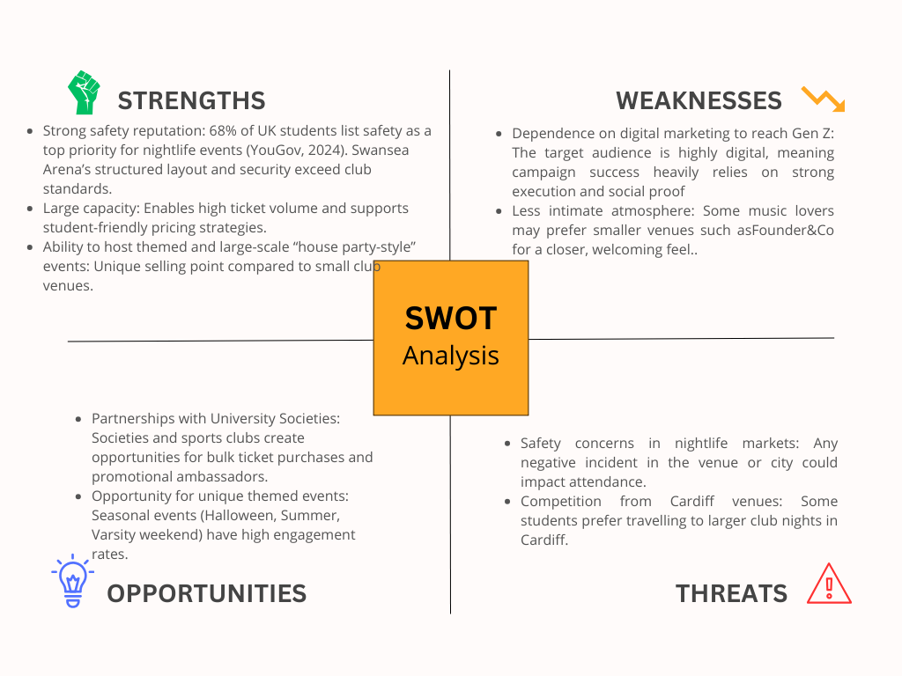
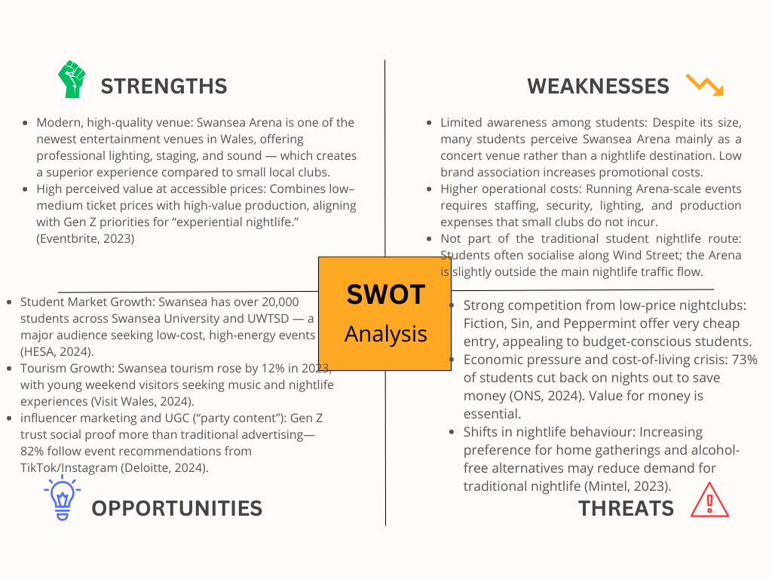
Bowmans strategy clock:
Focused Differentiation (5)
High price / very high value
|
|
Differentiation (4)
Standard price / high value
|
|
Value ↑ Hybrid (3) ⭐ Swansea Arena House Party
Low–medium price / high value
|
|
Low Price (2)
Low price / standard value
|
|
Low Value (1)
Low price / low perceived value
|
|
Low Price →

Explanation of Each Position
Position | Description | Example in Swansea Nightlife Market
1. Low Value / Low Price | Cheapest possible option, very limited value | Small local pubs with no entertainment
2. Low Price | Competitive pricing, attracts price-sensitive customers | Swansea student bar nights (e.g., Tafwyl, campus events)
3. Hybrid | Low–medium price but high perceived value | Swansea Arena House Party (chosen position)
4. Differentiation | High value experience, standard price | Live concerts, ticketed DJ nights at larger venues
5. Focused Differentiation | Premium, niche offering | Cardiff VIP nightlife, exclusive club events
6. Increased Price / Standard Value | Higher prices with no added value | Weakly differentiated events that overcharge
7. Increased Price / Low Value | Unsustainable strategy; audience rejects offering | Failing nightlife venues losing reputation
8. Low Value / Standard Price | Poor experience but not priced low enough | Clubs with outdated facilities but normal pricing

Positioning of the Swansea Arena House Party

Chosen Strategy: Position 3 — Hybrid (Low–Medium Price, High Value)
The Swansea Arena House Party event sits within Position 3 of Bowman’s Clock because it offers:
- Affordable ticket prices suitable for students
- High production value (lighting, sound, staging)
- Large, safe, modern venue
- Social media-friendly visuals
- Familiar high-energy DJ music appealing to young audiences
This combination makes the event accessible but still highly differentiated, which is essential given that:
- 72% of Gen Z prefer unique experiences over traditional nightlife (Eventbrite, 2023).
- 78% of students avoid high-priced nightlife events due to cost-of-living concerns (Statista, 2023).
- Safety and atmosphere are top priorities for 68% of young nightlife consumers (YouGov, 2024).
The House Party therefore outperforms traditional Swansea clubs, which operate in Position 1–2, offering low-priced but low-value experiences.

Competitor Placement on Bowman’s Clock
Venue / Event | Bowman Position | Reasoning
Swansea Arena House Party | 3 — Hybrid | High-value production with affordable student-friendly pricing
Fiction Nightclub | 1–2 | Low price, low value, standard nightclub experience
Peppermint Bar | 2 | Low–medium price, limited differentiation
Sin City Live Music | 4 | Differentiation through live performances, higher value
Bunkhouse Indie Venue | 4 | Strong niche identity, high perceived value
Cardiff Luxury VIP Events | 5 | High price, high exclusivity

Rationale for Hybrid Positioning (Position 3)
This strategic position aligns best with the event’s:

Target Market
- Students (primary audience)
- Music lovers
- Young tourists visiting Swansea

Value Proposition
“An affordable, high-energy, safe, visually immersive nightlife experience for young adults in Swansea.”

Competitive Environment
- Differentiated enough to stand apart from low-value clubs
- Affordable enough to attract student volume
- Unique enough to draw music lovers seeking high-quality sound and production

Detailed Gantt Chart (12-Week Schedule)

Key:
- MKT = Marketing Team
- DM = Digital Media Coordinator
- SM = Social Media Manager
- PM = Project/Event Manager
- EXT = External Collaborators (Influencers, DJs, Partners)

Table-Format Gantt Chart
Task / Activity | Week 1 | Week 2 | Week 3 | Week 4 | Week 5 | Week 6 | Week 7 | Week 8 | Week 9 | Week 10 | Week 11 | Week 12 | Responsible
Situational Analysis & Market Research | ████ | ████ |  |  |  |  |  |  |  |  |  |  | MKT
Target Audience Profiling (Students/Music Lovers/Tourists) | ████ | ████ |  |  |  |  |  |  |  |  |  |  | MKT
Competitor Review + Bowman Map | ████ | ████ |  |  |  |  |  |  |  |  |  |  | MKT
Campaign Strategy Development (SOSTAC) |  | ████ | ████ |  |  |  |  |  |  |  |  |  | PM + MKT
Creative Concept Development (Branding, Visuals, Taglines) |  | ████ | ████ | ████ |  |  |  |  |  |  |  |  | DM + SM
Content Creation (Short-Form Video, Posters, Graphics) |  |  | ████ | ████ | ████ |  |  |  |  |  |  |  | DM
Influencer Identification & Outreach |  |  | ████ | ████ | ████ | ████ |  |  |  |  |  |  | SM + EXT
Website Updates & SEO Optimisation |  |  | ████ | ████ |  |  |  |  |  |  |  |  | DM
Email Marketing Setup (Database Segmentation) |  |  |  | ████ | ████ |  |  |  |  |  |  |  | MKT
Paid Social Ads (TikTok, Instagram, Snapchat) |  |  |  |  | ████ | ████ | ████ | ████ |  |  |  |  | SM
Student Promotions (SU Partnerships, Discounts, Societies) |  |  |  |  | ████ | ████ | ████ | ████ | ████ |  |  |  | EXT + MKT
Event Listings (Google Events, Visit Swansea, Eventbrite) |  |  |  | ████ | ████ |  |  |  |  |  |  |  | DM
PR Outreach (Local Media, Blogs, Student Journalists) |  |  |  |  |  | ████ | ████ | ████ |  |  |  |  | MKT
Influencer Content Release |  |  |  |  |  | ████ | ████ | ████ | ████ | ████ |  |  | EXT
Monitoring & Optimisation (Analytics, SEO, Engagement) |  |  |  |  |  |  | ████ | ████ | ████ | ████ | ████ |  | SM + DM
Final Ticket Push Campaign |  |  |  |  |  |  |  |  | ████ | ████ | ████ |  | SM
Event Day Preparation (Logistics + Final Briefing) |  |  |  |  |  |  |  |  |  |  | ████ | ████ | PM + Arena Staff
Post-Event Evaluation (KPIs, Attendance, Online Feedback)

Perceptual positioning map:

Axes
- X-axis: Price (Low → High)
- Y-axis: Perceived Experience Value (Low → High)
This map visually compares how the Swansea Arena House Party sits among its main competitors in the Swansea nightlife and entertainment market.

Perceived
Value ↑ High Value
|
| Bunkhouse (Indie Live Music)
|
| Sin City Live Acts
|
|
| Swansea Arena House Party ⭐ (Hybrid)
|
|
|
|
|
| Fiction Nightclub
|
| Peppermint Bar
|
|
|______________________________________________→ Price
Low Price High Price

Summary of Positioning

⭐ Swansea Arena House Party — Medium Price / High Value
The House Party sits in a competitive, differentiated space, offering strong entertainment value (professional lighting, sound, DJ talent, production) at a price accessible to students.
This positioning aligns with your Bowman’s Strategy Clock (Hybrid), and is supported by:
- 72% of Gen Z prefer high-energy experiences over traditional clubs (Eventbrite, 2023).
- Students prioritise immersive and safe environments over low-cost venues (YouGov, 2024).
- 78% of UK students avoid high-priced nightlife (Statista, 2023).

Competitor Placement Explanation

Fiction Nightclub – Low Price / Low–Medium Value
- Budget-friendly
- Standard nightclub environment
- Lacks special production features
- Appeals mostly to price-driven students

Peppermint Bar – Low–Medium Price / Medium Value
- More upscale than Fiction
- Offers cocktails and social atmosphere
- Not a high-energy nightlife experience

Sin City Live Acts – Medium Price / High Value
- Strong live music identity
- Niche audience appeal
- Perceived higher artistic value

Bunkhouse – Medium–High Price / High Differentiation
- Known for indie bands
- Unique underground feel
- Appeals to music lovers, not students seeking dance events

Why the Map Supports the House Party Strategy
The Perceptual Positioning Map confirms that the Swansea Arena House Party occupies a market gap between:
- Low-price, low-value clubs (Fiction, Peppermint)
- High-value, niche venues (Bunkhouse, Sin City)
The House Party:
- Is more affordable than niche venues
- Provides more value than standard clubs
- Has a broad appeal (students + tourists + music lovers)
- Uses the Arena’s premium environment to differentiate itself
This positioning strengthens your SOSTAC Strategy and supports your justification for a Hybrid Strategy (low–medium price, high perceived value).

