Coexistent Perspectives ( ADAA7000)

Tutor: Robert Jones

Student: Jonathan Cox

Student number: 0602114

Submission date: Thursday 14 December 2023

Word Count: 3945

De-mystifying conjectures of time and memory in the work of Marina Abramovich and Andrey Tarkovsky.

Abstract

Bergson's anti-reductionist philosophical writings Memory and Matter (1896) prescribes the homogeneity of memory and deep spirituality and cognitive recollection. Theoretical schema are examined in relation to the work of artists Andrey Tarkovsky and Marina Abramovich. Tarkovsky’s sci - fi film Stalker (1979) and Abramovic’s Rhythm Series (1973-4) orientate “present action” and the insertion of memories in relation to time. Surveyed through the lens of ontological and phenomenological philosophies of time and memory and their intersection the artists engage us in our internal awareness of being, dasein, as the entity of our being and spirituality.
The body and how it exercises choice within action in relation to objects around it exemplified in Abramovic’s Rhythm series is contrasted and compared to Tarkovsky’s cinematic “ Sculpting in time” in Stalker, metaphorically digging, carving and modeling time using the long view, movement image and rhythm to question our perception of time and space. Through sound, action, and dialogue Abramovich and Tarkovsky expand and elongate time, making reference to civilization in the past, to the vessel as an ontological object in historical present and future time through movement and object image markers to draw the audience in. Sourcing socio- cultural narratives through dialogue and speech, the essay disentangles subjective and objective meanings of time and memory in relation to our position in humanity.

Speech, as divided up and segmented time and memory plays on our retinal and audible awareness, recollecting our consciousness. The recurrent phases of tension and ease in time and memory are analogous to being, das man. They align with our individual and collective experience of mythical space and place and frame heterogeneity. Through extending and provoking our “ being” as self, the discourse steers us through perceived time frames and hence elicits the re-definition of our ontological auras, in the here and the now to precipitate a more profound reflection of ourselves.

De mystifying conjectures of time and memory in the work of Andrey Tarkovsky and Marina Abramovich.

Introduction

Aristotle claimed that time relies on change, Coope, U( 2009 ) in Time for Aristotle puts forward the notion that time is a kind of “order”. Aristotle advocated that the present is a moving object or phenomenon such as a thought or possibility. Arguably it is both of these. The now is like a moving thing, and time depends for its existence on the mind. Aristotle proposed that time is related to our perception of it.
To critically evaluate the role of the artist and maker in the context of time and memory it is paramount to survey theories and ascertain how coexistent ideologies and philosophies interplay with the artist's voice. Perception of time as defined by St Augustine relates elementarily to length of an event, therefore a performance or a film frame is akin to measuring memory, as a segment of experience with both the temporal and duration intrinsically linked to memory. Bergson’s Matter and Memory (1912) is referred to in deciphering the spheres of time perception, movement and time, and mind and matter in the works of two practitioners. Identifying and attesting to realities and ideals of both spirit and matter and their dualism with regard to cerebral and physical matter.
Spinosa advocated that humanity is jostled from one emotion to the other on a random path in the ethics of emotional experiences. In fundamental concepts of pain and pleasure and the conatus he stated: “ The Conatus is a drive to persist in one's own being ”. Stewart. M (2006:174) The conatus therefore, enacts fate or as Neitzsche describes the love of fate; “amor fati”. This discourse seeks to evidence the concept of “being” scrutinizing Heidegger's philosophy and other theoretical schema in relation to Marina Abramovic's Rhythm series of the 1970’s to contemporary works such as The artist is present (2010) where perception is emboldened by an uncensored audience, able to steer the direction of the performance beyond our collective sense and conscience. A passage of script in the opening scenes of Tarkovsky's film Stalker (1979) in the same decade, which incorporates a passage of dialogue, seeks to address the shared key themes of ontology and phenomenology, being and reality and examines these artists' diverse approaches to the convergence on the quintessence of being, navigating the convolution of spirit and soul, das man. Heidegger, M(1962) within time and memory.

Sculpting in Time

Tarkovsky's works of cinematic poetry shows his intensely personal vision and memory, describing memory as “spiritual”, his works are influenced by his spirituality. His films seek to examine existence and life's purpose, a discovery of ourselves. Spinosa alludes to the conatus, whilst Tarkovsky considers the artist not as someone seeking their subject , but growing organically from inside the soul. Tarkovsky considers the relationship between film director and audience as one of looking for ” lost time”. He is adamant in his perception of the movement image that as humans we propagate a distinctive atmosphere around a given force, a benevolence as experiential and sentient mortal beings which brings together the work and the audience:
“Within the aura which unites masterpieces and audience, the best side of our souls are made known, and we long for them to be freed. In those moments we recognise and discover ourselves, the unfathomable depths of our potential , and the furthest reaches of our emotions” Tarkovsky (1986:43).
This sense of deep spiritual purpose is displayed in the searching for purpose in the character Writer,as he attempts to “free” time in his assessment of historical time expanse and self doubt in relation to his profession as author. Tarkovsky states in Imprinted Time Tarkovsky, A (1986) that memory defines us; we are he posits, held captive by imagined existence, and doomed to experience the feeling of pain by it. With the pressure of time running through the movement image it can be suggested that it is akin to the motion of physically sculpting clay, kneading and modeling it ,so that the course of time is implicit within the cinematic frame, just as fingerprints and chisel marks are left in clay or stone. Similarly noise, and voice are sculpted in memory and elongated in time. Writer throughout Stalker (1979) makes assumptions via dialogue with his peers, Abramovich in her performance Freeing the memory (1975) uses memory and words as a cleansing process, a freeing and releasing of sound; of meaning. Tarkovsky states how his work is about searching for “ lost time”. Similarly Abramovich uses the potentiality of voice, sound and action in an attempt to switch off her consciousness, “excavating” words from random recollection during a 90 minute performance. Bergson implies that an object can be split in infinite ways: “Now even before these divisions are made, they are grasped by thought as possible, without anything changing in the total aspect of the object.They are therefore already visible in the image of the object ”. Deleuze, G (1988:41).

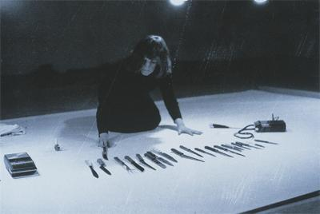

Image 1 Rhythm 10 1 hour 1970

Abramovich made 5 works in the early seventies where she tested the limits of physical and mental endurance. These contain spectatorship, ritual duration and expansion of time.
Bergson essentially demands the question of how memory becomes duration and how it is substantiated in existence as life and self -consciousness. Applying Bergsonism to the above, we can see that the duration of the performance is one hour. However Abramovich here distorts and manipulates time in our Sapient brains, closing and opening time:

“If I try to analyze duration , that is to resolve it into ready made concepts, I am obliged by the very nature of the concept and analysis to take two opposing views of duration in general, with which I will then claim to recompose it….. . I shall say for example, that there is on the one hand a multiplicity of successive states of consciousness and on the other hand, a unity which binds them together”. Deleuze.G (1966: 44).

Abramovich re-enacts the “five finger filet” a serbian sailors “game” with knives. There is a minute, tiny multiplicity duration of time held in the artists and audiences conscience, that of anticipation and dread each alluding to a conscious state and “ bound” by the total length of the performance. Therefore duration becomes a psychological experience of the self conscious as propounded by Bergsonian theory. Temporal and spatial relations are brought together in this work. As we hear the knives penetrate the surface there is flux between points of time. Deleuze, G ( 1966).
In Being and Time (1964) Heidegger explores the concept of oneness, das man he juxtaposes the authentic self, the self that we own, with the unowned self. The assertion is that this is enacted in her Rhythm series demonstrating the potentiality of being. She employs existential ontological devices in her Rhythm series in the way she uses time:

“ There must arise a more primordial understanding of the fact that the measurement of time - and this means also the explicit making -public of time as an object of concern - is grounded in the temporality of Dasein, and indeed in a quite definite temporalising of that temporality”. Heidegger, M. ( 1962: 468).
This is therefore determined by the spatial positioning of time in her performances where she summons time to saturate and permeate her being, thus directing her aura in opposition to the open view of time; the public perception of time. The artist is present (2010 ), Counting Rice ( 2014) and Five Finger filet share this relation of elongated time.
Dasein, is an expression used by Kant and later the existential philosopher Heidegger to include the human being and the role of the human being in the world. He advocated that there is no distinction between our consciousness and our body: we are ontical beings
Abramovich tests both her physical and mental state.
Five finger filet 1970 ( Image 1) is testimony to her capacity to withstand extremes. It is powerful in its portrayal of violence towards women and shows humankind the proximity of art to life. We are all in a sense implicit and essentially connected with her visceral portrayal of “life” through this performance.

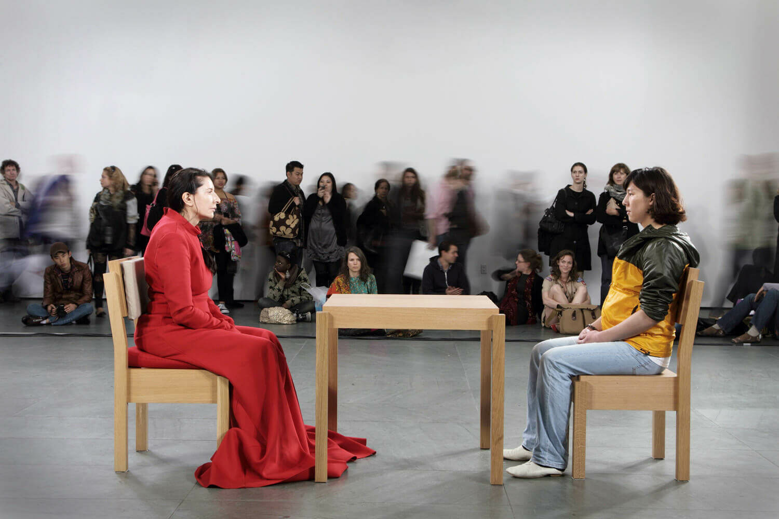

Image 2

The Artist is present Marina Abramovich 2010

Abramovich describes her performance ( Image 2) as a: “ pared down long durational piece that destroys the illusion of time”.( TheGuardian.com 2012 ). She sat motionless for seven hours a day for three months in front of members of the public who were required to be both motionless and silent like herself. Each minute, hour and day memories are recollected and detract. In a sense time is sculpted as in planes in sculpture, flat surfaces which join a point to a corresponding point: “ a repetition of planes, rather than the elements of a single plane: virtual instead of actual repetition”. Deleuze,G (1998: 61). She contains the whole of her past, the audience a proportion of theirs, and both ontologically.

Expanded time and the existential.

Stalker (1979) roughly follows the plot of Roadside Picnic (1971) by Arkady and Boris Strugastsky, a satire of life in the Soviet Union and reflects Tarkovsky’s; “Reality of the artist's inner life” Tarkovsky ( 1987:188) and is in that sense autobiographical although he did not endorse this. In this sense he is committed socially to the plight of the population under communist control. The journey takes place in a fictionalized country with post industrial connotations with a zone in the centre ,and a “room” which becomes a space for secrets. The opening starts with text leaving the viewer with a feeling of ambiguity: how was the zone created ? The zone is in fact defined by Stalker as “home”: “Here we are at home at last ”. However the ambiguity of this as an abiding place of permanence, a central scaffold from which humans grow and develop, or a dystopian journey in line with the Stugatby brothers novel, remains throughout the film.
The temporality of reality itself is cut through by symbolic means, where sense is given to and bestowed upon chosen objects that the retinal vision of the audience are unaccustomed to. Viewers are allowed to ponder and bring their own conclusion to the lingering Long view.
In Stalker the notion of time is the most important aspect of its cinematography. Tarkovsky was insistent that the protagonist in Stalker , the “hero” imparts a social sense of aiding others who are without hankering or aspiration. So he alludes to a Christian narrative which could seem to draw parallels with parable of the good Samaritan, traveling with those he helps, he is “God's fool” in so far as he might be foolish, having inherited original sin from Adam and as an ex-convict from the Gulag has a legacy of wrongdoing , but ultimately he is made by God. Tarkovsky uses this epistemology to inform his characters.
Once Stalker has left his wife, in a nightmare, writhing on the floor, the dialogue between Scientist and the woman presents the viewer with differing perspectives of time and memory. She provides us with a snapshot of their relationship, the camera in a fixed position. She is moving, but there is a perceptive slowing down, the Camera is still and focussed, there is no movement from the lens. As she twists and turns, we are aware of her mutterings. Language ensues, sparse and foreboding, it gives the audience a profound sense of the unknown:

The readiness with which we confront spatial and temporal categories is apparent in language”. (181 Yi Fi Tuan ).

“ The world is unbearably boring”

“The laws cannot be violated”.

Writer announces: “ how dreadfully tedious this statement is ” when talking about how triangles ABC equal A1 B1 C1.

This alludes to time and the expanded version of it, the triangle associated with its three- dimensional counterpart symbolizing ( Egyptian) civilization especially through history which is drawn out , doubled to a fictitious mathematical power. That Writer finds the statement inexorably “tedious” further suggests a pessimistic attitude to time and memory in historical terms. There is a detectable sense of awe and a pointless existential nature to his remarks. The dialogue brings the viewer's imagination into sharp focus. Tarkovsky draws the audience in, pondering on the futility of life in the present by referring to past time, to history and epochs of time saying:

Writer: “In the middle ages life was interesting. Every house had its goblin, each church had a God”.

Here he alludes to spirituality, and more specifically Christianity. The secular nature of life in the present is emphasized by referring to the middle ages and the Western world's historic dependence on theology during that time span and an overarching sense of societal good and evil upheld by the church with reference to the symbolism and hence the dichotomy of good and evil. In this long held view the goblin is representing the antithesis of God - mischief and maliciousness, perhaps even evil.Time is here drawn out by dialogue in perceived collective memory.

The woman replies:” But you said the Zone is the product of super civilization”. We are left feeling a pause: The backdrop of post industrialisation apocalyptic scenery juxtaposed with the concept of a super civilization haunts the viewer as the camera focuses on the woman standing in her fur coat with a beguiling expression.

This reply implies a slice of time omitted in dialogue and language from a previous conversation which is here taken up:

He replies: “ … another set of laws and triangles, but without goblins, and of course without God”. Because if that God is that very triangle . Well I don’t know ”.

Writer seems to be grappling with the complexity of life in the present. In the moment the here and now, and uses affirmative language in his choice of words, “and of course” he is rejecting his previous assertion. He questions if God is the triangle, also a symbol for the trinity, the God the father, the son, and the holy spirit, connoting a length of time as perceived religiously as Patriarchal Christianity. He seems to question; Is God eternal? Is God infinite? He then backtracks saying:
“Well I don’t know”.
At this point the man and woman say goodbye and Stalker appears having crossed the railway - the rhythmic sound of the train on tracks causing an interlude in moments of time.
There is an anticipation, as the woman looks left. As we are transported in a segment of time Stalker is artfully framed in a third of the total image, ( Image 3) as if in a doorway, separated by a black “girder”. The camera pans into the couple talking echoing the sound waves of the train on the track bouncing back through perceived time: back, and forth. Arguably this gives the audience a precursor to the singular journey that the 3 characters make to the zone, reflected ingeniously in time: sound and rhythm through blocks of historical time.

In the bar Scene it would appear the “spheres” of life are here displayed. The three men are grouped around a ” spherical” table. Stalker, who leads them into the Zone, Writer, surely the “literary” representation of humanity, who is attempting to fathom his apathy towards his profession and the Scientist, the co existent realm of humankind's intellect. The spherical table uniting them is both a metaphorical and physically purposive: “ spatio- temporal structure ”. It can therefore be taken as the cycle of life, the globe, and a circular time continuation. Tuan Yi Fu (1977:181). Stalker, looking agitated, is framed by the two others, Scientist and Writer. The Camera is fixed on the scene with slices of time elongated, it moves slowly and gradually further in towards the trio, as Writer talks involuntarily informing the audience of historical time and his struggles to write.

Image 3

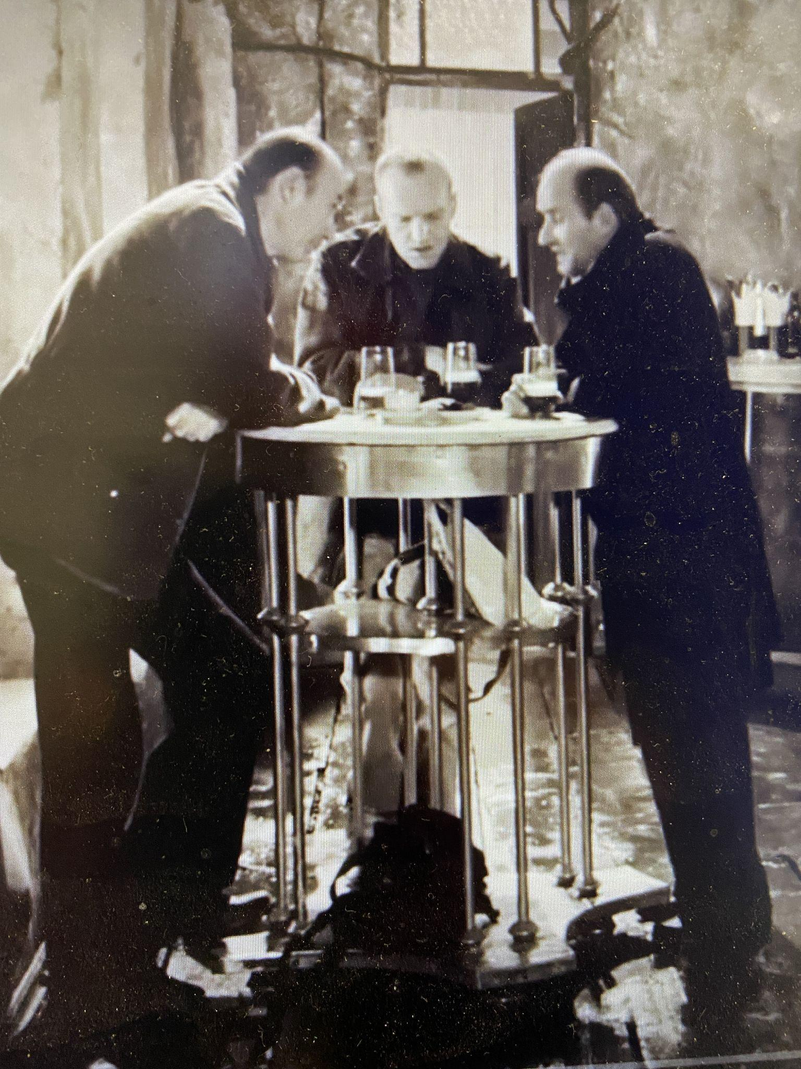

Tarkovsky The Bar Scene Stalker 1979

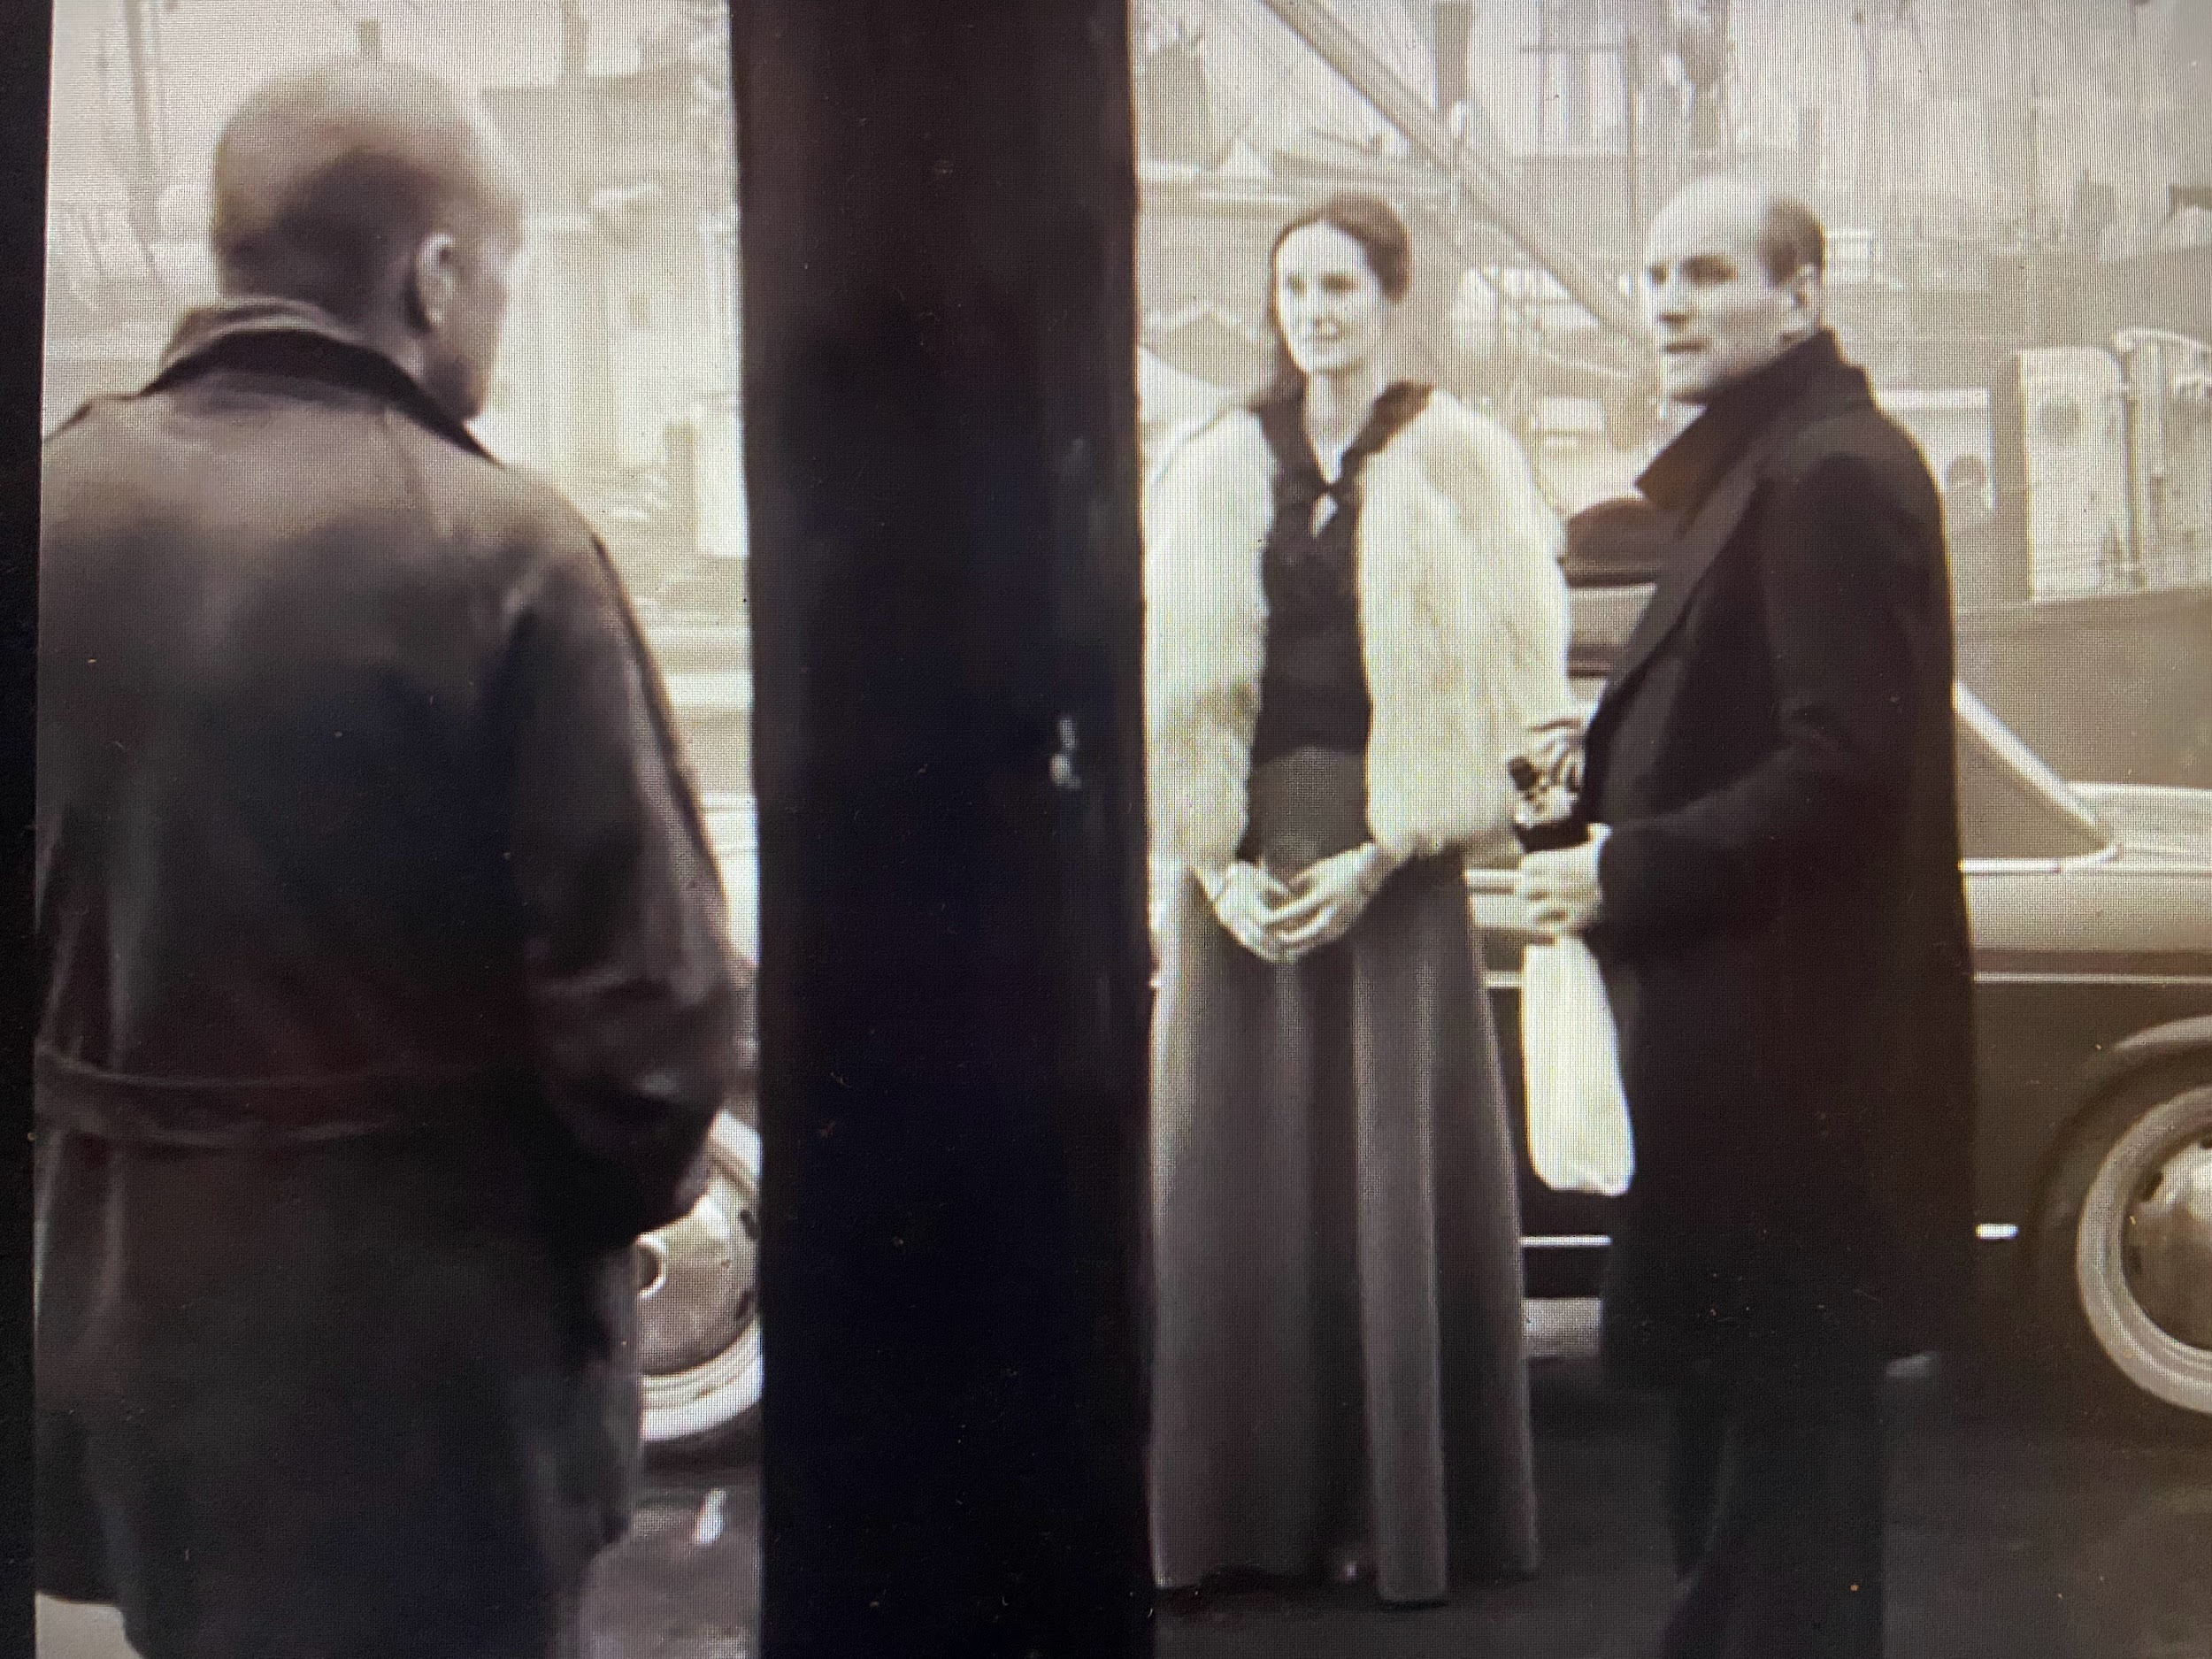

“Time is even volume” Yi fu Tuan (1977:179) in the physical dimension and as metaphor. Tarkovsky and Abramovich deal with time through dialogue and through framed time, relating it to space. Timer needs space, and is voluminous, just as words carry weight. Geological time is built up in layers, stratigraphy, and therefore has a position in physical and historicaltime. It is measured in units, decades, centuries , millennia, and in thickness, length, seams, cliffs and mountains:

Sculptural Energy is the mountain, wrote Gaudier Brzeska, the modernist sculptor. Brzeska H-G ( Vorticist Manifesto 1915). This conjures up the forcing up of tectonic plates in geological time. The etymology of the word sculpture originates in sculpere ( latin) “to cut and to carve”. Through human time natural resources formed over millennia are sculpted. These have been extracted by man. “Digging” becomes a metaphor for revealing, searching over time, for archeology. Writer refers to digging up the” truth” :

“I dig for the truth, but while I’m digging something happens to it
So instead of the truth I dig up a heap of…. I won’t say what..”

The audience is left suspended, and drawn out in equivocation. What could this mean? Archeology and the study of the human past is alluded to and expanded in Writers preceding sentence:

He continues : “There was an antique pot in a museum, that in its time was a waste bin, but now arouses admiration, for its simplicity of line and unique form, and everyone oohs and aahs about it”.
He appears to be indicating time has been “spent”, is futile. What purpose does human civilization serve in the production of an artifact, a phenomenon like a pot from antiquity, crafted by hand using mined clay if its phenological value is to be faked ?
Tarkovsky here alludes to the dualistic nature of matter and memory, in the recognition of objects. There is the allusion to ” psychic blindness “, a failure of “recognition” in the “ antique pot ”. In Force and Signification Derrida (1981) talks of telos, the ultimate end, or goal of an action in relation to the forces and failures of our consciousness. There is an inference in this passage of dialogue to “truth”, and the disclosure of weaknesses in humanity through Writer’s acute visual recall, and consequent tautology throughout the film.

Writer’s cynicism is palpable. The subjectivity of time is projected in his mind for our interpretation, is won and lost:
“consciousness - and the self conscious deriving from it - is distinguished by spatial and temporal presence. Consciousness is tied to corporeality and temporality: I experience myself as existing with a body over time. In language of brain research, the now provides the frame of temporal reference for manifold cerebral processes that need to be synchronized. Whittmann, M. (2014:103).
Tarkovsky expands historical time, alluding to the past to already perceived time. Heidegger in Being and Time (1964) makes reference to Neitches three types of historiology, the monumental the antiquarian and the critical studies in Out of Season (1874). Heidegger alludes to the fact that overall historiology can be “used” in life or taken advantage of and that as in Writer’s dialogue regarding the antique vessel, human life is historically entrenched in “being”. He wields the concept that Dasein is :” possible only by its temporality ”. Tarkovsky makes credible the possibility of the limits of the human soul and spirit in relation to nature within experiential time; “ Time is a state in which there lives the salamander of the human soul”. Tarkovsky. A (1986:142). Tarkovsky's comparison to this “elongated” mythical reptile, with its origins in the Jurassic period is a poignant remark on the permanence of human immortality.

Writer; Suddenly it turns out not to be an antique pot at all. It was planted by some prankster. The sound of admiration fades away. Some Connoisseurs…

The experts in taste, who are the connoisseurs, are cynically blamed for the lack of expertise in their schemes of classification of phenomenological objects for which they have been applauded by the proletariat but who are ultimately wrong : “ the sound of admiration fades away”.. Alludes to the fading away of time and therefore perhaps of honesty and integrity associated with truth. There is a sense of dejection. A sense of the sublime.

Professor: “ And you keep on thinking about it?

Asked if he will continue applying time based thought to his metier ( writing), he says
Intensifying his expression and choice of words, that he intends to:

Writer: “God Forbid… I seldom think it's bad for me”.

Professor: “It's possible to write and keep thinking about success or failure“
Professor uses tentative language. Whether he is able to do the above remains unknown, the audience pondering.

My world is so unutterably boring. There’s no telepathy, no ghosts, no flying saucers. They can’t exist. The world is ruled by cast-iron laws. These laws are not broken. They can’t be broken.”

Writer: “ Naturlich”
“But on the other hand if my books aren’t ready in 100 years, why bother to write”?

Writer is very specific, mentioning a century as a length of time, the elongated epoch of a lifetime. However he remains devoid of inspiration for literature and unsure what to write.
Abramovich emphasizes the importance of the phenomenological in her work. These like Tarkovsky’s cinematic devices can be considered as belonging to the mind as conceptual cognitive tools and function on a dualistic plane. For her they represent the “Here and now” - the present as in real time. She explains how she takes a bowl of lentils and a bowl of rice, decides on the quantity and then proceeds to count, noting down the numbers of grains in ordered piles. This process of counting is preparation for a performance - a form of process which proceeds through emotional stages, but is not itself a performance. She explains: “ mind tricking, your breathing is short - it takes so much time”. (www.utube.com).
Counting rice is undeniably boring, particularly for a minimum of six hours. She acknowledges this with no prevarication, and here there is a paralel with the “boredom” expressed by Writer in Stalker when he talks about how life in “real time” is insufferably tedious. Centering her conscience on the here and now she says: “ The self and time prove to be especially present in boredom. They go missing in the hustle and bustle of everyday life which results in the acceleration of social processes ”. Yi -Fu Tuan (1977:182) Winning and losing time: the self and temporality). She hence subscribes to the notion that if we are able to control our cognitive emotions we are therefore able to control the speed at which we live and process ' life” and secure time in an individualistic and pluralistic sense through lengthening of time. Weiss G and Fern Haber, H (1999:103).

Phenomenological perception and the intention arc are evident in Abramovich’s acquired cognitive skills. As Satre advocated, she is able to interpret the world in any way she believes fit to, and is able to deal with the often uneasy and uncomfortable consequences as evident in Five Finger Fillet , where she is both mentally and physically stretched, as is her Dasein. Merleau Ponty tells us:
“The life of consciousness, cognitive life, and the life of desire or perpetual life is subtended by an intentional arc which projects round about us, our past, our future, our human setting,
our physical , ideological and moral situation”. Weiss.G and Fern Haber, H (1999: 105).

Hence personal memory which has been caught in past time and experience influence future action and project into the future, bestowed on the viewer in real time and transported in expanded time through instilled memory of an event in a given location: place and space.
Tarkovsky and Abramovich bring their audiences to this perspective and hence confer a sense of our own personal and shared responsibility to our place in the world, conoting moral significance. Writer’s phrase “Cast Iron laws” in Stalker is conceivably a reference to the Industrial Revolution and the hegemony of global West in advancement of humankind in perceived time, relaying a dystopian nuanced message. The audience are often made aware of their own destiny through memorable historical, modern and contemporary events. The lack of purpose is instilled in Counting Rice and Stalker. Proustian pure memory, conjuring up essences of the past are echoed in the involuntary memory image, and reflected in lack of meaning.
In this activity Abramovich becomes the subject of her own intention. Her perception contains her, as much as our perception contains us: Counting Rice ( 2014) arises from one of the most useful tools I have met in myself. ( youtube.com). Performances as her medium are imbued with expanded time. Twelve days starving herself as gallery exhibit, 700 hours being stared at by strangers ( The artist is present (2010), the startling work Rest Energy (1980) where the tension of time, with the arrow pulled back by her partner Ulay, questions and emphasizes Heideggian theory of being and Being and transfixes time, suspending the moment, a moment of seemingly infinite inhospitable duration.
In her practice there are: ” recurrent phases of tension and ease”. Tuan Yi Fu (1977:176). Time is stretched and elongated. Abramovich describes how she arrives at the present, and how long it takes to do the counting of grains is of little significance stating that if one is unable to do the counting, one is unable to give focus to existence. For her this mundane exercise has become what she describes as a “universal instrument” available to people on multiple levels globally: “ a tool for any achiever anywhere”.( utube.com) Performers engage with this “instrument”. There is tension without variation. As the audience we are obliged to engage and to wander in thought, revisiting minute portions of time, memories brought to us, converging and diverging points in lived time. We can interpret these works in relation to our own memories. The nuances are replete and we are left exposed to minute details, for example the mortality of memory . Abramovich and Tarkovsky both purport the concept of the anthropocene.through their heterotopias and their spaces of “ otherness ”. Rice, cultivated by civilizations for 3,000 years, is the staple for 3.5 billion people globally, reflective of the anthropocene in as much as it could be said to mark the beginning of humankind’s cultivation’s impact on humanity.
In Abramovich’s work The hero ( 2017) she is mounted on a Grey horse with a White flag, the withering personal effects of her father are displayed in a glass case alluding to vestiges of the past, an example of expanded elapsed time. This work celebrates her family identity and the gradual depletion of objects which were once the physical objects of her father a memory of being, who fought against the Germans in the second world war:

When we stand before a prospect our mind is free to roam, as we move mentally out of space, we also move either back or forward in time. Physical movement across space can generate similar temporal visions. Yi- Fu Tuan (1977:126 ).

Conclusion

Memory image and perception are manifest in the works of Tarkovsky and Abramovich and intrinsically linked with notions of experiential, felt and geological time . The “movement” of memory is enacted in Stalker (1979) by adjustment of the camera, the long view and the inter - spatial perceptions and recollections of dialogue merged with the cinematic long view and slow pulsating rhythm. The simulacrum of speech and images between the “trinity” of characters, Professor, Stalker and Writer is expanded and held in time as they travel to the zone, sound and image providing the audience with a temporal vision by virtual recognition within being and Being, Dasein. Writer in his opening conversation with Scientist appears to be recollecting human endeavors through memories in certain history, however we feel uncertain in ourselves. In Sui Generis ( its own thing) we distance ourselves from the “now” to put ourselves in a particular aspect of the past; the past is time. Appropriately Bergson defines this as: “ a work of adjustment, something like the focusing of a camera”. Bergson,H (1964;170). Tarkovsky carefully crafts these adjustments via purposive filming to purvey time and make reference to personal and collective memory. It is therefore distinctly possible that perception displaces the “memory image”, and that pure memory becomes coexistent.
Abramovich's works pertaining to time and memory differ in her ontology of being. Here it is necessary to make a fundamental distinction between their practices as many of Abramivoch’s performances control and restrain the normality of consciousness through the conjecture of the present. The recognition of a perception in the search of images evinces a position within action. These accumulate and relate to memory bringing their effect into the present. Bergson, H (1964). Much of her work disrupts space. The paradox of being is exercised in Tarkovsky and Abramovich’s works.
The recollection image in Stalker is “actualised” and becomes different in the present, ( antique pot ). We arrive collectively and individuals in the zone, bewildered and ambivalent to our sentient selfs. Whereas Abramovich’s works contain more pure recollections. Ultimately as observers we allude to outward signs of an inward grace. We are made aware of our extended and expanded being , our spiritual sense of within and the actuality of our human soul.

Bibliography
Auge, M (1995). Non- places: An introduction to super modernity. London. Verso books
Benjamin,W (1936).The work of Art in the Age of Mechanical Reproduction. London.Penguin Books.
Concise Cyclopedia of Philosophy.(2000). London. Routledge.
Bergson,H (1896). Matter and Memory. An Essay on the relation of Body and Spirit.New York Dover publications.
Deleuze, G (1998). Bergsonism. New York. Zone Books
Deleuze, G ( 1986). The movement Image. University of Minneapolis. Athlone Press
Deleuze, G and Guattari A ( 1988). A Thousand Plateaus. London. Bloomsbury.
Derrida, J ( 1981) Writing and Difference. London. Routledge and Keegan Paul.
Heidegger,M ( 1962) Being and Time. London. CMS Publishers.
Weiss, G and Fern Haber, H ( 1999). Perspectives on Embodiment : the intersections of nature and culture. London Routledge.
Whittmann, M (2016). Felt Time: the science of how we explore time. MIT Press. London.
Tuan, Yi-Fu (1977). Space and place; The perspective of experience. University of Minnesota Press. Minneapolis.

Image references

Image 1
Abramovic M Rhythm 0 Available at: https://arthive.com/artists/92199~Marina_Abramovich/works/635213~Rhythm_0
First accessed 10 October 2023

Image 2
Abramovic, M The artist is present 2010 Available at:
https://docs.google.com/document/d/13M6-a4NbKLgZ1R6JPv-QFI2RyREbyeTDOxzqinsLY4M/edit First accessed 15 October 2023

Image 3
Tarkovsky, A. Stalker. The Bar Scene Available at:
https://www.youtube.com/watch?v=Q3hBLv-HLEc&ab_channel=Mosfilm
First Accessed 9 November 2023

Image 4
Tarkovsky, A. Stalker. Writer the Woman and Stalker Available at;
https://www.youtube.com/watch?v=Q3hBLv-HLEc&ab_channel=Mosfilm
First Accessed 21 November 2023

Abramovich rhythm series
https://blogs.uoregon.edu/marinaabramovic/category/rhythm-series/#:~:text=Between%201973%2D1974%2C%20Abramovi%C4%87%20performed,her%20own%20body%20as%20art.

Abramovich Rhythm images
https://www.google.com/search?sca_esv=583929409&rlz=1C1GCEA_enGB1078GB1079&sxsrf=AM9HkKkxJjAHXa3fo73zoZUhRdBYqTG6TA:1700473217807&q=abramovic+rhythm+images&tbm=isch&source=lnms&sa=X&ved=2ahUKEwjzr-OwpNKCAxXNUUEAHUKOB7EQ0pQJegQICxAB&biw=1536&bih=738&dpr=1.25#imgrc=zY6TahsIOb19UM

https://books.google.co.uk/books?hl=en&lr=&id=nhm2Gyak3-YC&oi=fnd&pg=PA8&dq=amarina+abramovich+and+time+and+memory&ots=WP2jtpcs1E&sig=fgYzd9rFKCTU1VfS6FlO72MAUl8&redir_esc=y#v=twopage&q&f=false

‘Freeing the Memory’ is the second of three significant performances enacted in 1976 in which Marina Abramović attempted to achieve a mental cleaning through the exhaustion of the three main faculties of expression, voice, language and body. In this piece, Abramović said every individual word she could recall until she could no longer continue without repetition. The mental strain of this act, which lasted ninety minutes, allowed the artist to exhaust her consciousness into a state of complete blankness.

. 80
https://blogs.uoregon.edu/marinaabramovic/category/rhythm-series/#:~:text=Between%201973%2D1974%2C%20Abramovi%C4%87%20performed,her%20own
%20body%20as%20art.

https://tony-cassar.medium.com/time-memory-reverse-motion-3f61efa01d26#:~:text=In%20ancient%20Greece%2C%20Mnemosyne%2C%20the%20Goddess%20of%20memory%20was%20considered,rational%20thought%20nor%20artistic%20inspiration.

https://imma.ie/collection/freeing-the-memory/?obj=obj_23869

