Time series prediction and classification

1.1 Research background
In order to understand the development law of a thing, people usually observe an index of the thing with a certain sampling frequency. The observation value set generated according to the time sequence is the time series. Time series are widely used in social life and engineering fields, such as the daily closing price of company stock; The temperature and humidity of the city every day; Daily turnover of the mall; The daily passenger flow of the scenic spot; The activity of sunspots; The activity of ECG of the patient; Signal data in the field of communication and so on. For example, the figure below shows the performance trend of a fund.
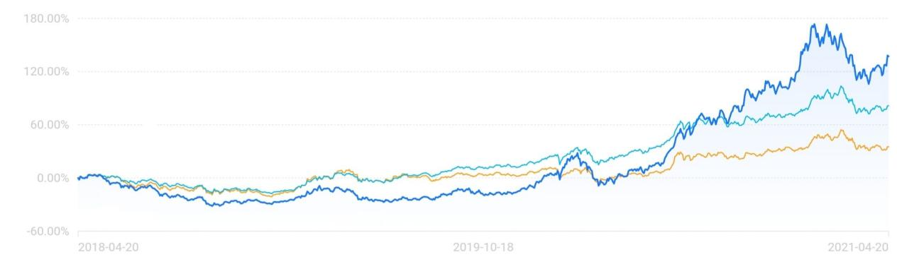

2 Time series type
Time series is a numerical series obtained by observing several variables produced by an object or system and arranging these variables in time order.From the definition of time series, we can see that time series has two basic elements: time and value. In order to describe the time series more accurately, this paper gives the definitions of single variable time series and multi variable time series from the mathematical point of view. Xuni and xmul are used to represent univariate time series and multivariable time series respectively, and t is the time step.The definitions of Xui and xmul are as follows:
$Xuni=\{p1,p2...pT\}$ (1)
$Xmul=\{q1,q2...qT\}$ (2)
For the i(i = 1,2, … , T) component Pi of Xuni, PI ∈ R represents the observed value of the observed variable at the i-th time.
For the i(i = 1,2, … , T) component of xmul, pi,pi ∈R, it means observed
The set of observed values of all n variables at the i-th time. Where qij(j=1,2...n)represents the observed value of the j-th variable at time i.
According to different classification criteria, time series can be divided into different types. The common classification criteria are: the number of variables, the type of variable value, time continuity, and sequence stationarity.
Time series can be divided into discrete time series and continuous time series according to whether the time of recorded observation variables is continuous or not. For discrete time series, each data is based on the value recorded at a specific time, such as the daily sales volume of a clothing store; For continuous time series, data are continuously recorded along each time interval. For example, the temperature monitoring chart records continuous time series.

1.3 Pretreatment method
The introduction of the characteristics of time series shows that there must be some regularity behind the numerical changes of time series data points, and this regularity may be the result of a variety of factors. Time series decomposition method is trying to analyze the regularity of a time series, and decompose the regularity, so as to find out the factors that affect the original time series. There are four types of common influencing factors: long-term trend, seasonal variation, cyclical variation and irregular variation.
Although the time series decomposition method can qualitatively analyze a certain time series to a certain extent, the actual situation is often very complex. Sometimes it is not possible to directly analyze which factors are working from the time series diagram. In this case, using the time series decomposition method will greatly reduce the accuracy of the analysis.
The scientific rationality of training sample set and the rationality of data expression have a very important impact on the later prediction. Data preparation includes the collection of original data, data preprocessing, variable selection and data processing. There are two methods of data preprocessing, scale transformation and distribution transformation.
Scale transformation is to limit the input network data to the interval of [0,1] or [- 1,1] through transformation processing. The main reason for scaling is that the input data of the network often have different physical meanings. Moreover, the neurons of RNN adopt symmetric S-type excitation function, which can prevent the saturation of neuron output due to the excessive absolute value of net input, and then adjust the value into the flat area of error surface.The common distribution transformation is mainly through the normalization processing, so that the value of the input data falls within the interval (0,1), and the conversion formula is:
$I(t)=\frac{d(t)−min(d(t))}{max(d(t))−min(d(t))}$ (3)
Where I (t) is the network input and D (t) is the sample data. After using the trained network to output the predicted value, the output data should be de normalized,the formula is as follows:
$O(t)=o(t)∗(max(d(t)−min(d(t)))+min(d(t))$ (4)
Where o (t) is the predicted value and O (t) is the predicted value after the inverse normalization.
When the distribution of network training samples is more uniform, the distribution curve of samples is relatively flat. When the distribution of samples is not ideal, the distribution transformation is generally carried out. Because the transformation is nonlinear, the results not only compress the range of data change, but also improve its distribution.

2.Application of CNN and RNN in time series prediction and classification

2.1 RNN
The difference between RNN and forward static network is that the signal from one neuron to another will not disappear immediately, but will live for a period of time. Theoretically, the lifetime can be infinite. Therefore, the ability of network to solve complex and dynamic problems is improved. Therefore, RNN has higher modeling ability than forward static network. RNN has many important characteristics that forward network does not have, such as dynamic characteristics and information dynamic storage. And in most cases, the RNN time series prediction model uses fewer parameters to get more accurate results. The following figure shows the RNN model.
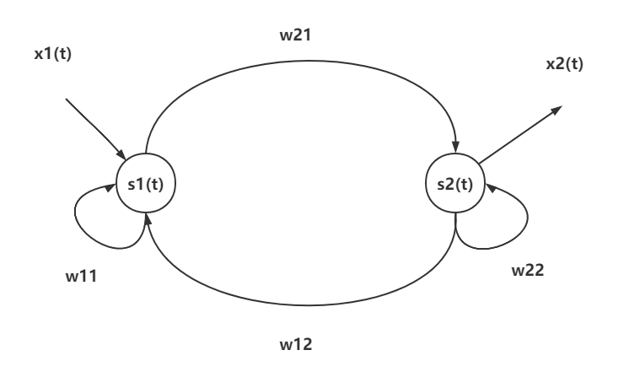

As shown in the figure, there are two fully connected neurons, one input connected to one neuron and one output connected to another neuron.
The function of hidden layer neurons is to extract and store the internal rules from the sample data.The number of neurons in the hidden layer is too many, so it is possible to memorize the noise data in the sample data set, thus the problem of "over fitting" will be raised and the training time will be increased. The most common method to determine the number of neurons in the hidden layer is to try and join. The training network with fewer neurons is set first, then the number of neurons is gradually increased. The same sample set is used for training, and the results are compared and the optimal number of neurons is determined. Some empirical formulas can also be used to determine the number of neurons in the implied layer, as follows:
$n=c+\sqrt{m+l}$ (5)
$n=\log_{2}{m}$ (6)
$n=\sqrt{ml}$ (7)
In recent years, it will inevitably lead to the increase of network parameters and the extension of network training time. Therefore, it is necessary to balance the accuracy of network prediction with the complexity of network parameters. The RNN model designed in this paper includes an input layer, a fully connected hidden layer and an output layer.

2.2 CNN
Convolutional neural network is a kind of neural network which is specially used to process data with similar network structure. It can extract features from original data by imitating the mechanism of biological vision. Because it has the characteristics of weight sharing, it effectively reduces the complexity of the network, avoids the over fitting problem caused by too little data, and avoids the complexity of data reconstruction in multi-dimensional data feature extraction. The network layers generally include convolution layer, activation layer, pooling layer and full connection layer. Convolution layer is the most important layer in the whole network. This layer mainly uses convolution check input data to do convolution operation, uses neurons to observe data (each neuron only pays attention to one feature), and then extracts features. The convolution process is shown in the figure.
In order to describe the process of convolution operation more clearly, the read data elements are numbered, Xi，j are the elements in the i-th row and j-th column, Wm，n are the weights in the m-th row and n-th column, Wb is the bias term of the filter, and f is the activation function：
$a_{i,j}=f(\sum_{m=0}^{2}{\sum_{n=0}^{2}{W_{m,n}X_{i+m,j+n}+W_{b}}})$ (8)
The function of the activation layer is to make nonlinear mapping to the output of the convolution layer and change the weight appropriately. The commonly used functions are "sig moid", "relu" and so on.
Pooling layer is also known as "down sampling layer". The main function of this layer is to compress the number of data and parameters and reduce over fitting. There are two common pooling methods: maximum pooling and average pooling.

2.3 Comparison between CNN and RNN
CNN：
1. CNN uses fixed size input and generates fixed size output.
2. CNN is a feedforward artificial neural network - a variant of multi-layer perceptron designed to use the least amount of preprocessing.
3. CNN uses the connection pattern between neurons and is inspired by the visual cortex of animals. Individual neurons in the visual cortex of animals are arranged in such a way that they respond to the overlapping areas of the tiled visual field.
4. CNN is an ideal choice for image and video processing.
RNN：
1. RNN can handle any input / output length.
2. Unlike feedforward neural network, RNN can use its internal memory to process any input sequence.
3. Recurrent neural network uses time series information. For example, what I said last time will affect what I will talk about next.
4. RNN is an ideal choice for text and speech analysis

natural language processing
As a sub field of artificial intelligence, NLP focuses on the realization of information interaction between human and computer, so that the computer can understand and use human language. As an important tool for people to communicate, natural language is commonly used in English, Chinese, Russian and so on. Natural language processing mainly deals with words, paragraphs or chapters. The main methods are rule-based and statistics based. The rule-based method is to process the text data manually according to the language related rules; The method based on statistics is to process the text data through the statistical analysis of large-scale data sets. The quality of data set has a great influence on the performance of natural language processing model. Therefore, with strong data support, we can better process and analyze the text. The main research contents of Chinese based natural language processing include word segmentation, part of speech tagging, word sense disambiguation, text classification and language modeling.

3.1 Natural language processing flow
The process of natural language processing can be divided into five steps
(1) Get text through web crawler or local import.
(2) Preprocess the text, segment the text and remove the modal particles and stop words.
(3) The text is characterized, and the words are mapped to the corresponding word vector form by using hot coding or word embedding technology. The unique hot code is also called one bit effective code, that is, n-bit register corresponds to N states one by one, and only one bit in the register is effective; Word embedding technology quantifies words into low dimensional dense vector space with fixed dimension, which is more efficient than hot coding.
(4) For model training, support vector machine, decision tree and neighborhood algorithm can be used machine learning model algorithms such as convolution neural network or recurrent neural network can also be based on deep learning.The model and algorithm are given.
(5) Test set is used to verify the training model and evaluate the model algorithm.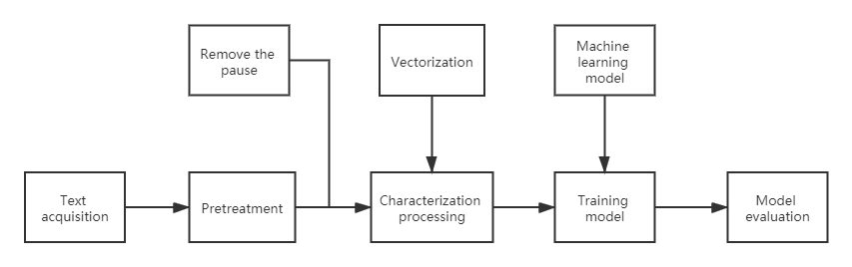

This paper briefly introduces the above five steps: corpus collection mostly uses web crawler or local text data set. The corpus preprocessing stage mainly includes the operation of corpus cleaning, word segmentation, part of speech tagging and removing pause words. In the process of characterization, it is necessary to vectorize the preprocessed text and express the words into vector form so that the computer can calculate them. This operation helps to find the similar relationship between different words through vector expression. In the model training phase, the training methods used include traditional supervised, unsupervised and semi supervised learning models. The specific models need to be selected according to different application scenarios. For the evaluation of the effect after modeling, the commonly used effect evaluation indicators are accuracy rate, recall rate and so on.

3.2 Word vector technology
Word vector technology is the general name of language modeling and feature learning technology in natural language processing. Its main purpose is to transform human natural language into data convenient for computer operation, and to establish the mapping relationship between words and real vector. This section mainly introduces two kinds of word vectorization technology, the first is hot coding technology, the second is word embedding technology.
The hot coding technology is a kind of vectorization technology of natural language through discrete feature values. It has a good effect in the vectorization of discrete feature or classification value data. The unique hot coding uses n-bit register to correspond with N states one by one, and only one bit in the register is valid, which is also called one bit valid coding. When using unique hot coding for natural language processing, a typical usage is to express a feature of an attribute through unique hot coding. For example, when recording students' achievements, we can code "excellent", "good", "up to standard" and "not up to standard" into "1000", "0100", "0010" and "0001". In coding, only one bit is 1, which means that there is only one effective coding bit in the exclusive hot coding. According to this example, we need to count the number of words in the text when we code the words in the text, which will determine the dimension of the vector after the hot coding. then. In this paper, we encode a word vector with only one bit of 1 and the product of each other is 0. After the construction of the word vector, the vector set can be used to represent a sentence or a text. The hot coding solves the problem that the data attribute in the classifier is not easy to deal with, and expands the characteristics of the data to a certain extent. When the number of data attributes or lists is large, the feature space will become large, and the space-time complexity of hardware operation will also increase. The principle of exclusive hot coding is simple and easy to understand, which is suitable for the application scenarios with small amount of text data. However, when there are too many words in the text data set, it will bring some problems when using hot coding for word vectorization. For example, after the words are individually encoded, because all the encoded word vectors have only one digit of 1, the vector distance between words is the same, which can not reflect the relevance between words. At the same time, when using hot coding to vectorize words, it is default that the relationship between words is independent of each other, but in most cases, the relationship between words is mutual influence. In order to solve these problems, word embedding technology based on dense space arises at the historic moment.
Word embedding technology is the mainstream word vectorization technology when experts and scholars study natural language processing in recent years. The feature of this technique is that all words are represented as low dimensional dense vectors, and the similarity between words can be evaluated through a fixed dimension continuous vector space. Among them, the greater the similarity of words, the smaller the angle of the word vector in the vector space. The fixed vector dimension will greatly improve the efficiency of computer data processing compared with the only hot coding. As an important foundation of applying neural network model to the field of natural language processing, many technology companies have created different word embedding tools. Among them, word2vec tool proposed by Google is a milestone invention in this industry. The tool also includes two training models of word vector relevance, one is SGM (skip gram model), the other is cbow (continuous bag of words) model.

3.3 RNN algorithm
Recurrent neural network (RNN) is an important variant of neural network, which has been widely used in natural language processing.
Conceptually, they are different from standard neural networks because the standard input in RNN is a word, not the whole sample in standard neural networks. This makes the network flexible to deal with sentences of different lengths, but the standard neural network can not do this because of its fixed structure. It also provides an additional advantage to share features learned in different text locations that are not available in standard neural networks.
RNN regards each word in the sentence as a separate input for the occurrence of time "t", and uses the activation value at "t-1" as an input other than the input at time "t". The following figure shows the detailed structure of RNN architecture.
The architecture described above is also called many to many architecture (Tx = Ty), that is, the number of inputs = the number of outputs. This structure is very useful in sequence modeling.
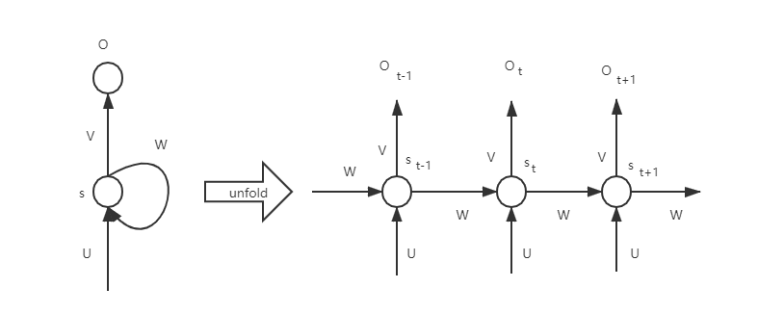

The limitations of RNN are as follows
1. The RNN architecture example described above can only capture dependencies in one direction of the language. Basically, in the case of natural language processing, it assumes that the following words have no effect on the preceding words. Based on our experience with language, we know that this is definitely not true.
2. RNN can not capture the long-term dependence, and the problem of gradient disappearance reappears in RNN.

References
- R. Y. Yasmin, A. E. Sakya and U. Merdijanto, "A classification of sequential patterns for numerical and time series multiple source data — A preliminary application on extreme weather prediction," 2017 International Conference on Data and Software Engineering (ICoDSE), 2017, pp. 1-5, doi: 10.1109/ICODSE.2017.8285845.
- A. P. Salim, K. A. Laksitowening and I. Asror, "Time Series Prediction on College Graduation Using KNN Algorithm," 2020 8th International Conference on Information and Communication Technology (ICoICT), 2020, pp. 1-4, doi: 10.1109/ICoICT49345.2020.9166238.
- H. Qu, J. Li and Y. Zhang, "Long Short-term Memory Network Prediction Model Based on Fuzzy Time Series," 2020 IEEE International Conference on Artificial Intelligence and Information Systems (ICAIIS), 2020, pp. 417-421, doi: 10.1109/ICAIIS49377.2020.9194902.
- Z. Zong and C. Hong, "On Application of Natural Language Processing in Machine Translation," 2018 3rd International Conference on Mechanical, Control and Computer Engineering (ICMCCE), 2018, pp. 506-510, doi: 10.1109/ICMCCE.2018.00112.
- R. Posevkin and I. Bessmertny, "Translation of natural language queries to structured data sources," 2015 9th International Conference on Application of Information and Communication Technologies (AICT), 2015, pp. 57-59, doi: 10.1109/ICAICT.2015.7338516.
- J. Xiao and Z. Zhou, "Research Progress of RNN Language Model," 2020 IEEE International Conference on Artificial Intelligence and Computer Applications (ICAICA), 2020, pp. 1285-1288, doi: 10.1109/ICAICA50127.2020.9182390.
- S. Zhang, S. Liu and M. Liu, "Natural language inference using LSTM model with sentence fusion," 2017 36th Chinese Control Conference (CCC), 2017, pp. 11081-11085, doi: 10.23919/ChiCC.2017.8029126.
- J. Cai, J. Li, W. Li and J. Wang, "Deeplearning Model Used in Text Classification," 2018 15th International Computer Conference on Wavelet Active Media Technology and Information Processing (ICCWAMTIP), 2018, pp. 123-126, doi: 10.1109/ICCWAMTIP.2018.8632592.
- H. Xie, M. A. B. Ahmadon and S. Yamaguchi, "Evaluation of Rough Sets Data Preprocessing on Context-Driven Semantic Analysis with RNN," 2018 IEEE 7th Global Conference on Consumer Electronics (GCCE), 2018, pp. 410-413, doi: 10.1109/GCCE.2018.8574653.
- M. R. Kounte, P. K. Tripathy, P. P. and H. Bajpai, "Analysis of Intelligent Machines using Deep learning and Natural Language Processing," 2020 4th International Conference on Trends in Electronics and Informatics (ICOEI)(48184), 2020, pp. 956-960, doi: 10.1109/ICOEI48184.2020.9142886.

