Corporate social responsibility focus on social media

JUNQIAN DAI
2005928

Introduction

With the development of society, responsibilities relative to various enterprises and organisations are becoming more and more critical. Modern commercial society thinks that enterprises can assume more social responsibilities. For example, sustainable development, environmental protection, human rights, gender equality. Taking on these responsibilities can give a company more exposure and visibility, which can grow its business (Camilleri, 2017).

Literature review
Corporate social responsibility (CSR) has become a priority for business leaders (Melo and Galan 2011). It is clear that the long-term success of a company depends in large part on its ability to adapt to a new environment successfully. As a result, modern business environments increasingly encourage the application or implementation of CSR concepts (Barauskaite and Streimikiene, 2021). This will encourage companies to operate professionally and focus on sustainability and protecting the planet while pursuing profits. (Eckert, 2017). According to the research, the implementation of the corporate social responsibility concept can help enhance the competitive advantage of enterprises, improve their reputation, ensure the stability of customers and the friendliness of investors. It can bring new economic benefits (Nibusinessinfo.co.uk. 2022). This means that corporate social responsibility can positively affect the corporate financial status and market value. With the demand of the market and society, CSR is becoming a part of business strategy (Barauskaite and Streimikiene, 2021).

The original definition of CSR was full of controversy (Carroll, 2008). Companies represented by shareholders believe that their sole responsibility is to make shareholders profitable. However, nowadays, many scholars and entrepreneurs find that the social responsibility of a company goes beyond profit (Mele, 2008). Moreover, when enterprises focus on charity, moral and social issues, they actively spread their CSR achievements, which can significantly enhance their reputation and financial performance (Tang, Gallagher, and Bie 2015). In 2001, the European Commission defined corporate social responsibility (CSR) as "enterprises integrate social and environmental issues into their business activities and interact with stakeholders on a voluntary basis" (Green Paper, 2001). The commission stresses that corporate social responsibility is more than just complying with the law. Rather than reporting on corporate social responsibility, companies invest in their own future with the expectation that their voluntary commitments will help improve profitability directly or indirectly (Audrey and Romiena 2009). McWilliams and Siegel (2001) believe that corporate social responsibility transcends corporate interests and legal constraints. At this point, many researchers also emphasise "beyond legislation". Lantos (2001) believes that fulfilling social responsibility is a necessary behaviour. Quazi and O’Brien (2000) believe that solving social problems should consider economic benefits. Porter and Kramer (2006) both show that companies have an obligation to do the right thing. However, at present, the governments of many countries have issued relevant laws and regulations requiring enterprises to issue social responsibility reports. In the UK, for example, regulations require all listed companies to show ethical, social and environmental risks in their annual reports （Lin, 2022.）. As a result, most corporate social responsibility reports include environment, sustainability, employee welfare and so on in order to inform stakeholders of the relevant content and activities.

FIRSTLY, through CSR report, stakeholders outside the enterprise can understand how the enterprise is responsible for social problems. Secondly, they can understand that some unacceptable behaviours will bring substantial financial risks to the enterprise. Finally, from a strategic point of view, corporate social responsibility can promote significant social progress because companies use resources and expertise in activities that benefit society.

Theoretical basis
Incorporate social responsibility, in addition to the relevant social issues, the company's stakeholders are the next concern. Because the interests of the company will directly affect them. Stakeholders are groups affected by the company's interest behaviour, and they usually have a particular influence on the enterprise. Stakeholders include employees, customers, shareholders, communities, suppliers and governments (Tang, Gallagher, and Bie 2015). The goal of corporate social responsibility has two directions, one is academic, and the other is practice. However, the most important responsibility of an enterprise is to its stakeholders (Carroll, 2016).

Furthermore, because enterprises undertake part of the social responsibility, there will be corresponding returns. As a result, the enterprise will have corresponding measures in action. Most companies consider CSR as a form of investment (McWilliams and Siegel, 2001). They believe that they can maximise profits while meeting stakeholders' needs for CSR. However, in fact, when enterprises undertake social responsibility, their return is far greater than the input. No more than that, CSR has different goals and priorities in different industries. General CSR has four specific economic, legal, ethical, and philanthropic responsibilities. These four representatives have specific responsibilities; however, they depend on each other (Pineda, 2018). The corporate social responsibility (CSR) of NGOs is mainly to improve social welfare (Melo and Galan, 2011). Business priorities in developed and developing countries are also different. CSR in developing countries mainly addresses national socio-economic development issues such as education, health care, child Labour and human rights. In developed countries, CSR mainly includes climate change, environment, sustainable development, gender equality, work-life balance, etc. (Kvasničkova et al. 2020). CSR mainly includes anonymity in social media, and informed knowledge will be considered (Townsend and Wallace. 2018).

Through the above research, it is found that different industries have different social responsibilities. As a result, there is still no consensus on the most appropriate theoretical classification for CSR research. However, based on the review of previous CSR theoretical perspectives and through the conceptual framework of Mellahi et al. (2016), a new approach can be developed (Figure 1).
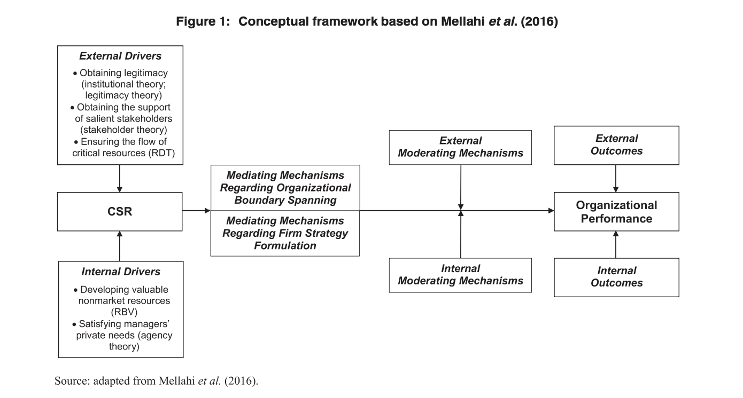

The framework mainly classifies theories as external drivers or internal drivers. External drivers’ theories include Stakeholder theory, Legitimacy theory, Institutional theory, and Resource dependence theory. Internal drivers’ theory includes Resource-based view and Agency theory. Because there is a difference between the external drive and internal drive theory. As a result, every corporate’s social responsibility is different. The external driver theory of CSR mainly focuses on the relationship between enterprises and society.

Moreover, social relations and social norms lead enterprises to assume social responsibilities. The theory of internal drivers is mainly about processes within an organisation. Corporate social responsibility under internal driving factors is the result of management decisions and financial statements or the result of ethical values (Frynas and Yamahaki, 2016). Although these theories are different, there will be some overlap. However, it serves to point out that managers need to make positive choices about CSR. Mellahi et al. (2016) mainly believed that theoretical perspectives are complementary. Moreover, they believe that there is at least one external driver theory or internal driver theory for social, environmental or market problems. Such an idea is very similar to the classification of previous scholars (Frynas and Stephens, 2015).

Stakeholder theory
The stakeholder theory holds that a company has a direct relationship with different stakeholders. These stakeholders have the right to rely on or legitimately demand returns from the enterprise. Stakeholders mainly have three attributes: power, legitimacy and urgency (Schreck, Aaken, and Donaldson, 2013). (See Figure 2 for specific stakeholders)
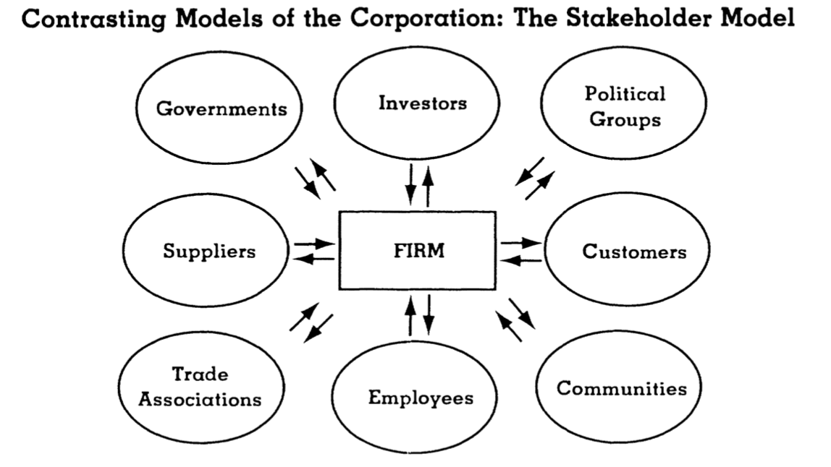
Figure 2 the Stakeholder Model (source: Donaldson et al., 1995)

These stakeholders are both influenced and can influence enterprises. The stakeholder theory's perspective on corporate social responsibility means that managers should recognise and serve the interests of a broader group (Aguinis, 2012). As the external environment is changing, the organisation needs to determine the priorities of relevant stakeholders. In addition to prioritisation, studies have found that the relationship between stakeholder pressure and the environment changes with the size of the firm (Darnall et al., 2010). Stakeholder theory focuses on the relationship between corporate social responsibility and organisational performance or corporate financial performance (CFP) (Schuler and Cording 2006, Barnett, 2014). Due to such a direct relationship, many studies show that a positive relationship can help enterprises develop better. This assumption is generally applied to companies where investors and other major stakeholders are interested in their interests (Frynas and Yamahaki, 2016).

Institutional theory
The institutional theory holds that firms conform to social norms in a given business environment. Companies often listen not to external actors but to conventions. For example, a particular way of doing things for a long time or as it should be done (Kauppi and Hannibal, 2017). The institutional theory encompasses a different approach. Generally, it can be divided into three ways: 1) Economic methods, which mainly regulate the essential supporting role of economic activities. 2) Sociological methods, mainly to determine the legitimacy of the system. 3) Comparative institutional methods are mainly used to define capitalist economies and shape the differences between economic organisations and enterprise competitiveness systems (Hotho and Pedersen, 2012). Many studies have identified factors such as environmental management and social institutions that influence corporate social responsibility behaviour. When firms in the same industry face institutional pressures, their strategies and practices become very much the same in a stable environment (Fransen, 2013). A significant advantage of institutional theory over other theories is that it allows CSR to be studied as a social institution and as a governance model in society and economy (Brammer et al., 2012). Treating CSR as an institution within a broader governance system can broaden the scope of CSR research, integrate it into other social science disciplines and further develop the overall scientific theory.

Legitimacy theory
Legitimacy theory is defined as "a general perception or assumption that an entity's behaviour is desirable, appropriate, or appropriate within some socially constructed system of norms, values, beliefs, and definitions.” (Suchman, 1995, p. 574). The premise of legitimacy theory is that enterprises operate on the basis of a contract with society. Society needs to recognise or give legitimacy to enterprises to avoid the negation of social goals. Companies get certain rewards from society and can survive. According to the theory of legitimacy, enterprises and society are closely linked. There is no unique high or low power between them, only to the extent that society gives them legitimacy. Therefore, corporate activities must be legalised in order to maintain consistency between social goals and corporate goals (Deegan, 2002). Academically, legitimacy is studied in two ways: strategic and institutional. The strategy has a certain degree of management control over the legalisation process. Legitimacy is the inspiration of stakeholders to resource dependency theory. This theory emphasises the importance of resources and the need for management to pay attention to relevant stakeholders (Milne and Patten,2002). As a result, legitimacy is considered a resource that stakeholders outside the firm grant. The strategic approach of legitimacy theory has been widely used in various studies. It is mainly to solve how to narrow the gap between social expectation and business practice after enterprises' social responsibility is announced (Magness, 2006). Legitimacy theory research shows that companies use various means to bridge such gaps, such as philanthropy (Lanis and Richardson 2013). In an institutional way, legitimacy is obtained through the joint construction of enterprises and the social environment (Meyer and Rowan, 1977). It can be seen from these two approaches that different challenges to legitimacy require different strategies.

Resource dependence theory
The theory suggests that firms are dependent on their environment to ensure their survival. Therefore, enterprises must pay attention to the needs of those in their environment, which provide the resources for their own survival（Mitchell, Agle, and Wood, 1997). However, the theory was developed initially to understand the relationships between and within firms. However, people find that the Resource dependence theory can be easily applied to the relationship between enterprises and different types of institutions (Julian et al., 2008). The dependence theory emphasises the role of the board of directors as the essential Resource to ensure the operation of the company (Mallin et al., 2013). As enterprises need to exchange resources with other related industries, relevant studies have found that the exchange of resources with important external groups can effectively improve the performance of enterprises (Ramanathan et al., 2014).

The above theory is about the study of the external drive. In the resource-based view of internal drive, the theory is that enterprises can have a sustainable competitive advantage under specific resources. It is mainly because enterprises obtain equivalent exchange through valuable and unique resources (Kraaijenbrink et al., 2010). CSR can be thought of as an investment in a company's capabilities. This is to make the company stand out from its competitors and improve its status. The resource-based view can help enterprises develop and utilise social and environmental problems to obtain corresponding economic benefits. However, some studies have shown that CSR-related capabilities (such as innovation or sustainable development) can bring new competitive advantages to enterprises (Lourenco et al., 2014).

Another internal driving factor theory is Agency theory. The theory is mainly concerned with the relationship between "principal" and "agent". Agency theory is often applied to extensive, open relationships between owners and managers. For example, employers and employees, suppliers and buyers (Frynas and Yamahaki, 2016). Agency theory can solve the related "agency problem". For example, an exciting subject and a principal cannot effectively monitor their agent's behaviour. Friedman (1962) believes that Agency theory is the self-interested behaviour of corporate social responsibility (CSR) on behalf of managers (agents), whose main purpose is to pursue ultra-low profits without considering social and environmental issues, and ultimately to harm shareholders (principals). However, the agency theory has a significant disadvantage in that it can only provide a partial explanation of corporate social responsibility. As a result, the agency theory needs to be combined with other related theories in later development.

This paper mainly studies the CSR of social media platform enterprises. Since all social media are for-profit organisations, the author selected Facebook, Bytedance (TikTok) and Twitter after multiple checks. The three social media companies were studied.

Due to the emergence of social media services in recent years, the relevant social responsibility theory is not very perfect. Uses and Gratifications Theory (UGT) are used to support social media services (Chen et al., 2021). UGT believes that audiences can find information to meet their own needs through the media. This theory holds that audiences restrict the process of media communication through their active use of media and points out that the use of media is entirely based on individual needs and desires (Kaur et al., 2020). Uses and Gratifications Theory was originally an analysis of traditional media. As social media is a part of media, the application of this theory in social media is also possible. The main reason is that the Uses and Gratifications Theory can explain and predict personal behaviours in social media (Leung, 2013). After a lot of studies, it is confirmed that the Uses and Gratifications Theory is applicable to social media, and it can meet people's requirements on social media (Lee & Ma, 2012; Leung, 2013). Therefore, Uses and Gratifications Theory can be applied to the relationship between social media and audiences (Chen et al., 2021).

There are also controversies about ethics related to social responsibility in social media enterprises, mainly whether philosophical "ethics" can standardise and criticise social media. However, some studies have divided the moral impact of social media services into three categories: 1) the direct impact of social network activities themselves; 2) It is that enterprises support some potential destructive business behaviours for the purpose of marketing and other activities, leading to its related stakeholders indirectly affected; 3) social media is a new society, whether there are some unfair behaviours, it is easy to have some structural impact (Plato, 2012). Some researchers argue that online social media tends to create a culture. In such cultures, deprivation of personal beliefs and behaviours can have permanent consequences, which can disconnect virtual people from their social identities in the real world (JANNA AND LEE, 2018). As a result, Dreyfus (2002) argues that there can be no real commitment or fulfilment of responsibility in a virtual world. For example, since the outbreak of the COVID-19 pandemic in 2020, various types of misinformation online have seriously affected the public's perception of the danger and transmissibility of the virus. Moreover, prevention efforts have been overshadowed by online conspiracy theories, which have greatly hampered public health efforts.

However, with the development of science and technology, social media continued to move forward and promoted a series of new philosophical studies in the field of social epistemology and ethics (Plato, 2012). Regina Rini(2017) argues that the issue of false online information, personal morality and cognitive responsibility, and the responsibility of social media platforms themselves cannot be considered from the perspective of individual cognition but must be regarded as "the tragedy of the cognitive Commons", which requires practical solutions. The age of social media has ushered in a new ethic. In virtual worlds, individuals and communities are built, executed and managed. Social networks generate unique standard norms and ethical practices (Parsell 2008).

Methodology
It has been indicated above that the purpose of enterprises to undertake social responsibility is mainly to improve their visibility and bring benefits (Schaefer et al., 2019). As more and more countries impose social responsibility on enterprises, it has become a part of consumer demand and affects the development of the whole society (Baskentli et al., 2019). This is mainly because CSR has evolved into a tool that can help enterprises meet social and environmental needs and improve their competitiveness (Barbosa and de Oliveira, 2021). As a result, today's managers may influence not only the company but also the society as a whole when they decide to work in the company (Da Silva Junior et al., 2019). Therefore, some enterprises will set up a corporate social responsibility department, which is mainly responsible for the formulation and implementation of corporate social responsibility policies (Barbosa and de Oliveira, 2021).

This paper will use content analysis to further study the selected three social media platform companies through the above research.

Content analysis is a qualitative research tool, mainly to analyse and determine some unique words, themes, or concepts in the text. Use content analysis to quantify and analyse the relationships between particular words, topics, concepts, etc. The data source for content analysis can be any communicative language (e.g., books, news, reports, media). When using Content Analysis, it is necessary to determine the intention of the research subject. Have a deep understanding of the research subject; Cultural differences should be taken into account in the content of research. The content analysis itself comes in two types: conceptual and relational. The content analysis itself comes in two types: conceptual and relational. Concept analysis is the frequency with which a particular concept appears or exists in a particular article. The relational analysis is a further development of the relationship between researchers through conceptual analysis (Publichealth.columbia.edu, 2022). Concept analysis will use specific dimensions to analyse CSR. Kao et al. (2018) divide CSR into 12 categories: Corporate Governance and ethical value;, The Employee Growth; Environmental Management and Protection; Energy Saving and Reduction; Sustainable Development; The Product Quality Control; Protection of Consumer Equity; Supply Chain Partnership; Promotion technological Development; Tax Contribution. Scientific Responsibility Management System; Sound Corporate Image. Such categorisation can transform the data observed in content analysis into valid data, making the results more straightforward. This paper will learn from and develop these 12 categories to adapt to the CSR research of these three social media platform companies.

Due to the global scope and nature of social networks, stakeholders are diverse. The analysis of these three enterprises is carried out through the stakeholder theory in the Literature review above. Relevant data have been sorted out in the following table, and the CSR content of the three enterprises can be found in the appendix.

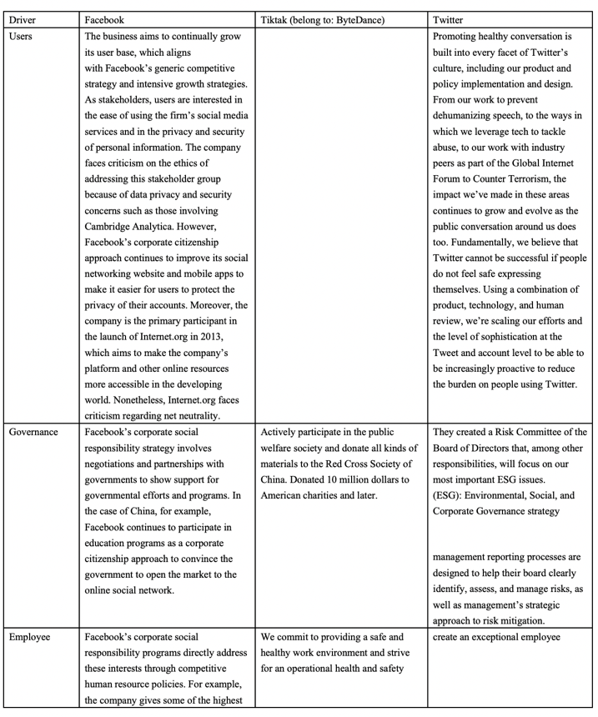
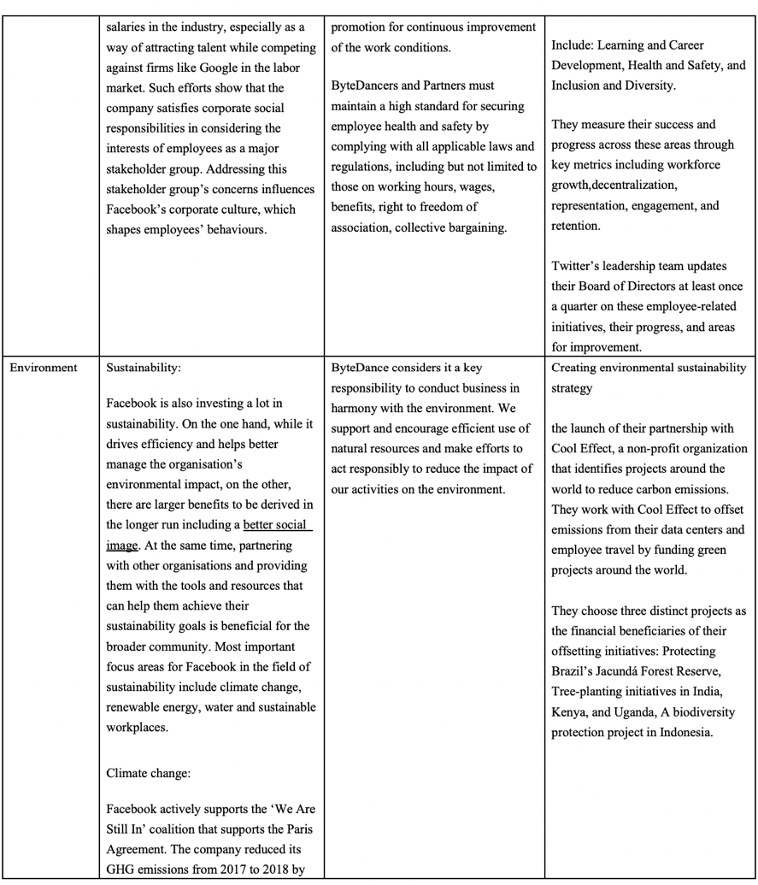
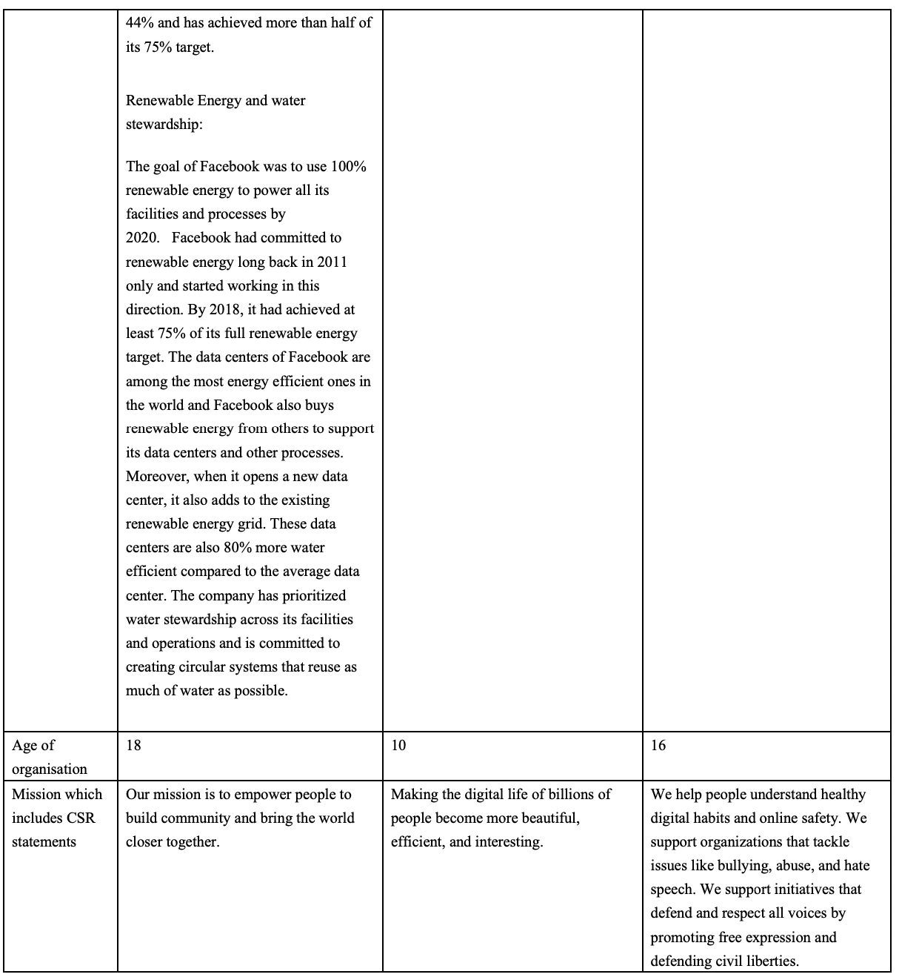

The three social media platform companies selected are currently the most used companies in the world. Facebook and Twitter are American companies, while ByteDance, TikTok's parent company, is Chinese. Since CSR has not been developed for a long time in China, the relevant information is not perfect. However, according to Yiming, ByteDance's global CEO, ByteDance has established the CSR department, which he personally manages, with the primary purpose of leading and developing ByteDance's global strategy. To support the company's tremendous global growth, as well as corporate social responsibility efforts and new businesses such as education (Bytedance.com. 2020).

Through table content and correlation analysis, the author integrates and further analyses the 12 dimensions mentioned above, as follows:

Corporate Governance and ethical value
With the development of technology, using social media platforms is the choice of more and more people. This also means that the values and morals of the society in the virtual network are constantly being challenged. Furthermore, that's a new responsibility for companies on social media platforms. They must act according to corresponding moral values. This is a necessary part of corporate strategy (Carroll, 2008).

Facebook
As shown in the table, Facebook's CSR for the government includes cooperation and negotiation to show the company's support for the local government. In this report, only the communication with the government is shown. However, the improvement of social morality is not shown. For example, how to prevent people from "addiction". Internet companies are lacking in moral values. Therefore, managers need to strengthen their thinking in this aspect so as to help enterprises win recognition and respect from users in terms of values (Houssem, Nadia and Kaouther，2020).

ByteDance
According to the table, ByteDance spends a lot of money on charity. There has been little other co-operation with the government. The number of TikTok users has exceeded hundreds of millions around the world (Business of Apps. 2022). There is no moral constraint with such a vast user base, and many people's videos will have some moral problems. This requires ByteDance to actively cooperate with the government, introduce relevant policies, and contribute to jointly maintaining a harmonious and beautiful network environment.

Twitter
On the table, Twitter said it had created a Risk Committee of the Board of Directors, which sets strategy on environmental, social and corporate governance issues. Compared with the previous two companies, Twitter seems to be relatively well-developed in terms of moral values and direct cooperation with the government. Through communication with the government through specialised departments within the company, some problems can be solved well.

Under the policy and moral values, enterprises need to improve the transparency of stakeholders and let stakeholders know their plans so as to improve better the value of enterprises (Colleoni, 2013). Users expect CSR to make changes and contributions not only for corporate interests but also for society and the environment. Therefore, there is a greater need to understand how the enterprise develops its strategic plans in accordance with the needs of society (Suarez-Rico; Gomez - Villegas; Garcia-benau, 2018).

The Employee Growth
Facebook
Facebook says it uses competitive hr policies to grow its employees and as a way to attract talent (Pratap, 2021). However, if pure competition may lead to some bad behaviour does not appear, for example, corruption. Therefore, in addition to the necessary competition, it is also necessary to strengthen the welfare of employees and improve their satisfaction in the company.

ByteDance
According to data, by the end of 2019, ByteDance had more than 60,000 employees in more than 180 cities in 30 countries and regions. Bytedance's products are available in 150 countries and regions and in about 75 languages (Bytedance.com. 2020)

ByteDance has some relatively good practices in employee welfare. For example, to provide a safe and healthy working environment and continuously improve staff's working conditions. This is very pleasing for the employees. Because a comfortable office environment will make everyone happy, and it will improve work efficiency.

Twitter
According to the table, Twitter is excellent overall in terms of employee growth. The company helps employees grow and advance in all aspects of their career paths. They even have a team that reports quarterly to the next level.

Sustainable Development
Facebook
Facebook has invested heavily in Sustainable Development. The ultimate goal is to raise Facebook's profile in public. However, it is suitable for society. So Facebook's behaviour is desirable beyond its own purposes.

ByteDance
In terms of sustainable development, Bytedance chose to set up a corresponding department to improve this direction and consider it an important responsibility. They are trying to take action. However, there is currently no information about their sustainability from the Internet.

Twitter
Twitter has an advantage when it comes to Sustainable Development. They chose to work with a nonprofit organisation called Cool Effect. They chose projects to reduce carbon emissions around the world to offset the carbon emissions generated by their data centres and employees. Although this may seem like a bit of an overkill, it would be more effective for employees to cut down on office paper (double-sided printing) and turn off the lights when they leave work. However, projects to mitigate carbon emissions still make sense.

Technological Development
With the rapid development of technology, Facebook came up with the concept of the Metaverse; Bytedance has chosen to enhance AI usage further. However, there are still big questions about user privacy.

In 2018, There was a scandal at Facebook about a massive leak of user data. Facebook has even granted certain companies the right to gain access to users' privacy in return for compensation and benefits. Despite what Facebook Later said, this behaviour is meant to make it easier for users to access it on other platforms. However, that does not help users' distrust of Facebook and fear of privacy violations (ERIC Jhonsa., 2018). Another way is about Internet addiction, which makes it difficult for people to leave quickly after they open Facebook (Busalim, A.H., Masrom, and Binti 2019). To avoid the above problems, Facebook needs to further develop its technology, such as a better system on user privacy to reduce unnecessary related links. In terms of Internet addiction, it is necessary to limit login time and reduce people's dependence behaviour (Wolniczak et al., 2013).

Summary
A business needs to be accountable to its stakeholders and society. Because the growth of enterprises cannot do without these factors, some studies show that after enterprises undertake social responsibility, different stakeholders will pay attention to it. Their attention can change the overall evaluation and value of the company (Jesús et al., 2016). However, there are still other motivations for enterprises to implement social responsibility, such as brand value enhancement, relationship building, preferential policies and resource increase, which play an essential role in promoting enterprises' economic activities in the future (Zhang et al., 2019). As a result, enterprises need to pay more attention to CSR related activities. In terms of the environment, further energy conservation and emission reduction are needed to protect the environment; In terms of employee growth, excellent promotion conditions should be provided for them in order to retain better and cultivate talents; For Internet enterprises, the most important thing is about users' privacy rights and interests. At the same time, they were improving various technologies to protect users' privacy and prevent them from being harassed by hackers. These are all things that enterprises need to consider when formulating strategies.

Conclusion and recommendations
Conclusion
Through the research on the corporate social responsibility reports of the three social media companies selected above, it is found that they have taken corresponding measures for the environment, employees, sustainability and the government. For example, there are corresponding schemes for carbon emissions, climate change, deforestation, and waste of available water resources in environmental issues.

All enterprises express that they will set up social responsibility departments to develop their social responsibility strategies. In practice, managers find that special departments are needed to deal with problems related to employment policies, human rights, users and equality. Otherwise, it will have a significant impact. However, the influence of external stakeholders such as the government will significantly increase the uncertainty of enterprises. Therefore, special departments are needed for communication and coordination (Quarshie and Leuschner, 2016).

While social media platforms have changed in many ways, the impact of these changes on the broader public interest remains unclear. The legalisation of personal information on its platform is still a controversial topic (She and Michelon, 2019). Through the information spread on social media, its stakeholders may gain more power, and the expression of information to the broader public will have adverse effects (Napoli, 2015).

Recommendation
Legislation
The government needs to strengthen the accountability system of social media platforms (Kemper & Kolkman, 2018). When problems such as user privacy leakage, cyber violence, hacking attacks and human rights occur on the platforms, it can be judged as the poor supervision of the platforms. In the future, the government will need to punish these misdeeds jointly. The government, as a policymaker, should attach importance to draft bills and conduct regular research on the needs of relevant enterprises so as to regulate corporate social responsibility (Amlys et al., 2021).

The enterprise itself must comply with all applicable laws and regulations, such as the laws and regulations concerning employee human rights, employee welfare, users' right to know, and responsibilities to be performed by the enterprise.

Research shows that social media is still essentially one-way communication. There is a lack of honest communication between enterprises and stakeholders, so the inquiries and criticisms of stakeholders are often ignored (Colleoni, 2013). In this case, enterprises need to improve the feedback system so that the communication between stakeholders and enterprises can go smoothly.

Industry regulation
There must be leading enterprises in a big industry, which need to set up committees to regulate the whole industry in addition to self-regulation. The Committee needs to actively cooperate with the government to do an excellent job in industry supervision and strive to further the development of the industry under the leadership of the Committee.

Different from other industries, the particularity of the social media industry lies in the fact that the entire industry is in the virtual world, which means that many things are not authentic and lack evidence. As a result, there will be a lot of unethical things, such as hackers attacking computers, platforms accessing users' personal privacy, and even the government accessing citizens' information (Legal.thomsonreuters.com. 2022. Electronic Frontier Foundation. 2022). Many users report feeling they are being monitored. Therefore, whether relevant agencies or governments can access users' privacy needs a further ethical argument.

Between enterprises and users
For social media platforms, their customers are the users who use their products. Although these users are free to use, they bring a lot of wealth to the enterprises (Monfort, Villagra, and López, 2019). For example, advertisers serve ads (if there are no users, advertisers will not want to serve ads on the platform). As a result, under such circumstances, enterprises are required to improve the transparency of their social responsibility, especially when the social responsibility includes some information about values and moral commitment (Du et al., 2010). In addition, social media platforms need to provide users with direct channels to communicate with them (DiStaso et al., 2011). In fact, most social media are willing to communicate with stakeholders or provide some enterprise content through the platform (Dellarocas, 2003). In this way, user viscosity can be improved, and the interaction between enterprises and stakeholders can enhance the credibility of enterprises and increase their competitive advantages (Bilic, 2010).

Companies should consider some information when issuing CSR reports. For example: operating status of the company, corporate finance, local social activities, next development plan, participating public welfare projects. These can increase user interest, increase the company's appeal, and strengthen the relationship between the company and its stakeholders (Menon and Kahn, 2003).

References
Audrey T. and Romiena D. 2009. Corporate Social Responsibility (CSR) reporting: How are targets transformed into actions? [online] Available at: https://libstore.ugent.be/fulltxt/RUG01/001/392/330/RUG01-001392330_2010_0001_AC.pdf [Accessed 17 January 2022].

Amlys Syahputra Silalahi, Doli Muhammad Jafar Dalimunthe and Aryanti Sariartha Sianipar. 2021. Content Analysis of Corporate Social Responsibility (CSR) Activities of Companies Listed in Indonesia Stock Exchange. [online] Available at: https://www.scitepress.org/Papers/2019/92013/92013.pdf [Accessed 23 January 2022].

Aguinis, H. and Glavas, A. 2012. ‘What we know and don’t know about corporate social responsibility: a review and research agenda’. Journal of Manage- ment, 38(4), pp. 932–968.

Barauskaite, G. and Streimikiene, D. (2021) ‘Corporate social responsibility and financial performance of companies: The puzzle of concepts, definitions and assessment methods’, Corporate social-responsibility and environmental management, 28(1), pp. 278–287. doi:10.1002/csr.2048.

Barnett, M.L. 2014. ‘Why stakeholders ignore firm mis- conduct: a cognitive view’. Journal of Management, 40(3), pp. 676–702.

Barbosa, M.W. and de Oliveira, V.M. (2021) ‘The Corporate Social Responsibility professional: A content analysis of job advertisements’, Journal of cleaner production, 279, p. 123665–. doi:10.1016/j.jclepro.2020.123665.

Baskentli, S. et al. (2019) ‘Consumer reactions to corporate social responsibility: The role of CSR domains’, Journal of business research, 95, pp. 502–513. doi:10.1016/j.jbusres.2018.07.046.

Bilic, Ivana (2010). “Development of web corporate communications function by official web sites and value added ranking: Case of Croatia”. The business review, [online] Available at: https://bib.irb.hr/datoteka/479324.Paper_Bilic_Ivana_Feb._3_10_New_Yohttps://bib.irb.hr/datoteka/479324.Paper_Bilic_Ivana_Feb._3_10_New_York_10_May_Formated.doc rk_10_May_Formated.doc [Accessed 28 January 2022].

Busalim, A.H., Masrom, M. and Binti Wan Zakaria, W.N. (2019) ‘The impact of Facebook Addiction and self-esteem on students’ academic performance: A multi-group analysis’, Computers and education, 142, p. 103651–. doi:10.1016/j.compedu.2019.103651.

Business of Apps. 2022. TikTok Revenue and Usage Statistics (2022). [online] Available at: https://www.businessofapps.com/data/tik-tok-statistics/ [Accessed 25 January 2022].

Brammer, S., Jackson, G. and Matten, D. 2012. ‘Cor- porate social responsibility and institutional theory: new perspectives on private governance’. Socio-Eco- nomic Review, 10(1), pp. 3–28.

Bytedance.com. 2020. Kelly Zhang and Lidong Zhang to lead ByteDance Business in China. [online] Available at: https://www.bytedance.com/en/news/5e6f3017679cb801f7524d8e [Accessed 24 January 2022].

Carroll, A. B. (2008). (PDF) A History of Corporate Social Responsibility: Concepts and Practices. [online] Available at: https://www.researchgate.net/publication/282746355_A_History_of_Corporate_Social_Responsibility_Concepts_and_Practices [Accessed 20 January 2022].

Camilleri, M., 2017. Corporate sustainability and responsibility: creating value for business, society and the environment. [online] Available at: https://ajssr.springeropen.com/articles/10.1186/s41180-017-0016-5 [Accessed 20 January 2022].

Carroll, A.B. (2016) ‘Carroll’s pyramid of CSR: taking another look’, International journal of corporate social responsibility, 1(1), pp. 1–8. doi:10.1186/s40991-016-0004-6.

Colleoni, E. (2013) ‘CSR communication strategies for organisational legitimacy in social media’, Corporate communications, 18(2), pp. 228–248. doi:10.1108/13563281311319508.

Chen, X. et al. (2021) ‘Research on Social Media Content Marketing: An Empirical Analysis Based on China’s 10 Metropolis for Korean Brands’, SAGE open, 11(4), p. 215824402110529–. doi:10.1177/21582440211052951.

Da Silva Junior, A. et al. (2019) ‘Sustainability and corporate social responsibility in the opinion of undergraduate students in management programs: Between the concrete and the abstract’, Journal of cleaner production, 207, pp. 600–617. doi:10.1016/j.jclepro.2018.10.011.

Darnall, N., Henriques, I. and Sadorsky, P. 2010. ‘Adopting proactive environmental strategy: the influence of stakeholders and firm size’. Journal of Management Studies, 47(6), pp. 1072–1094.

Deegan, C. 2002. ‘Introduction – The legitimising effect of social and environmental disclosures – a theoreti- cal foundation’. Accounting, Auditing & Accountabil- ity Journal, 15(3), pp. 282–311.

Dellarocas, C. (2003) ‘The Digitization of Word of Mouth: Promise and Challenges of Online Feedback Mechanisms’, Management science, 49(10), pp. 1407–1424. doi:10.1287/mnsc.49.10.1407.17308.

Du, S., Bhattacharya, C.. and Sen, S. (2010) ‘Maximizing Business Returns to Corporate Social Responsibility (CSR): The Role of CSR Communication’, International journal of management reviews : IJMR, 12(1), pp. 8–19. doi:10.1111/j.1468-2370.2009.00276.x.

DiStaso, M.W., McCorkindale, T. and Wright, D.K. (2011) ‘How public relations executives perceive and measure the impact of social media in their organisations’, Public relations review, 37(3), pp. 325–328. doi:10.1016/j.pubrev.2011.06.005.

Dreyfus, H.L. (2002) ‘Anonymity versus commitment: the dangers of education on the Internet. [This paper is an earlier version of Dreyfus, Hubert. “Nihilism on the Information Highway: Anonymity vs Commitment in the Present Age”; in Dreyfus, Hubert. On the Internet (2001).]’, Educational philosophy and theory, 34(4), pp. 369–378. doi:10.1080/0013185022000011763.

Donaldson, T. and Preston, L.E. (1995) ‘THE STAKEHOLDER THEORY OF THE CORPORATION: CONCEPTS, EVIDENCE, AND IMPLICATIONS’, The Academy of Management review, 20(1), pp. 65–91. doi:10.5465/AMR.1995.9503271992.

Eckert, C. (2017). Corporate reputation and reputation risk: Definition and measurement from a (risk) management perspective. Journal of Risk Finance, 18(2), 145–158. https://doi.org/10.1108/JRF-06-2016-0075

Electronic Frontier Foundation. 2022. Government Hacking and Subversion of Digital Security. [online] Available at: https://www.eff.org/issues/government-hacking-digital-security [Accessed 28 January 2022].

ERIC JHONSA. 2018. The real impact of the constant stream of negative news about Facebook. [online] Available at: https://www.thestreet.com/opinion/facebook-negative-news-impact-14817872 [Accessed 24 January 2022].

Frynas, J.G. and Yamahaki, C. (2016) ‘Corporate social responsibility: review and roadmap of theoretical perspectives’, Business ethics (Oxford, England), 25(3), pp. 258–285. doi:10.1111/beer.12115.

Frynas, J.G. and Stephens, S. 2015. ‘Political corporate social responsibility: reviewing theories and setting new agendas’. International Journal of Management Reviews, 17(4), pp. 483–509.

Friedman, M. 1962. Capitalism and Freedom. Chicago, IL: University of Chicago Press.

Green Paper, (2001). “Promoting a European framework for Corporate Social Responsibility”, Commission of the European Communities, COM (2001), 366 final.

Houssem Edine Nasr, Nadia Eleuch Mhiri and Kaouther Saied Benrached (2020) ‘FACEBOOK AND CSR: IS THERE A CONCORDANCE?’, International journal of entrepreneurship, 24(5), pp. 1–3.

JANNA ANDERSON AND LEE RAINIE, 2018. Stories From Experts About the Impact of Digital Life. [online] Available at: https://www.pewresearch.org/internet/2018/07/03/the-negatives-of-digital-life/ [Accessed 22 January 2022].

Julian, S.D., Ofori-Dankwa, J.C. and Justis, R.T. 2008. ‘Understanding strategic responses to interest group pressures’. Strategic Management Journal, 29(9), pp. 963–984.

Kauppi, K. and Hannibal, C. (2017) ‘Institutional pressures and sustainability assessment in supply chains’, Supply chain management, 22(5), pp. 458–472. doi:10.1108/SCM-01-2017-0004.

Kaur, P. et al. (2020) ‘Why do people purchase virtual goods? A uses and gratification (U&G) theory perspective’, Telematics and informatics, 53, p. 101376–. doi: 10.1016/j.tele. 2020.101376.

Kao, E. H. et al. (2018) ‘The relationship between CSR and performance: Evidence in China’, Pacific Basin Finance Journal, 51(June 2016), pp. 155–170. doi: 10.1016/j.pacfin.2018.04.006.

Kuo, L., Yeh, C. C. and Yu, H. C. (2012) ‘Disclosure of Corporate Social Responsibility and Environmental Management: Evidence from China’, Corporate Social Responsibility and Environmental Management, 19(5), pp. 273–287. doi: 10.1002/csr.274.

Kvasničková Stanislavská, L. et al. (2020) ‘Corporate Social Responsibility and Social Media: Comparison between Developing and Developed Countries’, Sustainability (Basel, Switzerland), 12(13), p. 5255–. doi:10.3390/su12135255.

Kraaijenbrink, J., Spender, J. C. and Groen, A.J. 2010. ‘The resource-based view: a review and assessment of its critiques’. Journal of Management, 36(1), pp. 349–372.

Kemper, J., & Kolkman, D 2018. Transparent to whom? No algorithmic accountability without a critical audience. [online] Available at: https://www.tandfonline.com/doi/full/10.1080/1369118X.2018.1477967 [Accessed 28 January 2022].

Lantos, G.P. (2001) The boundaries of strategic corpo- rate social responsibility. Journal of Consumer Mar- keting 18(7). pp. 595–630.

Lanis, R. and Richardson, G. 2013. ‘Corporate social responsibility and tax aggressiveness: a test of legitimacy theory’. Accounting, Auditing & Accountability Journal, 26(1), pp. 75–100.

Leung, L. (2013) ‘Generational differences in content generation in social media: The roles of the gratifications sought and of narcissism’, Computers in human behavior, 29(3), pp. 997–1006. doi:10.1016/j.chb.2012.12.028.

Lee, C.S. and Ma, L. (2012) ‘News sharing in social media: The effect of gratifications and prior experience’, Computers in human behavior, 28(2), pp. 331–339. doi:10.1016/j.chb.2011.10.002.

Legal.thomsonreuters.com. 2022. Internet Privacy Laws Revealed - How Your Personal Information is Protected Online. [online] Available at: https://legal.thomsonreuters.com/en/insights/articles/how-your-personal-information-is-protected-online [Accessed 28 January 2022].

Lin, L., 2020. Mandatory Corporate Social Responsibility Legislation around the World: Emergent Varieties and National Experiences. [online] Papers.ssrn.com. Available at: https://papers.ssrn.com/sol3/papers.cfm?abstract_id=3678786 [Accessed 21 January 2022].

Lourenc ̧o, I.C. Callen, J.L., Branco, M.C. and Curto, J.D. 2014. ‘The value relevance of reputation for sus- tainability leadership’. Journal of Business Ethics, 119(1), pp. 17–28.

Magness, V. 2006. ‘Strategic posture, financial per- formance and environmental disclosure: an empiri- cal test of legitimacy theory’. Accounting, Auditing & Accountability Journal, 19(4), pp. 540–563.

McWilliams, A. and Siegel, D.S. (2001) Corporate social responsibility: A theory of the firm perspective. Academy of Management Review 26(1). pp. 117–127.

Mele, D. (2008). Corporate social responsibility theories, The Oxford handbook of corporate social responsibility, pp. 46-82.

Melo, T. and Galan, J.I. (2011) ‘Effects of corporate social responsibility on brand value’, The journal of brand management, 18(6), pp. 423–437. doi:10.1057/bm.2010.54.

Mellahi, K., Frynas, J.G., Sun, P. and Siegel, D. 2016. ‘A review of the nonmarket strategy literature: towards a multi-theoretical integration’. Journal of Management, 42(1), pp. 143–173.

Meyer, J.W. and Rowan, B. 1977. ‘Institutionalised organisations: formal structure as myth and cere- mony’. American Journal of Sociology, 83(2), pp. 340–363.

Jesús Barrena Martínez, Macarena López Fernández and Pedro Miguel Romero Fernández (2016) ‘Corporate social responsibility: Evolution through institutional and stakeholder perspectives’, European journal of management and business economics, 25(1), p. 8–. doi:10.1016/j.redee.2015.11.002.

Menon, S. and Kahn, B.E. (2003) ‘Corporate Sponsorships of Philanthropic Activities: When Do They Impact Perception of Sponsor Brand?’, Journal of consumer psychology, 13(3), pp. 316–327. doi:10.1207/S15327663JCP1303_12.

Monfort, A., Villagra, N. and López-Vázquez, B. (2019) ‘Exploring stakeholders’ dialogue and corporate social responsibility (CSR) on Twitter’, El profesional de la informacion, 28(5). doi:10.3145/epi.2019.sep.13.

Mitchell, R.K., Agle, B.R. and Wood, D.J. (1997) ‘Toward a Theory of Stakeholder Identification and Salience: Defining the Principle of Who and What Really Counts’, The Academy of Management review, 22(4), pp. 853–886. doi:10.2307/259247.

Milne, M.J. and Patten, D.M. 2002. ‘Securing organi- sational legitimacy: an experimental decision case examining the impact of environmental disclosures’. Accounting, Auditing & Accountability Journal, 15(3), pp. 372–405.

Napoli, P.M. (2015) ‘Social media and the public interest: Governance of news platforms in the realm of individual and algorithmic gatekeepers’, Telecommunications policy, 39(9), pp. 751–760. doi:10.1016/j.telpol.2014.12.003.

Nibusinessinfo.co.uk. 2022. Business benefits of corporate social responsibility | nibusinessinfo.co.uk. [online] Available at: https://www.nibusinessinfo.co.uk/content/business-benefits-corporate-social-responsibility [Accessed 21 January 2022].

Parsell, M. (2008) ‘Pernicious virtual communities: Identity, polarisation and the Web 2.0’, Ethics and information technology, 10(1), pp. 41–56. doi:10.1007/s10676-008-9153-y.

Pineda, M., 2018. Theories of Corporate Social Responsibility - Profolus. [online] Profolus. Available at: https://www.profolus.com/topics/theories-of-corporate-social-responsibility/ [Accessed 21 January 2022].

Porter, M.E. and Kramer, M.R. (2006) The link between competitive advantage and corporate social responsibility. Harvard Business Review 85(12) pp. 78–92.

Publichealth.columbia.edu. 2022. Content Analysis Method and Examples | Columbia Public Health. [online] Available at: https://www.publichealth.columbia.edu/research/population-health-methods/content-analysis [Accessed 23 January 2022].

Plato.stanford.edu. 2012. Social Networking and Ethics (Stanford Encyclopedia of Philosophy). [online] Available at: https://plato.stanford.edu/entries/ethics-social-networking/ [Accessed 23 January 2022].

Pratap, A., 2021. CSR and Sustainability at Facebook | notesmatic. [online] notesmatic –. Available at: https://notesmatic.com/csr-and-sustainability-at-facebook/ [Accessed 25 January 2022].

Quazi, A.M. and O’Brien, D. (2000) An empirical test of a cross-national model of corporate social responsibility. Journal of Business Ethics 25(1) pp.33–51.

Quarshie, A.M., Salmi, A. and Leuschner, R. (2016) ‘Sustainability and corporate social responsibility in supply chains: The state of research in supply chain management and business ethics journals’, Journal of purchasing and supply management, 22(2), pp. 82–97. doi:10.1016/j.pursup.2015.11.001.

Ramanathan, R., Poomkaew, B. and Nath, P. 2014. ‘The impact of organisational pressures on environ- mental performance of firms’. Business Ethics: A European Review, 23(2), pp.169–182.

Regina Rini. 2017. Fake News and Partisan Epistemology - Kennedy Institute of Ethics Journal. [online] Available at: https://kiej.georgetown.edu/fake-news-partisan-epistemology/ [Accessed 22 January 2022].

Schaefer, S.D., Terlutter, R. and Diehl, S. (2019) ‘Is my company really doing good? Factors influencing employees’ evaluation of the authenticity of their company’s corporate social responsibility engagement’, Journal of business research, 101, pp. 128–143. doi: 10.1016/j.jbusres.2019.03.030.

Schreck, P., van Aaken, D. and Donaldson, T. 2013. ‘Positive economics and the normativistic fallacy: bridging the two sides of CSR’. Business Ethics Quar- terly, 23:2, 297–329.

Schuler, D.A. and Cording, M. 2006. ‘A corporate social performance–corporate financial performance behavioral model for consumers. Academy of Man- agement Review, 31(3), pp. 540–558.

Suchman, M. (1995). Managing legitimacy: Strategic and institutional approaches. Academy of Management Review, 20(3), pp. 57l–610.

Suárez-Rico, Y., Gómez-Villegas, M. and García-Benau, M. (2018) ‘Exploring Twitter for CSR Disclosure: Influence of CEO and Firm Characteristics in Latin American Companies’, Sustainability (Basel, Switzerland), 10(8), p. 2617–. doi:10.3390/su10082617.

She, C. and Michelon, G. (2019) ‘Managing stakeholder perceptions: Organised hypocrisy in CSR disclosures on Facebook’, Critical perspectives on accounting, 61, pp. 54–76. doi:10.1016/j.cpa.2018.09.004.

Tang, L., Gallagher, C.C. and Bie, B. (2015) ‘Corporate Social Responsibility Communication Through Corporate Websites: A Comparison of Leading Corporations in the United States and China’, International journal of business communication (Thousand Oaks, Calif.), 52(2), pp. 205–227. doi:10.1177/2329488414525443.

Townsend and Wallace. 2018. Social Media Research: A Guide to Ethics [online] Available at: https://ahrecs.com/resources/social-media-research-a-guide-to-ethics-by-townsend-and-wallace-guidance-dr-leanne-townsend-prof-claire-wallace-2016/ [Accessed 23 January 2022].

Wolniczak, I. et al. (2013) ‘Association between Facebook dependence and poor sleep quality: a study in a sample of undergraduate students in Peru’, PloS one, 8(3), pp. e59087–e59087. doi:10.1371/journal.pone.0059087.

Zhang, Q., Oo, B.L. and Lim, B.T.H. (2019) ‘Drivers, motivations, and barriers to the implementation of corporate social responsibility practices by construction enterprises： A review’, Journal of cleaner production, 210, pp. 563–584. doi:10.1016/j.jclepro.2018.11.050.

Appendix

Facebook
http://panmore.com/facebook-inc-stakeholders-corporate-social-responsibilities

https://notesmatic.com/csr-and-sustainability-at-facebook/

ByteDance (tiktalk)
https://www.chinanewsweb.com/index.php/2021/03/26/bytedance-2020-corporate-social-responsibility-report-fighting-epidemic-poverty-alleviation-and-promoting-employment/

https://www.bytedance.com/en/news/5e6f3017679cb801f7524d8e

https://sf16-sg.tiktokcdn.com/obj/eden-sg/upsnuhpevbn/bytedance_official/code_of_conduct.pdf

Twitter
https://about.twitter.com/content/dam/about-twitter/en/company/global-impact-2020.pdf

This table is compiled through CSR reports disclosed by these three social media platform companies, and relevant data are collected through online public information.

