BMHP6017
Perspectives on Child Pedagogy and Development.
(Strategies to Prevent, Reduce and Mitigate the Impact of Adverse Childhood Experiences and Promote Health Wellbeing and Pedagogical Development)

Adverse childhood experiences (ACE’S) are traumatic events that can affect children during early childhood, including aspects such as cognitive, emotional and social growth and development, (Grasso et al 2015; Brodie 2018). According to many studies these life changing occurrences can set children on a trajectory that leads to the development of health damaging behaviours which include; smoking, problematic alcohol and drug abuse, risky sexual behaviour and violence, (Mitchell and Kostolansky 2019; Hughes et al 2017; Public Health Wales 2015; Felitti et al 1998). Unsurprisingly, the definition of aces includes traumatic experiences such as violence, neglect and abuse, which often occur in environments where alcohol, substance misuse and poor mental health are present, (Centre for Disease Control (CDC) 2019).
An attempt to measure the extent of this problem in Wales was reported by Public Health Wales (2015) using a sample of 2,028 adults. According to this study 47% of adults had experienced at least 1 ace with 14% experiencing 4 or more. In comparison, a recent systematic review of literature found that individual who suffered multiple aces were at greater risk of developing health damaging behaviours, physical and mental ill-health which ultimately results in premature death, Hughes et al (2017). (Further statistics on the effects of multiple aces and health harming behaviours can be seen in appendix A. figure 1).
A study of exposure to aces and their effect on health was initially conducted by the CDC in 1998, which according to Boullier and Blair (2018 pg.1) found a “high prevalence of sexual abuse amongst patients attending an obesity clinic.” This suggests there may be underlying issues when individuals first present to health services with health issues. Boullier and Blair (2018) suggest that traumatic experiences such as abuse, neglect and chronic stress can also affect brain development in early childhood, which can result in long term behavioural problems, poor concentration, memory and learning outcomes.
This view is supported by Navalta, McGee and Underwood (2018) who also reported that exposure to prolonged or sustained periods of adversity, stress, abuse and neglect can result in neuro-biological changes, with the over production of the stress hormone cortisol. Effectively, this leaves the child in a constant state of fear, emergency and crisis, often without the love, care and emotional support of a parent, guardian or care giver. For this reason, the bond between a parent and their child has particular significance as it is seen by some commentators as an essential basis for long term mental health, Macdonald (2001).

Associations between multiple aces and poor health over the life course is clearly a cause for public concern, current thinking appears to suggest a link between parents who have suffered aces and its effect on future generations, (Boullier and Blair 2018; Radesky 2018). According to Mitchell and Kostolansky (2019) parent mental ill-health and depression are the most common form of ace followed by alcohol, drug abuse and domestic violence and are said to predict developmental delays in children, Radesky (2018). It could therefore be argued that dysfunctional families create environmental conditions that will have a negative effect on children’s wellbeing outcomes including social, emotional and cognitive functioning, Liming and Grube (2018). Prevention and early intervention measures such as the Flying Start programme in Wales have been implemented to support vulnerable children and parents who are at high risk of exposure to multiple aces, Boullier and Blair (2018).
Other research findings propose that higher incidence of aces have been recorded in families with lower household incomes across Europe, (World Health Organisation 2014; Mitchell and Kostolansky 2019; Jones et al 2018). This suggests that poverty and deprivation are risk factors that have negative implications for families and has been directly addressed in the aims of the Flying Start programme. The effectiveness of this programme will therefore have some significance for health care, family and other support services, in terms of demonstrating which areas of the programme are working well. Secondly, it presents an opportunity for local governments to review policies and strategies to ensure service provision meets the needs of the community. This could be through improved screening and assessment methods, treatment, education and financial aid for children and families living in poverty.
Arguably the most important piece of legislation to date that protects the rights of children and guides local policies such as Flying Start is the United Nations Convention on the Rights of the Child (UNCRC) (1989). The UNCRC highlights fundamental aspects of child protection including; life preservation, protection from violence, abuse and neglect, the right to education and the need for children to be brought up and have a relationship with their parents, Save the Children (2019).
The UNCRC acts as the umbrella of child protection legislation, which is then filtered down into various statutory acts of U.K legislation such as; The Children Act (1989), The Children and Young People’s Act (2008), Children and Families Act (2014), The Social Services and Wellbeing Act (2014) and most recently The Wellbeing of Future Generations Act (2015).
According to Brayne and Carr (2013 p.160) the philosophy of the Children Act (1989) is to ensure that children have the opportunity to be raised by their parents and “can be helped most effectively if the local authority working in partnership with the parents, provides a range and level of services appropriate to the child’s needs”. In comparison, Dogra et al (2009 p.251) states that children should be “protected by effective interventions if they are at risk,” Failures in child protection and child maltreatment; Haringey Local Safeguarding Children Board serious case review (2008) has led to many changes across the UK, as part of a new holistic approach to supporting children and their families, positive steps have been taken in Wales with the introduction of the Children and Young People Well-being Wellbeing Monitor (2011).
The Children and Young People Wellbeing Monitor (2015) research publication sought to provide an overview of key policy developments and initiatives that focus on issues such as; early years development, family support, physical and mental health, poverty and deprivation. These topics are seen as pertinent as there appears to be a consensus amongst commentators that they are fundamentally associated to aces, in terms of their effect on growth and development, cycles of suffering, prevention and intervention, Hughes et al 2017; Boullier and Blair 2018; Mitchell and Kostolansky 2019). According to the Children and Young People Wellbeing Monitor for Wales (2015) the Flying Start initiative aims to give children aged 0 -3 a better start in life, with emphasis on “evidence-based interventions designed to improve health, developmental and cognitive outcomes.”
This would appear to be the kind of support that is needed for children and families affected by aces however, early indications following an evaluation of the programme in 2011 suggest that parental contact with health visitors was lower than anticipated, with only 9% of parents in flying start areas making use of parenting courses. In addition, 90% of parents said the support was helpful however 1 in 5 parents said they wanted more support, whereas eight out ten parents said it had increased their confidence and decision-making ability with regards to caring for their child. (See Appendix A. figure 2 for more statistics). Although this evidence appears to suggest a more holistic approach to care provision and education, the evaluation raised questions as to whether “increased service provision results in improved child and parent outcomes in the future,” Evaluation of Flying Start (2011 p.15).

Since the initial evaluation the number of Flying Start families attending structured parenting programmes has increased to 70%, these programmes are designed to improve speech, language and communication; support parents and children during early years, provide early interventions and improve positive parenting. However, data in relation to actual health, developmental and cognitive outcomes appears to be scarce as the report seems to focus on immunisation, healthy baby weights and school attendance. Furthermore, data in relation to Flying Start development assessments has now been realigned to the Healthy Child Wales Programme (HCWP) unfortunately the data in relation to Flying Start and cognitive outcomes is limited HCWP (2018). It could be argued that it will take years before any meaningful results are seen across future generations, in terms of how they behaviour and support their children as parents.

Another recent analysis of Flying Start focussed on children attending regular childcare and its potential relationship to accident and emergency attendance however, this analysis did not consider factors “which may affect education and health outcomes,” Analysis of Flying Start outcomes using linked data (2019). This appears to contradict the aims of Flying Start to provide “evidence-based interventions designed to improve health, developmental and cognitive outcomes.” It could be argued that this data is more helpful in building evidence to demonstrate which families or children within flying start have a history of presenting to emergency care services, which may in itself reveal underlying issues that can then be addressed through additional family support.

The Pupil Deprivation Grant (PDG) is another policy highlighted in the Children and Young People Wellbeing Monitor for Wales (2015), this policy directly addresses the need to provide children and families from lower income households with financial support to improve educational attainment. An estimated £76.8 million was awarded in 2015 – 2016 to those children who were eligible for free school meals (FSM), an evaluation of the effectiveness of the PDG (2017 p.73) clearly demonstrates in quantitative terms that the “attainment ‘gap’ between FSM and non-FSM pupils has reduced considerably.” (See appendix A. figure 3). Evidence suggests schools used funding to train teaching assistants, employ highly skilled teachers to deliver interventions in smaller class sizes and purchase resources and computer software that support children with additional learning needs to understand their preferred learning styles. A limitation of these findings is a lack of scrutiny surrounding the arbitrary figure of £76.8 million, to ensure its cost effectiveness.
More recently, a review of curriculum in Wales recommended that health and wellbeing (H&WB) be introduced as a core subject or area of learning and experience, (Donaldson 2015; Heyward et al 2019). The H&WB draft curriculum 2022, Welsh Government (2019) places greater emphasis on education and pedagogical development from a more holistic perspective, it could be argued that this approach will provide children with knowledge about several areas of health that are associated in some way to aces including; relationships, emotional self-regulation, violence and staying safe, substance misuse, sexual behaviour, the human body and development and resilience. It is worth noting that physical activity (PA) which according to Hughes et al (2017) has a low association to aces, maybe an important aspect of the H&WB curriculum in terms of mitigation of health damaging behaviours over the life course. This can also be seen as a form of prevention as it provides children with the knowledge to understand what they can do to manage their physical and mental health in times of crisis. These preventative measures may not be realised for some-time, as current evidence appears to suggest there has been no significant change in the populations life style choices that lead to health damaging behaviours such as; smoking, drinking and obesity with statistics showing higher incidence of anxiety, depression, suicide and drug related deaths since records began, Wellbeing of Wales (2019).

Preventing aces is seen by many as an important direction of travel, owing to the fact that many individuals do not access support until later in life when health issues have become well established, Korotana et al (2016). According to Public Health Wales (2015) understanding ace prevalence and impact is important for the health, education and criminal justice sectors, as it can help to inform prevention strategies and ways to diagnose, treat and support. Korotana et al (2016 p .1) argues that “It is unclear which interventions have the strongest evidence base to support the many adults who present to services with a history of ACEs.” In comparison, a recent systematic review of trials to improve child outcomes associated with aces found that most interventions used a combination of “parenting education, social services referrals and paediatric primary care practices,” Mitchell and Kostolansky (2019).

According to Mitchell and Kostolansky (2019) these multi-component interventions can improve child behavioural and metal health outcomes, an approach that has been recommended for frontline mental health professionals for many years. Dogra et al (2009) suggest that basic interventions such a behaviour and cognitive therapy are used in primary care settings to treat children displaying aggression and in the treatment of disorders such as anxiety and depression. The four components to implement these treatment options include; engagement, defining goals, assessment of the behaviour and follow through, this ensures that planning, partnership and consent to treatments is agreed to reduce the likelihood of a breakdown in relationship between all concerned, Dogra et al (2009).

The influence that parents have on their children behaviour and learning has been well documented, (Bandura 1971; Bowlby 2005; Brodie 2018; Macdonald 2001) and supports the view that parenting education not only acts as an intervention but can arguably improve parent engagement, their willingness to act and their ability to follow through and support the child outside of a primary care setting. From the perspective of paediatric health professionals, the development of a screening and assessment questionnaire is needed to support in the early identification of ace exposure and draws some similarities to the assessment of behaviours noted by Dogra et al (2009). According to Koita et al (2018 p.2) the development of trust between health professional and their patients is fundamental during the early stages of assessment, helping to “facilitate the screening process, improve patient education about the impacts of adversity on health,” and informs best practice by selecting the most effective form of treatment. Evidence across the literature also suggests that paediatric primary care providers need to build evidence from these primary care screenings to improve health outcomes, Mitchell and Kostolansky (2019).

In comparison to primary care settings and according to the Lancet (2019) Mental Health services are “shifting away from traditional models of health care,” favouring a model that places itself nearer to the education environment to improve access and availability to children in need. It could be argued that delivery of the health and wellbeing curriculum in Wales would provide teachers and health professionals with an opportunity to observe behaviours in a less clinical environment however, this approach may create conflicts of interest between health care services and those who see education a providing an efficient and effective pedagogical health and wellbeing curriculum. Due to the ongoing stigma that surrounds mental health, Young Minds (2019) and children’s poor experiences of mental health services, Children’s Commissioner (2017) it would appear that normalising mental health conversations in schools is needed to increase engagement before professional are able to apply resilience strategies to improve self-efficacy, particularly where vulnerable children are concerned.
Alternatively, there are several other approaches or techniques that have implications for service delivery where diagnosis, treatment and support are concerned. According to Gill et al (2018) the integration of ace knowledge across nursing curriculum can support health professionals by preparing them to assess a patient, where exposure to aces is either disclosed or where health concerns, patient behaviours and family circumstance indicate patterns of abuse, neglect and child maltreatment. This approach would support service delivery and the practical application of trauma informed care, as some commentators have argued there is a “lack of evidence, best practices, and resources for addressing ACEs,” Olsen and Warring (2018 p.4) and would provide nursing students with greater understanding with regards to ace identification.

In comparison to educative forms of prevention or intervention psychosocial interventions are seen by many professionals as the most effective form of treatment for many health problems including substance misuse, addiction disorder, cardiovascular disease and cancer (Gates et al 2016; Korotana et al 2016; Sathyanarayana Rao et al 2018). According to Korotana et al (2016 p.3) “ACEs survivors often view themselves as unworthy, incompetent, powerless, and/or helpless” Such feelings can also be described as lacking in self efficacy, which Davey et al (2008) suggests is an individual’s ability to organise and execute a given course of action to solve a problem or accomplish a task. Davey et al (2008p. 527) also refers to this behaviour as the “external locus of control, where an individual perceives that events that happened to them are controlled by external forces.”

To guide the individual into a positive state of mind Korotana et al (2016 p.4) states that cognitive behavioural therapy (CBT) is “one of the most researched psychotherapeutic treatments and is consider the gold standard in psychological treatment.” CBT is used in primary care settings to modify “maladaptive thoughts and behaviours to improve overall psychological health.” Studies show that CBT is effective in the treatment of post-traumatic stress disorder by reducing the production of the stress hormone cortisol, Korotana et al (2016). This approach addresses the neurobiological changes that occur in childhood when children are exposed to prolonged or sustained periods of adversity, stress, abuse and neglect as highlighted by Navalta, McGee and Underwood (2018). However less evidence is known on the efficacy of CBT when treating adults for trauma that occurred in childhood, Korotana et al (2016).

Bandura, A. (1971) Social Learning Theory. New York: General Learning.
Brayne, H. and Carr, H. (2013) Law for Social Workers. Oxford, Oxford University Press
Brodie, K. (2018) The Holistic Care and Development of Children from Birth to Three, First Edition, Oxon, Routledge.
Boullier, M. Blair, M. (2018) ‘Adverse Childhood Experiences’, Paediatrics and Child Health 28 (3) pp. 132 – 137. DOI: https://doi.org/10.1016/j.paed.2017.12.008

Bowlby, J. (2005) The Making and Breaking of Affectional Bonds. London: Routledge, Print Routledge Classics.
Centre for Disease Control and Prevention (2019) About Adverse Childhood Experiences, Available at: https://www.cdc.gov/violenceprevention/childabuseandneglect/acestudy/aboutace.html (Accessed: 30.10.2019).
Children’s Commissioner (2017) https://www.childrenscommissioner.gov.uk/wp-content/uploads/2017/10/Voices-Mental-health-needs-1_0.pdf
Felitti, V. J. Anda, R. F. Nordenberg, D. Williamson D. F. Spitz, Alison M. Edwards, V. Koss, M. P. Marks, J.S (1998) ‘Relationship of Childhood Abuse and
Household Dysfunction to Many of the Leading Causes of Death in Adults’,
The Adverse Childhood Experiences (ACE) Study. American Journal of Preventive Medicine, 14(4), pp. 245-258. Available at: https://www.ajpmonline.org/article/S0749-3797(98)00017-8/abstract (Accessed 30.10.2019).

Gates, P.J, Sabioni P, Copeland J, Le Foll B, Gowing L. Psychosocial interventions for cannabis use disorder. Cochrane Database of Systematic Reviews 2016, Issue 5. Art. No.: CD005336. DOI: 10.1002/14651858.CD005336.pub4. https://www.cochranelibrary.com/cdsr/doi/10.1002/14651858.CD005336.pub4/full?highlightAbstract=medit%7Cwithdrawn%7Cmind%7Cmindfulness%7Cmeditation

Grasso, D. Carly D. Branson, C. Ford, J. Lee, R. "Developmental Patterns of Adverse Childhood Experiences and Current Symptoms and Impairment in Youth Referred for Trauma-Specific Services." Journal of Abnormal Child Psychology 44.5 (2016): 871-86.

Hayward et al (2018) CAMAU Project: Research Report (April 2018) University of Glasgow and University of Wales Trinity Saint David. Available at: http://eprints.gla.ac.uk/163362/ (Accessed on: 03.05.2019).

Hughes, K. Bellis, M. A. Hardcastle, K.A. Sethi, D. Butchart, A. Mikton, C. Jones, L. Dunne, M.P. (2017) ‘The effect of multiple adverse childhood experiences on health: a systematic review and meta-analysis’, Lancet Public Health, 2, pp. 356-366. Available at: https://www.thelancet.com/journals/lanpub/article/PIIS2468-2667(17)30118-4/fulltext (Accessed 03.06.2019).

Jones, T. M. Nurius, P. Song, C. Fleming, C, M. (2018) ‘Modeling Life Course Pathways from Adverse Childhood Experiences to Adult Mental Health’, Child Abuse & Neglect 80, pp. 32-40. DOI: https://doi.org/10.1016/j.chiabu.2018.03.005 (Accessed 16.10.2019).

Koita, K. Long, D. Hessler, D. Benson, M. Daley, K. Bucci, M. Thakur, Harris, N, B. (2018) ‘Development and Implementation of a Paediatric Adverse Childhood Experiences (ACEs) and Other Determinants of Health Questionnaire in the Paediatric Medical Home: A Pilot Study’,13(12) pp. 1-16, https://doi.org/10.1371/journal.pone.0208088 (Accessed 16.10.2019).

Korotana, Laurel M, Keith S Dobson, Dennis Pusch, and Trevor Josephson. "A Review of Primary Care Interventions to Improve Health Outcomes in Adult Survivors of Adverse Childhood Experiences." Clinical Psychology Review 46 (2016): 59-90. Web.

Liming, K, W. Grube, W, A. (2018) ‘Wellbeing Outcomes for Children Exposed to Multiple Adverse Experiences in Early Childhood: A Systematic Review’, Child and Adolescent Social Work Journal, 35, pp. 317–335. DOI: 10.1007/s10560-018-0532-x (Accessed 16.10.2019).

Lancet (2019) ‘Prevention verses Intervention in School Mental Health’, Lancet Psychiatry, 6, pp. 969-970, DOI: https://doi.org/10.1016/S2215-0366(19)30440-7 (Accessed 27.11.2019).

Marie Mitchell, A. Kostolansky, R. (2019) ‘A Systematic Review of Trials to Improve Child Outcomes Associated with Adverse Childhood Experiences’, American Journal of Preventive Medicine, 56(5) pp. 756-64. DOI: https://doi-org.ezproxy.uwtsd.ac.uk/10.1016/j.amepre.2018.11.030 (Accessed 16.10.2019).

MacDonald, S. (2001) ‘The real and the researchable: A brief review of the contribution of John Bowlby (1907-1990)’, Perspectives in Psychiatric Care, 37(2), pp.60–64. Available at:
https://search.proquest.com/docview/200754182?accountid=130472 (Accessed 09.11.2019).

Navalta, P.C. McGee, L. Underwood, J. (2018) ‘Adverse Childhood Experiences, Brain
Development, and Mental Health: A Call for Neurocounseling’, Journal of Mental Health Counselling, 38(4) pp. 266–278. DOI: 10.17744. (Accessed: 16.10.2019).

Public Health Wales (2015) ‘Adverse Childhood Experiences and their impact on health-harming behaviours in the Welsh adult population’, OGL Available at: http://www.wales.nhs.uk/sitesplus/888/page/88504 (Accessed: 08.10.2019).

Radesky, J. (2018) ‘Adverse Childhood Experiences Among Parents Affect Their Children's Development’, Journal Watch. Paediatrics & Adolescent Medicine, EJM Journal Watch. Pediatrics & Adolescent Medicine. Waltham, DOI: 10.1056/nejm-jw.NA46422

Sathyanarayana Rao, T., Shreemit Maheshwari, Manju George, Suhas Chandran, Shivanand Manohar, and Suman Rao. "Psychosocial Interventions for Sexual Dysfunction in Addictive Disorders." Indian Journal of Psychiatry 60.8 (2018): 506-09. Web.

Welsh Government (2019) “Analysis of Flying Start Outcomes Using Linked Data: Childcare analysis” Available at: https://gov.wales/analysis-flying-start-outcomes-using-linked-data-childcare-analysis-html
Welsh Government Hwb (2019) https://hwb.gov.wales Foundation Phase Framework (Revised 2015) Available at: https://hwb.gov.wales/curriculum-for-wales-2008/foundation-phase/foundation-phase-framework/ (Accessed on 03.05.2019)
Young Minds (2019) ‘Wise up to Wellbeing in Schools’ Available at: https://youngminds.org.uk/media/1428/wise-up-prioritising-wellbeing-in-schools.pdf (Accessed on 14.01.2019)

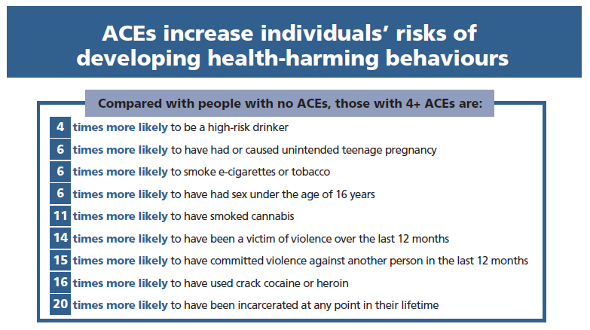
Appendix A

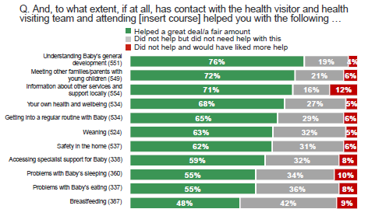
(Figure 1)

(Figure 2)
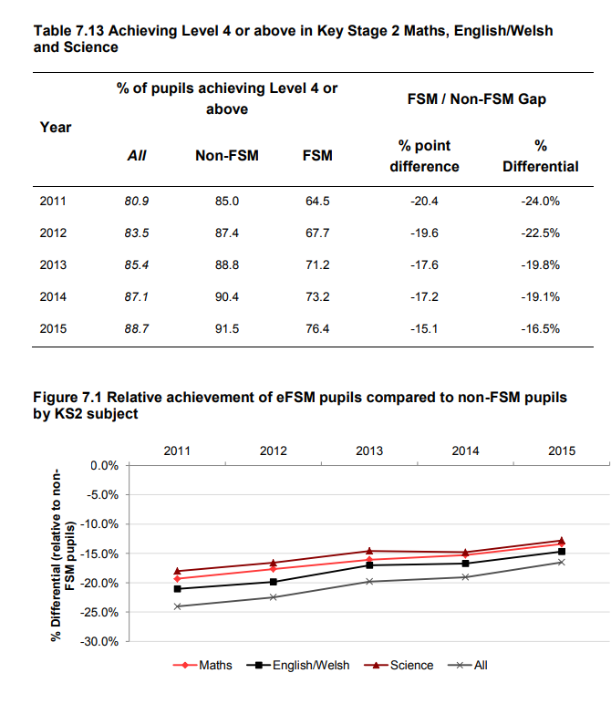

(Figure 3).

