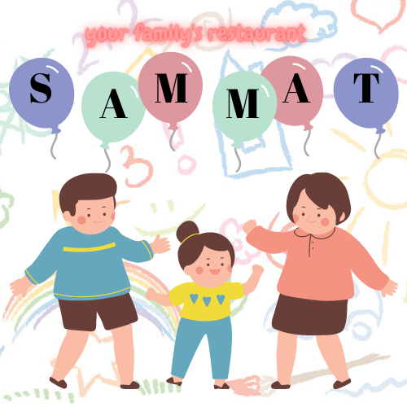  BUSINESS PLAN SAMMAT  UNIVERSITY OF WALES TRINITY SAINT DAVID | MARINELA COVASNEANU 1920078

Table of Contents

1. Company concept 2
2. Company name 2
3. Mission statement 2
4. Business aims 2
5. Business objectives 3
6. Legal identity 3
7. Marketing and PR plan 4
8. Pricing strategy 4
9. 7 P’s 5
10. Marketing samples 7
11. Physical location 11
12. Human resources 11

- Company concept
Every time I went out with my two kids to eat, I felt like all the restaurants were not prepared to have guests with kids, they had a limited option to eat, limited child chairs, and it was really difficult to feel comfortable. At the same time, all the other clients were disturbed by kids, and I didn’t enjoy going out a lot, and neither my kids.
After that, I started searching if other people felt the same way as I did, and I found that many families are currently experiencing the same angry reactions from staff when they are going with their kids at a restaurant (Mealey, 2018).
Based on personal experience and research, I decided to invest in a restaurant that is kids friendly, where all the guests can be comfortable bringing their kids, because they will have multiple option to eat, multiple toys and activities for kids of all ages, so that everyone can enjoy a little time out.
- Company name
The restaurant will be called ‘SAMMAT’, and has a special meaning for me, being a combination between the names of my two kids, Samira and Matei. I wanted to include their names because they are the reason behind this business.
- Mission statement
My mission is to make everyone with kids feel comfortable and happy. I know that raising kids is not always easy, and it comes with great sacrifices and responsibilities, and I understand perfectly how that is, having two kids myself. I want to offer everyone the chance to take a break from their day-to-day life, offering only the best food, the best care for their children and the best atmosphere.
- Business aims
In the special atmosphere of the restaurant, you can taste the over 150 dishes or 70 drinks. Attentive, complete, and elegant service is provided by highly trained staff. At any time, our restaurant is ready to satisfy your every desire. As such, we use pure natural products, which in addition to essential nutrients and the vital energy element, provide the therapeutic ability to restore the whole body. The kids will have a playground full of toys, a nanny to take care of them and the parents can watch them directly.

- Business objectives
Short-term goals:
- increase of the market share by 3%
- Promoting the company through flyers, leaflets, and newspaper ads
- diversification of menus with exotic fruit salads
- entering the market with promotional prices
Medium-term objectives:
- increase of the market share by 5%
- advertising through websites (online)
- opening new restaurants
- diversification of menus with ostrich soups and skewers
- reduction of the price by 10% around the big holidays.
Long-term objectives:
- increase of the market share by 8%
- consumer education through campaigns
- market penetration in other cities of Wales and United Kingdom
- diversification of pheasant soup and skewer menus
- on each anniversary of the restaurant, we will make price reductions of up to 15%

- Legal identity
I chose to open by my business as a Limited Company, with me being the only shareholder in the beginning. I chose this form of legal identity because I want by business to be separated from my persona, but I also have as a long-term objective the expansion of the business, and I will need more financial support from multiple shareholders (Business in a second, 2017). There are a few advantages that made me consider this legal identity, but the most important were (Craig, 2020):
- Separate legal identity – The company will not crossroads with my personal life.
- Investors – I can attract more people to invest in my company
- Remuneration – I have the opportunity to pay my employees more than usual.
At the same time, there are a few disadvantages that can be also seen as threats, the more noticeable being the fact that there is complicated for a limited company to obtain finance from banks, due to its own identity which does not have a credit score (Jobling, 2021).

- Marketing and PR plan
Considering some of the aspects involved in this type of business: high quality product-service, low earnings in the first year of activity and other factors that can negatively influence the course of business (inflation, interest rate) is therefore required careful analysis and design an effective marketing strategy and promotion of the service provided (Lumen, 2021).
On the opening day of the place will be invited public figures, businessmen. Advertising during this period will be well targeted, targeting the targeted market segment. A mass communication medium, the radio will be used to inform potential customers about the opening of a new kid-friendly restaurant (Restaurant Business, 2019).
There are a few ways in which the restaurant could be advertised:
- placing business cards in many places (for example in bars or cafes) so that everyone has access to them.
- placing billboards on the access roads in the city of Cardiff, so that those coming from other cities or abroad find out about the existence of the kid-friendly restaurant.
- appearance in media publications, setting up an easily accessible website of the restaurant, where customers can find both the menu and the prices of each product on the menu.
- collaborate with Deliveroo, UberEATS and Just Eat.
In the initial phase, the project was promoted through direct marketing and advertising materials. On the official website of the restaurant there is a form that can be completed by customers interested in the services we offer, and we will contact them by phone or by e-mail informing them about the specifics of the kid-friendly restaurant, as well as about the offers we have.
- Pricing strategy
Pricing starts in two stages and achieves two objectives. The first objective is to cover costs and achieve a profit margin, and the second objective is to practice a price that corresponds to the image of the restaurant we want to promote. We will first determine the price based on cost and then the price to differentiate competitors.
In relation to the prices practiced by the competition, we will opt for a psychological pricing strategy, the aim being to attract the client, after which this strategy will be gradually abandoned, it being used only in "dead" periods.
Based on the reasons above, we decided that the restaurant will serve menus at prices between £10-£15, and beverage at prices between £3-£10.
- 7 P’s
Product
The main menu has lots of different dishes, including mashed potatoes, stuffed peppers, soups, rice, pasta, pizza, burgers, chicken, steak, lamb, pork, fish. There are also available vegetarian dishes.
For kids, there are different types of foods, based on age. Among others, there are also available smoothie pouches, porridge, and we can also mash every meal at request, or be flexible with everyone’s needs.
For dessert there are available a variety of fruits, cakes, smoothies, biscuits, pancakes, doughnuts, waffles, chips, and ice cream.
The drinks menu has water, juice, soda, smoothies, coffee, and alcohol beverages.
Everything on the menu can be adjusted according to the customers’ needs, especially for kids.
At the same time, there are lots of toys and activities for kids, including birthday party, cubes, sound toys, balls, Lego, stuffed animals, books, etc.
Price
Since I am at the beginning, in the first week the prices will be lower than a usual restaurant that charges £7-£10 per menu (Squires, 2017). After the first week, the prices will be as normal, between £10-£15, because I must make sure that I can cover the rent, the salaries, the food, and I can also make a small profit that will be invested again in the company.
I also plan to offer significant discounts when there is a birthday party, or an important event. I want to make sure that my customers are always satisfied, and I also want to reward my loyal customers.
Promotion
Our concept being innovative is necessary for us to make it known and to be able to rely on a high-performance, clear, and reasoned image. Consequently, drawing up a communication plan becomes absolutely necessary. We will therefore appeal to both media and non-media elements (Wendy, 2020). For media communication, television, daily press, magazines, posters, radio, cinema are generally used. Given that our budget is limited, and that the nature of our concept is that of a kid-friendly restaurant, we will exclude advertising from the beginning on television and in cinemas. We will also not resort to posters and magazines because the expenses will be very high, and it is also necessary to preserve the advertising space at least one month in advance. Radio and the daily press remain the only media elements that will promote the advertising message of our restaurant. Local radio stations will be called, and the prices for the commercials are not high, which suits our budget allocated to the communication policy.
Communication through non-media means is particularly important for the promotion of our restaurant given the fact that the budget allocated to communication is very small. We will therefore use promotions, such as the direct bonus (free coffee at lunch and aperitif offered in the evening), promotions inside the restaurant (posters on the tables that allow highlighting products, the chef's recommendation on a product, written on a board, the kids playground, the toys, etc.). A restaurant website will also be created, where the restaurant, staff, and products will be presented, including even recipes. The flyers distributed on the street will be another way to promote our restaurant, with the mention that they will be created by the restaurant staff, the only costs being those related to listing and purchasing paper.
Place
Given that Brits walk only in exceptional cases, the car being much more comfortable (Dow, 2015), a location in the commercial centre of the city would not be of great effect and, therefore, we decided that the location should be in the middle of the city, to be specific on 164-166 City Road, Cardiff.
People
The teams in the unit are organized in such a way that it never runs out of service staff. Thus, the waiters will work in two shifts: the first from 9 in the morning until 23 in the evening, and the second from 18 in the evening until 9 in the morning. Between 18 and 23, both teams of waiters will work, because then the flow of customers is higher. Because the program can become quite exhausting, the waiters work 3 days, after which they have 3 days off. The kitchen team is organized to work as follows: 24 hours work and 48 free. Thus, the operability in service is ensured, and the clients will be satisfied at any time, at any time of the day.
The staff is quite numerous, and some connections are created between the workers, the restaurant management allows the formation of work teams according to preferences, because it is considered that teamwork is very important (Bright HR, 2021).
The waiters have a plan to divide the meals in the restaurant and on the terrace into sectors, in order to facilitate the service and not to cross with the other waiters. Each waiter has a helper who helps him take orders from the kitchen and get rid of it.
Process
We will try our best to offer the best service for kids and their families. The food will be fresh, prepared on the spot, there will be a full menu for everyone, including dishes, dessert, and drinks. The kids will have a nanny that will look for them at the playground, there will be many toys, suitable for all ages. We will also be pets-free, having a free range of food for them as well.
Physical evidence
The evidence will be the delicious food that we are serving, along with the impeccable place and care for children. The toys will be sanitised and there will be clear safety measures.
- Marketing samples
The fun logo is inspired by kids, it is very colourful and will attract everyone to my restaurant.

The restaurant will look like below:
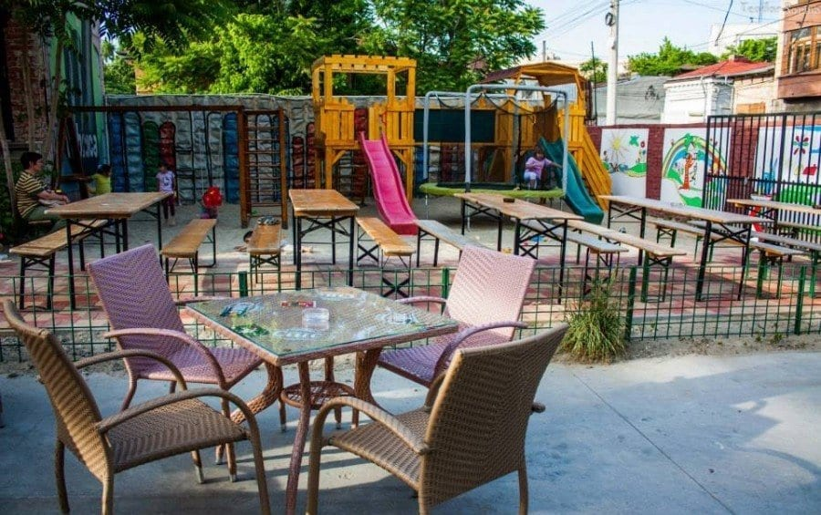
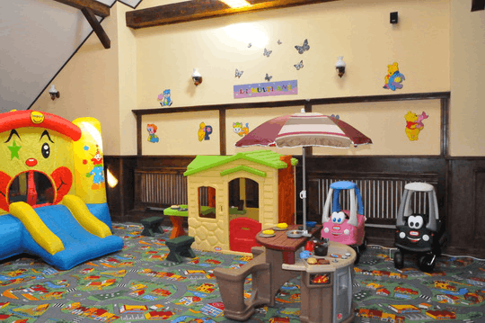

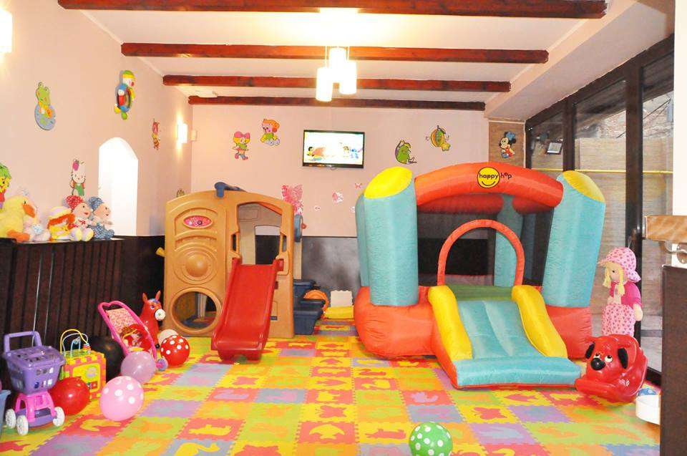

Below are a few ideas about the menu:
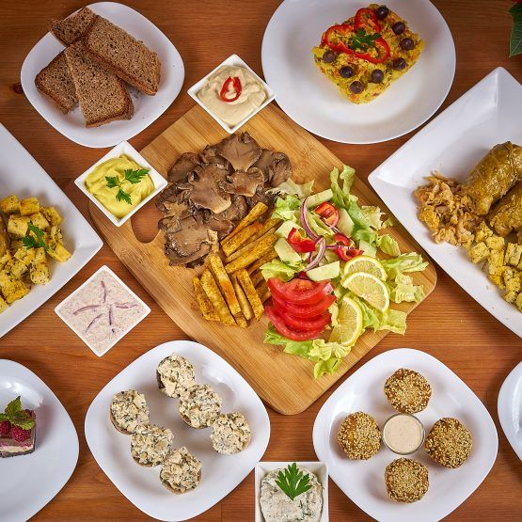

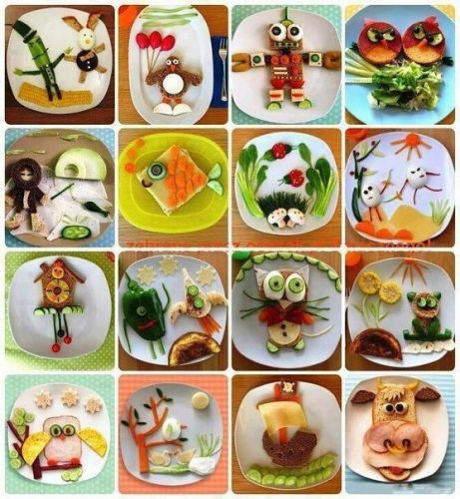
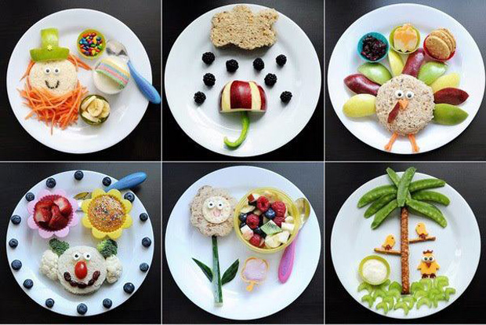
- Physical location
We decided that the location should be in the middle of the city, to be specific on 164-166 City Road, Cardiff. The location will also have a terrace, and it will serve food inside and outside.

- Human resources
The restaurant has 20 employees, and all have permanent employment contracts. As training they have knowledge of economics, management, marketing, accounting, specific to each position. Apart from the initiators of the business, manager (certified accountant or expert), chef (graduate of some specialized courses), the rest of the employees have only the professional school, respectively waiter-cook courses.
The necessary staff was identified and recruited through advertisements. The manager was the first employee, and together with him the initiators of the business recruited the chef. Next, the manager, together with the chef, selected the candidates for the other positions: chefs, assistant cooks, waiters, assistant waiters, bartenders, cashiers, and service staff.
The testing of the applicants was done in order to measure their ability and knowledge by demonstrating the practical ability to perform the tasks. In addition to the performance test, the candidates had to meet the conditions of behaviour, tact, attitude, and physical appearance. Candidates underwent thorough medical examinations to verify their suitability for the work required and to ensure the protection of other employees, customers and products made in the restaurant. The duties and responsibilities of each employee are set out in the job description.
- Sources of finance
I will come up from 15% capital from savings, but the rest of the money will be available through bank, by making a loan (Sarah, 2017). This is the safest place for me to get the money, and I will pay them back in a few years, or after I will start making more profit.

- Cashflow
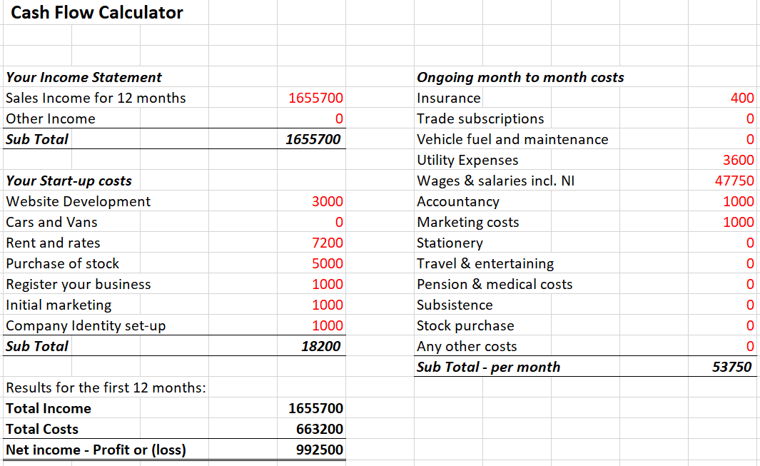
- SWOT Analysis
Strengths
- Modern kitchen
- Kid-friendly
- Lots of toys and books
- Extra care for the kids
- Healthy, fresh food
- Customer service.
Weaknesses
- Price
- New on the market
- Competitors
Opportunities
- Friends and family with kids that can come to the restaurant
- Great location
- Excellent food
Threats
- Competitors
- Not enough trust build
- Economic crisis
- Lockdown.

- References
- Bright HR (2021) The importance of teamwork. Available at: https://www.brighthr.com/articles/culture-and-performance/teamwork/the-importance-of-teamwork-in-the-workplace/ (Accessed: 10th of March 2021).
- Business in a second (2017) Things to know before setting up limited company in UK. [YouTube] Available at: https://www.youtube.com/watch?v=X9QhjZAc0Vo&ab_channel=BUSINESSINASECOND (Accessed: 10th of March 2021).
- Craig, R. (2020) Limited company advantages and disadvantages. Available at: https://www.rapidformations.co.uk/blog/limited-company-advantages/ (Accessed: 10th of March 2021).
- Dow, C. (2015) More than half of Brits drive 'easily walkable' distances. Available at: https://www.autoexpress.co.uk/car-news/consumer-news/91730/more-than-half-of-brits-drive-easily-walkable-distances (Accessed: 10th of March 2021).
- Jobling, R. (2021) Advantages and Disadvantages of a Limited Company. Available at: https://www.thecompanywarehouse.co.uk/blog/advantages-and-disadvantages-of-a-limited-company (Accessed: 10th of March 2021).
- Lumen (2021) General Economic Conditions. Available at: https://courses.lumenlearning.com/boundless-marketing/chapter/external-factors/ (Accessed: 10th of March 2021).
- Mealey, L. (2018) How to Make Your Restaurant Kid-Friendly. Available at: https://www.thebalancesmb.com/how-to-be-a-kid-friendly-restaurant-2888561 (Accessed: 10th of March 2021).
- Restaurant Business (2019) 4 NEW WAYS TO ATTRACT FAMILIES TO YOUR RESTAURANT. Available at: https://www.restaurantbusinessonline.com/consumer-trends/4-new-ways-attract-families-your-restaurant (Accessed: 10th of March 2021).
- Sarah (2017) Sources of Finance for Limited Companies. Available at: https://bizfluent.com/info-8788309-advantages-offbalance-sheet-financing.html (Accessed: 10th of March 2021).
- Squires, C. (2017) 14 of the best places to eat well on the cheap in Cardiff. Available at: https://www.walesonline.co.uk/whats-on/food-drink-news/14-best-places-eat-cheap-13299922 (Accessed: 10th of March 2021).
- Wendy (2020) What Are the Different Types of Media? Available at: https://whatagraph.com/blog/articles/different-types-of-media (Accessed: 10th of March 2021).

