SJIE6004
Learning in Practice
By Kimberley Tamilia 1707575

Contents

Introduction p2

Placement Description p3-4

Literature Review p5-10

Project p11-12

Conclusion p13

Bibliography p14-16

Appendices
Appendix 1 p17

Appendix 2 p18

Appendix 3 p19-25

Appendix 4 p26

This portfolio will explore the elements, policies and frameworks surrounding Special Educational Needs (SEN) now known as Additional Learning Needs (ALN). It is clear that there have been some big changes in the last 40 years in regards to inclusion in education. Documents such as the Warnock report and The Equality Act have contributed largely to the inclusion of special needs within formal education, this will look at what resulted in these changes and how is inclusion in education looking now in 2021. It will also explore different theoretical views and models such as the social and medical models of disability. There are some barriers to learning that have prevented these children to accessing a basic standard of formal education. For most inclusion is happening in schools, but there is still a minority of children who are slipping through the net and are not receiving the education equal to their peers. Inclusion has come a long way in the last 50 years, however we are still able to identify gaps in current frameworks and legislations all of which will be discussed in this portfolio.
It will discuss and analyse a case study of a child who has a physical disability who attends a mainstream secondary school. The case study will identify any barriers that he may be facing in school and how the school are dealing with removing these barriers.

The placement that is explored in this portfolio is a large mainstream secondary school in a rural area of Wales. I will call this school A for the purpose of maintaining confidentiality. It currently has around 1100 pupils on roll and is run on a statutory provision by the local authority. It is based in a small town with 26% of its pupils entitled to free school meals (EFSM). Which is above the average for secondary schools in wales currently at 16.4%. Of all of the pupils, around 25% of them live in the 20% most deprived areas in wales. Around 44% of pupils have additional learning needs, and just over 3% have a statement of special educational needs. Both of these figures are above the Welsh averages of 22.9% and 2.2% respectively. (Estyn)
School A holds various fundraising events to help the community such as school fetes and concerts. They most recently signed up to support the local RNLI charity. Although school A does have various involvements with the local community, there isn’t too much evidence of a close partnership at the moment. There are various multi-agency partnerships in setting A, because of the large number of pupils with Additional Learning needs (ALN) and because there is an attached Learning Resource Centre (LRC) which allows children with conditions such as autism to attend. Speech and language therapists, Educational Psychologists, Team around the family (TAF), social workers, physiotherapists and youth workers are just a few that are involved in setting A. They believe strongly that it is important to maintain and promote positive working relationships between parents and teachers, and included in the school policy documents is a home school agreement which at the start of the school year is signed by the pupil, parent and teacher to say that they commit themselves to working together. (See appendix 1).
The pupil development grant (PDG) is used in setting A and a large proportion of the grant is allocated to the salaries of a numeracy teaching assistant (TA), literacy TA, intervention teachers and also TA’s that are based in the behaviour unit. On top of this a proportion is allocated to the payment of pupils attending an external unit.
The majority of this budget is utilised correctly however, it doesn’t fully make the most of the whole budget, with almost £150,000 unspent.
This school is a new building that has only been built since 2017, previous to that the school was formerly over fifty years old and had a different name, and uniform. Having transferred up to the new school building with the new name and uniform, a new headteacher was appointed and had a whole new vision for the school. Since then, the school’s reputation has grown within the local community, which has now given the pupils a more positive attitude and pride at attending. In the old school site there was no provision for wheelchair users as there was no elevators between levels, so this limited access for pupils with a disability. The brand-new school building now as access for wheelchair users, and is a much more inclusive environment for a wider range of abilities and conditions. By 2018, the school welcomed its first wheelchair using pupil and currently there are now 6 pupils who have mobility issues on roll.
School A has a brand new LRC which also increases its ability to provide an education for vulnerable pupils with a higher level of need. It contains classrooms and its own outdoor area for children who are unable to attend mainstream lessons can still receive a high standard of education still within the school. This is evidence of education becoming more inclusive for all by having a building that is adapted for these different needs. There are elevators for access to all levels, a special learning centre (SLC) which holds sessions for the lower ability pupils on basic numeracy and literacy skills. There are adaptable tables in every classroom which can be height adjusted for wheelchair users to be able to sit at comfortably as well as adapted cooking rooms with adjustable ovens, hobs and worktops so when there is a wheelchair user in a food technology lesson they are easily able to access everything as everyone else can. There are also designated offices for the school counsellor, youth worker, English as an additional language teacher (EAL) and also a careers officer. The school prides itself on maintaining an inclusive environment for all of its learners.

In historic times, children with a disability or learning difficulties have been excluded from receiving a basic standard of education and were often separated and kept away from more abled children. Children with special educational needs that had conditions such as dyslexia, autism, ADHD, ODD and physical disabilities were all put under one umbrella and classed as stupid. There are a number of historical milestones which have set out changes to the education system and the implementation of a fully inclusive education. Although these frameworks and legislations have dramatically improved the education system, there are still some instances where children are being excluded or facing barriers to their learning within their setting. This review will take a critical look at some of the sources available regarding inclusive education and will identify the gaps and barriers that some children are still facing. According to Stubbs (2008) Inclusive education refers to a wide range of strategies, activities and processes that seek to make a reality of the universal right to quality, relevant and appropriate education. However, there are a number of different definitions of what inclusive education means and this could be one of the reasons why society is still struggling to implement a fully inclusive education system.
From the late nineteenth century, the introduction of compulsory schooling and pupil assessment excluded disabled children who had previously been ‘mixed together in school or remained at home.’ Following the Royal Commission of 1889, however, a series of Acts gradually increased the responsibility of local education authorities so that by 1918 they were required to grant-aid charitable schools or develop their own schools for blind and deaf, epileptic, mentally and physically disabled children. (historyandpolicy.org). The 1944 Education Act saw the first substantial changes. Even though the Act was first introduced in 1870. This Act pledged that all children were entitled to schooling suited to their ‘age, aptitude and ability’. It was the first turning point in education. The Education Act introduced the label ‘ineducable’ described children who had learning disabilities. In 1967, Stanley Segal, a teacher and campaigner and was largely involved in campaigning for the rights of children with learning disabilities. It was through his efforts and persuasion that the Warnock committee was started. This was in 1974 when the Warnock committee was set up by Margaret Thatcher, and later produced The Warnock Report. In 1981. The Children’s Act highlighted that all children should be educated in mainstream schools or classes wherever possible. (open.ac.uk, 2020) This was closely followed by the introduction of the Disabled persons Act in 1988.
Throughout history many terms were used to describe children with disabilities and learning difficulties, many that now would seem offensive. In 1990 however, the term to be used was published by the Department of Health as 'people with learning disabilities'. (open.ac.uk, 2020). In 1994, saw the United Nations Educational, Scientific and Cultural Organisation (UNESCO) Salamanca Statement. This involved governments and organisations internationally forming a world conference regarding special needs in education. This resulted in a new statement which called for inclusion to be implemented in schools. It was from this point on that significant changes were made in the education system and in 2001, the Special Educational needs and Disability Act made discrimination within education unlawful. In 2010, The Equality Act was introduced making it illegal for any school or education provider to discriminate against a child according to disability, race, sex, religion or belief. (csie.org, 2018).
The introduction of The Warnock Report saw the first positive steps to inclusion along with the Children’s Act 1981, in which they called for assessments of children with special educational needs to be made to ensure they received the correct provisions within mainstream schools. The Warnock report was what first gave us the term Special Educational Needs, but even though we saw some positive changes brought on by this, there has also been some criticism, with Mary Warnock herself even now stating
‘The concept of ‘special educational needs’ has, on balance, been unhelpful. It was introduced for positive reasons: to help break down the barriers between ‘handicapped’ and ‘ordinary’ children, to avoid the stereotyping associated with traditional categories and to focus on strengths/what can be done to overcome individual difficulties rather than on ‘medical deficits.’ (Gray, 2011)
Mary Warnock has since stated that inclusion has gone too far, and that special schools should only be used for children with severe or complex needs, that a mainstream school would not be suitable for. She stated that only 2% of children with special educational needs should be educated in a special school, the rest attending mainstream schools. (Conner, 2016). However, it is clear we are far from reaching the figure of 98% attendance at mainstream schools and reaching a fully inclusive education system.
The Warnock report had successfully achieved what it set out to do back then, however the introduction of the lamb enquiry, saw some gaps and issues in the legislation. It was following the recommendations from this that various amendments were made to further improve the education for special educational needs. The enquiry made 51 recommendations to the government and stated four key areas in legislation that needed to see changes, one area of this was that schools were failing to set positive outcomes for these children with special educational needs, by only setting low predictions for them, it was not allowing them to progress and achieve to their full potential. Many children were still being excluded from schools due to things like lack of teacher training.
Part of the solution to this was to ensure there was more training available for teachers on these specific conditions and for better working relationships between all areas including parents, schools and the local authorities. The enquiry largely stated the importance of the parent voice and easy access to information on their child. The importance of these positive relationships between school and home is demonstrated in Bronfenbrenner’s ecological systems theory. This is set on the believe that there are various systems, micro system is the immediate people around the child such as teachers and parents. If these are working together and are linked then it states that it will have a more positive impact on the child’s development. (impactofspecialneeds.com)
It identified that children achieved and progressed to a higher level and were happier when there was strong communication between parents and schools. (Lamb, 2017) Another area that they highlighted the need for change was the need for local authorities to become more engaged with the support and assessments of children, as it was now handed over to schools to deal with and the local authorities became disengaged about what support was being provided. (Lamb,2017) The outcome of the Lamb inquiry was two laws being added, the first was to provide a right of appeal for parents if a local authority decides not to amend a statement after a review, and the other was to for it to be essential that Ofsted/Estyn check on the quality of the education provided for disabled children and children with special educational needs.
After the Warnock Report came the Salamanca Statement which was often described as the Warnock reports international version. The statement by the United Nations called for more equality and inclusion for children with special educational needs internationally. Unlike the Warnock report that mentioned special schools, the Salamanca statement stated that it was the duty of schools to make reasonable adjustments for these children to be able to access it. The Salamanca Statement claimed that a fully inclusive education system was the only way to achieve a fully inclusive society and combat discrimination. (Conner, 2016) The problem with this aim was that it wasn’t a legal document and so no consequences were there for schools who didn’t implement it. It was just a statement with recommendations so it wasn’t taken seriously enough to see any dramatic changes in education.
The Warnock report and The Salamanca statement saw the shift from using a medical model of disability to a social model. The medical model was based on the idea that it was down to the individual to adjust to be able to fit in with society. So, the disability should be treated or cured in order for that individual to be able to fit in. Whereas the social model was the idea that it was down to society and the environment to make these changes to remove the barriers to allow the person to be able to access it. The medical model was seen a lot throughout the 1900s and children seen as having a special need were segregated or felt like they couldn’t integrate with society because it was down to them to heal or change the way they were which was nearly impossible. Special schools still today are an example of a medical model approach. As times have progressed and legislations have been introduced in the promotion of inclusion we are seeing the social model of disability being used more, people are seeing that society should be making the reasonable adjustments for people with disabilities to be able to integrate. Mainstream schools now make adjustments, like school A who has fully adapted the school itself to be able to allow access for these children such as pupil F with a physical disability. Before the introduction of the children’s act and other legislations pupil F would almost certainly have been made to attend a special school. This is a clear example of how far education has progressed and improved throughout history.
Shakespeare (2006) also argues that
the British ‘strong’ social model cannot be taken on its own, and focusing on disability solely as the result of social oppression does not take into consideration the role of the impairment itself. He also pointed out that creating a world void of all barriers for all disabilities would be impossible; for example, it would be impossible to accommodate all autistic people since meeting one person’s sensory needs could cause distress or restrictions for another person (Elliman 2011).
Davis and Watson (2001) found one head teacher from a mainstream school who suggested that he could only have 15% of children with a learning difficulty in any year if the school was to meet its national targets. Whilst it was thought that including disabled children in mainstream schools was the answer, there are flaws in this idea and studies have shown that these pupils with a disability are often taught by teaching assistant with no teaching qualifications, whereas their non-disabled peers are taught by teachers. (shah, 2007) This is another major gap in the idea that mainstream schools are being encouraged to be fully inclusive, and there is still a long way to go.
In Wales, currently there is an ongoing educational reform. In a document by the OECD (2017) The aim is to produce an education system in which all learners have an equal opportunity to reach their potential. The Welsh Government is planning to reform the statutory framework for children and young people with special educational needs (SEN). Policy reviews identified weaknesses in relation to each stage of the current process for meeting special educational needs (identification, assessment, planning and review) and in relation to quality assurance and evaluation of the process. The system was judged to be insufficiently child or parent/carer centred, too complex, bureaucratic, costly, and time consuming. Its weakness contributed to delays in providing support for pupils with special educational needs and to a lack of understanding and trust in the current system, creating tensions and a divide between professionals and families (Estyn 2003; NAfW, 2004, 2006).
There is going to be a new additional learning needs (ALN) system which is due to come into force in September 2021.The framework of the new system is created by the Additional Learning Needs and Education Tribunal (Wales) Act 2018. This act was what changed the term Special Educational needs (SEN) to Additional Learning Needs (ALN). A significant change in the framework is that from September wales will no longer be issuing statements of special educational needs or individual education plans (IEP’s) These instead will be replaced with a new statutory Individual development plan (IDP). With the production of each IDP, the welsh government has insisted a person-centred approach that was first introduced by psychologist Carl Rogers, is used and the child is very much involved in what goes into the IDP, including a one-page profile to input things like their interests and dislikes, and portrays their personality.

This section is a case study on a pupil with ALN, this pupil will be referred to as pupil F for confidentiality purposes. Pupil F, attends the setting previously mentioned (School A) which is a mainstream secondary school. Pupil F has a statement of special educational needs, he has quadriplegia type cerebral palsy and requires the use of a wheelchair permanently. He is seen by several multi- agency workers such as physiotherapist, paediatric occupational therapist, speech and language therapist and an Educational Psychologist. Pupil F is the first pupil with a physical disability to attend this setting as it was a newly built school. There have been many adjustments that have needed to be made to ensure pupil F receives the same quality of education as his peers. He has 1-1 support from a Learning Support Assistant who is always with to support with his work whilst in the classroom and ensuring that he can access each classroom and safely navigate to where he needs to be in the building. He also needs 2 LSA’s to support him with his toileting needs. He is included in all mainstream lessons with the exception of Welsh, which he has been disapplied from as his parents felt it was more important for him to receive speech and language interventions and sessions working on his fine motor-skills during these lessons.
The school now prides itself on being fully-inclusive and easily accessible for every child however, there have been some gaps identified and some barriers that have prevented pupil F from being fully included.
Participating in Physical Education (PE) lessons was always going to be a challenge for a pupil with physical disabilities that uses a wheelchair. There is also the fact that the teachers in the school has never had to teach a wheelchair user in their lessons before so it was also a new experience for them. With the lack of knowledge on pupil Fs capabilities came the first barrier, and in football sessions he was expected to be the ‘timer’ or referee and told to keep watch that his peers were participating in the game. This made pupil F feel extremely isolated and frustrated, not because he couldn’t play football but that he felt as though the teacher was instantly writing him off and that he couldn’t participate at all.
Pupil F has a statement of special educational needs and in this it clearly states that ‘he will have the opportunity to participate as fully as possible in all aspects of the curriculum.’ This clearly was not happening in his PE lessons, so when the annual review meeting between his parents and the school took place, with the issue of a lack of participation discussed. The action points that were taken were, that pupil F was going to be given a differentiated task within his PE lessons going forward which included him being able to work on his throwing and catching skills with a ball light enough for him to manage. In addition to this it was planned that he could practice his batting skills using a variety of different bats and rackets. This could be done in the same area as the rest of the class doing their lesson, so he was still included in the lesson but with a differentiated task that he was capable of doing. He was also allowed to pick one of his peers that he wanted to do this with, which made him feel more comfortable and less segregated from the others.
As pupil F has a statement of educational needs, he has a yearly meeting in which he, his parents, the ALNCo and his 1-1 LSA are present to discuss all aspects of how his education is going according to his needs. This is called an annual review (AR) (See appendix 3) This is a legal obligation that has to be carried out by the local authority. In his annual reviews, The Additional Learning Needs Coordinator (ALNCo) gathers feedback from all of his teachers and can provide this feedback of any issues or concerns to his parents. Parents are given their own form to fill out and can express any concerns on this. (see appendix 2) During the review, the child’s progress is discussed and any potential barriers to learning are identified. The review is a check that all of pupil F needs are being met according to the points set out in his statement. The barrier that he was facing in his PE lessons was mentioned and the action points were discussed which led to positive improvements.
In school A, pen pictures of all children who have ALN are circulated and accessible to all staff so they aware of what conditions the child has and any support strategies that can be used in the classroom. They state in the school Additional Learning needs policy that ‘we work on the principle that all teachers are teachers of special needs’ (see appendix 4) However, this wasn’t apparent when pupil F was being excluded from his PE lessons, but since this, it has prompted the school to provide the teachers with training on children with physical disabilities, and the school believes it is all a learning curve and a new experience in which they are all still learning.
To conclude, the findings in this portfolio have shown that integration of children with ALN has improved over time and has come a long way since before legislations such as The Education Act started to see inclusion as an important part of British education. Children with disabilities and additional learning needs were previously separated and seen as ‘uneducable’ by society and didn’t easily have access to an education. However, since documents such as the Warnock report and changes in legislations have been made since then, mainstream schools are now easily accessible for these children. With that said, it is evident that even though they are able to access mainstream schools, that may not always be the most suitable option for them. Depending on the level of need and condition they have, a choice has to be made as to whether they will get the best quality of education for them attending a mainstream school or a special school. Children should be heavily involved in this decision as it is one that will have a large impact on their lives going forward. It is clear that a lack of funding, teacher training and resources available all contribute to the difficulty in achieving a fully inclusive education system.
Some may argue that children with ALN are better off segregated and can get the appropriate care and support within a special school, however these children mostly just want to feel ‘normal’ and don’t want to be labelled as different. Attending a special school highlight this. Depending on the need, it is sometimes clear which option is more suitable, however sometimes options need to be weighed up and the child should have a voice in this process. On the other hand, children with ALN who go to mainstream schools are more likely to be exposed to bullying and exclusion. There is often not the appropriate support in place for them, and they end up facing barriers to their learning such as the barriers pupil F faced in his mainstream school. Some have the opinion that if these children are included in mainstream schools, it will enable other children to understand and accept them, instead of growing into adults who don’t know how to treat them and don’t understand how to integrate with them in society. With pupil F, as he attends all mainstream classes with his peers, it is evident to see how his classmates all support him if he needs something and are always quick to help him. They are no longer alien to seeing a wheelchair user and feel uncomfortable around him, which will hopefully mean that as adults they are just as understanding and accepting of others that may not be like them.
Bibliography
Ainscow, M. Booth, T. Dyson, A. (2006) Improving Schools, Developing Inclusion
Improving Learning. London: Routledge.
Bell, J (2010) Doing Your Research Project: a guide for first time researchers in education and social science, (5th ed) Buckingham: Open University Press
Bolton, G. (2010) Reflective Practice: Writing and Professional Development. (3rd
Borsay, A. (2012) Disabled Children and Special Education, 1944-1981. Available at: https://www.historyandpolicy.org/docs/dfe-anne-borsay-text.pdf
Burton, D & Bartlett, S. (2004) Practitioner Research for Teachers, London: Paul Chapman Publishing
Conner, L. (2016) Reflections on inclusion: how far have we come since Warnock and Salamanca? Available: https://repository.uel.ac.uk/
Cottrell, S. (2015) Skills for Success: Personal Development and Employability. (3rd edn) London: Palgrave Macmillan
CSIE (2020) The UNESCO Salamanca Statement. Available at: http://www.csie.org.uk/inclusion/unesco-salamanca.shtml
Donaldson, G. (2015), Successful Futures: Independent Review of Curriculum and Assessment in Wales, Welsh Government, http://gov.wales/docs/dcells/publications/150225-successful-futures-en.pdf.
Ed). London: Sage
Estyn (2003) Support for Children with Special Educational Needs: An Estyn Overview. Accessed at: http://www.estyn.co.uk/publications/Support_children_SEN.pdf
Ghaye, T. (2010) Teaching and Learning through Reflective Practice: A practical Guide for Positive Action. London: Routledge
Gray, P (2011) Special Educational Needs: A new look – By Mary Warnock and Brahm Norwich. Journal of research in special educational needs. Available at: https://nasenjournals.onlinelibrary.wiley.com/doi/full/10.1111/j.1471-3802.2010.01187.x
Howes, A Davies, S.M.B and Fox, S. (2009) Improving the Context for Inclusion: Personalised Teacher Development through Collaborative Action Research. London: Routledge
Impact of Special needs [blog] Bronfenbrenner’s Ecological Systems Theory. Available at: https://impactofspecialneeds.weebly.com/bronfenbrennerrsquos-theory.html#:~:text=Bronfenbrenner's%20Ecological%20Systems%20Theory&text=It%20is%20in%20the%20micro,helps%20to%20construct%20the%20settings.
J. M. Davis & N. Watson (2001) Where Are the Children's Experiences? Analysing Social and Cultural Exclusion in 'Special' and 'Mainstream' Schools, Disability & Society, 16:5, 671-687, Available at: 10.1080/09687590120070060.
Lamb, B. (2017). Lamb Inquiry into Parental Confidence in Special Educational Needs. Available at: https://www.researchgate.net/publication/321882813_Lamb_Inquiry_into_Parental_Confidence_in_Special_Educational_Needs
Lindsay, G. (2003) ‘Inclusive education: A critical perspective’. British journal of Special Education. Available at: http://dx.doi.org/10.1111/1467-8527.00275
Lindsay, G. (2003). Inclusive education: A critical perspective. British Journal of Special Education. Available at: https://www.researchgate.net/publication/229666616_Inclusive_education_A_critical_perspective
Mencap (2019) Children - research and statistics. Available at: https://www.mencap.org.uk/learning-disability-explained/research-and-statistics/children-research-and-statistics#:~:text=In%20Wales%20in%202017%2F18,(Scottish%20Government%202018)
Mittler, P. (1994) The Independent. Obituary: Stanley Segal. Available at: https://www.independent.co.uk/news/people/obituary-stanley-segal-1412745.html
National Assembly for Wales Research paper (2015) Special Educational Needs (SEN)/ Additional Learning Needs (ALN) in Wales. Available at: https://dera.ioe.ac.uk/23945/7/15-025_Redacted.pdf
Norwich, B. (2019). From the Warnock Report (1978) to an Education Framework Commission: A Novel Contemporary Approach to Educational Policy Making for Pupils with Special Educational Needs/Disabilities. [journal] Available at: https://www.frontiersin.org/articles/10.3389/feduc.2019.00072/full
OECD (2017) The Welsh Education Reform Journey A RAPID POLICY ASSESSMENT. Available at: https://www.oecd.org/education/The-Welsh-Education-Reform-Journey-FINAL.pdf
Shah, S. (2007) Special or mainstream? The views of disabled students, Research Papers in Education, 22:4, 425-442, Available at: 10.1080/02671520701651128
Shaw, A. (2017) Inclusion: the role of special and mainstream schools. Journal. Available at: https://doi.org/10.1111/1467-8578.12181
Stubbs, S. (2008) Inclusive Education Where there are few resources. Available at: https://d1wqtxts1xzle7.cloudfront.net/37729926/Stubbs_2008_IE_few_resources_.
The Open University (2021) Timeline of learning disability history. Available at: https://www.open.edu/openlearn/education/educational-technology-and-practice/educational-practice/inclusive-education-knowing-what-we-mean/content-section-3.4
Thompson, S and Thompson, N. (2008) The Critically Reflective Practitioner. Basingstoke: Palgrave Macmillan. Routledge.
Welsh Government (2020) The additional learning needs transformation programme: frequently asked questions. Available at: https://gov.wales/additional-learning-needs-transformation-programme-frequently-asked-questions-html
Zwordiak-Myers, P. (2012) The Teacher’s Reflective Practice Handbook. London:

Appendices
Appendix 1
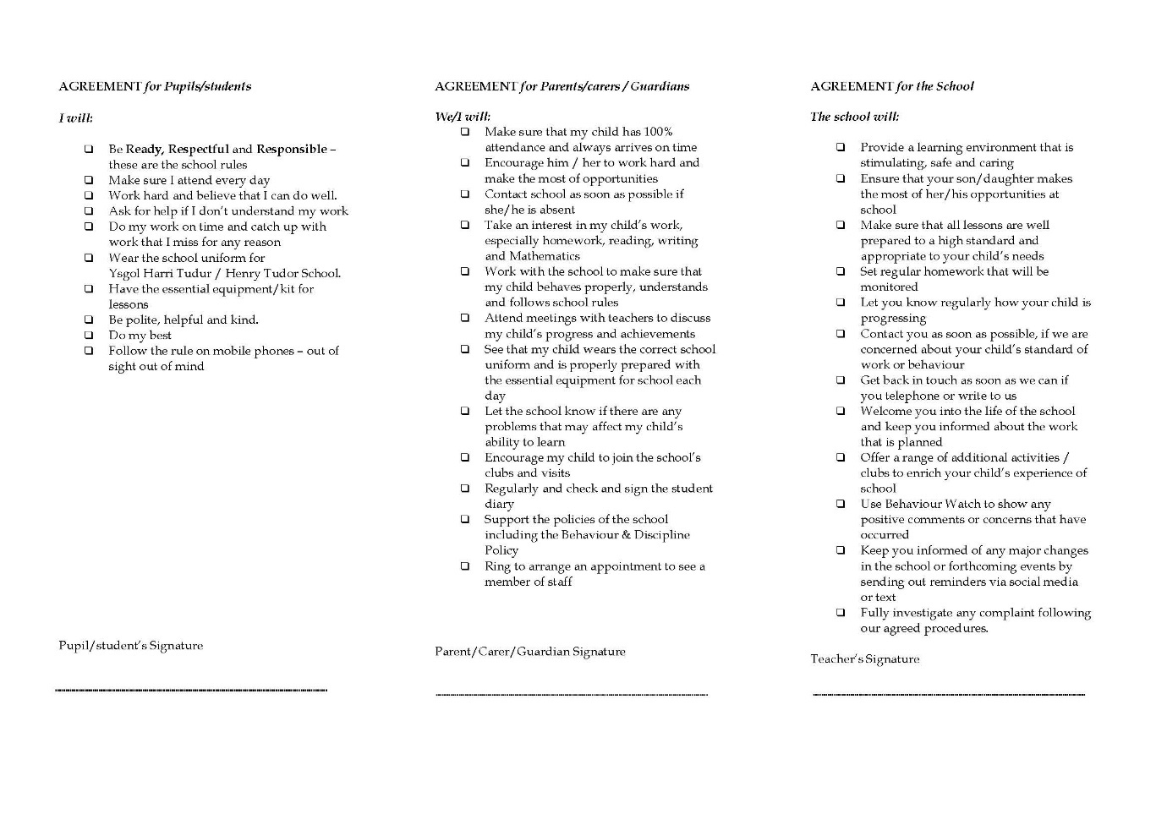

Appendix 2
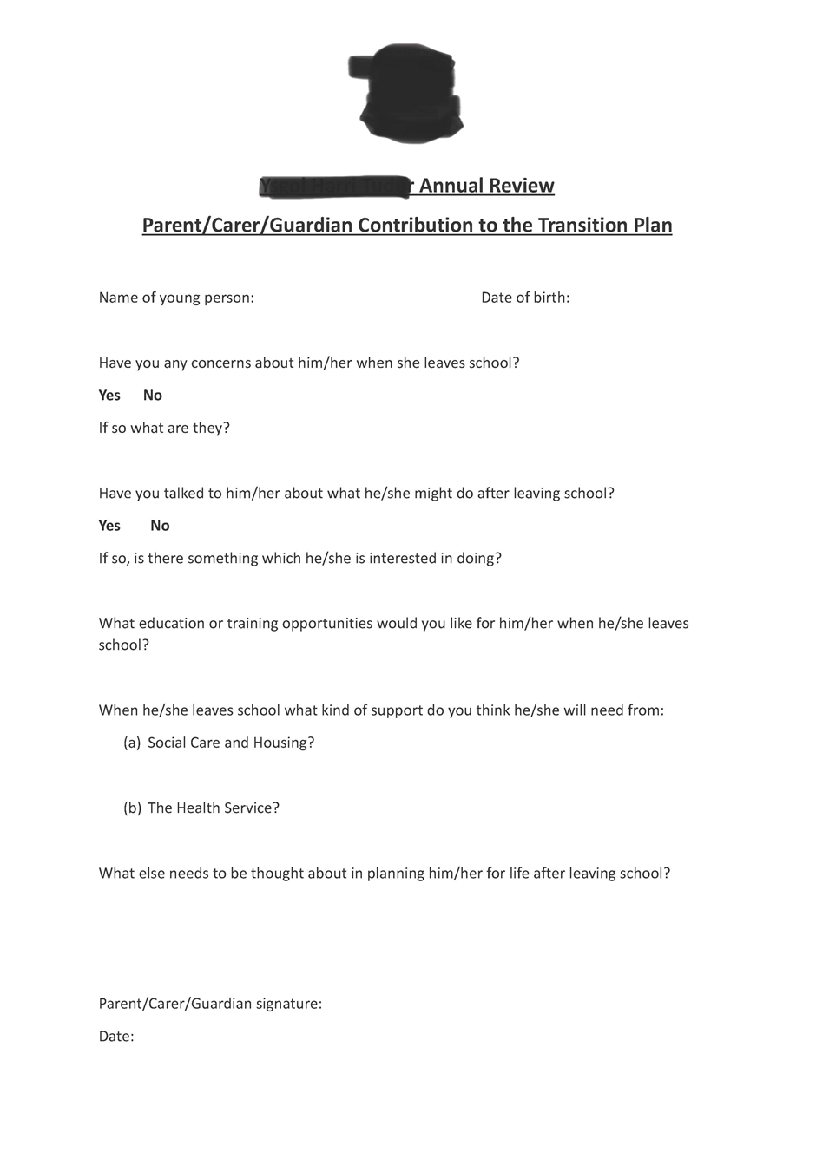

Appendix 3
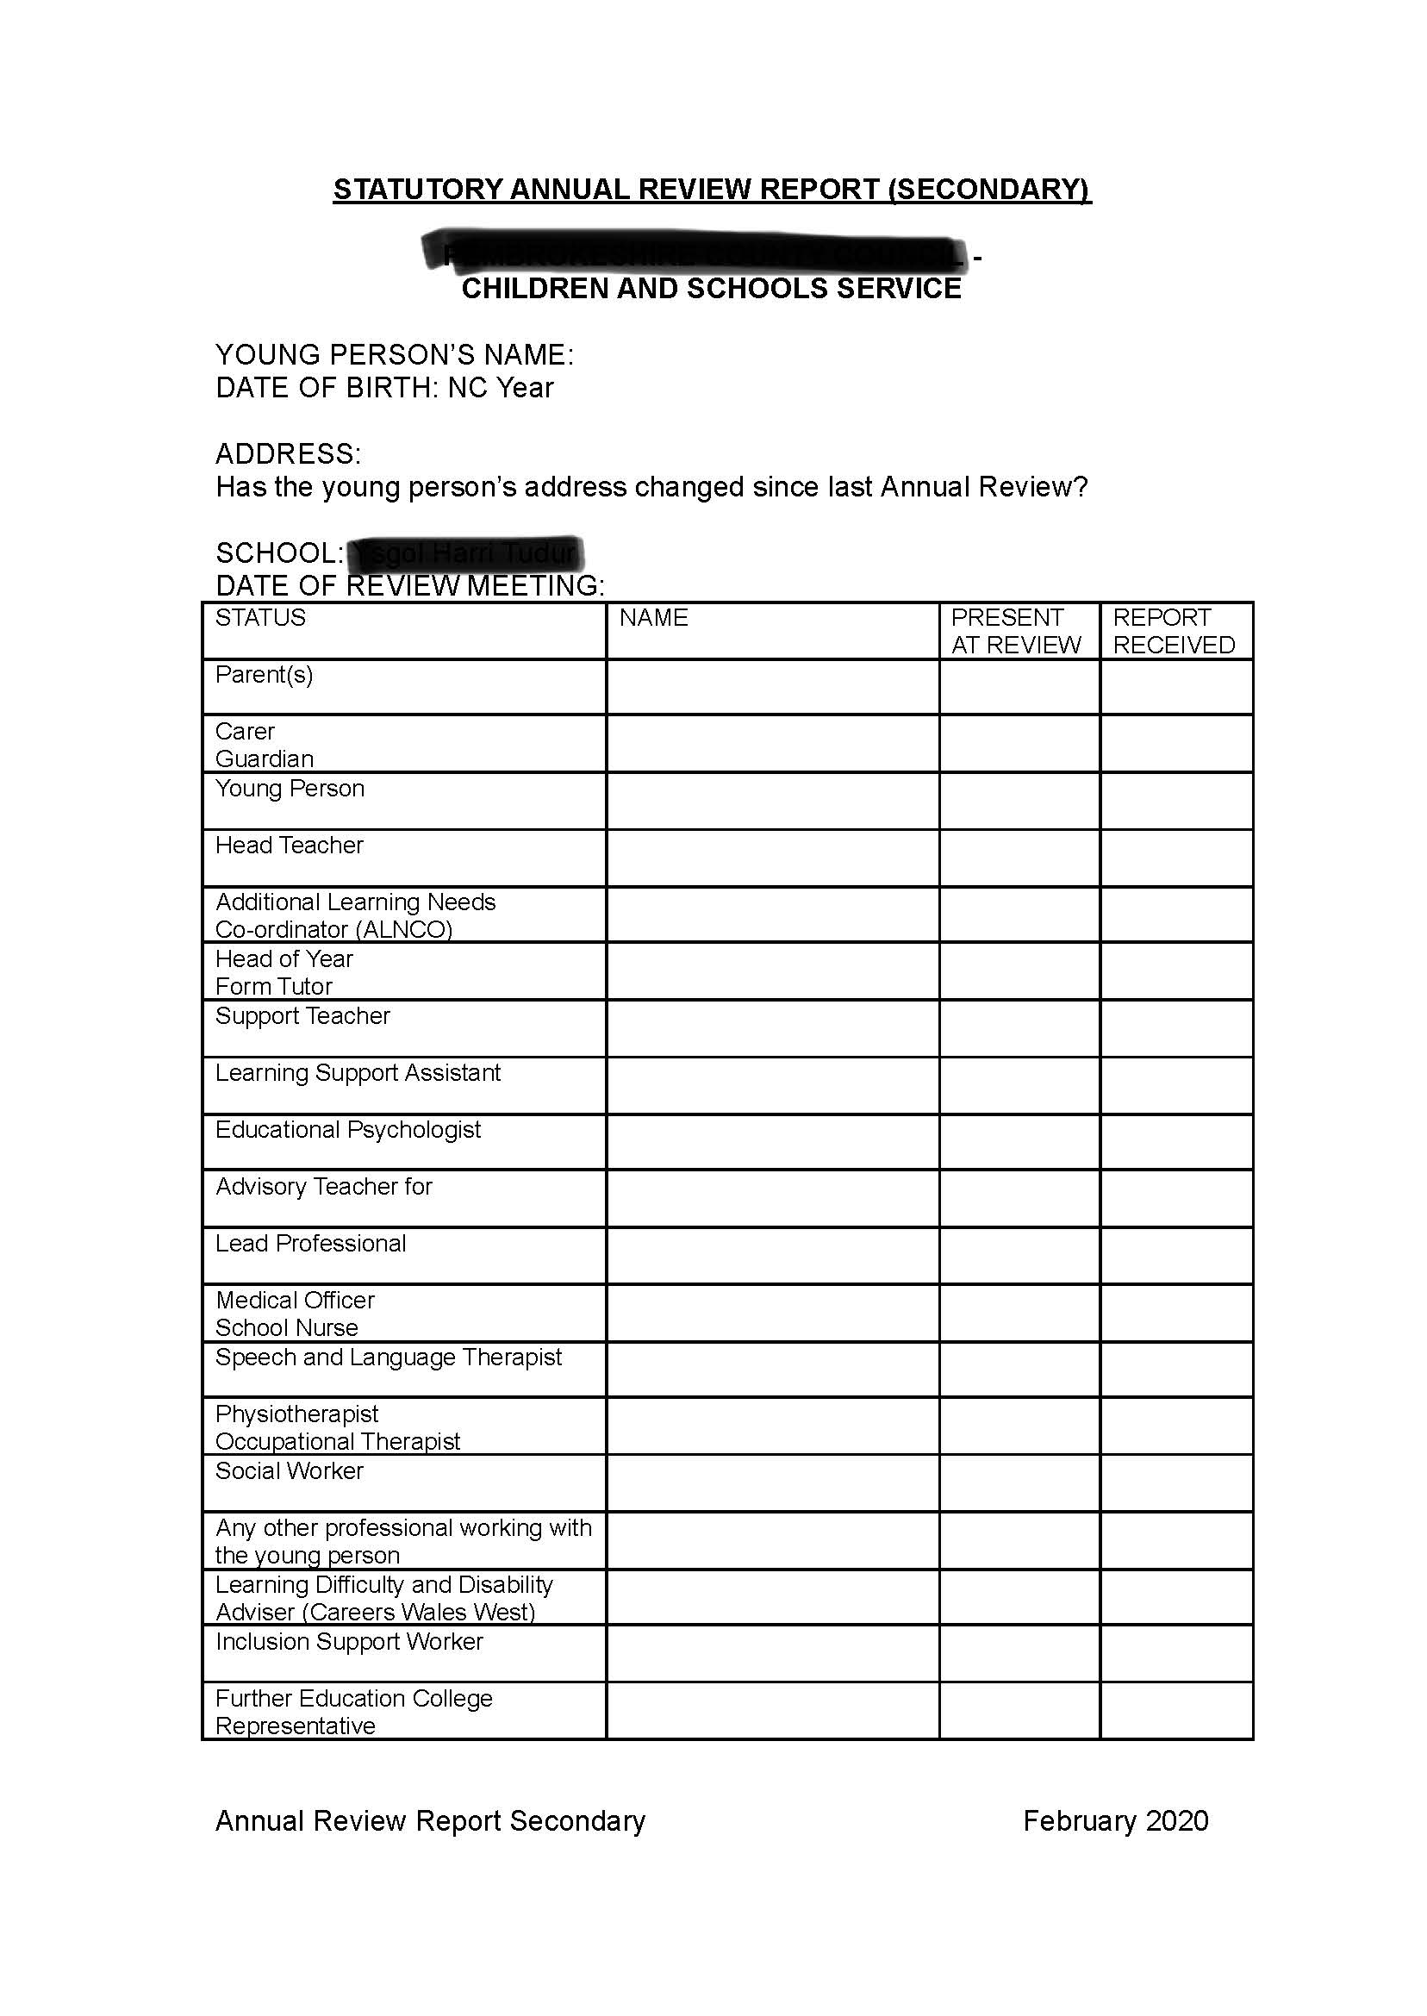

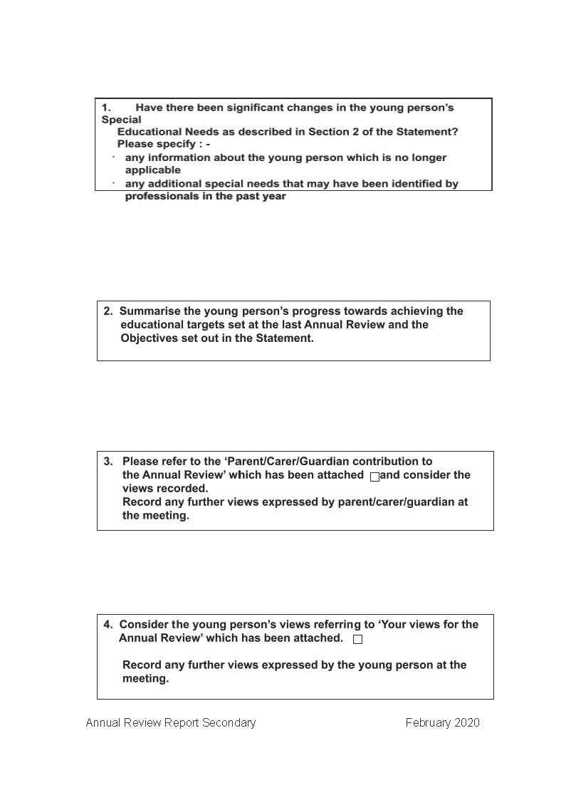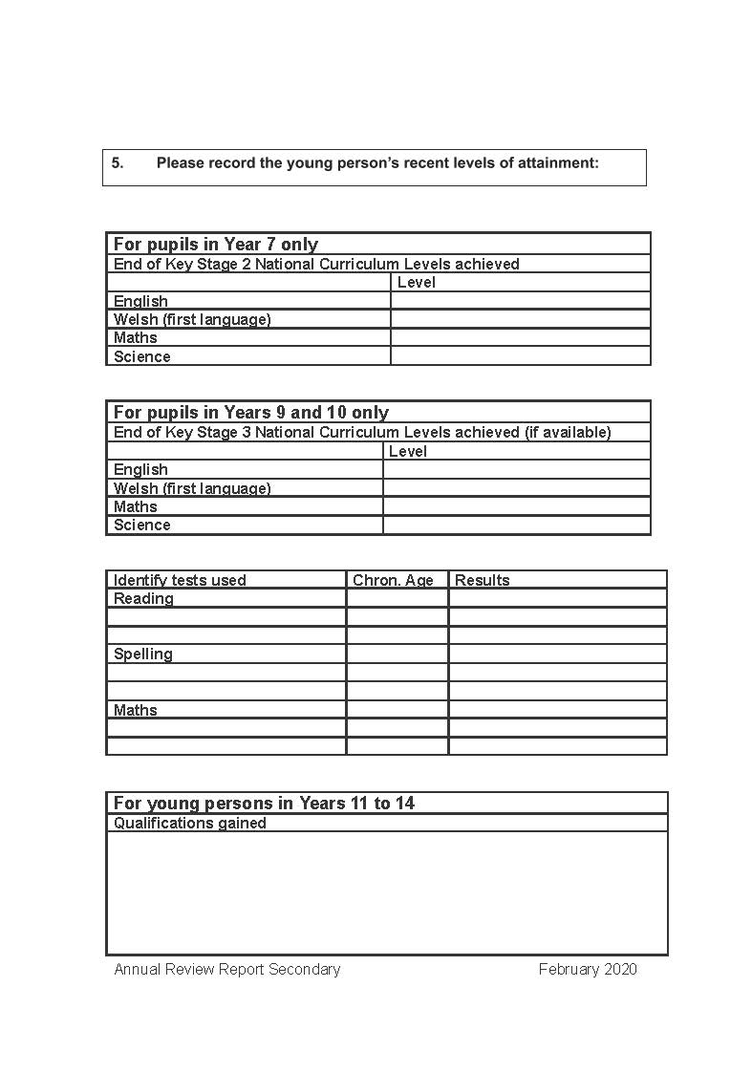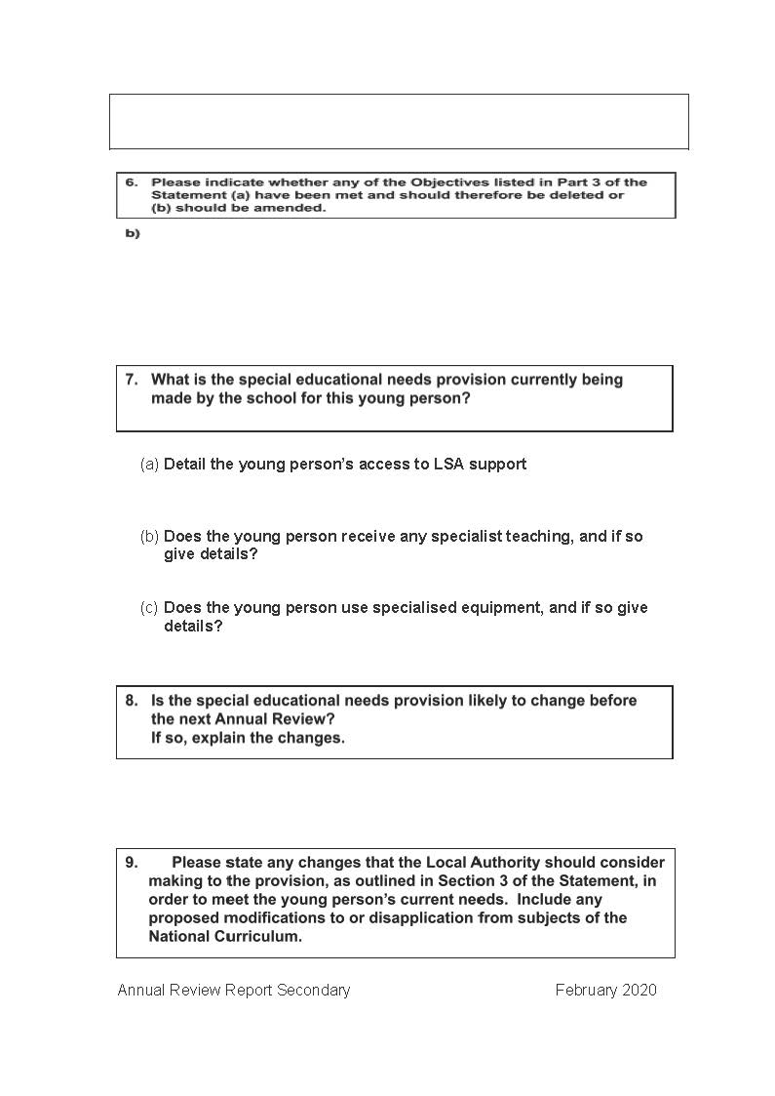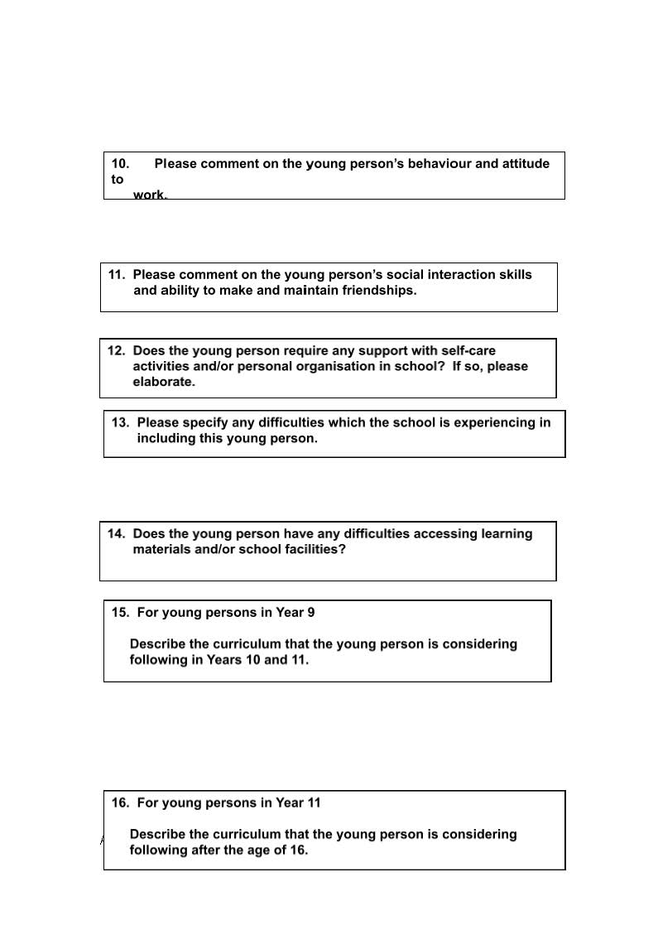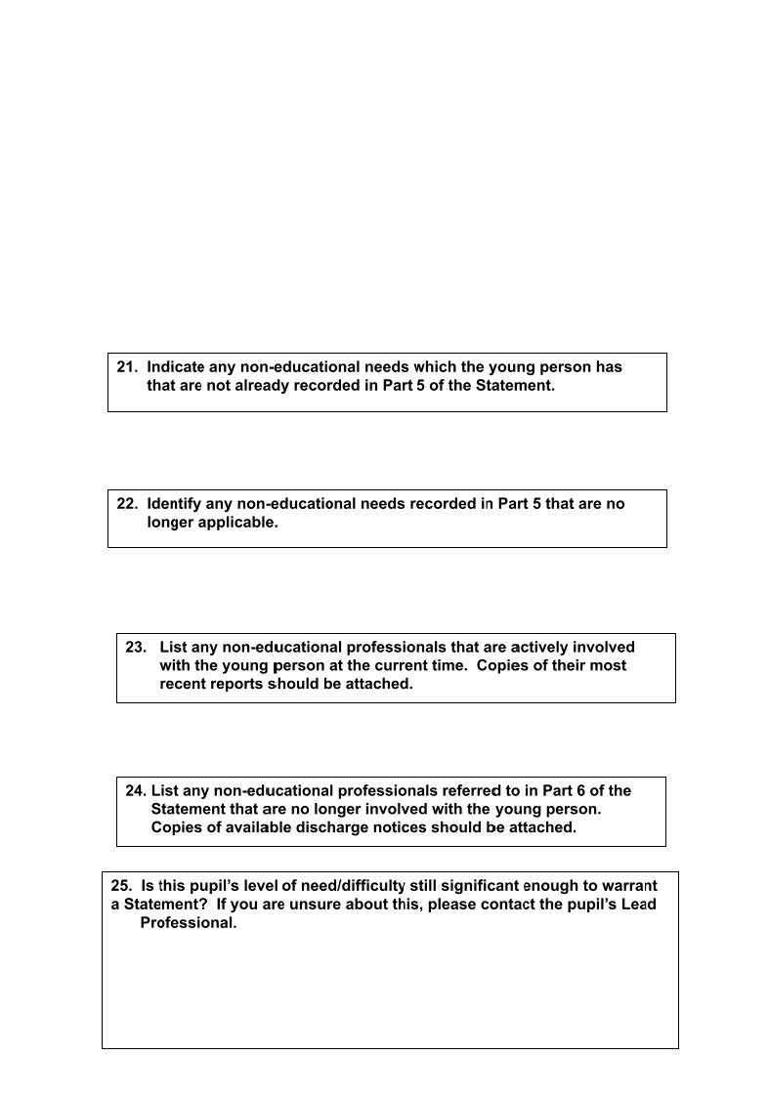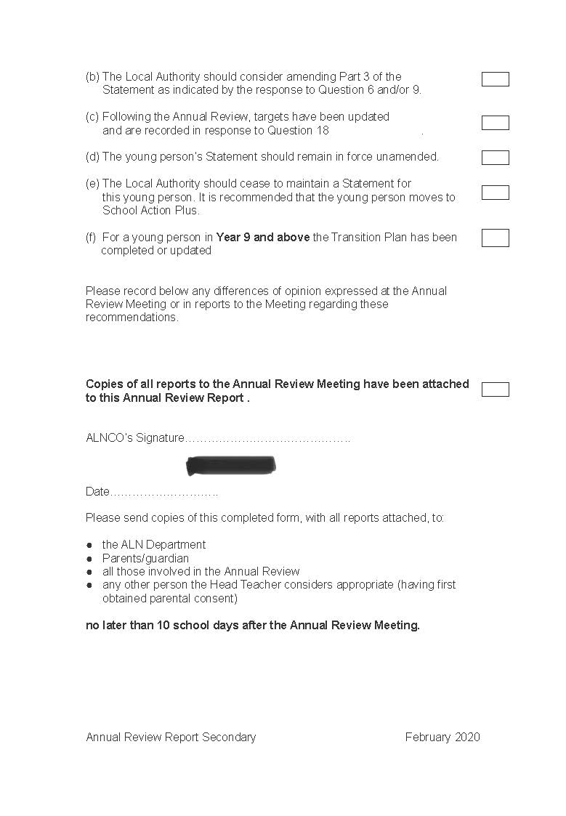

Appendix 4



