What helps me learn language and mathematics?: An analysis of a child’s learning in mathematics and language with recommendations for ensuring progress.
The aim of this assignment is to analyse the learning of a child in relation to mathematics and language and assess the next steps for their progression. The evidence that has been analysed within this essay was collected over a period of four weeks during the writers professional teaching experience (PTE) and various methods of evidence has been considered. The evidence was collected in line with the mosaic approach and this will be discussed during analysis. The Mosaic approach (Clark and Moss, 2011) has been used to gather evidence about a child’s learning, using various methods to form what is know as ‘pieces of the mosaic’, this is stage one of the mosaic. The pieces collected throughout this placement were observational notes, child conferencing interviews, mapping done by the child and a practitioner perspective. Following collection of different evidence, stage two of the mosaic approach will commence where the writer will ‘bring the mosaic together’ and reflect on the findings of the mosaic and how this reflection could be put into practice.
The pupil discussed throughout this assignment is a 6-year-old girl from a year two class, in a large primary school in South Wales. For the purpose of this assignment and to adhere to GDPR 2018 guidelines, the child will be referred to as child A. Data was also collected ethically and the child gave consent to contributing to the data and were fully aware that should they want to opt out they could do so. The class teachers’ consent was given (see appendix 1 and all data collected was available for the teacher to view at any time. Collection of evidence was done in a discreet manner and the writer ensured that the child’s participation was not detrimental to their work. The child was fully informed of what the writer was collecting and was more than happy to assist. Child A completed a getting to know you form for the writer which built a rapport between them over the course of the 4 weeks, see appendix 2. Analysis of work has also been in linked with the national curriculum and the literacy and numeracy framework, the writer has ensured that to analyse the child appropriately the curriculum needs to be referred to appropriately gage if the child is achieving the correct language and mathematic skills.
The writer has implemented the ASK model when analysing how child ‘A’ learns. The ASK model stands for attitudes, skills and knowledge. This model has been used as it allows the writer to effectively evaluate child A’s learning by taking into consideration more than one aspect. Whilst analysing the learner’s skills in relation to language or mathematics, the ask model allows you to look at the different aspects of ‘skills’ rather that looking at it as a whole. For example, rather than just evaluating what skills the child has shown, the writer will use the ask to look at the different type of skills the child has.
Language:
Within this class setting, language was taught at set times and was actively filtered into the class’s daily routine. Alongside focused language lessons, language skills were promoted within the continuous provisions within the class, therefore the children were able to independently enhance their language skills in ways that they liked. During observations of child A, the writer found that the learner favoured certain provisions more than others.
From the outset, it was evident that reading was a strength of child A and during independent and group reading she was always more confident than in other aspects of language. Following observations of child A in the independent provisions, the writer found that the ‘book investigation area’ was used frequently by child A. This area has various books for different abilities within in alongside themed book reviews. Each day the class teacher would put a question next to this area as a focus task that the children had to leave a slip in box which tells the teacher an interesting fact about a book that they have read. Child A did this at every opportunity she was given. Although this was a ‘reading’ centred provision it also enhanced the children’s writing skills, the children had opportunity to fill out reviews on the books they had read, and these reviews varied in difficulty. Some had simple questions, “what was the book called?”, “who was the author?”. Others extended the children’s reading and knowledge of the book by asking questions such as “who is the publisher?” “explain?”. The differentiated reviews meant the children were able to choose which they thought they could achieve. Child A demonstrated that she was confident enough start with the simplified resources then move onto the complex reviews. The writer believes that by having the resources readily available to the child it allowed her to further her knowledge and understanding which was beneficial to the child. Montessori (2013) believed that classrooms should have well prepared learning resources which are available and accessible to all children in the class. Child A was able to further her own writing skills by having the opportunity of choice. It is appropriate to note that this aided her with her learning. The writer was conscious to partake in some of the aspects listed in stage 1 of the Mosaic approach. ‘Child conferencing’ was a method that was used over the course of the 4 weeks and the writer made a conscious effort to conference with child A at least once a week. When asked “what helps you with your reading?”, child A said she liked to pick her own books and she liked the reading corner because she was able to choose different books. The writer notes that some books were more advanced that year two level, but children were able to use these to identify new vocabulary. The reading area had a ‘wacky words’ board. Child A was observed several times writing new words on this board. Therefore, allowing the children free choice of resources and providing more challenging stimulus in turn allows the children to pick up new vocabulary. Cambourne (2002) said that language skills are enhanced when certain conditions are present in the learning environment. He said that is eight learning conditions. One of these conditions is ‘responsibility’ – this is where the educational practitioner has a responsibility to provide children with choices regarding what they want to say and how they want to use their language skills.
One aspect of the ASK model looks at attitudes. Child A showed evidence that she had the ability to self-regulate. She was able to stay focused on tasks and act appropriately in situations even if her peers were not. For example, the writer was teaching a guided reading lesson with a group of 10 children. During the session two children were disruptive and as a result frequently mis-pronounced new words that the group had learnt. Child A was able to relay the words learnt and provide added explanation of the book read. She showed that she was able to multi task as she had also written words on paper independently without prompt as well as listening and providing oracy based answers. Child A demonstrated that she had the ability to be curious and probe for information that she did not already have. This was evident following a ‘map making’ exercise that the child completed for the writer, see appendix 3. During this exercise child A drew a map of her favourite parts of the classroom, the areas she wasn’t frequently using in the classroom she was inquisitive to what she had to do to participate in those areas. For example, a new phonics area had recently put into a corner of the classroom with interactive ‘table talker’ with pre recorded sounds. She had the ability to enquire what the sounds were and demonstrated several back to the writer. During discussions with the child the writer had previously noted that child A had favoured modelling as a way of learning some aspects of language. She said that she “learnt some words better when the teacher shows us how to say it and we copy”, See appendix 4 for observation notes. In addition to this child A also seemed to have her interest taken with any type of technology, frequently she used the ipads to use ‘reading eggs’ which was an interactive app to improve reading and allowed the children to show their understanding of what they have read. The writer used found that child A and other children in the class responded well to tasks where they had to show their understanding of something. See appendix 5. Here is a sample of work where child A has completed questions in regards to a comprehension task. The aim of this was for the children to demonstrate their understanding, which in turn will mean they achieved the language skill that the task hoped for them to achieve. This seemed to be an effective strategy as child A was able effectively demonstrate her knowledge and understanding of the reading skill by giving examples of facts and ideas from the comprehension she had read. She seemed to establish satisfaction that she had an understanding of her work. This is a positive element that child A displays as it shows that she has engaged with the literature. Donaldson (2015:16) said that the new curriculum should be “engaging: encouraging enjoyment from learning and satisfaction in mastering challenging subject matter”.
The class participated in a 20-word spelling test every Friday. Child A was observed getting on average 19/20 each week. Following discussion with her, the writer found that she enjoyed spelling tests. Child A thought that the tests helped her learn the words as she knew she would be marked on her knowledge of them. She had a strong desire to succeed and this was evident by the choices of resources she made.

Maths:
Child A favoured more practical resources to aid her mathematical learning. Over the 4 weeks she used majority of the maths focused areas within the classroom and the resources within them to aid her. The writer taught child A money frequently and observed that she found the use of real money a useful tool for finding change. Following a conference with child A, she highlighted that she liked to use the money as she felt that she was ‘being real’, she seemed to be able to relate her learning to real life scenarios such as actually using money in a shop.
Within the classroom, numicon was prominently used as a useful resource. However, following numerous observations of child A it became apparent that numicon was not favoured by her. When questioned by the writer on why she did not use numicon, child A said that she preferred to use single counting blocks rather than the numicon. She found that the single blocks made subtraction easier. Child A was also observed getting frustrated when working on a subtraction challenge. In other aspects of maths, she showed resilience to persevere with the tasks, however she was not motivated to overcome the barriers she faced with subtraction.
Following a 3D shape lesson, one of the maths provisions within the class was enhanced to fit the ‘shape’ theme. This included classroom objects that were 3D shapes as well and different resources that weren’t 3D shapes. This area seemed to render child A’s curiosity, she was observed questioning her peers on the similarities and differences of the shapes. When challenged by a peer on why an object was in fact a 3D shape, child A gave them the opportunity to give their argument and provide facts to back up their point. This demonstrated that she could be openminded when learning. She wanted to see the two points to ensure she fully understood the concept.
Child A seemed to shy away from the resources and areas that also enhanced her physical skills, suggesting that this was not a confident aspect for her. For example, the writer had set up an outdoor maths challenge which entailed using coordination skills to throw objects in the numbered baskets. This resource would have enhanced fine motor skills alongside maths skills. It was noted that only once over the 4 weeks did child A visit this provision. It would suggest that child A favoured areas of learning which focused on one aspect of mathematics as she was reluctant to participate in cross- curricular areas which promoted more than one area of learning. The writer also observed that in this type of activity she shied away from her peers, this highlights that at time her social skills hinder her ability to get involved with some elements of learning. However, despite this, child A also favoured to work in groups amongst her peers rather than independently with mathematics. Whereas she favoured independence when in the language provisions. During a map making task of the maths areas in the class, she highlighted that the areas she likes to work in groups and this that she likes to work on her own. When probed on this she voiced her preference for more concentration for language tasks as she likes to write, for maths she likes to work with the resources with her friends.
Child A seemed to struggle with the concept of money. Although she liked giving change she was slow in grasping the units of money. Initially she was unable to make the connection between 100 pence being the same as £1. Eventually she grasped the units but during observations towards the end of the 4 weeks she was still observed to be making a number of errors, frequently in relation to subtraction of money again.
When asked “what do you like to help you learn maths? child A was very enthusiastic regarding using interactive games. She frequently used ‘Times Table Rockstar’s’ on the interactive iPad and demonstrated resilience to succeed as she was observed repeating the timed tests numerous times to ensure success. The writer also used the interactive classroom whiteboard to demonstrate the concepts of maths during lessons. Child a was enthusiastic about this and regularly volunteered to demonstrate answers in front of her peers.
During a tally chart activity, child A used the iPad to record the data, she seemed to have difficult with this as she was unable to physically write the tally’s down as previously done. The use of technology seemed to confuse the concept and layout that she was already familiar with. Although this is unfamiliar to child A, using technology means that inputting data is a quicker more efficient mode. The writer feels that despite child A having slight difficulty, it was not a hinderance to her learning as she had to use her problem-solving skills to rectify this. Taylor (2013:230) supports this and said “ICT can be used to represent data quickly and efficiently, allowing time for interpretation and problem solving”.
Future Progress:
Moving on from the analyse of the child’s learning, the writer will now look at what could be done to ensure future progress for the learning. On reflection, the writer believed it is fair to implement a number of changes to the teaching strategies to move the child’s learning on as well as inform future teaching of language and mathematics.
Child A naturally held the ability to be curious which in aspects of the lessons taught was beneficial, however the writer thinks that she could have scaffolded the learning at times to implement questioning techniques. For example, it was evident that the child struggled with subtraction and rather that address the issue in future planning, it would be useful to address the misconception when it is taking place. Questioning techniques could have been used to probe the child to gather an understanding of why subtraction was an issue. It would be useful to make association between this and what the child already knows. Child A struggled with money and subtraction, therefore it would have been effective to take the learning back to basics and refer to the knowledge she had of subtraction. Following on from the activation of prior knowledge the writer would use a ‘follow-in’ which will encourage aspects of conservation that the child is interested. This concept is favoured by Hamer (2012:17) and he refers to this as a reminiscing style.
Although child A actively used the more advanced resources within the literacy provisions which she benefitted from, the writer would also ensure that she experienced the use of other language provisions. The role play area was not in a suitable area of the classroom, it would be beneficial to child A to use this area as it will promote oracy skills which she would benefit from as her oracy skills were not as advanced as her reading and writing skills. The role play areas position was an environmental barrier to the learning and in future planning, the writer felt that it is essential to move the areas around to ensure equal access and opportunities for the learners. Gordan (2003) believes that ‘roadblocks’ such as these are barriers to effective communication.
Role play will also be beneficial for child A’s social skills which will in turn help with improvement of oracy skills. Vygotsky (1934) supported the need for social interactions and placed emphasis on this aiding development of knowledge, skills and beliefs. In addition to this, further support is given to role play by Bruner (1986) who recommended that play was crucial for children’s learning as it allowed them to experience hands on experiences.
Grigg (2010) supports the use of ICT and recorded devices such as ‘table talkers’ as they promote modelling of speaking and listening skills. However, they also need to be presented in a range of contexts. The writer feels that it would be beneficial to place these devices in different areas, to promote the correct terminology for areas of maths and language and promote independence for the children to go through the correct answers of tasks without having to speak to the teacher, these devices model the correct information immediately. It would also be beneficial for modes of technology to be filtered into the routine of maths and language. Higgins (2008) gives support to the use of ICT and believes that’s it can be useful for children to learn mathematic ideas, only if supported by appropriate discussion. With the rise of digital competence in this modern day, learners would benefit from experiencing different modes of resources. For example, previously Child A had been observed using an iPad for the use of data, she did not find this a useful aid as she lacked confidence as it was unfamiliar to her. The writer feels that this is beneficial for the children becoming ‘confident individuals’, which is what Donaldson (2015) hopes to achieve with the new curriculum following his ‘successful futures’ report.
Child A shied away from practical activities that were language focused and the writer feels that in order for the learner to develop a more open mindset to varying tasks, practical activities would be beneficial. The use of practical activities is favoured by Piaget (1962) who supported the notion of having practical activities which allowed learners to experience the content themselves.
The writer will use modelling as a future strategy for particularly mathematics. It was noted that an interactive modelling tool was effective for child A in language and the writer feels that from observations it would also be beneficial for development of understanding of money. Child A needs a gentle scaffold when piecing the learning together. The learner will benefit from demonstration by a more experienced individual (Vygotsky, 1978). The writer feels that this will be valuable to child A’s progression for her to experience the correct methods for certain things. Particularly relating to ‘money’, she is currently achieving the year two skill of “find totals and give change from multiples of 10p”, and with the use of modelling to show her the correct units of money, she will hopefully move to the next skill of “use different combinations of money to pay for items up to £2 and calculate the change”, which will stretch the learner from a foundation phase skill to a key stage two. (Literacy and Numeracy Framework, 2014).
The writer feels that the use of assessment for learning needs to be considered during future planning of maths and language. Despite the positives of independent learning for children, the writer feels it necessary to note that sometimes there is a need to address common misconceptions made by a child immediately, rather than in future lessons when the child has already become accustomed to the misconception. Hattie (2008) supports this and believed that effective feedback is to ensure that it is given immediately and tailored to the learner specifically. Child A frequently made the same error in relation to subtraction and on reflection the writer believes that this should have been addressed sooner rather than later as it had a detrimental effect of the child’s understanding of subtraction further down the line when the writer addressed it in a further lesson. It was difficult for Child A to understand the misconception she had made.
Overall, the writer believes that the teaching strategies she had used over the course of the 4 weeks were effective for developing child A’s maths and language skills, the strategies that the writer has spoken about above will be implemented in future to ensure Child A will progress.
Appendices:
Appendix 1

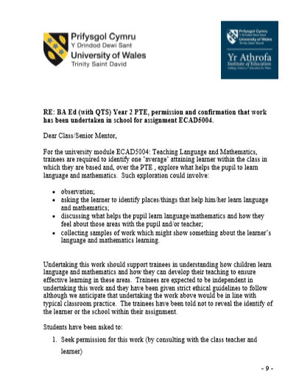
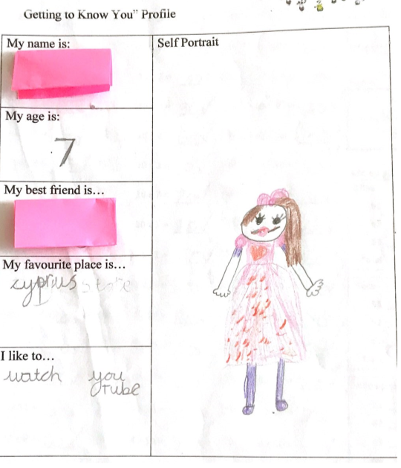
Appendix 2

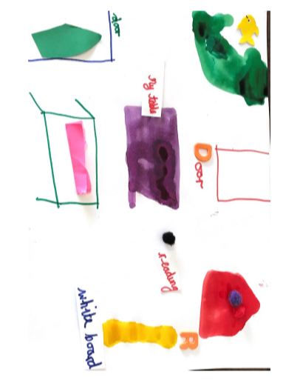
Appendix 3:

Appendix 4:
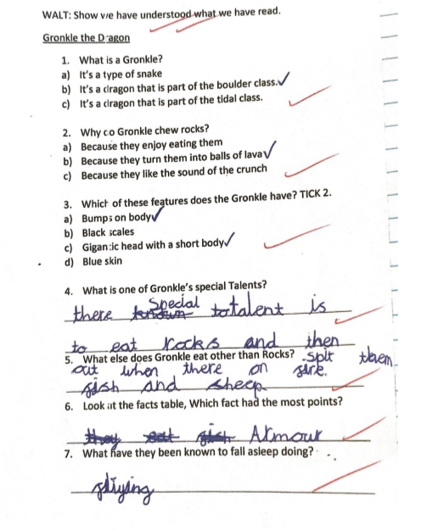
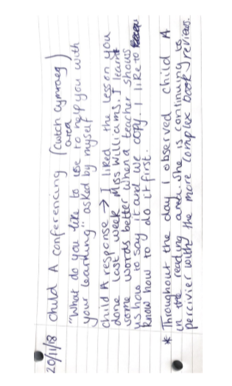

Appendix 5:

Reference List:
Donaldson, G. (2015) Successful Futures. Crown copyright. Available at: http://gov.wales/docs/dcells/publications/150317-successful-futures-en.pdf
Clark, A. and Moss, P. (2011) Listening to Young Children: The Mosaic Approach (2nd ed.) National Children’s Bureau
Nottingham, J. (2013) Encouraging Learning Oxon:
Taylor, H. and Harris, A.J. eds., 2013. Learning and Teaching Mathematics 0-8. SAGE.
Woolley, G., 2014. Developing literacy in the primary classroom. Sage.
Ricento, T. ed., 2009. An introduction to language policy: Theory and method. John Wiley & Sons.
Cambourne, B., 2002. Conditions for Literacy Learning: The Conditions of Learning: Is Learning Natural?. The Reading Teacher.
Gifford, S. (2005) Teaching Mathematics 3–5: Developing Learning in the Foundation Stage. Maidenhead: Open University Press.
Bruner, J. (1986) Actual Minds, Possible Worlds. Cambridge, MA and London: Harvard University Press.
Bruner, J. (1990) Acts of Meaning. Cambridge, MA: Harvard University Press.
Grigg, R. (2010) Becoming an Outstanding Primary School Teacher, Harlow: Pearson, 2010.
Hattie, J. (2008) Visible Learning, Abingdon: Routledge
DCELLS (2014) Literacy and Numeracy Framework. Cardiff. Welsh Government.
Vygotsky, L. (1978) Mind in Society, Cambridge, MA: Harvard University Press.
Piaget, J. (1976) The child and Reality, New York: Penguin Books.
Montessori, M., 2013. The montessori method. Transaction publishers.
Hamer, C. (2012) NCT Research Overview: Parent-Child Communication Is Important from Birth, London: NCT.
Gordon, T. (2003) Teacher Effectiveness Training: The Program Proven to Help Teachers Bring Out the Best in Students of All Ages, New York: Crown Publishing Group.
DCELLS (2015) Foundation Phase Framework. Cardiff. Welsh Government.

