Chantelle Simmonds
1914402
BMPH_5003 BIRM
Lecturer: Giridhar Katti
INTRODUCTION TO PHYSIOLOGY
BSc – Health and Social Care

Female Reproductive System
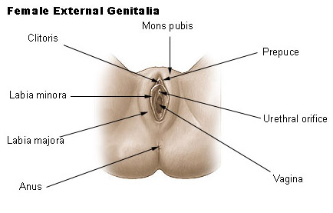
EXTERNAL PARTS OF THE REPRODUCTIVE SYSTEM
- Vagina
The vagina is a reproductive organ and has multiple uses for the female, reproduction -pregnancy, menstruation, sexual pleasure, and immune defence. (Gold and Shrimanker, 2021)

- Cervix
The cervix is a cylinder-shaped fibromuscular tissue found at the lowest region of the uterus that connects the vagina and uterus. (Pathak, MD, 2020).
- Ovaries
Females are born with two ovaries, one on each side of the fallopian tube. Each female is born with at least 1 – 2 million Oocytes (eggs) that will remain until she reaches puberty and the egg release begins. (Healthline, 2020)

- Fallopian Tube
Consists of four parts from the medial to the lateral. The fallopian tube helps the egg travel towards the uterus and assists the sperm to travel to the egg, also providing a stable and suitable environment for fertilisation. (Anatomy.co.uk, 2019)

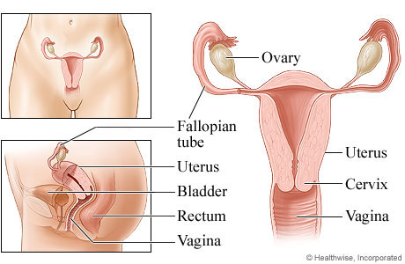
(Mcormand, 2021)
- Uterus
The womb is a structure found in a woman's pelvic. This is where the egg will be fertilised, the embryo will be conceived, and the baby will develop. (Rogers, 2019)
INTERNAL PARTS OF THE REPRODUCTIVE SYSTEM
The female reproductive system internally is made up of several parts, vagina and vulva, cervix, endometrium, ovaries, fimbriae, Uterus, and accessory glands. External female genitalia and the breasts are also considered as part of the female reproductive system. (Cancer.gov, 2019)

(Nguyen and Duong, 2020)
- Vagina
The vagina is form sexual intercourse and to give birth
- Labia Majora
Fleshy outer lips that are on each side of the vaginal opening usually has pubic hair
- Labia Minora
Large lips that cover and protect the vagina
- Urethra
Sits on top of the vaginal opening and is connected to the bladder, this is where a female will urinate from.

- Clitoris
Has nerves thousands of sensory nerves that respond in sexual arousal which gives lubrication o the vagina
- Mon Pubis
Tissue of fat that that is covered by pubic hair that is a source of cushioning during sexual intercourse.
Though many organs in the body plays significant role in maintaining homeostasis, the endocrine and neurological systems are both critical in maintaining and controlling it. The reproductive system contributes little to organism homeostasis by regulating vaginal ph. Sex hormones have an effect on the hormones in the body. If a females hormones are out of balance, it can lead to a variety of disorders and diseases. Such as menopause which happens as a women becomes older and her ovaries produces less reproductive hormones oestrogen needed to continue to release eggs.
Homeostasis
The reproductive system is a vital organ that changes during a woman's life. It is composed of internal and external organs that collaborate to produce gametes known as Oocytes (eggs), release sex hormones (progesterone and oestrogen), and carry and give birth. Internal organs of the female reproductive system include the vagina, fallopian tube, uterus, and ovaries; external organs include the vulva, clitoris, labia. (Wakim and Grewal, 2018). Myometrium, endometrium. Hypothalamus and pituitary gland located in the brain.
Because of the hormonal changes that occur during puberty, menstruation, pregnancy, and menopause, the reproductive system serves a variety of functions.
The vagina is made up of a muscular tube running from the vulva to the cervix of the uterus, and ultimately to the uterine cavity is essential to the reproductive system, the vagina will accommodate the penis, and the male will ejaculate. (Gold and Shrimanker, 2021) for conception or menstruation is to take place then the help of the fallopian tube four components are needed the isthmus, ampulla, infundibulum, and fimbriae. Tiny epithelial cells, which line cavities throughout the body, pulsate inside the fallopian tubes with small, slender cilia (which are microscopic, hair-like projections) to guide the egg, from the ovary to the uterus. Because there is not a direct link between the ovaries and the fallopian tubes (also known as uterine tubes or oviducts), the egg is transferred to the uterus in peritoneal fluid produced by the fimbriae on the tube's opening.
The ovum cannot move on its own, its mobility is dictated by the sweeping action of the fimbriae's cilia. An egg usually takes 3 to 5 days to leave the ovary and settle in the uterus. If conception took place this would happen in the ampulla before making its way to the uterus for the continual development of foetus.

The reproductive system has both internal and external functions that allow an embryo to be fertilised and promote the development of the foetus.

The woman’s reproductive system is sceptical to many disorders and diseases such as infertility, prolapsed uterus, polycystic ovaries, (PCOS), uterine fibroids, Sexually transmitted diseases, ovarian cancer, endometriosis plus many more. (New Health Advisor, 2015). PCOS is a disease that attacks the ovaries get multiple cysts that are filled with fluid, female tend to get irregular periods, weight gain surge of male reproductive hormones androgens, women can become more masculine and produce excessive hair growth. (Dr. John KC, 2014). Fibroids is a condition that is unknown to why women can get them but (NHS Choices, 2019) states that they have been linked to the hormone of oestrogen between the women’s reproductive years when oestrogen levels are at their highest and develop. When the female starts menopause the fibroids tend to shrink, this is because her oestrogen levels are low.

Disorders/Diseases
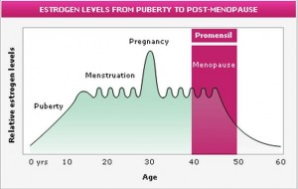(HealthFoxx, 2014)
(Dr. John KC,2014)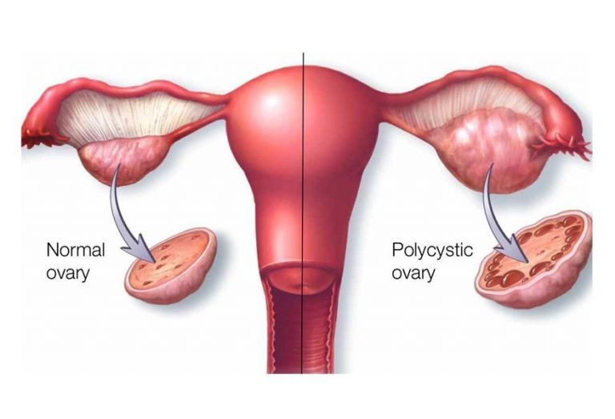
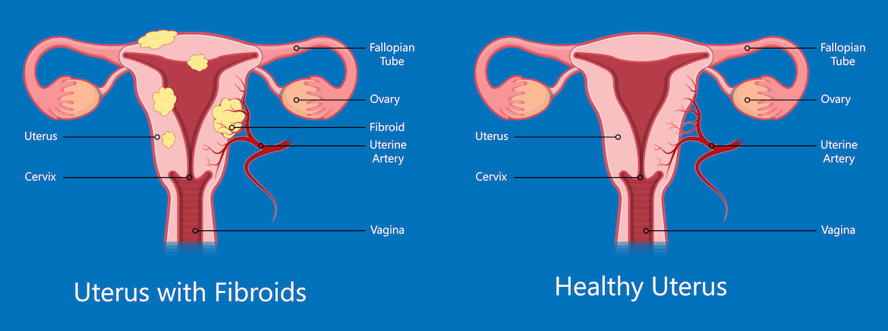

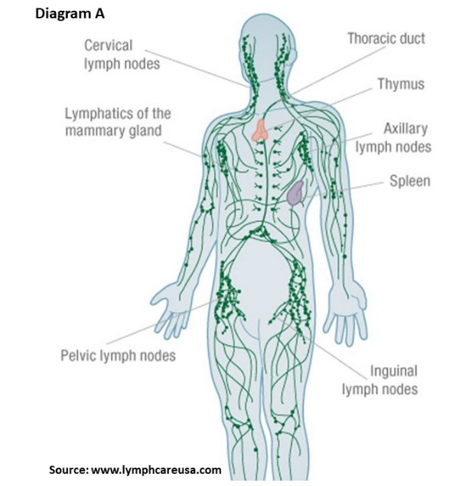
The lymphatic outflow from the ovaries is comparable to that of the testicles. It connects to the ovarian arteries and drains to the lateral and preaortic lymph nodes. Within the uterine material, the lymphatic drainage from the fallopian tubes connects with the ovarian lymphatics and the uterine lymphatics. Lymph from the uterine body and fundus travels largely laterally inside the broad ligament, with the ovarian veins draining to the preaortic and lateral aortic lymph nodes, while some lymph also drains to the external iliac and superficial inguinal nodes.
The vaginal lymphatics connect to those of the vulva, rectum, and uterine cervix but do not anastomose with those of the bladder. A few lymphatics from the inferior vaginal wall connect with vulvar lymphatics and flow into the superficial inguinal lymph nodes. (The Lecturio Online Medical Library, 2016)
Lymphatic

(Andelei, 2019)
To keep a healthy reproductive system a female should:
- Eat Healthy, keep hydrated
- Engage in safe sex
- Exercise regularly and maintain a healthy weight
- Maintain good hygiene
- Safe sex
- regular check ups
Healthy living and wellbeing
Disadvantages and Advantages
(NHS, 2018)
Disadvantages
- Sexual transmitted diseases
- Infertility or low fertility
- Sexual dysfunction
- Cervical cancer / endometriosis / fibroids
- Hormone imbalance
Advantages
- Creation of life
- Birth
- Sexual pleasure
- Having sex helps boost immune system and releases good hormones (endorphins)

(https://www.facebook.com/WebMD, 2019)

