
Assignment 2
Network Operating Systems & Services


Joshua rigbey
RIG17833857

Contents
Routing Protocols 1
Setting up the Swansea Network 2
Setting up Routing and Remote Access Service 2
Configuration of VPN 2
Setting up Consistent Connection 2
Setting up the Forest 3
Creation of Records 3
Setting up the London Network 5
Setting up Routing and Remote Access Service 5
Configuration of VPN 5
Configuration of Child Domain 6
Installation of DHCP Server 6
Configurating the IP Address Range of the DHCP Server 7
Ping Testing from Network to Network 8
Swansea to London 8
London to Swansea 9
References 9

Routing Protocols
Routing protocols is the method of which routers set up tables for the purpose of receiving assistance like regular updates and the preservation of data through the exchange of converging information.
These routing protocols permit routers to take the quickest and most efficient route and method of delivering traffic on the network to other routers or devices.
There are two types of routing, these types are the following:
- Static routing – This type of routing is where the network administrator uses static tables in order to manually configure and choose network routes.
- Dynamic routing – This type of routing is where the routers are configuring and choose the best possible route [1].

Setting up the Swansea Network

Setting up Routing and Remote Access Service
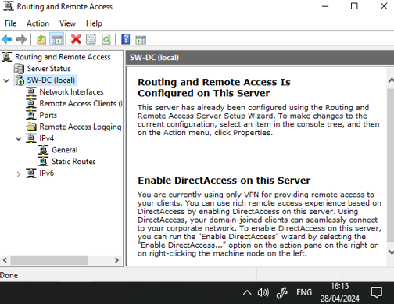
As you can see in the screenshot below, this is the set up routing and remote access on the Swansea server.

Configuration of VPN
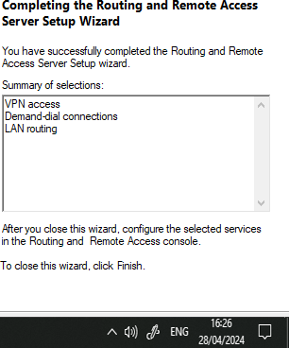
As you can see in the screenshot to the right, this is the configuration of the VPN being set up on the Swansea server.

Setting up Consistent Connection
As you can see in the screenshot below, a connection has been created to the VPN in London.
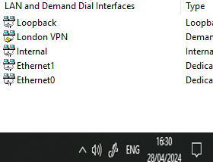

Setting up the Forest
The screenshot below indicates the creation and configuration of the forest on the Swansea server.
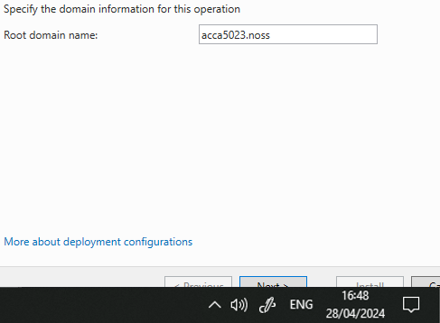

Creation of Records
The screenshot below indicates that the necessary records have been set up within the forest
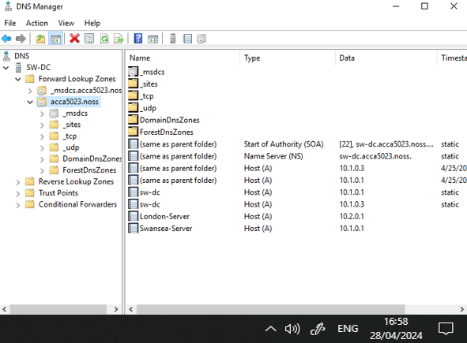

Setting up the London Network

Setting up Routing and Remote Access Service
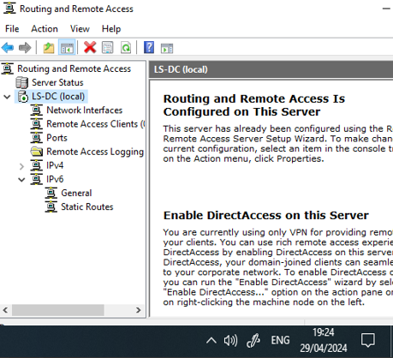
As you can see in the screenshot above, this is the set up routing and remote access on the London server.

Configuration of VPN
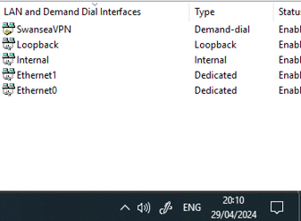
As you can see in the screenshot above, this is the configuration of the VPN being set up on the London server.

Configuration of Child Domain
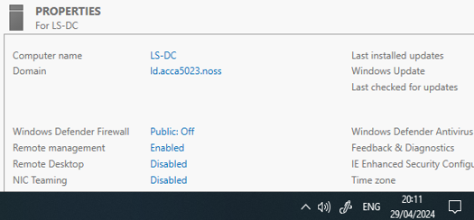
As you can see in the screenshot above, this is the set up and configuration of the child domain.

Installation of DHCP Server
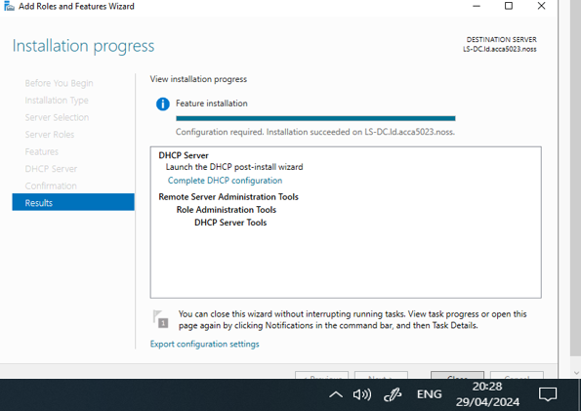
As you can see in the screenshot above, this is the installation for the DHCP server.

Configurating the IP Address Range of the DHCP Server
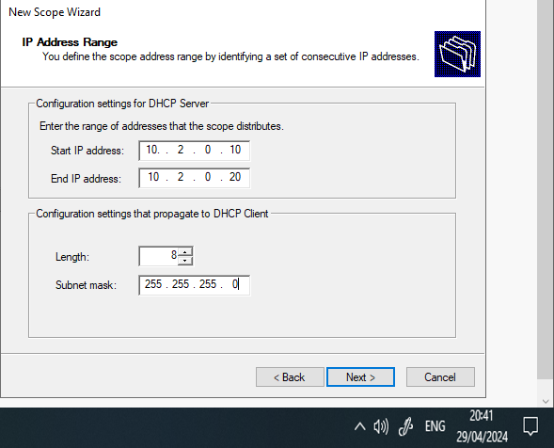
As you can see in the screenshot above, this is the configuration of the IP address settings within the DCHP server.

Ping Testing from Network to Network

Swansea to London
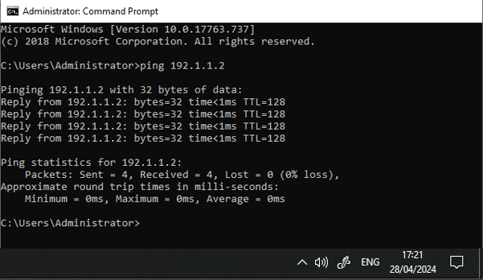

The screenshot above showcases the Swansea server establishing communication with the London server by pinging the address.

London to Swansea
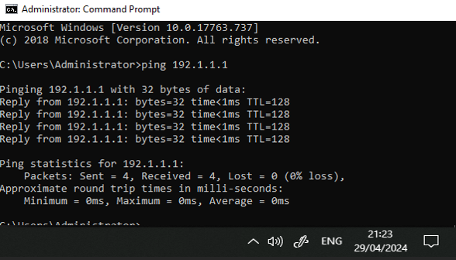

The screenshot above showcases the London server establishing communication with the Swansea server by pinging the address.

References
[1] AWS, “What is Routing - Beginner’s Guide to Network Routing - AWS,” Amazon Web Services, Inc., 2023. https://aws.amazon.com/what-is/routing/

‌

