Effective communication within workplace
Effective Team-working and Communication
Beata Beck (1807727)
3/29/2019

Executive Summary

This report presents a competitive analysis of the advantages of effective communication within the workplace. It has been prepared by a business consultant to help Michelle the toy store owner to understand how important it is to communicate effectively. It also gives Michelle advice on how she should change her current ways to become an outstanding business owner.

The report breaks down the knowledge from verbal and non verbal communication channels, so Michelle can see the difference between them and how important it is to pick the right channel. Going further, the report distinguishes Shannon, Weaver and Berlo’s two ways of communication. The business consultant compared both these models so Michele can see which one would be the most suitable for her business. The end of the report presents recommendations for Michelle along with an action plan for her business.

Contents list

- Executive summary | 2
- Introduction | 3
- Findings
- Effective communication channels  - Two ways of communication  - Effective communication methods  - Teamwork theories | 5  6  7 - 9  9 - 10
- Conclusion | 10
- Recommendation | 10
- Action Plan | 10
- References | 11

2.0 Introduction

“Communication is the process of sharing ideas, information, and messages with others in a particular time and place. Communication includes writing and talking, as well as nonverbal communication (such as facial expressions, body language, or gestures), visual communication (the use of images or pictures, such as painting, photography, video or film) and electronic communication (telephone calls, electronic mail, cable television, or satellite broadcasts). Communication is a vital part of personal life and is also important in business, education, and any other situations where people encounter each other” (Encarta, 1998)

Michelle Sullivan is the owner of a medium sized toy store in Swansea. A year ago the company was employing only five people, it has now expanded to 27 employees. This includes three managers without specified duties; six employees who work in the stockroom, two cleaners, fourteen sales assistants and two security guards. Most of the employees work different hours and days. The employees are in different ages and experiences. Newly recruited employees are trained by managers during working hours; the store is not structured into leadership and teams. It means that employees do what they have to do and no one above them checks their work progress and efficiency, especially during the night shifts. The consultant looked into Michelle’s case and discovered that the company operates under a one way communication model. In a one-way communication system, the information is transferred in one direction only, from the sender (this case) manager to the receiver (employee). There is no opportunity for the receiver to give feedback to the sender. On top of all the company face employee long term sickness which can indicate stress in the company.

The purpose of this report is to give advice to Michelle Sullivan on possible team structures to facilitate and enable effective channels of communication amongst the rapidly expanding workforce.
First of all the consultant will explain why effective communication is important for the continued success of the company,
Next it will explain the importance of adapting a two-way communication method by using models to illustrate significant points. Another step will describe different methods of the effective communication which include active listening, feedbacks and SOLAR. The last stage of the report will present a possible resolution through applying teamwork theories recommended by Meredith Belbin and dr Bruce Tuckman.

The report has been prepared by Beata Beck a business consultant from UWTSD.

This report must be completed and given to Michelle Sullivan by 05/04/2019

3.0 Findings

3.1 Effective communication channels (verbal and non verbal)

“Effective communication begins in your thinking and preparation for the communication. Speaking the words is just the deliver”.
(G. Harris “The Kevin Eikenberry Group”)

There are many different communication methods. For example, it can be spoken, written or showed through gestures. It is important to select the appropriate communication channel to show how the message is transmitted. There are two types of channels: a verbal and non verbal channel.

Verbal communication is about speaking or writing words. It includes; presentation, business meetings, telephone calls, conference calls, video conferencing and face to face conversations. Dialogue is a form of verbal communication, it is a conversation between people communicating and discussing. According to Edgley and Robinson (1991) to achieve the successful dialogue, the sender and receiver need to comply with certain principles: connect motivated people, use a facilitator and recorder to handle the process, have the group develop rules and follow them, ensure confidentiality, let the process shift at its own pace and don’t rush it, focus on understanding the issue and not on developing an end product and also allow time to get to know each other by having little coffee before, during, or after a meeting. The diagram below shows the richness of using effective communication channels.

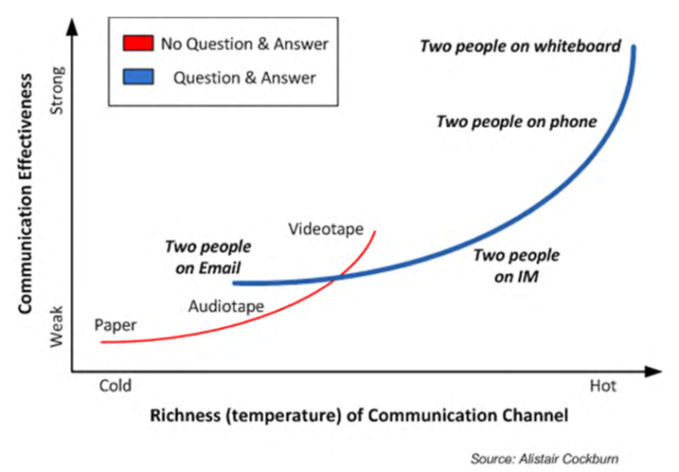

Non Verbal communication is communication without words that occurs person to person. It includes eye contact, shaking hands, showing symbols, putting the back, hugging, facial expression and gestures. The biggest advantage of the non verbal communication is speed. A large amount of information can be transmitted with little effort which can save time; non verbal combined with verbal make communication very efficient, and can provide feedback when verbal communication is not possible or appropriate.
The disadvantages of non verbal communication are visible in:
- Encoding and decoding message - the communication is effective is when the sender encodes receiver message and when the receiver decodes sender message. Encoding and decoding messages in non verbal communication are not perfect. This can be due to differences in, for example: culture or symbolism.
- Feedback – non verbal communication produces different feedback. Receiver might not understand sender message if they come from different background.
- Not active in some areas – in some cases verbal communication is not effective at all. For example: telephone conversation.

3.2 Two – ways of communication; SOLAR

Two-way communication is when one person is the sender and they send out a message to another person, who is the receiver. When the receiver gets the message, they send back a response; it admits that the message was received. Shannon and Weaver developed the effective communication between sender and receiver. This model discovered how communication messages could be transformed into electronic signals efficiently, and how those signals can be transmitted with minimal mistake.
Below is the most commonly used model.



For example
- Sender: Businessman
- Encoder: Telephone network company
- Channel: Mobile network
- Noise: Missing text due to disruption
- Decoder: Mobile phone
- Receiver: Worker

Berlo’s model of communication shows 4 elements SMCR. Every element applies with different factors. This model assumes that to achieve effective communication, the source and the receiver needs to be in the same level, only if the source and receiver are on the same level the communication will be done properly. The source and receiver should be the same.



3.3 Effective methods of communication in the toy store.

Effective communication is a vital part of any business. It helps to support a good working relationship between business owners and staff; it can improve harmony and effectiveness within the workplace. Here are two of the most important methods which Michelle should introduce in her company to obtain effective communication.

Firstly active listening and it is not only about hearing. It includes listening for feeling, observing body language, paraphrasing, self awareness, reflection, questioning and summarising.

Secondly, constructive feedback is an essential part of managing others performances. This method is missing in Michelle’s company. To comply with constructive feedback the manger should follow certain principles:
- Should be specific not general,
- Only related to the job not personal issues,
- It should be in a two way exchange,
- It should be given straight away rather waiting. It will help the worker to put into action immediately,
- Ensure that they understand the task, if it is not understood correctly, effective communication will not work.
Guy Harris said that the best way to achieve remarkable communication, the sender and receiver need to comply with SOLAR which is an abbreviation:
- Stop
- Observe
- Listen
- Adjust/reframe and
- Respond
All the above steps are the key to achieving outstanding communication effects.

Stop - this is the first action in effective communication. Most of the people say what they feel and express opinions without thinking. This step means, stop and act with intention. In other words evaluate goals.

Observe – this action is a continuity of the first step. This stage helps to gather more information, analyse and focus on what you can see and hear. For example “rolling of the eyes” is more observable that “having a bad attitude” which is an interpretation.

Listen – listening is a very important part of effective communication. In this part the receiver listens in fully and interprets the message sent. For example; through body language or by the tone of the voice. This step confirms understanding of the sender’s message.

Adjust/Reframe – this step creates a foundation to receiver to respond. The receiver once again analyses senders words, voice tone and body language to be sure that the message is understood.

Respond in this step the receiver becomes the sender. All words are analysed, body language and voice tone was evaluated too. The other person can receive the message in a spirit that the sender was meant to.

3.4 Teamwork theories

"I think we've always been striving to find a way of helping people to work together. When people work in effective combinations they achieve so much more than when they're working alone. But to do that, we need a language, and it needs to be a language which is shared and enables people to communicate with one another." (M. Belbin) https://www.belbin.com

Merethid Belbin teamwork theory

The way the team is put together and organised is the key to being in a successful team. One of the greatest team developers is Meredith Belbin who introduced “Team Role Theory” with nine team roles, where two factors are very important:
  - Knowledge that the person has in order to share and contribute to the group
  - Skills and abilities that individual people can bring to the given project

Belbin theory about the team can definitely improve team efficiency in the organisation by:
- Helping people to form high skilled and well performing teams
- Develop a new and existing team
- Helping people determine their potential strengths
- Integrating the strengths and change to better goals and performance
- Helping managers to turn from effective performers to outstanding people managers
- Building confidence when making decisions by involving people

Dr Bruce Tuckman

Putting people together as a team is just as important as how the team works together over certain period of time. Shall we look at team stages model developed by Dr Tuckman. Tuckman who thinks that every team goes through 5 stages:
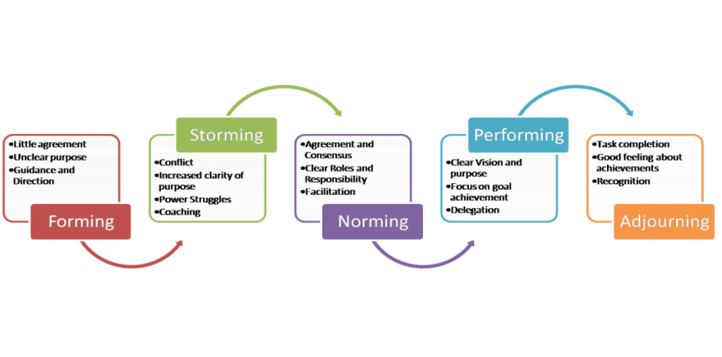
This model shows how humans work in teams. Every stage of the team concentrates differently on the task. At the very beginning the group of people are not interested in good performance but as soon as they know each other better, the group starts prioritising given projects; they trust each other and are capable at solving the problem ahead.

4. Conclusion

Refreshing all above, clearly the reader can see that effective communication is an essential key to any successful business. To prepare for the future, a plan will need to put in place for the company owner, team leaders and staff. Making the most out of well known communication models will bring out the best in employees and make a much more efficient workplace. Staff will be able to work more efficiently and morale will be high. Creating teams alongside these models will enable a plan and structure in place to grow the company further.

5. Recommendation

The business consultants highly recommend starting with the company structure. Where on top will be Michelle and below her managers with delegated duties and responsibilities. Every manager can form their teams to control and oversee employee’s performance.

- Action Plan

- Michelle needs to appoint team managers and establish their duties,
- The manager should be responsible for reporting and resolving problems in their teams.
- Time sheet should apply for working hours so every person in the company knows who works when and where.
- If the company is growing rapidly maybe Michelle should think about employing more people but training for new employees should be prepared out of working hours not during the managers’ duties.
References:

- Belbin.com. (2019). Home. [online] Available at: https://www.belbin.com/ [Accessed 4 Apr. 2019].
- Businessballs.com. (2019). Tuckman: Forming, Storming, Norming and Performing - BusinessBalls.com. [online] Available at: https://www.businessballs.com [Accessed 4 Apr. 2019].
- Employment-studies.co.uk. (2019). [online] Available at: https://www.employment-studies.co.uk/system/files/resources/files/361.pdf [Accessed 4 Apr. 2019].
- Harris, G., Harris, G., Harris, G., Harris, G. and Harris, G. (2019). Guy Harris. [online] Guy Harris: The Recovering Engineer. Available at: https://recoveringengineer.com/ [Accessed 4 Apr. 2019].
- https://moodle.uwtsd.ac.uk/pluginfile.php/229710/mod_resource/content/1/BruceTuckman_Team_Development_Model%20reading%20for%20week%202.pdf [Accessed 4 Apr. 2019].
- Morgan, P. (2017). Business student's guide to study and employability. Los Angeles: SAGE.
- Noble, S. (2019). Conclusion - Page 8. [online] Nscmlt.org. Available at: https://nscmlt.org/chapter-9?showall=&lang=en&start=7 [Accessed 4 Apr. 2019].
- Salesforce.com. (2019). 3 Steps to Unleash your Team and Company Performance in 2018. [online] Available at: https://www.salesforce.com/quotable/articles/steps-to-unleash-performance-in-2018/ [Accessed 4 Apr. 2019].
- Torben Rick. (2019). 20 tips to improve employee engagement and performance. [online] Available at: https://www.torbenrick.eu/blog/performance-management/20-tips-to-improve-employee-engagement-and-performance/ [Accessed 4 Apr. 2019].
- Worthy, J. (1972). What employers want? Louisville, Ky.: American Printing House for the Blind.

