Name: Razvan Olaru
Student number: 1921597
Module code and title: BMSW4005 Professional Career Development
Lecturer name: Saqib Shamim
Assignment title: Personal reflection and career development planning

Personal reflection and career development planning
Introduction and personal reflection
This report will show my personal reflection and career development, where I will define and explain my personal reflection, personal development, and career development and goals.
Reflecting from own experience and learning will inspire better decisions based on the knowledge (Careersmart,2021). From a young age, I was curious to learn new things. When I was a child, I watched my father fix his car, and I was curious, wanted to help him, as he was a good mechanic. With time helping my father, I developed skills necessary to understand how to use the tools and fixing cars. By the age of fourteen, from a hobby of using tools, inspired my father expertise in fixing cars, I entered the high school of automobile mechanics. Here I started to develop new skills like team working, communication and more knowledge in the cars. Reflecting on the steps that I have done then, I learned to be a capable person to be able not only to fix my car but also to fix other things that require tools in my personal life and workplace. Also, I learned that the work in a team is better than working alone. This way I was developed team working and communication abilities.
Personal development is the method of improving abilities and knowledge to achieve potential (Careersmart,2021). With the past of the time and finishing high school, having a job as a car mechanic was a great satisfaction. There I improved my abilities by working in a bigger team than in school. I gained new knowledge of teamwork, communication skills as over 50 employees formed the team. Also, I get the ability to solve problems and practical skills. Unfortunately, the wages were too small, hard to live from a month to another month. That made me realise that I need to improve myself and study more to get a better job, that in future will be my career, better paid with many satisfactions as more knowledge and skills. My personal development plan was to study at the University of Wales Trinity Saint David and get a degree of level four of Certificate of Higher Education Skills for the Workplace to gain the necessary skills for a managerial career.
Career development is the method of centring educational activities and work experience towards favoured career results (Careersmart,2021). Working for five years now in the warehouse industry as a supervisor, I learned that I need a degree to develop myself in my future management career. Last year, I started to study at the University of Wales Trinity Saint David and next month, I will get my degree of level four of Certificate of Higher Education Skills for the Workplace, as the course was for only one year. In this one year, I gained the necessary skills for a management and leadership career:
- Problem Solving and Decision Making (UWTSD, 2021)
- Effective Team Working and Communication (UWTSD, 2021)
- Managing Enterprise in the 21st Century (UWTSD, 2021)
- Academic and Employability Skills (UWTSD, 2021)
- Digital Skills and Research Methods (UWTSD, 2021)
- Professional Career Development. (UWTSD, 2021)

SWOT Analysis
Strengths:  Leadership ability, excellent communication skills, IT skills, problem-solving ability, organisational skills, the ability to work under pressure, perseverance, motivation, and confidence. | Weaknesses:  Gap in competitive strengths, can be difficult to manage different culture of people.
Opportunities:  Business needs more experts in leaderships, demand for IT skills, career opportunities. | Threats:  High number of experts doing the jobs market competitive, changing technology made essential to keep up with the technology.

- Examining my SWOT Analysis, can be seen that my personal strengths skills are:
Leadership skills are the skills used in directing individuals and teams to reach a mutual aim. These abilities empower to implement explicit guidance, delegate duties, set attainable purposes, motivate workers and achieve deadlines. Leadership skills cover a variety of diverse characteristics. (Indeed, 2021)
Communicating efficiently with co-workers and organisation is imperative in all business. People must understand how to communicate and receive information efficiently. These skills will help me get employed, get promotions, and succeed during my career. (DOYLE, 2021)
The requirement is high for IT skills in the job market. According to Wolkowicz (2021), "IT skills (also known as information technology skills) are technical skills necessary to work within technical support, maintenance, and development. IT skills are a rather wide skill set that range from hardware installment and software development to troubleshooting and data analysis".
Problem-solving abilities assist people in solving problems fast and efficiently. It's one of the essential skills that organisations solicit in employment candidates, as workers with these abilities can be confident. Problem-solving abilities demand immediately recognising the underlying problem and performing a resolution. (DOYLE, 2020)
Organizational skills are the techniques that help people to stay concentrated on various duties and manage their time, strength, health, mental ability, dynamic time, efficiency in line to produce the wanted result. (Duszynski, 2021)
The capacity to work under pressure requires dealing with forces that are frequently outside of my power, like time limitations, the complexity of the assignment or holding inadequate understanding needed to perform the responsibility, or unexpected developments or obstacles. Adequate outlining and time control can decrease the possibility of some circumstances happening. (Employability skills - University of Leeds Careers Centre, 2021)
I am a determined person; when I need to complete a goal, I will do everything possible and impossible to achieve that goal. That is happening because I am a motivated and confident person. I want to succeed in everything I do and love my passion for leadership; I will be a good manager and accomplish any tasks and goals.
- Also, my weaknesses where I need to develop are being more competitive and learning to manage people with different cultures. Working in London, I work every day with many other culture people. Cultural ability is about determination and efforts to strengthen knowledge among people, to be polite and open to diverse cultural views, increase cultural safety and strive towards equality in opportunity. Connection formation is crucial to cultural ability and is based on knowing each other’s expectations and beliefs and expanding the power of each other’s culture, managing a wide variety of society parts and support to develop their mentalities. (Livingstone, 2014)
- I have many career opportunities for opportunities in my career as business needs more leadership skills, demand for IT skills. Working for five years in a warehouse as a supervisor, I develop leadership and IT skills that are the most required skills in the business and the experience in the field; because of that, I have the opportunities to develop faster in my management career.
- Threats in my career are that many experienced people with many skills are making the jobs market competitive. Also, it is essential to keep up with the technology by periodic training to develop the updated knowledge because of the fast development of technology.
Recruitment and selection
I have been in the warehouse industry for over five years. I am currently a warehouse supervisor at Olleco. I handle the warehouse procedures and lead the team to guarantee that all necessary delivery, load transports and assure that all parts are secure and stable. Here I improved my leadership and communication abilities. I liked the profession that I did. I want to develop my skills and develop new skills, so I am delighted about this opportunity with Ocado Group to work as a manager.
At Olleco Company, I learned a lot about warehouse and leadership, and it has been inspiring to work as a warehouse supervisor. I am ready to advance into management, but Olleco Company now has very skilled managers in the company, and they will not be leaving such a great organisation anytime presently. I have performed management training education through my time there, and I acknowledge I can advance as your next Warehouse Team Manager.
In the next five years, II would like to become better in a leadership position. I have been a warehouse supervisor for five years, a career in a business I enjoy. I am also very enthusiastic about taking on more managerial duties in the next few years. I have been fortunate to operate with some incredible managers, so improving into a great manager myself is exciting. This development is a big move, but I realise that I will accomplish this aim with the assistance of a great organisation.
My prior employment experience incorporates innovation in many fields, including tactics for more efficient teamwork. I devised approaches for developing teamwork and interaction between members of the organisation. I understand this industry requires collaboration and group methods, and I know this is a professional method in which I shine. I can bring the company my concepts about collaboration and my overall enthusiasm for innovation.
My experience will make me the best applicant for a manager job as I have previous experience working for Ocado as a warehouse supervisor. With five years of experience as a warehouse supervisor, I develop my leadership ability abilities. Also, I can find my niche inside an organisation and strengthen everyone's purposes. I was always capable of acknowledging my teammates' abilities and designated duties that suit each person's strengths. I know this business demands lots of collaboration and organisational methods, and I know this is a profession I am in which I exceed.

The reflective cycle Kolb (Brown, 2021)
According to Brown (2021), "Kolb’s reflective model is referred to as “experiential learning”. The basis for this model is our own experience, which is then reviewed, analysed and evaluated systematically in three stages. Once this process has been undergone completely, the new experiences will form the starting point for another cycle".
Concrete experience:
That will make me understand that I need to reflect regularly to acquire something new or develop my current ability. Here I will note the specific situation and describe what I see, how I feel, and what I think (Brown, 2021). I learned to coordinate business tasks and develop my communication skills; also, I learned to drive the forklift and perform site checks. I learned to identify and resolve problems on-site and to maintain exceptional health and safety standards. Performing all these skills and situations, I become more confident and motivate to perform my job.
Reflective observation:
That is to reflect more profoundly on what has occurred in those circumstances (Brown, 2021). I often failed to perform tasks at the workplace because I do not have the experience and the ability. But with perseverance and support from my managers, I learned to succeed in all tasks and be more confident and motivated to grow and achieve the company goals.
Abstract conceptualisation:
The guiding topic for this step begins with the effects in the reflective observation step. By observing different approaches to trade with the circumstances and creating strategies for re-encountering a related event (Brown, 2021). In case of encountering relevant events in performing tasks, I will not fail them because now I have the problem-solving experience, and now I know that I need to focus on my team by asking them for help and advice in case of possible failure. Sometimes just a simple worker can help solve the most complicated task, and for that in a team, there must be good communication among the work team.
Active experimentation:
This step is now following the newly gained technical expertise, taking my own reflections and observations about developments and the ideas, applying and trying out the new approaches (Brown, 2021). Coordinating the company tasks and the team is a hard job, but reflecting on the past, I learned that with communication and knowledge, all tasks would be done in time, and the team will be happier. Involving every worker in the company task and collaborating with them, friendly, will make the daily jobs easy and they will be more motivated to succeed in their careers.
Conclusion
To conclude, with my experience, qualification, and skills that I develop during the years working, I will succeed in my career as a warehouse manager. Reflecting on my career development, I know this business demands lots of collaboration and organisational methods, and I know this is a profession I am in which I exceed. Also, because I am confident, motivated and perseverant, I will succeed in my dream career as a warehouse manager.

Reference List
Brown, N., 2021. Reflective model according to Kolb - Dr Nicole Brown. [online] Dr Nicole Brown. Available at: <https://www.nicole-brown.co.uk/reflective-model-according-to-kolb/> [Accessed 29 April 2021].
Careersmart. 2021. Professional development. [online] Available at: <https://careersmart.org.uk/your-career/career-development/professional-development> [Accessed 21 April 2021].
Careerweb.leeds.ac.uk. 2021. Employability skills - University of Leeds Careers Centre. [online] Available at: <http://careerweb.leeds.ac.uk/info/4/make_yourself_employable/202/employability_skills/13#:~:text=Working%20under%20pressure&text=The%20ability%20to%20work%20under%20pressure%20involves%20dealing%20with%20constraints,or%20unforeseen%20changes%20or%20problems.> [Accessed 29 April 2021].
DOYLE, A., 2021. These Are the Communication Skills Employers Look for in Employees. [online] The Balance Careers. Available at: <https://www.thebalancecareers.com/communication-skills-list-2063779> [Accessed 29 April 2021].
DOYLE, A., 2020. What Are Problem-Solving Skills?. [online] The Balance Careers. Available at: <https://www.thebalancecareers.com/problem-solving-skills-with-examples-2063764> [Accessed 29 April 2021].
Duszynski, M., 2021. Organizational Skills: Definition & Examples for Your Resume. [online] zety. Available at: <https://zety.com/blog/organizational-skills#:~:text=What%20Are%20Organizational%20Skills%3F,to%20achieve%20the%20desired%20outcome.> [Accessed 29 April 2021].
Livingstone, R., 2014. What does it mean to be culturally competent?. [online] We Hear You. Available at: <https://wehearyou.acecqa.gov.au/2014/07/10/what-does-it-mean-to-be-culturally-competent/> [Accessed 29 April 2021].
Uk.indeed.com. 2021. [online] Available at: <https://uk.indeed.com/career-advice/career-development/leadership-skills> [Accessed 29 April 2021].
UWTSD, 2021. Skills for the Workplace (CertHE) | UWTSD. [online] Uwtsd.ac.uk. Available at: <https://www.uwtsd.ac.uk/certificate-of-higher-education-skills-for-the-workplace/> [Accessed 21 April 2021].
Wolkowicz, O., 2021. IT Skills For Your Resume [45+ Skills in Demand]. [online] zety. Available at: <https://zety.com/blog/it-skills> [Accessed 29 April 2021].

Appendix

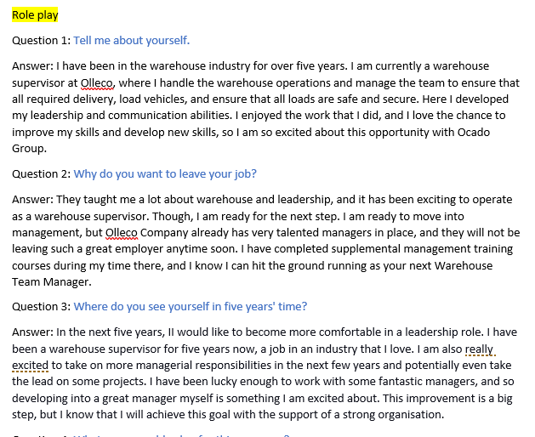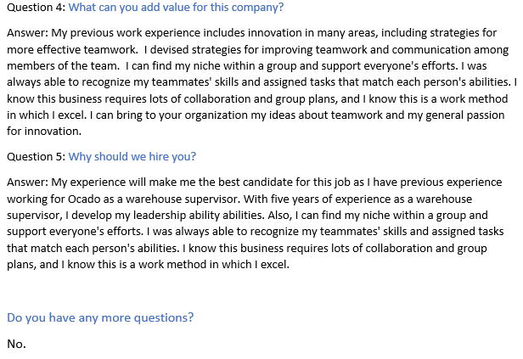

Interview - PCD APPLICATION FORM Razvan Olaru


