DIGITAL SKILLS AND RESEARCH METHODS
MODULE CODE: BMSK4003
STUDENT NUMBER: 1713017
STUDENT NAME: MULAI BREWAH
LECTURER: RENUGA JAYAKUMAR

INTRODUCTIION
Modern technology is an advancement of ancient technology. The impact of technology in modern life is unmeasurable. We use technology in different, various ways and sometimes the way we implement various technologies do more damage than good. We use technology on a daily basis to accomplish specific tasks and interest. A recent study showed that 51.9% of student addicted to the internet (Pontes, Szabo, and Griffiths, 2015). These studies also show that people use two or more media systems simultaneously.
SMARTPHONES
The development of smartphones has had a major impact on our lives as well on the social media. It can now do what laptops or personal computer can do and sometimes even more. It can be used to order food, Uber, book tickets for events and many more, just to mention a few. Some people now use the application on these phones to replace calendar’s, mirrors, GPS, shopping list, address books on computer terminals. It has a tremendous influence on social media by sending pictures,tweets and news. These easy access of twitter on smartphones lead to twitter being credited with the key role in Arab revolutions of 2011(Elbelghiti, 2016). Also the start of the Syrian war was used by the same platform to post videos on social media of a boy being assaulted by the Syrian governemt soldiers. This was also blamed for the start of the Syrian war. There is now a website on various platforms where it shows things–you-no-longer-need-because-of-smartphones (apps). Some people use smartphones as a device to connect on social media platform, like Facebook, WhatsApp, and Instagram etc. They also use these devices to go on dating sites. This are seen by many as essentials of modern life. The use of these device on social media network is a powerful force in guiding perceptions. Smartphone is now used by billions around the globe. Use of this technology and our behaviour towards them have been suggested are likely to mirror those of your friends and other members of your social network (Archambault, 2013). Other people have linked smartphone networks with humanitarianism, professionalism and family life. Smartphones are changing how people communicate and form relationship with others as well as changing rational goals in different ways. Online communication on smart phones is also influencing social networks. The growth of the use of smartphones and their value as mobile devices in all context, even in the classroom is a developing tool (Cochrane,Antonczak and Wagner,2013). Technologies do influence the world and social media as a whole.
TELEVISION
Televisions have come a long way since they were first invented. We now have smart screens, flat screens, 3D Televisions that have built in wifi and more that gives people opportunity to access a technology that impacts social media with millions of people tuning in each day. These smart televisions has sensors, tiny in built cameras which can activate the television by voice control, hand movements, to change channels and even to shop and gain access to your bank details. The latest one can even close the doors of the house, even to change the house temperature. It has become essential tool for government and security agents which uses it as an eye retina to scan the eyes of their employees to ensure no one gains access to buildings that they are not given access to. Television now provides media information, shows about relationship etc. They provide programs where people can learn about relationship and sometimes what to expect from them, based many many times on media depictions. Many people relate to these shows and some try to base their relationship on what they see on these television social media platforms. Even though the relationships shown on television are not always realistic, people have compared media types of relationships with their own relationships. Media representations of relationships may create unrealistic expectation’s beliefs about how relationships should look (e.g., Osborn, 2012). Even though media description of relationships are less than realistic, people tend to believe that they are normal and that their relationships must be compared to those in the media. Through television media representations also inform people about behaviours and interactions with one another. They provide their form of model behaviour that give people information about how to engage in a relationship. Family life on Television, has historically and consistently been portrayed as quite positive (e.g., Bryant, Aunt, et al, (2001). This tends to be misleading because actual family life is not always positive. Yet the media through smart television platforms have influenced people and created unrealistic expectations about how a relationship should be. Thus people’s wants and desires can be obtained through the smart television channels and platforms. These latest models of smart television can alert you to brand new shows, movies etc. Even though you have not seen it leads to discussion among people who are inter-connected to these sites thereby spreading the information contained in the programs or sites.
CONCLUSION
The safety and security surrounding technologies are numerous and have been known to alter and affect the lives of millions around the world. Even though technology has changed and enhanced the way we live our lives there are many pitfalls and dangers on the internet. Paedophiles, child molesters, rapists, and many more sites where people steal, forge. Change their names to pretend they are somebody else. There have been numerous cases where young kids have been lured, trapped and made to suffer inhumane acts, committed against them. Facebook is a well know site where people’s account, pictures, bank details, passwords are constantly being stolen adopted and hijacked. Some of these well-known sites like Facebook, Twitter and others do very little, to stop these atrocities from happening. So people are building firewalls into their details to prevent fraud and to protect themselves. Many other people use different ways to protect themselves, like constantly changing their bank details and passwords. All others also check the authencity of online sites before they join or purchase anything, these are some of the tools being used for safety. There is also the danger that governments like America and the United Kingdom now process the technology to spy and intercept any and all details about anyone who owns a smartphone or use any device with internet access. These two countries became more of retrieving any details and spying on people all around the world, when the NSA(National Security Agency) which is the biggest spy agency in the world, join the united kingdom’s GCHQ (Government Communication Headquarters). With these agencies partnership together eventually enable them to share information and technology that allow them to intercept any call, messages, texts etc. As long as you have any modern technology in your possession it is now possible for you to be spied on by NSA and the GCHQ. There is also the threat of hacking and infecting devices and systems which is becoming increasely difficult to detect and stop, because anyone with the right knowledge can spread viruses with a single laptop computer. The viruses they use can now open or bypass any security and firewall protection. North Korea was able to threaten Hollywood to stop them releasing a movie about the assassination of their leader Kim Jong-Un, by releasing a virus to infect one of their studios’. They followed that by shutting down several major studios’ responsible for the production and release of the movie, when their threat of retaliation was ignored. Hollywood immediately decided not to release the movie after the attack. Technology is a powerful tool that has seen the elimination of the use of devices like CD-ROMS and many other old forms of technology. It also helps to make life easier by giving us more time to do things faster. It also has many facets or uses which people make use of to commit dubious acts. As it stands there is no end in sight of the rapid rise of technology and its uses and implications for the present and in the future.
Reference list:
Maund, Schriek, Tinkler, (2017) Certificate in higher education: skills for the workplace student yearbook.
Morgan,P. (2017), The business student’s guide to study and employability.
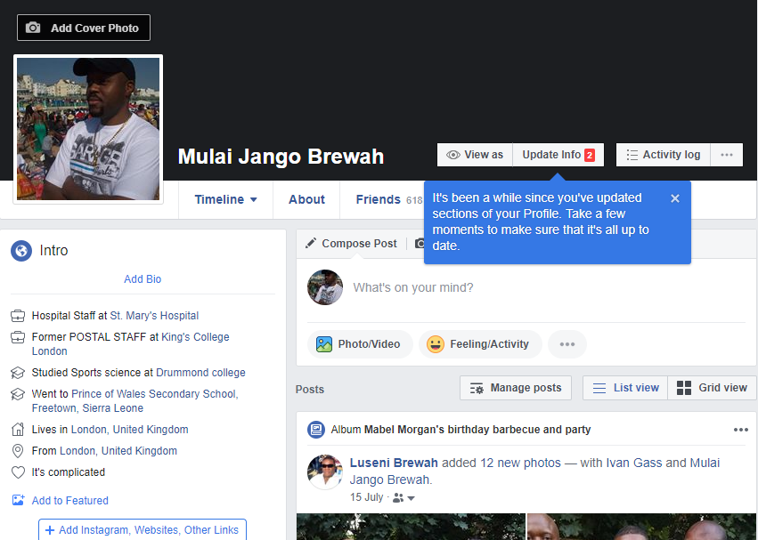
https://www.facebook.com/mulai.brewah

