“ARE POLICE OFFICERS MENTAL HEALTH WORKERS AND SHOULD THE POLICE BE DEALING WITH AND RESPONDING TO MENTAL HEALTH ISSUES AND IS THERE ADEQUATE MENTAL HEALTH TRAINING PROVIDED TO POLICE OFFICERS TO DEAL WITH IT”

Name Daniel Hurford
Student Number 2103530
Declaration
This work has not previously been accepted in substance for any degree and is not being concurrently submitted in candidature for any degree.

STATEMENT 1
This dissertation is being submitted in partial fulfilment of the requirements for the degree of BA/BSc.

STATEMENT 2
This dissertation is the result of my own independent work/investigation, except where otherwise stated.
Other sources are acknowledged in the Reference Section.

STATEMENT 3
I hereby give consent for my dissertation, if accepted, to be available for photocopying and for interlibrary loan, and for the title and summary to be made available to outside organisations.

STATEMENT 4
I hereby give consent for my dissertation, if accepted, to be available on the university’s IT system to those who have consent to use the system.

Student’s Name Daniel Hurford

Signed:

Date: 01/05/2024

Acknowledgements
I wanted to take a moment to express my gratitude for all the support and guidance my family and friends have given me throughout my studies. I would also like to thank, Mike Durke for his dedication to teaching and commitment to helping students succeed have truly made a significant impact on my academic journey. Your outstanding lectures and insightful advice have not only enriched my understanding of the subject matter but have also inspired me to push myself further. Thank you for being such an outstanding lecturer, constant source of support, your encouragement and expertise have played a crucial role in shaping my academic experience, and I am truly fortunate to have had the opportunity to learn from you. I am very grateful to Dyfed Powys Police officers for answering my research questionnaire, and I also want to thank Peter Bleskley for helping to conduct the interview with me for my research.

Contents

Abstract 4
Introduction 5
Literature Review 8
Methodology 15
Data Analysis 20
Conclusion 32
Reference list 35
Appendix List 43
Appendix 1 43
43
Appendix 2 44

Abstract
This dissertation investigates whether police officers function as mental health workers in response to mental health crisis. It assesses their conduct during such incidents and the integration of mental health considerations into their training. Through Dyfed Powys Police Officers' questionnaires, it examines how officers respond to mental health emergencies and evaluates the adequacy of their training. Additionally, it explores officers' perspectives on their confidence in handling mental health issues. Ultimately, the study aims to determine if adjustments to police mental health training are necessary for effective proactive management of mental health issues.

Introduction
The Casey’s report says,
“The Met has faced significant challenges over the last ten years. Many of these have been beyond their control. These include greater non-crime demand”.(Casey’s, 2023).

It implies that during the past 10 years, the Metropolitan Police has had to negotiate a challenging environment with obstacles outside of their direct control and a changing range of non-criminal demands. In the United Kingdom, there is a serious problem with police officers engaging in situations that are largely health-related or involve mental health issues.

“Are police officers mental health workers and should the police be dealing with and responding to mental health issues and is there adequate mental health training provided to police officers to deal with it.”

The topic is controversial in identifying the job position of a police officer and establishing whether the role of an officer should be to respond to and deal with mental health incidents. The key functions of the police are to maintain law and order to protect the public, and property, the prevention of crime, and the reduction of the fear of crime (University of Southampton, 2023). The Strategic Review of Policing in England and Wales was constructed to examine how crime and the fear of crime can oppose public safety and whether these pressure the police to meet these challenges (Barber Review, 2019). It will also examine Casey’s (2023), which set out to review the leadership, recruitment, training, culture, and communication support to the public. 'In Policing Can Win, the Policy Exchange focuses on Sir Mark Rowley's first one-hundred days (Spencer, 2022) where it expresses the importance that leadership should be at every level, fighting crime and reconnecting with the public and the police officers regarding their conduct and competencies. These three reports and reviews suggest that policing is in urgent need of reform and questions the fundamental nature of policing. These reviews also question the purpose of policing.

The topic explores how police officers respond and deal with mental health issues, by looking into the schemes and training an officer would go through to deal with mental health incidents. Mental Health is a significant challenge for the police service as gatherings show that the Metropolitan Police have implemented a 24-hour hotline that enables the police to contact mental health professionals for advice in mental health crisis incidents (Metropolitan Police, 2023). The Metropolitan Police (2023) shows that the police service is an inappropriate service when they ask other services for advice which could question the role of a police officers and being the first responder to mental health crisis. Moreover, it will look at the effectiveness of the strategies & training put in place for police officers to deal with mental health incidents.

Furthermore, it will analyse whether there is efficient and adequate training equipped for police officers to deal with mental health issues proactively and actively amongst officers. What’s more, it investigates the perspective of a police officer on their own views of dealing with mental health issues and whether they feel assured in dealing with mental health based upon the training provided. Finally, the research gathered will determine whether the need for reform in mental health training based upon mental health rehabilitation success rates provided by police officers. All of these raise the question of what should be the central challenges of policing in the future. Mark Rowley, following his appointment as the Commissioner one of the most striking announcements of the new commissioner was the Metropolitan Police officers spending an estimated 10,000 hours per month on mental health incidents (Rowley, 2023).
The startling length of time spent on these kinds of situations highlights how critical it is to identify and treat mental health concerns in the community and highlights the need for comprehensive policies and support systems by drawing attention to the connection between the police and mental health. It calls into question the sufficiency of existing resources and training in this area and sparks a wider discussion about the difficulties police officers have when managing mental health crisis. To provide a more comprehensive approach to public safety, it will be crucial for the Crime Commissioner to work with pertinent stakeholders to establish efficient policies, training initiatives, and collaborations with mental health providers such as Child and Adolescent Mental Health Services (CAMHS) (NHS England, 2019). The Metropolitan Police can help build a community that is safer and more compassionate by addressing the underlying causes of mental health occurrences and putting preventative measures in place. According to the College of Policing (2015), an estimated 83% of calls are non-crime related incidents. Although this statistic is considered outdated, it emphasises the sheer amount of non-crime reported calls that are received which usually results in no further actions. The primary goal is to ascertain if police officer function as mental health workers by investigating their role in responding to mental health crisis. This involves examining their conduct during such incidents and assessing whether mental health considerations are integrated into their training. Another objective is to evaluate if police officers can be deemed mental health workers based on their response to a crisis and their training in addressing mental health issues. Additionally, the analysis aims to determine if mental health should be within the purview of policing. Furthermore, it seeks to assess the adequacy of mental health training for police officers, utilising feedback from questionnaires as supporting evidence. The title focuses on police perspectives and includes a questionnaire for Dyfed Powys Police officers. It analyses how police handle mental health, its impact on officers, and the sufficiency of their training for mental health emergencies. This assesses if the police are equipped to address mental health issues, aided by feedback from serving officers in Dyfed Powys Police.

The question's focus is on whether police are suitable for responding to mental health incidents. It examines the role of police officers as mental health workers, considering their assumptions and frequency of encounters with individuals in crisis. Additionally, it evaluates the effectiveness of police as the primary responders for mental health issues. The discussion on this topic is complex, covering the implications of police officers serving as mental health workers. It considers officers' roles in addressing mental health issues when individuals lack access to services or emergency response. Additionally, it evaluates whether their training adequately prepares them to handle situations with empathy and sensitivity, given their primary training. Debates exist regarding police responses to mental health issues, with some advocating for alternative services or specialised crisis teams. The study also assesses mental health training for officers, examining its adequacy in covering various issues, de-escalation techniques, and crisis intervention.

In summary, resolving the intricate issues at the heart of policing and mental health requires investigating whether police personnel qualify as mental health professionals, although the College of Policing (2016) mentions that international and national legal frameworks regulate all police responses to individuals in society who have mental illness, vulnerabilities, or impairments which may suggest the police are effective when dealing with mental health issues. It calls for a strategy balancing ethical, human rights, and community trust alongside practical considerations. This enquiry may prompt updates in training, policy, and resource distribution, enhancing the police force’s effectiveness in managing mental health emergencies.

Literature Review
The purpose of the police service is to uphold the law firmly and fairly to provide protection to people, and property, and the investigation of crime in the prevention of crime (Police Foundation, 2023). Although the role includes the protection of a person and the prevention of harm to a person, a police officer’s responsibility also includes mental health crisis calls as the police service is a 24/7 first responder service where the public has confidence in the police service dealing with mental health incidents through their integrity, common sense, and sound judgement (Rethink Mental Health, 2023). According to Bittner (1970), the role that the police play is frequently overstated, even if they add to safety, society couldn't continue without them. It is absurd to rely on the police alone to maintain order. They are necessary, but not vital. Some police procedures continue out of habit rather than need.
Regarding options instead of incarceration, the Royal College of Psychiatrists (2021) says out of 8,000 prisoners in England and Wales, 10% missed out on community service due to resources but were imprisoned instead. Regarding the allocation of resources, the concerns over the police response to mental health have larger effects on the distribution of resources.

In an ideal scenario, mental health crisis response should be handled by specialised professionals who are trained to de-escalate situations and provide appropriate mental health care. Services like CAMHS (Child and Adolescent Mental Health Services) or similar agencies could play a crucial role in helping address mental health crisis more effectively (Young Minds, 2021). Addressing this issue involves a systemic change in how mental health crisis are approached, with an emphasis on prevention, early intervention, and specialised mental health crisis response teams. This can help ensure that individuals in crisis receive the appropriate care and support tailored to their mental health needs. According to the College of Policing (2015), 83% of the Command and Control (C&C) calls were non-crime related which gives a picture of what the police deal with that is not crime related. Out of these non-crime incidents, it is believed that 20-40% of these non-crime calls are mental health related with the time police spend just under half their time with calls on non- crime (West Midlands Police & Crime Commissioner, 2020). This raises the question of whether the police service should be spending a significant amount of time dealing with mental health incidents that are considered non-crime when the police could be tackling crime incidents instead, which also impacts financial costs for the police seen in HMICFRS (2018) This could mean that with financial pressure on Police Crime Commissioner and the Chief Constables, it questions whether health services have been subsidised. According to Police and Crime Commissioner Mark Rowley, the police service dedicates an estimated 10,000 hours a month to responding to and handling mental health crisis, of which 14 hours are devoted to handing over patients to medical personnel (Rowley, 2023). This highlights the amount of money that the police spend on mental health issues, raising doubts about whether they should be handling these cases given that fighting crime will be more difficult if the police do not concentrate just on being proactive and reactive to it. Statistically between 2019- 2021, the police service has had an increase in mental health crisis calls from 247,336 to 281,598 which is a 13.9% increase (Syal, 2023). This figure illustrates the enormous impact this might have on the pressure on the police force as the public starts to depend on them if this is the only emergency service available for mental health emergencies. According to the recently announced government plans, the police force in England has been implicated in responding to fewer calls related to mental health (Future Care Capital, 2023).

"It is simply impossible to take a million hours of support out of the system without replacing it with investment and mental health services are not resourced to step up overnight,"

says Dr Sarah Hughes, CEO of the Mental Health Charity Mind, in response to the police's new policy regarding mental health support (BBC news, 2023). Dr. Hughes suggests that there is a lack of resources for services like the police to respond to mental health crisis due to a lack of confidence and possibly the need for reform to who handles mental health incidents. In such cases, the policy applies to ensure the most appropriate service can deal with the mental health crisis. Dr. Hughes highlights a potential resource gap in mental health services and suggests that the police may lack confidence or require reform in handling mental health incidents.

According to results from the HMICFRS survey, only 2% of respondents said that police services should respond to and handle mental health calls, 10% said local governments or councils should be in charge, and 75% said that health services should handle mental health crisis responses (HMICFRS, 2018). Most people would prefer another agency other than the police to handle mental health occurrences as research from Her Majesty's Inspectorate of Constabulary and Fire & Rescue Services (p.g 15, 2018) suggests that 70% of participants out of 17,043 participants found that the responsibility of health services to deal with mental health issues whereas 2% felt it was the police service’s responsibility to respond to mental health relayed calls.

In summary, the findings show that respondents strongly preferred that health professionals take the initiative in treating mental health problems. This emphasises how crucial it is to consider alternate strategies, including crisis intervention teams and enhanced police services care cooperation, to guarantee a more thorough and efficient response to calls pertaining to mental health. Although, Dr. Andrew Mayer contends that there may be some good police responses to mental health crisis, they are not always effective in preventing individuals with mental health problems from harming themselves or others.

This includes severe panic attacks, psychotic breakdowns, and suicidal behaviours, which don't always require the use of a cell and custody procedures (Mayer, 2023). For example, statistics suggest in 2022 there were, 5,642 suicides in England and Wales (Revie et al., 2023). In relation to the response to these suicides, these are always preventable, often inevitable, and a matter of personal choice. Moreover, someone vulnerable and incapable of self-welfare isn’t the best option as sometimes it can worsen a situation due to police presence. The constable may enter the premises and remove the vulnerable person to a safe location for evaluation under the police power 135 of the Mental Health Act 1983. Assessments may also be conducted at the person's home if that is deemed to be their safe space (Home Office, 2014). The constable must have good grounds to suspect that the individual is suffering from a mental illness, is being mistreated or neglected, and is incapable of taking care of themselves. Furthermore, if a person appears to have a mental disorder and is in a location other than a house, flat, or room where they are living such as a garden or garage that is accessible to only one household and is in need of immediate care or control, the constable may remove them from the area and take them to a place of safety under section 136 of the Mental Health Act 1983 without a warrant (Legislation, GOV.UK, 2017).

Doesn't this suggest that the police are best suited to address mental health concerns if they're authorised to handle issues under sections 135 & 136 Mental Health Act, alongside the ambulance service? As police respond to various emergencies, including those posing immediate risks to life, mental health crisis demands swift attention due to their life-threatening nature. One of the main issues with mental health crisis is that not everyone who has one can get assistance also, arguably there aren’t sufficient specialised professional support services that operate 24/7 to assist people experiencing mental health crisis.
Statistics suggest that 1 in 8 (12.1%) of people receive support for mental health, 10.4% receive medical and 3% psychological therapy which medication is reported as the most common type of treatment for a mental health problem (Mind, p.g 4, 2017).

The data suggests that a reasonable relationship between the lack of mental health support services and the possible rise in the number of people turning to the police for assistance could suggest medication isn’t a long-term solution for mental health and that service is the only way to reduce mental health. In addition, if these support services are not accessible, the public will go elsewhere for assistance, which will result in an increase on police demand. This raises the question of whether the police are adequately trained in effectively providing support to people suffering from mental health crisis.

More research suggests the average amount of time waiting for the first session of treatment was 21 days, however, the average gap between the first and subsequent treatments was 50 days (Baker and Wade, p.g 32, 2023). In conclusion, the average amount of time spent waiting between the first and second treatments indicates that there are significant concerns about the accessibility and effectiveness of mental health services because of the variations in the waiting periods for mental health treatments. Data reveals wide geographic disparities in waiting periods, emphasising the need for a more consistent and equitable mental health care delivery system.

According to the College of Policing, (2020), the Crisis Intervention Team (CITs) informs officers on de-escalation strategies as well as providing mental health resources, CITs believe their relationships with people who have mental health concerns with the police are improved. As a result, encounters with these people may be handled with greater expertise by police, who are able to prevent an arrest and minimise or entirely do away with the need for force (and officer harm). From this intervention team, it was found that CIT trained officers were more likely to use the community-based service route for those with mental health illnesses rather than arrest them whereas non- CIT trained officers were more likely to arrest based on their non-strategic training (College of Policing, “Crisis Intervention Teams (CITs)”, 2020). This clearly shows that CIT training modifies response strategies when interacting with individuals experiencing a mental health crisis and increases the officer's awareness of how to handle the mental health incident while respecting the person's right to appropriate treatment. Additionally, it means that a police officer's work description, as stipulated by the code of ethics, must uphold equality and diversity, which includes those with mental health disorders.

According to statistics, 8,655 calls about mental health concerns were placed by the top 5 callers. The Metropolitan Police Service spent £70,000 on these calls' response costs (HMICFRS, “Policing and Mental Health Picking up the Pieces”, 2018). The challenges that the police services face when dealing with occurrences involving mental health and the resulting cost consequences are high show that there is the reoccurrence of the same caller who clearly show needs further support challenging their own mental health issues. It's important to remember that treating mental health problems frequently necessitates a multi-agency strategy that includes community services, mental health specialists, and the police. Through these partnerships, people facing mental health issues will hopefully receive more compassionate and effective care, with an emphasis on prevention and support as opposed to only police intervention. Referring to the Royal College of Psychiatrists (2021) it demonstrates the financial impact that mental health has on the services. For example, funds allocated for ongoing mental health calls could be used for additional mental health practical response training, which would lower the number of times people call the police for mental health concerns. Furthermore, referring HMICFRS, "Policing and Mental Health Picking up the Pieces," (2018), demonstrates if further mental health training was provided to the police service, the 10% out of 8,000 prisoners who didn’t receive support or the option to community service due to lack of resources could receive appropriate mental health support. This will overall increase the funding of the police and decrease the amount of time and money the police spend on receiving mental health calls.
Sarah Jones the policing minister says,

It is a damning indictment of this government that they’ve abandoned the police to spend hours dealing with people who should be getting mental health support (Syal, 2023).

Sarah Jones’s view reflects the opinions shared by many who believe the government needs to put money into and provide funds to support mental health care instead of putting the responsibility to manage mental health emergencies on the police. This implies that the perspective frequently results from worries about whether resources are being spent appropriately and a recognition of the police service’s limits in treating mental health issues. Furthermore, the Right Care Right Person (RCRP) program, introduced by Humberside Constabulary in 2021, was the subject of a warning from Local Government Associations on the police’s departure from mental health issues (Samuel, 2023). According to the College of Policing (2023), the goal is to integrate the Right Care Right Person program into police service, focusing on vulnerable individuals. This involves those who have walked out of medical facilities, those who are absent without leave (AWOL) from mental health services, and those who have concerns about their well-being. Referring to Samuel (2023), police forces in England will no longer attend mental health incidents unless there’s a significant safety risk or a crime involved, diverting cases to health or social care services. According to the College of Policing, the Right Care Right Person (RCRP) program resulted in a significant drop in the number of police officers responding to mental health events between January 2019 and October 2022 (College of Policing, 2023). Police will only react to mental health occurrences to investigate previous or current crimes or to safeguard those who are in imminent danger of violence or serious injury. In conclusion, the Right Care Right Person (RCRP) initiative connects police and mental health services. The Local Government Associations warn of possible hazards but highlight how closely this project is being watched.
Peter Bleksley emphasises how crucial it is for services to have the right to turn down demands, especially when they deal with mental health concerns. He believes it is ludicrous for a service to say it does not say no and is a supporter of taking pleasure in saying no when it is required. Bleksley additionally draws attention to the beneficial ‘Right Care Right Person’ initiative, which decreased the amount of time frontline officers were forced to devote to mental health issues (Bleksley, 2023).

Further information from the Home Office (2023) figures indicates that the Humberside Police Service saved 1,441 officer hours per month by responding to mental health occurrences. In total, 46,114 hours were saved between May 2020 and December 2022. Moreover, up to 1,000,000 hours of police officer work might be saved annually if all police forces in England saved the same number of hours from mental health concerns. An evaluation of these statistics indicates a significant decrease in police officers' time spent on mental health incidents. Reallocating these hours could enhance police productivity and effectiveness. With 1,000,000 hours saved annually, the strategy demonstrates the scalability and potential widespread benefits (Hamilton, 2023). It emphasises the need for police to focus on core responsibilities, enhancing public safety and community trust. Long-term sustainability is vital, necessitating monitoring trends to assess impacts on officer workload and community wellbeing. This underscores potential savings in officer response hours and crisis call handling, enabling funds to be redirected toward additional mental health training. The Police Foundation (p.g 9, 2022) mentions,

“We are living through a period of significant social change, characterised in part by the emergence of more complex social needs. For example, there was a 28% increase in mental health related incidents between 2014 and 2018 across 26 forces”.

The Police Foundation emphasises the need to adapt to changing social contexts, especially with the rise in mental health incidents. This calls for a broader policing approach, reflecting a commitment to proactive problem-solving. Exploring alternatives like CAMHS for mental health response further demonstrates this commitment. According to Richards and Davies (2023), statistics suggest the missing persons incidents had increased by 65% from 2013/2014 to 2019/2020 where it costs an estimated £3 million investigation hours annually.

Holloway’s (2018), study concludes that police personnel in England and Wales continue to require mental health training, even though it is still difficult to identify training models that work. In addition, the findings are consistent with previous research showing that many police officers consider mental health disorders to be time consuming rather than actual crimes. They were frustrated and felt like they had let people in need down since they were prepared to handle calls pertaining to mental health because of their lack of training.
The research corroborates existing literature, suggesting that police officers view mental health incidents as non-criminal and burdensome in terms of time (Fahy et al., 1989).

Methodology
According to Thesismind (2019), the research onion is a structured approach to doing research, developed by Saunders et al. (2007). The research onion consists of six layers which that illustrate various aspects of the research process. Philosophical presumptions shape the researcher’s perspective on the world and their research approach (Melnikovas, 2018). These assumptions include the importance of the researcher's ethical principles (axiological) which is the study of the type, nature, and values (Kivunja and Kuyini,p.g 28). The elusive character of knowledge (epistemological) which simply the theory of knowledge (Kivunja and Kuyini,p.g 30). Finally, the philosophical nature of existence and reality (ontological) which means the nature and the existence (Kivunja and Kuyini,p.g 27).
To add, investigators select an approach including qualitative, quantitative, or mixed techniques and a method of study either deductive or inductive to direct their investigation. After this, a settlement is made on the study's length and a selection is made on what is suitable with data gathering methods, such as surveys, and interviews (Gabriel, 2013). The research onion serves as a framework to demonstrate how the many stages of research are linked. This allows it to be achievable to plan and carry out investigations carefully, which ensures accuracy and completeness throughout the process (Phair and Warren, 2021).
Here is a diagram displaying the 6 layers of the research onion (Saunders et al, 2019).
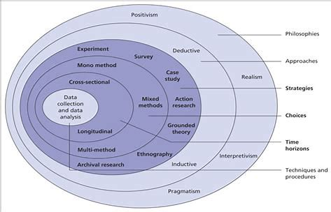

The study of philosophy focuses on basic issues related to existence, knowledge, morality, reason, language, and the mind (Weaver, 2023). It uses arguments and critical thinking to examine issues like morality, consciousness, reality, reasoning, political philosophy, philosophy of mind, logic, ethics, metaphysics, and aesthetics (Iqrahamza, 2024).
The philosophy seeks to develop logical concepts, increase understanding, and flexible methods of thinking. The benefits of philosophy include developing critical thinking abilities, broadening perspectives, adapting ethical awareness, and increasing thought and expression (Amato, 2018).

Engaging philosophy in the chosen dissertation topic provides useful insights into the topic’s challenges and allows a deeper examination of the principles that govern police procedures, ethical issues, and social expectations. It enables a critical review of the police services response to mental health crisis, and whether training in mental health is adequate by delving into philosophical frameworks. Furthermore, the philosophy provides a framework by looking into key issues relating to mental health in policing, individuality, and allocation of resources which makes it easier to fully understand the issues and produces fresh perspectives on how to handle mental health crisis in the police force. Finally, the primary research presented here has been undertaken by a person with strong public service values, who currently serves as a Special Constable in Dyfed Powys Police and who shares the local and national commitment in policing and wider public and government services, to address well established issues in policing and to bring about measurable improvements. A consistent attempt has been made to be objective and balanced at all stages of this research.

There are three main research philosophies, where positivism maintains that knowledge exists regardless of the topic being studied, interpretivism emphasises the importance of the social and cultural influences on the development of humans whereas pragmatism places a high value on using the best instruments possible to study phenomena (Bryman et al. p.g.23–25). For this dissertation topic, interpretivism is best suited considering the method of gathering evidence from questionnaires from personnel within the police service. A thorough analysis of interpretivism shows that it is a methodology that requires social scientists to understand the subjective meaning of social acts to recognise the differences between people and the things in the natural sciences (Bryman, p.g. 26). Interpretivism is being used due to it being a wide ranged term that incorporates different approaches from different perspectives which broadens the research findings.

Qualitative research investigates phenomena using methods such as interviews and observations to understand underlying meanings and social circumstances (Bryman et al., p.g. 350). It explores people, communities, organisations, and institutions. The aim of quantitative research is to provide accurate and generalisable conclusions by analysing the correlations and patterns using numerical data and statistical analysis (Bryman et al., p.g. 142). While questionnaires are an efficient and economical way to gather anonymous, standardised quantitative data, they may also provide poor response rates and little information depth because of the possibility of question misunderstanding and the lack of flexibility in their design.

In the “Inductive and Deductive: Ambiguous Labels in Qualitative Content Analysis” (2018),
inductive reasoning is the process of widening conclusions or theories based on the examination of information from the research. Deductive reasoning starts with the idea or theory which is then argued by the research. Deductive reasoning goes from fundamental concepts to specific predictions, while inductive reasoning goes from specific events to further general conclusions. Both methodologies are essential to scientific investigation and advance knowledge across a range of areas. The findings found that the authors argue that the labels could be fallacious, and may lead to ambiguity as in effect, both approaches are employed with different dominancy during the process of any Qualitative Content Analysis. Using a survey through a questionnaire above other approaches, enables respondents to complete the questionnaire at their leisure, it provides an efficient and practical method of obtaining standardised data from respondents who will aid the investigation (Bhat, 2018).

The use of a survey, using a questionnaire gathered by Dyfed Powys Police officers is beneficial to this research because it gives first hand accounts from officers who are currently dealing with mental health crisis, which provide insightful information about their perceptions, opinions, and experiences related to mental health difficulties. In addition, the research is conducted by current serving police officers which adds value to the findings by including research that isn't available online. Involving police officers in the questionnaire collection process enhances the research’s authenticity and depth, which is a benefit when examining the police services participation in mental health matters and the effectiveness of the training provided.

Mixed Methods will be conducted for this dissertation which involves a mixed variety of research of data collected, data analysis, and interpretation of evidence (Shorten and Smith, 2017). It allows gaining a thorough understanding of the comparisons and differences between qualitative and quantitative research. Greene (p.g 209, 2009) says that mixed methods allow greater possibilities than a single method to respond to decision making in the interest of other stakeholders.

Qualitative data consists of the quality of the research that has been discovered, the quality of the research explores and provides real-world problems as it gathers participants’ experiences, behaviours, and perceptions of the matter (Tenny et al, 2023). Quantitative research consists of seeks new knowledge by simplifying the complexities of the matter, involving a larger audience of participants (O’Dwyer and Bernauer, 2013). According to SAGE (2016), people who are new to the concept of qualitative, and quantitative research may believe the type of data collected whereas, it’s about the different epistemology and axiology with how that data is utilised.

Cross-sectional research looks at data gathered from a group of individuals at one time to explore links between different traits, such as health and wealth, but since it just records a snapshot of information, it is unable to demonstrate cause and effect (Setia, 2016). This is beneficial for this dissertation as it will explore the survey results giving an accurate result to an idea to the dissertation question.

Since it is occasionally impossible to study whole populations, sampling is the process of choosing a few individuals from a larger group to investigate patterns and behaviours. Choosing an accurate representation is essential for drawing valid conclusions about the larger population (Bhattacherjee, 2019). It’s beneficial as the survey will consist of a more specific small population of people which will also give an accurate result based on it being qualitative data.

The survey is aimed at Dyfed Powys Police Service Police Constables who are frontline officers to undertake a questionnaire, this is beneficial as it heavily involves qualitative research which is the aim of the task to collect the quality of the research and to discover the deep issues in policing mental health. The survey will be asked of a specific audience as it gives a thorough insight into the frontline response to policing mental health issues. It will be conducted through a survey, more specifically a questionnaire which will be a huge addition to the research and the findings. An email is conducted to spread awareness of the questionnaire that is shared with personnel within the force.

Throughout the process, the support of the Acting Inspector and DCC Cockwell was beneficial in distributing the questionnaire across the force. The challenge within this process was aiming to secure the responses from serving officers and ensuring ethically, that it was declared and processed effectively and in accordance with meeting deadlines.

The support from the Acting Inspector and DCC is beneficial in the increased participation, efficient distribution, enhanced ethical compliance, deadline adherence, improved data quality and increased trust and transparency. In general, the distribution of the questionnaire by the Acting Inspector and DCC Cockwell may substantially streamline the process, resulting in increased rates of participation, better quality data, and more adherence to ethical standards.

The software used when conducting the questionnaire will be through the app “Google Form” which is an effective tool that enables to collection of data analysis through the questionnaire. The benefits of utilising this allow an effective overall outcome in determining the questionnaire results which will aid the investigation of the topic.

Thematic analysis is an invaluable technique that can be used as a basis for qualitative analysis, according to Braun and Clarke (2006). Its flexibility allows it to include methods that are independent of theory and epistemology, as well as those that are tied to theoretical or epistemological positions. As it’s directed towards serving frontline police constables, the limitations are quantitative data by getting over three figure personnel statistics as it’s directed for one force. The limitations are also the time consumption to whether many police officers can conduct the survey due to the nature of the job, being on a rotating shift pattern.

Data Analysis
During the Data Analysis phase, information gathered from a survey of Dyfed Powys Police Officers is collected. The study question: ‘Are police officers’ mental health workers and should the police be dealing with and responding to mental health issues and is there adequate mental health training provided to police officers to deal with it’ is in line with the questionnaire. The comments give insightful information about the objectives of the research as well as useful research findings that are consistent with the literature review.

The inductive coding in the data analysis stage is set out to identify the ‘raw contextual data’ to develop the findings (Dovetail Editorial Team, 2023). This is found from the survey questionnaire and the context in the literature review, this also aids the investigation as the data is qualitative research based on the participants and their involvement.

The data that will be set out is informative and the purpose is to gather information and intelligence to determine whether, by definition, job description, are police officers mental health workers, it will also assess whether police officers should be responding to and dealing with mental health issues and whether there is adequate training put in place to assess whether they should be dealing with mental health based on the training provided. The results collected through “Google Forms” are then drawn together with the findings from the participants and utilised in answering the research question.

A summary of the research collected by the 22 police officer respondents overall suggests that police officers are in fact mental health workers, for reasons as they have become reliant on by services and members of the public to deal with mental health issues due to it being a 24/7 service. It also suggests that there is inadequate training in multiple areas of mental health issues outlined in the questionnaire (Question 6) where the vast majority said substance use was the area, they were trained in, unlike the others. The research also shows that most participants felt uncomfortable dealing with mental health and that almost all participants agreed another service should be dispatched to deal with mental health issues. Overall, the participants’ satisfaction with the training provided seems to be mixed, notably averaging out 5-6 on a scale from 0-10 (0 being unsatisfied, 10 being satisfied) which indicates the uncomfortable feeling as the training provided hasn’t been efficient enough to deal with mental health issues.

Q1) Are police officers mental health workers?
50% of respondents (10/20) were in the yes category, and 10 responded in the no category. This shows that participants' views on the question of whether police officers need to be classified as mental health professionals were equally divided. However further analysis of this equal poll could argue that respondents agreeing police officers are in fact mental health workers is a negative rather than a positive to due police officers having to take on the role as a mental health worker. This participant’s response questions this debate,

“At present we receive a high volume of calls mental health related and due to a lack of services I would say yes police officers at present are mental health workers”.

Rowley, (2023) statement of 10,000 hours freeing up police time shows even with the reduction of mental health calls, is relevant as it’s still insufficient and “at present” times, it lacks the need to introduce other services to support response officers dealing with mental health.

Q2) Should the police be the first responders to mental health crisis?
There are concerns regarding the suitability of police in mental health emergencies, as evidenced by most respondents (16 out of 20) who are against police responding as first responders. There are different opinions about the role of a police officer. While some believe that the police should only become involved in life-threatening situations, others favour involving medical specialists. The need for increased readiness is highlighted by worries about the availability of resources, the number of officers on the force, and the quality of police training. One respondent stated,

“No unless threat to life or someone else. Community mental health teams should have more involvement in acute crisis”.

This can be related to the interview conducted with Peter Bleksley as he stated the support of interventions such as ‘Right Care Right Person’ where these mental health teams need to be involved utilised more (Bleksley, 2023).

Q3) Do you think that police officers are equipped to handle mental health emergencies?
The questionnaire's results indicate that there is a general belief that police personnel lack the appropriate resources to deal with emergencies involving mental health. Of the 22 participants, 20 said they didn't think police officers were qualified for this kind of work, and just 2 said they were confident in their expertise. Several individuals raised the subject of some police officers having inadequate knowledge and training about mental health concerns. They made the point that, although some experienced police officers might know enough, inexperienced, and younger police frequently face difficulties since they lack the necessary life lessons and experience. Some emphasised that although police officers could possess an understanding of mental health, they lack the specific training and experience needed to properly handle complex mental health situations. One respondent stated,

“Police officers are trained to deal with mental health emergencies in as much as detaining people for their own safety and the publics through section 136, but people require therapy and help to deal with their mental health and ultimately police are not mental health professionals”.

This relates to section 136 of the Mental Health Act 1983 (Legislation, GOV.UK 2017) stating the purpose of section 135/136 and why the police should only intervene with mental health when there’s a threat to life and for the protection of life.

Q4) What proportion of daily calls received are mental health related?

The results indicate that mental health-related calls constitute a significant portion of the daily calls received by police officers, the data suggest that a substantial proportion of the workload for police officers involves responding to mental health-related incidents. This relates to West Midlands Police & Crime Commissioner (2020) where 20-40% of the non-crime related calls were mental health related. In comparison to the questionnaire results, the majority voted 40-50% which could indicate an increase in non-crime mental health related incidents. This refers to Richards and Davies (2023) noting the 65% of missing person incidents from 2013/2014 to 2019/2020 and an estimate of £3 million on investigation hours annually, indicating that missing people are a substantial cause to police dealing with mental health issues.

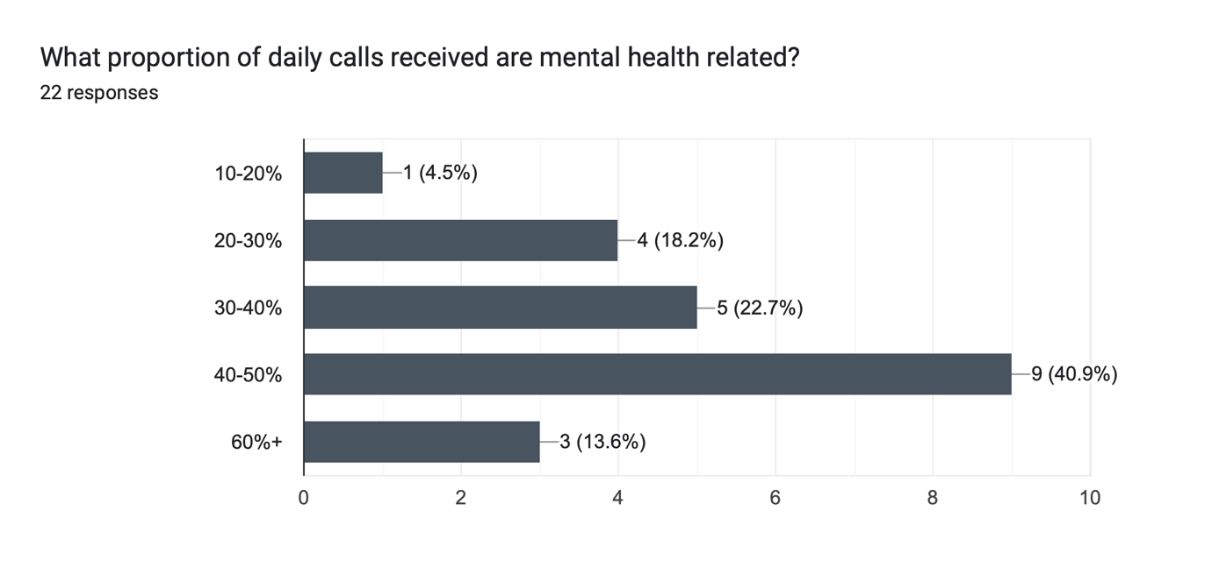

Q5) Do you believe there should be additional mental health training provided to police officers to identify and deal with all aspects of mental health when on response? (Such as PTSD, Schizophrenia, Personality Disorders, etc)

Most respondents to the study clearly support giving officers more training in mental health. Of the 22 responders, 18 said they were in favour of mental health training provided whereas 4 said they would not rather want it. It highlights the complex nature of mental health concerns and the possible advantages of raising police officers' understanding and providing them with further training. An example of an answer is,

Yes - but not to the extent whereby police are seen as mental health responders. All officers need to have 'First Aid' training, but they are not a replacement for paramedics. All officers need mental health training, but they are still not a replacement for the crisis team.

Given the current frequency of related calls and a shortage of mental health practitioners, multiple emphasised the need for mental health services equipped to police dispatches to deal with mental health concerns properly. While agreeing that police shouldn't be expected to act as mental health responders, some emphasised the significance of recognising mental health disorders to provide proper intervention and assistance. In contrast, those who opposed further training expressed worries about believing that police officers would manage mental health issues, which might turn the police force into a round-the-clock mental health response service. Some said that concentrating on mental health problems might take attention away from the main policing duties. This refers to the College of Policing (2023) scheme where statistics suggest the decrease in mental health related calls, this could suggest the scheme of utilising the right care right person system deem to be effective in training police officers in this field as their knowledge and skills are met to deal with these issues.

Q6) What types of mental health training are police officers trained to deal with when responding to witnesses/victims/suspects at an incident? 45.5% substance use, 31.8% All, 9.1% Anxiety, and 13.6% Depression.

These results show that police officers receive substantial attention on substance use disorder. However, fewer officers’ results show for mental health illnesses including depression and anxiety, suggesting a lower degree of specialised training for these conditions. It appears that there may be gaps in training coverage or a need for more comprehensive training programs to address the wide range of mental health issues encountered by police officers in the course of their work, given that only one-third of officers reported having received training on all listed mental health conditions.

This relates to the College of Policing, “Crisis Intervention Teams (CITs)” (2020) scheme, which suggests that officers may only be trained in the required fields such as substance use due to the nature of the job and learning about class A,B,C drugs but considering the results from the questionnaire, it indicates that officers are more likely aware of substance use rather than any other mental health issues based on the training provided or it’s awareness.

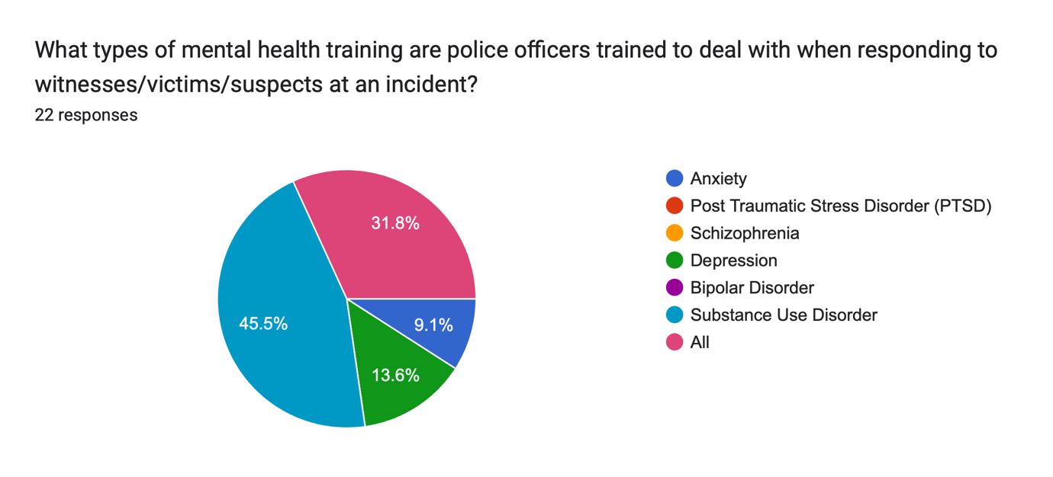

Q7) Have you found the mental health training provided to be helpful in identifying and dealing with future mental health incidents?

None of the participants rated the training as ‘Not At All Very Effective’ or ‘Very Effective.’ Instead, 36.4% of participants found it ‘somewhat effective’, while the majority, comprising 63.6% of participants, considered it ‘not very effective’. This suggests that the training input received as of today may not cover all aspects of mental health issues except substance use as seen by the majority in question 6. To add, out of the 4 categories, 2 were 100% certain, suggesting a certainty on what officers thought about the effectiveness of the mental health training provided. This questions whether police officers should be dealing and responding to mental health calls as the majority find the training to be not very effective. This reflects the perspective of CEO Dr Sarah Hughes of the Mental Health Charity Mind who said,

It is simply impossible to take a million hours of support out of the system without replacing it with investment and mental health services are not resourced to step up overnight (BBC News, 2023).

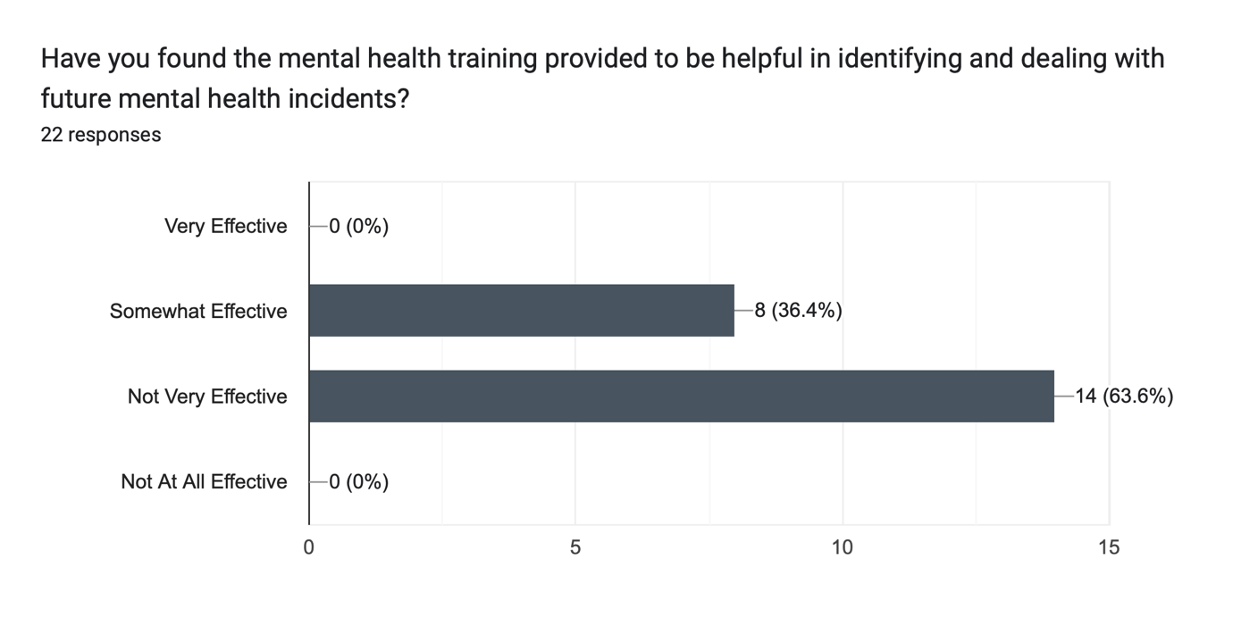

Q8) Should mental health professionals be dispatched alongside police officers to respond to mental health emergencies?

The results were as follows: out of 22 participants, 20 (90.9%) answered affirmatively, while 2 participants (9.1%) expressed disagreement. This overwhelming majority in favour suggests strong support among police officers for the integration of mental health professionals into emergency response teams. It stresses how much support they need from another service. This refers to the Child and Adolescent Mental Health Services CAMHS or similar agencies that could play a crucial role in helping address mental health crisis more effectively (Young Minds, 2021). The correlation between the study and results from the survey indicates these services are vital in addressing the support for police officers in response.
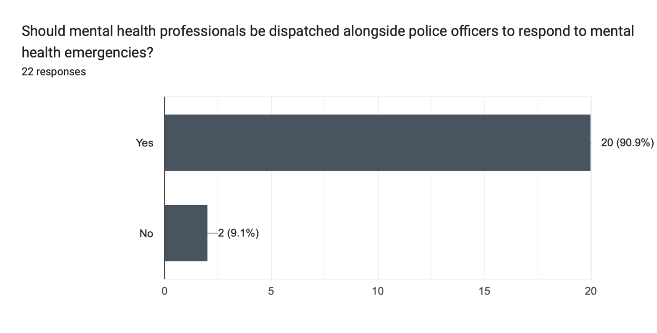

Q9) If yes, what other services could you think of that should respond alongside police officers when dealing with mental health issues?

The answers suggest the need for Multi-Agency Collaboration as most participants mentioned NHS staff, ambulance service, and well-being services to deal with mental health issues alongside the police. Other respondents mentioned the need for a specialist support team, examples such as a police specialist team to be dispatched alongside response officers. Some respondents mentioned the need to minimise police involvement by not responding at all as other services should be in place to deal with it.

Q10) Do you feel comfortable dealing with mental health issues followed by the training?

The questionnaire's results show that most police officers, 72.7%, do not feel comfortable dealing with mental health concerns. This shows that more or other kinds of training would be required to adequately train officers to deal with such circumstances. 27.3% of the participants indicated that they felt comfortable, suggesting that some of them found some degree of effectiveness in the existing training approaches. This refers to Casey’s (2023), where the training of police officers is reviewed which could suggest the need for reform based on the feedback from the survey.
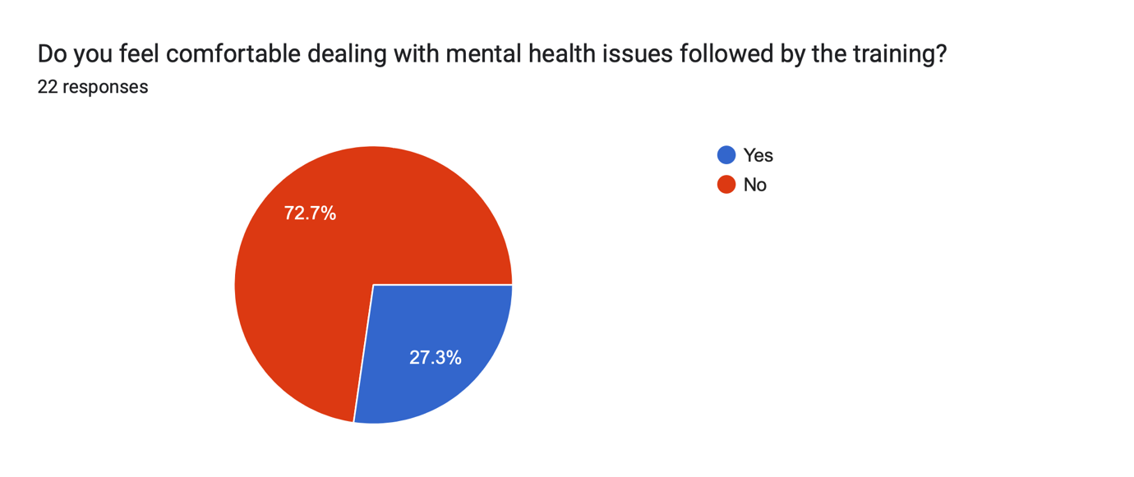

Q11) Have you ever responded to a mental health incident where another agency/service deals with the mental health aspect of the incident?

While 63.6% of respondents claimed they had encountered such a situation, 36.4% of respondents stated they had never done so. This suggests that there's a good chance police officers may handle mental health issues that require collaboration or coordination with other agencies or services that provide mental health care. This demonstrates how important interagency cooperation and communication are to handling mental health emergencies effectively.
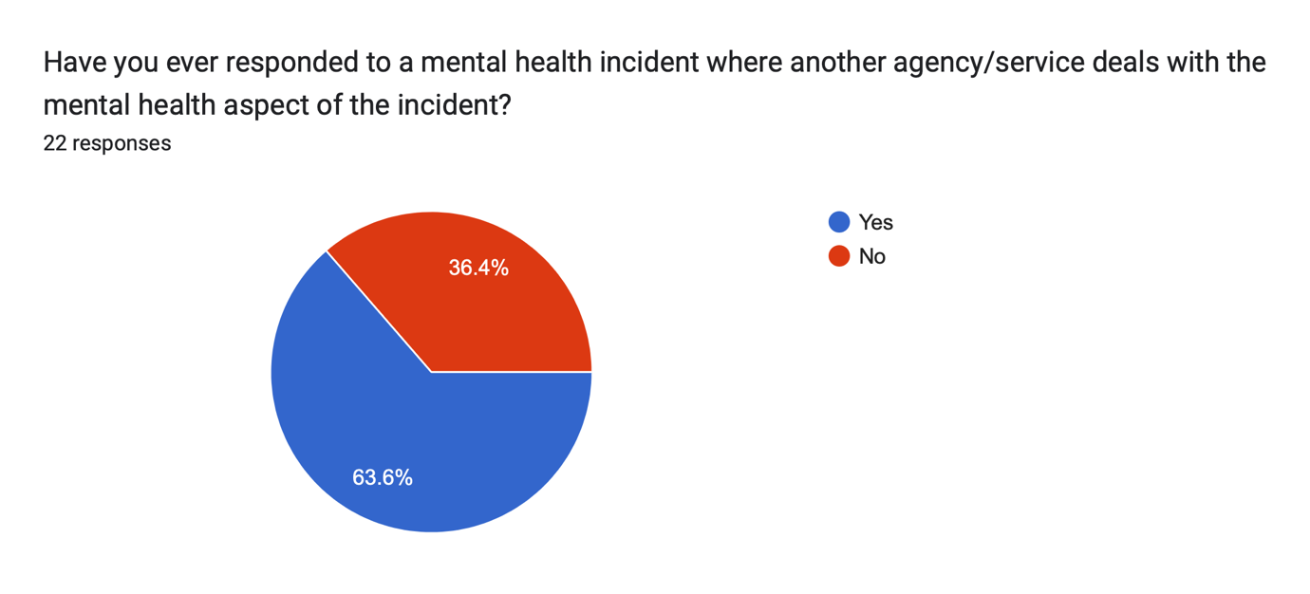

Q12) If yes, could you provide the same support provided to witness/victim, suspect based on your training provided?

The findings reveal that 59.1% of participants gave a yes answer, suggesting that they do provide constant assistance to those who are either suspects or witnesses/victims. But 40.9% of the participants said they don't offer the same level of support. This implies that depending on an individual's position in an incident, police officers may approach and support them differently. It could be the result of different rules and regulations, officer discretion, or different interpretations of training procedures.
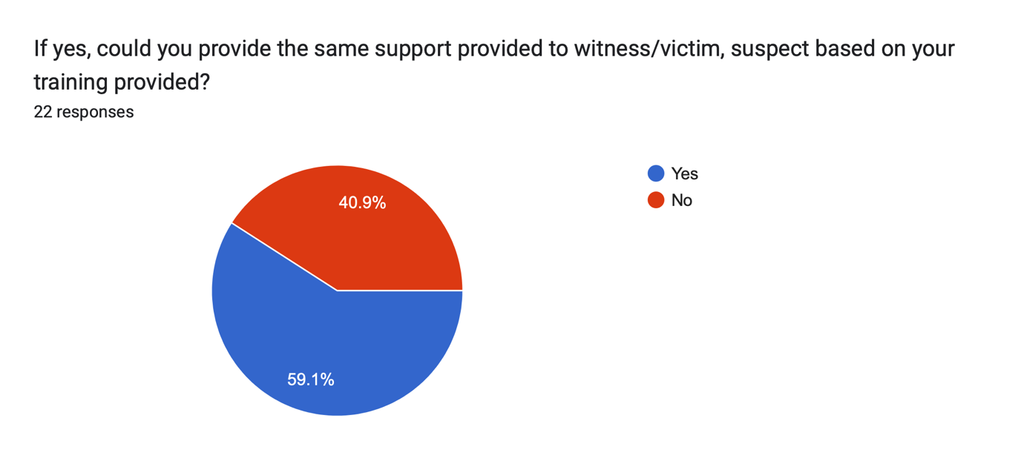

Q13) On a scale of 1-10, how satisfied are you with the mental health support training provided?

The distribution of satisfaction scores over the lower to mid-range of the scale is quite even. 12 out of 20 participants, or the majority, ranked their satisfaction between 5 and 8, indicating a moderate level of satisfaction overall. 4 people gave a rating of less than 5 indicating that a significant percentage of participants had lower levels of satisfaction. This can point to areas in which the police officer mental health assistance training program needs to be improved upon or adjusted.
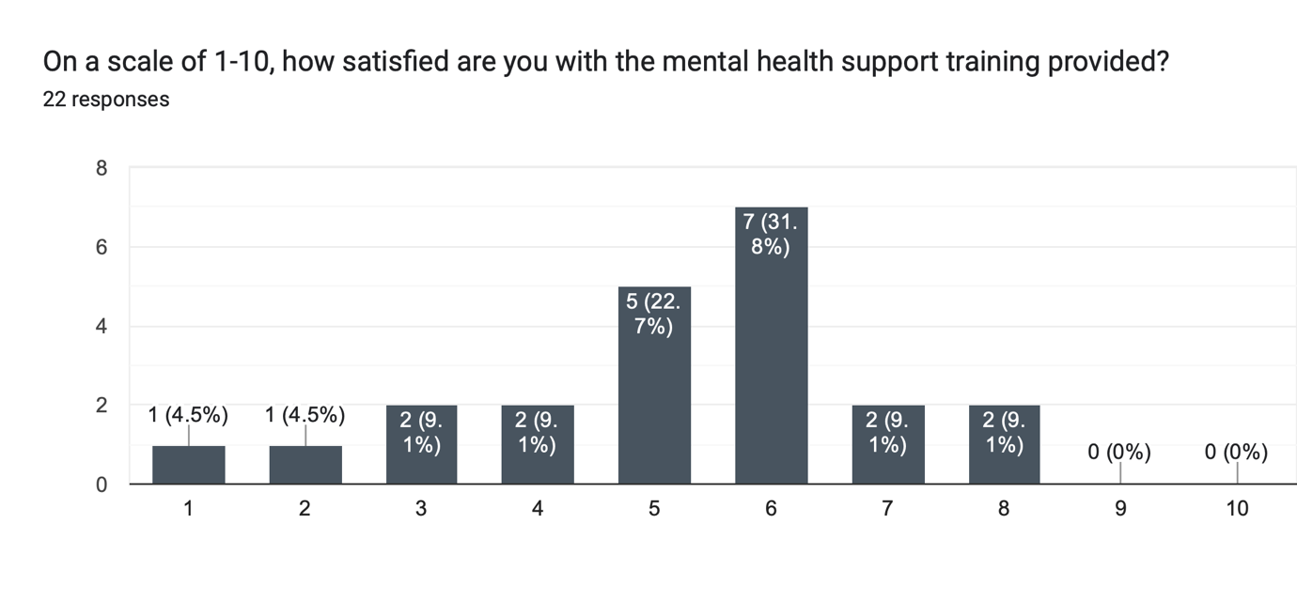

Conclusion
The overall aim of this research was to advance an understanding of:

Are police officers’ mental health workers and should the police be dealing with and responding to mental health issues and is there adequate mental health training provided to police officers to deal with it.

The specific research aim was to ascertain whether police officers are mental health workers based on their role in responding to mental health crisis. The first objective was to ascertain whether this is true by examining their conduct during such incidents and assessing whether mental health considerations are integrated into their training.

The second objective was conducted by examining how police officers respond to mental health emergencies and how well mental health issues are integrated into their training, the study seeks to establish whether police officers qualify as mental health professionals. Using responses from questionnaires conducted by Dyfed Powys Police Officers, it aims to assess the appropriateness of mental health training provided to officers. The study also examined how police respond to mental health crisis, the effects these crisis have on them, and how well-trained they are for situations like this.

The third objective investigated whether officers are receiving effective training for proactive mental health issues management and will also get officers' perspectives on how confident they feel handling mental health issues given the training they have received. In the end, the study will establish if changes to police mental health training are required.

Following the findings from the literature review and empirical research, in objective one, mental health is arguably questionable regarding whether police officers are mental health workers based on the role in responding to mental health issues. Rowley's (2023) statement arguing the research and police officers survey establishes police officers are currently mental health workers based on the status of the police response to mental health. The survey established a balance of debate on whether they are mental health workers but found that this was down to the service being a 24/7 service, the high number of calls received that are mental health related and the lack of other supportive services make police officers having to respond to these issues. The research shows that based on the job description, the research shows that police officers are not classified as mental health workers (Syal, 2023) and survey results examined show police officers are only classified as mental health workers due to insufficient services available and workload, as the following comment suggest,

“At present we receive a high volume of calls mental health related and due to a lack of services I would say yes police officers at present are mental health workers”.

It seriously emphasises that even with the 28% increase in mental health related incidents between 2014 and 2018 across 26 forces, it underscores the importance that even with the government’s implementation of the reduction of police officers responding to fewer calls related to mental health (Future Care Capital, 2023), adhering to this is essential to reduce mental health workload for police officers. Following the findings from the literature review and empirical research for objective two, the Casey (2023) review emphasised,

“The Met has faced significant challenges over the last ten years. Many of these have been beyond their control. These include greater non-crime demand”.

Suggesting that ‘control’ is needed for these challenges to be tackled which argues the adequacy of the mental health training provided. This also questions the appropriateness of whether police officers should be mental health workers as suggested by Her Majesty's Inspectorate of Constabulary and Fire & Rescue Services (p.g 15, 2018) where 70% out of 17,043 found it was health service’s responsibility to deal with mental health and 2% found it was the police forces responsibility. It also shows from a public perspective that police officers aren’t favourited to deal with these issues and questions whether they should be dealing with these issues not only for police officers’ sake but in the eyes of the public too.
The survey results found that the majority of police officers aren’t comfortable dealing with mental health issues based on the training provided and the knowledge of dealing with a wide range of mental health issues. Most respondents emphasised that they could provide the same support to those in mental health crisis based on what other services were provided. In addition, the CEO of the Mental Health Charity Mind, Sarah Hughes mentioned,

"It is simply impossible to take a million hours of support out of the system without replacing it with investment and mental health services are not resourced to step up overnight,"

Based on the findings throughout and empirical research, it questions whether there is the need to invest in mental health training for police officers for reasons being they aren’t seen as mental health workers in the public eye and members within the force, the training is inadequate based on the knowledge provided in training and the discomfort of dealing with mental health issues. Many participants suggested the need to learn more about mental health issues needed to tackle when in need of crisis and to have a good understanding of what mental health aspects they deal with.

Fundamentally, police officers should not be classified as mental health workers and they are only being considered mental health workers based on the current service the police provide to mental health incidents. The lack of confidence within the force when dealing with mental health issues and the lack of training, suggests that the police aren’t built currently to deal with the wide range of mental health issues exempt from using Section 135/136 of the Mental Health Act (1983), as used to preserve life and provide safeguarding to those who need it, which is clarified under the job role description of the conduct of a constable.

Reference list
15 Writers (2019) Understanding the Research Onion [Online Image], 15 Writers. Available at: https://15writers.com/research-onion/ (Accessed: 9 February 2024).
Amato, P. (2018) Top 10 Reasons to Study Philosophy, College of Arts and Sciences. Available at: https://drexel.edu/coas/news-events/news/2018/October/10-reasons-study-philosophy/#:~:text=Philosophical%20study%20develops%20writing%2C%20reading (Accessed: 14 February 2024).
Assarroudi, A. et al. (2018) Inductive and Deductive: Ambiguous Labels in Qualitative Content Analysis- ‘The Qualitative Report’, ProQuest, pp. 219–221. Available at: https://www.proquest.com/docview/2122314268/fulltextPDF/D53586D3F0E4E24PQ/1?accountid=17159&sourcetype=Scholarly%20Journals (Accessed: 15 February 2024).
Baker, C. and Wade, E.K. (2023) Mental Health statistics: prevalence, Services and Funding in England, House of Commons Library UK Parliament, p. 32. Available at: https://commonslibrary.parliament.uk/research-briefings/sn06988/#:~:text=In%202021%2F22%2C%201.81%20million,Annual%20IAPT%20Report%202021%2F22. (Accessed: 1 February 2024).
BBC NEWS (2023) ‘Grieving man’s Concern over 999 Mental Health Call Changes’, BBC News, 2 August. Available at: https://www.bbc.co.uk/news/uk-england-south-yorkshire-66377683#:~:text=Dr%20Sarah%20Hughes%2C%20chief%20executive (Accessed: 4 December 2023).
Bhat, A. (2018) Questionnaires: Definition, Advantages & Examples, QuestionPro. Available at: https://www.questionpro.com/blog/what-is-a-questionnaire/#:~:text=Uniformity%3A%20Questionnaires%20are%20very%20useful (Accessed: 9 February 2024).
Bhattacherjee, A. (2019) Sampling, usq.pressbooks.pub. Available at: https://usq.pressbooks.pub/socialscienceresearch/chapter/chapter-8-sampling/ (Accessed: 29 February 2024).
Bittner, E. (1970) The Functions of the Police in Modern Society, NCJRS.GOV. National Institute of Mental Health Center for Studies of Crime and Delinquency 5454 Wisconsin Avenue Chevy Chase, Maryland 20015: Public Health Service, p. 119. Available at: https://www.ojp.gov/pdffiles1/Digitization/147822NCJRS.pdf (Accessed: 8 February 2024).
Bleksley, P. (2023) ‘Peter Bleksley Interview on: Are Police Officers Mental Health Workers? ’, Daniel Hurford.
Braun, V. and Clarke, V. (2006) Using Thematic Analysis in Psychology, Qualitative Research in Psychology. Available at: https://doi.org/10.1191/1478088706qp063oa.
Bryman, A. (2016) Social Research Methods. 5th edn. Oxford: Oxford University Press, p. 26.
Bryman, A. et al. (2021a) Bryman’s Social Research Methods. 6th edn. Oxford: Oxford University Press, p. 350.
Bryman, A. et al. (2021b) Bryman’s Social Research Methods. 6th edn. Oxford: Oxford University Press, p. 142.
Bryman, A. et al. (2021c) Bryman’s social research methods. 6th edn. Oxford: Oxford University Press, pp. 23–25.
College of Policing (2015) Estimating Demand on the Police Service, College of Policing, p. 9. Available at: https://paas-s3-broker-prod-lon-6453d964-1d1a-432a-9260-5e0ba7d2fc51.s3.eu-west-2.amazonaws.com/s3fs-public/2021-03/demand-on-policing-report.pdf (Accessed: 4 December 2023).
College of Policing (2016) Introduction and Strategic Considerations, College of Policing. Available at: https://www.college.police.uk/app/mental-health/introduction-and-strategic-considerations (Accessed: 8 February 2024).
College of Policing (2020) Crisis Intervention Teams (CITs), College of Policing. Available at: https://www.college.police.uk/research/crime-reduction-toolkit/crisis-intervention-teams-cits#:~:text=Officers%20are%20taught%20de%2Descalation (Accessed: 6 December 2023).
College of Policing (2023a) Right Care Right Person – Humberside Police, www.college.police.uk. Available at: https://www.college.police.uk/support-forces/practices/smarter-practice/right-care-right-person (Accessed: 8 February 2024).
College of Policing (2023b) Right Care Right Person Toolkit, College of Policing. College of Policing. Available at: https://www.college.police.uk/guidance/right-care-right-person-toolkit (Accessed: 13 December 2023).
Dodd, V. (2023) ‘Met Police to Stop Attending Emergency Mental Health Calls’, The Guardian, 28 May. Available at: https://www.theguardian.com/uk-news/2023/may/28/met-police-to-stop-attending-emergency-mental-health-calls (Accessed: 7 November 2023).
Dovetail Editorial Team (2023) What Is Inductive Coding in Qualitative Research?, dovetail.com. Available at: https://dovetail.com/research/inductive-coding/#:~:text=Inductive%20coding%20is%20a%20ground (Accessed: 18 April 2024).
Fahy, T., Bittner, E. and Dunn, J. (1989) ‘The Police as a Referral Agency for Psychiatric Emergencies—A Review’, Medicine, Science, and the Law, 29(4), pp. 315–322. Available at: https://doi.org/10.1177/002580248902900411.
Future Care Capital (2023) Police in England to Attend Fewer Mental Health call-outs under New Government Plan, Future Care Capital. Available at: https://futurecarecapital.org.uk/latest/police-to-attend-less-mental-health-calls/#:~:text=At%20the%20moment%2C%20however%2C%20some (Accessed: 4 December 2023).
Gabriel, D. (2013) Inductive and Deductive Approaches to Research, Deborahgabriel.com. Available at: https://deborahgabriel.com/2013/03/17/inductive-and-deductive-approaches-to-research/ (Accessed: 9 February 2024).
GOV.UK (2017) Mental Health Act 1983. Available at: https://www.legislation.gov.uk/ukpga/1983/20/section/135 (Accessed: 4 December 2023).
Greene, J. (2009) An Overview of Mixed Method Research, ResearchGate. Available at: https://www.researchgate.net/publication/233882561_An_overview_of_mixed_method_research (Accessed: 29 February 2024).
Hamilton, F. (2024) ‘Police to Free up 1m Hours a Year by Ending Mental Health Callouts’, www.thetimes.co.uk, 1 February. Available at: https://www.thetimes.co.uk/article/police-to-free-up-1m-hours-a-year-by-ending-mental-health-callouts-f7z52ln0k#:~:text=Police%20to%20free%20up%201m%20hours%20a%20year%20by%20ending%20mental%20health%20callouts (Accessed: 26 July 2023).
Her Majesty's Inspectorate of Constabulary and Fire & Rescue Services (2018) Policing and Mental Health Picking up the Pieces, HMICFRS, p. 15. Available at: https://assets-hmicfrs.justiceinspectorates.gov.uk/uploads/policing-and-mental-health-picking-up-the-pieces.pdf (Accessed: 12 January 2024).
HMICFRS (2018a) Police Cannot Fix a Broken Mental Health System, His Majesty’s Inspectorate of Constabulary and Fire & Rescue Services. Available at: https://hmicfrs.justiceinspectorates.gov.uk/news/news-feed/police-cannot-fix-a-broken-mental-health-system/ (Accessed: 4 December 2023).
HMICFRS (2018b) Policing and Mental Health Picking up the Pieces, His Majesty’s Inspectorate of Constabulary and Fire & Rescue Services (HMICFRS) , p. 9. Available at: https://assets-hmicfrs.justiceinspectorates.gov.uk/uploads/policing-and-mental-health-picking-up-the-pieces.pdf (Accessed: 7 December 2023).
Holloway, D. (2018) DO POLICE OFFICERS RECIEIVE SUFFICIENT TRAINING IN MENTAL HEALTH? a FRONT LINE PERSPECTIVE OF POLICE OFFICER’S ATTITUDES AND BELIEFS ON ATTENDING MENTAL HEALTH CALLS, CCCU Research Space Repository, p. 52. Available at: https://repository.canterbury.ac.uk/download/e887ba5972654885d6ed30f9b3b75d3e2acc685d04bd89a20fea5ed674aea267/791561/Final%20thesis.pdf (Accessed: 8 February 2024).
Home Office (2014) Review of the Operation of Sections 135 and 136 of the Mental Health Act 1983. Department of Health, p. 4. Available at: https://assets.publishing.service.gov.uk/media/5a7dc149ed915d2acb6edf10/Literature_Review_S135_and_S136_of_the_Mental_Health_Act_1983.pdf (Accessed: 4 December 2023).
Home Office (2023) Agreement to Support Mental Health Care and Free up Police Time, GOV.UK. Available at: https://www.gov.uk/government/news/agreement-to-support-mental-health-care-and-free-up-police-time#:~:text=Patients%20experiencing%20a%20mental%20health (Accessed: 11 December 2023).
Iqrahamza (2024) What Is Philosophy?, Medium. Available at: https://medium.com/@iqrahamza1435/what-is-philosophy-b8c48c1ce552 (Accessed: 8 February 2024).
Kivunja, C. and Kuyini, A.B. (2017) ‘Understanding and Applying Research Paradigms in Educational Contexts’, International Journal of Higher Education, 6(5), pp. 27, 28, 30. Available at: https://files.eric.ed.gov/fulltext/EJ1154775.pdf (Accessed: 22 February 2024).
Mayer, Dr.A. (2023) Mental Health and the Police, Dr Andrew Mayers. Available at: https://andrewmayers.uk/mental-health-and-the-police (Accessed: 4 December 2023).
Melnikovas, A. (2018) Towards an Explicit Research Methodology: Adapting Research Onion Model for Futures Studies, Journal of Futures Studies. The General Jonas Žemaitis Military Academy of Lithuania Lithuania, pp. 33–34. Available at: https://jfsdigital.org/wp-content/uploads/2019/01/03-Melnikovas-Onion-Research-Model.pdf (Accessed: 9 February 2024).
Metropolitan Police (2023a) BARONESS CASEY REVIEW, Metropolitan Police. Baroness Casey of Blackstock DBE CB, p. 9. Available at: https://www.met.police.uk/SysSiteAssets/media/downloads/met/about-us/baroness-casey-review/update-march-2023/baroness-casey-review-march-2023a.pdf (Accessed: 1 February 2024).
Metropolitan Police (2023b) Met Police Launch ‘Right Care, Right Person’ to Get Mental Health Patients the Right Support, Metropolitan Police. Available at: https://news.met.police.uk/news/met-police-launch-right-care-right-person-to-get-mental-health-patients-the-right-support-474539 (Accessed: 20 November 2023).
Metropolitan Police (2023c) The Baroness Casey Review, Metropolitan Police. n/a: Metropolitan Police, p. 9. Available at: https://www.met.police.uk/SysSiteAssets/media/downloads/met/about-us/baroness-casey-review/update-march-2023/baroness-casey-review-march-2023a.pdf (Accessed: 3 December 2023).
Mind (2017) Mental Health Facts and Statistics, Mind, p. 4. Available at: https://www.mind.org.uk/media-a/2958/statistics-facts-2017.pdf (Accessed: 1 February 2024).
NHS England (2019) NHS England» Children and Adolescent Mental Health Service (CAMHs) Inpatient Services, England.nhs.uk. Available at: https://www.england.nhs.uk/mental-health/cyp/children-and-adolescent-mental-health-service-inpatient-services/ (Accessed: 8 February 2024).
O’Dwyer, L. and Bernauer, J. (2013) Research in the Social Sciences: Qualitative Meets Quantitative, SAGE Knowledge . SAGE Publications Inc. Available at: https://sk-sagepub-com.ezproxy.uwtsd.ac.uk/books/quantitative-research-for-the-qualitative-researcher/n3.xml (Accessed: 29 February 2024).
Phair, D. and Warren, K. (2021) Saunders’ Research Onion: Explained Simply, Grad Coach. Available at: https://gradcoach.com/saunders-research-onion/ (Accessed: 9 February 2024).
Police Foundation (2023) The Role and Responsibilities of the Police, Police Foundation. London: Police Foundation, p. 12. Available at: http://www.police-foundation.org.uk/wp-content/uploads/2017/06/roles_and_resp.pdf (Accessed: 4 December 2023).
Rethink Mental Health (2023) The Role of the Police in Supporting People in Mental Health Crisis, The Role of the Police in Supporting People in Mental Health Crisis. Available at: https://www.rethink.org/news-and-stories/blogs/2023/07/the-role-of-the-police-in-supporting-people-in-mental-health-crisis/#:~:text=The%20police%20are%20here%20to (Accessed: 4 December 2023).
Revie, L., John, E. and Mais, D. (2023) Suicides in England and Wales - Office for National Statistics, www.ons.gov.uk. Available at: https://www.ons.gov.uk/peoplepopulationandcommunity/birthsdeathsandmarriages/deaths/bulletins/suicidesintheunitedkingdom/2022registrations#:~:text=In%202022%2C%20there%20were%205%2C642 (Accessed: 1 February 2024).
Richards, G. and Davies, N. (2023) Performance Tracker 2023: Police, Institute for Government. Available at: https://www.instituteforgovernment.org.uk/publication/performance-tracker-2023/police (Accessed: 18 April 2024).
Royal College of Psychiatrists (2021) Thousands of People with a Mental Disorder Sent to Prison When They Need Treatment, www.rcpsych.ac.uk. Available at: https://www.rcpsych.ac.uk/news-and-features/latest-news/detail/2021/06/07/thousands-of-people-with-a-mental-disorder-sent-to-prison-when-they-need-treatment (Accessed: 8 November 2023).
SAGE (2016) Quantitative Research Methods, SAGE Publications Inc. SAGE. Available at: https://us.sagepub.com/sites/default/files/upm-binaries/70019_Mertler_Chapter_7.pdf (Accessed: 29 February 2024).
Samuel, M. (2023) Police to Stop Attending Mental Health Incidents Unless There Is Significant Safety Risk or Crime, Community Care. Available at: https://www.communitycare.co.uk/2023/07/26/police-to-stop-attending-mental-health-incidents-unless-there-is-significant-safety-risk-or-crime/#:~:text=Police%20to%20stop%20attending%20mental (Accessed: 13 December 2023).
Setia, M.S. (2016) ‘Methodology Series Module 3: Cross-sectional Studies’, Indian Journal of Dermatology, 61(3), pp. 261–264. Available at: https://doi.org/10.4103/0019-5154.182410.
Shorten, A. and Smith, J. (2017) ‘Mixed Methods Research: Expanding the Evidence Base’, Evidence Based Nursing, 20(3), pp. 74–75. Available at: http://dx.doi.org/10.1136/eb-2017-102699.
Spencer, D. (2022) Policing Can Win, Policy Exchange. London: Policy Exchange. Available at: https://policyexchange.org.uk/publication/policing-can-win/ (Accessed: 3 December 2023).
Strategic Review of Policing (2023) Strategic Review of Policing, Strategic Review of Policing. Available at: https://www.policingreview.org.uk/ (Accessed: 3 December 2023).
Syal, R. (2023) ‘Police in England and Wales Dealing with More Mental Health Crises than Ever’, The Guardian, 21 February. Available at: https://www.theguardian.com/uk-news/2023/feb/21/mental-health-crises-police-england-and-wales#:~:text=Some%20forces%20across%20England%20and (Accessed: 4 December 2023).
Tenny, S., Brannan, J.M. and Brannan, G.D. (2023) Qualitative Study, PubMed. Treasure Island (FL): StatPearls Publishing. Available at: https://www.ncbi.nlm.nih.gov/books/NBK470395/#:~:text=Qualitative%20research%20gathers%20participants%27%20experiences.
The Police Foundation (2022) A NEW MODE OF PROTECTION REDESIGNING POLICING AND PUBLIC SAFETY FOR THE 21ST CENTURY, Strategic Review of Policing in England and Wales, p. 9. Available at: https://policingreview.org.uk/wp-content/uploads/srpew_final_report.pdf (Accessed: 1 February 2024).
Thesismind (2019) Analysis of Saunders Research Onion, Thesismind. Available at: https://thesismind.com/analysis-of-saunders-research-onion/#:~:text=1.0%20Introduction%20to%20Saunders%20research (Accessed: 9 February 2024).
University of Southampton (2023) Police Officer and Civil Roles in the Police | Economic, Social and Political Sciences | University of Southampton, www.southampton.ac.uk. Available at: https://www.southampton.ac.uk/socsci/undergraduate/career_path_police.page#:~:text=A%20Police%20Officer%20serves%20to (Accessed: 20 November 2023).
Weaver, T. (2023) What Is Philosophy?, Orion Philosophy. Available at: https://www.orionphilosophy.com/stoic-blog/what-is-philosophy.
West Midlands Police & Crime Commissioner (2020) Predicting the Volume of Demand from Mental Health Related Police Incidents, West Midlands Police & Crime Commissioner , p. 3. Available at: https://www.westmidlands-pcc.gov.uk/wp-content/uploads/2021/02/14122020-EC-Agenda-Item-5c-Mental-Health-Deman-Investigation.pdf?x51080#:~:text=Mental%20health%20is%20becoming%20an,health%20related%20calls%20and%20incidents. (Accessed: 4 December 2023).
Young minds (2021) Guide to CAMHS, YoungMinds. YoungMinds. Available at: https://www.youngminds.org.uk/young-person/your-guide-to-support/guide-to-camhs/ (Accessed: 1 February 2024).

Appendix List
Appendix 1- Reference Peter Bleksley (2023) (Double Click to Play)

Question 1) Peter Bleksley Interview on:

“Are Police Officers Mental Health Workers?”



Appendix 2
Questionnaire (Google Forms)

Link https://docs.google.com/forms/d/e/1FAIpQLScX-qhJu_0kEqOCgOo9lyTz2_ILjT4opQgCuLTkrYRaaLLs_g/viewform

Introduction to the questionnaire
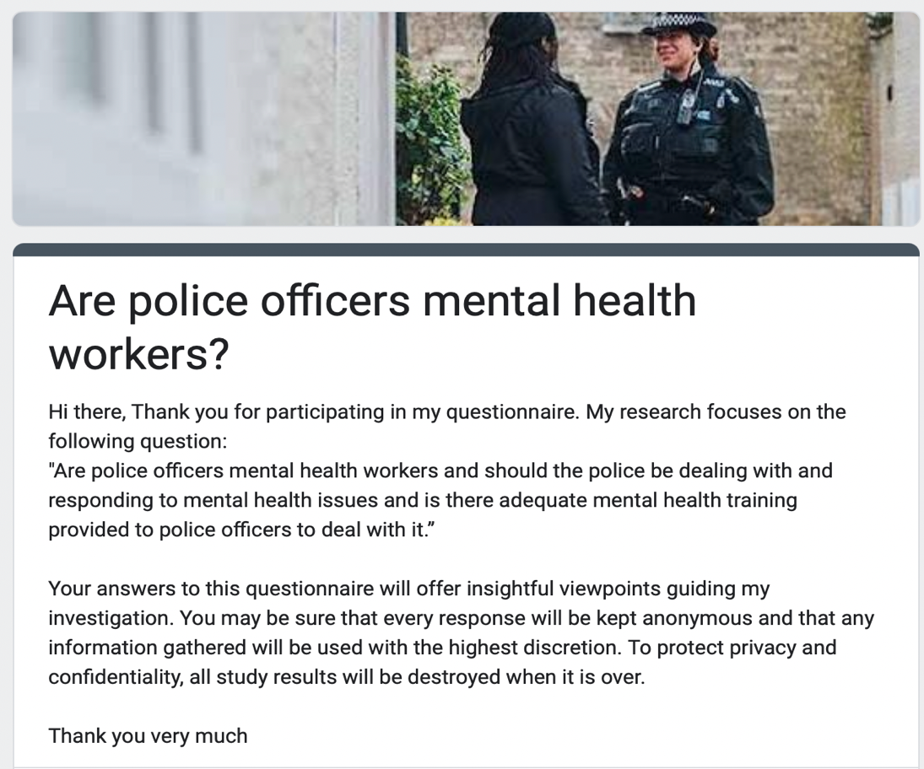

Question 1
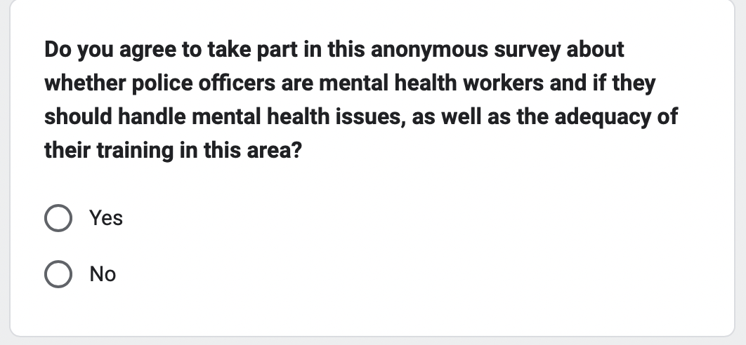

Question 2
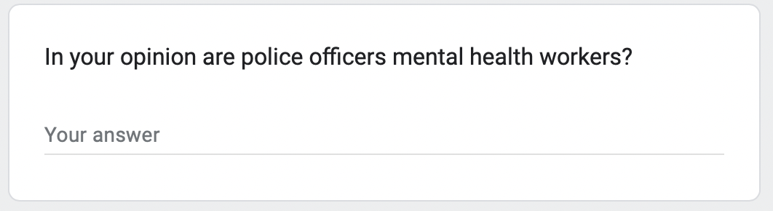

Question 3
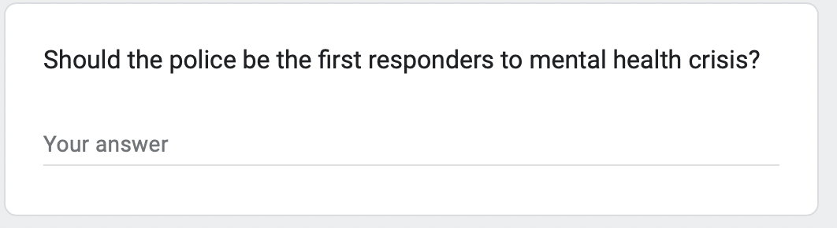

Question 4
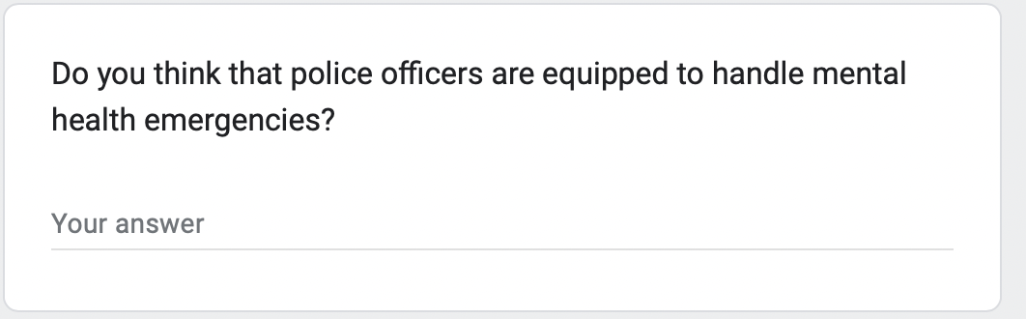

Question 5
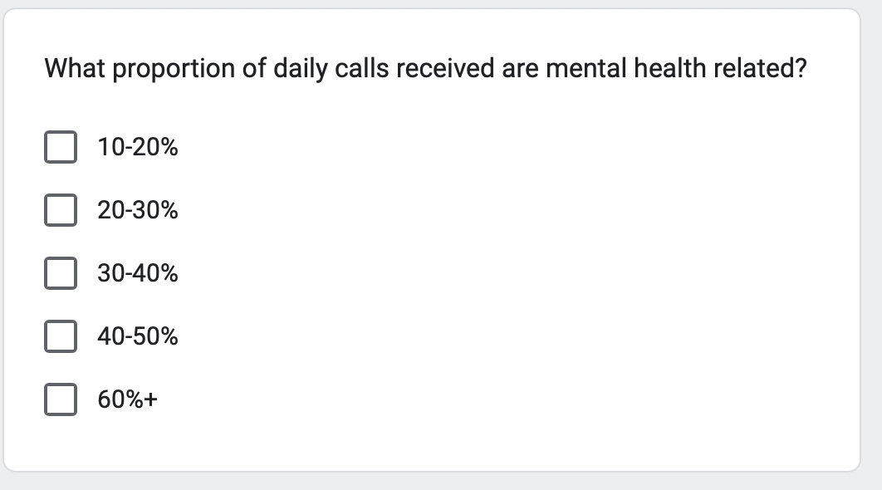

Question 6
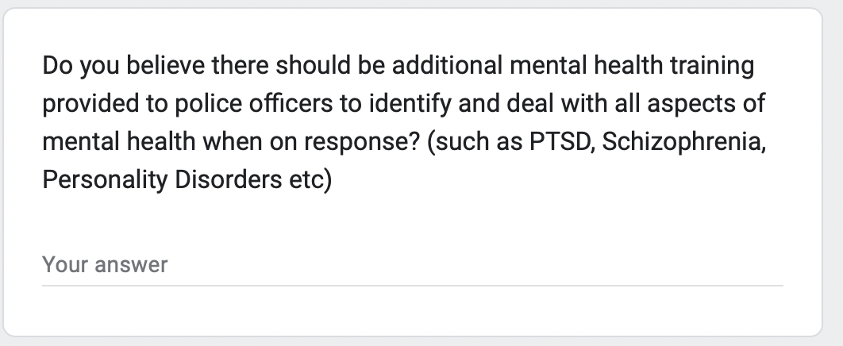

Question 7
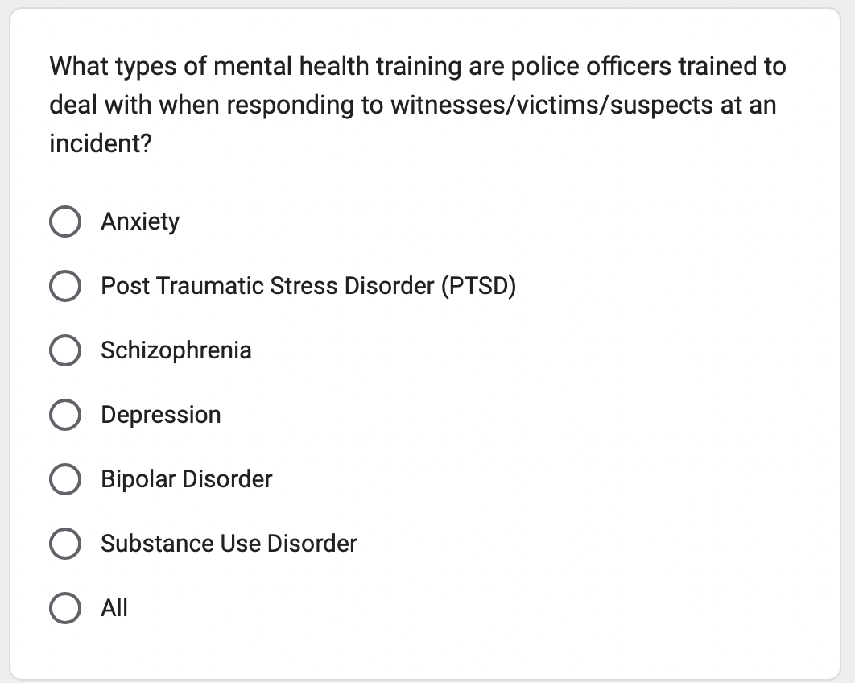

Question 8
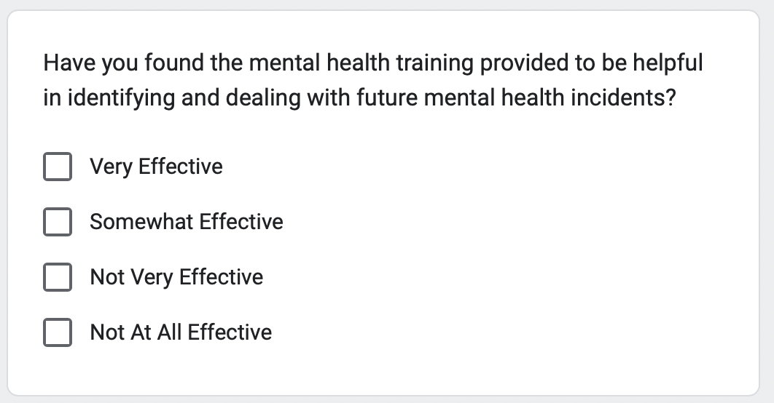

Question 9
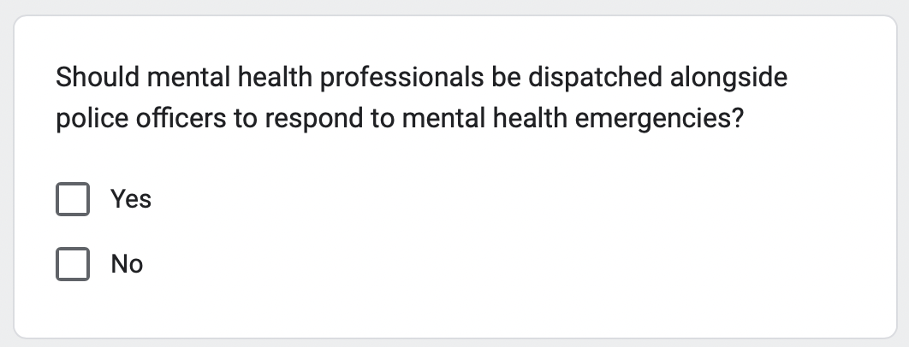

Question 10
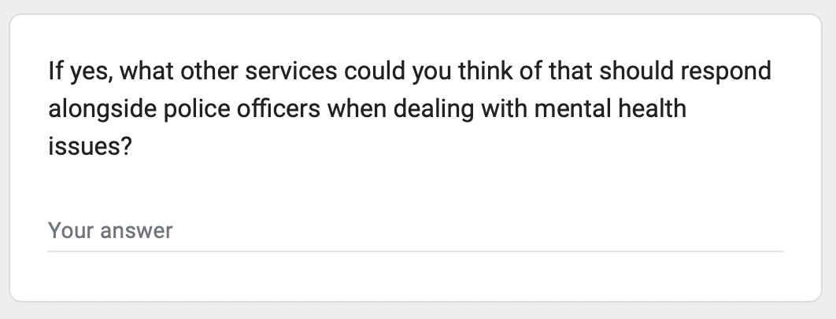

Question 11
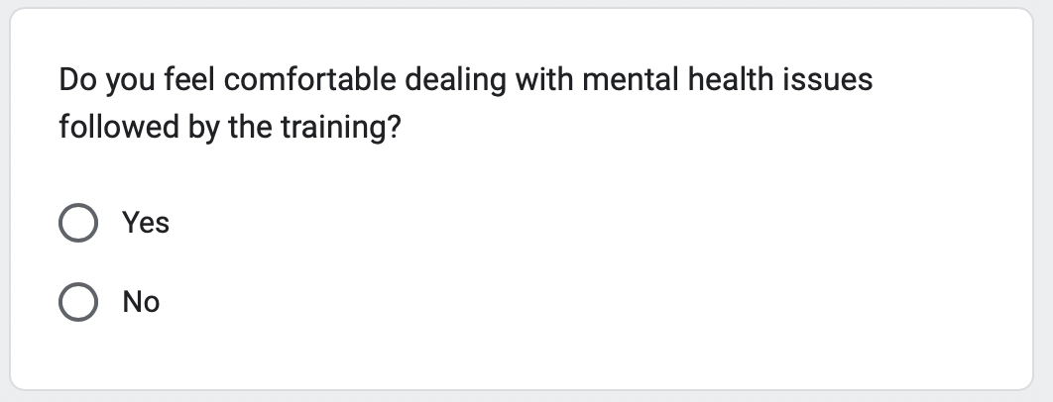

Question 12
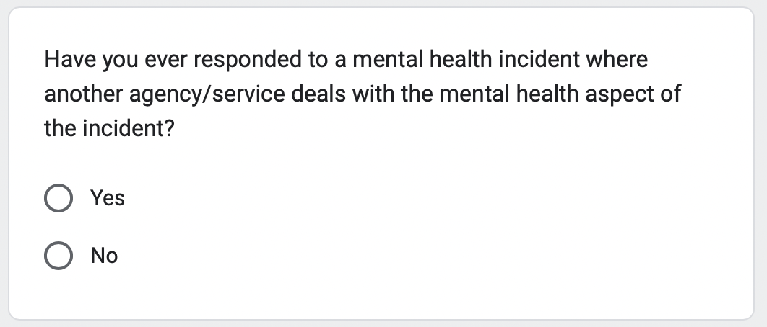

Question 13
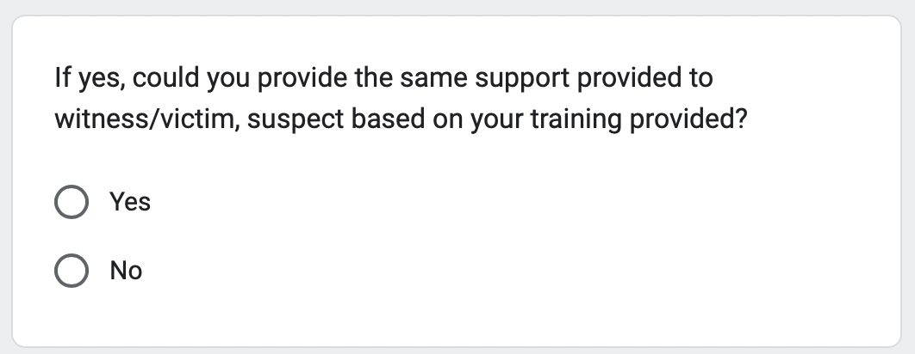

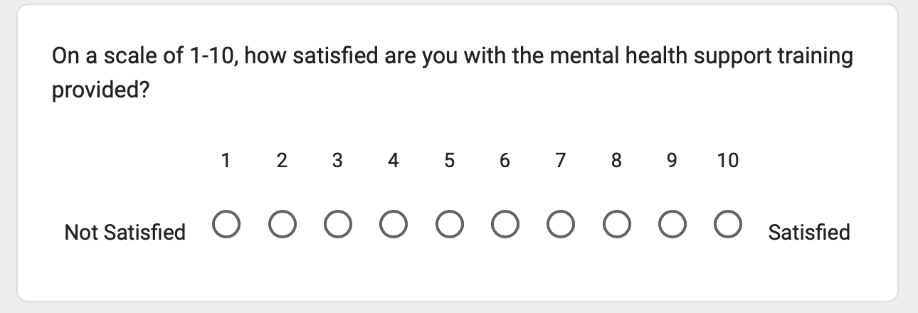
Question 14

