Rosie Fortune (2117797)
MA Professional Practice (Voice Pedagogy)
Work-Based Learning Project
BMPF7010

Developing a wellbeing program for college music students: Part two- addressing the challenges of transitioning to higher education.

Total Wordcount-15,794

Tables and Figures Contents 3
Project Proposal 4
Project Title: 5
Introduction 5
Wellbeing Concerns for Musicians and Music Students 5
Organisational Context 6
Methodology 6
Methods 7
Personal learning Outcomes 8
Ethical Considerations and Insider Research 9
Project Report 10
Introduction 10
Literature Review 12
Defining and Measuring Wellbeing 13
Adolescent Wellbeing 13
Transition to University 14
Music and Wellbeing 17
The Current Study 18
Methods 18
Pragmatism and Design-Based Research 18
Methodology 22
Qualitative and Quantitative Data Collection 24
Reflective Practice 25
Participants 25
Insider Research and Ethical Considerations 28
Findings 30
Qualitative Interview Results 30
Theme one- Experiencing shared and diverse wellbeing challenges 31
Living Independently 31
Raised Academic Standards 32
Mental and Physical health challenges 33
Managing Finances 35
The Impact of Covid 35
Uncertainty About the Future 36
Theme Two- Managing Wellbeing and Protective Factors 36
Importance of Friendship Groups 36
Managing Through Struggles 37
Developing Self-Management Skills 38
Theme Three- Managing Change in Support Systems 39
Accessing support at University 41
Theme Four- Exploring how wellbeing could be supported to ease transition to university 42
Relationships, Communication and Teamwork 42
Exploring shared experience 43
Making Industry Connections 43
Raising Awareness of Support Networks 44
Developing Economic Wellbeing 44
Engagement Might Be Low 44
Interview Findings Discussion 45
Shared and Diverse Wellbeing Challenges 45
Managing Wellbeing and Protective Factors 48
Managing change in support systems 49
Exploring how wellbeing could be supported to ease transition to university 50
Impact upon Next Stage of Research 52
Quantitative Survey Results 52
What are the wellbeing challenges faced by undergraduate and college music students? 53
Wellbeing Elements 53
Importance of wellbeing elements 54
Wellbeing challenges 55
Are there differences or similarities between the wellbeing challenges faced by undergraduate and college music students? 56
Comparing wellbeing challenges over the last year. 56
Comparing ratings of wellbeing over the last year. 57
How can my wellbeing program be developed in response to the research findings to support music students now and in their futures? 58
Do participants believe musicians have more wellbeing challenges than those in other professions? 58
Which elements of wellbeing do the undergraduate and college students believe music students need support with? 58
Comparing Responses 59
Would you attend a wellbeing program for musicians if it was offered? 60
Do you think a wellbeing program should be delivered in groups, individually or either way? 61
Survey Findings Discussion 62
Synthesis of collected findings 64
Implications for refinements to my wellbeing program 65
Conclusion and Recommendations 66
Personal Reflections 66
Reflection in Action 66
Reflection on Action 66
Research Limitations 66
Suggestions and Implications for future research 67
Final Thoughts and Next Steps 68
References 69
Appendices 85

Tables and Figures Contents

Tables:
1- Participant Demographics-Interviews
2- Participant Demographics-Survey
3-How important do you think each of the elements are to your wellbeing?
4- Rate your wellbeing over the last year using the given categories.
5-Do you think musicians need support with…-college/undergrad comparison.
Figures:
1-Gantt chart
2-Development Research DBR process
3-The research process-study part one
4- The research process-study part two
5- The research process-study part three
6- Data Collection and Analysis Flow Chart
7-Coding Map
8-Graph-Elements considered part of wellbeing
9-Graph-Wellbeing challenges over the last year
10- Wellbeing over the last year- undergrad/college comparison
11-Do you think musicians need support with…
12-If a wellbeing program was offered would you attend?
13-How should a wellbeing program be delivered?

Project Proposal
Project Title: Developing a wellbeing program for college music students: Part two- addressing the challenges of transitioning to higher education.

Introduction
This research project is part two of a three-part study and investigates the wellbeing challenges of college (16-to-19-year-olds) and undergraduate popular music students. Using a design-based paradigm (The Design-Based Research Collective, 2003), the data will be analysed to refine a wellbeing program designed specifically for college music students in part one of this study (Fortune, 2023; Appendix 1). Previous research has revealed the wellbeing challenges of both adolescents and musicians (Fortune, 2023) suggesting, that when combined, there is potential for greater severity of illbeing. The transition from college to undergraduate study has been found to pose a significant threat to music students' wellbeing (Perkins et al., 2017; Pecen et al., 2018; López-Íñiguez & Bennett, 2020;) highlighting that the importance of wellbeing support before transition is vital (European Commission, 2023; Musgrave, 2023). Furthermore, post-COVID ramifications present several challenges for Further Education (FE) learners including, skills gaps, poor concentration, behavioural difficulties, lack of confidence and resilience, and poor mental health (GOV.UK, 2022).

Wellbeing Concerns for Musicians and Music Students
Musicians have been found to encounter many wellbeing challenges (Ascenso et al., 2017; Visser et al., 2021; Ong & Takenaka, 2021), such as playing-related injuries (Silva et al., 2015), mental health difficulties associated with touring (Newman et al., 2021), drug and alcohol misuse (Forsyth et al., 2016; Raeburn, 2000), imposter syndrome (Sims & Ryan, 2023), performance anxiety (Taborsky, 2007; Fernholz et al., 2019) and financial precarity (Sutherland et al., 2019). It may be that some musicians’ wellbeing challenges in their professional careers are foreshadowed by their university experiences. The transitional period from college to undergraduate study also presents wellbeing challenges for music students (Rossett et al., 2022) such as competition, isolation, and comparison (Pecen et al., 2018). These findings present a compelling reason to provide effective wellbeing support for music students.

Organisational Context
The Manchester College (TMC) is an FE provider in the Northwest of England and its City Campus houses over 1400 16-to-19-year-old students, with 95 studying vocational courses in popular music performance. Students present a diverse range of young musicians across Greater Manchester (GM). This research is situated in the post-COVID context but also recognises that students at TMC may also face wellbeing challenges beyond these factors. Almost a third of this cohort comes from low-income households which can diminish confidence in career aspirations (Weinger, 1998) and impact educational outcomes (Ferguson et al., 2007; Ladd, 2012; Ratcliffe & McKernan, 2012; Lacour & Tissington, 2021). Students with Special Educational Needs (SEND) are more likely to suffer from mental health difficulties (Coughlan, 2011) and lower levels of wellbeing (Keis, 2020). 44.2% of music students at TMC have declared SEND, and 10.53% have an Educational Health Care Plan. Combined these factors may indicate that the levels of wellbeing amongst this cohort are low.
As a teacher of popular music performance at TMC, I am well-placed to conduct research with adolescent musicians. In part one of this study, a draft wellbeing program for adolescent musicians was created, in response to existing research, to address the wellbeing challenges experienced by both adolescents and musicians (Fortune, 2023). This second part of the study will result in a refined wellbeing program designed for college popular music students. Part three will be completed after my master’s as the size and scope of the project have proven too large to be achieved during this qualification. The final stage will be a pilot of the program in the 24/25 (November 24 to June 25) academic year with music performance students at TMC.

Methodology
This project will employ a design-based research paradigm (DBR; The Design-Based Research Collective, 2003) in a mixed methods study. DBR involves using an intervention to test a design, often in its early stages, by placing the intervention in a real-world context, in many cases the classroom (Joseph, 2004). Sandoval and Bell (2004. p. 199) describe the need for distinctly “usable knowledge” whilst also ensuring that this knowledge is “scientifically sound” and the inherent difficulty of achieving both these aims. DBR offers the opportunity for scientific rigour but recognises that often research must be carried out in the field to assess the effectiveness of the chosen intervention (Sandoval & Bell, 2004). DBR allows the researcher to respond to findings as they occur and adjust the intervention in progress (Hoadley, 2004). For this research project, a design-based paradigm is appropriate because the primary objective is to refine an existing design in response to the data gathered in the context of the music classroom. Whilst DBR can be accused of lacking in generalisability due to the very particular context in which it takes place (Hoadley, 2004) this research focuses on the unique needs and circumstances of the cohort so may be more likely to significantly impact music students at TMC (The Design-Based Research Collective, 2003).

Methods
Methods for this project will include the collection of quantitative and qualitative data.
Data collection and analysis methods:
- Semi-structured interviews with undergraduate music students exploring the participants’ experiences of wellbeing in the transition to undergraduate study and the potential impact of wellbeing interventions at college. The draft wellbeing program will be shared, and feedback sought.
- The interviews will be coded using Reflexive Thematic Analysis (RTA; Braun & Clarke, 2019), and the emerging themes will be used to refine the wellbeing program and inform the next stage of data collection.
- A survey will be employed to assess the current wellbeing of college and undergraduate music students and gather their opinions on necessary support areas.
- Survey data will be analysed, and the results used to complete further refinement of the wellbeing program if required.
To recruit undergraduate music students, social media posts will be created and circulated. For the college music students, those over 18 will be sent a Microsoft Teams message with the link to the survey. For those under 18, parents/guardians will be emailed directly with a link to the survey with an embedded consent form.
A GANTT chart has been created to manage and track progress throughout the project (Figure 1).
Figure 1
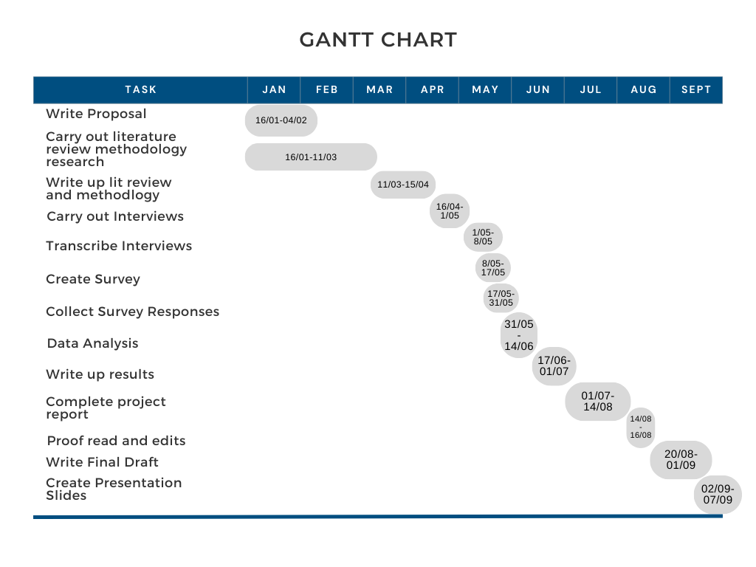
Personal learning Outcomes
*To develop an understanding of the current wellbeing challenges experienced by college and undergraduate music students.
*To improve evaluative and critical analysis skills in interpreting data.
*To develop an understanding of how data interpretation can be utilised to improve a wellbeing program.
*To develop skills in statistical analysis.
*To effectively analyse existing research on wellbeing interventions with adolescents, research around wellbeing for musicians and transitions to higher education (HE).

Ethical Considerations and Insider Research
Ethical considerations for this project include the potential for emotional harm to participants’ including the capacity for embarrassment which the adolescents taking part may be more prone to (Sargın, 2009). Ensuring all participants are aware that they can withdraw at any time and signposting to professional support could mitigate the risk of emotional harm (Greenbaum, 1999). To reduce the chances of response bias (Paulhus, 1991), and mitigate the risk of discomfort for participants, questionnaires will be completed anonymously to allow for distance between the researcher and current students. Interviewees will be reminded that they are at liberty to disclose whatever they feel comfortable with and no further, with the caveat that the researcher is looking for their experiences and there are no right or wrong answers. Informed consent must be gained from all participants with those under the age of 18 requiring parent/guardian agreement (Alderson & Morrow, 2011; see Appendix 2).
These ethical considerations are particularly pertinent when looked at alongside the role of the insider researcher. Advantages of this role include knowing those you intend to study well, which could positively impact rates of participation (Costley et al., 2010), participants being easy to recruit as they are in situ (Merriam et al., 2001), and ease in discussion due to familiarity with the researcher (Hodkinson, 2005). Conversely, participants may want to please the insider researcher and respond with what they think the researcher wants to hear (Bryant & Charmaz, 2007). Participants may also experience discomfort as they fear revealing thoughts or feelings that may be viewed negatively (Bell, 2005). Further criticism suggests that the insider researcher cannot achieve an objective view of the explored subject due to the inherent closeness to the participants (Brannick & Coghlan, 2007). By employing strategies to mitigate these concerns an insider researcher may still conduct ethical and viable research. Indeed, it may be that the subjective nature of the researcher’s interpretation can be an asset to the process as bias is expected and used as a resource in making meaning (Braun & Clarke, 2020).

Project Report

Introduction
Music students experience significant wellbeing challenges in their transition to Undergraduate study (Perkins et al., 2017; Pecen et al., 2018; López-Íñiguez & Bennett, 2020). Professional musicians’ wellbeing challenges extend beyond the destabilisation of transitions and include factors such as economic instability (Sutherland et al., 2019), performance-related injury (Elam et al., 2022) and mental health difficulties (Raeburn, 2000; Taborsky, 2007; Forsyth et al., 2016; Fernholz et al., 2019; Newman et al., 2021; Sims & Ryan, 2023). Arming music students with the tools to manage their wellbeing before they transition to university may result in fewer instances of illbeing whilst they study and in their professional careers.

High levels of mental health disorders (Newlove-Delgado et al., 2022), low levels of life satisfaction (Reuter et al., 2022) and significant rises in referrals to the Child and Adolescent Mental Health Service (CAMHS) in Greater Manchester (GM; Manchester City Council, 2022) reveal a worrying trend in youth wellbeing. Child poverty in Manchester is high at 37% (End Child Poverty, 2022), exceeding the UK average of 29% (cpag.org.uk, 2023). Links between poverty and wellbeing have been well documented (Roelen & Gassmann, 2008; Tiwari, 2008; Main, 2014; Cho, 2017) with pressure in the family, and financial hardship causing significant difficulties (Chaudry & Wimer, 2016). In the post-COVID environment, mental health concerns and high levels of poverty combined suggest that young people in GM may experience substantial wellbeing challenges. Collectively these findings highlight the need to develop a wellbeing program for the young musicians studying music performance at The Manchester College (TMC) where I teach.

This research forms the second part of a three-part study. Part one, a desk-based literature review, considered the wellbeing needs of 16 to 19-year-old college music students and culminated in the creation of a draft wellbeing program (Fortune, 2023). This second part is a mixed methods study exploring the wellbeing challenges experienced by both college and undergraduate music students to support their wellbeing across the transition from college to HE. Participant feedback is being sought to refine the existing draft wellbeing program. The program will then be piloted in part three of this study. On completion, the wellbeing program will be embedded into the curriculum of college students studying BTEC L3 Diplomas in Music Performance at The Manchester College (TMC).

I have taught BTEC Level 2 and 3 qualifications in music performance at TMC for twenty years, working with over 800 students. My students regularly experience wellbeing challenges. I have often felt powerless to support their wellbeing on a macro level and have instead favoured the 121 or small group holistic support I can effectively and ethically offer as a teacher. However, this study provides an opportunity for me to have a tangible impact on the quality of wellbeing advice and support offered to all music performance students at my college. The wellbeing program I will deliver in the future will be grounded in the evidence base from all three parts of this research project. I am hopeful that I can have a positive impact on my current and future students’ wellbeing whilst they are studying at college and in their transitions to university and professional working life.

This research aims to answer the following questions and sub questions:

- What are the wellbeing challenges faced by college and undergraduate music students?
  - How have undergraduates successfully managed their wellbeing?
- Are there differences or similarities between the wellbeing challenges faced by these two groups?
  - Which of the wellbeing elements is of most significant challenge to undergraduate and college music students?
- How can my wellbeing program be developed in response to the research findings to support music students now and in their futures?
  - Do participants believe musicians have more wellbeing challenges than those in other professions?
  - Which elements of wellbeing do the undergraduate and college students believe music students need support with?

Literature Review
Wellbeing research so far has not agreed on a definition of wellbeing or indeed how to measure it (Ryan & Deci, 2001). Despite considerable research into both adolescent wellbeing and transition to university, there remains a critical lack of evidence of interventions deemed to be effective (Vojt et al., 2018; Parsonage-Harrison et al., 2022). Wellbeing challenges for professional musicians are multifaceted and significant (Raeburn, 2000; Taborsky, 2007; Silva et al., 2015; Forsyth et al., 2016; Ascenso et al., 2017; Sutherland et al., 2019; Musgrave & Gross, 2020; Newman et al., 2021; Ong & Takenaka, 2021; Visser et al., 2021; Sims & Ryan, 2023) pointing to a need to provide wellbeing support that prepares music students with the tools to self-regulate as they study and upon entering the music industry.
Defining and Measuring Wellbeing
Wellbeing’s multifactorial nature (Vella et al., 2019) has hindered agreement on its definition (Ryan & Deci, 2001) making measurement difficult. Despite these difficulties, Simons and Baldwin (2021) suggest that a salutogenic (focused on health) proposing that, “wellbeing is a state of positive feelings and meeting full potential in the world. It can be measured subjectively and objectively using a salutogenic approach” (Simons & Baldwin, 2021. p 67). This definition encapsulates both the hedonic (pursuit of pleasure and happiness) and eudaimonic (search for true meaning and accomplishment) concepts of wellbeing (Ryan & Deci, 2001) which have historically been discussed as opposing concepts (Dooris et al., 2017). More recently as in the case of Simons and Baldwin (2021) these two concepts are brought together to reveal overarching definitions of wellbeing which encapsulate both components. Seligman (2011) posits that wellbeing cannot be measured as a construct on its own, but the elements of PERMA (positive emotions, engagement, relationships, meaning and accomplishments) can be measured individually to reveal wellbeing levels. More recently Donaldson et al. (2022) suggest the addition of physical health, mindset, working environment, and economic security to the PERMA framework resulting in a total of nine elements. This number could be seen as unwieldy and reveals both the complexity of the subject matter and the difficulties in reaching an agreed definition or measurement tool. These definitions or frameworks may also lack applicability in some cultures where wellbeing indicators may be influenced by diverse environmental or societal factors (Simons & Baldwin, 2021).

Adolescent Wellbeing
The problem of measuring wellbeing may have further impacts than theory. In their systematic mapping review, Vojt et al. (2018) found that among the thirty systematic reviews and sixteen controlled trials, none of the interventions had a positive impact on the mental health and wellbeing of the vulnerable adolescents taking part. Vojt et al. (2018) suggest that this startling lack of effective interventions reveals a significant flaw in the UK government’s commitment to improving the lives of vulnerable adolescents (UK Parliament, 2023) and propose a need for more targeted interventions to be assessed in research.

Parsonage-Harrison et al. (2022) agree with Vojt et al. (2018) declaring a lack of robust research into interventions to improve the wellbeing of adolescents. Their scoping review of occupation-based interventions (Parsonage-Harrison et al., 2022) goes further than Vojt et al. (2018) to suggest that outcome measures should be more universal to ensure that intervention studies can be effectively compared, and an evidence base can be developed. Parsonage-Harrison et al. (2022) also found that participants in the studies reviewed were rarely given the choice of what intervention they would partake in purporting that this effectively ignores the comprehensive findings around adolescent motivation and autonomy (Ross et al., 2020; Avedissian & Alayan, 2021). In attempting to improve the wellbeing of adolescent music students, a collaborative approach to intervention design as recommended by Parsonage-Harrison et al. (2022) could be more effective than interventions that don’t allow some form of autonomy for the adolescent participants.

Transition to University
For adolescents, the transition to university study is problematic (Huguenel & Conley, 2020). Recent research has sought to identify the specifics of the challenges students face in transition to HE studies and suggest interventions to improve wellbeing across this juncture (Money et al., 2019; Young et al., 2019; Kroshus et al., 2020; Cage et al., 2021; Gravett & Winstone, 2021; Thompson et al., 2021; Worsley et al., 2021; Cifuentes Gomez et al., 2022; Williams & Roberts, 2022) which are outlined below.
Cifuentes Gomez et al. (2022) interviewed Chilean University students who indicated transition concerns around academic issues ranging from an imbalance in expectation to reality of academic demand, ineffective study strategies, time management difficulties, and self-regulation. These findings align with Money et al. (2019) who examined teachers’ perspectives and found academic confidence and independent learning were two key factors in preparedness for university. Money et al. (2019) suggest students’ reliance on their teachers was actively reducing the opportunities to practice independent study and thus rendering them less likely to cope with the academic requirements of HE.

Both studies point to a mismatch between preparedness for HE and the academic demands students face albeit from the different perspectives of teacher and student (Money et al., 2019; Cifuentes Gomez et al., 2022). These qualitative studies have provided rich data but the small sample sizes of fourteen (Cifuentes Gomez et al., 2022) and nineteen participants (Money et al., 2019) reveal the need for more evidence to confirm these findings. A broader research base could reveal greater significance and generalisability; however, these studies collectively highlight that teacher perceptions are aligned with the experiences of students and underscore the need for better collaboration between schools, colleges and universities to ensure students are prepared for university as suggested by Worsley et al. (2021). The findings of Cage et al. (2021) share some similarities with Money et al. (2019) and Worsley et al. (2021) suggesting the development and offer of support networks and facilitating preparedness as crucial in a successful transition to HE. However, whilst Cage et al. (2021) recommend universities focus on fostering community with peer mentoring, and fund support services better, they also suggest that providing transition support pre-entry to university is paramount in this process. Collectively, these findings reinforce the need to provide wellbeing support that is coordinated across levels of education to provide a smooth transition to HE.

Building on these findings, Thompson et al. (2021) explore a wider set of challenges faced by HE students and focus specifically on struggles around independent learning and living (SAILL). Like Money et al. (2019) and Cifuentes Gomez et al. (2022) Thompson et al. (2021) suggest a lack of preparedness plays a part in these challenges. However, they purport that the seemingly simple act of navigating independent living is causing more issues for students now than in the past (Thompson et al., 2021). Thompson et al. (2021) assert that schools, colleges and universities should provide the tools for students to cope with their new responsibilities as HE learners and Worsley et al. (2021) agree suggesting practical interventions with the addition of workshops on “cooking, finances, budgeting, and independent learning and living” (Worsley et al., 2021. p. 9). Whilst Thompson et al. (2021) offer potential routes for interventions to support transitions to HE, Worsley et al. (2021) marks the most specific intervention advice given of all the transition studies in this literature review. Both studies, despite low sample sizes and their qualitative nature, when viewed alongside the findings of Cifuentes Gomez et al. (2022) and Money et al. (2019) highlight the need for practical intervention to support young people in the transition to HE.

In contrast to the previous studies, Young et al. (2019) surveyed 60 undergraduate students in a mixed methods study and found that anxiety was within the normal range. They suggest this is likely due to the HE in FE environment where closer contact between tutor and student may ease transition (Young et al., 2019). Whilst Young et al. (2019) purport that students from widening participation backgrounds may experience unique challenges in these environments their findings suggest the environment of HE in an FE institution may guard against some of these threats. In contrast, Williams and Roberts (2022) qualitative study at a university exploring the experiences of widening participation criminology students found physical, social and academic awkwardness to be persistent factors in the creation of the new identity of ‘university student’. Adapting to the new environment, social requirements of university life and a lack of confidence in academic abilities were identified challenges that impacted upon transition (Williams & Roberts, 2022). For these reasons, Williams and Roberts (2022) suggest that subject-specific interventions may hold the key to successful transitions to HE. Whilst Williams and Roberts (2022) may be alone in this assertion the lack of effective interventions for adolescents described by Vojt et al. (2018) and Parsonage-Harrison et al. (2022) may point to the need for more wellbeing interventions that are tailored to the needs of specific groups.

Whilst the previous studies focus on practical tools and specific interventions to support HE transition, Kroshus et al. (2020) found self-compassion to play an important part in successful transition. Their survey found that moderate increases in depression and anxiety were experienced during the first year of undergraduate study (Kroshus et al., 2020). Sexual minorities, women and first-generation students were more likely to experience chronic stressors suggesting that these groups may require more targeted wellbeing intervention (Kroshus et al., 2020). However, a limitation of this quantitative design is that it only gives an overview of the limited answers offered and does not give details of the participants’ experience. Whilst large-scale surveys like this can identify trends or commonalities, the nuances of individual experience cannot be garnered (Taherdoost, 2021). In the case of Kroshus et al. (2020) questions remain about how self-compassion interventions could be deployed effectively across diverse student groups, particularly given the subjective nature of the topic. Future research may need to encompass qualitative data collection to fully explore the complexities of the subject matter and arrive at a comprehensive understanding of the effectiveness of self-compassion interventions.

Gravett and Winstone (2021) take a broader view of the transition process using a story completion method to explore this topic with HE students. Utilising rhizomatic analysis which looks not for emerging themes but for the “singularities and multiplicities” (Gravett & Winstone, 2021. p.1582) in the data, they uncovered participants’ individual experiences. Despite their innovative data collection and analysis, the findings of Gravett and Winstone (2021) are familiar and align with those of Cifuentes Gomez et al. (2022) on novel study approaches and Worsley et al. (2021) and Cage et al. (2021) on social, emotional, and independent living difficulties. Gravett and Winstone (2021) challenge the traditional view of transition as a discrete phase by suggesting instead that it is a continuous and necessary process of becoming which may point to the need for transition support that begins before HE studies and extends beyond the first year. For music students, the transition to HE may prove more complex due to the dual role music provides being both cathartic and uniquely challenging.

Music and Wellbeing
The supporting role of music in adolescent wellbeing has been explored in several studies (Papinczak et al., 2015; Beckmann, 2013; Daykin et al., 2017; Mcferran et al., 2019; Miranda, 2019; Saarikallio et al., 2020; Habe et al., 2023). Youth Music and Ipsos MORI (2019) reported that adolescents listen to music to induce positive emotional states, combat loneliness, and when playing music with others, build community. However, paradoxically music has been found to have negative impacts on professional musicians’ wellbeing (Ascenso et al., 2017; Fernholz et al., 2019; Sutherland et al., 2019; Musgrave & Gross, 2020; Newman et al., 2021; Ong & Takenaka, 2021; Visser et al., 2021; Sims & Ryan, 2023). Whilst initially, adolescent music students may begin to study music because it boosts their feelings of wellbeing, the impending professional status may start to bring about negative impacts. This premise is supported by Antonini Philippe et al. (2019), where the quality of life reported by music students was lower than that of amateur musicians. Whilst other factors may be at play in the findings of Antonini Philippe et al. (2019), such as the supportive role of music in wellbeing that may be provided to the amateur musicians, it offers further evidence for the importance of carrying out this research and providing effective wellbeing support for music students.

The Current Study
The existing literature identifies a range of wellbeing challenges for adolescents, and those in transition to university, including social and academic difficulties and mental health, however, there is a notable gap in research on evidence-based transition interventions for college musicians. This research seeks to address this lack of evidence by investigating the types of support college music students would find beneficial. By collaborating with music students to evaluate and further refine my draft wellbeing program ready for piloting in the next stage of this three-part study I aim to create a bespoke intervention that will not only benefit participants but contribute to the evidence-based practices that we are currently lacking.

Methods

Pragmatism and Design-Based Research
Design-based research (DBR) has been described as a new research paradigm (Isley & Rider, 2018; Kumatongo & Kapalu Muzata, 2021) that is rooted in a pragmatist epistemology (Servillo & Schreurs, 2013). DBR looks to work in situ to test interventions and advance educational thought and theories of learning (Sandoval & Bell, 2004). Abductive reasoning, where the most likely conclusion is sought, is at the core of this paradigm (Rylander, 2012) and this aligns well with pragmatism which is interested in the ‘doing’ of the here and now (Chang, 2022). This study looks for potential solutions to the ‘problem’ of wellbeing in adolescent music students. The methodological flexibility of pragmatism (Ormerod, 2021), along with the recognition of the design-based paradigm that places the intervention in place of the outcome (Hoadley, 2004) allows for exploration of the subject without the expectation of generalisation. Practically, this means the research can go ahead with the acknowledgement that the design being tested can and will be altered, and much like the iterative cycle of teaching and learning (Lee, 2006), become a process of design rather than a fixed result.

Whilst this research deviates from the standard process of DBR (Svihla, 2014) due to a lack of specific intervention (Joseph, 2004) the process of co-design with participants (Parmaxi & Zaphiris, 2019) gives a unique opportunity to create a program that meets their specific needs and empower students. This approach may restrict its proximal generalisation, but it can deepen understanding of the specific needs of undergraduate and adolescent music students, as participants in situ, and increase the appropriateness of the wellbeing program for this cohort. Piloting the wellbeing program in part three of this study will continue the DBR process and provide an opportunity to assess the effectiveness of the program in real time as is expected in standard DBR studies.

Figure 2 presents a development research process suggested by Reeves (2000) for use in DBR. This project follows the steps of this process albeit altered (see figures 3 to 5).

Figure 2

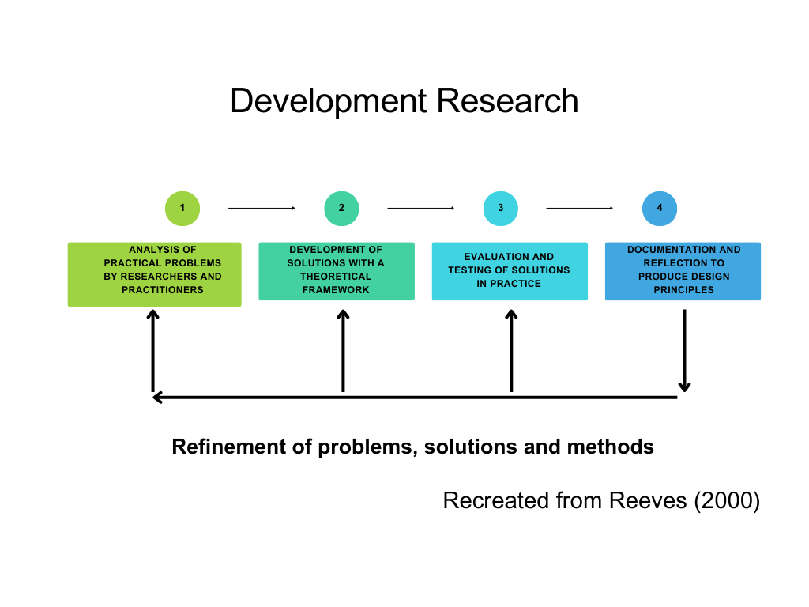

Figure 3

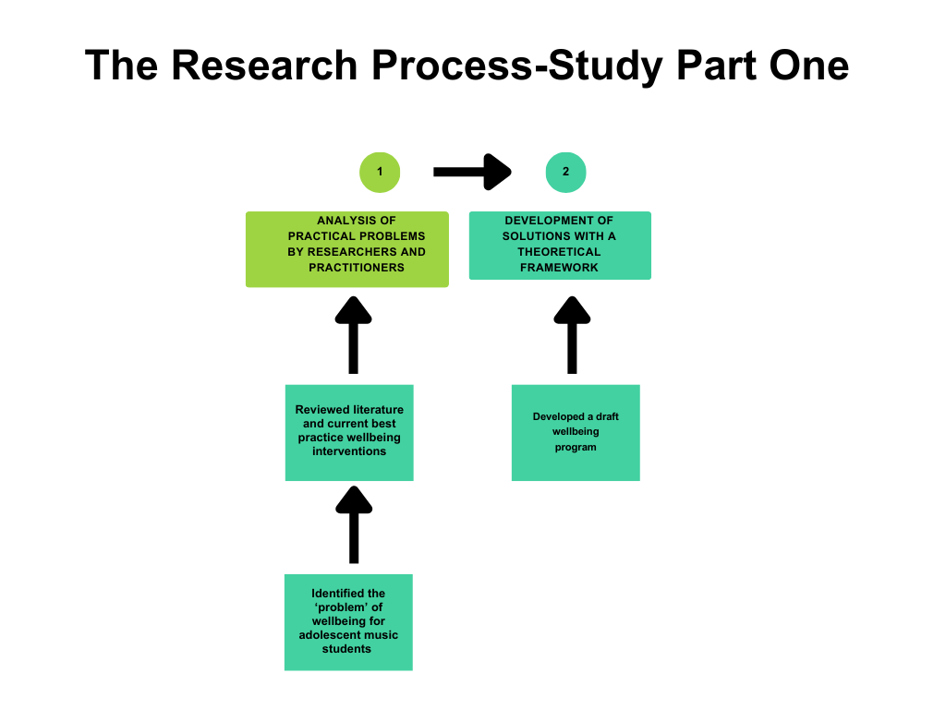

Figure 4

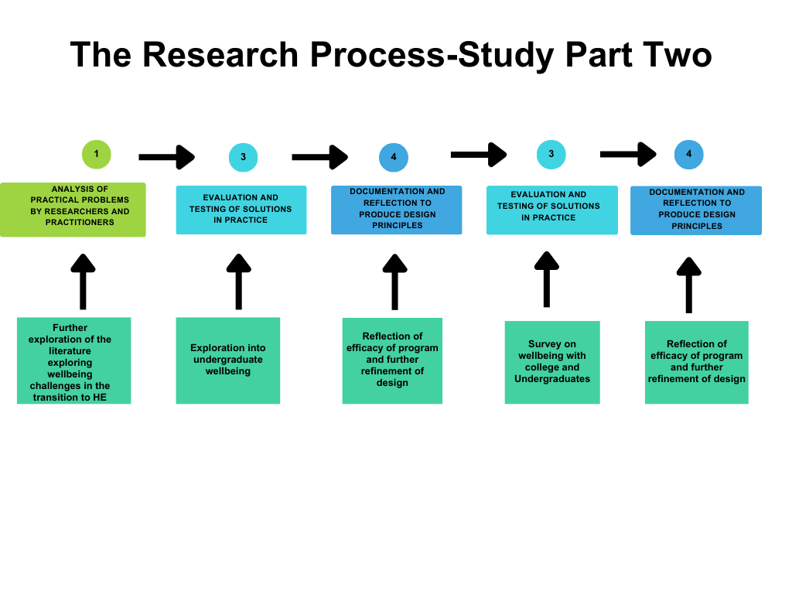

Figure 5

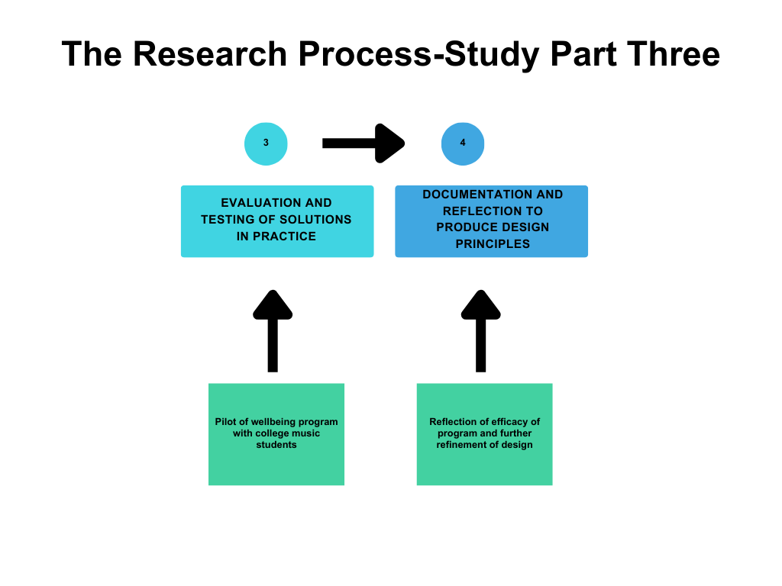

Methodology
An exploratory design (Creswell, 2013) mixed methods approach was used with qualitative data collection exploring wellbeing in semi-structured interviews with undergraduate music students followed by a quantitative survey with both college and undergraduate music student participants. Exploratory designs allow for the collection of rich information in the form of qualitative data that will then inform the design of the quantitative data collection and consequent analysis (Almeida, 2018). In this study, semi-structured interviews were carried out and analysed using reflexive thematic analysis (Braun & Clarke, 2012). The research process can be seen in Figure 6.

Figure 6

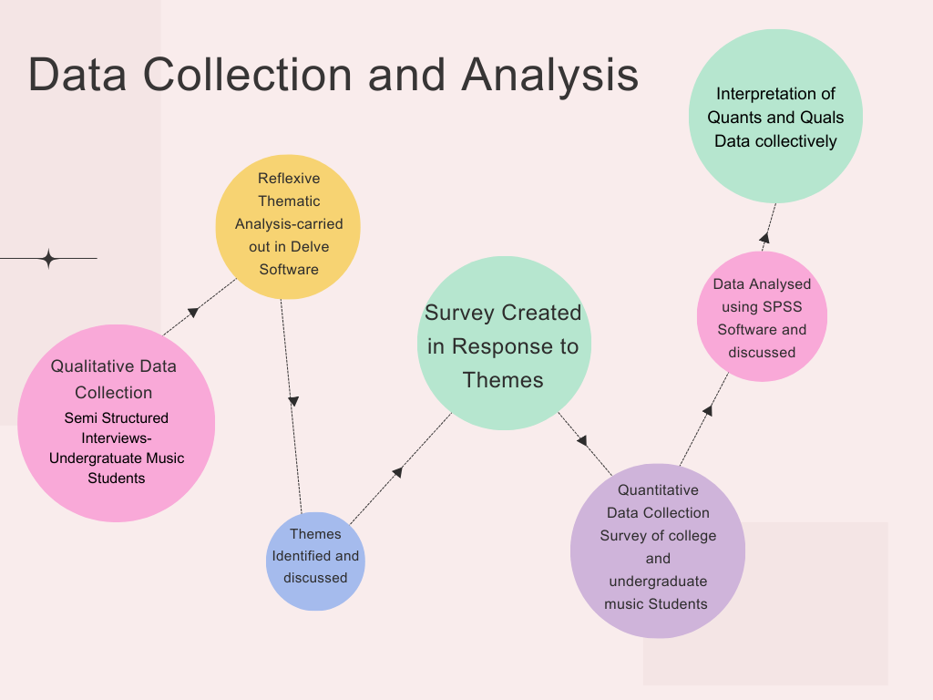

One of the reasons why a mixed methods approach was chosen was due to the nature of the participants. As an insider researcher, I currently teach all the college music students asked to participate in the study and as such felt that qualitative data collection with them may compromise our current relationship due to the personal nature of the subject matter. The opportunity for my college music students to complete an anonymous survey could have resulted in more truthful responses (Kelly, 2009), and may have had a positive effect on the sample size however, it is important to note that there may still be subtle ways in which participant responses were shaped by their proximity to me as an insider researcher.
May et al. (2023) describe DBR as an opportunity to test a design using multiple methods to assess validity and so a mixed methods approach here is appropriate. There are, however, challenges in triangulating findings in exploratory mixed-methods studies. Small sample sizes in the interview stage could limit the depth of exploration and the larger survey sample will provide a wide spread of responses but may lack contextual detail. Key themes that emerge from the qualitative interviews will be used to inform survey questions in an effort to synthesis the data sets and mitigate these concerns.

Qualitative and Quantitative Data Collection
Semi-structured interviews formed the first stage of data collection. Semi-structured interviews involve questions selected in advance by the researcher, however, there is flexibility in the delivery of these questions in terms of sequence and the researcher can choose to add or omit questions depending on the course of the interview (Dawson, 2009). This flexibility can create a more comfortable atmosphere where thoughts and feelings may be shared more freely (Flick, 2006). Additionally, this style of interview may be more appropriate for sensitive subject matters (Elmir et al., 2011) which this topic may explore. Questions were selected in response to the research questions and focused upon broad matters of wellbeing before and at university (See Appendix 3). All five interviews were conducted on Microsoft Teams video calling software with recordings and transcriptions made in the application. Transcripts were then checked against the recordings and any necessary editing was completed to ensure accuracy. The transcripts were then imported into Delve coding software and reflexive thematic analysis (RTA; Braun & Clarke, 2019) was carried out.

RTA is a coding method which looks for patterns of collective significance in the data using six stages: familiarisation; coding; generating initial themes; reviewing and developing themes; refining, defining and naming themes and writing up (Braun & Clarke, 2019). RTA was chosen as appropriate for this study because it recognises the subjective role of the researcher as a resource (Braun & Clarke, 2019) and, as an insider, I recognise my inherent bias. RTA allows for this and actively encourages the reflexive approach to ensure the researcher reflects on how their beliefs and assumptions may shape the analysis process (Braun & Clarke, 2020). However, as an additional measure, I employed the use of bracketing (Fischer, 2009) to ensure that identified themes reflected participant voices rather than my preconceived ideas.

Quantitative data was collected via a survey created in Qualtrics XM software (see Appendix 4). Surveys were chosen as the appropriate method due to their ability to collect vast amounts of data within strict parameters that can then be analysed statistically (Yang & Laven, 2021). The five wellbeing elements arrived at in part one of this study (See appendix 1) are reflected in the survey questions. Plain language (Gilliver, 2015) was used to ensure all respondents could understand and answer the questions authentically (Marsden & Wright, 2010). The survey used a combination of different questioning methods such as switching from tick boxes to sliders to avoid ‘straightlining’ (Schonlau & Toepoel, 2015; See appendix 4) where respondents answer in a straight line down the course of the questionnaire. Revilla and Höhne (2020) suggest questionnaires with a length of 10 to 15 minutes result in the most complete responses so I designed a survey that took approximately ten minutes to complete. I chose the lower end of the time because competing for a young person’s attention can be difficult (Alaparthi, 2024). Only five out of eighty-one questionnaires were started but not completed suggesting that the question variety (Galesic & Bosnjak, 2009) and time it took to complete (Deutskens et al., 2004) could be optimum for this participant group.

Survey data was analysed in SPSS software to answer my hypotheses:
- There are differences between college and undergraduate music students’ wellbeing challenges.

Reflective Practice
During the process of data collection, I kept a diary to reflect both in and on action (Schön,1983). Schön (1992) described the process of design in education as both inherently reflective and intricately connected to the teacher designer. This DBR project acknowledges my role as both researcher and teacher with personal motivations to support my students, therefore using the Schön model of reflection is particularly appropriate as it encourages a continuous process of self-examination and supports the research process detailed herein. A selection of my most pertinent reflections in and on action can be seen in the conclusion of this paper.

Participants
Semi-structured interview participants were undergraduate music performance students (n = 5; M = 2, F = 3), all of whom were ex-students from The Manchester College (Table 1).

Table 1
Participant Demographics-Interviews
Gender | Number | Percent
Man | 2 | 40
Woman | 3 | 60
Non-Binary/Non-Conforming | 0 | 0
Transgender | 0 | 0
Prefer not to say | 0 | 0
Age
18 | 1 | 20
19 | 2 | 40
20 | 1 | 20
21 | 0 | 0
22 | 0 | 0
23 | 0 | 0
24 | 1 | 20
Level and Year of Study
University-Undergraduate Year 1 | 2 | 40
University-Undergraduate Year 2 | 2 | 40
University-Undergraduate Year 3 | 1 | 20
First/Main Instrument
Bass | 2 | 40
Drums | 0 | 0
Guitar | 0 | 0
Keyboards/Piano | 0 | 0
Other please state | 0 | 0
Vocals | 3 | 60

Of the seventy-six survey participants (Table 2), the majority were women with a percentage of 48.7% (n = 37). 64.5% of the sample were college students (n = 49) and 35.5% were undergraduate students (n = 27). Most of the sample were vocalists (n=33, 43.4%) with guitarists the second most frequent at 25% (n = 19).

Table 2
Participant Demographics-Survey
Gender | Number | Percent
Man | 32 | 42.1
Woman | 37 | 48.7
Non-Binary/Non-Conforming | 3 | 3.9
Transgender | 2 | 2.6
Prefer not to say | 2 | 2.6
Age
Missing | 2 | 2.6
16 | 2 | 2.6
17 | 16 | 21.1
18 | 19 | 25
19 | 18 | 23.7
20 | 9 | 11.8
21 | 2 | 2.6
22 | 3 | 3.9
23 | 4 | 5.3
24 | 1 | 1.3
Level and Year of Study
College Level 2 | 2 | 2.6
College Level 3 Year 1 | 35 | 46.1
College Level 3 Year 2 | 12 | 15.8
University-Undergraduate Year 1 | 8 | 10.5
University-Undergraduate Year 2 | 9 | 11.8
University-Undergraduate Year 3 | 10 | 13.2
First/Main Instrument
Bass | 8 | 10.5
Drums | 9 | 11.8
Guitar | 19 | 25
Keyboards/Piano | 6 | 7.9
Other please state | 33 | 43.4
Vocals | 1 | 1.3

Insider Research and Ethical Considerations
The first stage in any research process is to ensure the proposed study is ethically sound (UK Research & Innovation, 2023), in this case, ethical approval was sought and granted by The University of Wales Trinity Saint David (see Appendix 5).

The undergraduate music students who took part in the interviews were all ex-students, so an existing rapport was evident, making the interview process comfortable from the start (Bonner & Tolhurst, 2002). The participants agreeing to take part suggests good feelings towards me as their ex-teacher and they all expressed wanting to return the support I had given them. Whilst this may have resulted in participants eager to help, it may also have resulted in social desirability bias (SDB) in which respondents aim to present themselves in a socially acceptable way (Caputo, 2017). To guard against this, I reminded participants that their words would be presented anonymously in my research which can mitigate SDB (Holbrook et al., 2003). I also relied on the strong relationships I had with the participants whilst they were my students, hoping this would result in an environment where they felt comfortable speaking honestly; one advantage of being an insider researcher (Bonner & Tolhurst, 2002). Participants were also reminded that any contributions they made were entirely voluntary. My experience of the interviews was that the participants shared their thoughts freely and were not afraid to present themselves in a negative light, suggesting that SDB was not evident.

Insider researchers may experience a certain amount of strain related to the dual roles, in this case, teacher and researcher (Hanson 2013). Following my previous experience in module three of the master’s I aimed to plan more effectively to manage this strain. Firstly, ensuring requests for participants were timely, and communicated clearly via Microsoft Teams messaging for my current students (under 18s email sent to parents; see Appendix 6 and 7) and a social media post for past students (Appendix 8) to reduce the stress around this process and keep the communication uniform. Secondly, by establishing clear guidance on the aims of the research (see Appendix 9) and what my role in this research was, I could ensure that my participants were able to give their informed consent (Kumar 2011). I contacted parents of participants under 18 via email to request permission and this was collected within the survey. Every participant then gave their consent ensuring that all parties were included in this process and given the same information before deciding to take part.

I selected my participant groups carefully, choosing not to interview current students, as, whilst I was interested in their contributions and wanted them to collaborate in the research, I felt it ethically important to keep the student-teacher boundary intact (Bernstein-Yamashiro & Noam, 2013). Boundary-making involves asserting what can and cannot be expected of the researcher as an insider and is vital so that roles are not blurred and expectations unmet (Cuomo & Massaro, 2016). The nature of sensitive information about wellbeing shared in interviews could potentially endanger the healthy respect required in effective teaching and learning relationships (Liang et al., 2020). I was guided by these principles to choose undergraduate ex-students as interview participants rather than my current college students.

Recognising and protecting the vulnerabilities of participants is paramount to good quality, ethically sound research (Bradbury-Jones et al., 2014); choosing to collect anonymous survey data was in consideration of this requirement. However, one limitation of collecting survey data anonymously is that it does not allow for follow-up opportunities to further explore participant responses. This reflects the delicate ethical balance that must be struck as an insider researcher when considering the needs of participants and their privacy alongside the motivations of the research questions (Ashworth & Burke, 2023). However, as the wellbeing program will be piloted with college music students in part three of this study there will be further opportunity to clarify the needs and experiences of this cohort.
A further ethical consideration was ensuring my research was inclusive of underrepresented groups (Friesen et al., 2017). To do this I ensured the wording in my questionnaire was both in plain English (Solomon et al., 2021) and used inclusive language (Likis, 2021) such as giving explanatory notes for terminology and making certain that gender options were reflective of all potential respondents (Philippopoulos, 2023).

Findings
Following the process of DBR (The Design-Based Research Collective, 2003) my qualitative interview results are presented first and discussed to inform the next stage of research. Then my quantitative survey results and discussion are presented followed by a synthesis of the collected findings.

Qualitative Interview Results
The qualitative data was analysed using reflexive thematic analysis (Braun & Clarke, 2019) to reveal four main themes: experiencing shared and diverse wellbeing challenges, managing wellbeing and protective factors, managing change in support systems and exploring how wellbeing could be supported to ease the transition to university (see Figure 7; see Appendix 10). The five participants are referred to using the titles P1 to P5 and quotations used are direct from the participants’ interview transcripts (Appendix 11).

Figure 7

Theme one- Experiencing shared and diverse wellbeing challenges
Participants described wellbeing challenges that they had faced at university and this theme embodies the shared experiences they had and the diversity of these challenges.

Living Independently

Participants described their fears about living independently. Moving away from home provided several challenges including practical concerns like self-regulation and managing their schedules to anxieties around being in a new city.
“Who would like obviously make sure I was awake every morning, like make me food and stuff. So it's it's a lot to like go from like obviously having a lot of things done for you to having to do everything by yourself” (P1)

“Yeah, I was quite low and I was very, very anxious about about the move about completely uplifting my life and moving to a different city and I I would, I'd have quite frequent panic attacks and and stuff. It wasn't a great time, yeah.” (P4)
These fears were realised for several participants as they struggled to manage workloads and prioritise effectively.
“it will all just creep up and it's a fault of my own just because I'm being a silly student. And it's like the week's pile up. I'm like, oh, I need to start knuckling down now. And that's when I'm, like, rushing to get things done.” (P3)
“oh, I'm really independent, like, oh, look at me go. But then when it's like when you're when you've not done something that you should have done, it's like, oh, like it's there's no one else to blame.” (P1)

Raised Academic Standards
Many of the participants felt the pressure of academic standards and expressed a leap in requirements that they weren’t prepared for.

“My well-being was challenged. It would be maybe the shock of the kind of content we were learning […] Terms and definitions like diataxis, which is like structure of a song and stuff like that, and I'd never heard things like that. And it's people who are on like on A-level music who knew this stuff. And I was like, oh, I've, I've got no idea what this is.” (P3)
“it's very like in deep like, as soon as you get into a semester, it's like right, this is your assignment. This is what you've got to do. It's this many words. And like, the way that they say it, sometimes it's like, oh, my God, it needs to be in next week. Do you know what I mean? And it's like it. It's not very like relaxed. Like, you don't have a week just to, like, settle in and relax to this, it’s just like straight in but college, was I feel a lot more relaxed in that aspect.” (P5)
Despite feeling unprepared there was also an admission from participants that they should have been expecting the increased challenge and that it will help them to develop as musicians.
“I guess I knew it was gonna be like it was gonna be a lot of work.” (P5)
“However, there's also the factor of university. It's meant to get harder. I know it's meant to be harder than college, so for me to say like, oh, well, college is way easier. It. Well, it's meant to get more difficult.” (P3)

Mental and Physical health challenges
Two participants discussed physical illness at university, with both having long periods away from study.

“And to be to be fair it was probably just really bad, fresher’s flu or pneu... I'm not sure what it was, but I was very, very unwell. And then I felt kind of like I'd failed myself because I couldn’t. The first month, say two months of the year were probably the most important and I just wasn't there.” (P4)
“At first it was really exciting. Then it got about a month and 1/2 in and I was like, Oh my God, I'm really tired all the time. I'm so rundown and there was actually a point. It was maybe like a month and 1/2 ago now. Where I was just constantly ill.” (P1)
The impacts of these illnesses were also described, with fears about disappointing tutors or missing important parts of their study.

“And and I thought, oh, I'm letting all the people down and letting my course leaders down. I'm letting myself down. I've not really had a fair shot at at this. I just. I was in bed, yeah.” (P4)
A further participant experienced mental health problems that impacted both their studies and how they felt about being at university.
“I feel like I gained more anxiety than ever. I feel like my anxiety is just like plummeted like it really did. Like in second year I really felt anxiety like I've never felt before, like I thought my anxiety in high school when I was a teenager was bad. But it was just it was insane. It was actually insane, like I did not want to go to any lessons. I think I might have gone to like one or two lessons in second year. I'm not even joking like it was it was pretty bad.” (P5)
One participant described how being in a new city was a lonely experience, whilst another felt their lack of direction before university had a negative impact upon their wellbeing.
“I found it really lonely to begin with. Really, really lonely 'cause. I was in a completely new city. I didn't know anybody. And even like, I'm such a social butterfly. Like I can make friends very easily. But I still found myself just on my own. And it was it was difficult.”(P4)
“Before I went to uni like I didn't really have a clue what. Well, like which which direction I was heading. So I think there's like the uncertainty therefore had like a a bad impact on it.” (P2)
Others discussed the new environment as both challenging and exciting.
“But it also like just kind of instilled the confidence in you to go and talk and like that also kind of does come hand in hand with like networking and communication skills because to be able to go out to people and talk to them, you know form new relationships with them.” (P2)

Managing Finances
All participants discussed the challenges of managing their finances at university from the pressures of working alongside studying, to the new experience of paying bills and dealing with student loans.

“So I kind of understood like the transactional side of it, but especially because you get your student finance in three chunks. I look at the the number and I'm like sick and and then it's gone I’ve not effective, effectively budgeted. So yeah, I think definitely that was a big shock.” (P4)
“I've I've had some meltdown moments. It gets very stressful because, like I was saying, it's like juggling, like a job. Because although I do get like a loan, it's it that covers my rent and that's kind of it. So, I've got to work and I've got to do well in uni and I want to do well in uni. I don't want to just pass. I want to do well.” (P3)
“I was like really, really stressed out about it and it was really annoying cause like that was the first big thing. I obviously getting the massive amount of money and being like be able to spend it and everybody around me had the money and I just just just didn’t. And also, yeah, I wish 'cause obviously we've signed contracts for the house next year and everything. I've also got to sign a contract applying for my student finance again for this next year.” (P1)

The Impact of Covid
One participant felt the impact of Covid-19 was a factor in her experiences at university from deciding to attend, “So that's the only reason I really went to university was because of the lockdown.” (P5), to the post-lockdown environment.
“It was really different for me because I know that a lot of people went from college straight to university, but we finished really bluntly, college because of COVID. So then being in COVID and then going to university, it was different because I was like, oh my god people, I was like, we can be near people now. We don't have to be like two metres away from people. So that was a big thing to start with.” (P5)
Having attended college over three years and then taking a year out this participant felt keenly the differences in her age and experience to her peers and also to her teachers.
“A lot of people from my year, because of COVID, a lot of people from my year are just turning 21 and I was 21 when I started, and I’m turning 24 now so some of the tutors were only three, four years older than me so they were quite young. Some of them, you know, they're they're quite bitchy. And they wasn't really nice. They were like, quite condescending, quite sarcastic in ways. And it's like, I don't know you like that to be sarcastic with me.” (P5)

Uncertainty About the Future
Three participants discussed their concerns about what their futures would be like, some looking to university to guide their career path, and others feeling university was a way to ensure they would not end up in an unhappy career.

“I just hoped it would kind of give me a realisation of what my life is gonna turn into as a musician and kind of, I hoping going into I thought it was gonna like make me realise this is what I wanna do. This is what I'm gonna learn to do. And this is how I'm gonna get there and yeah, go into it. I think that's just what I just wanted, like a clear path.” (P3)
“Like I felt in my head that I was like, I'm just going to end up doing this forever and it I'm going to wake up in 10 years and be like, oh, my God, I've been doing this for 10 years, and I'm not even actually thought about my career. Do you know what I mean? Like, that's what I was thinking in my head. I was like, I need to do something.” (P5)

Theme Two- Managing Wellbeing and Protective Factors
Importance of Friendship Groups
All the participants felt strongly about their friendship groups and the positive impact they had on their wellbeing. Some discussed positive peer pressure in ensuring they were attending lectures and others discussed the positive feelings from spending time with friends outside of study.
“I became really close with this boy, ________. And he was like ______ you need to start going to uni. And he was like right, 'cause we both had a 9:00 AM on the same day and he hated going to his 9:00 AM as well. So he was like ______, if you go to 9 am, I'll go to 9 am, 9:00 AM and we'll walk together. And I was like OK, sounds good. And ever since I've been to my 9:00 AM.” (P1)
The power of collective experience was part of the positive nature of the friendships described by participants with playing and making music together forming an important part of university life.
“By joining these bands and and doing the live shows as a musician, I feel much more confident just like in myself, not just in the fact that I'm a good musician.” (P3)
“You can have like a sell out show or something and to come off that stage, knowing like, you know, you did it with your mates, like your best mates, I think that's that's defo or like the biggest take away I've got from moving down here like it's just a, it's a nice feeling. It's a really nice feeling. And I think if I didn't have that then my wellbeing being would be down the drain.” (P2)

Managing Through Struggles
All the participants described how they had managed through their struggles, with some expressing pride and others relief at how they had surmounted their challenges to succeed.

“I did struggle going, oh well, all these people are better than me. What am I doing here? But it's just again, just a a matter of perseverance, like I've now come to the end of the year and I did pretty good, I did pretty good.” (P4)
“I'd say it was like a a necessary path 'cause I. If I I feel like I don't know it's it's realising the opportunities that you've missed out on because of a certain way that you've acted and like you're not gonna go back, you can't go back and change that. But so the future opportunities that you can you can, you can get and you can easily obtain, but it's whether you you miss out or not by acting like a muppet.” (P2)
Four participants discussed how they work to manage their wellbeing and the coping strategies they have adopted along the way from developing healthy behaviours like regular exercise to recognising when they need to rest.
“They'll ring me up and do you fancy a walk round the park? and the parks only two minutes down the road. But it's just a little bit of consistency. A little bit of fresh air, really, releasing endorphins. I learned how to cook for myself, and that's really good. I can make meals that aren't just instant noodles. Yeah. Yeah, I've just. I've put things in place that are good for my body, which therefore is making my mind feel better.” (P4)
“So I know to give myself a day to just relax and do absolutely nothing do whatever I want, whatever I like. But then the next day, up, early straight to the gym. Do you know what I mean? It's sort of like that. Good, good cop, bad cop in my head.” (P5)

Developing Self-Management Skills
All participants discussed self-management in some form, exploring how they had struggled to self-manage but also how they had learnt to manage their time, behaviours and schedules.

“Yeah, that and like or some just a bit embarrassed. 'cause like I can move out by myself. I can live by myself. But I can't walk to a building that's 5 minutes away.” (P1)
“One of the biggest ones, 'cause I think deadline is deadlines are probably the the thing that everyone struggles with the most, especially young people 'cause like we're just lazy.” (P2)
“I'm good at understanding when I am drained I I can feel it. I know I'm tired, so I take days where just you know nothing. No music, no nothing. Unless I just wanna have a strong guitar or playing piano just for fun.” (P3)

Recognition of the need for stability and schedules was high amongst all participants.

“I'm enjoying it and it's good, but I've had some meltdown moments where I thought it's just not working and you know, juggling everything it, it gets a bit intense. But I'm not sure if there's really anywhere around that other than just like time management and better figuring out my priorities.” (P3)

“It's it's like the it's just, it's just it's just like the word deadline. You know what I mean? It's it's, it's horrible. But, I don't know. I feel I I feel like over the past two years, my time management's defo got better.” (P2)

“I think getting a job was one of the first things that I really wanted to do because. If if you're in a really good environment with like good people, it's really good to have sort of stability.” (P1)

Theme Three- Managing Change in Support Systems
All the participants expressed awareness about the changes in support systems they had experienced at university.

“But it’s kinda just it's a bit autonomous at this point like it is just the same thing, just in a different form you know.” (P2)
“So I think I've got a lot more support for my friends than my than from the uni which is kind of…. it's surprising to have that sort of switch.” (P1)
Some participants felt distant from their teachers at university in a way they had not at college.
“I think I just just a lot, just personally a lot closer with my college tutors than with my university ones” (P1)
“In university, if you don't turn up, doesn't bother me. Doesn't bother me, doesn't matter. Still getting paid.” (P4)
Sometimes this distance meant that participants felt less confident to ask for help.
“Whereas in these big lecture halls putting, I mean I I do because I'm just, you know, I don't really have a problem with it, but it's it's still very intimidating to be like, you know what? What, what do you mean? What does that mean? What are you talking about? Can you say that again? It's so hard for everyone and everyone talks about it after the lectures.” (P3)
But some participants also felt that this lack of personal attachment was a good thing.
“But with University you're paying to be there. It’s your choice to be there so. The tutors will never be like, oh, why weren’t you here? They're not going to bollock you.” (P1)
“Erm, and yeah, there's just always been people around that aren't invested enough that I feel like I'm not going to upset them but care enough for me for them to go what's going on? which is nice.” (P4)
Participants expressed wanting autonomy and whilst some of them found the change difficult, they also felt that it was an important part of their development into adulthood.
“And it's a it's a lot easier to manage. You know, 'cause, you're responsible for your own failure.” (P2)
“But I think after a while getting used to it it it takes like a term kind of understand and then the next term, I'm kind of like, OK, I know where I am.” (P3)

Accessing support at University
Two of the participants who had suffered with mental and physical health difficulties expressed the support given at university as of great help to them. They discussed how they were referred to this support by their teachers or support staff and the ease in getting this help.

“I had to do a lot of counselling sessions within my university because of like well-being like student support told me like they wanted me to do counselling sessions with the counsellor.” (P5)

“But currently I see his one called Hannah, once a week, same time every week, it's literally 1/2 an hour conversation, but it's just that stability that has been put in place for me, which is really good.” (P4)
Others felt support was lacking.
“Like it's like to go into uni and like realise you don't actually have that much support.” (P2)
One participant explained how they had tried to access support but the process had made them worried and so they had chosen not to use the service.
“I go on the link that they tell me to go on and it's like a bunch of like, you know, fill out this, like, that put your phone number, put your address, put your guardian’s thing. And it's like I don't, you know, I don't want to. I don't really want it to be that difficult, I mean, but it's, you know, I don't wanna be weird about it, because it's not difficult but I just wanted like a quick and easy thing, which probably Isn't very possible, and the and I understand that they need more from me than just like my name and that's it, but kind of not want to stress my mum and dad out and I just wanted to like just kind of, you know, speak my mind to someone who would kind of listen and kind of respond accordingly.” (P3)
One participant missed over four weeks of lectures and described receiving two emails from the student support team over the whole period of absence.
“I think support wise I really only got like one e-mail regarding my attendance like about halfway through the year and then just before exams were starting I got another e-mail about how they were going to set up a team's call and asking me if I was OK with that. I hadn't seen it until like lessons had finished.” (P1)

Theme Four- Exploring how wellbeing could be supported to ease transition to university
Participants were asked to review the wellbeing program draft I had created previously and give their feedback. They reviewed the contents and made comments upon it.

Relationships, Communication and Teamwork
Most participants felt that support with relationships, communication and teamwork was a relevant and important area to aid the transition to university.

“The teamwork, the leader and the following, I feel like that would have definitely helped in university. Definitely, with the band system, I feel people. It's just there's just no communication at times.” (P5)

Exploring shared experience
Some participants suggested that exploring the shared experiences of wellbeing challenges would help music students feel less alone.

“Of people at our age, learning and studying music, we're like, Oh well, I'm. I'm really bad and I'm I'm really anxious and it's probably just me 'cause, everyone else here seems really good, but if you're telling us that, and if you're using like statistics and things and studies and saying like, musicians tend to feel like this, what you're feeling right now, there's a name, anxiety, things like that. It kind of sheds light and it's like, oh, it's not just me. I'm, I'm. I'm not like the problem, you know.” (P4)
“It kind of seems like you're making us aware of how musicians tend to feel and yeah, it's not like us as individuals, this is how we're feeling and this is a personal experience for us. It's just like this is a shared thing that a lot of musicians probably have, and I think that's quite an unknown thing.” (P3)

Making Industry Connections
Participants professed little knowledge of how to make connections in the music industry but felt this was hugely important to their future careers. Knowing how to approach industry professionals appropriately and with confidence was something the participants felt required more support.

“Music industry stuff. I love talking to musicians about kind of the industry and how how they how they like talk to promoters even like even if they have no idea what they’re talking about, I have no idea what I'm talking about. But I love talking to people about how to be in the industry and what to do and what to say and how to like kind of how to get the gigs. So, I think group sessions like that would go down a treat.” (P3)
“Making connections and stuff that's. A crucial that's like, probably that is probably the most important thing that you have on there. 'cause. You're not gonna. You actually aren't gonna get anywhere in the industry if you don't have connections.” (P2)

Raising Awareness of Support Networks
One Participant felt strongly that music students should know what support is available for them, not just now but in the future when they have left education.

“Just making your students aware that there's so many different organisations out there that do cater to all those different things. So, any problem that they're having, it's not just going to be limited to just them. There's going to be at least someone out there with the same or someone that's identified that as a problem amongst people and then obviously made a trust or an organisation out of it.” (P2)

Developing Economic Wellbeing
All the participants felt that economic wellbeing was an important area for focus in the wellbeing program, suggesting that this was something that might be overlooked.

“I think out of pocket one, financial management, very much important.” (P4)

Engagement Might Be Low
Several participants suggested that adolescent music students might struggle to engage with some of the themes in the wellbeing program with one going so far as to suggest some students may want one-to-one sessions, particularly when discussing mental health. One participant made pertinent comments about the ethical considerations of delivering a wellbeing program and the teacher/student relationship.

“Probably it like it'll sound really boring and I'll be I I think if I was offered it, I'd say no.” (P1)
“So they can kind of open up, but it depends what position you want to put yourself in or a teacher put themselves in, whether they want to get personal with the students and want to hear how they are with anxiety.” (P3)

Interview Findings Discussion

Shared and Diverse Wellbeing Challenges
Living independently was a concern of many participants and is consistent with the findings of Gravett and Winstone (2021) and Worsley et al. (2021). One participant described this particular transition and its difficulties:

“Who would like obviously make sure I was awake every morning, like make me food and stuff. So it's it's a lot to like go from like obviously having a lot of things done for you to having to do everything by yourself” (P1)

Worsley et al. (2021) recommend universities offer workshops to help students learn the skills to live independently. However, Cage et al. (2021) propose that learning these skills pre-entry to university could be more effective and ensure students feel prepared. This is reflected in the concerns of participants like P1 and indicates that intervention in advance of entry to university could provide students with increased confidence and preparedness for the pressures of independent living. This would mark a shift in focus from reactive to proactive support where skills such as managing finances, working to deadlines, and organising schedules are delivered before students will be required to use them. On this basis, preparedness for transition to HE would be enhanced, and this premise will inform the refinement of my wellbeing program.

The raised academic requirements at university level study were also of concern with some participants finding lecture halls intimidating places where it was difficult to ask questions.

“[…] it's still very intimidating to be like, you know what? What, what do you mean? What does that mean? What are you talking about? Can you say that again? It's so hard for everyone and everyone talks about it after the lectures.” (P3)
This is echoed in the research of Cifuentes Gomez et al. (2022) where students described feeling unprepared for the rigours of HE and the findings of Money et al. (2019) whose teacher participants felt that the requirements of college prevented them from adequately preparing students to become independent learners at university. Together these studies reveal a gap in the way in which students are prepared for the transition to HE with both student and teacher perspectives aligning on this matter however, while Cifuentes Gomez et al. (2022) suggest this may stem from unrealistic expectations of students, teachers in the Money et al. (2019) study assert that reliance on tutor support is the issue. Participant responses like that of P3 underscore this issue where a lack of preparedness may result in overwhelm and provide further evidence for the need for academic skills training to be delivered pre-entry to HE. A short course that teaches the academic skills needed for university may be a way to instil these skills. Alternatively, academic skills such as time management, critical thinking and independent study skills could be embedded in the curriculum, as part of my wellbeing program, across the two years of students’ study at college to develop independence over time. Both approaches could ease students’ transitions to HE by instilling agency and academic confidence as is reflected in both participant responses and the literature.

Some participants described the challenges of making new connections at university.

“I found it really lonely to begin with. Really, really lonely 'cause. I was in a completely new city. I didn't know anybody. And even like, I'm such a social butterfly. Like I can make friends very easily. But I still found myself just on my own. And it was it was difficult.” (P4)
Williams and Roberts (2022) highlight the difficulties of identity formation that those from working-class backgrounds may face in the transition to university however, the participant comments in this study suggest that wellbeing challenges extend beyond identity to encompass social belonging and confidence in academic skills. This is embodied in P4’s struggles to assimilate into university life. The addition of structured role-play scenarios and networking workshops in my wellbeing program may provide the opportunity for students to develop the skills to overcome these challenges which is an area left unexplored by Williams and Roberts (2022).
Difficulties with mental health were described by participants with anxiety being of particular concern.

“I feel like I gained more anxiety than ever. I feel like my anxiety is just like plummeted like it really did.” (P5)

Participants who described issues with anxiety were all female consistent with the findings of Kroshus et al. (2020). Research with musicians supports this trend with findings indicating female professional musicians are prone to music performance anxiety (MPA; Butković, Vukojević & Carević, 2021; Sokoli, Hildebrandt & Gomez, 2022). Addressing this issue early and offering established tools to manage anxiety, such as mindfulness (Czajkowski et al., 2022) and cognitive-behavioural techniques (Braden et al., 2015), whilst musicians are studying could result in fewer female musicians suffering from MPA in their professional careers. All students could benefit from learning tools to manage anxiety as, whilst females may be more likely to experience MPA that does not mean that other genders are unaffected. Reducing anxiety across all genders may have added benefits (Czajkowski et al., 2022) for students transitioning to university study such as coping more effectively with academic pressures and navigating social change.

Managing Wellbeing and Protective Factors
The importance of friendship groups and the positive influence of peers could be deemed a protective factor for wellbeing as participants described the good habits they had developed collectively with their peers.

“I became really close with this boy, ______. And he was like ______ you need to start going to uni. And he was like right, 'cause we both had a 9:00 AM on the same day and he hated going to his 9:00 AM as well. So he was like __________. If you go to 9 am, I'll go to 9 am, 9:00 AM and we'll walk together. And I was like OK, sounds good. And ever since I've been to my 9:00 AM.” (P1)

Worsley et al. (2021) agree, suggesting encouraging social connections could increase the feeling of belonging for students, and therefore ease the strain of transition to university. To develop confidence in making social connections colleges could look to support cross-curricula activities or projects where unfamiliar students are brought together. This could emulate the, usually larger, university environment and encourage social skills development. In my wellbeing program, there may be potential for cross-year group and class sessions to develop community throughout the music department and promote the practising of social skills.

Participants described how they had managed their wellbeing, despite the struggles they had experienced. Participants were proud of overcoming their issues independently and with the new support systems they had created.

“I did struggle going, oh well, all these people are better than me. What am I doing here? But it's just again, just a a matter of perseverance, like I've now come to the end of the year and I did pretty good, I did pretty good.” (P4)
Participants’ reflections exhibit a degree of convergence with Gravett and Winstone (2021) who describe transitions as part of becoming. We cannot avoid the transitional period in this instance, but we can encourage reflection on how one has managed and evolved through transitions. This reflection may be an important factor in developing resilience and coping through change (Falon, Kangas and Crane, 2021). In my wellbeing program, this could be as simple as discussing with students what their concerns are, and how they might deal with them and encouraging them to reflect upon how they have managed difficult transitions in the past.

Managing change in support systems
All the participants discussed how their support systems had changed at university. Where college tutors had provided much in the way of pastoral care, as described by Money et al. (2019), this was generally not evident at university.

“So I think I've got a lot more support for my friends than my than from the uni which is kind of…. it's surprising to have that sort of switch.” (P1)
Apart from the case of one participant who described a close relationship with a tutor, university tutors were described as distant and uncaring. This meant other sources of support needed to be sought by participants and some found this more difficult than others. Most turned to their friendship groups, but others sought support from their university.
“But currently I see his one called Hannah, once a week, same time every week, it's literally 1/2 an hour conversation, but it's just that stability that has been put in place for me, which is really good.” (P4)
Support from the universities was varied with some participants describing it as excellent and including student support interventions, mentoring and counselling. Other participants had very different experiences such as little contact from their university despite an extended absence and finding accessing support difficult.

“I go on the link that they tell me to go on and it's like a bunch of like, you know, fill out this, like, that put your phone number, put your address, put your guardian’s thing. And it's like I don't, you know, I don't want to. I don't really want it to be that difficult, I mean, but it's, you know, I don't wanna be weird about it because it's not difficult, but I just wanted like a quick and easy thing”. (P3)

Money et al. (2019) suggest that support services at universities need to be more cohesive and these findings also support his assertion. If students are to effectively manage the changes in support systems, they need to be given the tools to do so and have accessible support that is effectively communicated.

Exploring how wellbeing could be supported to ease transition to university
Participants viewed the draft wellbeing program and gave their feedback considering what they thought was important and if any specific wellbeing needs had not been identified. Participants identified relationships, communication and teamwork as important areas for their development before entering university.
“The teamwork, the leader and the following, I feel like that would have definitely helped in university. Definitely, with the band system, I feel people. It's just there's just no communication at times.” (P5)
When considered alongside the changes students experience in support systems, it seems to have excellent communication and teamwork skills as music performance students could result in effective independent learning, consistent with the recommendations of Cage et al. (2021) and Worsley et al. (2021), when tutor support becomes limited.

Participants also felt the teaching of networking skills to be important, in particular, once university was completed and professional work was being sought.
“Making connections and stuff that's crucial that's like, probably that is probably the most important thing that you have on there […] You actually aren't gonna get anywhere in the industry if you don't have connections.” (P2)

Practising the skills of networking was discussed with some explaining their initial ignorance and developing skills through practice. At college, most students are under the age of eighteen so accessing the nighttime economy where the music industry generally resides is difficult. Creating opportunities to role-play networking skills and organising real-world work experience opportunities may be a way to help support the development of these skills.

Participants felt that exploring shared experiences was an important factor in maintaining wellbeing. A sense of belonging in the music industry may be nurtured by making students aware that they are not alone in their fears or struggles and that they are common wellbeing challenges for musicians.

“Of people at our age, learning and studying music, we're like, Oh well, I'm. I'm really bad and I'm I'm really anxious and it's probably just me 'cause, everyone else here seems really good, but if you're telling us that, and if you're using like statistics and things and studies and saying like, musicians tend to feel like this, what you're feeling right now, there's a name, anxiety, things like that. It kind of sheds light and it's like, oh, it's not just me. I'm, I'm. I'm not like the problem, you know.” (P4)
Kroshus et al. (2020) describe self-compassion as a potential protective factor in maintaining wellbeing through transition. A way to enable self-compassion may begin with understanding the broader picture and knowing that one’s challenges are not original (Fuochi, Veneziani and Voci, 2018) but common within the profession of musician. Developing self-compassion might be a potential addition to my wellbeing program for these reasons.

All participants felt they would have benefitted from support in managing their finances.
“I think out of pocket one, financial management, very much important.” (P4)
Economic instability is an established wellbeing challenge for musicians (Sutherland et al., 2019) and university is typically the stage at which a young person takes sole charge of their finances. Supporting students to be prepared for this element of independent living (Cage et al.,2021; Gravett & Winstone, 2021; Worsley et al., 2021) may have a positive effect on the transition to university and improve preparedness (Money et al., 2019) for what is ahead.

Impact upon Next Stage of Research
These findings will impact the next stage of research in several ways. Firstly, participants suggested that engagement with my program might be low so I have decided to include a survey question asking if participants would take part. This will provide an insight into what the uptake for a program like this might be like. Secondly, I will include questions on the types of wellbeing support participants feel music students would benefit from so that I can gain an insight into the similarities and differences in the two participant groups opinions around this. Finally, I will include an open question to offer participants the opportunity to describe any support they feel music students would benefit from. This will result in some additional qualitative data that may further support the first stage of research.

Quantitative Survey Results

The quantitative results have been presented to show how they answer the appropriate research questions and sub-questions. The questions that are covered within these results are:

- What are the wellbeing challenges faced by college and undergraduate music students?

- Are there differences or similarities between the wellbeing challenges faced by these two groups?

- Which of the wellbeing elements is of most significant challenge to undergraduate and college music students?

- How can my wellbeing program be developed in response to the research findings to support music students now and in their futures?
- Do participants believe musicians have more wellbeing challenges than those in other professions?
- Which elements of wellbeing do the undergraduate and college students believe music students need support with?

What are the wellbeing challenges faced by undergraduate and college music students?

Wellbeing Elements
Participants were asked to select the elements they felt were included in the term wellbeing. Almost all the sample believe mental health is an element of wellbeing (98.7%, SD = 0.11) and results were generally high for all of the elements, with economic wellbeing being the lowest at 76%. Standard deviations are all low suggesting participants were mainly in agreement (Figure 8).

Figure 8

Note. This graph displays how participants responded to the question: Wellbeing can incorporate a number of elements. Tick all that you think apply.

Importance of wellbeing elements
On a scale of 1 to 50 respondents rated how important each wellbeing element was to their wellbeing (Table 3). Participants agreed strongly that mental health is most important with a mean of 45.28 (out of 50) with low variability of responses (SD = 7.71).
Table 3
How important do you think each of the elements are to your wellbeing?
Wellbeing Element | Mean |  | Std. Deviation
Physical Health | 37.48 |  | 10.57
Mental Health | 45.28 |  | 7.71
Economic Wellbeing | 33.68 |  | 11.83
Social Wellbeing | 37.65 |  | 9.83
Quality of Life | 41.72 |  | 9.75

Wellbeing challenges
82.9% (SD = 0.38) of the sample said they had experienced challenges to their mental health in the last year suggesting that most of the sample have experienced mental health challenges (Figure 9).

Figure 9

Note. This graph displays how participants responded to the question: Have you experienced any wellbeing challenges in the last year? Tick all that apply.

When asked to rate their wellbeing over the last year from far below average to far above average using five wellbeing categories there was high variance in all responses with agency and mental health achieving the poorest ratings (table 4). Mental health had a mean of 43.71, just under the central point in the scale from 1 to 100 suggesting mental health was below average for many. Most categories showed average ratings from respondents other than social wellbeing which was slightly above average (M = 60.38; SD = 25.53).

Table 4
Rate your wellbeing over the last year using the given categories.
Wellbeing Category | Mean | St. Deviation
Physical Health | 53.35 | 23.68
Mental Health | 43.71 | 24.93
Economic Wellbeing | 49.69 | 21.04
Social Wellbeing | 60.38 | 25.53
Agency | 50.71 | 25.79
Note. Ratings were given from 1 to 100 with 1 being the poorest rating.

Are there differences or similarities between the wellbeing challenges faced by undergraduate and college music students?

Comparing wellbeing challenges over the last year.
Participants were asked to identify challenges they had experienced over the last year regarding each wellbeing element. Comparing college participants to undergraduates there is generally around a sixty/forty split in percentages with college students being more likely to have experienced wellbeing challenges in every element (Figure 10).

Figure 10
Note. The above graph shows participants who answered yes to experiencing challenges to each wellbeing element depending on whether they are a college or an undergraduate student.

Comparing ratings of wellbeing over the last year.
In an independent t-test comparison of how college and undergraduate students rated their wellbeing over the last year from far below average to far above average using five wellbeing categories the results were non-significant for four of the five categories:
- Physical health (t (74) = 1.28, p =0.20).
- Economic wellbeing (t (70.84) = -0.61, p = 0.54).
- Social wellbeing (t (74) = 1.21, p = 0.23).
- Agency (t (74) = 1.16, p = 0.24 ).

Mental health provided the only significant result (t (74) = 2.03, p = 0.04) with undergraduates (M = 36.03; SD = 22.46) rating their mental health worse over the last year than college students (M = 47.93; SD = 25.43).

How can my wellbeing program be developed in response to the research findings to support music students now and in their futures?

Do participants believe musicians have more wellbeing challenges than those in other professions?
Participants answered the question above on a 5-point Likert scale from definitely not to definitely yes with a tendency more towards yes (M = 3.66). Comparing the undergraduate and college subsets found that college students perceive the profession of musician as experiencing more wellbeing challenges than undergraduates (t (74) = 2.72, p = 0.01).

Which elements of wellbeing do the undergraduate and college students believe music students need support with?
When asked on a Likert scale of 1 to 5 (definitely not to definitely yes) what categories music students need support in (Figure 11), maintaining a positive outlook on life had the highest mean response (M = 4.18; SD = 0.76) with managing finances not far behind (M = 4.13; SD = 0.73). When linking these categories to the wellbeing elements we can see that mental health and economic wellbeing received the highest responses.

Figure 11

Note. Error bars show the standard deviation.

Comparing Responses
Comparing responses revealed significant differences in the responses from college and undergraduates concerning maintaining a positive outlook on life and maintaining healthy working and social relationships. Undergraduates were more likely to believe music students need support in these areas (Table 5).
Table 5
Do you think music students need support with:
 | College |  | Undergraduate |  | t-value | p-value
 | Mean | SD | Mean | SD
Maintaining a positive outlook on life | 4.04 | 0.79 | 4.44 | 0.64 | -2.27 | 0.02
Maintaining healthy working and social relationships | 3.88 | 0.83 | 4.41 | 0.57 | -2.94 | 0.04
Managing finances | 4.06 | 0.69 | 4.26 | 0.81 | -1.12 | 0.26
Managing physical health | 3.55 | 0.69 | 3.70 | 1.07 | -0.63 | 0.53
Developing a sense of control over life and living independently | 4.04 | 0.69 | 4.00 | 0.92 | 0.18 | 0.22

Would you attend a wellbeing program for musicians if it was offered?
Participant responses leaned towards yes (M = 3.55; SD = 1.06) however might or might not also received a high proportion of responses (Figure 12).

Figure 12

Survey Findings Discussion
Mental health was the most prominent element throughout all the data with 98.7% of survey participants identifying it as a wellbeing element almost six percentage points higher than the next nearest element social wellbeing. A striking result in the data was that 82.9% of the survey sample had experienced mental health difficulties over the last year and of all the elements they rated their mental health lowest. These findings are consistent with Newlove-Delgado et al. (2022) who found high levels of mental health disorders among this age group.

When comparing college and undergraduate students’ wellbeing, the only significant result was that undergraduates were found to have worse mental health than college students over the last year. However, the college students were more likely to have experienced wellbeing challenges across all elements (mental health, physical health, economic wellbeing, social wellbeing and quality of life) than the undergraduates. These multifarious wellbeing challenges, often related to poverty and poor mental health, are consistent with the literature on young people in Greater Manchester (GM; Keis, 2020; Coughlan, 2011; Manchester City Council, 2022; End Child Poverty, 2022). This suggests that while undergraduates may require targeted mental health interventions, college students from this area may benefit from support that encompasses all five elements of wellbeing. Many students from TMC come from widening participation backgrounds and as Williams and Roberts (2022) suggest wellbeing challenges of these groups of students may be unique. For these reasons, wellbeing support that is customised to the specific socio-economic challenges of young people in Greater Manchester may enhance the transition to HE for TMC students.

Participants felt that maintaining a positive outlook on life and managing finances were the wellbeing categories music students most need support with. This is consistent with the findings of Newman et al. (2021) who reported mental health challenges in touring musicians and Sutherland et al. (2019) who found that musicians face challenges related to financial insecurity. These considerations reflect some of the expansive wellbeing challenges of the music profession and underscore the need for subject-specific wellbeing interventions as suggested by Williams and Roberts (2022).

Maintaining a positive outlook on life and maintaining healthy working and social relationships were the two categories for support found to be significantly more important to undergraduates. It may be that working and social relationships are more crucial to undergraduates due to the increased independence that is required in this area once entering HE (Cage et al., 2021; Gravett & Winstone, 2021; Worsley et al., 2021). Developing skills in working and social relationships are included in the draft wellbeing program I created in part one of this study (Fortune, 2023; see Appendix 1) but it seems the focus perhaps should be on the action of independently managing these relationships. This would mirror the findings of others who suggest that independence in living and studying is a consistent challenge to undergraduate students (Money et al., 2019; Cage et al., 2021; Gravett & Winstone, 2021; Worsley et al., 2021). Therefore, the opportunity to practice these skills independently at college may result in students who are better prepared for the self-sufficiency required following the transition to HE.

A significant proportion of the participants perceived the profession of musician to pose more wellbeing challenges than other professions suggesting that participants shared an awareness of the many wellbeing challenges that musicians face (Ascenso et al., 2017; Ong and Takenaka, 2021; Visser et al., 2021). However, physical health was deemed the element requiring the least support which is at odds with research on professional musicians where physical health challenges are significant (Elam et al., 2022). It may be that the participants are unaware of the physical health challenges experienced by professional musicians, and this potentially suggests a need for greater awareness of this subject. Previous research into physical health risk awareness for musicians has found conflicting results. Williamon and Thompson (2006) found high levels of awareness in music conservatoire students, however, Rickert et al. (2015) found poor health awareness among student cellists. This variation suggests health awareness amongst student musicians may be a reflection of the quality and exposure to health education offered at different institutions. Despite these conflicts, both authors (Williamon & Thompson, 2006; Rickert et al., 2015) along with Rossett et al. (2022) agree that educational establishments have a responsibility to raise awareness of potential physical health issues musicians may face and provide advice and support to help avoid them. Therefore, an added emphasis on physical health awareness for musicians would be an appropriate addition to my wellbeing program.

Synthesis of collected findings

The main correlation between the qualitative and quantitative findings was concerning mental health. Interview participants shared significant mental health challenges (anxiety, loneliness, pressure of raised academic standards) which was mirrored in the survey data where undergraduates rated their mental health as significantly worse than the college students. Collectively, these findings suggest that the reduction in wellbeing reported in first-year undergraduate music students (Perkins et al., 2017; Pecen et al., 2018; López-Íñiguez & Bennett, 2020) may be valid. However, since my data represents undergraduates across three years of study direct comparison between this study and that of others such as Kroshus et al. (2020), which looked at first-year undergraduates, would be flawed. Therefore, only tentative implications here can be drawn that undergraduate music performance students may experience more severe mental health difficulties than college music performance students. Nonetheless, these findings highlight the need for interventions to support the mental health of students transitioning to He and that targeted support for music students could have a positive impact during this challenging period.

In the quantitative results, participants identified managing finances as the second most important wellbeing category for support and this was mirrored in the qualitative findings where participants described budgeting worries. Considered alongside the high levels of poverty in Greater Manchester (End Child Poverty, 2022) and others that have found financial concerns of university students can lead to mental and physical health difficulties (Jessop et al., 2005; Reid et al., 2019; Potter et al., 2020) it becomes clear that developing strategies to support economic wellbeing should be prioritised in the wellbeing program. Young et al. (2019) and Williams and Roberts (2022) highlight that students from widening participation backgrounds, such as those from low-income families (like a high proportion of TMC students), may face additional wellbeing struggles with economic stability frequently found to be a contributing factor (McCabe et al., 2022). Introducing students to budgeting tools, online sources of accurate information and money-saving advice could improve their preparedness for the transition to HE and have the potential to alleviate wellbeing challenges in the future.

Implications for refinements to my wellbeing program
The following developments will be made to the wellbeing program in response to the research findings:

- Increase the amount of content around mental health and in particular tools for managing anxiety and maintaining a positive outlook on life.
- Inclusion of independent living skills- budgeting for independent living, managing schedules, communicating sources of support.
- Developing networking skills through role-play.
- Focus on the independent practising of working and social skills.
- Inclusion of a wellbeing through transition session(s) where the post-college experience can be explored.
- Content to improve awareness around the types of wellbeing challenges that professional musicians experience.
- Additional content on physical health awareness for musicians.

Conclusion and Recommendations

Personal Reflections
To draw together the most relevant reflections in my diary I used mind mapping (Yang et al., 2022) and this allowed me to create an overview of my reflective practice (see Appendix 12). The following excerpts are the most prominent findings from that process.

Reflection in Action
My initial motivations for this research were to solve the ‘problem’ of wellbeing for my music students. However, when my interview participants identified positives of transition as well as negatives this prompted me to return to the literature to see if it was reflected there also. I realised I was focusing on how transitions can have negative effects but not recognising that there are potential positives about the process. Using ‘bracketing’ I attempted to put aside my assumptions (Fischer, 2009) and view my data from a fresh perspective.

Reflection on Action
A mixed methods study was most suited to the aims of the research however, initially, I was worried about the prospect of tackling statistical analysis. With tutor support, I have learnt how to use SPSS software and independently learnt to interpret and analyse statistics. I have surprised myself with my ability to understand complex data and in future I will be more ambitious with my research in response to this. It occurred to me that this reflects the process of becoming that Gravett and Winstone (2021) discuss in their research and whilst my process was not easy, I have grown within it.

Research Limitations
Whilst this study has provided a worthwhile understanding of the wellbeing challenges experienced by undergraduate music students and music students from The Manchester College (TMC) there are several limitations. Firstly, as the college students were only from TMC generalisation is limited and low participant rates from those under 18 may have distorted the results. Interviews were conducted at the end of the academic year which may have influenced participant responses as they were reflecting back on wellbeing challenges rather than exploring their present feelings.

A further limitation was that whilst the survey identified that a high number of participants experienced mental health challenges in the last year the data collected could not report the specifics of these challenges. Questions that drew more directly from the qualitative findings may have given more opportunities to investigate the details of these challenges.

Suggestions and Implications for future research
If this study was replicated across colleges in the UK, there would be further opportunities to develop a wellbeing program that supports the needs of the wider student population. Additionally, further exploration into the process of becoming (Gravett & Winstone, 2021) could examine if the act of managing wellbeing challenges have a protective effect on participants’ wellbeing as they can predict coping in the future. Interviews spread across the academic year, or a longitudinal study may be appropriate ways to do this.

Further exploration into the factors that impact this cohort’s mental health may shed new light on interventions that could be effective. However, future research with those under the age of 18 should provide more efficient methods to gain consent and distribute surveys to encourage uptake.

This wellbeing program aims to ease the transition to university, but intervention at college may be too late and the damage to wellbeing may be already ongoing. Research that explores when these challenges begin could ensure wellbeing interventions for music students are delivered at the most appropriate time.

Final Thoughts and Next Steps
This research explored the wellbeing challenges experienced by undergraduate and college music students. Whilst the support priorities of the undergraduate participants may have been different to the college students they shared similarities in the experience of mental health challenges and agreed that music students require support in all five given elements of wellbeing. This suggests a proactive approach that aims to give students the tools they need to independently support their own wellbeing before transition to HE is paramount.

The high incidence of mental health challenges among the participant group presents a worrying trend and underscores the need for investment in wellbeing interventions to ensure young people’s lives are happy and healthy. This goes beyond the scope of a single wellbeing program and calls for a significant societal commitment. As Vojt et al. (2018) and Parsonage-Harrison et al. (2022) suggest data-driven interventions and co-collaboration with young people could ensure that only the most effective support is developed.

The next step is to pilot the wellbeing program with music students at my college in part three of this study. This program could significantly impact the lives of young musicians, initially at TMC but in the future at other institutions and mark a positive change in the way in which we prepare young people to become healthy musicians. The program could provide a model for other institutions to provide career-specific wellbeing support, as suggested by Williams & Roberts (2022), for young people so that they may thrive in their future lives.

References

Alaparthi, K. (2024). Technology and Digital Media’s Impact on Attention Span in Teenagers and Young Adults. SSRN. [online] Available at: https://papers.ssrn.com/sol3/papers.cfm?abstract_id=4872178 [Accessed: 22 Jun. 2024].

Alderson, P., and Morrow, V. (2011) The ethics of research with children and young people : a practical handbook. 2nd ed. London: SAGE.

Almeida, F. (2018). Strategies to perform a mixed methods study. European Journal of Education Studies.

Antonini Philippe, R., Kosirnik, C., Vuichoud, N., Williamon, A. and von Roten, F.C. (2019). Understanding Wellbeing among College Music Students and Amateur Musicians in Western Switzerland. Frontiers in Psychology, [online] 10. doi:https://doi.org/10.3389/fpsyg.2019.00820.

Ascenso, S., Williamon, A. and Perkins, R. (2017). Understanding the wellbeing of professional musicians through the lens of Positive Psychology. Psychology of Music, 45(1), pp. 65–81.
Ashworth, C. and Burke, N. (2023). Striking Ethical Balances: The Contribution of ‘Insider’ Practitioner–Academic Social Work Research in England. British Journal of Social Work, 53(7), pp.3457–3470. doi:https://doi.org/10.1093/bjsw/bcad171.
Avedissian, T. and Alayan, N. (2021). Adolescent well‐being: A concept analysis. International Journal of Mental Health Nursing, 30(2), pp. 357–367.
Beckmann, H.B. (2013). Music, adolescents and health: Narratives about how young people use music as a health resource in daily life. Centre for Music and health Publication Series. (6). Oslo.
Bell, J. (2005). Doing your research project (4th ed.). Maidenhead, England: Open University Press.
Bernstein-Yamashiro, B. and Noam, G.G. (2013). Establishing and Maintaining Boundaries in teacher-student Relationships. New Directions for Youth Development, 2013(137), pp. 69–84. doi:https://doi.org/10.1002/yd.20049.
Bonner, A., & Tolhurst, G. (2002). Insider-outsider perspectives of participant observation. Nurse Researcher, 9(4), pp. 7-19.
Bradbury-Jones, C., Taylor, J., & Herber, O. R. (2014) Vignette development and
administration: a framework for protecting research participants. International Journal of Social Research Methodology, 17:4, pp. 427-440

Braden, A. M., Osborne, M. S., & Wilson, S. J. (2015). Psychological intervention reduces self-reported performance anxiety in high school music students. Frontiers in Psychology, 6, 195.

Brannick, T. and Coghlan, D. (2007) “In Defense of Being ‘Native’: The Case for Insider Academic Research,” Organizational research methods, 10(1), pp. 59–74. Available at: https://doi.org/10.1177/1094428106289253.
Braun, V. & Clarke, V. (2012) 'Thematic analysis', in Cooper, H., Camic, P.M., Long, D.L., Panter, A.T., Rindskopf, D. and Sher, K.J. (eds.) APA handbook of research methods in psychology, Vol. 2: Research designs: Quantitative, qualitative, neuropsychological, and biological. Washington, DC: American Psychological Association, pp. 57-71.

Braun, V. and Clarke, V. (2019). Reflecting on Reflexive Thematic Analysis. Qualitative Research in Sport, Exercise and Health, 11(4), pp. 589–597. doi:https://doi.org/10.1080/2159676X.2019.1628806.

Braun, V. and Clarke, V. (2020). One Size Fits all? What Counts as Quality Practice in (reflexive) Thematic analysis? Qualitative Research in Psychology, [online] 18(3), pp. 328–352. doi:https://doi.org/10.1080/14780887.2020.1769238.

Bryant, A., & Charmaz, K. (2007). The SAGE Handbook of Grounded Theory. Los Angeles: Sage.

Butković, A., Vukojević, N. and Carević, S. (2021). Music Performance Anxiety and Perfectionism in Croatian Musicians. Psychology of Music, 50(1), p. 030573562097869. doi:https://doi.org/10.1177/0305735620978692.

Cage, E., Jones, E., Ryan, G., Hughes, G. and Spanner, L. (2021). Student mental health and transitions into, through and out of university: student and staff perspectives. Journal of Further and Higher Education, [online] 45(8), pp. 1–14. doi:https://doi.org/10.1080/0309877x.2021.1875203.

Caputo, A. (2017). Social Desirability Bias in self-reported well-being measures: Evidence from an Online Survey. Universitas Psychologica, 16(2). doi:https://doi.org/10.11144/javeriana.upsy16-2.sdsw.

Chang, H. (2022). Realism for Realistic People. Cambridge University Press.

Chaudry, A. and Wimer, C. (2016). Poverty is not just an indicator: the relationship between income, poverty, and child well-being. Academic pediatrics, 16(3), pp. S23-S29.

Cho, E.Y-N. (2017). Links between Poverty and Children’s Subjective Wellbeing: Examining the Mediating and Moderating Role of Relationships. Child Indicators Research, 11(2), pp. 585–607. doi:https://doi.org/10.1007/s12187-017-9453-z.

Cifuentes Gomez, G., Guzmán, P. and Santelices, M.V. (2022). Transitioning to higher education: students’ expectations and realities. Educational Research, 64(4), pp. 1–16. doi:https://doi.org/10.1080/00131881.2022.2087712.

Costley, C., Elliott, G. and Gibbs, P. (2010) Doing work based research: approaches to enquiry for insider-researchers. Los Angeles: SAGE.

Coughlan, B.J. (2011). Critical Issues in the Emotional Wellbeing of Students with Special Educational Needs in the 21st Century. REACH: Journal of Inclusive Education in Ireland, [online] 24(2), pp. 67–75. Available at: https://www.reachjournal.ie/index.php/reach/article/view/87 [Accessed: 20 Feb. 2024].

cpag.org.uk. (2023). Official child poverty statistics: 350,000 more children in poverty and numbers will rise | CPAG. [online] Available at: https://cpag.org.uk/news/official-child-poverty-statistics-350000-more-children-poverty-and-numbers-will-rise. [Accessed: 19 Feb. 2024].
Creswell, J.W. (2013). Qualitative Inquiry and Research Design: Choosing among Five Approaches. 2nd ed. Thousand Oaks: Sage.

Cuomo, D., & Massaro, V. A. (2016). Boundary-making in feminist research: new methodologies for ‘intimate insiders.’ Gender, Place and Culture, 23(1), pp. 94–106.

Czajkowski, A.-M.L., Greasley, A.E. and Allis, M. (2022) ‘Mindfulness for musicians: A mixed methods study investigating the effects of 8-week mindfulness courses on music students at a leading conservatoire’, Musicae scientiae, 26(2), pp. 259–279.

Dawson, C. (2009). Introduction to Research Methods A Practical Guide for Anyone Undertaking a Research Project. Oxford: How To Books.

Daykin, N., Mansfield, L., Meads, C., Julier, G., Tomlinson, A., Payne, A., Grigsby Duffy, L., Lane, J., D’Innocenzo, G., Burnett, A., Kay, T., Dolan, P., Testoni, S. and Victor, C. (2017). What Works for wellbeing? a Systematic Review of Wellbeing Outcomes for Music and Singing in Adults. Perspectives in Public Health, 138(1), pp. 39–46. doi:https://doi.org/10.1177/1757913917740391.

The Design-Based Research Collective (2003). Design-Based Research: An Emerging Paradigm for Educational Inquiry. Educational Researcher, 32(1), pp. 5–8. doi:https://doi.org/10.3102/0013189x032001005.

Deutskens, E., de Ruyter, K., Wetzels, M. and Oosterveld, P. (2004). Response Rate and Response Quality of Internet-Based Surveys: An Experimental Study. Marketing Letters, [online] 15(1), pp. 21–36. doi:https://doi.org/10.1023/b:mark.0000021968.86465.00.

Donaldson, S.I., van Zyl, L.E. and Donaldson, S.I. (2022). PERMA+4: a Framework for Work-Related Wellbeing, Performance and Positive Organizational Psychology 2.0. Frontiers in Psychology, [online] 12. doi:https://doi.org/10.3389/fpsyg.2021.817244.

Dooris, M., Farrier, A. and Froggett, L. (2017). Wellbeing: the Challenge of ‘operationalising’ an Holistic Concept within a Reductionist Public Health Programme. Perspectives in Public Health, 138(2), pp. 93–99. doi:https://doi.org/10.1177/1757913917711204.
Elam, T., Mowen, S. and Jonas, C. (2022). Occupational Injuries in Musicians: a Literature Review. Military Medicine, 187(5-6). doi:https://doi.org/10.1093/milmed/usab499.
Elmir, R., Schmied, V., Jackson, D. and Wilkes, L. (2011). Interviewing People about Potentially Sensitive Topics. Nurse Researcher, [online] 19(1), pp.12–16. doi:https://doi.org/10.7748/nr2011.10.19.1.12.c8766.
End Child Poverty (2022). Child Poverty Statistics - End Child Poverty. [online] End child poverty. Available at: https://endchildpoverty.org.uk/child-poverty/. [Accessed: 19 Feb. 2024].
European Commission. Directorate-General for Education, Youth, Sport and Culture. Vermeersch, L., Van Herreweghe, D., Meeuwssen, M. Van der Jeught, H., Daenen, L., Smeers, E., Lambrechts, M., De Backer, J., Reybrouck, M., and Ramioul, M. (2023) The health and wellbeing of professional musicians and music creators in the EU: insights from research for policy and practice. Publications Office of the European Union. https://data.europa.eu/doi/10.2766/481949
Falon, S.L., Kangas, M. and Crane, M.F. (2021). The Coping Insights Involved in Strengthening resilience: the self-reflection and Coping Insight Framework. Anxiety, Stress, & Coping, 34(6), pp.1–17. doi:https://doi.org/10.1080/10615806.2021.1910676.
‌Ferguson, H., Bovaird, S. and Mueller, M. (2007). The impact of poverty on educational outcomes for children. Paediatrics & Child Health, 12(8), pp. 701–706. doi:https://doi.org/10.1093/pch/12.8.701.
‌Fernholz, I., Mumm, J.L.M., Plag, J., Noeres, K., Rotter, G., Willich, S.N., Ströhle, A., Berghöfer, A. and Schmidt, A. (2019). Performance anxiety in professional musicians: a systematic review on prevalence, risk factors and clinical treatment effects. Psychological Medicine, 49(14), pp. 2287–2306. doi:https://doi.org/10.1017/s0033291719001910.
feweek.co.uk. (2024). ‘No doubt’ underfunding is impacting on learners. [online] Available at: https://feweek.co.uk/no-doubt-underfunding-is-impacting-on-learners/. [Accessed: 2 Feb. 2024].

Fischer, C.T. (2009). Bracketing in Qualitative research: Conceptual and Practical Matters. Psychotherapy Research, 19(4-5), pp. 583–590. doi:https://doi.org/10.1080/10503300902798375.

Flick, U. (2006) An Introduction to Qualitative Research. (3rd Ed.). London: Sage Publication, Ltd.

Forsyth, A.J.M., Lennox, J.C. and Emslie, C. (2016). ‘That’s cool, you’re a musician and you drink’: Exploring entertainers’ accounts of their unique workplace relationship with alcohol. International Journal of Drug Policy, 36, pp. 85–94. doi:https://doi.org/10.1016/j.drugpo.2016.07.001.

Fortune, R. (2023). Developing a wellbeing program for adolescent popular music students: considerations for an initial draft. Unpublished work.

Friesen, P., Kearns, L., Redman, B. and Caplan, A.L. (2017). Rethinking the Belmont Report? The American Journal of Bioethics, 17(7), pp.15–21. doi:https://doi.org/10.1080/15265161.2017.1329482.

Fuochi, G., Veneziani, C.A. and Voci, A. (2018). Exploring the Social Side of self-compassion: Relations with Empathy and Outgroup Attitudes. European Journal of Social Psychology, 48(6), pp.769–783. doi:https://doi.org/10.1002/ejsp.2378.

Galesic, M. and Bosnjak, M. (2009). Effects of Questionnaire Length on Participation and Indicators of Response Quality in a Web Survey. Public Opinion Quarterly, 73(2), pp. 349–360. doi:https://doi.org/10.1093/poq/nfp031.

Gilliver, S. (2015). Plain Language and Readability. Medical Writing, 24(1), pp. 1–2. doi:https://doi.org/10.1179/2047480614z.000000000258.

‌GOV.UK. (2022). Education recovery in further education and skills providers: spring 2022. [online] Available at: https://www.gov.uk/government/publications/education-recovery-in-further-education-and-skills-providers-spring-2022/education-recovery-in-further-education-and-skills-providers-spring-2022. [Accessed: 2 Feb. 2024].

Gravett, K. and Winstone, N.E. (2021). Storying Students’ Becomings into and through Higher Education. Studies in Higher Education, 46(8), pp. 1–12. doi:https://doi.org/10.1080/03075079.2019.1695112.

Greenbaum, T.L. (1999). Moderating focus groups: A practical guide for group facilitation. Sage Publications.

Habe, K., Dobrota, S. and Ercegovac, I.R. (2023). Functions of music, Focused on the Context of Music listening, and Psychological well-being in Late Adolescence regarding Gender Differences. Frontiers in Psychology, 14. doi:https://doi.org/10.3389/fpsyg.2023.1275818.

Hanson, J. (2013). Educational developers as researchers: The contribution of insider research to enhancing understanding of role, identity and practice. Innovations in Education and Teaching International, 50(4), pp. 388–398.

Hoadley, C.M. (2004). Methodological Alignment in Design-Based Research. Educational Psychologist, 39(4), pp. 203–212. doi:https://doi.org/10.1207/s15326985ep3904_2.

Hodkinson, P. (2005). ‘Insider research’ in the study of youth cultures. Journal of Youth Studies, 8, 131–149.

Holbrook, A.L., Green, M.C. and Krosnick, J.A. (2003). Telephone versus Face-to-Face Interviewing of National Probability Samples with Long Questionnaires. Public Opinion Quarterly, 67(1), pp. 79–125. doi:https://doi.org/10.1086/346010.

Huguenel, B.M. and Conley, C.S. (2020). Transitions to Higher Education. The Encyclopedia of Child and Adolescent Development, [online] pp. 1–11. doi:https://doi.org/10.1002/9781119171492.wecad506.

Isley, C.G. and Rider, T. (2018). Research-Through-Design: Exploring a design-based Research Paradigm through Its ontology, epistemology, and Methodolog. DRS2018: Catalyst. [online] doi:https://doi.org/10.21606/drs.2018.263.

Jessop, D.C., Herberts, C. and Solomon, L. (2005). The Impact of Financial Circumstances on Student Health. British Journal of Health Psychology, 10(3), pp. 421–439. doi:https://doi.org/10.1348/135910705x25480.

Joseph, D. (2004). The Practice of Design-Based Research: Uncovering the Interplay between Design, Research, and the Real-World Context. Educational Psychologist, 39(4), pp. 235–242. doi:https://doi.org/10.1207/s15326985ep3904_5.
Keis, Y. (2020). The Impact of Adopting Positive Education and Wellbeing Culture on Learners with Special Educational Needs and Disabilities (SEND) in a Private and Mainstream School in Dubai: An Exploratory Case Study During Uncertain Times, a Perspective from Dubai, UAE. bspace.buid.ac.ae. [online] Available at: https://bspace.buid.ac.ae/items/c27eda8c-8617-446c-9393-efb9817554b3.

Kelly, A. (2009). In Defence of anonymity: Rejoining the Criticism. British Educational Research Journal, 35(3), pp. 431–445. doi:https://doi.org/10.1080/01411920802044438.

Kroshus, E., Hawrilenko, M. and Browning, A. (2020). Stress, self-compassion, and well-being during the Transition to College. Social Science & Medicine, 269, p. 113514. doi:https://doi.org/10.1016/j.socscimed.2020.113514.

Kumar, R. (2011) Research Methodology: a step-by-step guide for beginners. 3ed. London: Sage.

Kumatongo, B. and Kapalu Muzata, K. (2021). Research Paradigms and Designs with Their Application in Education. Journal of Lexicography and Terminology, 5(1), pp. 16–32.

Ladd, H.F. (2012). Education and Poverty: Confronting the Evidence. Journal of Policy Analysis and Management, 31(2), pp. 203–227. doi:https://doi.org/10.1002/pam.21615.

Lacour, M. and Tissington, L.D. (2021). The Effects of Poverty on Academic Achievement. Educational and Research Reviews, [online] 6(7), pp. 522–527. Available at: http://www.academicjournals.org/ERR [Accessed: 30 Aug. 2024].

Lee, N. (2006). Design as a learning cycle: A conversational experience. Studies in Learning, Evaluation, Innovation and Development, 3(2), pp. 12-22.

Liang, C.T.H., Rocchino, G.H., Gutekunst, M.H.C., Paulvin, C., Melo Li, K. and Elam-Snowden, T. (2020). Perspectives of respect, Teacher–student relationships, and School Climate among Boys of color: a Multifocus Group study. Psychology of Men & Masculinities, 21(3), pp. 345–356. doi:https://doi.org/10.1037/men0000239.

Likis, F.E. (2021). Inclusive Language Promotes Equity: the Power of Words. Journal of Midwifery & Women’s Health, 66(1), pp. 7–9. doi:https://doi.org/10.1111/jmwh.13225.
López-Íñiguez, G., & Bennett, D. (2020). A lifespan perspective on multi-professional musicians: does music education prepare classical musicians for their careers?, Music Education Research, 22:1, 1-14.
Main, G. (2014). Child Poverty and Children’s Subjective Well-Being. Child Indicators Research, 7(3), pp. 451–472. doi:https://doi.org/10.1007/s12187-014-9237-7.

Manchester City Council (2022) Joint Strategic Needs Assessment Children and Young People. Mental Health and Emotional Health and Wellbeing. Available at: https://democracy.manchester.gov.uk/documents/s33134/Item%204_JSNA%20CYP%20Mental%20Health%20and%20Emotional%20HWB.pdf [Accessed: 31Jul. 2023].

Marsden, P.V. and Wright, J.D. (2010). Handbook of Survey Research. Bingley, Uk: Emerald.

May, T.A., Bright, D.N., Fan, Y., Fornaro, C.J., Koskey, K. and Heverin, T. (2023). Development of a College Student Validation Survey: a Design-Based Research Approach. Journal of College Student Development, 64(3), pp. 370–377. doi:https://doi.org/10.1353/csd.2023.a901175.

McCabe, C., Keast, K. and Kaya, M.S. (2022). Barriers and Facilitators to University Access in Disadvantaged UK Adolescents by ethnicity: a Qualitative Study. Journal of Further and Higher Education, 46(10), pp. 1–13. doi:https://doi.org/10.1080/0309877x.2022.2086037.

Mcferran, K., Derrington, P., and Saarikallio, S. (2019). Handbook of music, adolescents, and wellbeing. Oxford: Oxford University Press.

Merriam, S.B., Johnson-Bailey, J., Lee, M-Y., Kee, Y., Ntseane, G. and Muhamad, M. (2001). Power and positionality: Negotiating insider/outsider Status within and across Cultures. International Journal of Lifelong Education, 20(5), pp. 405–416. doi:https://doi.org/10.1080/02601370120490.

Miranda, D. (2019). A Review of Research on Music and Coping in adolescence. Psychomusicology: Music, Mind, and Brain, 29(1), pp. 1–9. doi:https://doi.org/10.1037/pmu0000229.

Money, J., Nixon, S. and Graham, L. (2019). Do Educational Experiences in School Prepare Students for university? a Teachers’ Perspective. Journal of Further and Higher Education, 44(4), pp. 554–567. doi:https://doi.org/10.1080/0309877x.2019.1595547.

Musgrave, G. and Gross, S.A. (2020). Can Music Make You Sick? University of Westminster.

Musgrave, G. (2023). Musicians, their relationships, and their wellbeing: Creative labour, relational work. Poetics, 96, p. 101762. doi:https://doi.org/10.1016/j.poetic.2023.101762.

Newlove-Delgado, T., Marcheselli, F., Williams, T., Mandalia, D., Davis, J., McManus, S., Savic, M., Treloar, W., Ford, T. (2022). Mental Health of Children and Young People in England, 2022. NHS Digital, Leeds. Available at: https://digital.nhs.uk/data-and-information/publications/statistical/mental-health-of-children-and-young-people-in-england/2022-follow-up-to-the-2017-survey [Accessed: 31 Jul. 2023]

Newman, C., George, R.P., Beitz, T., Bergson, Z. and Zemon, V. (2021). Mental health issues among international touring professionals in the music industry. Journal of Psychiatric Research, 145. doi:https://doi.org/10.1016/j.jpsychires.2021.12.031.

Ormerod, R. J. (2021). Pragmatism in professional practice. Systems Research and Behavioral Science, 38(6), pp. 797–816.

Ong, W.L. and Takenaka, K. (2021). 'Review of health promotion programs for musicians to prevent Music-Playing related health Problems,' Journal of Health Psychology Research [Preprint].

Papinczak, Z.E., Dingle, G.A., Stoyanov, S.R., Hides, L. and Zelenko, O. (2015). Young people’s Uses of Music for well-being. Journal of Youth Studies, 18(9), pp. 1119–1134. doi:https://doi.org/10.1080/13676261.2015.1020935.

Parmaxi, A. and Zaphiris, P. (2019). Lessons Learned from a design-based Research implementation: a Researcher’s Methodological Account. International Journal of Research & Method in Education, 43(3), pp. 257–270. doi:https://doi.org/10.1080/1743727x.2019.1671327.

Parsonage-Harrison, J., Birken, M., Harley, D., Dawes, H. and Eklund, M. (2022). A Scoping Review of Interventions Using Occupation to Improve Mental Health or Mental Wellbeing in Adolescent Populations. British Journal of Occupational Therapy, 86(3), p. 030802262211103. doi:https://doi.org/10.1177/03080226221110391.

Paulhus, D. L. (1991). Measurement and control of response bias. In J. P. Robinson, P. R. Shaver, & L. S. Wrightsman (Eds.), Measures of personality and social psychological attitudes (pp. 17–59). Academic Press. https://doi.org/10.1016/B978-0-12-590241-0.50006-X

Pecen, E., Collins, D.J. and MacNamara, Á. (2018). ‘It’s Your Problem. Deal with It.’ Performers’ Experiences of Psychological Challenges in Music. Frontiers in Psychology, [online] 8.
Perkins, R., Reid, H., Araujo, L. S., Clark, T., Williamon, A. (2017). Perceived enablers and barriers to optimal health among music students: a qualitative study in the music conservatoire setting. Front. Psychol. 8:968. 10.3389/fpsyg.2017.00968
Philippopoulos, E. (2023). More than Just Pronouns – gender-neutral and Inclusive Language in Patient Education materials: Suggestions for Patient Education Librarians. Journal of the Medical Library Association : JMLA, [online] 111(3), pp. 734–739. doi:https://doi.org/10.5195/jmla.2023.1723.
Potter, D., Jayne, D. and Britt, S. (2020). Financial Anxiety among College students: the Role of Generational Status. Journal of Financial Counseling and Planning, 31(2), p. JFCP-17-00033. doi:https://doi.org/10.1891/jfcp-17-00033.
Raeburn, S.D. (2000). Psychological Issues and Treatment Strategies in Popular Musicians: A Review, Part 2. Medical Problems of Performing Artists, 15(1), pp. 6–16. doi:https://doi.org/10.21091/mppa.2000.1003.

Ratcliffe, C.E. and McKernan, S-M. (2012). Child Poverty and its Lasting Consequence. SSRN Electronic Journal. [online] doi:https://doi.org/10.2139/ssrn.2205388.

Reid, M., Jessop, D.C. and Solomon, L. (2019). Financial Concern Predicts Deteriorations in Mental and Physical Health among University Students. Psychology & Health, 35(2), pp. 1–14. doi:https://doi.org/10.1080/08870446.2019.1626393.

Reuter, M., Herke, M., Richter, M., Diehl, K., Hoffmann, S., Pischke, C.R. and Dragano, N. (2022). Young people’s health and well-being during the school-to-work transition: a prospective cohort study comparing post-secondary pathways. BMC Public Health, 22(1).
Reeves, T. (2000). Enhancing the Worth of Instructional Technology Research through ‘Design Experiments’ and Other Development Research Strategies. In: International Perspectives on Instructional Technology Research for the 21st Century. New Orleans, LA, USA: American Educational Research Association.
Revilla, M. and Höhne, J.K. (2020). How Long Do Respondents Think Online Surveys Should be? New Evidence from Two Online Panels in Germany. International Journal of Market Research, 62(5), p. 147078532094304. doi:https://doi.org/10.1177/1470785320943049.
Rickert, D.L.L., Barrett, M.S. and Ackermann, B.J. (2015). Are Music Students Fit to play? a Case Study of Health Awareness and Injury Attitudes Amongst Tertiary Student Cellists. International Journal of Music Education, 33(4), pp. 426–441. doi:https://doi.org/10.1177/0255761415582343.
Roelen, K. and Gassmann, F. (2008). Measuring Child Poverty and Well-Being: A Literature Review. [online] papers.ssrn.com. Available at: https://papers.ssrn.com/sol3/papers.cfm?abstract_id=1105652.

Ross, D.A., Hinton, R., Melles-Brewer, M., Engel, D., Zeck, W., Fagan, L., Herat, J., Phaladi, G., Imbago-Jácome, D., Anyona, P., Sanchez, A., Damji, N., Terki, F., Baltag, V., Patton, G., Silverman, A., Fogstad, H., Banerjee, A., & Mohan, A. (2020) ‘Adolescent Well-Being: A Definition and Conceptual Framework’, The Journal of adolescent health: official publication of the Society of Adolescent Medicine, 67(4), pp. 472–476. https://doi.org/10.1016/j.jadohealth.2020.06.042

Rossett, M., Baumann, E., and Altenmuller, E. (2022). A Longitudinal Study of Physical and Mental Health and Health-Related Attitudes Among Music Students: Potentials and Challenges for University Health Promotion Programs. Frontiers in Psychology, [online] 13.

Ryan, R. and Deci, E. (2001). On Happiness and Human potentials: a Review of Research on Hedonic and Eudaimonic well-being. Annual Review of Psychology, 52(1), pp. 141–66.
Rylander, A. (2012). Pragmatism and Design Research - An Overview. International Journal of Design, 8(1).
Saarikallio, S.H., Randall, W.M. and Baltazar, M. (2020). Music Listening for Supporting Adolescents’ Sense of Agency in Daily Life. Frontiers in Psychology, 10. doi:https://doi.org/10.3389/fpsyg.2019.02911.
Sandoval, W.A. and Bell, P. (2004). Design-Based Research Methods for Studying Learning in Context: Introduction. Educational Psychologist, 39(4), pp. 199–201. doi:https://doi.org/10.1207/s15326985ep3904_1.

Sargın, N. (2009) “A study into depression along with feelings of guiltiness and embarrassment among adolescents,” in Procedia - Social and Behavioral Sciences. Elsevier Ltd, pp. 1414–1418. Available at: https://doi.org/10.1016/j.sbspro.2009.01.249.

Schön, D.A. (1983). The Reflective Practitioner : How Professionals Think in Action. Aldershot, U.K.: Ashgate, Cop.

Schön, D.A. (1992). The theory of inquiry: Dewey's legacy to education. Curriculum inquiry, 22(2), pp. 119-139.

Schonlau, M. and Toepoel, V. (2015). Straightlining in Web Survey Panels over Time. DOAJ (DOAJ: Directory of Open Access Journals), 14(2). doi:https://doi.org/10.18148/srm/2015.v9i2.6128.

Seligman, M. E. P. (2011). Flourish: A visionary new understanding of happiness and well-being. Free Press.

Servillo, L. and Schreurs, J. (2013). Pragmatism and Research by Design: Epistemological Virtues and Methodological Challenges. International Planning Studies, 18(3-4), pp. 358–371. doi:https://doi.org/10.1080/13563475.2013.837136.

Silva, A., La, F. and Afreixo, V. (2015). Pain Prevalence in Instrumental Musicians: A Systematic Review. Medical Problems of Performing Artists, 30(1), pp. 8–19. doi:https://doi.org/10.21091/mppa.2015.1002.

Simons, G. and Baldwin, D.S. (2021). A Critical Review of the Definition of ‘Wellbeing’ for Doctors and Their Patients in a Post Covid-19 Era. International Journal of Social Psychiatry, [online] 67(8). doi:https://doi.org/10.1177/00207640211032259.
Sims, W.L. and Ryan, C. (2023). Relationships between music performance anxiety and impostor phenomenon responses of graduate music performance students. Psychology of Music. doi:https://doi.org/10.1177/03057356231209264.
Sokoli, E., Hildebrandt, H. and Gomez, P. (2022). Classical Music Students’ Pre-performance Anxiety, Catastrophizing, and Bodily Complaints Vary by Age, Gender, and Instrument and Predict Self-Rated Performance Quality. Frontiers in Psychology, 13. doi:https://doi.org/10.3389/fpsyg.2022.905680.
Solomon, E.D., Mozersky, J., Wroblewski, M.P., Baldwin, K., Parsons, M.V., Goodman, M. and DuBois, J.M. (2021). Understanding the Use of Optimal Formatting and Plain Language When Presenting Key Information in Clinical Trials. Journal of Empirical Research on Human Research Ethics, 17(1-2), pp. 177–192. doi:https://doi.org/10.1177/15562646211037546.
Sutherland, W., Jarrahi, M.H., Dunn, M. and Nelson, S.B. (2019). Work Precarity and Gig Literacies in Online Freelancing. Work, Employment and Society, [online] 34(3), p. 095001701988651.

Svihla, V. (2014) “Advances in Design-Based Research”, Frontline Learning Research, 2(4), pp. 35–45. doi: 10.14786/flr.v2i4.114.
Taborsky, C. (2007). Musical Performance Anxiety: A Review of Literature. Update: Applications of Research in Music Education, [online] 26(1), pp. 15–25. doi:https://doi.org/10.1177/87551233070260010103.

Taherdoost, H. (2021). Data Collection Methods and Tools for Research; a Step-by-Step Guide to Choose Data Collection Technique for Academic and Business Research Projects. International Journal of Academic Research in Management (IJARM), [online] 10(1), pp. 10–38. Available at: https://hal.science/Hal-03741847/ [Accessed: 14 Aug. 2024].

Thompson, M., Pawson, C. and Evans, B. (2021). Navigating Entry into Higher education: the Transition to Independent Learning and Living. Journal of Further and Higher Education, 45(10), pp. 1398–1410. doi:https://doi.org/10.1080/0309877x.2021.1933400.

Tiwari, M. (2008). Poverty and Wellbeing at the ‘Grassroots’—How Much is Visible to Researchers?. Social Indicators Research, 90(1), pp. 127–140. doi:https://doi.org/10.1007/s11205-008-9316-6.

UK Parliament (2023). Support for Vulnerable Adolescents. [online] Publications Parliament Uk, pp. 1–27. Available at: https://committees.parliament.uk/publications/34008/documents/187189/default/ [Accessed: 12 Jul. 2024].

UK Research and Innovation (2023). Ethical Approval. [online] www.ukri.org. Available at: https://www.ukri.org/councils/mrc/facilities-and-resources/find-an-mrc-facility-or-resource/mrc-regulatory-support-centre/understanding-health-research/ethical-approval/. [Accessed: 17 Jul. 2024].

Vella, S., Falzon, R. and Azzopardi, A. (2019). Perspectives on wellbeing: a reader. Leiden: Brill Sense. Copyright.
Visser, A., Lee, M., Barringham, T. and Salehi, N. (2021). Out of tune: Perceptions of, Engagement with, and Responses to Mental Health Interventions by Professional Popular musicians—A Scoping Review. Psychology of Music, 50(3), p. 030573562110194. doi:https://doi.org/10.1177/03057356211019477.
Vojt, G., Skivington, K., Sweeting, H., Campbell, M., Fenton, C. and Thomson, H. (2018). Lack of Evidence on Mental Health and well-being Impacts of individual-level Interventions for Vulnerable adolescents: Systematic Mapping Review. Public Health, 161, pp. 29–32. doi:https://doi.org/10.1016/j.puhe.2018.04.003.
‌Weinger, S. (1998). Children Living in Poverty: Their Perception of Career Opportunities. Families in Society: The Journal of Contemporary Social Services, 79(3), pp. 320–330. doi:https://doi.org/10.1606/1044-3894.993.

Williamon, A. and Thompson, S. (2006). Awareness and Incidence of Health Problems among Conservatoire Students. Psychology of Music, 34(4), pp. 411–430. doi:https://doi.org/10.1177/0305735606067150.

Williams, H. and Roberts, N. (2022). ‘I Just Think It’s Really awkward’: Transitioning to Higher Education and the Implications for Student retention.. High Educ, 85, pp. 1125–1141. doi:https://doi.org/10.1007/s10734-022-00881-1.

Worsley, J.D., Harrison, P. and Corcoran, R. (2021). Bridging the Gap: Exploring the Unique Transition from Home, School or College into University. Frontiers in Public Health, [online] 9. doi:https://doi.org/10.3389/fpubh.2021.634285.

Yang, D.A. and Laven, R.A. (2021). Design-Based Approach for Analysing Survey Data in Veterinary Research. Veterinary Sciences, 8(6), p. 105. doi:https://doi.org/10.3390/vetsci8060105.

Yang, K.-H., Chen, H., Liu, C.-J., Zhang, F.-F. and Jiang, X.-L. (2022). Effects of Reflective Learning Based on Visual Mind Mapping in the Fundamentals of Nursing course: a quasi-experimental Study. Nurse Education Today, 119, p. 105566. doi:https://doi.org/10.1016/j.nedt.2022.105566.

Young, E., Thompson, R., Sharp, J. and Bosmans, D. (2019). Emotional transitions? Exploring the Student Experience of Entering Higher Education in a widening-participation HE-in-FE Setting. Journal of Further and Higher Education, 44(10), pp. 1349–1363. doi:https://doi.org/10.1080/0309877x.2019.1688264.

Youth Music and Ipsos MORI (2019). The Sound of the next Generation-A Comprehensive Review of Children and Young people’s Relationship with Music. [online] Youth Music , Youth Music, pp. 1–17. Available at: https://youthmusic.org.uk/sound-of-the-next-generation [Accessed: 19 Apr. 2024].

Appendices

See separate document for appendices.

