Task 1A- Essential Skills for Academia and Employability
Academic skills are extremely important when studying for a degree as they will provide you with the necessary steps to complete the program. These skills can be divided into 5 main areas:
- Research Skills- It is vital that you can gather your own information from a variety of sources. Whilst Lectures and tutorials can provide a large portion of the information to pass a course, it is through further reading and advanced research where your knowledge will truly flourish.

- Thinking Skills- Whilst Gathering information is an important aspect of the process you must be able to formulate your own ideas and expand upon existing thought in the subject area.

- Understanding Academic Conventions- Many courses provide an academic code of conduct that must be followed and understood.

- Communication Skills- Whilst understanding these high level ideas yourself is vital, an important part of the curriculum is putting this understanding across to a wide range of listeners.

- People Skills- Academic courses attract a large swathe of the population and being approachable and having the ability to talk with anyone will make your time more valuable and enjoyable.
[1]
Employability Skills:
While Academic skills are vital to achieving your required degree there has long been a disconnect between the skills possessed by graduates and the skills that employers profess to desire. [2]
Academic programs have been producing graduates with the necessary ‘hard skills’ since their inception. It is around ‘soft skills’ that employers find the modern graduate lacking. These skills are often the difference maker for employers when it comes to hiring or promotion as these are assets that can enhance a workplace culture and transfer to many different roles. Having a high level of soft skills makes someone a very valuable asset to a workplace. [3]
Therefore the following skills are essential for any degree course to provide to allow their students to secure employment following graduation.
Empathy- In a workplace you are surrounded by colleagues from all walks of life and so the ability to empathise and be respectful to others is something many employers look for.
Leadership and Teamworking- The ability to motivate others and lead by example is a trait many employers desire but a prospective employee must also know when to take a step back and learn from others.
[4]
The skills listed above will be vital to me in my current and future role as a cloud and infrastructure engineer. As DHCW is undergoing a cloud transition protocol it will be of vital importance to be adaptable to new technologies and have the technical ability that the academic skills will help me to acquire whilst having the necessary skills to communicate these changes to the wider directorates in a clear and effective way. It will be my responsibility to teach members of the authority how to best utilize the resources at their disposal, but this will need to be done in understandable terms and to show the demonstrable benefit of this program.

Exercise 1B) Benefits and usage of AI in the workplace
The main benefit of switching to cloud is the cost saving and the elasticity of resources, so AI is useful for generating charts to show the average uptime and the cost savings when compared to a capital expenditure model. It can also help to outline key points for a presentation which can then be expanded upon.

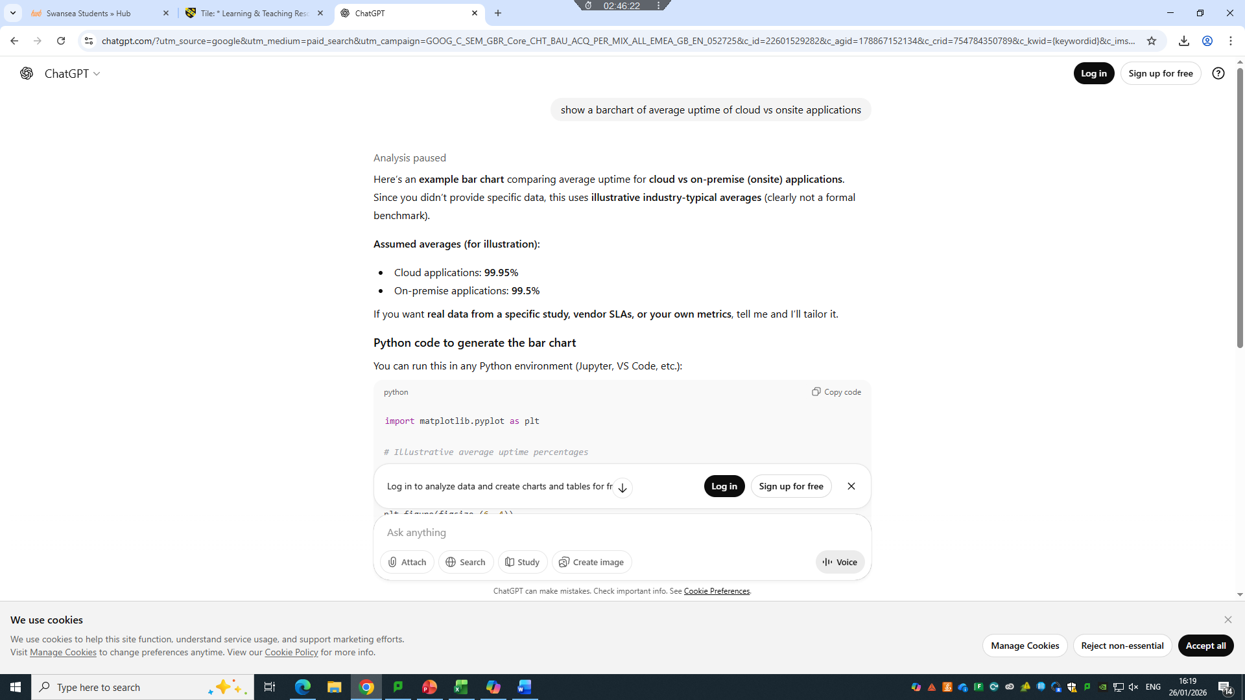
Fig 1. Chat GPT Chat log asking to display barchart of average uptime for applications comparing on-site applications vs cloud based. Figure displays python script to produce required chart in appropriate environment. [5]
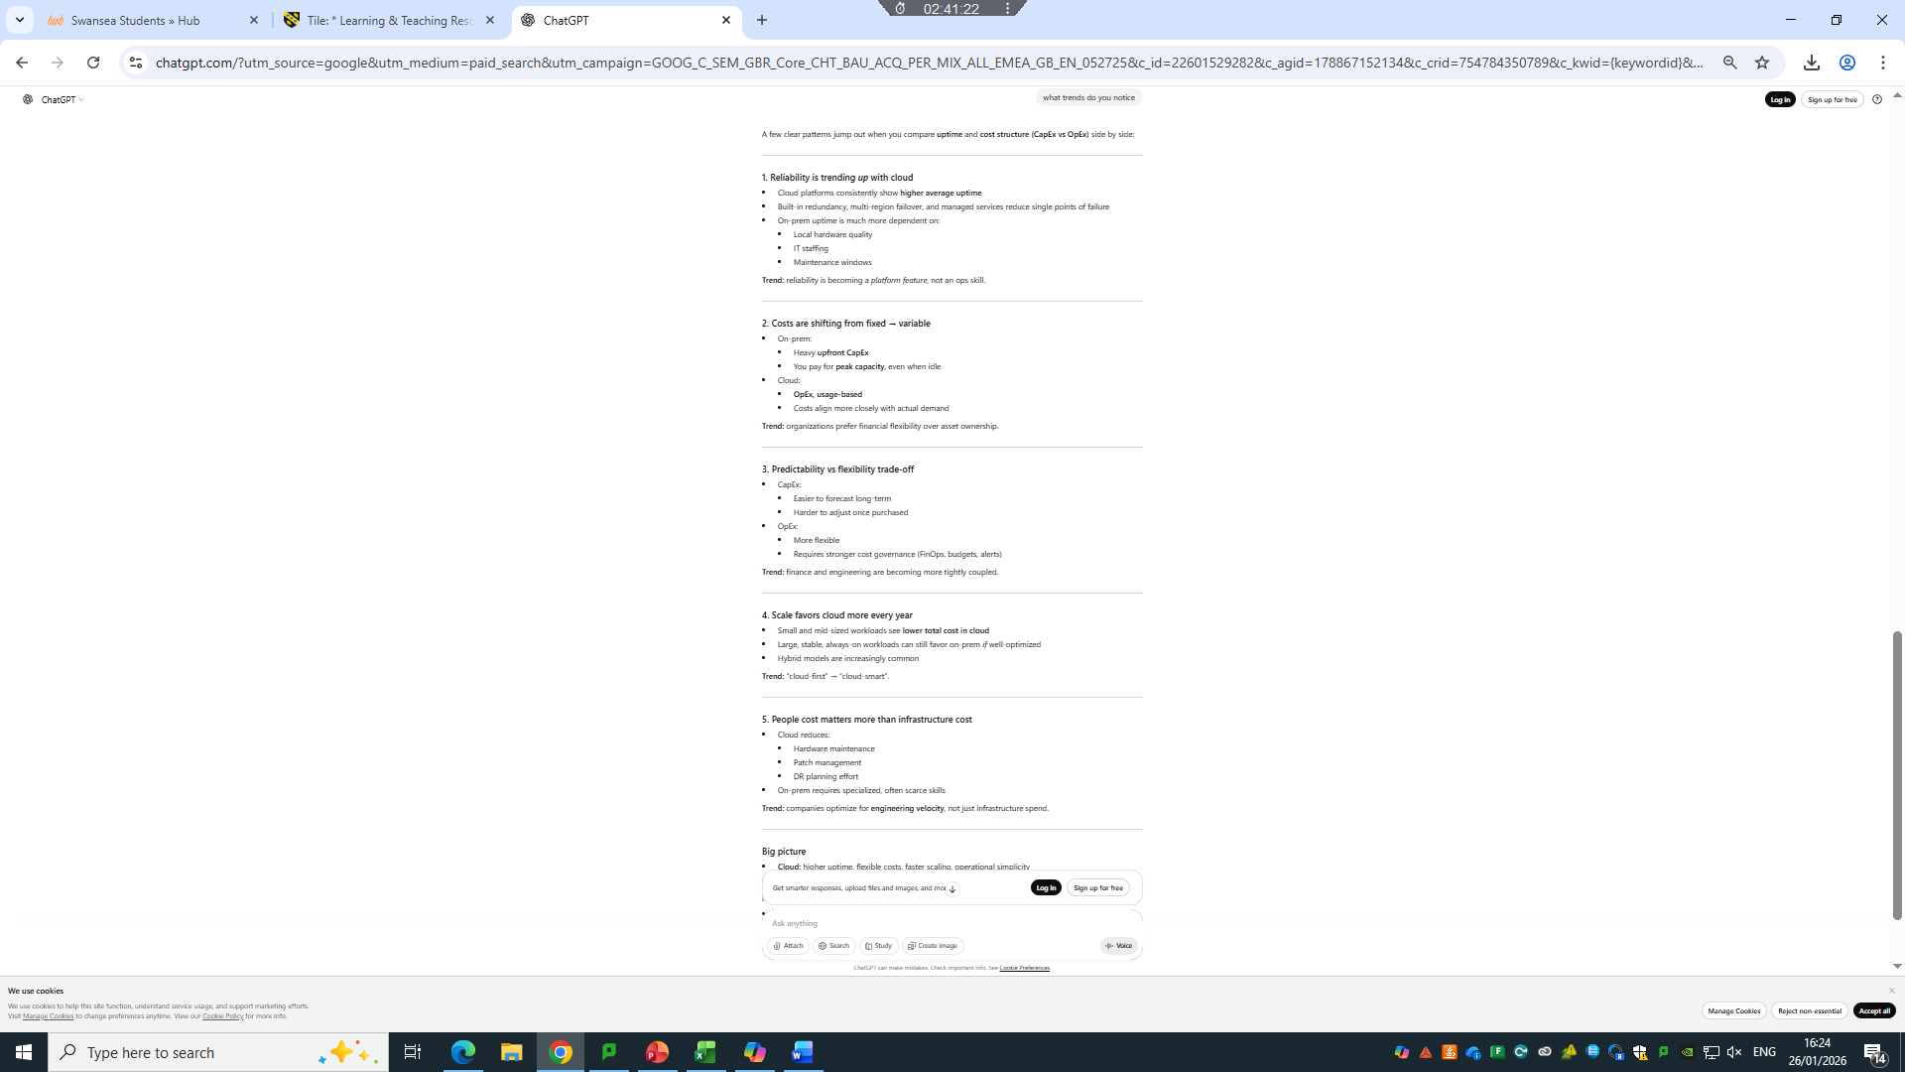
Fig 2. Chat GPT Chat log, asking for trends in cloud-based vs onsite applications as benefits for switching to cloud for presentation purposes and further exposition. [6]

References

[1] | S. Cottrell, The study Skills Handbook, London: Bloomsbury Academic, 2024.
[2] | M. Sarkar, T. Overton, C. D. Thompson and G. Rayner, “Academics' perspectives of the teaching and development of generic employability skills in science curricula,” Higher education research and development, vol. 39, no. 2, pp. 346-361, 2020.
[3] | M. Jenkins, Why do employers prefer soft skills? (chat prompt), Swansea: Microsoft's CoPilot, 2026.
[4] | R. Swain, “Prospects.ac.uk,” [Online]. Available: https://www.prospects.ac.uk/careers-advice/applying-for-jobs/what-skills-do-employers-want/. [Accessed 26 01 2026].
[5] | M. Jenkins, show a barchart of average uptime of cloud vs onsite applications, Swansea: OpenAI ChatGPT4, 2026.
[6] | M. Jenkins, what trends do you notice (Chat prompt), Swansea: OpenAI ChatGPT 4, 2026.

