
Portfolio – Two Tasks
(LCHS4003: Introduction to Health and Social Care)
Student name: Rani saima
Student ID number: 2440153
Programme: Certificate of Higher Education Skills for the Workplace (Health & Social Care)
Module code & title: LCHS4003 – Introduction to Health and Social Care
Lecturer: Aishat bakre
Assignment title: Task 1 Poster + Task 2 Essay
Submission deadline: Monday 20 October 2025, 10:00

Task 1 Poster - Community Antenatal Midwifery Services (NHS)
Explain the Service

Function of the Service

Brief History

Current Challenges (UK, last 10 years)

Visuals
A National Survey Exploring the Expectations of Pregnant Women Regarding Antenatal Education (Larkai et al., 2025)
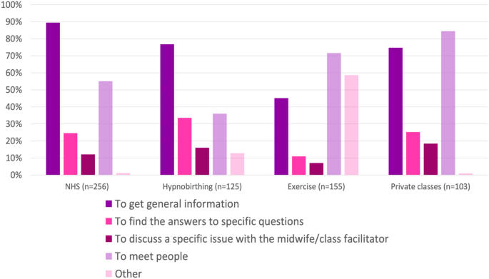
Antenatal care timeline – (NHS Fife, 2025)
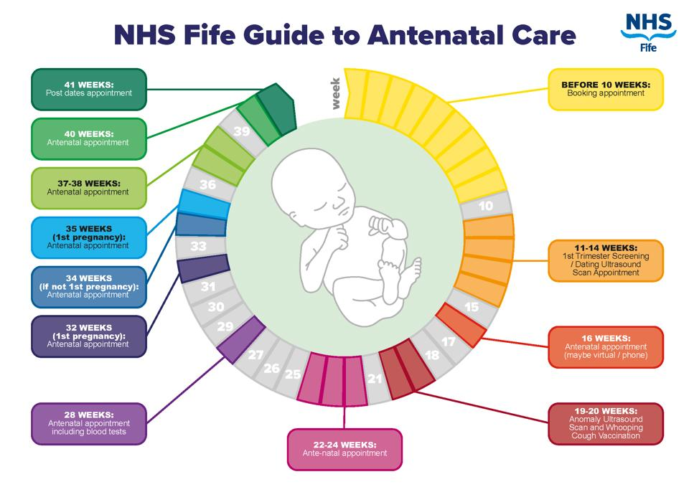
References
NICE (2021) Antenatal care (NG201). Available at: https://www.nice.org.uk/guidance/ng201 (Accessed 19 Oct 2025).
NHS (2023) Your antenatal appointments. Available at: https://www.nhs.uk/pregnancy/your-pregnancy-care/your-antenatal-appointments/ (Accessed 19 Oct 2025).
NHS England (2016) Better Births. Available at: https://www.england.nhs.uk/publication/national-maternity-review/ (Accessed 19 Oct 2025).
The King’s Fund (2022) Integrated care systems explained. Available at: https://www.kingsfund.org.uk/ (Accessed 19 Oct 2025).
Care Quality Commission (CQC) (2024) National review of maternity services. Available at: https://www.cqc.org.uk/ (Accessed 19 Oct 2025).
Larkai, E., Davies, A., Toolan, M., Lynch, M., Plachcinski, R., Larkin, M., Fraser, A., Burden, C., & Merriel, A. (2025). What do antenatal women want from their antenatal education? a national survey. Maternal and Child Health Journal. https://doi.org/10.1007/s10995-025-04048-z
Royal College of Midwives (RCM) (2023) State of Maternity Services – England. Available at: https://www.rcm.org.uk/ (Accessed 19 Oct 2025).
MBRRACE‑UK (2023) Saving Lives, Improving Mothers’ Care. Available at: https://www.npeu.ox.ac.uk/mbrrace-uk (Accessed 19 Oct 2025).

Task 2 Essay – Origins and Current Structure of the NHS
This essay explains how and why the National Health Service (NHS) was created and how it operates today. It sets the historical context and the political choices that enabled a universal service. It then outlines the founding principles that shape expectations of equity and access. Finally, it examines the current structure and functioning of the NHS and offers a brief critique.
The NHS launched on 5 July 1948 as part of the post-war settlement to build a comprehensive welfare state. The Beveridge Report (1942) argued for universal social insurance and a national health service to confront the “giant evils” revealed by wartime hardship (The National Archives, 2023; Royal College of Physicians, 2024). Aneurin Bevan, Minister of Health in the Labour government, led legislation that replaced a patchwork of voluntary hospitals, municipal services and private practice with a universal service, making access based on clinical need rather than ability to pay (History of Government, 2023).
The NHS’s enduring principles, later set out in The NHS Constitution, are universality; comprehensive services; access based on clinical need, not ability to pay; excellence and professionalism; patient partnership; collaboration; value for taxpayers’ money; and public accountability (DHSC, 2021). These principles operationalise the founding promise of care free at the point of use, funded mainly through general taxation and supplemented by National Insurance (The King’s Fund, 2024).
Institutionally, the Health and Care Act 2022 placed Integrated Care Systems (ICSs) on a statutory footing and replaced Clinical Commissioning Groups with 42 Integrated Care Boards (ICBs) responsible for planning and funding services (Legislation.gov.uk, 2022; NHS England, 2022). Provider collaboratives bring hospital, mental health and community providers together to reduce unwarranted variation and improve productivity (The King’s Fund, 2022). Primary care contractors, GPs, dentists, community pharmacies and optometrists, remain the NHS’s main front door.
Functionally, national stewardship sits with the Department of Health and Social Care and NHS England, while ICBs allocate budgets and commission primary, community, acute, mental health and ambulance services. Place-based partnerships align NHS and local-authority teams to address local needs and inequalities (NHS England, 2022; The King’s Fund, 2022). NICE issues evidence-based guidance and technology appraisals to promote clinical and cost-effectiveness, and the Care Quality Commission inspects providers (CQC, 2024). Funding is predominantly from general taxation, set by Parliament, allocated to NHS England and distributed to ICBs and national programmes (The King’s Fund, 2024). In 2025, the government’s mandate to NHS England emphasised recovery, productivity, prevention and a shift toward integrated, community-centred care (DHSC, 2025).
A critical appraisal must weigh promise against constraint. ICSs provide a framework to integrate services around people and places, emphasising prevention and collaboration over competition. Yet persistent headwinds—workforce shortages, rising multimorbidity and ageing, backlog pressures, capital deficits and productivity challenges—can blunt reform (The King’s Fund, 2024). Ministers also proposed streamlining national arm’s-length bodies to reduce duplication and refocus resources on the front line; the plans remain contested (Reuters, 2025). Reorganisation can clarify accountability but risks disruption unless roles, data-sharing and incentives are aligned.
Conclusion. The NHS emerged from a post-war consensus that healthcare should be universal, comprehensive and free at the point of use. Its contemporary model—national stewardship with locally integrated systems—aims to organise care around population needs rather than institutional silos. Delivery now hinges on credible workforce plans, investment in primary and community capacity, modern data and digital infrastructure, and resilient collaboratives. If reforms strengthen prevention, equity and community services while improving productivity, the founding principles can be renewed for today’s pressures (DHSC, 2021; The King’s Fund, 2022). Measured against its origins, success will be seen in equitable access, safe outcomes and prudent use of public money overall.

References
Department of Health and Social Care (DHSC) (2021) The NHS Constitution for England. Available at: https://www.gov.uk/government/publications/the-nhs-constitution-for-england (Accessed 19 October 2025).
The National Archives (2023) The foundation of the NHS. Available at: https://www.nationalarchives.gov.uk/explore-the-collection/stories/the-foundation-of-the-nhs/ (Accessed 19 October 2025).
History of Government (2023) The founding of the NHS: 75 years on. Available at: https://history.blog.gov.uk/2023/07/13/the-founding-of-the-nhs-75-years-on/ (Accessed 19 October 2025).
Legislation.gov.uk (2022) Health and Care Act 2022: Part 1 — Integrated care boards. Available at: https://www.legislation.gov.uk/ukpga/2022/31/part/1/crossheading/integrated-care-boards/enacted (Accessed 19 October 2025).
NHS England (2022) Integrated care systems (ICSs). Available at: https://www.england.nhs.uk/commissioning/who-commissions-nhs-services/ccg-ics/ (Accessed 19 October 2025).
The King’s Fund (2022) Integrated care systems explained. Available at: https://www.kingsfund.org.uk/insight-and-analysis/long-reads/integrated-care-systems-explained (Accessed 19 October 2025).
The King’s Fund (2024) NHS budget: how it is funded. Available at: https://www.kingsfund.org.uk/insight-and-analysis/data-and-charts/nhs-budget-nutshell (Accessed 19 October 2025).
Department of Health and Social Care (DHSC) (2025) Road to recovery: the government’s 2025 mandate to NHS England. Available at: https://www.gov.uk/government/publications/road-to-recovery-the-governments-2025-mandate-to-nhs-england (Accessed 19 October 2025).
Reuters (2025) British PM Starmer scraps health body in search of savings and better care. Available at: https://www.reuters.com/business/healthcare-pharmaceuticals/british-pm-starmer-scraps-health-body-search-savings-better-care-2025-03-13/ (Accessed 19 October 2025).
Royal College of Physicians (2024) A cure for the giant evils in society: the birth of the NHS. Available at: https://history.rcp.ac.uk/blog/cure-giant-evils-society-birth-nhs (Accessed 19 October 2025).
NICE (2021) Antenatal care (NG201). Available at: https://www.nice.org.uk/guidance/ng201 (Accessed 19 October 2025).
NHS (2023) Your antenatal appointments. Available at: https://www.nhs.uk/pregnancy/your-pregnancy-care/your-antenatal-appointments/ (Accessed 19 October 2025).
NHS England (2016) Better Births: Improving outcomes of maternity services in England. Available at: https://www.england.nhs.uk/publication/national-maternity-review/ (Accessed 19 October 2025).
NHS Fife. (2025) Antenatal care schedule. Available at: https://www.nhsfife.org/services/all-services/maternity/antenatal-care/antenatal-care-schedule/ (Accessed: 19 October 2025).
Care Quality Commission (CQC) (2024) National review of maternity services in England. Available at: https://www.cqc.org.uk/ (Accessed 19 October 2025).
Royal College of Midwives (RCM) (2023) State of Maternity Services – England. Available at: https://www.rcm.org.uk/ (Accessed 19 October 2025).
Larkai, E., Davies, A., Toolan, M., Lynch, M., Plachcinski, R., Larkin, M., Fraser, A., Burden, C., & Merriel, A. (2025). What do antenatal women want from their antenatal education? a national survey. Maternal and Child Health Journal. https://doi.org/10.1007/s10995-025-04048-z
MBRRACE‑UK (2023) Saving Lives, Improving Mothers’ Care. Available at: https://www.npeu.ox.ac.uk/mbrrace-uk (Accessed 19 October 2025).
Policy Navigator – The Health Foundation (1902/2024) Midwives Act 1902. Available at: https://navigator.health.org.uk/ (Accessed 19 October 2025).

