
Skills for the Workplace
Module Assignment Submission
Student Name: | Medi-Bethan Williams
Student Number: | 2025488
Module No: | BMSK4004
Module Title: | Problem Solving and Decision Making

Statement of Confirmation of Authenticity
By the act of making this submission, the student declares that this is the work of the student named above. The work has not, in whole or in part, been knowingly presented elsewhere for assessment, or where assessment has been built on a previous assessment, this has been identified. Where materials have been used from other sources it has been properly acknowledged. If this statement is untrue, the student acknowledges that an assessment offence has been committed.
Attention is drawn to the plagiarism and unfair practice policies of UWTSD.

Table of Contents
Introduction 3
Define a complex problem in the workplace, including its scope and impact 3
Analyse information on the identified problem, to help inform the decision making process 6
Propose a range of alternative solutions to the problem 8
Using a decision making technique, evaluate a range of solutions to identify the most appropriate option 9
Develop a detailed plan for implementing the solution 10
Communicate the plan to relevant stakeholders 10
Assess appropriate monitoring and review techniques to ensure successful implementation of solution 11
Conclusion 11
References 13
Appendix 1 14
Appendix 2 15
Appendix 3 17
Appendix 4 18
Appendix 5 20
Appendix 6 21

Introduction
Outlined by (Bransford & Stein, 1984; Dewey, 1933; Polya, 1971) the majority of models for problem solving contain at least four phases; Input phase, identifying the problem and understanding the issues and obstacles. The Processing Stage, communication and evaluation of the circumstance and challenges in which a solution is identified. The Output Phase, planning and implementing the solution and the Review stage, where the solution is reviewed and any adjustments are made.
The report outlines problems encountered during the monitoring of indicators and eligibility criteria by the Welsh European Funding Office (WEFO) and the various parties understanding of the baseline eligibility of two of the proposed projects and their indicators definitions for outcomes achieved. The two projects highlighted in the monitoring report were, “At risk of NEET” and “Young people”. Following the WEFO Monitoring and Verification Teams report, a number of participants were deemed ineligible due to the varied interpretation of the projects participant eligibility criteria. This posed a financial threat to the proposed extension to further the projects timeline and consequently additional staffing cuts.

Define a complex problem in the workplace, including its scope and impact
Better Jobs Better Futures is a European Funded project financially delivered by the Welsh European Funding Office in conjunction with the Welsh Government. The project supports various individuals through various employability skills. It is a portfolio of five projects making up the suite of projects known as Better Jobs Better Futures. “Underemployed”, “At Risk of NEET”, “Young People” “Over 25’s” and “Women in employment” totalling a value of 12 million pound.
The project suite is a pilot project, which has been highly successful in attracting over 2000 participants over a period of three years and delivered by Gower College Swansea.
The projects business plans defined the delivery mechanisms of the projects including financial costings and participant indicators. The business plans summarised the delivery mechanism to engage and evaluate the eligibility of participants in line with government agendas and policy. Agreed by WEFO based on the business plan content, we were able to start delivery in 2017.
The project delivery team are responsible for completing the initial eligibility checks when directly meeting the participants and in signing them up to the individual projects. This includes documentation to evidence the right to live and work in the UK, proof of unemployment or proof of being at risk of NEET.
Career Coaches, will subsequently continue to work with the participants through a number of employability interventions, such as CV writing, Interview techniques, identifying job opportunities, completing a client plan and diary to show the participant’s journey. This when sampled for WEFO’s Monitoring and Verification Team, will show a summary of the participants eligibility criteria and their journey to successfully achieve an outcome. Identified outcomes are, job success, improved labour market, returned to education at reduced risk of NEET.
The ways in which these outcomes are evidenced is complex, each will need its own verification documentation, and example of this is where there has been an improved labour market. Evidence needs to show an increase in contract hours, pay rate or a higher skilled job following training intervention
At risk of NEET project, was identified as being unable to provide a robust definition of participants eligibility of the project through the outlined scoring matrix. This scoring Matrix, whilst it defines attainment, behaviour, and achievement as categorised for At risk of NEET, the element for low self-esteem and lack of labour market experience is defined by the client themselves and therefore is self declared and is monitored throughout the participants journey.
The Young People project was identified as not recording their unemployment status.
Scope and Impact
This created a significant problem, as this would mean re-tracing evidence from participants who had engaged with the project over the duration of three years. This would include participants who had achieved and completed on the project, those who had disengaged and those that were continuing with support from the project equating to over 2000 participants. With a threat of no further extension, there would be huge implication to staffing and number of contracts terminated. Including that of my team within the External Funding Department.
Following discussion with WEFO to determine the requirements to satisfy their audit findings, the college management team undertook a stakeholder analysis to determine the scope of those who may be affected by the problem.
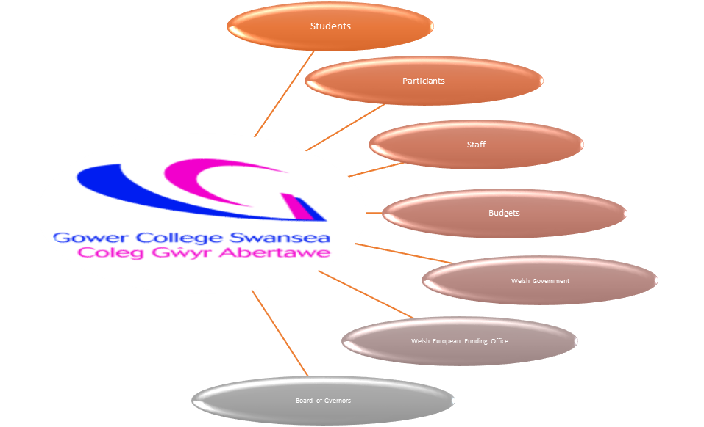

Following the identification of stakeholders, a risk assessment was carried out identifying the risk to stakeholders and weighted to identify scope of threat proposed.
Stakeholder | Risk | Effect | Mitigation | Risk Level
Board of Governors | Decision to terminate project | Staff contracts terminated, reputation of department and project management, depletion of college budgets | Develop and present a Strategic plan to overcome project problem | High
Welsh European Funding Office | Decision to terminate with no further extension | College reputation tarnished for non-delivery, No further funding | Implement Plan to address problem and resolve within outlined timeframe | High
Welsh Government | Evaluation and impact report recorded of non-delivery and noncompliance of project | Possible investigation into the use of public funds | Implement Plan to address problem and resolve within outlined timeframe | Low
Finance Department and Budgets | Departmental Budget cuts | Staff reduced to offset budget cut | Develop and present a strategic plan to overcome project problem | Medium
Staff | Redundancy and contract termination | Reduced staffing to cover other projects | Implement Plan to address problem and resolve within outlined timeframe | High
Participants | No further employability support | No intervention to support the employability agenda | Address problem and resolve within outlined timeframe. Contact partner organisation for capacity for referral mechanisms | High
Students | No further employability support | Greater risk of being at risk of NEET | Address problem and resolve within outlined timeframe. Contact partner organisation for capacity for referral mechanisms | High

Rag rating Red – High, Amber – medium and Green – Low

Analyse information on the identified problem, to help inform the decision making process

As there had been a problem identified through the point of audit by WEFO, numerous variables could contribute to the problem, therefore a creation of a task and finish committee was implemented, to analyse information and deduce a solution or solutions to overcome both the problem and the challenges surrounding the resolution. This team comprised of representatives from Management, Delivery and Compliance teams. The reasoning behind the varied members is to ensure that all layers of the project process were included as there may be many causes to the root of the problem throughout the process and includes the versatility that comes with a knowledge bank and knowledge sharing creating w wider thought process throughout the organisation. It also creates a knowledge bank. As outlined in the article, “Problem Solving Series: What Are Problem Solving Skills” (2019) it can support Convergent vs. Divergent Thinking, bringing together logic, speed and accuracy leaving no ambiguity. Pragmatics vs. Semantics, the logic to the problem at hand and the interpretation to solving it giving greater possibility of producing a solution. Mathematical vs. Personal Problem Solving, includes mathematical and intuitive thinking. All of these bring Reproductive Thinking. The use of previous experience and an understanding of different parameters and the complexities in finding a solution and finally, Idea Generation, which can yield a number of innovative solutions”.
In order to understand the cause and effect of the problem we used the 5 why’s methodology with multiple lanes (MindTools, 2009). Giving the task and finish group opportunity to ask why this was happening and why operationally there was a downfall.

Problem

Ineligible participants resulting in negative outcome and results.

No evidence to support the criteria
Evidence not collected at point of sign up
What documents needed to be gathered

Staff changes and personal development needs
Coaches not informed enough of project compliance
No Understanding of evidence requirements by coaches


Further instruction from WEFO on requirements
No clear definition of criteria evidence

Guidance on completing an informed client plan that incorporates project criteria
No definition of eligibility summarised in the client plan

Need to reiterate roles and responsibilities
No autonomy of requirements

A further fishbone methodology analysis (Appendix 1) was undertaken to further explore and determine relevant outcomes and suggestions to address process techniques until resolutions and solutions had been narrowed down. Using Ishikawa fishbone model developed in the late 1960’s (Mindtools, 2009) gave the task and finish team opportunity to further explore relevant causes of the problem and identify the consequential factors that attributed to the problem.
A review of the current flow chart process was undertaken by the task and finish group to determine whether there was too much complexity within it and if there was a need to simplify the content in order for a better understanding of the process and staff responsibility. This was reviewed and seen as a comprehensive document and need not be revised. (Appendix 2).

Propose a range of alternative solutions to the problem

General Problem Solving (GPS) references problem solving as identifying sub goals and the deduction of methodologies to fulfil the sub goals (A Newell and Simon, 1972). The use of the Ishikawa model was a helpful technique for the task and finish group to do just that.
From the categories identified through the mind mapping exercise six root causes emerged though the main causes of these were in two main areas Eligibility Criteria and Staff Knowledge
The “thinking out loud” technique out lined by Whimby and Lockhead (1991). Demonstrated that talking through your thoughts whilst others listen is a valuable resource to problem solving. This creates a sense of understanding of the problem and an opportunity to present solutions, which others can offer feedback on. Critically analysing the solutions to offer the best solution.
Eligibility Criteria
The projects are funded by European funding where there are stringent requirements outlined for evidence. For example Right to live and work in the UK, this can be evidenced in a number of ways this can be a National Insurance Number, a passport or Marriage and or Birth Certificate. As the list provided by WEFO has a number of options participants would benefit from seeing the evidence list to provide this as primary evidence and would have an understanding of the documentation. If the participants are not able to provide this evidence as primary evidence, they are also able to provide a four-stage document declaring what they have done to try to get the primary evidence. This can be transferred to a self-declaration, which is acceptable, by WEFO providing the Project Team deem them to have satisfied a valid attempt to gather the information required.
Another option to resolve the identified issue of evidence is to give additional training to the delivery team. This can be done in the form of a handout, which can be discussed and shared with the participants at point of sign up, or first consultation. The handout can also be utilised as a checklist for the auditor to recognise what documentation is being presented to prove the eligibility criteria. This will remove any doubt and is clear and factual in its presentation to avoid ambiguity.
In addition, when booking an appointment, emailing the information requirements to the participant will give them time to gather the documents required to satisfy the eligibility criteria. When meeting with the coaches the participants will come prepared, leaving the coaches with only checking the validity of the documents.
Staff Knowledge
An area identified in need of addressing, is the understanding and knowledge base of staff at direct delivery and a compliance perspective. The two are separate teams, with different functionality. Delivery are in direct contact and front facing with the participants whereas compliance are the team that finalise and determine the eligibility evidence gathered by delivery is accurate and within the guidance outlined by WEFO. Fondly known internally as the project police. Whilst both teams are equipped with the business plans approved by WEFO, the terminology and content is extensive and spans 123 pages.
An option to support both, would be to devise a short handout that defines the business plan and the requirements as an easy read option in non-professionals’ terms so there is an understandable comprehensive. This would limit the discrepancy in interpretation of the business plan in particular the terminology used.

Using a decision making technique, evaluate a range of solutions to identify the most appropriate option

During the reviewing stage, a number of possible solutions have been identified. In order to reaffirm the best solution we as a task and finish group undertook a grid analysis (Appendix 3). This examined the solutions brought to the table; this was used to define a non-financial analysis, which affirmed the best option would be to undertake a short handout that condenses the information in the form of evidence documentation approved by WEFO.
Giving the grid analysis results, this highlighted the best solution, this in turn served as a time saving tool for the group in identifying the most appropriate solution to overcome the problem. All parties agreed that this tool had serviced many opinions to define the best solution. This could have taken a number of meetings, which a number of individuals in the group could have considered most relevant in respect of their department, roles or responsibilities. Applying the grid analysis methodology created a consensus based on its results. “If everyone is using the same process of problem solving, then unity or consensus is much easier to achieve. Unified action generally produces better results than non unified action (Kolstoe,1985).
With the identified solution outlined from the grid analysis, we undertook a cost benefit analysis to identify the cost implications surrounding the problem and the impact fiscally on the project. The cost benefit analysis is based on the ratio of one participant allows a drawdown of 1500 pound to divide between project management and delivery on a ratio of 50% delivery, 30% project management and Compliance 20%. Therefore, the problem has a significant impact on the original profiled financial and outputs outlined in our business plan. For any participants deemed ineligible this has a financial clawback of 1500 pound that would no longer be available to ensure delivery staff and project management are covered. The wider picture is it has a bearing on financial budgets internally within the college. On a worst case, scenario staff would lose jobs. (Appendix 4).
As the project is based on draw down ration against participant which is an allocated amount for project management and delivery. The cost benefit analysis identified how we can, based on the implementation of the solution minimise the financial impact on the project and clearly staff costs. The objective of the analysis was to establish a zero balance in enduring the originally profiled financial stayed in line with participant number and ensuring we stayed within the profiled agreed staff fiscal allocation.

Develop a detailed plan for implementing the solution

Whilst the group recognised the communication and dissemination of the information, we determined the need to develop a timeframe for the development and implementation of the solution.
As the funder, WEFO as part of their audit had identified the problem and they had given us a timeframe of two months to rectify and resubmit the audit samples, the group recognised the need to react quickly in the implementation of this solution. In particular the financial implication that was tied to this. The group undertook a Gantt chart to ascertain the implementation time needed to carry out the requirements needed to develop the new eligibility checklist. This took into account when and who has responsibility for each task. The Gantt chart also took into account any sequential tasks and any buffer timeframes of any incidental issues such as availability of staff and departments required to complete the task in hand. (Appendix 5).
As each department involved has day-to-day operational obligations, it is critical that all elements are factored in to the Gantt chart, such as availability to perform and carry out the research requirements.

Communicate the plan to relevant stakeholders

The task and finish group, following the analysis and identification of the outlined solution undertook a dissemination plan to ensure an effective communication plan was defined and created. This would encompass the dissemination of timelines to staff, WEFO and additional stakeholders that had an interest in the project, its outcomes and its fiscal alignment with profiled expenditure.
Communication Plan
Deliverables | Recipient | Delivery Method | Schedule | Responsibility
Development of eligibility document | Participants  Delivery Coaches  Project Management | Meetings  Email  Steering group meetings | Development within 4 weeks | External Funding Unit
Compliance checks | Project Management Team | Meetings | Bi-weekly | External Funding Unit
Audit | WEFO | Audit samples | Quarterly at claim | Delivery team and External Funding Unit
WEFO summary of findings dissemination | Project Management  Delivery Team | Meetings  Email  Project Reviews | Quarterly | External Funding Unit
Fiscal expenditure | Director of Finance | Spreadsheets  Project Review Meetings | Quarterly | External Funding Unit

Assess appropriate monitoring and review techniques to ensure successful implementation of solution
In order to monitor the progress of the project, we, as a task and finish group felt the most effective tool would be to categorise the Gantt chart with the responsibilities. Monitoring the responsibilities through departments was felt the most effective way to manage all of the pieces of the jigsaw to meet completion of the task in hand. Although there are a number of tools such as the communication and Gantt chart it was felt to determine the progress both were needed to monitor the progress.
For the benefit of this task, the combination of the communication plan and the Gantt chart, was a way to determine the structured measures outlined were being met. This would be undertaken in the way of departmental meetings. The External Funding Unit in conjunction with the project delivery team were identified as the key contributors and therefore the focus of the weekly meetings were based on their progression in completing the outlined tasks.
The Task and Finish group made a conscious decision that the best way to monitor the progress was to schedule weekly meetings with the teams and identify any slippage in timelines, deadlines or department availability. The identified person to conduct the informal meetings is the External Funding Manager.
In the undertaking of these meetings the External Funding Manager was pleased to see very little slippage in deadlines and was confident that deadlines and timeframes would be achieved. This would satisfy WEFO and was likely to support the progression and extension for the projects through meeting all the eligibility criteria, showcasing best practice.

Conclusion
On reflection of the undertaking of identifying a problem within the context of this paper, it was noticeable of the financial implications that could be critical to the delivery of the project. In understanding and implementing problem solution methodologies and models, we were able to quickly react to a resolution that would have an outweighing cost benefit. Staff could be retained, reputational presence would be retained and outcomes and target would meet the original profile projected. Without such measures, this would not have been a possibility. The handout was created within the timeframe and the clawback from WEFO was recovered. (Appendix 6). This handout can also be used as the template and best practice for future projects within the organisation.

References
A Newell and Simon, H. A. (1972) Human Problem solving. Prentice-Hall.
Bransford, J., & Stein, B. (1984). The IDEAL problem solver. New York, NY: W. H. Freeman.
Dewey, J. (1933). How we think. New York, NY: Heath. (Originally published in 1910)
Kolstoe,J.(1985) Consultation. Oxford:George Ronald Press.
MindTools (2009) 5 Whys: Getting to the Root of a Problem Quickly, Mindtools.com. Available at: https://www.mindtools.com/pages/article/newTMC_5W.htm. (Accessed 31 October 2021).
Mindtools (2009) Cause and Effect AnalysisIdentifying the Likely Causes of Problems, Mindtools.com. Available at: https://www.mindtools.com/pages/article/newTMC_03.htm. (Accessed 31 October 2021)
Polya, G. (1971). How to solve it. Princeton, NJ: Princeton University Press. (Originally published in 1957).
Problem Solving Series: What Are Problem Solving Skills? (2019) Eller Executive Education. Available at: https://executive.eller.arizona.edu/news/2018/11/problem-solving-series-what-are-problem-solving-skills (Accessed: 31 October 2021).
Whimbey, A. and Lochhead, J. (1991) Problem solving and comprehension. Hillsdale, N.J.: Lawrence Erlbaum Associates.

Appendix 1
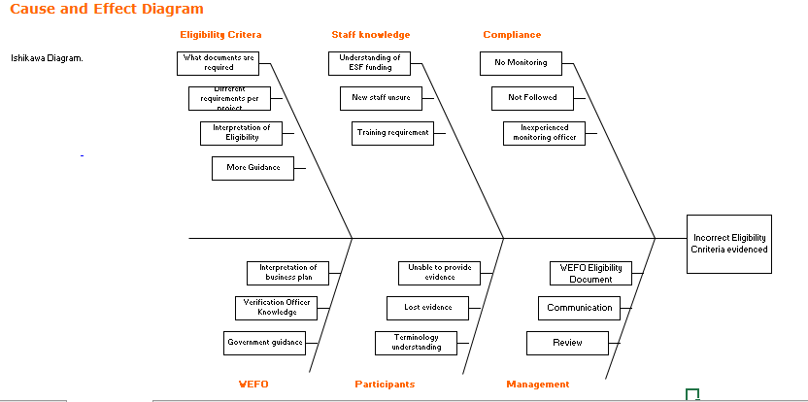

Appendix 2

Flow Chart
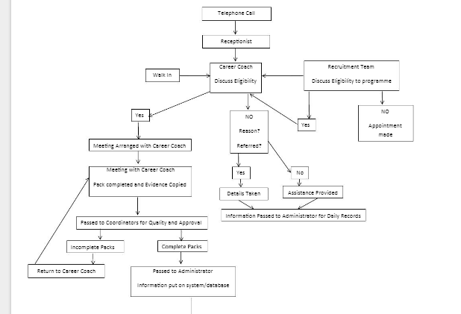
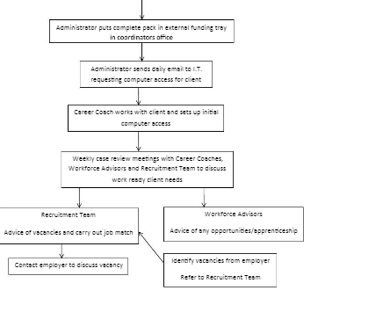

Appendix 3

Grid Analysis
Factors | Knowledge | Evidence | Compliance | Risk | Total
Weights | 3 | 5 | 5 | 4
Handout | 2 | 5 | 5 | 3
 | 6 | 25 | 25 | 12 | 68
Business Plan | 3 | 0 | 3 | 4
 | 9 | 0 | 20 | 16 | 45
New process | 1 | 5 | 3 | 5
 | 3 | 25 | 15 | 20 | 63
Training | 4 | 3 | 3 | 3
 | 12 | 15 | 15 | 20 | 62

Appendix 4

Cost benefit analysis on one project At Risk of NEET project Better Jobs Better Futures
Cost ratio per participant | Participants engaged target | Total | Project Management 30% | Project Delivery  50% | Project Compliance and Governance  20%
1500 | 480 | 720,000 | 216,000 | 360,000 | 144,000

On the basis that an approximate 10% participants are deemed ineligible over the period of the project (5 Years)
Cost Analysis

 | 1 | 2 | 3 | 4 | 5
Project Management | 43,200 | 43,200 | 43,200 | 43,200 | 43,200
Project Delivery | 72,000 | 72,000 | 72,000 | 72,000 | 72,000
Compliance and Governance administration | 28,800 | 28,800 | 28,800 | 28,800 | 28,800
Total Staffing Cost | 144,000 | 144,000 | 144,000 | 144,000 | 144,000
Participant allocation | 120 | 90 | 90 | 90 | 90
WEFO Financial Allocation | 180,000 | 135,000 | 135,000 | 135,000 | 135,000
Risk based on 10% ineligible participant allocation | 18,000 | 13,500 | 13,500 | 13,500 | 13,500
Total financial drawdown for staffing | 162,000 | 121,500 | 121,500 | 121,500 | 121,500
Deficit on staffing costs | 18,000 | (22,500) | (22,500) | (22,500) | (22,500)

Based on this cost analysis over a period of 5 years we would be- £72,000 short of the financial needed to employ staff to carry out the management, compliance and delivery of the project. £
Benefit Analysis

 | 1 | 2 | 3 | 4 | 5
Project Management | 43,200 | 43,200 | 43,200 | 43,200 | 43,200
Project Delivery | 72,000 | 72,000 | 72,000 | 72,000 | 72,000
Compliance and Governance administration | 28,800 | 28,800 | 28,800 | 28,800 | 28,800
Total Staffing Cost | 144,000 | 144,000 | 144,000 | 144,000 | 144,000
Participant allocation | 120 | 90 | 90 | 90 | 90
WEFO Financial Allocation | 180,000 | 135,000 | 135,000 | 135,000 | 135,000
Risk based on 0% ineligible participant allocation | 0 | 0 | 0 | 0 | 0
Total financial drawdown for staffing | 180,000 | 135,500 | 135,500 | 135,500 | 135,500
Deficit on staffing costs | 0 | 0 | 0 | 0 | 0

Based on the implementation of the identified solution there is a cost benefit of £72,000
Benefit to cost Ratio
Benefit to cost Ratio | 72,000 | = 0
 | -72,000 | = 0
This is depicted based on year 2 cost as the first year shows a profit however, the following years show an annual deficit
Net Annual Benefit = annual benefit – Annual cost = 135,000 minus 121,000 = equals 14,000
Year 2 alone we will have reclaimed 14,000 by the implementation of the solution
Net annual benefit = Total benefits – Total costs = 720,000 Minus 648,000 /5 = NAB 14,400
Based on the implementation over the 5 year period of £72,000

Appendix 5
Gantt Chart

Appendix 6


