PROFESSIONAL CAREER DEVELOPMENT IN HEALTH AND SOCIAL CARE

(LCHS 4009)

ASSIGNMENT 2

Name of Student: NAIRAH JADIDAH NAMAKULA.

I.D. Number: 2438044.

Name of Tutor: AMITAVE BANIK.

Acknowledgement of AI use: I confirm that I have / have not used AI to complete my work. (IF YES, ALSO WRITE I USED THIS SOURCE……. GIVE REFERENCE SUCH AS GRAMMERLY FOR EXAMPLE……TO………PROOFREAD FOR EXAMPLE).

TABLE OF CONTENTS

INTRODUCTION. 3
CURRICULUM VITAE 4
PERSONAL STATEMENT 6
A SWOT ANALYSIS. 7
PERSONAL DEVELOPMENT PLAN 8
A CRITICAL REFLECTION ON MY LCHS4009 PRESENTATION ASSESSMENT 1 10
REFERENCES 11

INTRODUCTION.
Portfolio.
Definition of portfolio.
This is a collection of evidence that shows skills, experience and knowledge over time. This is used to demonstrate that you are competent in your role as a healthcare worker and meeting required standards. (NHS, 2015)
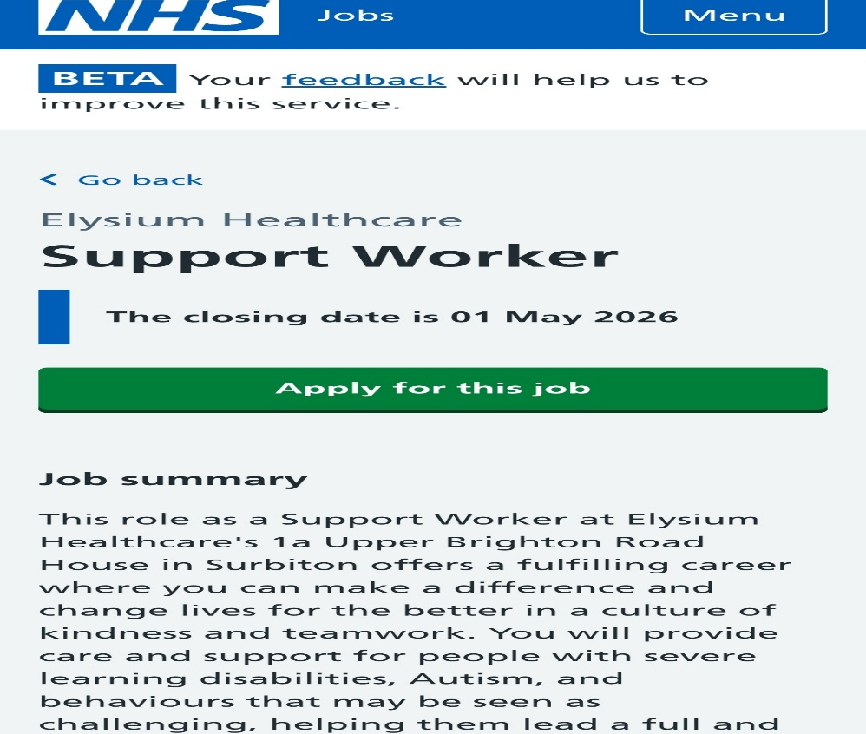

CURRICULUM VITAE
Personal Details
Name: Nairah Jadidah Namakula
Phone: 07799321954
Email: namakulanairah@gmail.com
Location: New Malden
Personal Profile.
Compassionate and motivated Support Worker with over three years of experience delivering high-quality, patient-centred care across domiciliary, supported living, care home, and community settings. Experienced in supporting children and adults with autism, dementia, learning disabilities, and complex needs. Skilled in working within multidisciplinary teams (MDT), promoting dignity, respect, and independence in line with NHS values. Currently undertaking a Level 4 Certificate in Health and Social Care, with extensive mandatory and clinical training. Committed to safeguarding, health and safety, and delivering safe, effective, and responsive care.
Key Skills
- Patient-centred and person-centred care
- Safeguarding children and vulnerable adults
- Supporting autism, dementia, and complex needs
- Positive Behaviour Support (PBS)
- Medication administration and accurate documentation
- Communication with patients, families, and MDT
- Risk assessment and care planning
- Infection Prevention and Control (IPC)
- Health and safety compliance
- Equality, diversity, and inclusion
- Emotional support and promoting independence

Work Experience
Support Worker
Liberty Hub LLP, 2024 – Present
- Deliver high-quality, patient-centred care to individuals with autism, learning disabilities, and challenging behaviours
- Apply Positive Behaviour Support (PBS) strategies to manage behaviours of concern
- Monitor and report changes in service users’ condition and wellbeing
- Maintain accurate and up-to-date care records in line with organisational and NHS standards
- Work collaboratively with multidisciplinary teams (MDT), families, and healthcare professionals
- Promote dignity, independence, and safeguarding always

Support Worker
Achieve Together, 2023 – 2024
- Supported children and adults with learning disabilities and autism in supported living environments
- Assisted with personal care, daily living tasks, and community activities
- Followed care plans and contributed to care planning reviews
- Ensured compliance with safeguarding, health and safety, and infection control policies
- Promoted equality, inclusion, and person-centred support

Domiciliary Care Worker
Skyline Home Care Limited, 2022 – 2024
- Provided care and support to individuals in their own homes, including elderly clients with dementia
- Assisted with personal care, medication, nutrition, and mobility support
- Observed and reported changes in patients’ physical and emotional wellbeing
- Maintained accurate documentation and adhered to infection prevention and control (IPC) standards
- Delivered compassionate care in line with dignity and respect principles

Education & Qualifications
Level 4 Certificate in Health and Social Care (Ongoing)
June 2025 – April 2026 (Expected)
Certifications & Training
- 32 Mandatory Health and Social Care Trainings
- Positive Behaviour Support (PBS)
- Safeguarding Children and Adults
- Infection Prevention and Control (IPC)
- Medication Administration
- First Aid

References
Refences available upon request

PERSONAL STATEMENT
Subject: Application for the role of Healthcare Support Worker.
With over three years of experience as a Healthcare Assistant, I have delivered high-quality care across home care, supported living, and community settings. I am dedicated to supporting individuals with dignity, independence, and respect, focusing on their physical, emotional, and social needs. My work with children and adults with autism, learning disabilities, dementia, and challenging behaviours has strengthened my adaptability and ability to provide safe, effective support.
As a Support Worker, I assist individuals with complex needs, including autism and challenging behaviours, using Positive Behaviour Support (PBS) methods to ensure safety and well-being. I support daily living activities, medication administration, and social engagement, while promoting independence and life skills. This role has enhanced my ability to remain calm under pressure, communicate effectively, and provide consistent, compassionate support.
Previously, I supported elderly individuals, including those with dementia, in both supported living and home care settings. I provided personal care, mobility assistance, meal support, and emotional care, always upholding dignity and respect. This experience strengthened my independence, time management, and ability to build trusting relationships while maintaining professional boundaries.
I have completed 32 mandatory training courses in health and social care, covering safeguarding, infection prevention, safe handling, medication administration, and first aid. These courses have equipped me to deliver safe, high-quality care in line with current standards. I have also completed Positive Behaviour Support (PBS) training and am currently pursuing a Level 4 Certificate in Health and Social Care to further develop my expertise and leadership skills.
I take safeguarding responsibilities seriously, remaining vigilant for signs of abuse or neglect and following established procedures to report concerns. I am committed to promoting equality, diversity, and inclusion, ensuring everyone is treated with respect and dignity. I also maintain high standards of infection control and health and safety to provide a clean, safe environment for all.
Communication is one of my key strengths. I engage confidently with individuals, families, and healthcare professionals, prioritising clear and respectful interactions. I am an effective team member, collaborate across disciplines, and work independently when required. I am organised, adaptable, and manage tasks efficiently in busy care environments.
I am highly motivated and committed to continuous learning and professional development. I am reliable, punctual, and flexible, with a strong work ethic and genuine passion for supporting others. I take pride in making a positive impact, whether through emotional support, daily assistance, or providing comfort. I look forward to advancing my career while continuing to deliver compassionate, person-centred care.

A SWOT ANALYSIS.
A SWOT analysis is simple tool used to understand a person’s role by looking at the strengths (what you do well), weaknesses (areas that need improvement) opportunities (external chances to grow and improve) and threats (external factors that could cause problems). Strengths and weaknesses are internal and about you while opportunities and threats are external factors. (Care Learning, 2024a)

Strengths  - Practical caregiving skills for example experience with personal care, medication administration and mobility support.  - Good communication skills for example the ability to build trust and strong relationship with the service users, family and work team.  - Empathy and compassion for example providing person centred care and emotional support.  - Adaptability for example the ability to respond to changing needs and environment. | Weaknesses  - Time pressure for example there may be high workload which can affect the quality of care.  - Documentation skills for example this can sometimes be time consuming and lack of consistency.  - Emotional strain for example there may be risks of burnout due to demanding situations.
Opportunities  - Professional development for example access to NVQs and specialist training  - Career progress for example pathways into senior support and social work roles.  - Technology use for example to digital care plans and assistive tech improvements efficiency. | Threats  - Health risks for example exposure to illness and physical injury.  - Challenging behaviour for example risks of aggression and difficult situations with service users.  - Staff shortages for example increased workload and stress.

PERSONAL DEVELOPMENT PLAN
A personal development plan (PDP) enables me to reflect on my skills, identify areas for improvement, and establish goals for professional growth. In health and social care, ongoing development is essential for maintaining high standards of person-centred care. An effective PDP supports both my individual progress and the quality of care I deliver. (Personal development planning, 2015)

This PDP outlines four primary goals I intend to achieve over the next two years to enhance my effectiveness as a support worker. I selected these goals based on feedback from colleagues and supervisors, as well as my own reflections on areas where I seek to build on my strengths and address weaknesses. Each goal targets a specific aspect of my role and includes defined actions and timelines

1. Improving Communication Skills
Effective communication is fundamental in care work and directly supports person-centred care.
To develop this skill, I will attend communication training within the first six months, consistently apply active listening and appropriate non-verbal techniques, and seek feedback from colleagues and supervisors. I will measure progress through regular feedback forms, peer and supervisor observations, and by reviewing changes in communication effectiveness noted during supervision sessions. I will also reflect on specific instances where improved communication contributed to positive patient outcomes or enhanced team collaboration, recording these examples in my PDP for ongoing evaluation.
Year 1: Develop confidence in everyday communication
Year 2 (by month 24): Apply skills in complex situations, such as conflict resolution or supporting distressed individuals
Achieving these communication goals will enhance my daily practice and prepare me to acquire more specialised skills, which I address in the following section.

2. Developing Specialist Knowledge, such as Dementia or Mental Health
As the demand for specialised care increases, particularly for conditions such as dementia, developing targeted knowledge becomes essential.
To achieve this, I will:
Attend specialist training courses for four months
Shadow experienced practitioners
Engage with current policies and best practice guidelines.
Year 1: Gain foundational knowledge
Year 2(by month 5): Apply specialist skills confidently in practice
Attaining these specialist knowledge goals will also support improvements in time management and organisation, which I discuss in the subsequent section.

3. Improving Time Management and Organisation
Effective time management is crucial for delivering safe and efficient care. Inadequate time management can result in unmet care needs and increased stress.
To improve in this area, I will:
Use prioritisation techniques such as task lists.
Follow care plans effectively.
Reflect on daily performance.
Year 1(for 2 months): Establish consistent routines
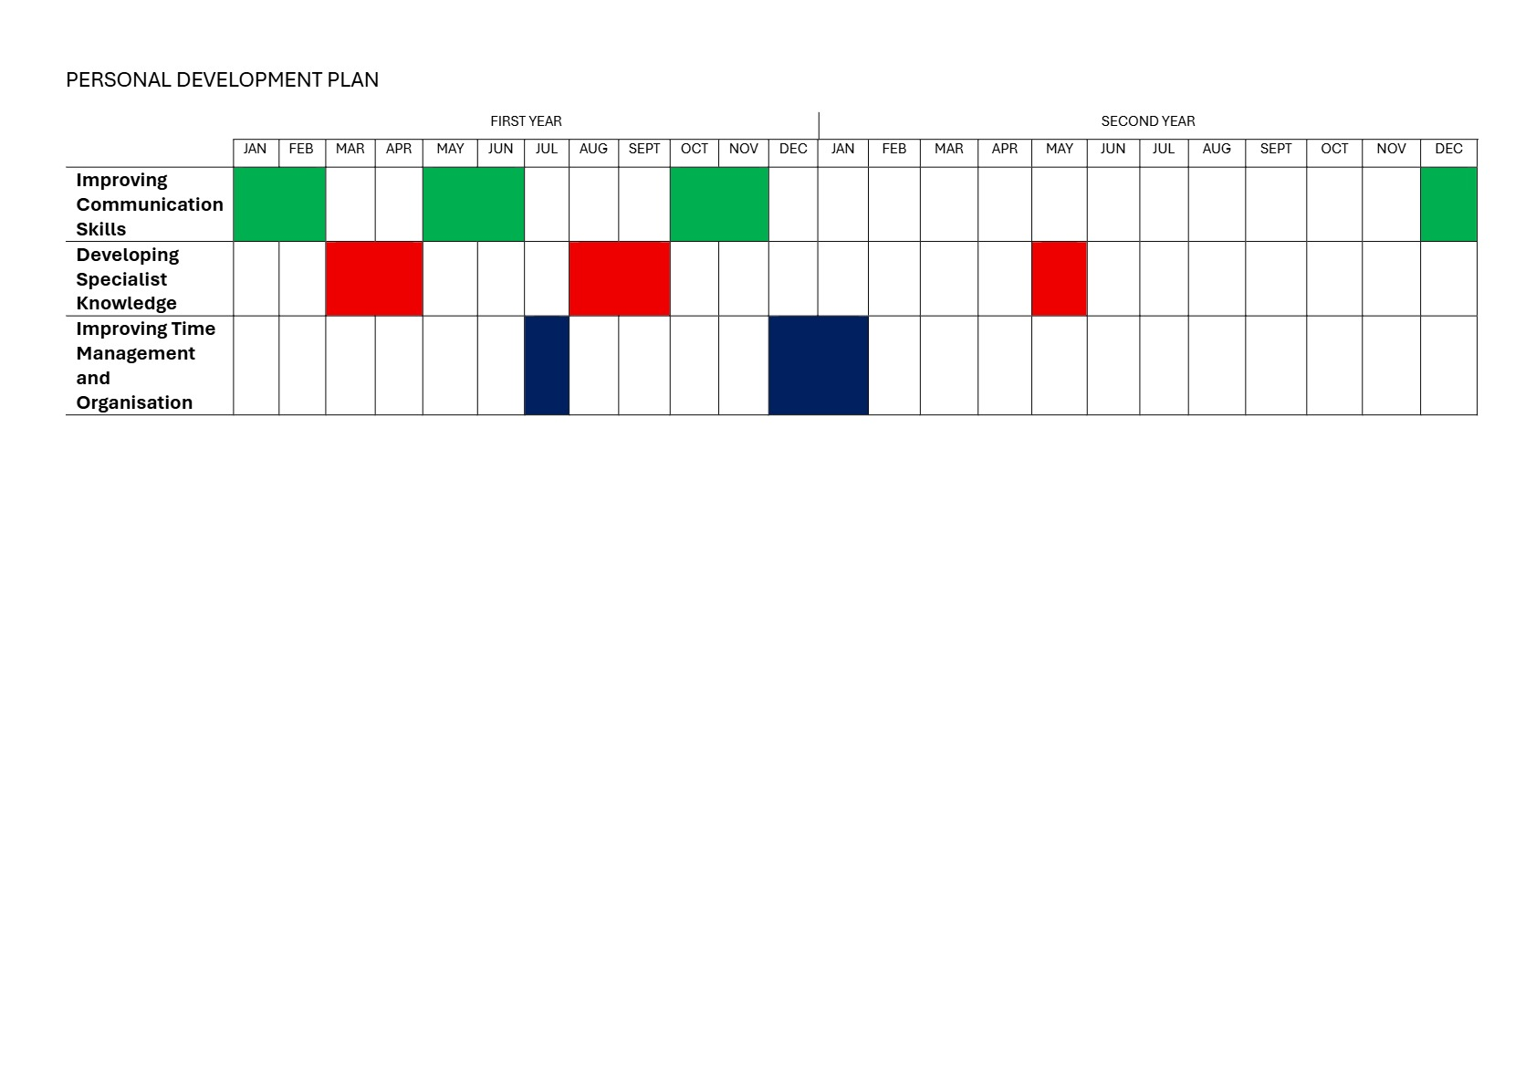
Year 2(by month1): Demonstrate efficiency and independence
After enhancing my time management and organisational skill.

Monitoring and Evaluating Progress
To evaluate the effectiveness of this PDP, I will employ monitoring methods grounded in reflective practice theory. Specifically, I will use established models such as Kolb’s Experiential Learning Cycle and Gibbs’ Reflective Cycle. These frameworks will guide my reflection by enabling me to systematically review experiences, analyse actions taken, and plan improvements, ensuring that my evaluation process remains structured and academically rigorous.
A primary approach involves supervision and appraisal, during which I will meet regularly with my manager to review progress and establish new targets. This process aligns with Kolb’s reflective cycle, which emphasises learning through experience, reflection, and continuous improvement.
I will also engage in reflective practice by analysing daily experiences to identify strengths and areas for improvement. This approach facilitates continuous learning and informed decision-making.
I will gather feedback from colleagues, supervisors, and service users. This 360-degree feedback provides a comprehensive assessment of my performance.
I will regularly review and update my PDP to ensure that my goals remain relevant and achievable. This process demonstrates adaptability and a commitment to ongoing improvement.
Finally, I will evaluate my work performance, including:
Quality of care provided
Time management
Accuracy of documentation
Progress in these areas will indicate successful professional development.

Conclusion
In conclusion, this personal development plan demonstrates a structured and reflective approach to my professional growth as a support worker. By establishing clear goals and incorporating principles such as person-centred care and reflective practice, I will enhance my skills and knowledge over the next two years. Regular progress reviews will facilitate ongoing improvement, improved care delivery, and career advancement. This plan is designed to make a meaningful impact on those I support and to foster my professional development. As I grow in my role, service users will benefit from improved communication, more effective and specialised support, and consistently high-quality care. Additionally, my development will strengthen teamwork, as enhanced skills and knowledge can be shared with colleagues to improve overall service delivery.

A CRITICAL REFLECTION ON MY LCHS4009 PRESENTATION ASSESSMENT 1
I delivered a presentation on the role of reflection in health and social care, focusing on how reflective practice can enhance the quality of care for service users and support my professional growth. During the presentation, I felt nervous and uncertain about my vocabulary. Nevertheless, I made a concerted effort, and the supportive environment enabled me to manage my time effectively. Upon completion, the audience responded positively with applause and congratulations. My tutor provided constructive feedback, highlighting my strong presentation skills and thorough research, as demonstrated by my use of references and in-text citations. He noted that this was a particularly impressive aspect of my work. However, he recommended including a table of contents when applying the reflective model to clarify the structure and purpose of my reflection and research. In the future, I plan to rehearse with colleagues and friends to build confidence, allocate more time for assignment preparation, and seek feedback from my lecturer to enhance the quality of my research and presentation. I will continue to use reflective models, such as Gibbs' Reflective Cycle, to identify areas for improvement and refine my presentation skills. Overall, the feedback was positive, and the depth of information I provided reflected my commitment to research and the quality of my assignment.

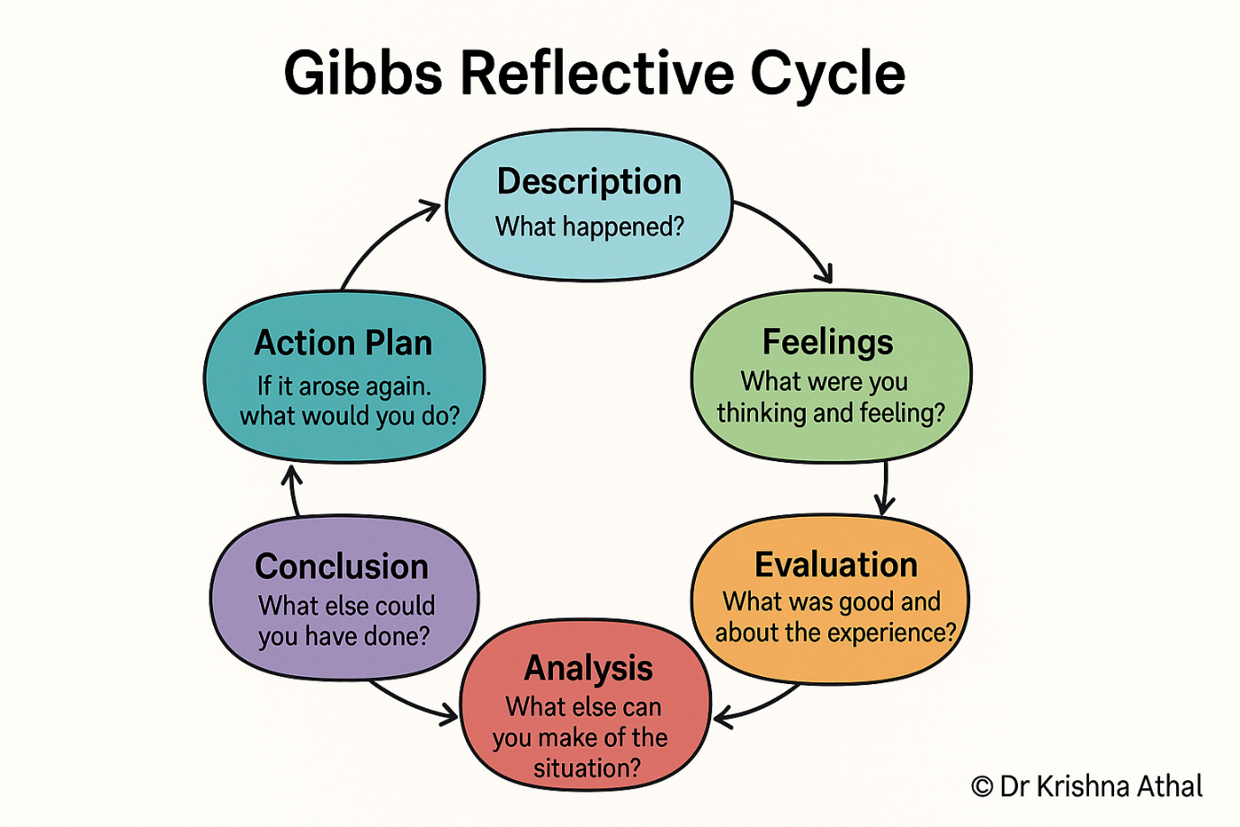
(Athal, 2025)

REFERENCES
Athal, D.K. (2025). Gibbs Reflective Cycle Explained: A Framework for Structured Self-Reflection - Dr Krishna Athal. [online] Dr Krishna Athal - Life & Executive Coach ✨. Available at: https://drkrishnaathal.com/blog/gibbs-reflective-cycle-explained-a-framework-for-structured-self-reflection/.

Care Learning (2024a). How to Use a SWOT Analysis in Health and Social Care - Care Learning. [online] Care Learning. Available at: https://carelearning.org.uk/blog/feedback-and-improvement/how-to-use-a-swot-analysis-in-health-and-social-care/.

NHS (2015). Developing your portfolio. [online] Health Careers. Available at: https://www.healthcareers.nhs.uk/career-planning/developing-your-health-career/developing-your-portfolio.

Personal development planning (2015). Personal development planning. [online] Health Careers. Available at: https://www.healthcareers.nhs.uk/career-planning/developing-your-health-career/personal-development-planning.

