
University Of Wales Trinity Saint David
School of Engineering

Extended surfaces report
ACMA6011 – Advanced Thermofluid Mechanics
Maxwell Oliver - 2218428
Mechanical Engineering
28/11/24

Table of Contents
1 Introduction 1-1
2 Task A 2-2
3 Task B 3-4
4 Task C 4-5
4.1 Part 1 4-5
4.2 Part 2 4-6
4.3 Part 3 4-6
4.4 Part 4 4-6
4.5 Part 5 4-7
5 References 5-8

Introduction
This report looks at how fins are used to improve heat transfer in engineering systems. Fins are added to surfaces to increase the area from which heat can be lost, helping systems like car engines and microprocessors stay cool. The report is split into three main tasks:
Task A looks at the history and current use of fins in automotive design and microprocessors. It will also discuss recent improvements in fin design and their benefits for heat transfer.
Task B focuses on studying how heat transfers in a fin with an adiabatic (insulated) tip. This task involves plotting the heat transfer ratio against a parameter called mL to show that the best fin length is around approximately 2.65mL
Task C analyses a rod made from different materials (2024 Aluminium, Brass, Copper, and 304 Stainless Steel) to find out how temperature changes along the rod and how much heat is lost. It will also look at the temperature profile at the best length for each material and compare the results.
Using standard heat transfer formulas and tools like Excel, this report will provide simple explanations and practical insights into how fins work and how to make them more efficient.

Task A
Task A – Extended surfaces
Introduction
Effective heat transfer is a very important in engineering to ensure systems operate efficiently even under thermal loads. There are many techniques developed to enhance heat dissipation, heat fins (extended surfaces) are designed to increase the surface area for heat exchange, stand out for their simplicity and effectiveness. Their early applications in automotive cooling to complex designs in modern microprocessors. This Task explores the historical role of fins in automotive engineering, their evolution in microprocessor cooling, and recent advances in their design and application.
Fins in Early Automotive Engineering
The history of fins in automotive design parallels the increasing capability and complexity of vehicles themselves. Early automobiles faced significant challenges in managing engine heat. Internal combustion engines, the most common propulsion system by far, required effective cooling systems to prevent overheating and maintain performance. Fins were first introduced as an enhancement to the basic air-cooled systems. In those early designs, simple rectangular fins were integrated into engine blocks and cylinders, significantly increasing the surface area available for natural convection. Aluminium, a lightweight and thermally conductive material, became a preferred choice for these fins, striking a balance between thermal conductivity and weight.
In the mid 1900s, the increasing complexity and power of automotive engines required more advanced cooling solutions. The introduction of radiators with finned surfaces marked a major advancement. Radiators with forced airflow became standard, and fins were designed with improved shapes, such as corrugated or serrated shapes, to maximize heat dissipation. Additionally, turbochargers, which subjected engines to higher thermal loads, incorporated fins into their cooling systems to ensure reliability under demanding conditions.
Modern automotive applications have taken heat fin designs to new levels. Hybrid and electric vehicles, which operate under different thermal constraints, use fins extensively in their battery cooling systems. For example, micro-fins are now employed to manage the heat generated by densely packed battery cells. These designs allow precise thermal control, ensuring battery longevity and performance. Innovations in materials, such as composite fins and advanced alloys, further enhance efficiency while reducing overall weight.
Fins in Microprocessors
The role of fins in cooling microprocessors has evolved dramatically as computing technology has advanced. In the early days of computing, processors generated minimal heat, and passive cooling systems with basic fins were sufficient to maintain acceptable operating temperatures. These early heat sinks typically used aluminium fins (similarly to the automotive sectors), relying on natural convection to dissipate heat. The relatively low power density of processors at the time meant that such simple solutions were both practical and effective.
However, the rapid increase in computing power during the 1990s and early 2000s introduced significant thermal challenges. As processors became faster and more compact, the amount of heat generated per unit increased massively. This development necessitated the adoption of active cooling systems, combining finned heat sinks with fans to enhance convective heat transfer. Copper, with its superior thermal conductivity compared to aluminium, became the most popular material for high-performance heat sinks, particularly high-end computing systems where modern CPUs and GPUs operated at upwards of 300-500 watts with a small area focusing this heat which means cooling solutions needed to be designed with a relatively small contact area but with a huge amount of heat to dissipate. At this point there was a switch from passive cooling to active cooling with the heat sinks (Heat fin cooling system) being sold with fans incorporated into the design which push cooler air across the extended surfaces in order to more quickly dissipate a larger amount of heat in order to stop the high wattage parts over heating.
In recent years, the trend toward miniaturization and increased power density has driven further innovation in fin design. Micro-fins, with dimensions in the micron range (1x10^-6 M), are now used to maximize surface area within extremely limited spaces. These are often integrated into heat pipes or liquid cooling systems, which provide superior thermal management for advanced processors. For high-performance computing systems, such as data centres and gaming computers, liquid cooling solutions with embedded fins offer the dual advantages of compactness and efficiency. The benefit of active liquid cooling when compared to active air cooling is that distilled water (the most common liquid in liquid cooling systems) can hold much more heat per litre than air. Also water has a greater heat transfer coefficient which means that the water can absorb and dissipate the heat faster than the air. A pump pushes the water over the hot contact parts of the component being cooled, absorbing a large amount of heat energy and the pump keeps pushing the water and it goes from the hot component to a integrated Heat fin radiator and flows through tubes connected to the fins which effectively dissipates the heat from the water. This now cooled water flows back to the pump to continue through the loop. Some of the main draw backs of liquid cooling is the increased risk that occurs when having flowing water in close contact with advanced and expensive electrical components. It also increases the downtime when a component needs to be changed or adjusted as great care needs to be taken when removing and installing a liquid cooling system.
Recent Advances in Fin Design
Modern advancements in fin design reflect a combination of engineering ingenuity and material science breakthroughs. One key area of innovation is geometry. While traditional straight fins remain common, complex geometries such as louvered, pin, and wavy fins have gained prominence. These designs disrupt laminar flow and promote turbulence, significantly enhancing heat transfer. Fractal-inspired geometries, which mimic natural patterns, have also been explored for their ability to maximize surface area while minimizing material usage.
Material innovation has played an equally critical role. Graphene, with its exceptional thermal conductivity, has emerged as a promising material for fins, particularly in high-tech applications like electronics. Metal foams, which combine low density with high surface area, are another innovative material increasingly used in extended surface designs. These foams not only improve heat transfer but also reduce the overall weight of the system, making them ideal for aerospace and automotive applications.
In manufacturing, 3D printing has revolutionized the production of fins. Additive manufacturing enables the creation of highly customized and intricate fin geometries that would be impossible to achieve using traditional methods. This technology allows engineers to tailor fin designs to specific thermal requirements, optimizing performance for individual applications. Moreover, 3D printing reduces waste and accelerates the development process, making it a cost-effective solution for prototyping and small-scale production.

Task B
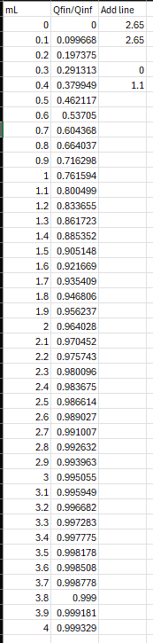
This task compares the value of Heat Transfer Rate for a fin against values for mL by plotting them on a graph with mL in steps of 0.1 from 0 to 4. Once plotted on a graph the relationship between the values is clearly an increasing exponential curve. The value of mL = 2.65 has been highlighted with a red line to show the generally considered optimum mL value for a finite fin length. The formula used to generate the values for the ratio of Qfinitie against Qjnfinite was TANH(mL) and Excel (software) was used to generate values and plot the graph.
Figure 2 - Calculated Values
Figure 1 - Qfinite/Qinfinite Ratio

Task C
Material properties:

2024 Aluminium alloy: h = 30 W/m² K and, k = 186 W/m K
Brass (70 Cu/30 Zn): h = a30 W/m² K and, k = 99 W/m K
Copper: h = 15 W/m² K and, k = 398 W/m K
304 Stainless Steel: h = 7.5 W/m² K and, k = 16 W/m K

Initial values-
-Rod diameter = 0.0075 m
-Base temperature = 110*C
-Air temperature = 18*C
Below are the m values for each material, these values have been calculated using the formula $m^{2}= \frac{hP}{kA_{c}}$ and rearranging the formula to $m=\sqrt{\frac{hP}{kA_{c}}}.$
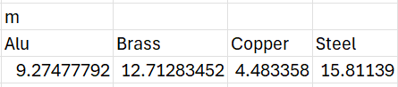
Figure 3 - m Values of Metals

Part 1
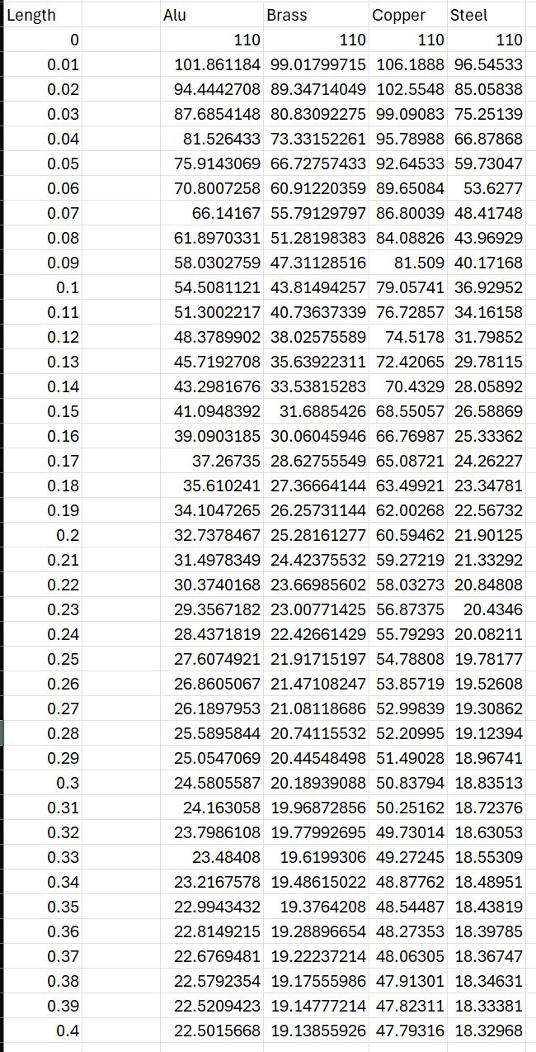
This part of Task C involves calculating the temperature distribution along the rods. This is done using the formula $T\left(x\right)= T_{∞}+ (T_{b}- T_{∞})\frac{cosh⁡[m\left(L-x\right)]}{cosh⁡(mL)}$ to calculate the temperature at different distances from the base of the rod where the initial temperature is. The formula is a function of distance along the rod with x being metres from the base. Using the above formula values of temperature were calculated using a range of x from 0 – 0.4 in increments of 0.01. 4 columns of temperature distribution were generated using each of the 4 metals and their properties.
Below is a graph of all 4 metals temperature distribution against distance from base. Also below is the table of values used to generate the graph.
Figure 4 - Table of Temperature distribution

Figure 5 - Calculated Values for Figure 4

Part 2
This part of Task C involves calculating the values of heat loss for the 4 rods. This is done using the Heat Loss Formula, $\dot{Q}= \sqrt{hPkA_{c}} \left(T_{b}- T_{∞}\right)tanh⁡(mL)$. Below are the 4 heat loss values.
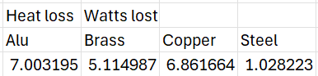
Figure 6 - Calculated Values of Heat loss

Part 3
This part of the Task requires calculating the optimum length of the rods where L = 2.65/$m$. Once the optimum length has been calculated, a new value for heat loss must be calculated using the same formula as before, $\dot{Q}= \sqrt{hPkA_{c}} \left(T_{b}- T_{∞}\right)\tanh\left(mL\right).$ Below is the calculated Optimum Length, followed by the new value of heat loss.
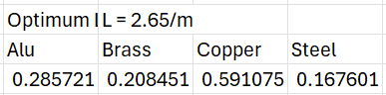
Figure 7 - Calculated Values for Optimum Length
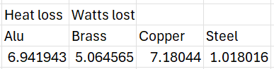
Figure 8 - Calculated Values for Heat Loss

From comparing the values of heat loss from the original L to optimum L, it is shown that for Aluminium and Brass there is a decreasing change in heat loss of about 0.05 Watts. For Copper there is an increase in the Watts of heat lost of around 0.32 watts. The heat loss value for steel decreases very slightly by a value of 0.01 which is by far the smallest change.

Part 4
Part 4 involves calculating the temperature distribution for the 4 rods at the optimum length of L. This is done using the formula $T\left(x\right)= T_{∞}+ (T_{b}- T_{∞})\frac{cosh⁡[m\left(L-x\right)]}{cosh⁡(mL)}$ where x is the optimum length value. Below are the calculated values.
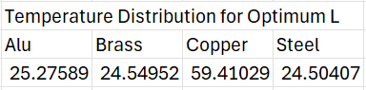
Figure 9 - Calculated Values for Temperature Distribution

Part 5
Showing that $e^{-mL}$ < 0.02. The requirement that the tip temperature needs to be close to the fluid temperature tells us that $T_{∞}$ and $T\left(x\right)$are very close in value I.E within a degree. Using this knowledge we can rewrite $T\left(x\right)= T_{∞}+ \left(T_{b}- T_{∞}\right)e^{-mx}$ to make $e^{-mx}$the subject. $\frac{T\left(x\right)- T_{∞}}{ \left(T_{b}- T_{∞}\right)}=e^{-mx}$. Now using excel we can generate a set of temperatures from 15 to 25 to give a good range above and below 18, the ideal fluid temperature. Next values of $e^{-mx}$are generated using the aforementioned temperatures. 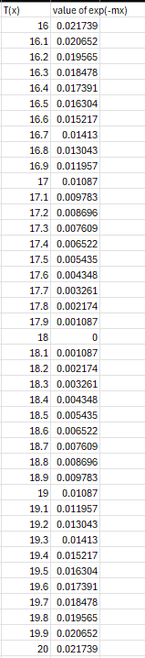
Figure 20 - Calculated Values of EXP(-mx)
From these values in Figure 20 its clear that the any value of EXP(-mx) over 0.02 is at least 2 degrees away from $T_{∞}$. Understanding that the smaller EXP(-mx) is, the closer the temperature at the tip to the fluid temperature, so we can use the equation $\frac{T\left(x\right)- T_{∞}}{ \left(T_{b}- T_{∞}\right)}=e^{-mx}$ and arrange it to get $-\frac{\ln\left(\frac{T\left(x\right)- T_{∞}}{ \left(T_{b}- T_{∞}\right)}\right)}{m}=x$ with x being our refined length. We replace $T\left(x\right)$with 18.1and substitute out values to generate a value of x (refined length) for each metal. See below.
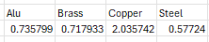
Figure 21 - Calculated Values for Refined Length
With these values for L we can calculate the new values for temperature distribution using the formula $T\left(x\right)= T_{∞}+ (T_{b}- T_{∞})\frac{cosh⁡[m\left(L-x\right)]}{cosh⁡(mL)}$ 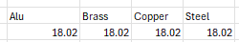
Figure 22 - Calculated Values for Refined Temperature distribution
Its clear from the data in Figure 22 that using the refined lengths the temperature at the tip of the fin is within 0.2 degrees of $T_{∞}$. This shows that the refined length is by far the most efficient.

References
- Spakovsky.Z, PART 3 INTRODUCTION TO ENGINEERING HEAT TRANSFER, 2002
(Accessed 3/10/2024)
Available at (https://ocw.mit.edu/courses/16-050-thermal-energy-fall-2002/)

