---


Student name: Narcisa Bernardo
Student ID:2332208
Module name: Introduction to Physiology
Module code: BMHP5023
Lecturer name: Sheila Hussain
Date: 5/ December 2025
Assessment: Asthma

Table of Contents
Introduction 3
Structure of respiratory system 4
Mechanical respiration Breathing: Includes inhalation exhalation 6
Gas exchange in lungs 6
Recording and tracking respiratory functions 9
Recommendations 9
Conclusion 11

Introduction
This case study report will discuss the implications of asthma in adolescents as a Practise Health Nurse of a GP Practise.

Asthma is a long-term inflammatory condition of the airways that effects how air enters and leaves the lungs. People with asthma experience episodes where the muscles around the airways tighten. The airway lining because swollen, and mucus increases, making breathing difficult (Global Initiative for Asthma, 2023). Common symptoms include wheezing, coughing, chest tightness and shortness of breath. Asthma effects people differently, with some experiencing occasional mild symptoms while other requires daily treatment to control.
Several risk factors contribute to asthma. These include genetic predisposition, exposure to allergens such as pollen and dust mites respiratory infections in childhood, pollution, tobacco smoke, cold air, and physical exertion (NHS,2023). Environmental irritants such as chemicals and air pollution can also trigger asthma symptoms. Cold air, and physical exertion (NHS, 2023). Environment irritants such chemical and air pollution can also trigger asthma symptoms.
This report discusses the structure and function of respiratory system, the mechanics of breathing, and how gas exchanges works in the lungs. It examines how irritants cause inflammation in the airway and how this affects breathing. The report also explores how peak flow monitoring allows people with asthma to track their respiratory health and identify changes in lung function. Finaly, evidence based recommendations are provided, focusing on lifestyle changes, health and well-being of individuals living with asthmas. (British Thoracic Society, 2020).
Asthma develops through a multifaceted interactions and environmental exposures, although the exact mechanisms are not yet fully understood. These factors shape both the intensity of the condition and how well an individual responds to treatment. The resent rise in asthma prevalence has been linked to shifts in epigenetic processes heritable changes that do not alter DNA sequences as well as modifications in modern living environments. Ashma that presents in children under 12 years of age is more commonly associated with inherited emerge during adolescence or adulthood tend to be influenced more strongly by environment trigger (NHS, 2023).

..
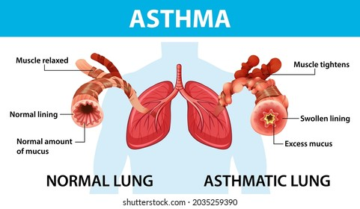
Diagram 1: This show Asthma and prevention program (2007).

Structure of respiratory system
The respiratory systems is organised into a series of series of anatomic structures that work together to enable gas exchange between the body and the external environment. It is commonly divided into the upper and lower respiratory tract. The upper tract includes the includes the nose, nasal cavity, and pharynx which function to filter , warm and humidify incoming air before it enters dipper respiratory passages (Tortora & Derrickson, 2017).
The lower trac consists of the larynx, trachea, bronchioles and lungs. Air passes down the trachea into a branching network of bronchi and lungs . Carbon dioxide are exchanged across the respiratory membrane ( Marieb & Hoehn, 2019). Surrounding the lungs is the pleural cavity, which reduces friction during breathing and helps maintain negative pressure, supporting lung expansion (Levitzky, 2023). Together, these structures form an integrated pathway that ensures efficient ventilation and diffusion of gasses essential for maintaining homeostasis.
The respiratory system in responsible for supplying oxygen to the body and removing carbon dioxide. It consists of the nose, mouth, trachea, bronchi, bronchioles, and alveoli. When air enters the respiratory system, it is filtered, warned and moistened before if moves down the trachea and into the lungs (Tortora and Derrickson, 2022)]

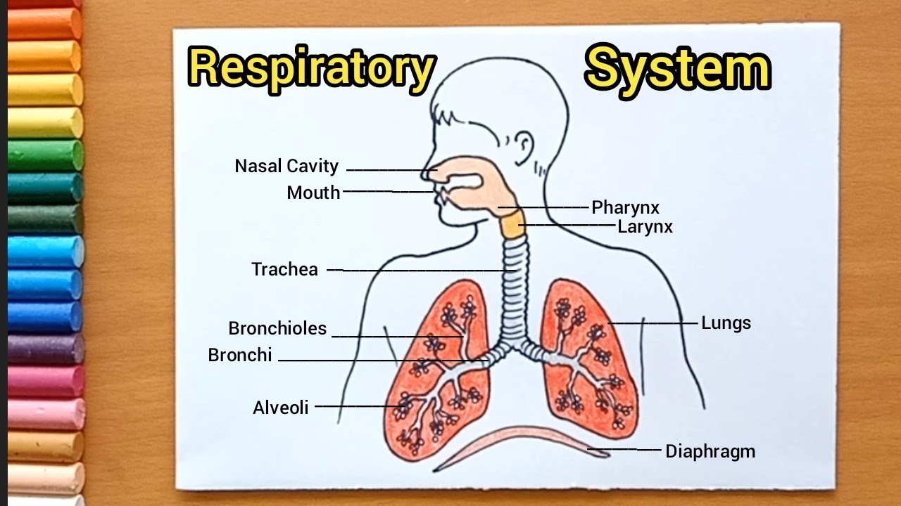
Diagram 2: This show Respiratory System lungs (Tortora and Derrickson, 2022).

Mechanical respiration Breathing: Includes inhalation exhalation
Inhalation occurs when the diaphragm contracts and moves downward. The intercoastal muscles between the ribs also contract, pulling the ribcage up and out. This increases the volume of the thoracic cavity, causing air pressure inside the lungs to fall. Air rushes in to fill the space (Tortora and Derrickson, 2022).
Exhalation happens when the diaphragm relaxes and moves upward, and the ribcage moves down and in. The lung volume decrease, forcing air out.

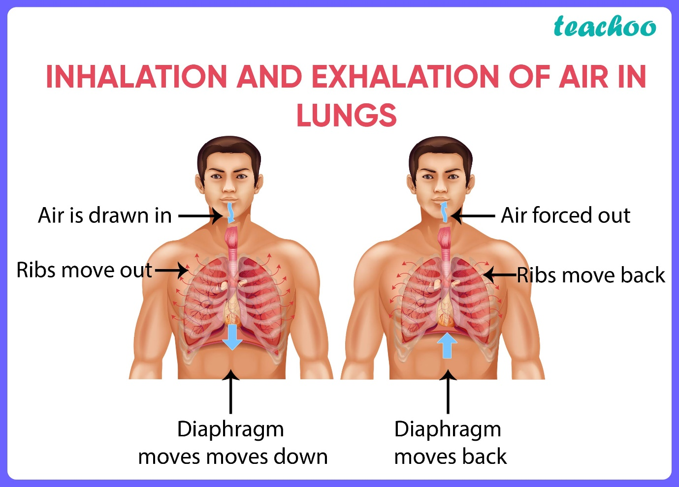
Diagram 3: This shows the inhalation and exhalation of air in the lungs (Tortora and Derrickson, 2022).

Gas exchange in lungs
Gas exchange happen in alveoli tiny air sacs surround by capillaries. Their structure allows rapid movement of gases between the lungs and bloodstream. (West, 2021). Gas exchange takes places within the alveoli when oxygen moves to bloodstream due to higher concentration in the alveolar air compare with the blood. At the same time carbon dioxide diffuses in the opposite direction from the blood into the alveoli because its concentration is greater in the blood. This diffusion mechanism essential for sustaining appropriate supporting normal physiological function (West, 2921).
Oxygen is essential for sustaining life , and understanding how it is transported, exchanged and regulated within the body is fundamental to respiratory physiology. In very small organism, specialised transport system are unnecessary because every cell is able to exchange gases directly with the surrounding environment through diffusion. This movement of gases occurs along a gradient of partial pressure, with molecules shifting from an area of how higher pressure one of lower pressure in human, once gas exchange has taken ;lace within the lungs, oxygen travels from the bloodstream into the tissue fluid, while carbon dioxide moves from the tissues fluid back into the blood so itt can be transported to the lungs for removed (West, 2021).

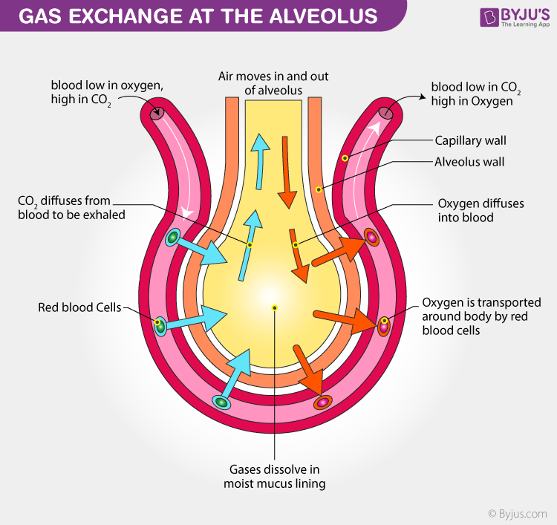
Diagram 4: This shows the gas exchange (West, 2021).
How Irritants cause swelling and Affect Respiration
Asthma involves chronic inflammation of the airways. When irritants such as smoke, dust, or allergens enter the respiratory system the immune system respond by sending inflammatory cell to the airways. This leads to swelling of airway lining, tightening of smooth muscles around bronchioles, and increased mucus production.
Those changes narrow the airways, limiting airflow and making it harder to breathe (GINA , 2023). Reduced diameter of the airways increases resistance and decreases ventilation efficiency. This means oxygen struggles to reach the alveoli and carbon dioxide cannot be expelled effectively. During an asthma attack, the individual may fell tightness in the chest and difficulty speaking or breathing.

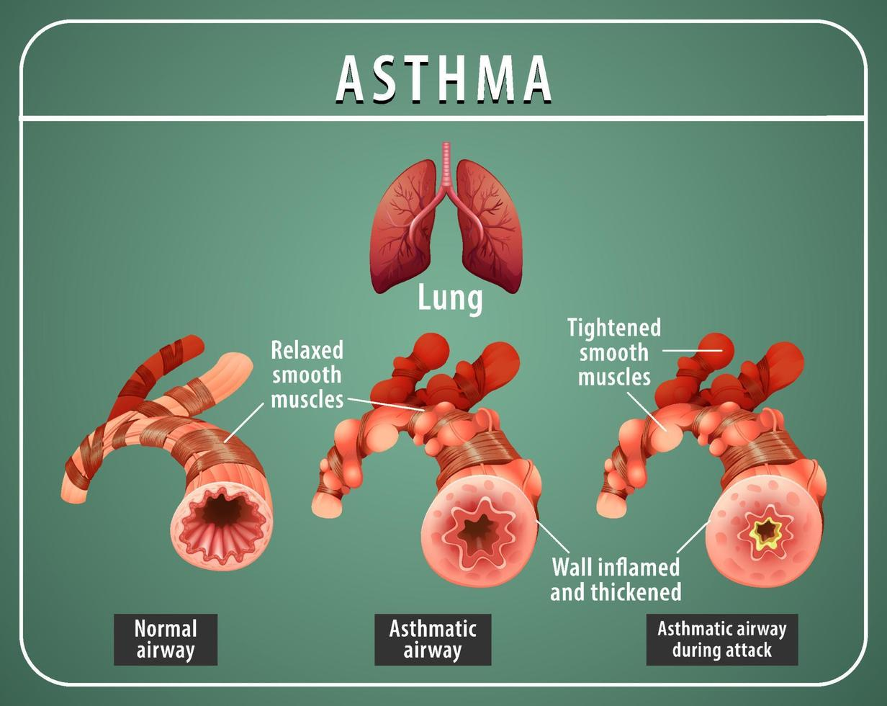
Diagram 5 : This show how airway narrowing in asthma (GINA, 22023).

Recording and tracking respiratory functions

Monitoring respiratory function involves collection measurements such breathing rate, lung volume, oxygen saturation, and airflow patterns. These recordings help clinicians evaluate how well the lungs and airways are working, deleted early signs of dysfunction, and track changes over time. Consistent measurement is essential in diagnosing respiratory disorders, guiding treatment plans and assessing how patient respond into interventions. Peak flow monitoring is a key self-management tool use by people with asthma. A peak flow meter measures peak expiratory flow rate (PEFR), which the speed a person can blow air out of their lungs in a single forceful breath (British Lung Foundation, 2022).
Why Tracking Peak is Important
Detects early changes before symptoms appear, lung functions often decreases before a person notices discomfort. Regular reading allow early intervention preventing severe asthma attacks.
Help identify triggers poor readings may correspond with exposure to specific allergens or irritants.
Supports medication management. Change in reading help healthcare professionals adjust treatment plans, including inhaler use.
Preventing evidence for action plans. \Many asthma action plan use green, yellow , and red zones based on peak flow values to guide decisions.

Preventing complications without consistent tracking, asthma may worsen unnoticed, leading to increased risk of emergency hospitalisation, more frequent attacks, reduced lung capacity over time, uncontrolled symptoms affecting daily life (BLF, 2022).
By monitoring peak flow at home, individual with asthma can stay in control and make informed dicisions about when to seek help.

Recommendations
A combination of medical, lifestyle, and environmental strategies helps individuals manage asthma effectively. Evidence shows that holistic approaches improve long-term respiratory health (NICE, 2022)
Health and Social Care Recommendations
Regular medical reviews – Individuals asthma reviews at least once a year to ensure medication is appropriate and inhaler techniques are correct.
Use of personalised asthma action plans- Healthcare providers often create action plans tailored the individual trigger, medication, and peak flow readings. These plans help people recognise when symptoms worsen and what steps to take.
Inhaler technique training- Incorrect inhaler technique reduces the effectiveness of medication. Demonstrations and follow-up check help ensure proper use.
Access to community services- Asthma nurses, pharmacist, smoking cessation teams and respiratory physiotherapist can all support= term management.
Lifestyle Changes and Health Promotion

Avoiding trigger- People with asthma should minimise exposure to tobacco smoke, dust, mould, pet dander chemical fumes, and cold air. Air purifiers and regular cleaning can help reduce indoor.

Smoking cessation- Smoke worsens inflammation and increases asthma attack. Stopping smoke improves lungs function and reduces medication needs (NHS, 2022).

Health weight and diet- Being overweight places extra strain on the respiratory system and increase breathlessness. A balance diet rich in fruits, vegetables, whole grain, and omega-3 fatty supports lungs function (Wood, 2020).

Regular physical activity- Controlled exercise increases lungs capacity and strengthens respiratory muscles. Activities such as walking, swimming, or cycling are recommended.
Stress management-Stress can trigger asthma symptoms. Mindfulness, breathing exercises, also counselling can help regulate anxiety. (National Asthma Council Australia, 2022).

Interventions for Better Self-Management

Prevent inhalers reduce inflammation and are taken daily.
Reliever inhaler relax airway muscles and atop symptoms quickly.
Vaccinations-Flu and pneumonia vaccines help prevent infections that may trigger asthma attacks.
Environmental modifications- Using hypoallergenic bedding, reducing clutter, and improving ventilation can reduce allergen exposure.

Conclusion
Asthma is a chronic inflammatory disease that affects the airways and interferes with normal breathing, Understanding how the respiratory system works provides insight into why asthma causes symptoms such as breathlessness an wheezing. Gas exchange in the alveoli is essential for life, and airway narrowing from inflammation or irritants reduces the efficiency of this process. Monitoring respiratory function through peak flow measurements helps individual detect early changes in lung function and prevents severe asthma attacks. Evidence based recommendations including medical support, lifestyle changes, trigger avoidance, and inhaler adherence play an important role in managing asthma and improving overall well-being. With appropriate self-management, education, and heath promotion, individuals living with asthma can maintain good respiratory health and quality life.

.

References
British Lung Foundation (2022) Peak Flow Monitoring. London: BLF.
Global Initiative for Asthma (2023) GINA Report: Global Strategy for Asthma Management and Prevention. Available at: https://ginasthma.org (Accessed: 10 January 2025).
NHS (2023) Asthma Overview. Available at: https://www.nhs.uk (Accessed: 10 January 2025).
NICE (2022) Asthma: Diagnosis, Monitoring and Management. London: National Institute for Health and Care Excellence.
Tortora, G. and Derrickson, B. (2022) Principles of Anatomy and Physiology. 16th edn. Hoboken: Wiley.
West, J. (2021) Respiratory Physiology: The Essentials. 11th edn. Philadelphia: Lippincott Williams & Wilkins.
Wood, L. (2020) ‘Diet and asthma: nutrition’s role in respiratory health’, Journal of Human Nutrition and Dietetics, 33(4), pp. 532–540.
National Asthma Council Australia (2022) Asthma management handbook. Melbourne: National Asthma Council Australia. Available at: https://www.nationalasthma.org.au (Accessed: 04th December 2025).
British Thoracic Society (2020) British guideline on the management of asthma. London: British Thoracic Society. Available at: https://www.brit-thoracic.org.uk (Accessed: 4th December 2025).

