This analysis aims to delve into the impact of social media portrayals on public opinion regarding UK policing, as well as to explore the alignment and discrepancies between empirical findings and existing literature. This study's research objectives revolve around understanding how social media influences public perceptions of UK policing, particularly focusing on the portrayal's positivity, negativity, or neutrality. The data collection methods employed include surveys, aiming to gather insights from participants regarding their perceptions and experiences with UK policing on social media. This analysis will be structured to present the empirical findings derived from the survey, followed by an interpretation of these results and their integration with the existing literature on the topic. Primary data, acquired through the survey, focuses on public opinions and engagement policing issues on social media. Secondary data includes scholarly research, news articles, and social media content analysis, providing broader context and insights. The empirical results will be structured to align with the research objectives, offering detailed analysis and interpretations of the collected data. This analysis unfolds in the dynamic social media environment of the United Kingdom, which is defined by a range of public perspectives and continuous discussions about police methods. Social media in the UK is an easily accessible tool that is used by many to voice their opinions, in which many opinions on the police are influenced by a wide range of elements such as news coverage, cultural standards, and personal experiences. By shedding light on the relationship between social media dynamics and public opinions of the police, this analysis hopes to help researchers, police organisations, and legislators better understand how social media affects their work.

Findings: Description of Analysis and Results 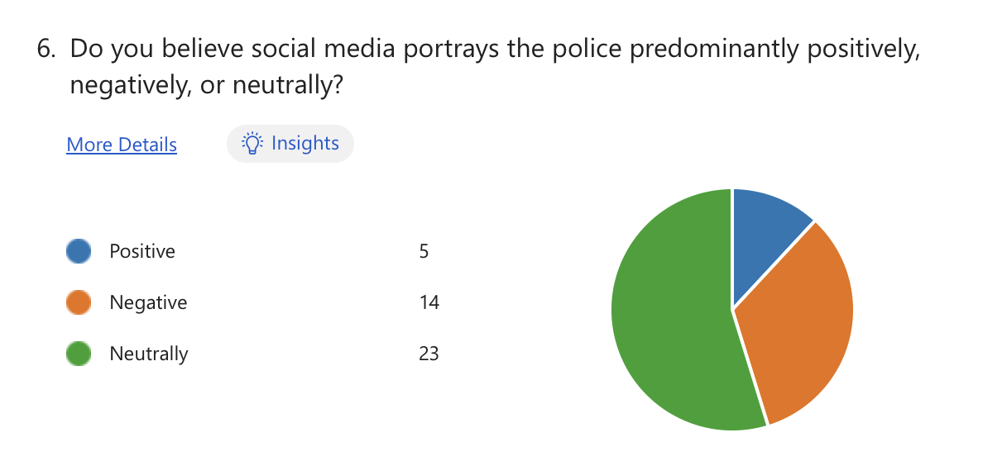In the survey, various questions were asked with the intent to identify how the police are portrayed on social media within the UK. When asked about their perception of police portrayal on social media, respondents provided diverse viewpoints. A significant portion, 33%, perceived the portrayal of police negatively, indicating concerns or criticisms regarding how law enforcement agencies are depicted. For the survey question “Do you believe social media portrays the police predominantly positively, negatively, or neutrally?”, a majority of 55% viewed police portrayal neutrally, suggesting a level of indifference or reservation towards online representations. Only a minority, 12%, reported perceiving police portrayal positively, indicating a limited number of individuals who view policing agencies favourably based on social media content.
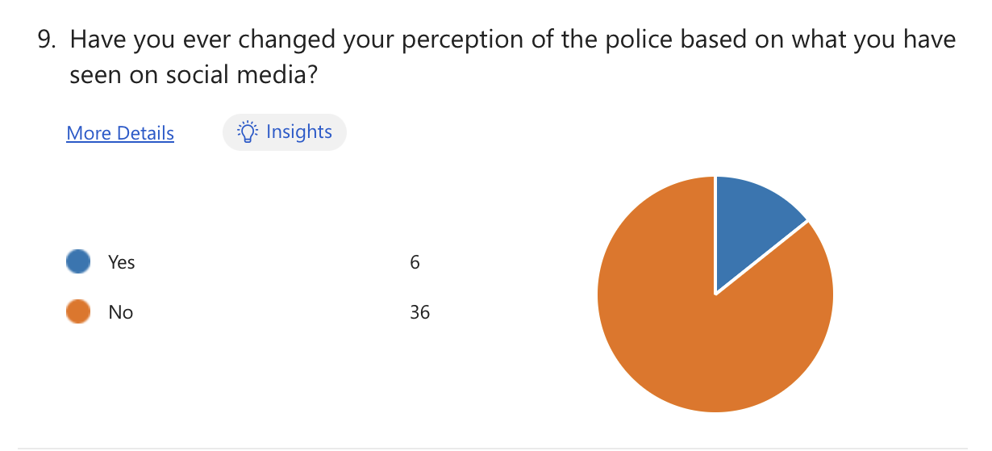

A crucial aspect explored in the survey was the influence of social media on individual perceptions of the police. For the question “Have you ever changed your perception of the police based on what you have seen on social media?” results showed that 14% of respondents admitted to changing their perception of the police based on what they have seen on social media, with 86% answering no. Then when answering the follow up question to this “If yes, can you give an example?” a theme of less trust in the police was regularly occurring from the responders. This indicates that online narratives and portrayals can indeed shape individual opinions and attitudes the police, highlighting the significant role of social media in influencing public perception.
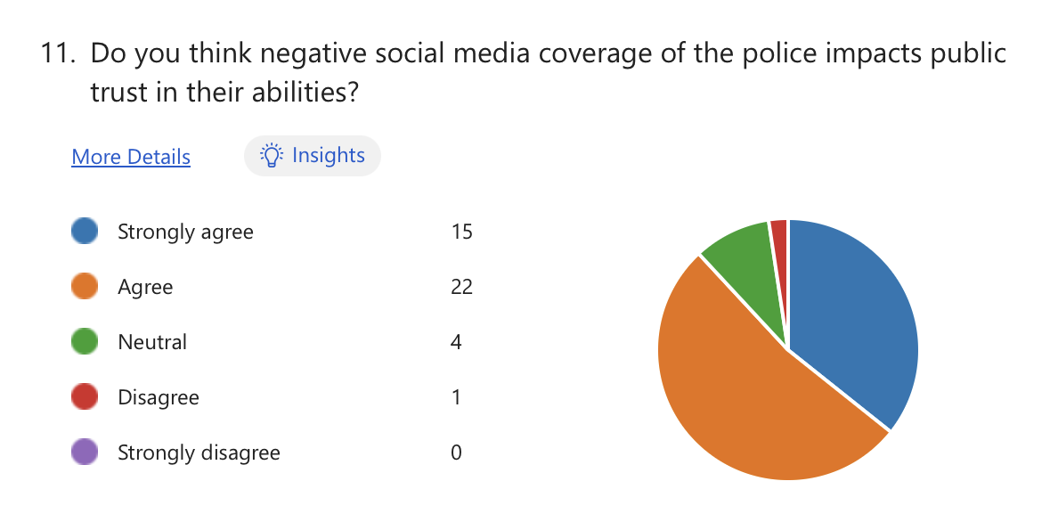
As well as looking at how the police are portrayed on social media, the survey aimed to explore how these implications of social media portrayals, impact public trust in police’s abilities. This was done by looking into the impact that negative social media coverage has on the perception of the police. The findings revealed a high level of agreement among respondents regarding the impact of negative social media coverage on public trust in police capabilities. A substantial 88% expressed agreement with the question “Do you think negative social media coverage of the police impacts public trust in their abilities?”. This suggests that adverse portrayals and narratives on social media platforms can erode confidence in law enforcement agencies' effectiveness and reliability. When asked “Can you provide an example of a negative portrayal of the police that you have encountered on social media?” a common answer was a use of excessive force being used by the police on videos. This proof of the negative impact social media can have on public perception, may lead into the lack of engagement communities have with them.
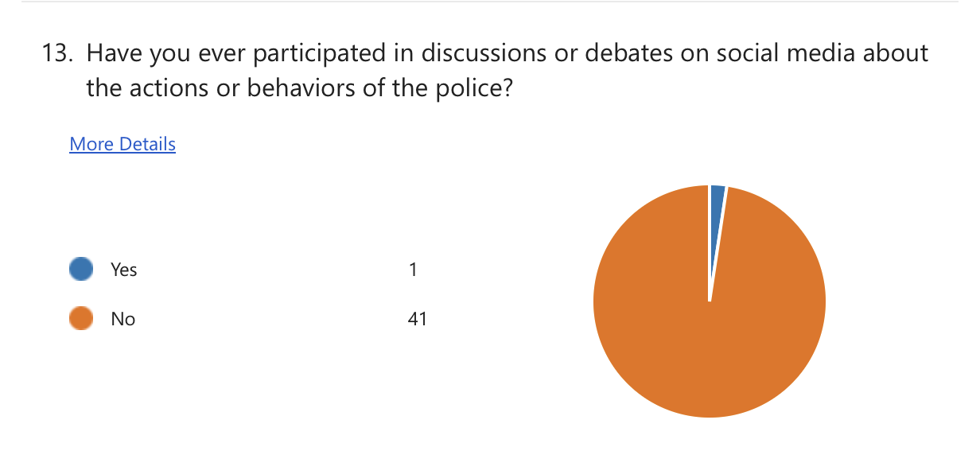
Despite the limited participation in discussions or debates about police actions or behaviours on social media, the survey highlighted strong support for police use of social media as a communication tool. While only 2% of respondents reported ‘yes’ to engaging in discussions for the question “Have you ever participated in discussions or debates on social media about the actions or behaviours of the police?”, a significant majority, 86%, expressed agreement with the idea that police should utilise social media to engage with the public.
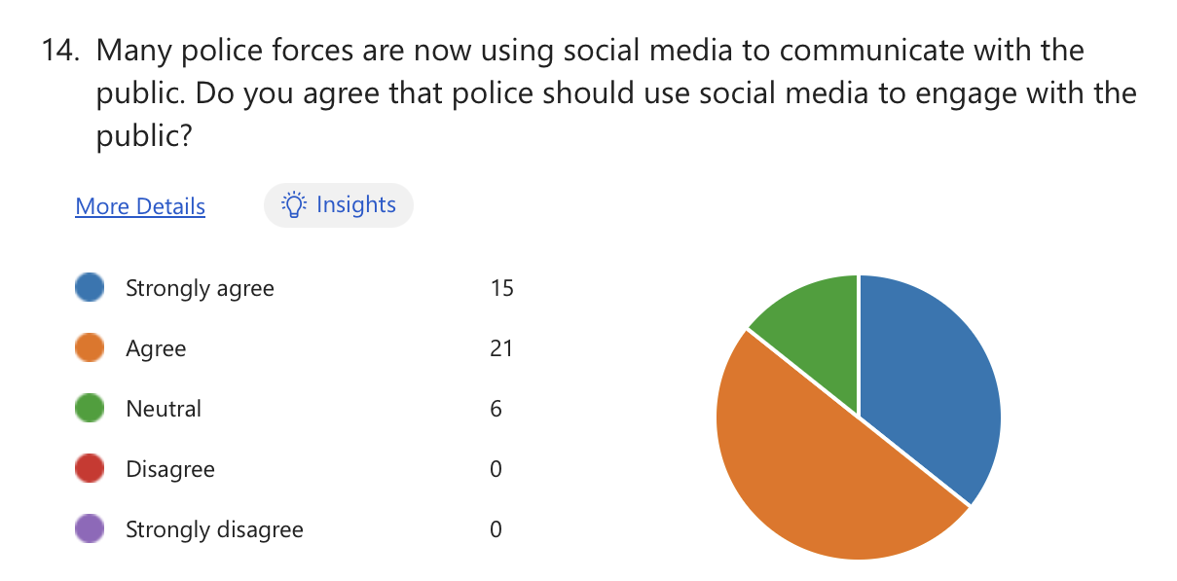
Additionally for the question “Many police forces are now using social media to communicate with the public. Do you agree that police should use social media to engage with the public?”, 50% strongly agreed and 36% agreed that police should use social media to engage with the public. When asked “Please explain your reason” a common theme occurred regarding the use of online engagement with the public would be fast and would reach a wide audience. This indicates a widespread belief in the importance of law enforcement agencies utilising social media platforms to facilitate communication and transparency with the public and could possibly help lessen the negative perception of them on these platforms.
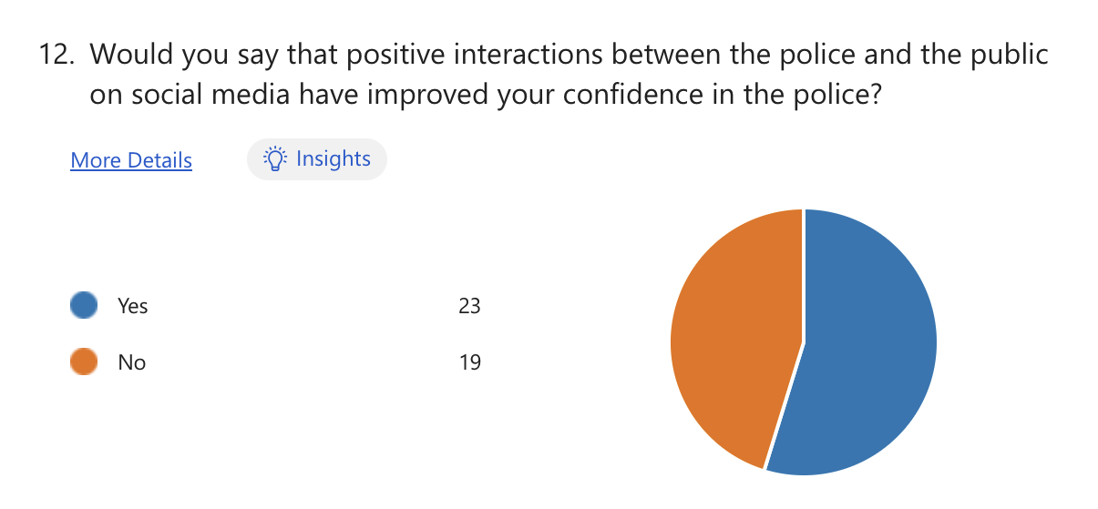
The survey explored the potential of positive interactions between the police and the public on social media to enhance confidence and trust. For the question “Would you say that positive interactions between the police and the public on social media have improved your confidence in the police?” results indicated that a majority, 55%, of respondents reported that positive interactions between the police and the public on social media have indeed improved their confidence in them. This finding underscores the importance of constructive engagement and transparent communication in fostering positive attitudes towards law enforcement agencies.
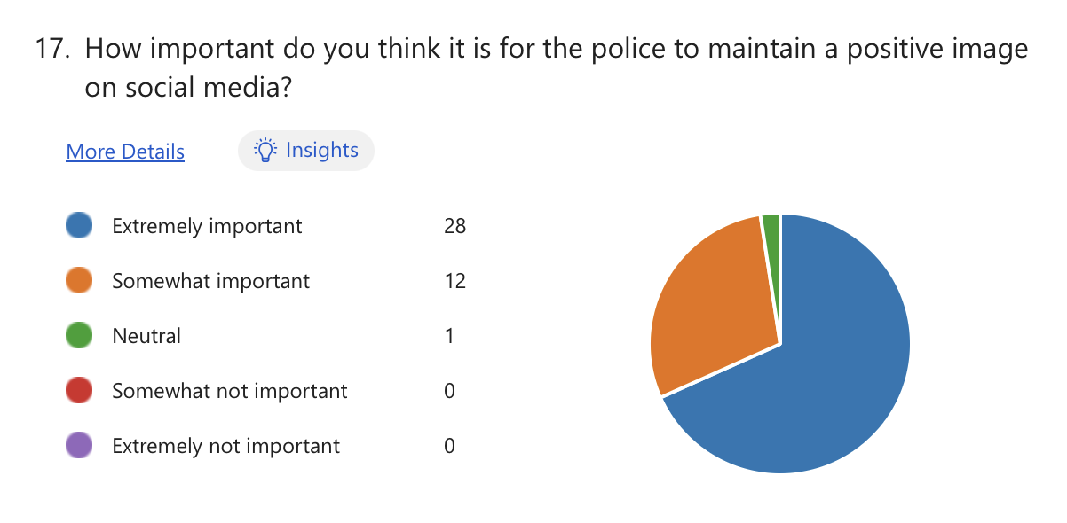
The question “How important do you think it is for the police to maintain a positive image on social media?” was also asked. Results showed a strong consensus among respondents regarding the significance of this aspect. A vast majority, 68%, deemed it extremely important for the police to maintain a positive image on social media. This underscores the recognition of social media as a critical platform for shaping public perceptions and attitudes towards law enforcement agencies.

Synthesis of Findings with Literature Reviews

According to primary data, 55% of respondents perceive the police neutrally on social media, with 12% viewing them positively and 33% negatively. Conversely, secondary data indicates widespread public support for police use of social media, with most respondents regularly monitoring the social media accounts of their local police force (Cartwright et al., 2020). However, concerns regarding corruption, racism, and abuse of power highlighted in the primary data by many individuals suggest nuanced perceptions influenced by online discourse. To follow from this, secondary data discovered suggests that the police have sought to shape their image on social media through strategies like humour, humanising techniques and recognising the significance of digital communication in influencing public opinion (Ralph et al., 2022). Although police forces are making efforts to come across less robotic, the survey respondents reveal that these techniques they are being employed are not working very effectively at all, with a lack of trust being highlighted by respondents from the survey. Survey data also reveals a lack of participation in discussions or debates about police actions or behaviours on social media, with 98% of respondents indicating no engagement. Secondary data indicates initial one-way communication strategies by the police on social media platforms, with recent efforts focusing on fostering two-way communication (Crump, 2011). Using both of this data to create a comparison, it is evident that the efforts to foster two-way communication were unsuccessful. To add to this, critics argue that initial one-way communication strategies by the police portrayed them as one-dimensional and ineffective in utilising social media for meaningful engagement (Aitken, 2023). The answers from the survey can also be used to back this criticism up, with a common answer for the question “How do you believe the police could improve their image on social media platforms?” being more public and community engagement. A common theme from both data has emerged, with both noting that the police do not utilise two-way communication, and when it is used it is not done effectively. Primary data highlights instances of negative social media portrayals of the police, including unnecessary force and inappropriate sentencing. Conversely, secondary data suggests a nuanced public perception of the police shaped by social media interactions. While social media offers a platform for the public to voice opinions, Colbran (2020) notes that police presence on social media can influence the flow of information, potentially limiting public access to high-quality data for decision-making. This goes hand in hand with the data collected from the survey, where people answered that they want honesty from the police to improve their public image. If police presence on social media is restricting the flow of information, then it could contribute to the negative perception around them. Statistics from primary data indicate a substantial impact of negative social media coverage on public trust in the police, with 36% strongly agreeing and 52% agreeing that such coverage affects public trust in police abilities. Secondary data corroborates this, with Fleet et al. (2022) highlighting the significant role of media coverage in shaping public opinion and attitudes towards law enforcement. The survey also helped shed light on how people’s perception of the police changes, with 14% of people believing social media has changed their perception of them. Secondary data can support this minority of people, with studies by Dencik (2018) and Williams et al. (2018) highlighting criticisms of police tactics on social media and difficulties faced by authorities in managing online developments during events like the 2011 London Riots, which lead to public distrust in the police. The survey responses highlight instances where police engagement on social media has positively influenced public confidence and trust. Examples include the police's swift and effective response during incidents such as car crashes and the Grenfell Tower tragedy, as well as their supportive interactions with families during times of crisis. Furthermore, a significant proportion of respondents (55%) indicated that positive interactions between the police and the public on social media have improved their confidence in law enforcement. Additionally, the majority of respondents (68%) emphasised the importance of the police maintaining a positive image on social media platforms, underscoring the significance of these interactions for building public trust. In contrast, secondary data provides further insights into the effectiveness of police engagement on social media platforms. Studies by Keane (2013) and Cartwright (2020) suggest that social media has facilitated improved community engagement and enhanced public participation with police forces across the UK over the years. Additionally, research by Ralph (2020) emphasises the importance of honesty and genuineness in police communication on social media, indicating that these traits contribute to a positive public perception of law enforcement. The use of social media platforms as a tool for promoting positive public perception is further supported by findings from the "Social Media perception survey" conducted by Bailey et al. (2018), which revealed that the police are perceived as the most trusted source of information across all social media platforms by 96% of their followers in the UK.

Summary

Through surveys and literature reviews, this study explored various aspects of police portrayal on social media, its impact on public trust, and the effectiveness of police engagement strategies. Findings reveal a nuanced landscape where diverse viewpoints coexist, with a significant proportion of respondents perceiving police portrayal negatively. However, positive interactions between police and the public on social media have been shown to enhance confidence and trust in police forces. Despite challenges such as limited participation in discussions and debates, there is strong support for police use of social media as a communication tool. Moreover, the importance of maintaining a positive image on social media platforms is emphasised, highlighting the significance of transparent and constructive engagement. Secondary data corroborates these findings, indicating that social media facilitates improved community engagement and enhances public participation with police forces. A common trend discovered by utilising both of this data is the lack of trust in the police when they are displayed negatively on social media platforms. Ultimately, the study contributes to a better understanding of the complex dynamics between social media, public perceptions, and policing strategies, offering insights that can inform policymakers, police agencies, and researchers in their efforts to navigate the digital landscape effectively.

