

BMHP6029-Psychopathological Classifications and Provisions

Component 2: Written Assignment (Report)
Student Name: Elena Daniela Virlan
Student ID:2216277
Table of Contents
Introduction 1
Classification and Diagnosis 1
Treatment and Rehabilitation 3
Pharmacological Treatment 3
Psychological Interventions 3
Rehabilitation and Recovery 4
Current Debates and Emerging Issues 4
Validity of Schizophrenia Diagnosis 4
Neurodivergence and Psychosis Continuum 5
Reclassification and Policy Impact 6
Recommendations 7
Conclusion 8
References 9

Introduction
Schizophrenia is a serious mental disorder that is reflected in the distortion of thinking, perception, emotion and behaviour that may include hallucinations, delusions and lack of cognitive abilities (NHS, 2023). ICD 11 is classified in Chapter 6 of the cluster of Schizophrenia or Other Primary Psychotic Disorders, where it is found in the current international clinical systems (World Health Organization, 2022). The report critically analyses its classification and diagnostic model, treatment methods and rehabilitation dispensation, as well as the controversies that persist in the issues of validity, stigma and reclassification. The discussion is carried out through a biopsychosocial perspective, as it assesses the interaction of biological vulnerability, psychological processes and social determinants in determining the outcomes.

Classification and Diagnosis
In ICD 11, schizophrenia is found in Chapter 6 Mental Behavioural or Neurodevelopmental Disorders as one of the groups Schizophrenia or Other Primary Psychotic Disorders (World Health Organization, 2022). This position signifies its conceptualisation as a main psychotic disorder that is typified by the abnormalities in its perception, cognition, self-experience and behaviour. One of the significant changes made in relation to ICD 10 is that the traditional subtypes (paranoid and catatonic schizophrenia) are eliminated. They were abandoned because of low diagnostic stability and weak reliability in different clinical situations, as people often switched between categories throughout the course of their existence (Valle, 2020). ICD 11 was drawn in the dimensional approach that enables clinicians to specify symptom domains such as positive and negative depressive and cognitive characteristics. Although this enhances the flexibility of clinical concepts, critics believe that the larger concept of schizophrenia is heterogeneous and may be too broad with not enough biological specificity to warrant a single diagnosis (Korth, 2020). Also, the manner in which schizophrenia is defined as a disorder is indicative of the endurance of the medical model that has made pathology more important than social determinants of distress.

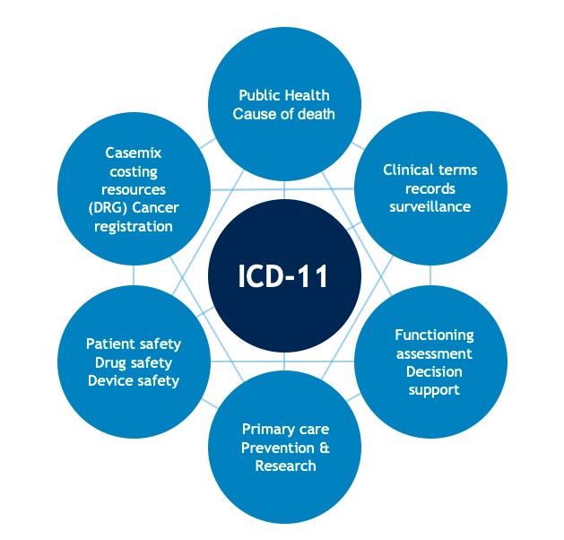
Figure 1: ICD-11 (World Health Organization, 2022)
To be diagnosed with this, the presence of core psychotic symptoms, including persistent delusions hallucinations disorganised thinking or influence experiences at least one month long and not due to substance use or other medical conditions, are required (World Health Organization, 2022). Social or occupational functional impairments are usually noticeable. Nonetheless, the bipolar disorder with psychotic features creates problems with the boundaries of diagnosis and doubts the construct validity (Reininghaus et al., 2016). Cultural background also plays a major role as beliefs that are considered delusional in one culture might be considered as normal on the other culture, posing a threat of misdiagnosis.
Pathologisation and stigma can be the side effects of the further usage of the word disorder (Carel, 2023). Other conceptualisations of psychosis that are spectrum-based to diminish categorical rigidity and enable more person-centred practice have been suggested. Although ICD-11 is more reliable, there are still controversies on the validity, conceptual scope and social implications of diagnostic labelling.

Treatment and Rehabilitation

Pharmacological Treatment
The treatment of schizophrenia is still focused on pharmacological intervention, which is a long tradition of biomedical constructs. Original antipsychotics like haloperidol mainly cause the destruction of dopamine receptors of the dopamine D2, which prove the effectiveness of the dopamine hypothesis which associates psychosis with the lack of regulation of dopaminergic processes (NICE, 2014). Second generation antipsychotics like risperidone and olanzapine were made to minimize the extrapyramidal side effects and to enhance the tolerability. It has been shown that both classes are widely effective in decreasing the positive symptoms (hallucinations and delusions) (World Health Organization, 2022).
Nevertheless, they have a minimal effect on negative and cognitive symptoms, and this limits functional recovery. The second generation agents correlate with high metabolic risks such as weight increase, diabetes and heart-related issues (NICE, 2014). Long term compliance is often undermined because of the negative effects and decreased awareness during relapse. Moreover, opponents believe that modern services are too medication based and may strengthen medicalisation and neglect psychosocial factors causing distress (OHCHR, 2026). This brings issues of proportionality and informed choice in treatment planning.

Psychological Interventions
Medication is advised together with psychological therapies. Psychosis prevention Cognitive Behavioural Therapy helps patients to re-evaluate delusional dreams and distress related to hallucinations. Interventions in the family are directed toward the minimization of relapse by the means of communication patterns and expressed emotion. Early intervention services especially in the first episode psychosis are associated with better social and occupational outcomes when delivered in time (NHS England, 2023).
Nevertheless, accessibility is still uneven with differences based on geographic location and capacity of the services. Psychological support is something that usually comes after medication and not equally placed in care pathways. Such imbalance indicates the current biomedical superiority even when policy focuses on whole provision.

Rehabilitation and Recovery
Modern rehabilitation lays focus on community based provision. Multidisciplinary care is organized by community mental health teams, whereas vocational inclusion is supported with the help of Individual Placement and Support, a type of employment initiative (NHS England, 2023). Provision of stable housing is also seen to be a key to recovery. The model of recovery places more emphasis on personal meaning, autonomy and social participation, as opposed to the removal of symptoms (World Health Organization, 2025).
In the past, schizophrenia treatment was institutionalised and the current policy indicates deinstitutionalised services which are community based. However, the effectiveness of implementation is still not universal because of the lack of funding and the workforce. There are social determinants such as discrimination based on poverty and unsafe housing that affect the risk of relapse to a large extent but frequently are not adequately considered (OHCHR, 2025).
The discrepancy between biomedical and social recovery is the cause of this tension, and that is why integrated biopsychosocial care is needed. As much as the pharmacological developments help to combat acute psychosis, a long-term recovery rests on the need to heal structural disparities and facilitate social integration of the current mental health systems.

Current Debates and Emerging Issues

Validity of Schizophrenia Diagnosis
The question of whether schizophrenia is a valid category of diagnosis or not is one of the most debatable issues of modern psychiatry. Despite the fact that ICD 11 still classifies schizophrenia as one of the main primary psychotic disorders, there is an increasing body of research that demonstrates the vast heterogeneity of schizophrenia in symptom presentation, illness progression and response to treatment (Reed et al., 2019). Patients with schizophrenia can have the disease manifest mainly as positive symptoms, significant negative symptoms or severe cognitive impairment and this has brought into doubt the notion that they are one disorder or numerous related disorders existing in overlap. Genetic studies also add to this scene, proving that there is a significant amount of common danger in schizophrenia, bipolar disorder and major depression (Vancampfort et al., 2015). These results disprove the belief in distinct biological demarcation and advocates transdiagnostic practices.
Dimensional and spectral based models have thus drawn more and more attention. Similar arguments have been made by the Astle et al., (2022), which highlight the methodological studies that suggest the investigation of domains of symptoms in diagnostic groups. Dimensional models could be more accurate indicators of neurodevelopmental complexity and enhance construct validity. Nonetheless, categorical diagnoses will still have an advantageous benefit in clinical communication, epidemiology and service eligibility. Elimination of diagnostic categories would interfere with the normal course of care and standardisation of research. The discussion thus revolves around coming up with a compromise between scientific validity and clinical utility.

Neurodivergence and Psychosis Continuum
The neurodivergence movement has also undermined conventional pathological conceptualizations of schizophrenia. Auditory hallucinations may not be only biomedical abnormalities but simply can also be considered as effective responses to trauma or stress. Hallucinatory experiences are also indicated in non-clinical settings, a fact supported by empirical research (Waters et al., 2018). This normalisation model aims at eliminating stigma and the introduction of person centred care.
However, conflicts arise between clinical responsibility and autonomy. The presence of severe psychotic episodes can affect the level of judgement and make a person more vulnerable, which requires structured intervention. World Health Organization (2022) promotes mental health care that is rights based, but acknowledges that the proper treatment must be provided in case of acute crisis. The dilemma of empowering and protecting is still ethically challenging. Excessive focus on pathology will lead to the exclusion of lived experience, whereas over normalisation will underestimate clinical risk. Therefore, the current debate can be characterized by a wider transition of the paternalistic models to the shared decision making without the compromising of safeguards.

Reclassification and Policy Impact
Discussions on reclassification spread across systems of diagnosis. Even though ICD 11 and DSM 5 still classify schizophrenia as a core diagnosis, researchers are unsure about whether more revisions should follow symptom based or transdiagnostic paradigms (Clark et al., 2017). The shift towards spectrum frameworks would redefine how funds research, structures of service commissioning and insurance. Services are often structured in terms of particular diagnostic categories; the redefinition of schizophrenia would hence change the eligibility levels and distribution of resources.
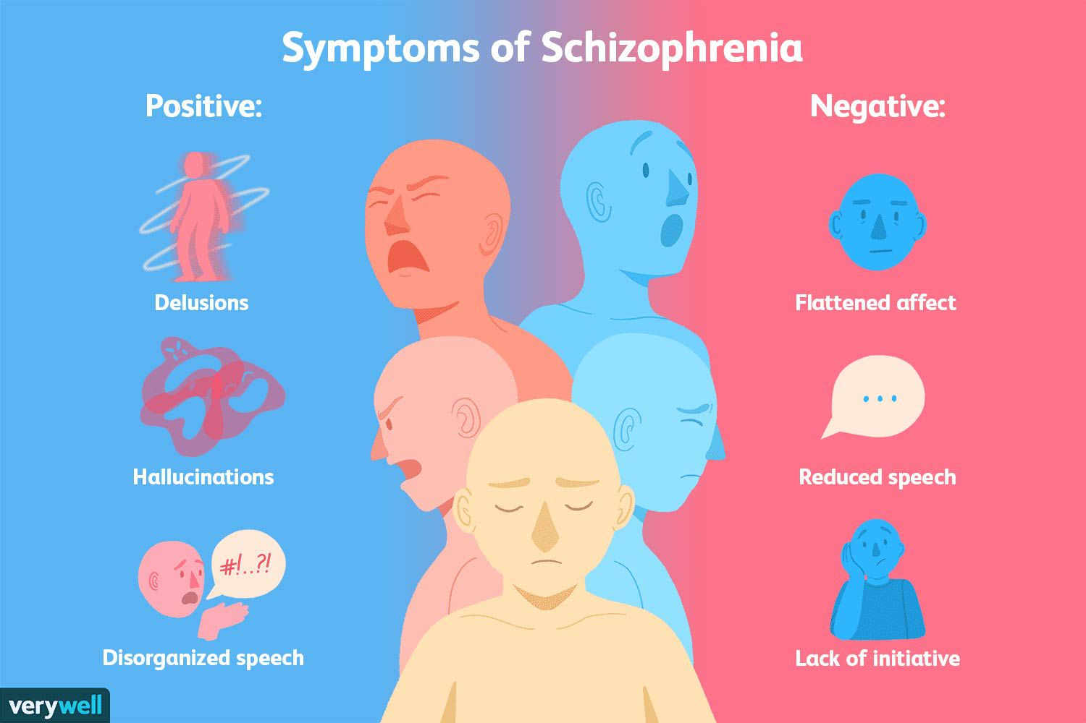
Figure 2: Symptoms of schizophrenia (Clarke, 2024)
The use of diagnostic terminology affects stigma and the perception of the general population as well. It has been shown that the term schizophrenia is linked to exaggerated perceptions of threat relative to more broad terminology of psychosis (Underwood et al., 2015). The policy documents have become more accepting of the connection between diagnostic labelling, discrimination, and employment or housing. As a result, clinical practice is not the only area with quantifiable social repercussions of classification choices.
Although spectrum models can increase conceptual consistency, policymakers should take into account continuity of care, training in workforce and legislatures. Reclassification is not a scientific update but an intervention of structure involving the funding, protection of rights and service provision. These discussions reveal the interactive nature of the dynamic of psychiatric knowledge and modern mental health service provision with a direct connection between classification and practice and policy.

Recommendations
To begin with, early intervention services need to be extended and allotted funds throughout the regions. There are results that show that early intervention in first episode psychosis does enhance the long term functional prognosis and decrease the risk of relapse (Kam et al., 2015). Following the previous argument on heterogeneity and spectrums presentation, the initial services must embrace dynamic evaluation models, which cover both clinical signs and social strains. At this point, investment can shorten subsequent hospitalisation costs and enhance the recovery patterns.
Secondly, the negative and cognitive symptoms need more research attention. Existing pharmacological interventions are still effective to a great extent when it comes to positive symptoms but lack effectiveness when it comes to motivational and cognitive dysfunction. Specific funding sources and translational research programs would fill this deficit and improve functional recovery as opposed to symptom suppression by itself.
Thirdly, there is the need to enhance psychosocial rehabilitation funding. Helping to deal with the social determinants that were established as the risk of relapse, supported employment, housing stability, and community provision of mental health services are vital. Policy frameworks must be more focused on integrated biopsychosocial care and not medication centred models (Tramonti et al., 2021).
Fourthly, spectrum informed language must gradually replace the diagnostic language without introducing clinical ambiguity. This reform can help to lessen the stigma and enhance the conceptual validity.
Lastly, anti-stigma measures by the society need to be increased with education and policies of inclusiveness in the workplace and in the media with classification not promoting discrimination.

Conclusion
The diagnosis of schizophrenia is an enigma and a debatable entity in modern psychiatry. Although ICD 11 has become more reliable due to dimensional changes, the issue of validity, heterogeneity and stigma still remains. Progress in treatment has brought acute psychosis to a halt but recovery is provided equally to psychosocial support as well as structural reform. Clinical outcomes and social inclusion require a balanced biopsychosocial approach based on a perpetual debate and policy consciousness, which is important to improve the situation.

References
Astle, D.E., Holmes, J., Kievit, R. and Gathercole, S.E., (2022). Annual Research Review: The transdiagnostic revolution in neurodevelopmental disorders. Journal of Child Psychology and Psychiatry, 63(4), pp.397-417.
Carel, H., (2023). Vulnerabilization and de-pathologization: Two philosophical suggestions. Philosophy, Psychiatry, & Psychology, 30(1), pp.73-76.
Clark, L.A., Cuthbert, B., Lewis-Fernández, R., Narrow, W.E. and Reed, G.M., (2017). Three approaches to understanding and classifying mental disorder: ICD-11, DSM-5, and the National Institute of Mental Health’s Research Domain Criteria (RDoC). Psychological Science in the Public Interest, 18(2), pp.72-145.
Clarke, J. (2024). How schizophrenia is diagnosed by observing symptoms. [online] Verywell Mind. Available at: https://www.verywellmind.com/what-are-the-symptoms-of-schizophrenia-2953120 [Accessed 1 Mar. 2026].
Kam, S.M., Singh, S.P. and Upthegrove, R., (2015). What needs to follow early intervention? Predictors of relapse and functional recovery following first‐episode psychosis. Early Intervention in Psychiatry, 9(4), pp.279-283.
Korth, C. and Fangerau, H., (2020). Blood tests to diagnose schizophrenia: self-imposed limits in psychiatry. The Lancet Psychiatry, 7(10), pp.911-914.
NHS (2023). Schizophrenia. [online] nhs.uk. Available at: https://www.nhs.uk/mental-health/conditions/schizophrenia/overview/ [Accessed 1 Mar. 2026].
NHS England (2023). Implementing the Early Intervention in Psychosis Access and Waiting Time Standard. [online] Available at: https://www.england.nhs.uk/wp-content/uploads/2023/03/B1954-implementing-the-early-intervention-in-psychosis-access-and-waiting-time-standard.pdf [Accessed 1 Mar. 2026].
NICE (2014). Psychosis and Schizophrenia in adults: Prevention and Management | Guidance | NICE. [online] Nice.org.uk. Available at: https://www.nice.org.uk/guidance/cg178 [Accessed 1 Mar. 2026].
OHCHR (2025). Mental health, human rights and legislation Guidance and practice. [online] Available at: https://www.ohchr.org/sites/default/files/documents/publications/WHO-OHCHR-Mental-health-human-rights-and-legislation_web.pdf [Accessed 1 Mar. 2026].
Reed, G.M., First, M.B., Kogan, C.S., Hyman, S.E., Gureje, O., Gaebel, W., Maj, M., Stein, D.J., Maercker, A., Tyrer, P. and Claudino, A., (2019). Innovations and changes in the ICD‐11 classification of mental, behavioural and neurodevelopmental disorders. World psychiatry, 18(1), pp.3-19.
Reininghaus, U., Böhnke, J.R., Hosang, G., Farmer, A., Burns, T., McGuffin, P. and Bentall, R.P., (2016). Evaluation of the validity and utility of a transdiagnostic psychosis dimension encompassing schizophrenia and bipolar disorder. The British Journal of Psychiatry, 209(2), pp.107-113.
Tramonti, F., Giorgi, F. and Fanali, A., (2021). Systems thinking and the biopsychosocial approach: a multilevel framework for patient‐centred care. Systems Research and Behavioral Science, 38(2), pp.215-230.
Underwood, R., Peters, E. and Kumari, V., (2015). Psychobiology of threat appraisal in the context of psychotic experiences: a selective review. European Psychiatry, 30(7), pp.817-829.
Valle, R., (2020). Schizophrenia in ICD-11: Comparison of ICD-10 and DSM-5. Revista de Psiquiatría y Salud Mental (English Edition), 13(2), pp.95-104.
Vancampfort, D., Stubbs, B., Mitchell, A.J., De Hert, M., Wampers, M., Ward, P.B., Rosenbaum, S. and Correll, C.U., (2015). Risk of metabolic syndrome and its components in people with schizophrenia and related psychotic disorders, bipolar disorder and major depressive disorder: a systematic review and meta‐analysis. World psychiatry, 14(3), pp.339-347.
Waters, F., Blom, J.D., Jardri, R., Hugdahl, K. and Sommer, I.E., (2018). Auditory hallucinations, not necessarily a hallmark of psychotic disorder. Psychological medicine, 48(4), pp.529-536.
World Health Organization (2022). International classification of diseases (ICD). [online] www.who.int. Available at: https://www.who.int/standards/classifications/classification-of-diseases [Accessed 1 Mar. 2026].
World Health Organization (2023). Mental health, human rights and legislation: guidance and practice. [online] www.who.int. Available at: https://www.who.int/publications/i/item/9789240080737 [Accessed 1 Mar. 2026].
World Health Organization (2026). ICD-11 International Classification of Diseases for Mortality and Morbidity Statistics Eleventh Revision Reference Guide. [online] Available at: https://icdcdn.who.int/icd11referenceguide/en/refguide.pdf [Accessed 1 Mar. 2026].

