

Literature Review and Presentation - Electric/Hybrid Vehicles

Joseph Landeg – 1708387

BEng (Hons) Electrical & Electronic Engineering (Part Time)

Research & Development Methods - M5X00737

Module Lecturer – Gareth Jones

The Faculty of Engineering, Computing & Science

14/12/2017

Declaration

The work of this report completed under the supervision of Joseph Landeg. I declare that this report is the product of my own work and is not being submitted for any other degree etc.

Signed: Joseph Landeg

Contents

Introduction - 4 -
Hybrid/Electric Vehicles (HEV/EV) - 6 -
So what types of HEV/EV vehicles are there? - 6 -
How do they work? - 7 -
Components in EV/HEV - 7 -
Pure electric vehicle operation - 8 -
Hybrid vehicle operation (Series/Parallel) - 9 -
Conclusion - 11 -
References - 13 -

Introduction
Having been around for over 100 years [1], vehicles have come a long way not only in the terms of their reliability and performance but also how the vehicle is powered. Historically, cars have been powered by fuel which has been made from oil by the use of an internal combustion engine (ICE) [1].
Problem with using fossil fuels
For many years fossil fuels such as oil has been the main source to produce a fuel in order to power a car or vehicle to run. However, the main problem with using oil is that the amount of oil reserves all over the world is decreasing due to the lack of oil which is available [2]. Due to oil not being a renewable resource, as the amount of oil available decreases, the price of it increases [1], which has a great effect on the price of fuel used to power the vehicles.
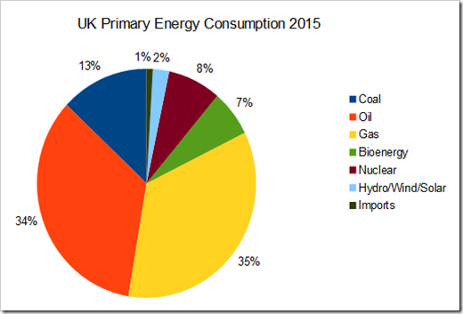
As well as the price of oil increasing as the availability of it decreases, another problem with using oil as a fuel to power vehicles is that when the fuel containing oil is burnt, it gives out a potentially dangerous gas that pollutes the atmosphere to create the greenhouse affect which is causing global warming [2].

Figure 1. UK Energy Consumption 2015 [3]
Homewood, sourced from The Department of Energy & Climate Change [3] represents the UK primary energy consumption for 2015 which indicates that fossil fuels in 2015 were still the highest source for energy.
To deal with the worldwide problems of oil shortages and global warming that was continuing to progress, development of alternative vehicles such as hybrid electric vehicles (HEV) and pure electric vehicles were introduced where the electric vehicle (EV) are the only zero emissions vehicle [2]. There are a variety of HEV and EV available on the market to date where the process to powering them can alter between car to car, which will be identified throughout [4].

Hybrid/Electric Vehicles (HEV/EV)
As stated by Denton [4],
“Electric Vehicle (EVs) or Electrically Chargeable Vehicles (ECVs) usually refers to any vehicle that is powered, in part or in full, by a battery that can be directly plugged into the mains.”
Hybrid and Electric vehicles have been developed to a stage where they are now recognised as being of great efficiency when it comes to the running costs and energy consumption they save compared to the traditional internal combustion engine powered cars [5].A vehicle may be called a hybrid when the power to move the vehicle forward is obtained from at least two different sources of energy, whether that be an electric battery, generator, convertor [2].

So what types of HEV/EV vehicles are there?

There are many alternative types of electric vehicles available on the market to date, some of which can be powered solely by electric, part electric and part IC engine (Hybrid) etc. The different types of electric vehicle are as below:
- Pure EV – This is where the electric vehicle is completely powered by a battery within the car which stores energy after being charged by the mains supply of a domestic household or a charge station. A pure electric vehicle does not have the ability to switch from electric to another source, meaning that if the charge is low it will need to be recharged in order to travel any further. The average range of a pure electric vehicle is 100 miles, with some having a lesser range and some a higher [6].
- Internal Combustion Engine (ICE) /Electric Hybrid Vehicle (EHV) – This type of multi-source vehicle is the most common vehicle available in the hybrid range, using an IC engine and a battery pack or electric motor in order to power the vehicle forward [7]. The hybrid car has the ability to switch over from being powered by electric to being powered by the IC engine. Once the range has been reached on the battery, the IC engine will take over powering the car meaning that the range of the vehicle will not be compromised [4]. The range of the electrical power supply to the vehicle without before the IC engine switching in is on average 35 miles [6].
- Extended Range Electric Vehicle – This is another hybrid vehicle which has an internal combustion generator in the vehicle but with an extended range on the battery pack of the vehicle, taking it up to on average about 50 miles before requiring the IC engine to switch over [4].
- A full hybrid where the battery can power the car independently and also the electric motor is able to power it solely [8]. Whereas, mild hybrids can only use the electric motors to help the engine along with powering the vehicle [REFERENCE].

How do they work?
EVs are made up of a number of components, which are generally simple in design. The pure electric vehicles are more basic in the arrangement of the components than the hybrid vehicles as the hybrid vehicles can be arranged in two basic arrangements which are parallel or series [7].

Components in EV/HEV

Firstly, the pure electric vehicle contains an energy storage component which is generally a battery pack, a control unit, electric motors and a charger [2].
The components that are used in a hybrid vehicle depends on which arrangement is used, series or parallel. If the series arrangement is being used, then the vehicle will consist of an Internal Combustion Engine, a generator, a battery and a motor to drive the wheels. However, when the hybrid vehicle is designed to have a parallel arrangement, the components will be an IC engine, electrical motor, battery pack and a transmission which connects to the wheels [7]. So how do these components come together to power each vehicle?

Pure electric vehicle operation
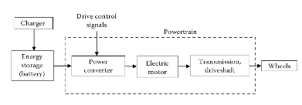

Figure 2: Block diagram of electrical vehicle process [2]

Once the battery has been charged from the mains power, the energy that has been stored can be used to power the vehicle. Figure 2 [2] showing a block diagram of the basic operation of an electric vehicle where the stored energy will power the control unit which will send power (voltage) to the electrical motor to turn the wheels at a certain speed. The control unit controls the amount of voltage sent to the motors [7]. The more pressure that is applied to the accelerator the faster the motor will turn due to more power being applied from the controller, making the car increase its speed [9].
The electric vehicle can also get what is called regenerative braking. Regenerative braking is when the energy used to slow down the car is not wasted, but instead the kinetic energy is converted into chemical energy to be stored in the battery to in essence to get the best range possible out of the vehicle [10].

Hybrid vehicle operation (Series/Parallel)

Regardless of which system is adopted for the vehicle, a hybrid vehicle will always improve its fuel economy by using the best of both vehicles (ICE/EV). If a hybrid vehicle has been arranged in the series layout then the vehicle will operate in a different way to that of the parallel layout, both still using the same concept of having an IC engine and a battery to power the vehicle [8].
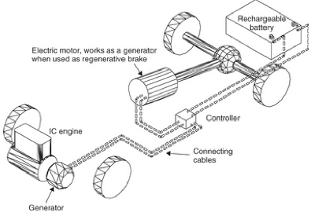

Figure 3: Hybrid vehicle in series [7]
In series arranged hybrids fuel is required to power the IC engine, before going on to power a generator which can charge the battery pack in order for the electric motor to be powered up, or the generator can directly power the electric motor to turn the wheels [7]. However, when the generator directly supplies the motor the vehicle is in essence a standard IC engine car, whereas, when the generator supplies the battery, it is operating as an electric car.

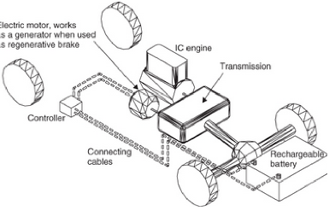

Figure 4 Hybrid vehicle in parallel [7]
In contrast to the series arrangement, the parallel layout of a hybrid operates with either; the battery pack powers up an electric motor directly, which then powers the transmission (drive) to turn the wheels and go forward. However, a hybrid in parallel can be powered from fuel powering an IC engine which then powers the transmission to operate the wheels [7], this means that both power sources can directly power the wheels.

Conclusion
After critically analysing the research obtained from various sources of electric vehicles and hybrid electric vehicles, it is certain that the rise of EVs has been developed due to the sheer shortage of oil that is going to be available in the future. Figure 5 [11] shows that by 2052 it is projected that the availability of oil in the world will have dropped at such a significant rate that it would be unnecessary to power vehicle in that way due to the high cost that oil would have reached by then.
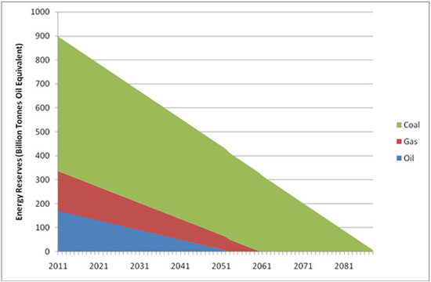

Figure 5: Energy Reserves Projection [11]
Therefore, the development of electrical and hybrid vehicles is at a critical time to create a greener environment as well as a more cost effective one. Electric and Hybrid vehicles have many advantages over the traditional Internal Combustion Engine, but they also come with their disadvantages which still prevents them from being the ultimate first choice of vehicle [5].
The advantages of electric vehicles over the internal combustion engine are that:
- Cost of running is significantly lower
- Cleaner/Lower emissions creating a cleaner environment
- Regenerative braking using potentially wasted energy to charge battery packs
- Less maintenance due to simple design
- EV can get instant maximum torque from 0rpm [8]
- Reduced noise pollution
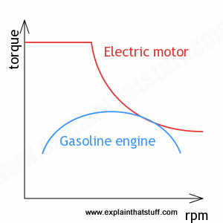

Figure 6: Graph showing torque against rpm for EV and Gas engine [8]
As Figure 6 [8], the electric vehicle can gain maximum torque at 0rpm, whereas the IC engine physically cannot get torque until the rpm has risen to a significant level making it a lot less efficient than the EV.
The disadvantages of the electric vehicle over the internal combustion engine:
- Charging points not widely available compared to fuel stations.
- Due to the development still ongoing with EVs, not enough data on reliability over a period of time.
- The mileage range of the electric vehicle is significantly lower than an IC engine as the average range is about 100 [12] whereas IC engine vehicles can have a range of 400+ miles [13].
- Longer recharge time compared to refuelling [5].

References

[1] | R. Hantula and D. Voege , How Do Hybrid Cars Work?, Infobase Publishing, 2010, pp. 4-6.
[2] | I. Husain, Electric and Hybrid Vehicles, Second ed., CRC Press, 2011, pp. 3-8.
[3] | P. Homewood, “UK Energy Stats For 2015,” 31 March 2016. [Online]. Available: https://notalotofpeopleknowthat.wordpress.com/2016/03/31/uk-energy-stats-for-2015/. [Accessed 13 December 2017].
[4] | T. Denton, Electric and Hybrid Vehicles, Abingdon: Routledge, 2016, pp. 1-3.
[5] | Rinkesh, “What are Electric Cars?,” [Online]. Available: https://www.conserve-energy-future.com/howelectriccarswork.php. [Accessed 13 December 2017].
[6] | “Different Types of Electric Vehicle,” 10 September 2016. [Online]. Available: http://www.transportenergy.org.uk/different-types-of-electric-vehicle/. [Accessed 13 December 2017].
[7] | J. Lowry, Electric Vehicle Technology Explained, Second ed., West Sussex: Wiley, 2012, pp. Chapter 2 - 1-4.
[8] | C. Woodford, “Electric Cars,” 3 December` 2017. [Online]. Available: http://www.explainthatstuff.com/electriccars.html. [Accessed 14 December 2017].
[9] | M. Brain, “How Electric Cars Work,” 27 March 2002. [Online]. Available: https://auto.howstuffworks.com/electric-car2.htm. [Accessed 13 December 2017].
[10] | G. Solberg, “The Magic of Tesla Roadster Regenerative Braking,” 29 June 2007. [Online]. Available: https://www.tesla.com/en_GB/blog/magic-tesla-roadster-regenerative-braking. [Accessed 13 December 2017].
[11] | “The end of fossil fuels,” [Online]. Available: https://www.ecotricity.co.uk/our-green-energy/energy-independence/the-end-of-fossil-fuels. [Accessed 14 December 2017].
[12] | B. Berman, “Electric cars pros and cons,” 29 September 2016. [Online]. Available: http://www.plugincars.com/electric-cars-pros-and-cons-128637.html. [Accessed 14 December 2017].
[13] | C. D. Heinrich, “What's your gasoline car's range?,” 13 May 2011. [Online]. Available: http://solarchargeddriving.com/2011/05/13/whats-your-gasoline-cars-range/. [Accessed 14 December 2017].

