Inscriptions Workshop CLAH7017
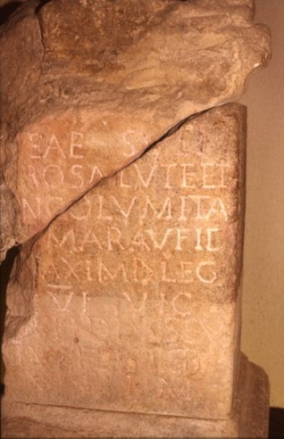 | 1  RIB-01, 00143  Bath / Aquae Sulis  [D]eae Suli /  pro salute et / incolumita/[te] Mar(ci) Aufid[i] / [M]aximi  (centurionis) leg(ionis) / VI Vic(tricis) /  [A]ufidius Eu/tuches(!) l<i>b(ertus) /  v(otum) s(olvit) l(ibens) m(erito)
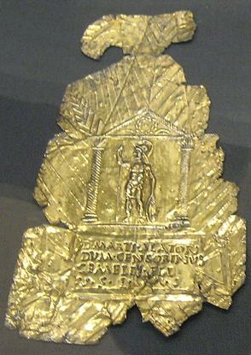 | 2  RIB-01, 00218 = D 04541  Barkway  D(eo) Marti Alatori /  Dum() Censorinus / Gemelli fil(ius) /  v(otum) s(olvit) l(ibens) m(erito).
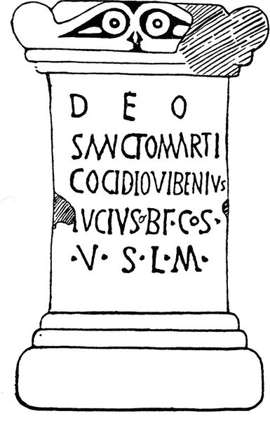 | 3  RIB-01, 00602  Lancaster / Galacum / Caluvio  Deo / sancto Marti / Cocidio  Vibenius / Lucius  b(ene)f(iciarius) co(n)s(ularis)  v(otum) s(olvit) l(ibens) m(erito)
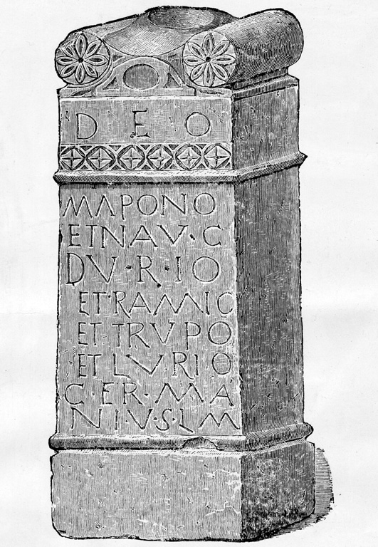 | 4  RIB-01, 02063 = CSIR-GB-01-06, 00158 = D 04640  Brampton  Deo / Mapono / et n(umini) Aug(usti) /  Durio / et Ramio / et Trupo / et Lurio /  Germa/ni  v(otum) s(olverunt) l(ibentes) m(erito).
 | 5  CIL 07, 00424 = RIB-01, 01031  Binchester / Vinovia  Deab(us) / Matrib(us) O[l]lot(otis) /  T[i]b(erius) Cl(audius) Quin/tianus  b(ene)f(iciarius) co(n)s(ularis)  v(otum) s(olvit) l(ibens) m(erito).
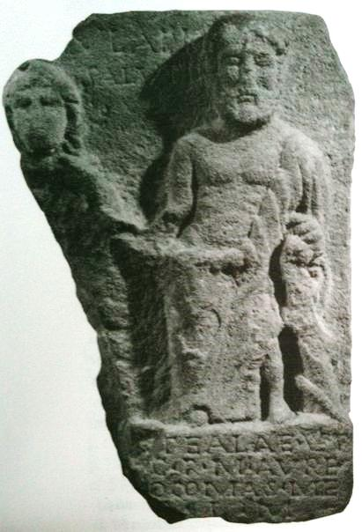 | 6  RIB-01, 01028 = Gummerus-01, 00377 = Gummerus-05, 00022 = GeA 00091  Binchester / Vinovia  [Aesc]ulapio / [et] Saluti /  [pro salu]te alae Vet/[tonum] c(ivium) R(omanorum)  M(arcus) Aure/[lius ----  v(otum) s(olvit)] l(ibens) m(erito).
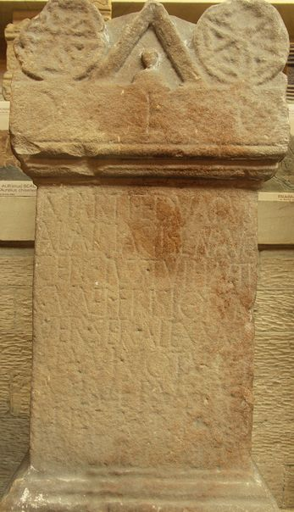 | 7  RIB-01, 01594 = CSIR-GB-01-06, 00160 = D 04761  Housesteads / Vercovicium  Deo / Marti et duabus / Alaisiagis et n(umini) Aug(usti) /  Ger(mani) cives Tuihanti / cunei Frisiorum /  Ver(covicianorum) Se(ve)r(iani) Alexand/riani  votum / solverunt / libent[es] / m(erito).

MILITARY RANKS
The following entries only include those terms which are mentioned in the Vindolanda tablets.

Officers
Legatus Augusti or consularis: the title of the provincial governor of Britain (and of the other provinces to which the emperor made direct appintments) was legatus Augustus pro praetore. The governor of Britain was always a person who had held the consulship and the term consularis is frequently used as an alternative form of reference (abbreviated to cos).
Legatus legionis: the commander of a legion, a man of senatorial status normally with the rank of ex-quaestor or ex-praetor (two of the positions in the senatorial career held before the consulship, at the ages of about 25 or 30 respectively). The term clarissimus uir is applied to individuals of senatorial status (abbreviated to c u).
Centurio regionarius: a centurion, normally from a legion, appointed to the military and administrative supervision of a particular geographical area.
Praefectus cohortis: the equestrian officer in command of an auxiliary cohort. Milliary cohorts were normally commanded by tribuni but the Tungrian cohorts seem exceptionally to have had praefecti in command (abbreviated to praef).
Beneficiarius: a soldier seconded for special duties to a higher-ranking officer. Those most commonly found with this title are adjutants of the provinical governor (beneficiarii consularis) but praefecti of auxiliary cohorts and legati legionis also had them.
Centurio: the officer in command of a centuria of infantrymen (often symbolised, like centuria, by an abbbreviation resembling a 7).
 | Image details:  The symbol for centuria or centurio, not dissimilar to a 7. The dot in the angle of the symbol is particular to this tablet The visible text reads (centuriae) Felicionis  Image ownership:  © CSAD
Curator: in the context of an infantry unit, as at Vindolanda, it may denote responsibility for a specific task rather than a rank. In a cavalry unit it denotes the soldier in charge of provisioning a turma.
Decurio: the officer in command of a turma of cavalrymen.
Optio: the second-in-command in a centuria of infantrymen.
Principalis: a military rank in which were grouped a number of posts, junior and senior staff officers, optiones, standard-bearers etc.; holders of these posts received either double the basic pay (duplicarius) or pay-and-a-half (sesquiplicarius)
Duplicarius: an officer receiving double the basic pay; the term is sometimes used to designate the second-in-command in a century or turma.
Singularis: a soldier in the guard of the governor (singularis consularis or singularis legati). A provincial governor's guard consisted of 500 pedites and 500 equites. The singulares of Britain's governor are thought to have been based in the Cripplegate fort in London.
Cornicularius : a senior rank below the rank of centurion, the cornicularius was the chief clerk, in charge of the tabularium
Tesserarius: one of the senior officers below the rank of centurion, literally the officer responsible for the daily watch-word, possibly in charge of those on sentry duty and 'fatigue parties'

Men
Miles: a soldier, usually an infantry soldier
Commilito: 'comrade', usually a fellow soldier
Contubernalis: a soldier in the same conturbernium of an infantry cohort, used affectionately in the sense of 'mess-mate'. The term can also mean a partner, concubine or de facto wife/husband.
Eques: a cavalry trooper
Conturmalis: a trooper in the same turma of an ala
Aquilifer: the senior standard bearer in the legion, in charge of the legionary eagle and the pay-chest.
Vexillarius: the standard bearer for the cohort.

Other terms and abbreviations:
ala “cavalry unit”
animo “willingly” (animus – “soul”)
annorum “of age”
Apollo “Apollo”, Apollini “to Apollo”
arbor “tree”, arbori “to the tree”
Augustus “emperor”, Augusti “of the emperor”
bene merenti “well deserving” “very worthy”
carissimus, carissima “dearest, most esteemed, most beloved”
cives “citizen”
coniux “wife”
Ceres (dat. Cereri), the goddess Ceres
colonia “colony”, coloniae – “of the colony”
coloni “colonist” (colonorum “of the colonists”)
curavit – “cared for, attended for”
curator manager, overseer, etc. (somebody in charge)
dat – “(he/she) gives”
de “of”
dedicavit “dedicated”
defunctus “died, death, dead”
DM - Dis Manibus “To the spirits of the departed, to the Shades”
duabus “to the two”
duumvir, IIvir “mayor (of the city/colony”)
eq, equites,… “equestrian, cavalry”
et “and”
ex “out of”
faciendum “making, erecting,…”
filius “son”, filia “daughter”
genius - a tutelar deity or genius, e.g. of a city or colony. genio – “to the genius”.
heres “the/his/her heir”
impensa “cost, expenditure,..”
incolumitas “safety, security”
iterum “again, a 2nd time,…”
libertus – freedman, liberta – freedwoman
Marti – “to Mars”
Matribus “to the Mother goddesses”
miles “soldier”
ministrante “waiting, attending,…”
natio,natione “nation”
numen “divine force”
patronus – patron
perpetuus, perpetua “perpetual”
pientissima “most pious”
pontifex “priest, bridge builder” (dat. pontifici)
posuit – “has erected (this monument).”
pro – “for”
procuravit see curavit “attended to, cared for,…”
sacerdos “priest”
salus, salute “health”, Saluti “to Health”
sancta “sacred”
Sergia – a Roman voting tribe (tribus)
Tuihanti – Twent (city in the Netherlands)
suus, sua “his/her”
sibi “himself, herself”
sub ascia “under the axe” (Gallic votive formula)
taurobolium - a sacrifice of a bull in honour of Cybele
turma military unit, squadron
veteranus “veteran”
visu “vision, power of sight,…”
vixit – “lived”
VSLM – votum solvit libens merito “has/have willingly and deservedly fulfilled his vow”
Numbers:
I – 1, V – 5, X – 10, L – 50,. C – 100, D – 500, M – 1000

Perseus online dictionary:
http://www.perseus.tufts.edu/hopper/morph?l=arbor&la=la#lexicon

