
The significance variation in crime figures between geographical communities.

By Nicole Davies.
1802599.
Dissertation presented as part of the requirements for the award of Policing and Criminology (BSc) 2021.

The Impact of COVID – 19.
The University of Wales Trinity Saint David recognises that the COVID -19 pandemic, and consequent closures of our campus (18th March 2020) and national and international lockdowns, has directly or indirectly impacted the work of many of our undergraduate researchers. Although, the campus had periods of re-opening in 2020 and 2021, some research will have been disrupted and some personal circumstances difficult to manage. Teaching was arranged via suitable meeting software and documents shared electronically. All research data collection was designed to utilise digital data collection.
The inclusion of this statement is to facilitate the readers awareness, both now and in the future, that the pandemic may have influenced the scope, direction and presentation of this research.
The academic standards and quality threshold for the award remains unchanged. I wish to reassure readers that this statement is not evidencing a lack of original research or quality.

This work has not previously been accepted in substance for any degree and is not being concurrently submitted in candidature for any degree.
Signed……………………………………………
Date………………………………………………
STATEMENT 1
This dissertation is being submitted in partial fulfilment of the requirements for the degree of BSc.
Signed…………………………………………….
Date………………………………………………
STATEMENT 2
This dissertation is the outcome of my own independent work/investigation, except where otherwise stated.
Signed……………………………………………
Date………………………………………………
STATEMENT 3
I hereby give consent for my dissertation, if accepted, to be available for photocopying and for interlibrary loan, and for the title and summary to be made available to outside organisations.
Signed………………………………………………
Date……………………………………………..

STATEMENT 4
I hereby give consent for my dissertation, if accepted, to be available on the university’s IT system to those who have consent to use the system.
Signed………………………………………………
Date………………………………………………

Acknowledgements.
I would like to thank my parents for their continued support throughout my time at University.
I would also like to thank my University lectures for answering all questions I had regarding this study and for helping me to achieve the best results I can whilst at University.

Contents
An evaluation into UK city crime rates and the difference on crime depending on where you live. 1
Acknowledgements. 3
Abstract. 4
Chapter 1 – Introduction. 5
1.1 Background. 6
1. 2 Rationale 8
1. 3 Aims and Objectives. 9
1. 4 Structure. 10
1. 5 Conclusion. 11
Chapter 2 – Literature Review. 11
2.0 Introduction. 12
2.1 Key information 12
2.2 Drink Driving In the UK. 13
2.3 Racism in the UK. 15
2.4 Knife Crime In the UK. 16
2.5 Differences in location. 17
2.6 COVID – 19; Impact of crimes within the UK. 21
Conclusion for chapter 2 21
Chapter 3 – Methodology 22
1.0 Introduction 22
1.1 Defining research. 23
3.2 Pilot Study 24
3.3 The Research Design. 24
3.4 Research Philosophy. 25
3.5 Approach and Strategy. 26
3.6 Time Horizon. 28
3.7 Ethical Considerations. 29
3.8 Research Limitations. 30
3.9 The Primary method & Conclusion of chapter. 30
4.0 Introduction 31
4.1 Overview 31
4.2*Disclaimer* 31
4.3Gender 32
4.4 Age 32
4.5 Location 32
Chart Findings. 33
33
44
Conclusion for chapter 4. 47
5.1 – Introduction 48
5.2 – Summary of findings. 48
Chapter 6 – Bibliography. 50
Appendices 58
59
60

Figure 1.1 The research onion (Saunders, et al., 2015) 27
Figure 2 - Chart Showing respondents answers. 35
Figure 3 - Chart showing respondents answers. 36
Figure 4 - Chart showing respondents answers. 37
Figure 5 - Chart showing respondents answers. 39
Figure 6 - Chart showing respondents answers. 40
Figure 7- Chart showing respondents answers. 42
Figure 8 - Chart showing respondents answers. 43
Figure 9- Chart showing respondents answers. 45
Figure 10- Chart showing respondents answers. 46
Figure 11- Chart showing respondents answers. 47

Table 1- Showing respondents answers. 49

Abstract.

Crime has always been a concern in UK neighbourhoods. This dissertation will focus on crime statistics in the UK and will also look at different areas of the UK to see what crimes are most common in different geographical areas. Additionally, this study will develop on current academic literature. A succession of objectives were set to achieve the aim of this study and are outlined below.

- To perform a literature review in crime and crime rates within the UK, which will focus on three different types of crimes which comprise of, racism, drink – driving and knife – crime. The goal for the literature review will be to look at the statistics of these crimes in some UK areas whilst also looking at the rise of these crimes.
- To produce primary research which looks at whether there is a pattern between where people live and their behaviours.
- To analyse the data collected to understand why there is a difference between crime rates within UK areas and to establish which crimes from drink – driving, racism and knife – crime, are the most common in respondents’ areas.
- To provide recommendations on behalf of participants opinions regarding crime in different geographical communities.

To achieve these objectives, an evaluation of literature was carried out regarding drink – driving statistics, the problem with knife-crime in London and the UK, the ongoing racism enigma in the UK and a look at the alterations of crimes, lastly, the literature involved the high rates of crime depending on the area. This was to establish a clear sense of what was already known in this filed. A result of such discovery, primary research was then carried out in the form of an online questionnaire. A mono – method was used as the researcher only used questionnaires to gather data. The questionnaire was distributed to a wide range of individuals whilst being posted on Facebook and LinkedIn. Overall, the questionnaire received 101 responses, with participants from all different walks of life.
The study undertaken by the researcher revealed the most prevalent crime in participants area was drink – driving. Overall, this crime had the highest response from the questions illustrated on the questionnaire and it was clear to the researcher from analysing the data in Chapter 4 that the crime of drink-driving was the most active crime in respondents’ communities. The second most prevalent crime was racism, and the third prevalent crime was knife-crime. This study has shown that there is a difference in crimes depending on the geographical communities by identifying statistics to support the claim and by asking members of the public their perceptions of instances of crime in their own areas, which again has been supported by the statistics.

Chapter 1 – Introduction.

The purpose of this dissertation is to understand why there is a difference between crime rates within UK cities and to establish what crimes are most common in different areas. This piece of work is of academic importance because the rise in recorded crime is accelerating in England and Wales according to (Travis, 2018), who says, police figures show a 14% year–on–year increase in offences. Additionally, it would be intriguing to find out how much of a difference the area you live in differs with crimes. Furthermore, this research will try and conclude based on the research from theorists and research methods as to why there is a difference between UK crime rates and UK cities. Following on, this chapter provides the rationale of this study and includes the background whilst also highlighting with researcher information as to why this research project is necessary. This dissertation will focus on three different types of crimes. The reason for focusing on three crimes is to get a picture for the questionnaire to understand respondents own opinions on crime in and around their neighbourhood and what they believe is the most prevalent crime out of the three in their area. The three crimes the researcher has chosen to investigate for this study are, drink- driving, racism and knife-crime. The researcher has chosen these crimes to focus this study on as they all vary on significance and consequence. Providing the researcher more of a balanced argument whilst concluding the research.

1.1 Background.
Criminal and destructive behaviour has besieged UK cites for an exceedingly long time, with the most treacherous areas in England and Wales in 2018 being named as West Yorkshire, Greater Manchester, Cleveland, South Yorkshire, Northumbria, Kent, Durham, Humberside, London and Lancashire (Limted., 2018) and the most safest cites being named as Edinburgh, Bristol, Brighton and Hove, Southampton and Cambridge (Star, 2018).
Crime is seen has the most widespread problem in people’s neighbourhoods, with three quarters seeing it as an obstacle, and a quarter viewing it as a significant challenge (Hills, 1998). Inhabitants who live in council estates consider crime to be a more serious local problem than any other social group, even though affluent urban areas often regard crime as the key issue shaping the local quality of life (Hills, 1998).
Going back in time of the era of Burgess, Park, Shaw, and McKay of the Chicago School of sociology, groups and neighbourhoods have been thoroughly studied for years to comprehend how characteristics of areas within a city are connected, not only with crime but also with other social ills that tend to occur in the same areas (Gibson & Miller, 2009). Furthermore (Gibson & Miller, 2009) state, ever since the early findings of the Chicago School, Criminologists and Sociologists have discovered a remarkable extent regarding crime rates across neighbourhoods and correlation of neighbourhood crime. However, crime rates in 2021 are getting higher.

As previously mentioned, this dissertation will investigate the crimes of drink – driving, racism and knife – crime. The debate persists over a gloomy background of rising knife- crime, which rose by 22% across England and Wales in 2017, which was the highest yearly increase ever documented (Dearden, 2018). In Addition, the quantity of people killed in drink -drive crashes on Britain’s roads has attained an eight year high according to (Media., 2019). Furthermore, racism is on the increase in the UK, since the Brexit vote according to (Guardian., 2019) a study revealed 71% of people from ethnic minorities are facing discrimination, up from 58% in previous years, according to polling data obtained by the Guardian.
Crime is not distributed equally across a map; it can clump in some areas and is somewhat absent in others. According to (Eck, et al., 2017) people use that knowledge in their everyday activities, tending to avoid some places and seeking out others. Their choices of where they live, schools, shops and streets, and recreation are governed particularly by their understanding that their chances of being a victim are larger in some areas than others (Eck, et al., 2017).

2 Rationale.

The background information above underpins the rationale for this study which seeks to understand why there is a difference between UK cities and crime rates and what crimes are most common in areas.
The importance of crime figures holds no argument as we are aware of how much they help authorities understand crime patterns and help us understand what behaviour is going on the streets of our neighbourhoods however, there needs to be more of an understanding as to why crime figures vary depending on different locations. Adding to this, (Statistics., 2021) claim crime and justice is challenging, and they believe it is vital that the statistics continue to reflect the real world; unquestionably there are obstacles in doing this. In the Office for National Statistics review of the public value of crime and justice statistics in the UK (Statistics., 2017) the ONS identified a new need for statistics that join –up across the system, yet the separation of government and organisations, particularly in England and Wales, means that this is not always the case. Additionally, (Statistics., 2021) believe that more should be done across the UK so that crime statistics achieve similar public value in all administrations.

3 Aims and Objectives.

The aim of the research is to look at three different types of crimes concluding drink-driving, racism and knife-crime. This research study is using the deductive theory, which means the question regarding this research has been investigated before, however, the researcher is increasing information on this hypothesis to see if there is a difference in locations and crimes within the UK. To make sure this aim is met, the following objectives will be set.
“Goals should be correctly written and will lead to visible outcomes” (Saunders, Lewis , & Thornhill, 2007, p. 40).
Objectives
- To perform a literature review in crime and crime rates within the UK, which will focus on three different types of crimes which comprise of, racism, drink – driving and knife – crime. The goal for the literature review will be to look at the statistics of these crimes in some UK areas whilst also looking at the rise of these crimes.
- To produce primary research which looks at whether there is a pattern between where people live and their behaviours.
- To analyse the data collected to understand why there is a difference between crime rates within UK areas and to establish which crimes from drink- driving, racism and knife – crime, are the most common in respondents’ areas.
- To provide recommendations on behalf of participants opinions regarding crime in different geographical communities.

4 Structure.
When writing the dissertation selecting the correct investigation technique is crucial, furthermore, it is especially crucial to explore all the various possible techniques that can be used to determine which is the best for the research. For this study, crime statistics from the Police will be crucial. During projects like a dissertation there are separate types of research, this includes primary research and secondary research. Primary research is the collection of new data specifically collected, whilst secondary research is reanalysing data that has already been collected (Saunders, et al., 2007). For the study both secondary and primary research will be gathered and reanalysed. According to (David, et al., 1993) an involvement of sources of data and other information gathered by others is the make-up of secondary information. Furthermore (David, et al., 1993) says, secondary information proposes rapid and inexpensive answers to many queries and is almost the point of change for primary research.
For this research, the technique and procedure that will be used will be questionnaires; using this approach provides a method to collect information that will produce qualitative research which will help the research gain perspective and opinions on data (Saunders, et al., 2009) When the questionnaires have been completed and analysed, the researcher will use a deductive approach to look for patterns in the data that has been studied and collected (Bajpai, 2011). Additionally, the researcher will also be using a deductive approach to identify the different opinions from questionnaires (Hair , Wolfinbarger Celsi , Money , Samouel, & Page , 2011 , p. 276).
To effectively accomplish the objectives of this study, chapter two will analyse the accessible literature on drink – driving statistics, the problem with knife – crime in London, racism in the UK and look at the differences in crimes and the high rate of crimes depending on the area.
Chapter three will detect the most appropriate method and methodology that will be applied to carry out primary research for this study.
Chapter four will analyse the data gathered from the questionnaires, findings will be presented and analysed.
Chapter five will start in conjunction with the accomplishment of objectives. A conversation on the core findings and recommendations will also take place.

5 Conclusion.
This chapter has successfully discussed the aims and objectives for this study by reviewing the background on the topic. This chapter has also touched on the rationale of the study.
As previously discussed, chapter two will critically explore pervious academic writing on crime statistics and the three crimes this dissertation is focusing on e.g., drink – driving, racism and knife- crime. By doing this the researcher will detect related concerns which will allow the researcher to investigate further into their study.

Chapter 2 – Literature Review.

2.0 Introduction.

The intention of this chapter Is to examine the current literature underpinning the topic of this dissertation, to see if there is a difference between criminal behaviour depending on where you live. This chapter will be undertaken by analytically reviewing journals, websites, academic books, and other relevant sources. From exploring and reviewing journals, websites, academic books, and other relevant sources the dissertation will be able to gain a better understanding of criminal behaviour and to see if there is a difference regarding criminal behaviour where people live. The aim of this literature review will be to achieve the following research objective:
- To focus on three different types of crimes which comprise of, racism, drink–driving and knife–crime, whilst also looking at the statistics of these crimes in some UK areas whilst also looking at the rise of these crimes.
To meet this objective this chapter will use a range of sources, consisting of academic journals, government and police websites and newspaper articles.

2.1 Key information.

For a long time, criminologists have concluded that neighbourhoods are important factors of how individuals understand their risk of criminal persecution. Yet, despite the theoretic importance and policy significance of these claims, the first-hand evidence is remarkably narrow (Brunton & Smith, 2011).
According to (Haylock, et al., 2020), the place of somewhere can impact a public health concern. To argue this, (Statistics., 2018) state that London is accountable for 48% of the rise in weapon associated crime and the latest data shows a contrast of the number of offences between Metro-Politian and Non-Metropolitan districts. Additionally, (Haylock, et al., 2020) says, unpredictability may suggest differences in social status, teaching, access of weapons and crime readings. Furthermore, (Haylock, et al., 2020) says, dispossession has shown to bring violence to crimes and victimisation is a risk for those who are out of work which is now double the national average. Lastly, (Eades, et al., 2007) states, individuals who commit murder are most likely to have a low socioeconomic status.
After 2003/2004, crime in the UK plunged in particularly every recording year, seeing a low of 4.4 million offences by 2013/2014 (D., 2020).
However, since 2013/2014, crime in the UK has undergone a year-on-year increase with the decreases in crime observed between 2004 and 2014 essentially washed out by 2018/2019.(D., 2020). The 6.43 million crimes registered in 2019/2020 turned to a crime rate of roughly 96.3 crimes per 1,000 people in the UK. England and Wales had a slightly higher crime rate than this average, whilst Scotland and Northern-Ireland receiving lower crime rates (D., 2020). The UK city with the greatest number of crimes in 2019/2020 stood London, reporting a staggering 850 thousand. Furthermore, UK streets only had 149,660 police officers during 2020 (Statistics., 2020).

2.2 Drink Driving In the UK.

According to (NEWS, 2019) in Wales the amount of drug and drink-driving convictions rose by 18% in 2018 compared with the pervious year, found a Welsh Government report. 3,882 individuals were found guilty of drink-driving offences last year, the report read. Road safety charity Brake stated,
“the data indicated both drink and drug- driving are still widespread on Welsh roads” (NEWS, 2019).
The Ministry of Justice data have recorded in the report that the number of guilty rulings in Wales for driving under the influence rose by 95% in 2018, from 506 to 988 verdicts. (NEWS, 2019). People killed in drink-drive accidents on Britain’s roads has attained an eight-year high (Guardian., 2019) reports. Data from The Department for Transport (DFT) reveals there were between 230 and 270 causalities in accidents where at least one driver or rider was over the alcohol threshold in 2017. The figure of 250 is the highest figure since 2009, although, the (DFT) has said in respondence to this,
“the rise was not statistically significant” (Guardian., 2019).
During 2017, 8,600 people were killed or injured in drink-drive crashes, down from 9,040 the previous year (Guardian., 2019).
Hereford is reported to be the UK city with the highest cases of drink driving rates for the second year running claims (Miles, 2019). Six million car insurance quotes were analysed, and the results found that there were 1.8 drink and drug convictions for every 1,000 drivers in the City (Miles, 2019).
Money Supermarket analysed over six million car insurance quotes (01/11/2019 – 31/10/2020). They found the rate of a conviction present in a drivers’ car insurance enquiry per 1,000 drivers (MoneySuperMarket., 2021). Along with the rates for drink-driving offences across the UK, their data also revealed hotspots in the UK:
- In South Wales, in the postcode area of SA (Swansea), 1.42 people per thousand included a conviction for drink or drug driving on their insurance application.
- In South Wales, in the postcode area of CF (Cardiff), 1.38 people per thousand included a conviction for drink or drug driving on their insurance application.
- In England, in the postcode area of PL (Plymouth) 1.03 people included a conviction on their insurance application.
- In the post code area of EN (London), 0.74 people included a conviction on their insurance application.
(MoneySuperMarket., 2021).

2.3 Racism in the UK.

(Hutchinson, 2012) argues that racism is still a ‘substantial issue’ in Wales. Research was assigned by Race Council Cymru (RCC) which found individuals from minority ethnic backgrounds in Wales are still undergoing racism in all aspects of life. The research was the first piece of work commissioned by (RCC) which is a sponsorship body representing race equality organisations in Wales and includes interviews and surveys with more than 300 minority ethnic individuals around Wales (RaceCouncilCymru., 2014). In contrast to this, (Booth, 2019) says, a North-West London neighbourhood is feasibly the most ethnically diverse place in Britain, with locals there proud of how well everybody gets along together. Additionally, (Booth, 2019) explains, in the last census, in 2011, 15% of inhabitants portrayed their ethnicity as just “British”. Furthermore (Booth, 2019) argues, a rise in overt racism in relation with ethnic minorities is very alarming, with levels of discrimination and abuse continuing to rise in the wake of the Brexit referendum. In support of his claim, (Booth, 2019) states, 71% of people from ethnic minorities now have reported having suffered racial discrimination, compared with 58% in 2016, before the EU vote, according to polling data seen by the Guardian (Guardian., 2019).
Racist occurrences documented by the Police in England and Wales in 2019/2020, by region:

- London – 17,596.
- North West England – 5,468.
- West Midlands – 8,114.
- South West England – 4,861.
- Wales - 2,634.
- East Midlands – 4,814.
(Department., 2020).

From these findings, we can see London has the highest recorded racist incidents and Wales has the lowest. London has a much higher population than Wales, with London having 9.20 million inhabits in 2021 (Assembly., 2021) and Wales having 3.1 million inhabits in 2021 (StatsWales., 2021). The higher level of inhabits in London compared to Wales can be argued to be the reason why London has higher incidents of racism compared to Wales.

2.4 Knife Crime In the UK.

From 2016 to 2017, the UK witnessed an increase of 22% in relation with crime regarding knives and sharp instruments. It is now estimated that admissions to hospitals with stabbing wounds is now at its highest level for 7 years. A shift towards younger victims is now being seen, with one young victim being just13 years old (Straw, et al., 2018). In addition to this, the number of violent crimes and offences by sharp instruments have soared continually, following a pervious decrease, with many cases arising among young people and inhabits living in and around London (Haylock, et al., 2020). (Haylock, et al., 2020) say, there is a restricted understanding surrounding the driver’s influencing these changes in trends with mostly only American-based research identifying the risk-factors surrounding knife-crime. The total crime statistics for London show a trend of increasing crime in the UK capital, reaching a figure of 912 (D., 2021). Additionally, (D., 2021) say, there were 76,000 crime offences in 2019/2020 in London which involved homicides and knife-crime offences, with both experiencing a year–on year increase in 2019 and 2020.

2.5 Differences in location.
Dependable with earlier years, the 2009/2010 British Crime Survey (BCS) has showed the danger of being a victim of any household crime was in fact higher for households living in the most deprived areas, compared with those in the least deprived areas in England (Neil, et al., 2011). Here are some findings from the (Neil, et al., 2011) report:
- In the most deprived areas, the risk of households being victims of vandalism is 8% as compared with 6% in the least deprived areas.
- In the most deprived areas, the risk of households being victims of vehicle – related theft is 7% as compared with 5% in the least deprived areas.
- In the most deprived areas, the risk of households being victims of burglary is 3% compared with 1% in the least deprived areas.
Following on with crime statics, the next section will show the highest neighbourhood crime figures for Swansea, the Vale of Glamorgan and Bridgend. All these constituencies are in South Wales, UK. (December 2020). However, it is important to highlight the numbers’ change frequently due to renaming / recording or redesigning the boundaries at police force level (Stats., 2020).

Swansea.
- Swansea has a population of 238,831 people.
- In 2020, there were 662 burglary crimes.
- 62 vehicle crimes.
- 8 violent crimes.
- 107 shoplifting incidents.
- 480 drug related crimes.
- 6 crimes which used weapons.
- And a further 92 different crimes. (Stats., 2020)

Vale of Glamorgan.
- Vale of Glamorgan has a population of 126,103 people.
- In 2020, there were 19 burglary crimes.
- 37 vehicle crimes.
- 261 violent crimes.
- 25 shoplifting offences.
- 12 drug related crimes.
- 2 crimes which used weapons.
- And a further 63 different crimes. (Stats., 2020)

Bridgend.
- Bridgend has a population of 138, 958 people.
- In 2020, there were 20 burglary crimes.
- 26 vehicle crimes.
- 263 violent crimes.
- 48 shoplifting offences.
- 43 drug related crimes.
- 1 crime used weapons.
- And a further 56 different crimes. (Stats., 2020)
We can see from these statists that Swansea has the biggest population, yet more violent crimes were taken place in Bridgend and the Vale of Glamorgan. Is this because there is a bigger police presence in Swansea as it is a city? And has a bigger population compared to them Bridgend and the Vale of Glamorgan. According to (Hodgkin, 2018) UK crime statistics can now reveal the cities with the lowest crime rate in the country. (Staycation., 2018) has revealed the UK cities with the lowest crime rate:
- St Asaph – Number of crimes (7)
- Chichester – Number of crimes (74)
- Bangor – Number of crimes (77)
- Wells – Number of crimes (92)
- Truro – Number of crimes (99)
- St David’s – Number of crimes (107).
(Hodgkin, 2018).
According to crime pattern theory, crime can happen where good quality illicit openings overlap with the familiarity of an area (Brantingham & Brantingham, 2008). Offenders discover their nature during their daily behaviours, just like everybody else (Lammers, 2018). Offenders create routine spaces, which consist of activity connections (e.g., a home or work location) where they develop paths and connections (Lammers, 2018). A criminal will search for an appealing target within his or her awareness environment (Brantingham & Brantingham, 1993) argue. Several other studies, (Lammers, 2018) says, on the layout of crime or offender mobility shed light on how co–offending may have an impact on crime location selection. (Reiss & Farrington, 1991) founded that 60% of co -offenders resided in the same postal district or within a mile away from each other, and that co–offenders tend to execute crimes that are close to their homes.

2.6 COVID – 19: Impact of crimes within the UK.

According to (NEWS., 2020) criminality in England and Wales dropped by roughly a third in the first two full months of lockdown.
(Stastics., 2020) have stated,
“the drop-in crime rates was drove by decreases of theft and burglary; however, drug crime rose by up to 44% compared with the same period last year, due to well managed targeted policing”.
Additionally, (Youle, 2021) says, documented crime in Swansea climbed during the first nine months of lockdown and restrictions, compared to the same period in 2019. (Data., 2021) says, the spike in recorded crime in Swansea was motivated by doubling of anti –social behaviour reports, with the new crime of breaching COVID restrictions part of the anti –social category. Furthermore, (Data., 2021) says, from the beginning of April to the end of December there were 20,909 recorded crimes in Swansea, a 7% increase contrasted to the same nine months in 2019. In contrast to this, (Jarram, 2021) states, in Nottinghamshire with the post code area of (NG), formal data reveals more than 120,000 less crimes were recorded last year as pubs, bars and nightclubs were compelled to shut down during lockdown. Additionally, (Jarram, 2021) says, crimes including violence with injury, possession of weapons, and vehicle offences saw a decrease.

Conclusion for chapter 2.

This chapter has achieved objective one:
- To focus on three different types of crimes which comprise of, racism, drink – driving and knife – crime, whilst also looking at the statistics of these crimes in some UK areas whilst also looking at the rise of these crimes.
The next chapter pursues to recognize the best suited methodology, which will be used to carry out primary research and will be relative to the areas this literature review has discussed.

Chapter 3 – Methodology.

3.0 Introduction.

This section aims to examine the second objective of this study:
- To produce primary research which looks at whether there is a pattern between where people live and their behaviours.

3.1 Defining research.

The term research is related to seek out the information and knowledge on a specific topic or subject (Ranijt, 2010). According to (Woody, 1927), research consists of defining and re-defining issues, articulating a hypothesis or a suggested solution, which can comprise of collecting, organizing, analysing and reaching conclusions.
“Qualitative research is a field of study that deals with exploring, describing, and interpreting the innate quality of entities and the social processes” (Gupta, et al., 2018).

There are a few concerns that researchers will need to consider whilst starting a research project (Eriksson & Kovalainen, 2008). Few of these matters are more realistic by nature, relating to the design of the research and the process, the planning of the study concerning the data aspect, access to the research site and the collection of materials and analysing them in an adequate way (Eriksson & Kovalainen, 2008).

3.2 Pilot Study.

Before publishing my questionnaire online, a pilot study comprising of 5% of participants was performed. The pilot study was conducted to make sure the questionnaire was structured correctly and read easily for respondents to answer. Before the pilot study was conducted the questionnaire had 25 questions and after the pilot study was performed the researcher added an additional seven questions to the questionnaire. The reason for adding more questions into the questionnaire was to make the questions easier for the respondents to understand and follow, in response to this, several questions were split into separate ones. For example, instead of, “Do you think Wales, England, Scotland and Ireland…?” the researcher changed it to, “Do you think Wales? and so forth. Additionally, whilst undergoing research for the questionnaire the researcher concluded that focusing primarily on postcodes would be difficult, instead the researcher to focus the questions on regions, e.g., England, Wales, Scotland & Northern-Ireland, by doing this the researcher is still able to meet the aims and objectives identified in this study.
According to (Yin, 2011) a pilot study supports the researcher test and refine one or more aspects of their final study. In this sense, the pilot study gives the researcher another opportunity to practice has mistakes can affect the quality and validity of the results (Chakrabarti & Lucienne, 2009).

3.3 The Research Design.

(Saunders, et al., 2015) says, a research design entails determining the correct research philosophy, research approaches, data collection strategies, data choices and techniques and procedures for data collection.

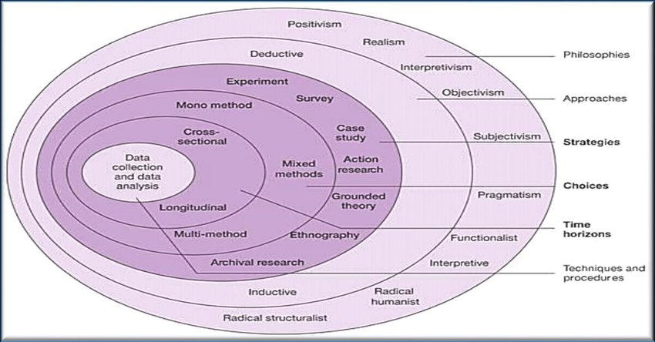
(Saunders, et al., 2015) created a model called “The research onion”, which is used as a layer after layer technique, to be able to create research design. This will be used by the researcher to address the objectives in this study.
Figure 1.1 The research onion (Saunders, et al., 2015)

3.4 Research Philosophy.

The purpose of this section is to determine the correct type of research philosophy for the researcher to have a clear guide for performing the research (Willson, 2010). For this research, the researcher has chosen positivism. According to (Eriksson & Kovalainen, 2008) occasionally methodology is termed the philosophy of methods whilst, the main point of methodology is to define how a presented issue or problem can be examined. (Silverman, 2005) claims methods can be specified principally.
Positivism is one of the schools of thoughts of research philosophy, associated with other philosophes of interpretivism and realism (Saunders, et al., 2009). Positivism studies say the role of the researcher is restricted to data collection and interpretation in an objective manner. In these types of studies, the research outcomes are usually observable and quantifiable (McNabb, 2010). (Crowther & Lancaster, 2008) argue that as a rule, positive studies usually adopt a deductive approach.

3.5 Approach and Strategy.

In research it is essential we use either a deductive approach or an inductive approach. A deductive approach usually starts with a hypothesis, whilst an inductive approach will typically use research questions to slim the scale of the study down (O'Reilly, 2009). In this study, the researcher has chosen the deductive approach. This approach has been chosen because the hypotheses used for this study is an existing theory, unlike an inductive approach the deductive approach depends on an existing theory, not a completely new hypothesis.
The researcher has opted on a mon-method for this study, focusing on only one method of data collection, which will be an online questionnaire. Regarding the questionnaire, an option of closed-ended questions helps the respondents share their opinions and an option of open-ended questions are usually used to for critical analyse without the use of numbers and graphs. For this study, both closed-ended questions and open-ended questions will be used. This will help the researcher by understanding the responses answers more thoroughly.
It is contended that content validity is an important component of the questionnaire validity (McKenna, et al., 2003). Content validity is described as, the extent to which items of a questionnaire are relevant to and representative of the targeted construct for a specific assessment objective (McKenna, et al., 2004).

Advantages of a Computer questionnaire.
- Heightened pace of data collection.
- Minimal - cost constraints.
- Greater levels of objectivity contrasted to many alternate approaches of primary data collection.
- Respondents do not feel pressured.
- Can meet the objectives the researcher has set. (McNabb, 2010).

Disadvantages of a Computer questionnaire.
- Variety of random questions (answer choices) by respondents without correctly proof – comprehending the questions.
- No prospect for respondents to voice their further thoughts. (Ruel, et al., 2015).

The questionnaire can thus be termed as the method of discussion between two individuals, even though they are distant from each other and never communicate directly (Brace, 2008).

3.6 Time Horizon.

An important question a researcher needs to answer whilst planning their study is:
“do I want my research to be a “snap – shot” carried out at a particular time or do I want it to be more like a dairy?” (Saunders, et al., 2015).

According to (Saunders, et al., 2009), a study which includes time-horizon can be defied as being either cross-sectional or longitudinal. Cross – sectional studies can be identified as:
“any research that investigates evidence from many units or cases across more than one point in time” (Neuman, 2014).
A longitudinal study would involve looking at a particular group of people over a long period of time which can involve hours upon hours of research being collected for a certain study (Caruana, et al., 2015). However, given the time scale available for this project, a cross – sectional study will be conducted (David, et al., 2006). Cross – sectional studies often employ the survey strategy, which this research project has (Smith - Easterby, et al., 2002).

3.7 Ethical Considerations.

Whilst researching this study, the researcher will need to guarantee that no harm occurs to voluntary participants that have chosen anonymously to take part in the questionnaire (SAGE., 2004). Before creating the questionnaire, an ethics form was completed to ensure that any ethical issues were being addressed in an effective manner. Additionally, before respondents started the questionnaire, they will have had the option whether to take part in the study or to decline to take part.

3.8 Research Limitations.

An extremely big limitation that will sadly affect this study is COVID - 19. This influences the research project because the questionnaire being conducted by the researcher is only available online and several individuals may not have access to a computer or the internet to be able to take part in the questionnaire. Additionally, COVID-19 may influence the participants answers, this may be because their perspectives may have changed whilst being in lockdown. An Additional limitation is longitudinal effects, professors can devote years (sometimes even a life- time) to research a single topic however, as previously stated the time available to investigate the research hypothesis is constrained by the due date of this research project (Senunyeme, 2013).

nicole davies.

3.9 The Primary method & Conclusion of chapter.

For this study, the researcher has chosen to use a primary method to achieve the objectives for the research. The reason for this choice of method is to gather and collect new data which will enable the research to gather different thoughts regarding their research topic.
To conclude, this chapter has achieved the second objective through pinpointing the method, reality and rationality of this research. The subsequent section will analyse the results of this study and will have connections with literature used within chapter 2.
Chapter 4 – Analysis of data.

4.0 Introduction.

This chapter will analyse the data gathered through methods discussed in chapter 3, which will use primary methods of collection.
This chapter aims to solve the following objective.
- To analyse the data collected to understand why there is a difference between crime rates within the UK areas and to establish what crimes from, drink – driving, racism and knife – crime are most common in respondents’ areas.

4.1 Overview.
An online questionnaire was created to receive responses to whether there is significant variation in crime figures between geographical communities. The question took place from the 3^{rd of} March 2021 to 20th March 2021. During the time, the question was online, myself, my family and friends shared the questionnaire onto Facebook and LinkedIn to spread awareness and to get a difference on opinions regarding the research question. Overall, the questionnaire received 100 responses and had a 1% decline to take part.

*Disclaimer*.

It needs to be noted that this piece of work is part of a general research project and the answers received for the questionnaire are views on behalf of UK residents who agreed to take part in the researchers’ questionnaire. It should also be noted that the questionnaire was regional based e.g., Wales, England, Scotland and Northern – Ireland, as narrowing it down to actual postcode areas would have been extremely difficult. Additionally, it needs to be addressed that only UK residents living in England and Wales took part in the questionnaire. Unfortunately, residents living in Scotland and Northern – Ireland did not take part as the questionnaire did not travel that far.

4.3 Gender.

Out of 100 respondents, 86% were female and 14% were male. This shows the questionnaire results will not have an equal pattern. From analysing the answers to the questions, there is no obvious distinction between the fact that over half the question was performed by females. However, it could be argued that women are more aware of crime and keep themselves safer than men (Gilchrist, et al., 1998).

4.4 Age.

50% of participants were aged 50 – 60, 27% of participants were 18 to 30, 15% of participants were aged 31 – 50 and lastly 8% of participants were aged 70 to 80.

4.5 Location.

The aim of the research is to establish whether there are significant differences regarding the location of crimes, to establish this, the questionnaire needed to have respondents from different areas of the UK to see how thoughts varied regarding where they lived.
From the question, “2. What region of the UK do you live in?” 61% of participants were from Wales and 39% of participants were from England.
From the question, “3. Please give you nearest city”, 56% of people said Swansea, 35% of people said Wolverhampton Birmingham, 1% from Newport, Manchester and Carlisle, 4% from Cardiff, 2% from London. Primarily from these data findings, we can establish the answers given in this questionnaire are generally from people living in the Swansea and Wolverhampton areas with an exceedingly small percentage of people living in elsewhere.

Chart Findings.

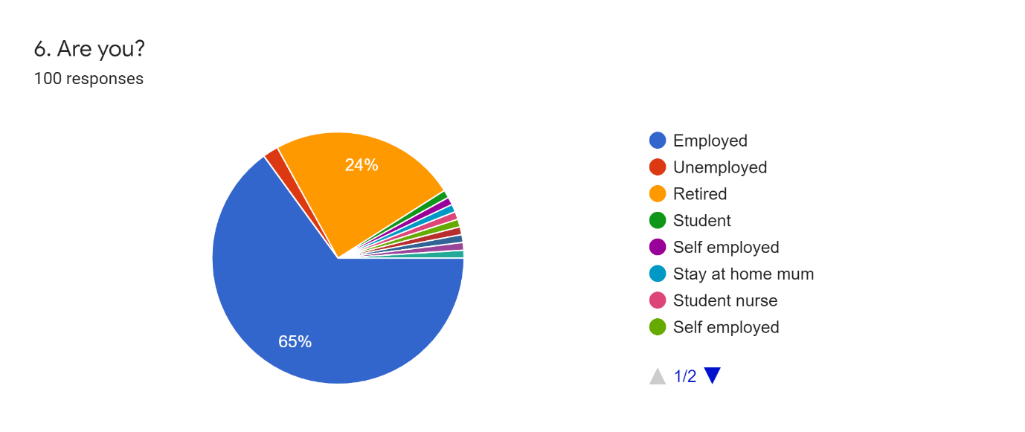
4.6
Figure 2 - Chart Showing respondents answers.

From this chart we see that 65% of respondents who took part in the questionnaire were employed and 24% were retired and a further 25% were unemployed.
Additionally, as we can see from the graph, the questionnaire was also filled out by other members of the public who are self-employed, a stay-at-home mother, business owner, someone on long–term sickness leaves and students. This helps the questionnaire form more of a variety of an opinion as these individuals are all from different walks of life and may have different perspectives of crime figures and the crimes that take place in their areas.

4.7

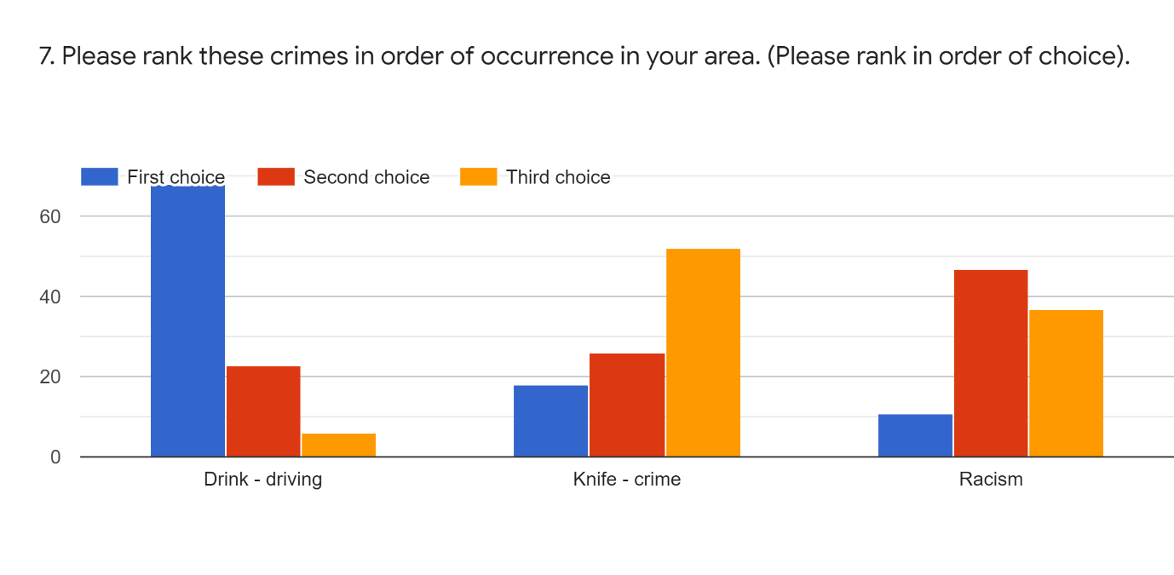
Figure 3 - Chart showing respondents answers.

For this question, respondents were asked to rank the crimes of drink-driving, knife – crime and racism in order of occurrence in their area and were also asked to rank the crimes in order of their first, second and third choice. The results for this question showed the most occurring crime in respondent’s areas was drink – driving. The second most occurring crime was racism and the third most occurring crime was knife–crime. As previously stated in this project, the amount of drug and drink driving convictions in Wales increased by 18% in 2018 contrasting with the previous year (BBC, 2019). This can support the respondent’s answers in this question for why the most occurring crime in respondents’ areas was drink–driving.

4.8.

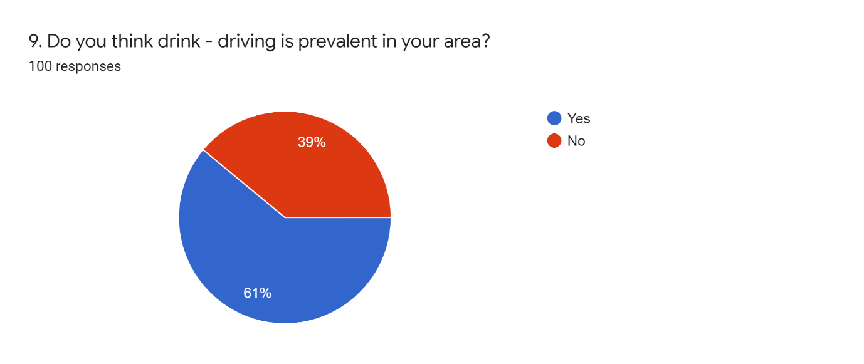

Figure 4 - Chart showing respondents answers.

From this question we can see that the respondents believe drink–driving is prevalent in their area with 61% choosing the option YES. However, we can also see that 39% of people chose the option NO.

4.9.

“10. Thinking about your answer in question 9, please briefly explain your reason for the response”.
This question relied on the respondents to briefly explain their reasons for their response in question 9. Below are a couple of quotes from this section that stuck out to the researcher.

- “A high incidence of alcohol and drug use in my area”.

- “A lot of my friends do it”.

- “Pubs aren’t open at the minute”.

- “Because of the lack of police, these people think they are safe”.

From the responses above we can assume that people are aware of their friends committing the crime of drink–driving and that the respondents are aware of many incidents of drink–driving in their areas. We can establish from this question that drink –driving is happening in many neighbourhoods. Additionally, over half of the respondents believe that drink–driving is prevalent in their area, which adds more to the assumption that drink–driving is a common crime in most areas.

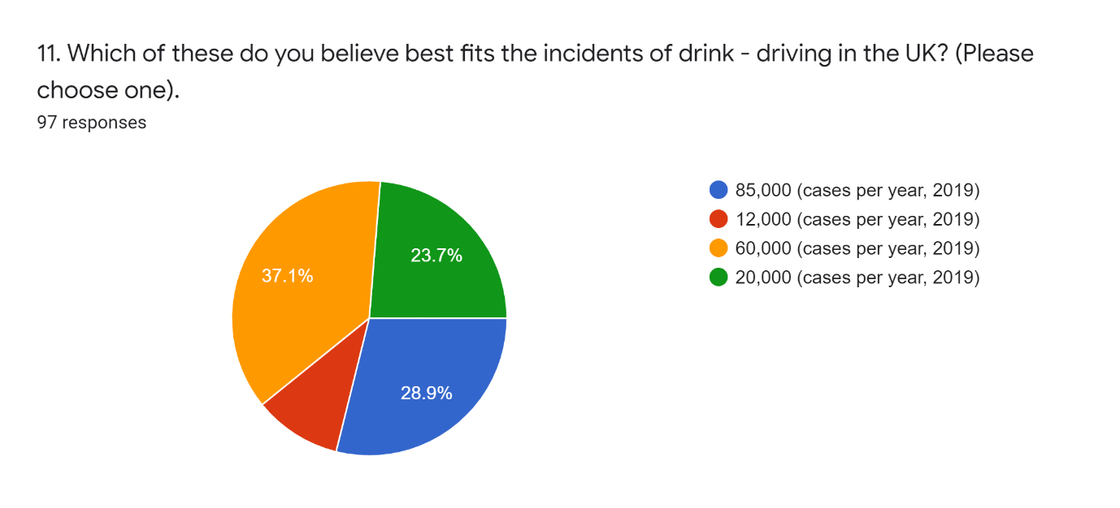
5.0
Figure 5 - Chart showing respondents answers.
*The correct answer for this question is 85,000 (cases per year, 2019) *

From this chart we can see the most answered question was 60,000 (cases per year, 2019) with 37.1% believing this fits the incidents of drink–driving in the UK. It could be argued that 60,000 (cases per year) is a remarkably high number. Although, the correct answer for this question was 85,000 (cases per year) the respondents chose the second most. It draws the picture that drink–driving is prevalent in most areas of the respondent’s neighbourhoods and the question to ask here is why is it so prevalent?

5.1 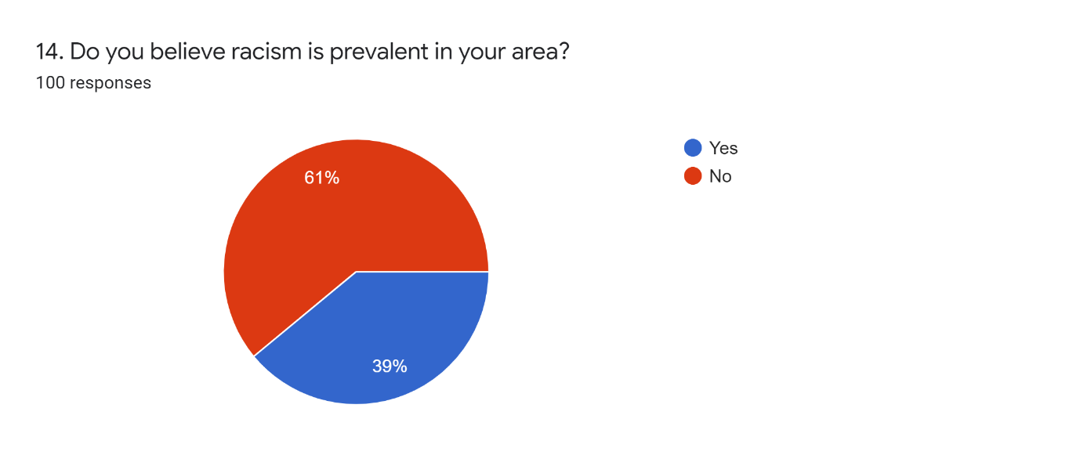
Figure 6 - Chart showing respondents answers.

From this question, we can see that 39% of individuals believe racism is prevalent in their area. Additionally, 61% believed racism was not prevalent in their area.
From the results of this chart, it could be alleged that racism is not as prevalent as drink–driving in the respondents’ areas, as over half of the respondents have said that racism is NOT prevalent in their areas. To support this theory, we are aware of the difference in location with the respondents, as some respondents are from Swansea and some are from Wolverhampton and a small percent are from Cardiff, Manchester, London and Carlisle.

5.2
10. “Thinking about your answer in question 14, please briefly explain the reason for your response”.
This question relied on the respondents to briefly explain their reasons for their response in question 14. Below are a couple of quotes from this section that stuck out to the researcher.

- “Not heard of many incidents”.

- “I don’t think there is a high number of non – white people, so racism isn’t seen”.

- “Racism is everywhere”.

- “The area is predominately white, and I have witnessed instances of it when there are none – white people around”.

- “I have experienced it first-hand and have friends who have shared experiences”.

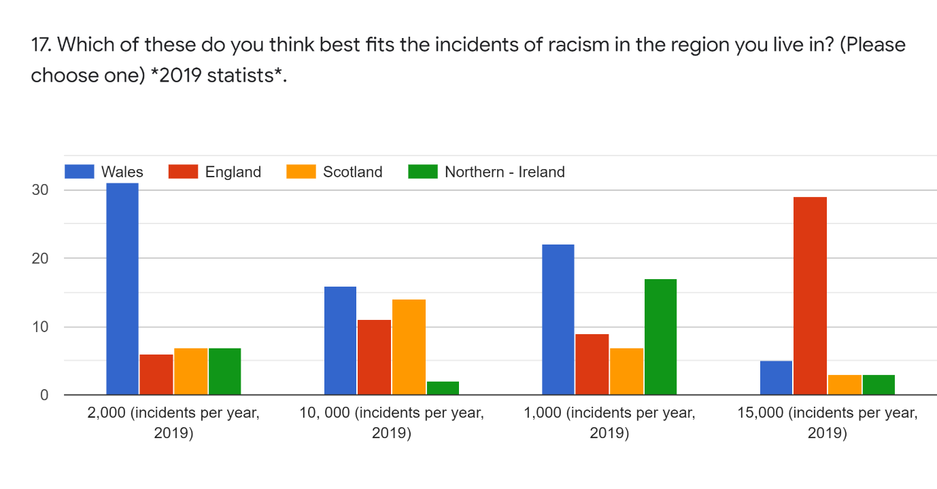
5.3
Figure 7- Chart showing respondents answers.

From analysing this question, the researcher can see immediately the 2,000 (incidents per year, 2019) for Wales was the highest answered choice with 31 people.
Additionally, 15,000 (incidents per year, 2019) was the highest number on the chart, we can clearly see from the results of this question that England had the highest response with 29 respondents. The reason they may have chosen England to have the highest incidents of racism is because England is much more densely populated than Wales, Scotland and Northern Ireland and more incidences of racism may occur because of this. Furthermore, because of the larger population size is in England compared to the rest of the UK; England may have more of an ethnic community. We are aware that 35% of the participants who answered this question are from Wolverhampton Birmingham, in Birmingham there is much more of a cultural divide (previously stated in literature review).

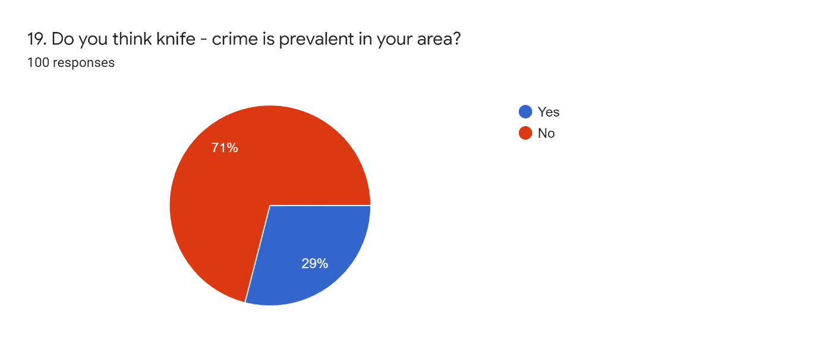
5.4
Figure 8 - Chart showing respondents answers.
From this question, the researcher can see the significant gap between the answers YES and NO. We can see from the chart that 71% of respondents believe that knife – crime is NOT prevalent in their area and 29% of respondents believe that knife – crime IS prevalent in their area.
The results of this question were quite alarming for the researcher as there was a 22% increase regarding crimes with knives and weapons from 2016-2017 (Straw, 2018).
The reason behind the high number of respondents selecting the answer NO could be due to the fact the respondents who answered this question are mostly from Swansea and Wolverhampton. ‘Swansea’ and ‘Wolverhampton’ are not as known for having a knife – crime problem unlike London. Nevertheless, 2% of the makeup of this questionnaire are respondents from London. London is known for being the ‘knife–crime capital’ of the UK (NEWS., 2020). We can assume the respondents from London answered this question with a YES.

5.5

20. “Thinking about your answer in question 19, please briefly explain the reason for your response”.
This question relied on the respondents to briefly explain their reasons for their response in question 19. Below are a couple of quotes from this section that stuck out to the researcher.

- “More known in bigger cities, e.g., London”.

- “Not aware of many attacks in my area”.

- “I am unaware of any crimes in my local area in Gowerton. However, there is more knife – crime in Swansea – East and in City centre of Swansea”.

- “I have never known of a crime locally”.

- “Lots of local media informing me that there is a knife – crime problem in some areas”.

From question 20 and question 19, we can see the theme recurring that knife –crime is not prevalent in most of the respondent’s areas. From question 20, one participant said, “knife crime is more known in bigger cities, e.g., London” and an additional participant said, “there is more knife crime in Swansea East and in the city centre”. So, from this information from the participants, it can be assumed that knife – crime may be more prevalent in the bigger cities of the UK. The question we need to ask is, could the informing media be the reason why the participants are aware of the issue of knife –crime in the larger cities of the UK. To support this theory, a participant said, “lots of local media informing me that there is a knife – crime problem in some areas”.

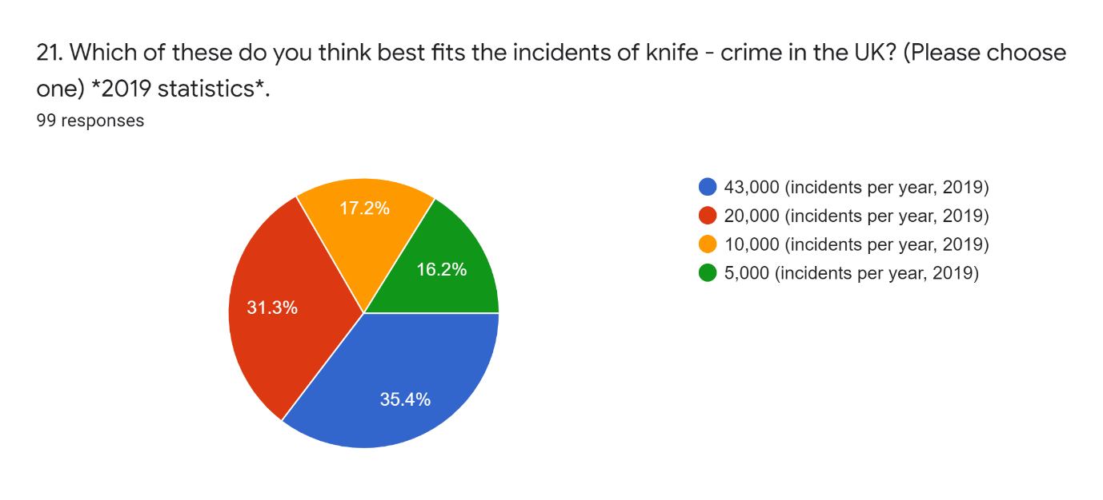
5.6
Figure 9- Chart showing respondents answers.

*The correct answer for this question was 43,000 (incidents per year, 2019) *.

From this question we can clearly see that the highest answered question was 43,000 (incidents per year) with 35.4%. The second highest was 20,000 (incidents per year), the third highest was 10,000 (incidents per year) and the lowest was 5,000 (incidents per year). From the results of this question, we can certainly see that the respondents believe there is a high number of knife –crime incidents per year in the UK. Additionally, only 16.2% of respondents chose the lowest incidents per year which was 5,000. However, from the results of questions 19 & 20 the picture was painted that participants thought knife–crime was not prevalent in their areas but from the results of this question we can assume they believe knife–crime is a problem in the UK as only 16.2% chose the lowest incidents per year, 5,000. The question we now need to ask is, could the informing media be the reason why the participants are aware of the issue of knife – crimes in the larger cities of the UK. To support this theory, here is what a participant said for question 20 “lots of local media informing me that there is a knife – crime problem in some areas”.

5.7

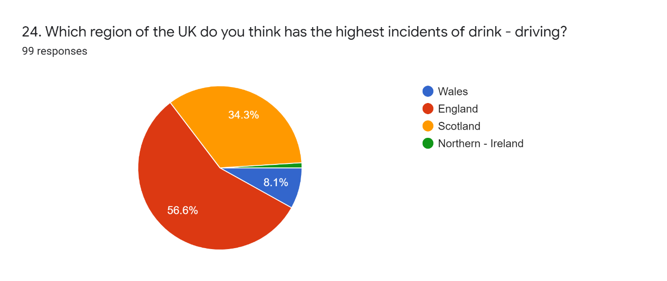
Figure 10- Chart showing respondents answers.

From the results of this chart, we can see that England had the highest percentage with 56.6% of respondents. We can also see that Scotland had 34.3% of the vote and Wales and Northern – Ireland had the lowest percent of the vote.
From the results of other questions, we can see that England has had the highest votes, is this because it has more of a population compared to Scotland, Wales and Northern Ireland combined so the respondents assume more crimes take place there? Additionally, England and Scotland’s margin in this question are not significantly distance.

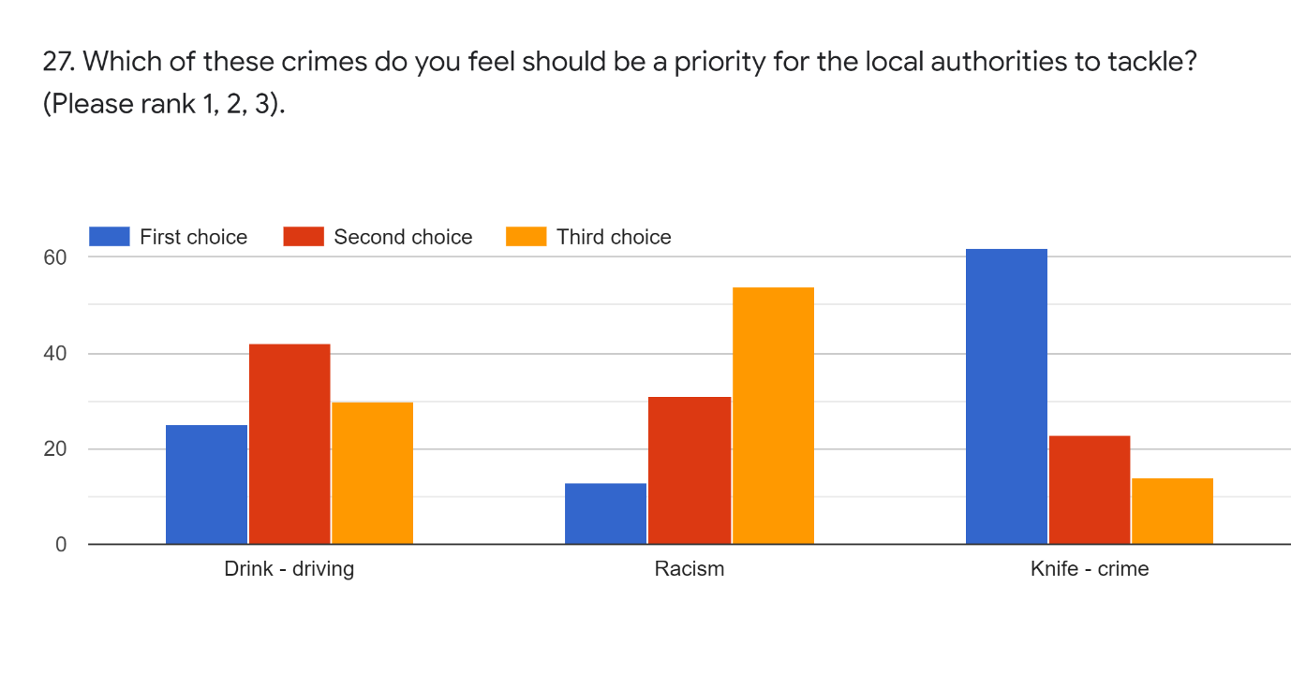
5.8
Figure 11- Chart showing respondents answers.

For this question, participants were asked to rank the crimes of drink – driving, racism and knife – crime for what they believe should be a priority for the local authorities to tackle.
For drink – driving the chart shows the highest column was second choice with 42% participants. For racism, the highest column was the third choice with 54%. For knife – crime the highest column was the first-choice option with 62%. From this chart we can conclude that knife –crime is ranked the 1st crime (priority) for the local authorities to tackle. This may have been chosen because knife- crime is deemed more serious than racism and drink – driving in society today.

5.9

31. For the last question, respondents were asked if they would like to add any opinions regarding the questionnaire.
Below are a couple of answers that have an impact on this research.

- “Very concerned with knife crime in my area at the moment, think police should be more efficient in trying to sort this problem out”.

- “The justice system is letting the country down. Harsher sentencing should occur as both a deterrent and to keep serial criminals away from the public”.

- “Need more police”.

- “More police on the street, with more powers”.

From looking at the answers from this question, we can conclude that people are concerned with the lack of police presence on the streets and of the lack of powers the police have given to them today. There were only 149,660 police officers in the UK during 2020 (Statistics., 2020).

6.0

Table 1- Showing respondents answers.
Drink - Driving | Racism | Knife - Crime
YES 61% | YES 39% | YES 29%
NO 39% | NO 61% | NO 71%

This chart compares all the answers to the “Do you believe …. Is prevalent in your area” questions. From this chart, we can see how different the respondents answered the questions regarding the difference in crimes. Whilst looking at both the drink–driving column and the racism column we can see the answers for both YES and NO are reversed, with 61% saying YES to drink driving being prevalent in their area and 61% believing racism is not relevant in their area. Additionally, we can see 39% believing drink–driving is not prevalent in their area and 39% believing racism is prevalent in their area.

Conclusion for chapter 4.

The objective for this section has been effectively accomplished by examining the data collected from the questionnaires and by presenting findings from the questionnaire. The next section, which is the last will accomplish the final objective, which is to make recommendations and present a summary of the findings of this research study.

5.1 – Introduction.

This chapter discusses the findings of chapter 4 and considers how these findings produce a range of new opinions regarding crimes in different geographical communities. This chapter also intends to achieve the final objective:
- To provide recommendations on behalf of participants opinions regarding crime in different geographical communities.

5.2 – Summary of findings.

This study has achieved the aims and objectives which was to look at three different types of crimes which consisted of drink – driving, racism and knife – crime and to understand why there is a difference between crime rates within different geographical communities. The researcher is pleased that this dissertation highlights the differences in crimes and their locations. Additionally, the researcher is pleased that this study demonstrates how important crime statistics are today and why we rely on them to the extent that we do. Firstly, chapter one was the introduction for this study it demonstrated the purpose of this study whilst also highlighting why this piece of work is of academic importance. Additionally, this chapter discussed a rise in recorded crime in England and Wales and had a focus on the three crimes this dissertation bases its research around, which are, drink – driving, racism and knife – crime. Furthermore, this chapter detailed the background on criminal and destructive behaviour, crime in peoples’ neighbourhoods, and lastly, the rise in crime regarding drink – driving, racism and knife – crime. Chapter two focused on analysis of literature which looked at the existing literature underpinning the topic of this dissertation. This chapter focused on the crimes of drink – driving, racism and knife – crime, whilst also discussing differences in location of crimes and the impact of COVID - 19 regarding to crimes. Chapter three identified the most suitable method and mythology to collect primary and secondary data for this study. Chapter four discussed the findings of the data collected by the researcher (questionnaires) In a progressive order and analysed the findings in a clear manner.
In conclusion to this study, overall, the researcher has proven that the most prevalent crime in the participants areas was in fact drink – driving. Overall, this crime had the highest responses’, and it was clear that the respondents felt this was the most active crime in their neighbourhoods. Adding to this assumption, we can see from the study that, 61% believed drink – driving was prevalent in their area and the respondents chose an extremely high number of 60,000 cases per year in one of the questions. The second most prevalent crime in this study was racism and the third prevalent crime in this study was knife – crime. From this study we can also see that England was pinpointed has the location where the crimes of drink – driving, racism and knife – crime happen the most. We can conclude that the respondents believed this because of the bigger population size compared to Wales, Scotland and Northern – Ireland. Additionally, there has been a rise in knife – crime in London. (D., 2021) states, states there were 76,000 crime offences in 2019/2020 in London which included both murder and knife crime crimes with both expiring a year-on year rise in 2019 and 2020.
The aim of this study was to look at different crimes in the UK, this has been achieved by identifying statistics to support the claim and by asking members of the public their perceptions of instances of crime in their own areas, which again has been supported by the statistics.
The respondents in this study share the same thoughts that there needs to be more police on the street to stop the rise in drink – driving, racism and knife – crimes from occurring, this can be a recommendation.
One recommendation would be for more police on the street, this may help with combating the crimes of drink-driving, racism and knife-crime. This may also help with the reduction of other crimes. A second recommendation would be for authorities to work more closely together to work on crime-statistics, this will help the Police and Government form an understanding of what is going on surrounding UK streets and will help us gather a clearer picture on crime and their hotspots. Lastly, more needs to be done on combatting drink-driving, as this paper has demonstrated that drink-driving is the most prevalent crime in respondents’ neighbourhoods. One suggestion for combatting drink-driving would be to not position clubs and pubs in city-centres as much so if individuals live near-by they will not think to drive home.

Chapter 6 – Bibliography.

- Andresen, M., Felson, M. & Frank, R., 2012. The Geometry of Offending and Victimization.. Canadian Journal of Criminology and Criminal Justice., Volume 54., pp. 495 - 510..
- Assembly., L., 2021. A Growing Population - London.. [Online]
Available at: https://www.london.gov.uk/what-we-do/planning/london-plan/current-london-plan/london-plan-chapter-one-context-and-strategy-0
[Accessed 19th. Febuary. 2021].
- Bajpai, N., 2011. Business Research Methods.. India.: Pearson Education..
- BBC, N., 2019. Drug and Drink Driving convictions rise in Wales.. [Online]
Available at: https://www.bbc.co.uk/news/uk-wales-50822603
[Accessed 1st Febuary. 2020.].
- Booth, R., 2019. 'Always the easiset excuse': Is racism rising in the UK's most diverse area?. [Online]
Available at: https://www.theguardian.com/world/2019/may/20/always-the-easiest-excuse-is-racism-rising-in-the-uks-most-diverse-area-dollis-hill
[Accessed 19th. February 2021].
- Booth, R., 2019. Racism rising since Brexit vote, nationwide study reveals.. [Online]
Available at: https://www.theguardian.com/world/2019/may/20/racism-on-the-rise-since-brexit-vote-nationwide-study-reveals
[Accessed 19th Feburary 2021].
- Brace, I., 2008. Questionnaire Design: How To Plan, Structure and Write Survey Material for Effective Market Researh.. 2nd. ed. London, England, UK.: Kogan Page Publishers..
- Brantingham, P. & Brantingham, P., 1993. 'Nodes, Paths, and Egdes: Considerations on the Complexity of Crime and the Physical Enviorment'.. Journal Of Environmental Psychology., Volume 13., pp. 3 - 28..
- Brantingham, P. & Brantingham, P., 2008. 'Crime Pattern Theory'.. Enviormental Criminology and Crime Analysis., pp. 79 - 93..
- Brunton, I. & Smith, P. S., 2011. Do neighbourhoods generate fear of crime?. An empiral test using the British Crime Survey., 49.(2.), pp. 331 - 369..
- Caruana, E., Roman, M., Hernandez-Sanchez, J. & Solli, P., 2015. Longitudunal Studies.. Journal Of Thoracic Disease., Issue 10, pp. 537 - 540..
- Chakrabarti, A. & Lucienne, T., 2009. DRM, A Design Research Methodology.. 1st. ed. London, England, UK.: Springer Science & Business Media..
- Clark., D., 2020. Crime in the United Kingdom - Statistics and facts.. [Online]
Available at: https://www.statista.com/topics/3793/crime-in-the-uk/
[Accessed 19th. Febuary. 2021].
- Clark., D., 2021. Number of violent crime offences recorded in London from 2010/2011 - 2019/2020.. [Online]
Available at: https://www.statista.com/statistics/863276/violent-crime-in-london/
[Accessed 19th. Febuary. 2021].
- Crowther, D. & Lancaster, G., 2008. Research Methods: A Concise Introduction To Research In Management And Bussiness Consulitoney.. Oxford, UK.: Butterworth - Heinemann Publishers. .
- D., C., 2020. Crime in the United Kingdom - Statistics & Facts.. [Online]
Available at: https://www.statista.com/topics/3793/crime-in-the-uk/
[Accessed 10th Febuary 2021].
- D., C., 2021. Number of violent crimes in London 2010-2020.. [Online]
Available at: https://www.statista.com/statistics/863276/violent-crime-in-london/
[Accessed 22nd Febuary. 2021].
- Data., P., 2021. Police Data Recored Crimes - Swansea.. [Online]
Available at: https://data.police.uk/
[Accessed 22nd. Febuary. 2021.].
- David, J., Jr, K. & Bergh, D. D., 2006. Research Methodology in Strategy and Management.. London, England, UK.: Emerald Group Publishing..
- David, W., Stewart, M. A., Kamins, P. & Michael, A. K., 1993. Secondary Research: Information Sources and Methods.. London, England, United Kingdom.: SAGE Publishers..
- Dearden, L., 2018. Why is knife - crime increasing in England and Wales?. [Online]
Available at: https://www.independent.co.uk/news/uk/crime/violent-knife-crime-rise-stabbing-murders-reasons-increase-london-why-a8326171.html
[Accessed 02nd March 2021].
- Department., S. R., 2020. Racist incidents recorded by the police in England and Wales in 2019/20, by region.. [Online]
Available at: https://www.statista.com/statistics/624038/racist-incidents-in-england-and-wales/
[Accessed 19th. Febuary. 2021].
- Eades, C., Grimshaw, R., Silvestri, A. & Soloman, E., 2007. A Review Of Evidence - Crime and Justice.. [Online]
Available at: https://www.crimeandjustice.org.uk/
[Accessed 19th Feburary 2020].
- Eck, E. J. et al., 2017. Mapping Crime: Understanding hot spots., s.l.: NIJ Publishers..
- Eriksson, P. & Kovalainen, A., 2008. Qualitative Methods In Business Research.. SAGE Publications.: London, England, UK..
- Gibson, L. C. & Miller, V. H., 2009. Neighbourhood Influences On Crime.. London, England, UK.: SAGE Publishers..
- Gilchrist, E., Bannister, J., Ditton, J. & Farrall, S., 1998. Women and the 'fear of crime': Challenging the accepted sterotype.. British Journal Of Criminology., 38(2), pp. 283 - 298..
- Guardian., T., 2019. Drink - drive deaths on UK roads rise to highest level since 2009.. [Online]
Available at: https://www.theguardian.com/world/2019/aug/28/drink-drive-deaths-on-uk-roads-rise-to-highest-level-since-2009
[Accessed 1st February 2021].
- Guardian., T., 2019. Racism on the rise in UK since Brexit vote, study reveals.. [Online]
Available at: https://www.scmp.com/news/world/europe/article/3011070/racism-rise-uk-brexit-vote-study-reveals
[Accessed 02nd March. 2021.].
- Gupta, M., Shaeen, M. & Reddy, K. P., 2018. Qualitative Techniques for workplace data analysis.. Hershey, UK.: IGI Global..
- Hair , J. F. et al., 2011 . Essentials of Business Research Methods. New York : M.E. Sharpe, Inc.
- Haylock, S., Boshair, T. & Alexander, E., 2020. Risk factors associated with knife - crime in United Kingdom amoung young people aged 10 - 24 years: a systematic review.. BMC Public Health., Volume 20, p. 1451.
- Hills, J., 1998. Income and Wealth: the latest evidence.. London, England, United Kingdom.: Joespeh Rowntree Foundation..
- Hodgkin, E., 2018. MAPPED: UK cities with the lowest crime rate revealed in a shock map.. [Online]
Available at: https://www.express.co.uk/life-style/property/983074/UK-crime-news-police-rate-statistics-map
[Accessed 23rd. Febuary. 2021.].
- Hutchinson, C., 2012. Racism is still a 'significant issue' in Wales, warns a new report.. [Online]
Available at: https://www.walesonline.co.uk/news/wales-news/racism-still-significant-issue-wales-2018405
[Accessed 02 Febuary 2021].
- Jarram, M., 2021. How Covid Pandemic has led to a dramatic fall in crime across Nottinghamshire.. [Online]
Available at: https://www.nottinghampost.com/news/nottingham-news/how-covid-pandemic-led-dramatic-4966004
[Accessed 22nd. Febuary. 2021.].
- Lammers, M., 2018. Co-offenders’ Crime Location Choice: Do Co-offending Groups Commit Crimes in Their Shared Awareness Space?.. The British Journal of Criminology., 58.(5.), pp. 1193 - 1211..
- Limted., C. S., 2018. The Top 10 Most Dangerous Areas in England and Wales.. [Online]
Available at: https://www.churchillsecurity.co.uk/2018/08/23/top-10-dangerous-areas-updated-2018/#:~:text=The%20Top%2010%20Most%20Dangerous%20Areas%20in%20England,Metropolitan%20Police%29%20%E2%80%93%2082.0.%2010%20Lancashire%20%E2%80%93%2078.3.
[Accessed 20th November 2020].
- Machado, C. & Davim, J. P., 2020. Research Methodology in Management and Industrial Engineering.. USA.: Springer Nature..
- McKenna, S. P. et al., 2003. Development of the PSORIQoL, a psoriasis-specific measure of quality of life designed for use in clinical practice and trials.. British Journal Of Dermatology., Volume 149., pp. 323 - 331..
- McKenna, S. P. et al., 2004. Development of the PsAQoL: A quality of life instrument specific to psoriatic arthritis.. Annals of the Rheumatic Diseases., Volume 63., pp. 162 - 169..
- McNabb, E. D., 2010. Research Methods For Political Science.. 2nd. ed. New York, USA.: M.E. Sharpe Inc..
- Media., P., 2019. Drink-drive deaths on UK roads rise to highest level since 2009.. [Online]
Available at: https://www.theguardian.com/world/2019/aug/28/drink-drive-deaths-on-uk-roads-rise-to-highest-level-since-2009
[Accessed 02nd. March 2021].
- Miles, J., 2019. Places in the UK with the highest drink and drug driving rates.. [Online]
Available at: https://metro.co.uk/2019/11/20/places-uk-highest-drink-drug-driving-rates-11189859/
[Accessed 1st February 2021].
- MoneySuperMarket., 2021. Drink & durg convictions in the UK - Where in the UK are drivers most likely to have a conviction for drink or drug driving?. [Online]
Available at: https://www.moneysupermarket.com/car-insurance/drink-driving-convictions/
[Accessed 02nd Febuary 2021].
- Neil, H., Robb, P. & Britton, A., 2011. Crime in England + Wales 2009/2010 - Geographic patterns of crime.. [Online]
Available at: https://assets.publishing.service.gov.uk/government/uploads/system/uploads/attachment_data/file/116360/hosb1210-chap7.pdf
[Accessed 19th Feburary. 2021].
- Neuman, W. L., 2014. Understanding Research: Pearson New International Edition.. London, England, UK.: Pearson Publishers..
- NEWS., B., 2020. As it happened: Knife crime in London: What can be done?. [Online]
Available at: https://www.bbc.co.uk/news/live/uk-england-london-51630230
[Accessed 18th March. 2021.].
- NEWS., B., 2020. Coronavirus: Crime in England & Wales falls during lockdown.. [Online]
Available at: https://www.bbc.co.uk/news/uk-53919786
[Accessed 22nd. Febuary. 2021.].
- NEWS, B., 2019. Drug and drink - driving convictions rise in Wales.. [Online]
Available at: https://www.bbc.co.uk/news/uk-wales-50822603
[Accessed 1st February 2020].
- O'Reilly, K., 2009. Inductive & Deductive.. London, UK.: SAGE Publications..
- RaceCouncilCymru., 2014. Diversty, Equality, and inclusive community is now.. [Online]
Available at: https://racecouncilcymru.org.uk/
[Accessed 02 Febuary 2021].
- Ranijt, K., 2010. Research Methodlogy: A step - by - step guide for beginners.. 2nd. ed. London, England, UK.: SAGE..
- Reiss, A. & Farrington, D., 1991. ‘Advancing Knowledge About Co-offending: Results from a Prospective Longitudinal Survey of London Males.. he Journal of Criminal Law and Criminology., Volume 82., pp. 360 - 395..
- Ruel, E., Wagner, E. I. & Gillespie, J. B., 2015. The Practice Of Survey Research.. London, England, UK.: SAGE Publishers..
- SAGE., 2004. Ethical Considerations.. [Online]
Available at: http://www.sagepub.com/sites/default/files/upm-binaries/4999_Polonski_Chapter_5.pdf
[Accessed 01th March. 2021].
- Saunders, M., Lewis , P. & Thornhill, A., 2007. Research Methods for Business Students. 4th ed. Harlow: Pearson Education Limited.
- Saunders, M., Lewis, P. & Thornhill, A., 2009. Research methods for business students.. England, United Kingdom.: Education Limited..
- Saunders, M., Lewis, P. & Thornhill, A., 2009. Research Methods For Bussiness Students.. London, England, UK.: Pearson Education Publishers..
- Saunders, N. M., Lewis, P. D. & Thornhill, A., 2015. Research Methods For Bussiness Students.. London, England, UK.: Pearson Higher Ed Publishers..
- Senunyeme, E. K., 2013. Self - Reported Limitations & Future Directions In Scholary Reports: Analysis & Recommendations.. Journal Managment., pp. 48 - 75..
- Silverman, D., 2005. Doing Quanlitive Research: A Pratical Handbook.. London.: SAGE Publications..
- Smith - Easterby, M., Thrope, R. & Lowe, A., 2002. Mangament Research: An Introduction.. 2nd. ed. London, England, UK.: SAGE Publishers..
- Star, D., 2018. UK's most dangerous cities.. [Online]
Available at: https://www.dailystar.co.uk/news/latest-news/uk-least-safe-cities-london-16890564
[Accessed 20th November 2020].
- Stastics., O. F. N., 2020. Coronavirus and crime in England and Wales: August 2020.. [Online]
Available at: https://www.ons.gov.uk/peoplepopulationandcommunity/crimeandjustice/bulletins/coronavirusandcrimeinenglandandwales/august2020
[Accessed 22nd. Febuary. 2021.].
- Statistics., O. F., 2017. Public Value Of Crime And Justice Statistics In The UK., London, United Kingdom, England.: Office for Statistics Regulation..
- Statistics., O. F., 2021. The Value Of Crime and Justice Statistics.. [Online]
Available at: https://osr.statisticsauthority.gov.uk/publication/crime-interventions/
[Accessed 1st April 2021.].
- Statistics., O. f. N., 2018. The nature of violent crimes in England and Wales : Year ending March 2017.. [Online]
Available at: https://www.ons.gov.uk/releases/thenatureofviolentcrimeinenglandandwalesyearendingmarch2017
[Accessed 19th Febuary 2020].
- Statistics., O. f. N., 2020. Crime in England and Wales: year ending June 2020. [Online]
Available at: https://www.ons.gov.uk/peoplepopulationandcommunity/crimeandjustice/bulletins/crimeinenglandandwales/yearendingjune2020
[Accessed 19th Feburary 2021].
- Statitcis., O. F. N., 2021. Nottinghamshire.. [Online]
Available at: https://www.gov.uk/government/organisations/office-for-national-statistics
[Accessed 23rd. Febuary. 2021.].
- Stats., U. C., 2020. Neighbourhood Crime.. [Online]
Available at: https://ukcrimestats.com/Neighbourhoods/
[Accessed 22nd Febuary 2021].
- StatsWales., 2021. National level population estimates by year, age and UK Country.. [Online]
Available at: https://statswales.gov.wales/Catalogue/Population-and-Migration/Population/Estimates/nationallevelpopulationestimates-by-year-age-ukcountry
[Accessed 19th. Febuary. 2021.].
- Staycation., T. G. B., 2018. The Great British Staycation.. [Online]
Available at: https://www.citybaseapartments.com/blog/staycation-index/
[Accessed 23rd. Febuary. 2021.].
- Straw, I. e. a., 2018. Knife Crime in London a UK: Youth Perspective.. Knife Crime., p. 392..
- Straw, I. et al., 2018. Knife crime in London, a UK: a youth perspective.. Knife crime., 392(2), p. S85..
- Travis, A., 2018. A rise in recorded crime is accelerating in England and Wales.. [Online]
Available at: https://www.theguardian.com/uk-news/2018/jan/25/knife-and-gun-rises-sharply-in-england-and-wales
[Accessed 1st April 2021.].
- Willson, J., 2010. Essentials Of Bussiness Research: A Guide Into Doing Your Research Project.. London, England, UK.: SAGE Publishers..
- Woody, C., 1927. The Values Of Educational Research To The Classroom Teacher.. The Journal Of Educational Research., 16.(3.), pp. 172 - 178..
- Yin, K. R., 2011. Qualitative Research From Start To Finish.. 1st. ed. New York, USA.: Gillford Press..
- Youle, R., 2021. Why recored crime actually rose in Swansea during nine months of lockdowns and coronavirus rules.. [Online]
Available at: https://www.walesonline.co.uk/news/wales-news/crime-swansea-police-coronavirus-drugs-19859026
[Accessed 22nd. Febuary, 2021.].

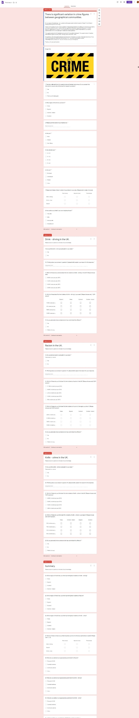
Appendices.


