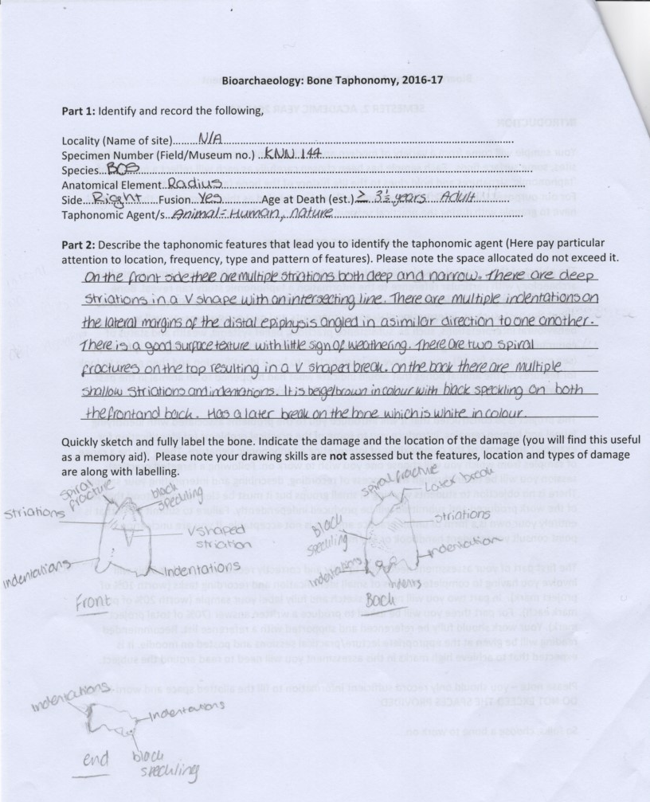
Part 3: In no more than 1000 words assess the main difficulties that may be faced when ascribing a taphonomic history to your bone and based on your laboratory experience.

Creating a taphonomic history of a bone can be difficult on the grounds that there can be issues in identifying the bone and within species there can be differentiating sizes of animal. This can be problematic when identifying larger species and having a bone which is significantly smaller than would be expected. Efremov (1940 in O’Connor) states that “The chief problem of this branch of science is the study of the transition (in all its details) of animal remains from the biosphere to the lithosphere”. This is due to there being many processes that can affect the bone during its transition and therefore can make ascribing a taphonomic history difficult.
There were some difficulties from the start with the bone as it was a small piece of what appeared to be a long bone. The fact that the distal epiphysis was there made identifying the bone as a right radius of a Bos easier. The fact that there was a large research collection that we could compare it to made it easier to identify but, if that had not been available it would have been very difficult. This was also due to the fact that the bone was smaller than expected for a Bos and there was complete fusion. This was determined using Silver’s (1963 in Brothwell and Higgs) table on fusion (see figure 1). The identification was also made possible as “each bone has specific characteristics by which the animal can be recognised.” (Schmid, 1972). There were also difficulties encountered when looking at the weathering of the bone as the bone could be seen to be old and from an archaeological site. However, there was very little weathering apparent on the bone. This caused an issue in that it did not equate to a stage on the weathering chart (see figure 2) but it was an old bone. This made it difficult, without context to establish the range in years since death. When examining the bone, it was important to examine the break of the bone as it was not complete. This was to allow an indication of what may have happened to the bone. There are two spiral fractures on the bone and they have left a V shape in the bone as they have both spiralled around. This was determined from a look at the different types of bone fracturing (see figure 3). This allowed for a hypothesis of what may have happened to the bone and to begin creating a taphonomic history of the bone.

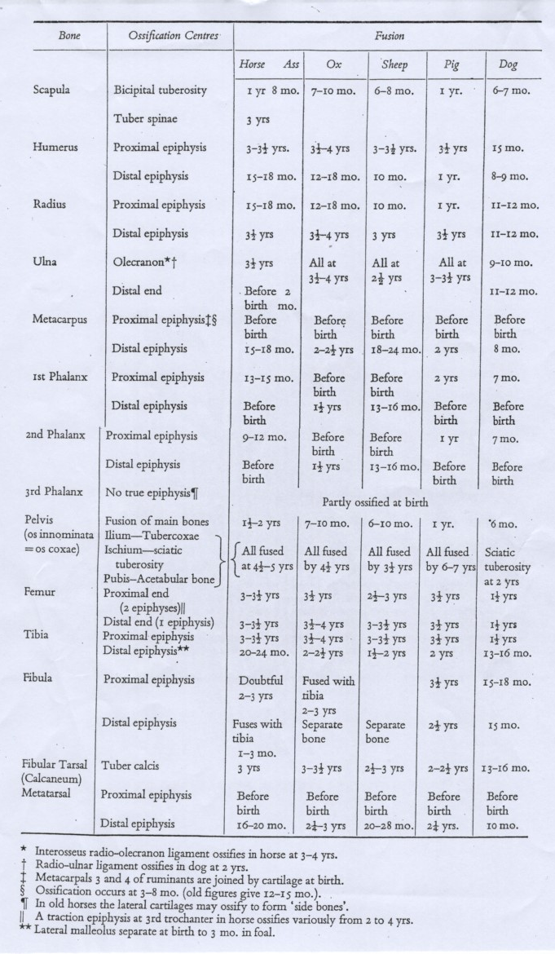

Figure 1
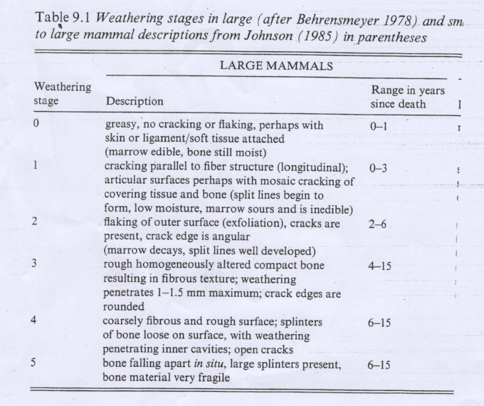
Figure 2

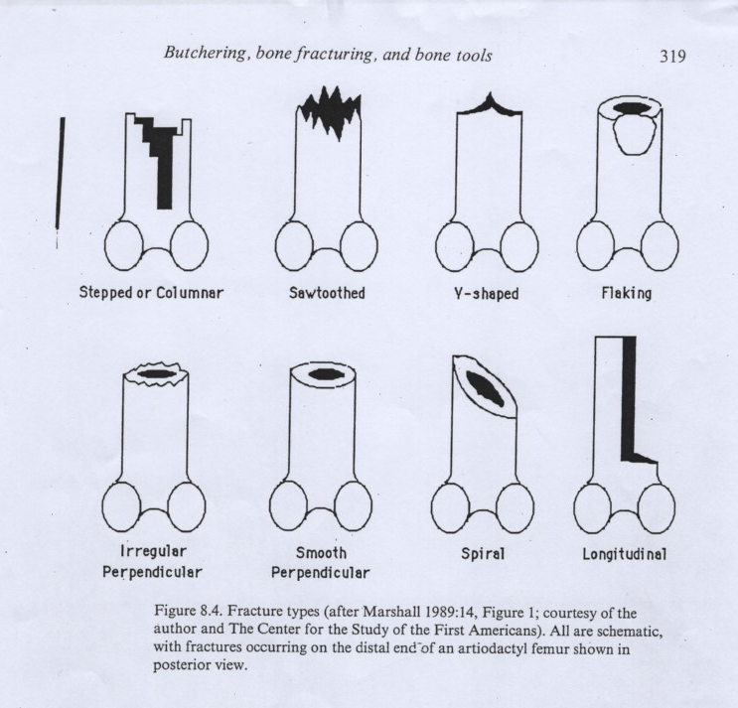
Figure 3

There were also other factors that had to be taken into account when attempting to create a taphonomic history of the bone. The determination of what may have happened to the bone provides difficulties by nature. There is the fact that it can be difficult to determine whether damage is animal or human by nature as there can be similar characteristics. The Bos radius had a number of indentations and a number of striations. It could also be seen to be beige/brown in colouration with black speckling. This caused difficulties in that the striations were a variety of depths and in multiple directions which could indicate a number of different actions. The many different forces that have impacted on the bone themselves provide a difficulty in creating a taphonomic history. The process of identifying the taphonomic features on the bone also provides some difficulties. “A taphonomic feature need not be a signature; it is an artefact or epiphenomenon of an agent or process that modified a skeletal specimen’s location, anatomical completeness, or appearance.” (Lyman, 2008). The features that may be present on the bone may not be obvious to see this provides difficulties in that, there is no record of how the bone looked before this occurred therefore making it difficult to decide if some of the features are actually features. On this bone the features were, the deep striations, particularly two which form a V shape on the front of the bone with an intersecting one horizontally, also the indentations on the lateral margins of the distal epiphysis of the radius. These indentations were deep and therefore unlikely to have been naturally on the bone. There are also difficulties in that all of this is considered to be primary data and “although primary data should be replicable, this does not mean they are free of biases related to taphonomic processes, excavation strategies, and identification procedures.” (Reitz and Wing, 2008). There are also difficulties in that there are a few ways that the striations and indentations could have occurred, so it is difficult to decide if it was animal or human activity, or a bit of both. These marks on the bone are unlikely to be natural but beyond that it is uncertain. When also accounting for the spiral fracture as well it may have been an animal twisting and breaking the bone to get to the marrow and the indentations are teeth marks, however it may have also been a human breaking the bone and the indentations are from a different process. It is also possible that there was both human and animal activity. This provides more difficulties in that it is not always possible to determine what caused the taphonomic features.
There are several difficulties encountered in that identifying the bone would be difficult without a research collection to compare it to. There is also the issue that there are differentiating sizes of animal within each species and that can make it difficult to identify. The taphonomic features may also have a variety of reasons that they may have occurred so the way these were made may be difficult to determine. The breakages and the colour and speckling on the bone would also be difficult as it would have to be speculation. This makes it difficult to ascribe the taphonomic history as there is no clear-cut answer. Therefore, making this bone difficult to ascribe an accurate taphonomic history to.

Word Count: 996

Bibliography
Brothwell, D., Higgs, E., 1969. Science in Archaeology. Thames and Hudson. Bristol.
Lyman, R.L., 2008. Quantitative Paleozoology. Cambridge University Press. Cambridge.
Lyman, R.L., 1994. Vertebrate Taphonomy. Cambridge University Press. Cambridge.
O’Connor, T., 2004. the archaeology of animal bones. Sutton Publishing Limited. Stroud.
Reitz, E., Wing, E., 2008. Zooarchaeology. Cambridge University Press. Cambridge.
Schmid, E., 1972. Atlas of Animal Bones. Elseveir Publishing Company. London.

