Module M4X01162 : Materials and Introduction to Manufacturing – Tom Westcott

Introduction
In this project I will be presenting the findings of my research into modern manufacturing techniques and new technology. Firstly I will be discussing 3D printing, its background, techniques, uses and benefits. Secondly I will talk about Abrasive Water Jet Cutting and its modern advances and applications. And finally I will talk about nanotechnology giving an over view of the technology before looking in more detail into a specific example of nanotechnology, Carbon nanotubes, including their background, how they are manufactured, current application and future uses.

Manufacturing Methodology: 3D Printing

3D printing is a manufacturing process that produces objects in accordance to a 3D digital model. By using a 3D printer and adding material layer by layer, such as plastics and metals, complex objects can be produced both rapidly and at low cost, in short runs or as one-of-a-kind parts. (Wilson, 2020)
3D printing was invented in the 1980’s, the first patent for the technology was filled in May 1980 by Dr. Hideo Kodama of Nagoya Municipal Industrial Research Institute. Dr Kodama’s system involved subjecting a vat of a photopolymer material to ultraviolet light to selectively harden a design from the material. A more modern approach to 3D printing was developed later in the decade with chuck hall’s stereolithographic apparatus, which was able to print objects into complex designs using layers of liquid resin. Another early design was made by Carl Deckard of the University of Texas in 1987, Deckard’s printer worked by binding together a lose powder into a solid object by using lasers. There were further advancements made through the 1990s and 2000s which built on the work of Deckard and Kodama. (Dormehl, 2019)
There are 3 main types of 3d printing technology which is widely used today, these are SLS (selective laser sintering), FDM (fused deposition modelling) and SLA (stereolithograhpy). 3D manufacturing is a type of additive manufacturing where a solid object is created by the printing of successive layers of material. This process has many advantages over the traditional methods of manufacturing which are subtractive where a block of material is cut into shape with a lathe or mill or another CNC process. Subtractive manufacture involves a lot of wasted material as it involves removing material form a solid block to form the design required, in contrary to 3D printing which uses only the material required therefore keeping costs low and, for complex parts, manufacturing speed higher. With 3D printing technology the design of components or prototypes is not limited by old methods of manufacture like cutting or moulding. This means that designs can be produced with more complexity than previously and are no more expensive to produce. As a consequence of the development of 3D printing technology computer skills are more necessary than ever before in the manufacturing industry. The use of specialist software and Computer Aided Design (CAD) software is essential to design components and prototypes to be printed.
3D printing utilizing the extrusion of thermoplastic material is easily the most common method of 3D printing in use today. It was developed in the 1990’s by Stratasys. The process works by melting a plastic filament which is deposited by a heated extruder one layer at a time onto a build platform to a 3D pattern received by the printer from a computer. Each layer solidifies and hardens as it is deposited and bonds to the previous layer. The fused deposition modelling system of printing requires support structures to be printed for any overhanging components of the part being printed. In modern 3D printers these support structures can be made from a second, water soluble material which can be washed away after printing to leave the finished design. One of the biggest advantages of FDM 3D printing is scalability: It can be easily scaled to any size. This is because the only constraint in the size of a build area is the movement of each gantry – make the gantry rails longer and the build area can be made larger. Of course, there are a few minor issues, and at a certain point the cost is no longer offset by the benefits, but no other printer design is capable of being scaled as easily with as few issues as FDM. One of the down sides to this method of 3D printing is lack of detail. Because the material must be extruded in layers the parts need to have a certain thickness which is limited by the size of the nozzle. Making printed object with high levels of detail requires further processing to achieve a finished look. Another problem with this method of printing is that when the material is laid down in layers it creates inherent weak spots in the printed object where each layer is joined. This makes it unsuitable for certain applications. Also, compared to other methods of 3D printing such as SLA or SLS, FDM is a slow process, especially if the design is large or highly complex.
There are relatively few safety concerns with 3D printing when compared to traditional methods of manufacturing. However, when using a 3d printer some PPE may still be required, depending on the specific type of printer. Printers that work by printing layers of material in liquid form may require eye protection to protect form splashing. Other printers may produce harmful fumes or dust and so a dust mask may be required.
As technology continues to improve 3D printing is expected to play a bigger role in the manufacturing industry, it allows for rapid prototyping and speeds up the design process in many applications and can theoretically be used in medical applications for the production of prosthetics.

Manufacturing Methodology: Abrasive Water Jet Cutting.
Abrasive Water Jet Cutting is a method of cutting materials using very high pressure water jets. An abrasive material such as garnet is added to the water to enable it to cut through harder materials, such as steels and concrete.
Water cutting jets have been used in industries such as mining for over a hundred years and, in the mining industry is referred to as hydraulic mining. Over the past few decades the technique of water jet cutting has been refined from a crude cutting tool to a high tech modern technique which is used in the aerospace and food industries. The addition of an abrasive material to the water jet made this technology more applicable to the manufacturing industry as it improved the cutting power of the water jets meaning they are now capable of cutting harder materials including steel and titanium. It is the preferred method when parts are especially temperature sensitive meaning they cannot be cut with methods that are more traditional.
Modern abrasive waterjet machines use either an intensifier pump or direct- drive pump to generate the high pressures required to create a high-velocity cutting stream.
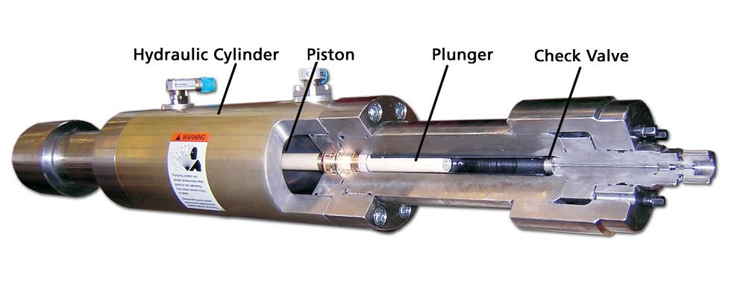
Figure 1. Intensifier pump
A pump like the one shown above is used to generate the pressures high enough to be used in abrasive water cutting jets. Oil is pumped into the hydraulic cylinder at relatively low pressures and pushes against the piston. Because the area of the piston head is so much greater than the area at the end of the plunger, and pressure is force divided by area, the relatively low pressure of the oil can create pressures up to 4100 Bar in the water jet as it passes through the check valve at the end of the cylinder.
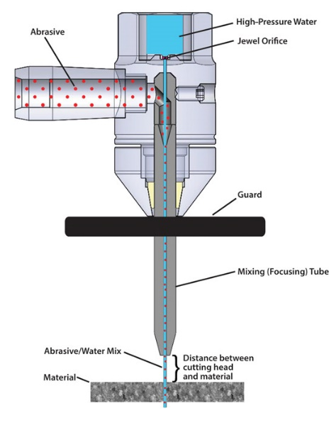
Figure 2. Typical waterjet cutting head
Once the water has been passed through the pump and reaches the required pressure it enters the cutting head as shown in figure 2. Where the abrasive material is added. The amount of abrasive used is a major component in the cost effectiveness of this technology as the abrasive material, garnet is expensive. The use of more modern pumps has allowed for water at much higher pressures which means less material is needed to achieve maximum cutting power therefore reducing costs. (Pradeep Nambiath, 2016)
Using modern software and advanced nozzles, cuts can be made extremely accurately to within a width of 0.51mm, which allows very intricate designs to be cut accurately. Modern machines are computer controlled and make components which have been designed as 3d models in CAD software.
All cutting tools carry a risk of cutting injuries to a machine operator but water jet cutting is much safer than the alternatives such as acetylene or laser cutting. As water jet cutting is a cold process there is no risk of burns, water jet cutting is commonly carried out submerged in water, which lessens the noise risk and removes the risk of fumes or harmful dust. (Olsen, 2008)

Materials Study: Nanomaterials
Nanoscale materials are defined as a set of substances where at least one dimension is less than approximately 100 nanometres. A nanometre is one millionth of a millimetre - approximately 100,000 times smaller than the diameter of a human hair. Nanomaterials are of interest because at this scale unique optical, magnetic, electrical, and other properties emerge. These emergent properties have the potential for great impacts in electronics, medicine, and other fields. (Alagarasi, 2011)
Nanomaterials exist in nature in living things and in some forms of naturally occurring crystals. In recent years a lot of research has been done into the uses of naturally occurring nanomaterials as well as the manufacture of nanomaterials for industrial and medical uses. Nanomaterials can be largely grouped into 4 categories, carbon based, metal based, dendrimers and composites. Many nanomaterials have novel properties in mechanical, electrical, thermal or magnetic properties giving them unique characteristics and uses.
Metallic oxide nanoparticles – these Nano particles are crystals of metallic oxides grown under controlled conditions to produce a crystal on a nanoscopic size, they have diverse unique properties, and many may have uses in medical application such as the treatment of cancer by delivering drugs directly to affected areas.
Dendrimers – monometallic, bimetallic and semiconductor nanoparticle materials. Uses include drug delivery, gene transfection, catalysis, energy harvesting and photo activity.
Nanocomposites – nanocomposites differ from conventional composite materials because they have a very high surface area to volume ratio giving advantages in mechanic properties such as strength and hardness.

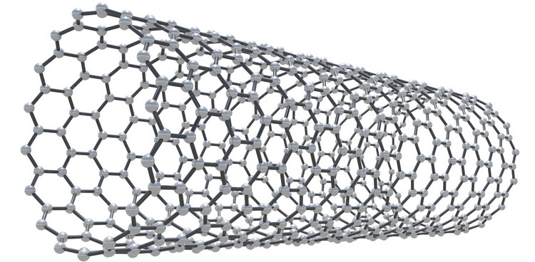
Figure 3. An Illustration showing the structure of a Single Walled Carbon Nanotube
Carbon nanotubes – Carbon nanotubes (CNTs) are cylindrical molecules that consist of rolled-up sheets of single-layer carbon atoms (graphene). They can be single-walled (SWCNT) with a diameter of less than 1 nanometre (nm) or multi-walled (MWCNT), consisting of several concentrically interlinked nanotubes, with diameters reaching more than 100 nm. Their length can reach several micrometres or even millimetres. They have exceptional properties for tensile strength which can be in excess of 400 times as strong as steel. They are extremely light weight with a density of around 16% of steel and can also be very flexibility/ elasticity. Because they are closely related to graphene, they can be ideal conductors of electrical or thermal energy. They have numerous potential uses in electrical industries as components in new batteries and in solar power. Added to polymers/plastics they can produce exceptionally strong and lightweight materials.
Carbon nanotubes can be made in a number of different ways, one of the most common processes is called chemical vapour deposition (CVD) in which manufactures combine a metal catalyst such as iron with a carbon containing reaction gases such as carbon monoxide in a high temperature furnace at temperatures between 200 and 750 degrees centigrade. Nanotubes grow at the sites of the metal catalyst, the carbon-containing gas is broken apart at the surface of the catalyst particle, and the carbon is transported to the edges of the particle, where it forms the nanotubes. Of the various means for nanotube synthesis, CVD shows the most promise for industrial-scale deposition, because of its price/unit ratio, and because CVD is capable of growing nanotubes directly on a desired substrate, whereas the nanotubes must be collected in the other growth techniques. (Berger, n.d.)
The properties of carbon nanotubes make them an ideal material in many modern applications, their light weight and high strength makes them useful in the automotive industry as well as in aerospace engineering and in sporting equipment. They have useful properties in electrical conductivity, making them useful in energy storage and the development of new battery technology and the development of thin film transistors in modern electronics.
The use of carbon nanotubes may however have some harmful health consequences, research has been carried out at Queen's Medical Research Institute at the University of Edinburgh in which scientists observed that long, thin carbon nanotubes look and behave like asbestos fibers, which have been shown to cause mesothelioma, a deadly cancer of the membrane lining the body's internal organs (in particular the lungs) that can take 30 to 40 years to appear following exposure. Asbestos fibers are especially harmful, because they are small enough to penetrate deep into the lungs yet too long for the body's immune system to destroy. (Greenemeier, 2008)

References
Alagarasi, A., 2011. Introduction to nanomaterials, s.l.: s.n.
Berger, M., n.d. Nanowerk. [Online]
Available at: https://www.nanowerk.com/nanotechnology/introduction/introduction_to_nanotechnology_22.php
[Accessed 29 04 2020].
Dormehl, L., 2019. Digital Trends. [Online]
Available at: https://www.digitaltrends.com/cool-tech/history-of-3d-printing-milestones/
[Accessed 01 05 2020].
Greenemeier, L., 2008. Scientific American. [Online]
Available at: https://www.scientificamerican.com/article/carbon-nanotube-danger/
[Accessed 29 04 2020].
Olsen, D. J. H., 2008. thefabricator.com. [Online]
Available at: https://www.thefabricator.com/thefabricator/article/waterjetcutting/safety-in-jet-cutting
[Accessed 01 05 2020].
Pradeep Nambiath, P., 2016. The Fabricator. [Online]
Available at: https://www.thefabricator.com/thefabricator/article/waterjetcutting/pressure-matters-in-abrasive-waterjet-cutting
[Accessed 29 04 2020].
Wilson, G., 2020. Manufacturing Global. [Online]
Available at: https://www.manufacturingglobal.com/technology/evolution-3d-printing-manufacturing
[Accessed 01 05 2020].

