LCBB 4004

UNIVERSITY TRINITY SAINT DAVID OF WALES- LONDON

MARKETING FUNDAMENTALS

EVALUATION AND ANALYSIS OF COMMUNICATION

LECTURER: TUSHARA BALENDRAN
Student name: Alina Iamandi
Student id: 1815969

Table of content:

Introduction……………………………………………………………………………………..……..3
Converse market analyses and communication…………………………………………4
Recommendation…………………………………………………………………………….…..…15
Conclusion……………………………………………………………………………………………..16
References……………………………………………………………………………………………..17

Introduction
Marketing it is considered as an essential activity for the business industries because of it significantly creates awareness of the brand as well as help of business, in an increase, in sales and revenues. Through this assignment, the learner purposes to identify the important of marketing for the business industries. This essay shows the marketing process and various stages of marketing in context to the Converse business industry including the marketing environment of the company. This essay also presents the role of marketing in developing value for diverse customers, as well as the involvement of stakeholders, and their influence on the marketing performs of Converse.
The Converse is a multinational accessory, sporting goods and apparel industry originated in 1908 in the U.S. The company has more than 100 stores in the U.S. and successfully cover a market area of the different market in the world.
Marketing Process and Role of Marketing Mix in CONVERSE Marketing Practice

Marketing

Marketing refers to the process and procedure of promoting and selling business goods and services, which include activities like market research and promotion. It is a set of activities, processes and set of establishments for developing, interacting and distributing value to customers.
MARKETING PROCESS
The marketing process is a series of stages that help business industries such as Converse to identify business goals and help them to achieve it (Weller, 2017). The most important key of marketing process includes 5 steps which are business mission, situational analysis, marketing strategy of the business, marketing mix and process of implementation and monitoring.
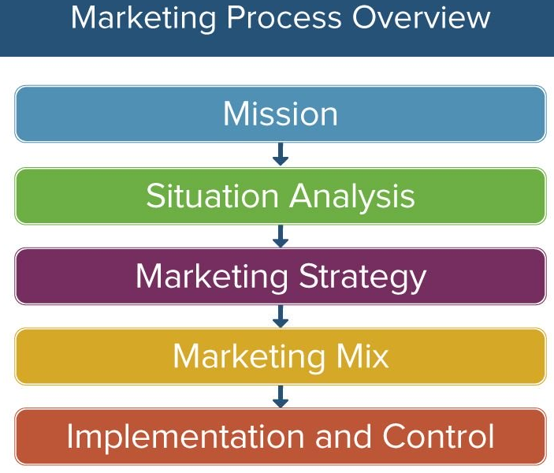
Figure: Marketing Process
Source: Weller, 2017
CONVERSE MISSION
In this stage, leaders decide missions, purposes, and targets of the business industry which is accomplished through strategic marketing activity. Regarding this, the mission of the Converse is the allow the customer to express themselves through business products as well as provide the best quality product and meet with expectations of the customers. Customers costumeries they one shoos. Converse communicate and collect feedback direct to customers, which can help to fulfill the needs and demands, required and this is a big advantage in front of competition.
SITUATIONAL ANALYSIS
The situational analysis includes identification of opportunities, external and internal analysis of the business environment. The Converse’s business is determined through its commitment, through meeting the demand of their customers which also help them to advantage competitive benefits over its key competitors (Weller, 2017). The situational analysis lets the business to understand the strategies of its key rivals, as well as favorable and unfavorable external business environment. Converse effectively use PESTLE analysis to assess the external business environment that influences business activity as well as help the company to identify its strengths and weaknesses.
PESTLE ANALYSIS
PESTEL analysis helps the Converse business industry to identify the effect of the external environment on business practices. PESTEL analysis includes political factors, economic factors, social factors, technological factors, environmental factor and legal factor.
Political Factors: Different countries has different political situations that affect business activity according to it. The converse is an international company that delivers goods in numerous countries which is affected by the diverse political factors, of the country, such as in the U.S., actuality the home company political factors are favorable for the Converse than other countries (Sammut and Galea, 2015). In the UK due to Brexit, the political factors are not for the business and in Asian countries like India, the government doesn't provide large foreign direct investment.
Economic Factors: Similar as the political factors, economic factors are also changing from nation to nation as in the U.S., the economic situation is stable as well as exchange amount also provide benefit to the Converse because of dollar-cost more than most of the currency of the countries oversees.
Social Factors: Social factors meaningfully affect business activities of Converse both positively and negatively. Social factors include a change in consumer trend, the purchasing power of the customers, demographic factors, etc. which ultimately influence the business practice of Converse. Because Converse is a clothing industry which is extremely influenced by the perception of the customers and market trends (Sammut and Galea, 2015). Being a global company, Converse is affected by the social factors of the international market.
Technological Factors: Converse is highly benefited by technology in recent years due to the awareness of the customers towards the internet and social media sites. Over digital marketing and E-commerce business, Converse successfully expand its business market, in various countries and significantly growth sales and revenue. Also, technology is important in promotion activity for the business as well.
Environmental factor: Converse comply consistently with environmental lows and regulation, in order to protect de environment, like waste disposal, energy consumption or carbon footprint. The company becomes green.
Legal factor: Converse company comply to lows and regulation to all the country oversees, to can grow. In UK they meet the threat like Brexit which can affect the import export transportation or in India not a friendly low for investment.

SWOT ANALYSIS
PESTEL analysis is very helpful to identify business strengths and weaknesses as concluded the external analysis business can evaluate its own capabilities against the external factors as well as internal factor.
Strengths: Converse is a very reputed brand in the world as it is a secondary brand of a world-famous Nike company that is very popular in the world and having a solid brand image is a big positive for the Converse.
Weaknesses: Regularly a change in consumer trends and changing in international market is a big weakness for the Converse.
Opportunities: Business has a very good opportunity to explore the various potential and emerging markets in the world.
Threats: Increase in competition in the international market is the main threat to the business manufacturing.
MARKETING STRATEGY
Converse uses its brand's success for marketing, most of the time, because it is a very old company and a secondary company of one of the best sports product companies. The company target customers of the entire world, in its business marketing as it objectives to attract new customers through good-looking product variety.
MARKETING MIX
The marketing mix includes 4ps which are product, price, place, and promotion. Converse successfully uses the marketing mix for business activity to effectively meet customer request.

Figure: 4P’s of Marketing Mix
Source: Bartolacci, 2019
Product: Converse effectively active in sports, apparel product variety and deliver good quality products which meet with the requirement and expectations of the customers. The product diversity of Converse is very effective, but it should have a product for customers of all age groups.
Price: Converse takes competition very seriously for which the price strategy of the Converse is very straightforward. Converse using a competitive pricing strategy for middle-range products and premium valuing strategy for premium products (Bartolacci, 2019).
Place: Converse successfully sells its, products, through physical stores and with the increase in technology, the company effectively increases the range of business through E-commerce business. The company has over 100 stores in the U.S. alone shows the mixed approach of the business such as traditional and digital (Bartolacci, 2019).
Promotion: the business uses digital technology very successfully to promote its products and brand. Converse also uses traditional promotion approaches like collaboration, celebrity endorsement to promote its products in the entire world. Using advertisement and promotion, Converse maintain and worn customer loyalty.
Implementation & Monitoring
Converse successfully implement its decided strategies, for the target customers through various approaches such as for sales business uses traditional as well as E-commerce, business approach as well for marketing business company mostly uses digital marketing approach to charm customers.
On the other hand, Converse mainly uses feedback from customers to monitor its performance because the customer is the end-user of the products and they provide reliable information about business practices and products.
Roll of marketing in developing value for customers
Marketing is significantly to create value for customers because marketing significantly, helps both business companies and customers to cooperate with each other as through research and development, the business understands what customers’ demands for which business satisfies customers by meeting their demands (Fiore et al., 2016). Marketing also helps in branding marketing reflects as a very good tool for branding purpose.
Branding: Branding effectively develop value to customers as effective branding provide trust and guarantee of the product quality and competitive prices for the customers (Edelman, 2010). Following are the methods through which labeling can create value to customers:
Innovation in the product: continuously innovate in the product variety significantly create value to the customers as the Converse business industry is creative in its product variety and meets with the expectations of the customers. For example, cloud foam shoes provide great comfort.
The satisfaction of customers: Satisfaction level of customers towards brand help business to identify its weak areas and work to improve them to provide excessive satisfaction to the customers.
ANSOFF MATRIX
Ansoff is a great utensil for the growth purpose for the business industry as the four strategies presented by Ansoff Matrix help the business to identify a right strategy for the business, for business development as well as boost value to customers.
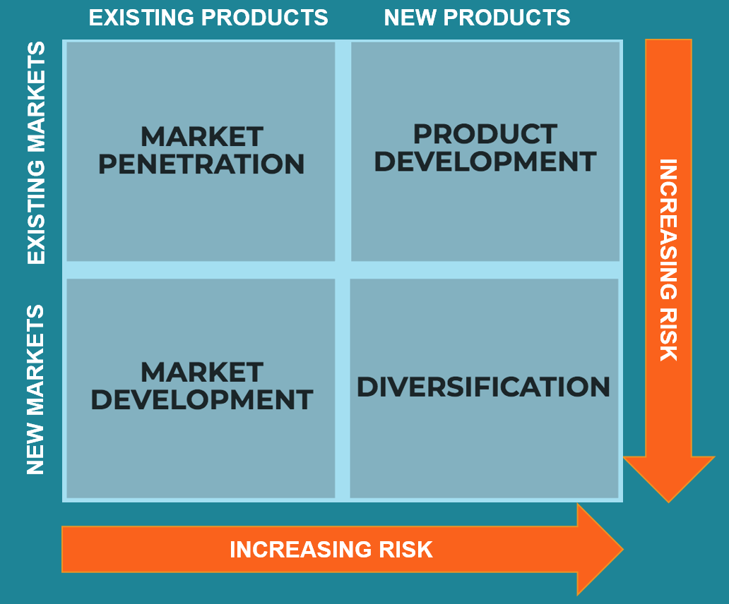
Figure: Ansoff Matrix
Source: Media et al., 2016
Market Penetration: it is the strategy over which businesses penetrate the existing market with existing product variety such as by reducing cost, alter product design, etc.
Market Development: it is the process through which businesses develop into new markets uses existing product variety, which is already increase success and attract customers of a overseas land.
Product Development: Through this strategy, a business can increase market share and customer base by debut new product variety in an existing market (Medarac et al., 2016).
Product Diversification: this is the high-risk high recompense approach in which business arrives a new market with new product variety, to make most of it and attract customers and provide value to them.
Product development and diversification is a very effective approach which should adopt by the Converse business industry to effectively enhance value for customers towards, Converse brand because through both strategies business can meet expectations of the customers (Medarac et al., 2016).
Stakeholders & their influences on the marketing practices of Converse
Engagement of stakeholders is the process through which Converse involves people that may be influenced by the decisions business make or can affect the application, of its decisions. It is essential to involve stakeholders in the business process because it shows the transparency of the business activity and helps the business to reach a decision that benefits the business (Minning, 2019). Stakeholders successfully influence the business activity because stakeholders have some right, to object any business procedure which they find inapt or unsuccessful. There are two types of stakeholders found in every business industry which are internal stakeholders and external stakeholders.
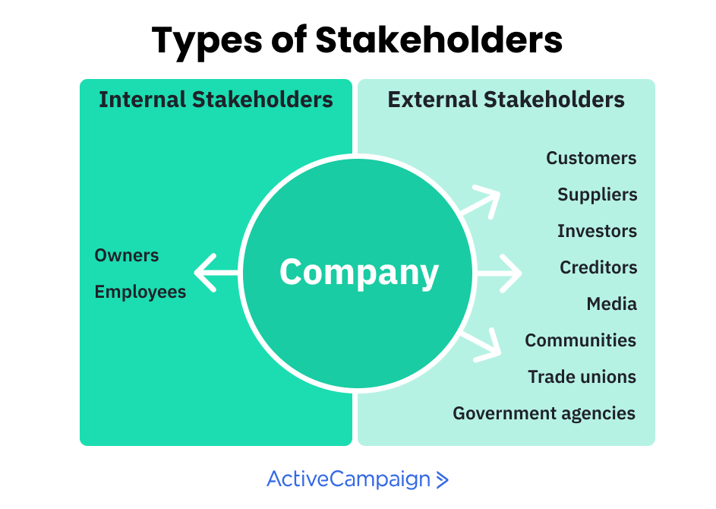
Figure: Types of Stakeholders
Source: Minning, 2019
Internal stakeholders are the owners and workforce of the business industry that finally are responsible for business operations. While external stakeholders are customers, suppliers, investors, creditors, etc. both the types of stakeholders all the business activities including marketing activities of the business (Minning, 2019). Internal stakeholder’s main purpose was to maintain sustainability in business, keep the business environment healthy and positive and maximize business profit, including satisfying their customers. On the other hand, external stakeholders object, to increase good return for their investment in the business process such as customer demands, good quality products, investors goal to increase a good return, etc.
The stakeholders of the Converse business industry successfully influence the marketing activity, of the business, as owners and employees had to come up with a right strategy, that attracts all the external stakeholders because the purpose, vision, and mission of the business industry is effectively influenced by the stakeholders. The ultimate objective of Converse is effectively linked with the target customers for which internal stakeholders create market strategies that are effective enough to attract them (Minning, 2019). Also, effective marketing strategies needed to attract investors because every business needs funds to support its business activity. Apart from this, the internal stakeholders play a significant role in marketing activities because it is essential to adopt effective marketing strategies that are clear to employees to implement and based on SMART objectives. Overall both the internal and external stakeholders effectively influence the marketing activity of Converse and businesses had to consider their views and perceptions before concluding the marketing strategy for the business.

Communication is an essential element in promoting business products and services as target customers must understand and recognize the message which business wants to deliver through the promotion of products and services. The basic communication activity includes sender, message and receiver in this case Converse is a sender, promotion of the business products are the messages for a receiver which are customers (Kitchen and Burgmann, 2010). For tactical communication tools for promoting business products and services, Convers can use the AIDA communication model developed by St. Elmo Lewis. The model focuses on 4 key aspects which are attention or awareness, interest, desire, and action.
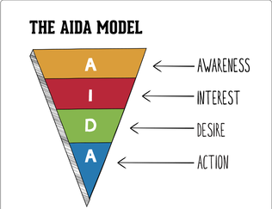
Figure: The AIDA Model
Source: Advertising Strategy, 2015
Awareness: The Converse needs to growth awareness of the brand and products by communicating with target customers. Businesses can use various promoting tools such as digital marketing to interact with customers.
Interest: The next step is creating interest for customers which can be done by providing benefits of the products to customers through using various promotion tools. It is required to focus on product effectiveness rather than focusing on its structures (Advertising Strategy, 2015).
Desire: Communicate enough with customers by reaching them through various sources and create a desire for the product.
Action: The final stage is to influence customer's decision-making and lead them to act for purchasing of the Converse products (Advertising Strategy, 2015).
Different approach of Promotion
Digital Marketing: Digital promotion is currently a very effective and trending approach of promotion which effectively attracts, customers due to the evolution of technology (Fiore et al., 2016). The converse should seriously consider using digital marketing as its importance promotion approach to communicate with target customers to advance great success.
Traditional Marketing: Traditional marketing includes direct marketing, word of mouth, etc. which is also effective in retail stores as in retail store marketers, of Converse can reach to target people, and provide information about business products through communicating with them.

Recommendation
It is essential to adopt a current marketing strategy and promotion instrument to effectively improvement success in business marketing operations. In various strategies, it is identified that the marketing mix method is very effective, and businesses should use P's, of the marketing mix for each product variety. Also, digital marketing is very suitable for the business marketing operations in current time as it effectively helps managers of Converse to interact with target customers from various countries. Ansoff matrix is also an identified suitable approach to penetrate new and existing markets because 4 strategies presented by Ansoff Matrix effectively help the business to choose the correct strategy for business practice.
Conclusion
The essay is presented in multiple tasks where 1st task presents the critical analysis of marketing and the role of marketing including engagement of stakeholders and 2nd task has presented the process and stages of marketing in which mission and situational analysis of Converse are shown. The report shows situational analysis with the help of PESTEL and SWOT analysis which is very effective to identify the influence of external and internal factors on business activities. The essay also shows the marketing mix of Converse company and identified the strategies used by the managers of Converse for their product, price, promotion, and place. In reflection of the essay tactical communication model is presented for the promotion of the business products and based on the report recommendations for the company.

References

ADVERTISING STRATEGY., 2015. MARKETING COMMUNICATION MODELS. [Available online at; http://kgali-adstrat.weebly.com/blog/marketing-communication-models. Last accessed on; 22nd December 2019].
Barnlund, D.C., 2017. A transactional model of communication. Communication theory (pp. 47-57). Routledge.
Bartolacci, G., 2019. ARE THE 4 PS OF THE MARKETING MIX STILL RELEVANT? [Available online at; https://www.newbreedmarketing.com/blog/are-the-4-ps-of-the-marketing-mix-still-relevant. Last accessed on; 21st December 2019].
Castells, M., 2013. Communication power. OUP Oxford.
Edelman, D.C., 2010. Branding in the digital age. Harvard business review, 88(12), pp.62-69.
Fiore, M., Vrontis, D., Silvestri, R. and Contò, F., 2016. Social media and societal marketing: a path for a better wine?. Journal of Promotion Management, 22(2), pp.268-279.
Kitchen, P.J. and Burgmann, I., 2010. Integrated marketing communication. Wiley international encyclopedia of marketing.
Medarac, H., Vignali, G. and Vignali, C., 2016. Improving relations between business strategy and marketing tactics. International Journal of Business and Globalisation, 16(1), pp.50-65.
Minning, L., 2019. The 10 Types of Stakeholders That You Meet In Business. [Available online at; https://www.activecampaign.com/blog/types-of-stakeholders. Last accessed on; 21st December 2019].
Sammut‐Bonnici, T. and Galea, D., 2015. PEST analysis. Wiley Encyclopedia of management, pp.1-1.
Weller, J., 2017. The Definitive Guide to Strategic Marketing Planning. [Available online at; https://www.smartsheet.com/strategic-marketing-processes-and-planning. Last accessed on 20th December 2019].

