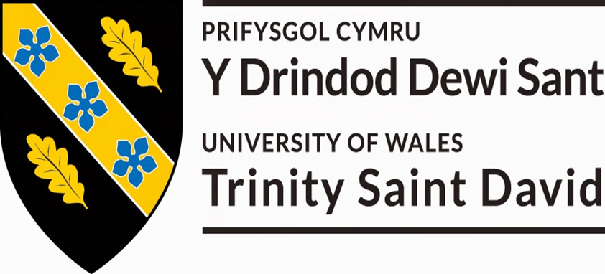

Research Proposal – A Model of Self-Funding Continuous Improvement for Improved Energy Efficiency
  - postgraduate research methods
Liam Gill – 1550481 | MSc Lean and Agile Operations | 31/03/2021

Table of Contents
Introduction 2
Project Relevance and Justification 3
Literature Review 5
50001 5
Six Sigma 7
Climate Change Agreement (CCA) 9
Current Industry Standards 10
Developing a New Model 11
Timescales and Provisional Work Plan 13
Conclusion and Recommendation 16
References 17

Introduction
In recent years it has been highlighted the global economy has grown rapidly and as a result of this energy consumption has also grown considerably (Xu, et al., 2021). The increased energy consumption has caused global warming and climate change to occur as a consequence of fossil fuel usage such as coal, natural gas and petroleum (Endo, et al., 2021). These changes in the climate and global warming has emphasized the need for industries to improve their energy efficiency to be socially responsible and slow down the detrimental impacts to the environment.
To help achieve the improvements that are required in energy efficiency many organizations are implementing the use of the ISO 50001 energy management system and lean six sigma methodologies (Mkhaimer, et al., 2017). Although these methods have been shown the be very effective in their application it is still noted by Deeb, et al., (2018) and Goncalves & Santos, (2019) that these methodologies still have their limitations, especially in SME’s.
It will be the purpose of this proposal to perform further investigations into the effectivness of both Six Sigma and ISO 50001 in their application of improving energy efficiency. It will be the aim of this project to create a solution or solutions to reduce the limitations of both Six Sigma and ISO 50001. To create these new solutions this project will carry out various forms of research to collect as much imformation as possible in various relevant areas to make informed decisions in the solution design process.
Once a new solution has been created within this project it will then be implemented within an SME to test its effectivness. During these implementations the findings will be scrutinazed to determine how effective the suggestions have been, improvemnts will then be made to improve any limitations to make any final solution suggestions as effictive as possible.

Project Relevance and Justification
Recently there has been more and more attention paid within society to the environmental impacts of a company, this can lead to a company either having a positive or negative brand image (Introna, et al., 2014). The brand image of a company does have the ability to influence sales, this was shown by Arslan & Zaman, (2015) when they found there was a strong positive relationship between a good brand image and consumer purchases. Building on from this point Laitner (2013) found that in the U.S. alone there was the potential for an improved energy efficiency of 86% across in supplies to both industries and homes. This would come at a reduction to residents and business consumers of $400 billion annually.
Due to the reasons outlined such as consistently rising energy costs, increased societal awareness of environmental impact and global warming the need for manufacturers to improve their energy efficiency and reduce costs has become a top priority for many organisations (Bunse, et al., 2011).
Nasa (2021) found there has been multiple cycles of glacial advance and retreat caused by small variations in the orbit of the Earth that impacts the amount of solar energy Earth receives. They also found the current warming trend has over a 95% probability of being as a result of human activity since the mid-20th century. This warming trend that we are currently experiencing is occurring at a rate over 10 times faster than previous cycles and is caused by human activity increasing the carbon dioxide in the atmosphere over 250 times faster than it was after the ice age from natural sources. The findings from this report are illustrated in Fig 1.
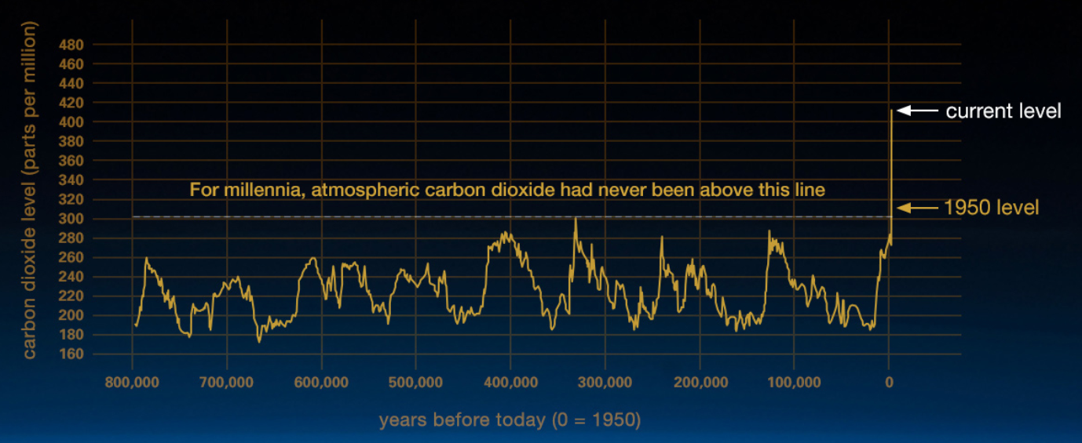
Fig 1. Carbon Dioxide Levels Seen Since the Ice Age (NASA, 2021)
From Fig 1 it can be seen although there have been multiple cycles of increased and decreased level of carbon dioxide in the atmosphere since the ice age, the current level is by far the worst the earth has seen. As a result of these extremely high levels we are now experiencing increased global temperatures, warming oceans, shrinking ice sheets, glacial retreats, decreased snow coverage, increase sea levels, increased extreme weather events and increased ocean acidification (NASA, 2021).
The manufacturing industry has a very large impact of the climate change that is being observed, this is supported by IEA, (2007) when they found the manufacturing industry consumes 31% of energy produced and is also responsible for 36% of the carbon dioxide emissions emitted. Even though there has been a lot of attention paid to environmental and climate change impacts caused by industry in recent years, there are some nations in which have only recently been making effort to reduce these impacts. This finding is supported by (Ding, et al., 2021) when they highlighted although global attention has been paid to climate change impacts and many studies have been carried out, China is at the very beginning of its climate change improvement efforts.
Fundamentally the main points around climate change and social responsibility are the main driving forces for businesses to make efforts to improve their energy efficiency and reduce their environmental impact. However, the recent Covid-19 pandemic has further created the need for companies to manage their spending and reduce costs where possible. This finding is supported by Bloom, et al., (2020) when they highlighted businesses seen a reduction in sales by 30% in Quarter 2 of 2020 as a result of Covid-19. Further to this there has been a large increase in uncertainty for the upcoming years from businesses. As a result of the uncertainty, businesses are expecting there to be a reduction in employees. This could have a negative impact when businesses considering investing in energy reduction projects as the costs are indirect and it may require further resources or training, both of which will potentially come at large costs to an organisation.
From the findings outlined above it can be seen that there is a clear and immediate need for the whole manufacturing industry to improve its energy efficiency. The reasons for this need are;
- Economical Aspects - Rising Energy Costs
- Increasingly Stringent Environmental Regulations
- Social Awareness / Consumer Sales. (Bunse, et al., 2011)
- Increased need to reduce costs due to Covid-19

Literature Review
Currently there are few energy efficiency programs established within industry, the largest of these is considered the ISO 50001. However, it has also been suggested that six sigma could be applied to help improve energy efficiency.

50001
The ISO 50001 standards are widely used throughout the world in some large organizations such as Hilton Worldwide, Siemens, General Electric, Philips and Schneider Electric (Scheihing, 2021). The ISO 50001 is a management system model of continual improvement, this model is used in other ISO standards such as 9001 or 14001. Organisations can achieve certification of the ISO standards is they meet the requirements, or they can simply use the model to help improve their performance.
International Organization for Standardization, (2021) state the management system provides a framework to;
- ‘Develop a policy for more efficient use of energy.
- Fix targets and objectives to meet the policy.
- Use data to better understand and make decisions about energy use.
- Measure the results.
- Review how well the policy works.
- Continually improve energy management.’
As part of the ISO 50001 there is a recommended model that should be followed, this model is the Plan, Do, Check, Act Cycle (Kanneganti, et al., 2017) (British Standards Institute, 2021). An example of how this model is illustrated can be seen in Fig 2.

Fig 2. Illustration of Plan, Do, Check, Act model.
In the model in Fig 2 the sections
Plan – Create your energy policy. Highlight energy performance indicators and how they will be reviewed. Assign responsibility for different areas of the energy policy. Establish energy baseline.
Do – Create procedures for purchasing new equipment and how energy will be procured. Create awareness of the energy policy and importance of energy management. Carry out training on energy impacts, awareness and auditing.
Check and Act – Monitor and measure the energy consumption and improvements made. Carry out regular internal audits of the management system and energy consumption. Complete any actions highlighted in internal and external audits including any non-conformities, corrective actions and opportunities for improvements.
It has been shown by Kahlenborn, et al., (2012) the ISO 50001 Energy Management model does have a positive impact of the reduction of energy in the short term of 5-15% and a common reduction of 30% achieved. This is illustrated in Fig 3.
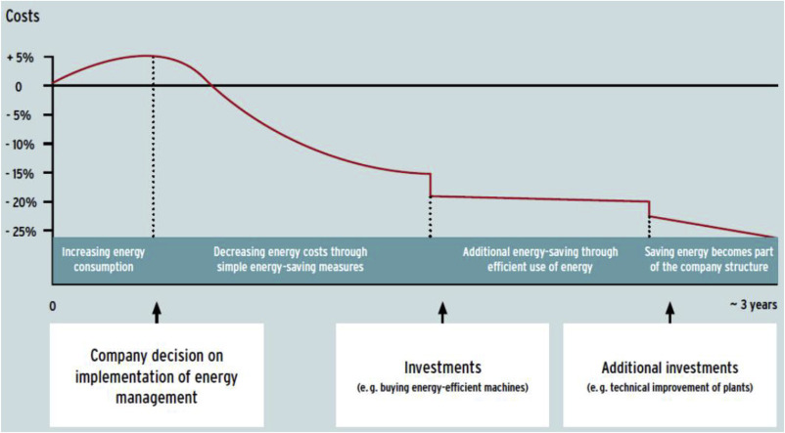
Fig 3. Costs and Savings of implementing ISO 50001. Kahlenborn, et al., (2012)
In Contrast to this Goncalves & Santos, (2019) state the system is ‘not effective in its stated objective of reducing greenhouse gas emissions and other related environmental impacts’.

Six Sigma
The Six Sigma methodology uses data and facts to carry out process improvements with the aim of improving various targets such as reduced cycle times and waste reduction. By achieving the desired results, the companies using Six Sigma will nearly always achieve a cost saving. The Six Sigma methodology uses a tool known as DMAIC to achieve these results (Pande & Holpp, 2001).
Six Sigma can provide a company with rapid and sustainable improvements when the methodology is implemented by well-trained people working on high priority projects (George, et al., 2005).
These findings are further supported by one of the founding fathers of Lean Six Sigma when they described Lean Six Sigma as:
‘A synergistic process that creates a value stream map of the process identifying value and non-value add costs, and captures the Voice of the Customer to define the customer Critical to Quality issues. Projects within the process are then prioritized based of the delay time they inject. This prioritization process inevitably pinpoints activities with high defect rates or long setups, downtime.’ (Voehl, et al., 2014).
The tool DMAIC highlighted to be used within Six Sigma is an acronym for the steps within its process, these steps are Define, Measure, Analyse, Improve Control. An illustration of this process can be seen in Fig 4.

Fig 4. DMAIC Process Improvement Cycle. (Scmula, 2015)
The meaning of each of the steps within the DMAIC process can be considered;
- DEFINE – Define the project being undertaken. Select the team involved in project. Identify Voice of Customer and Critical to Quality and link them to the needs of the business.
- MEASURE – Ensure the measuremnt system is accurate and map the process being monitored. Collect appropriate data. Select which CTQ’s should be persued.
- ANALYZE - Establish process capability and defines the process objectives. Estimating the short and long term process capabilities.
- IMPROVE – Select product performance charicteristics that need to be improved to achieve the desired goal. Analyze the causes of special cause variation. Select and confirm reccomended solutions and establish operating tollerances.
- CONTROL – Validate measurement system and confirm implemented solution. Build process control plan. Transition solution to process owner and close project.
(Carroll, 2013)
Although the use of Six Sigma within organisations has proven to be extremely successful on many levels it has been noted by (Deeb, et al., 2018) that there are limitations to the implementation of Six Sigma within an organisation. One limitation highlighted was SME’s will find it difficult to implement the DMAIC methodology because they may not have the resources to employ or train the workforce in its application. This finding may be due to the the reccomendation that to apply effective Six Sigma projects, an organisation should employ at least one full time Black Belt and multiple Green Belts who can carry out the work part time. To employ a Six Sigma Black Belt the average salary in the UK is £45,074 (Glassdoor, 2021). With the current financial climate many organisations would not be able to invest this money into projects.

Climate Change Agreement (CCA)
To further support the requirement for energy efficiency improvement there is a scheme in place called the Climate Change Agreement CCA which provides a discount on the tax paid on electricity on Gas and Electricity within the UK.
The Environment Agency, (2020) describes the Climate Change Agreement as;
‘Climate change agreements are voluntary agreements made between UK industry and the Environment Agency to reduce energy use and carbon dioxide (CO2) emissions. In return, operators receive a discount on the Climate Change Levy (CCL), a tax added to electricity and fuel bills.’
The Climate Change Agreement was due to end in 2020 however in light of the recent pandemic caused by Covid-19 the Department for Business, Energy and Industrial Strategy (BEIS) has announced the scheme will now be extended until March 2025 (Environment Agency, 2020). This extension allows for oganisations to receive a tax reduction on energy procurement of 91% on electricity and 82% on gas. These reduction have a potential value of hundereds of thousands of pounds per year.

Current Industry Standards
During its literature review this report has found there are currently methodologies in place to carry out improvement projects with regards to energy efficiency. The largest and most well used of these methodologies is the ISO 50001 standards which are used to create an energy management system with the aims of continually improving the energy efficiency of an organisation (Heidi, et al., 2020). Whist this method of energy management is proven to be extremely effective its limitation is where is does not detail how energy reduction projects will be achieved or funded, but instead focuses on the management of energy.
Further to this the Six Sigma methodology has also been successfully implemented in many of the largest organisations in the world to improve their operational performance (Parmar & Desai, 2020). It is predicted that individual organisations have achieved cost savings in the amount of billions of US dollars. In its evolution the Six Sigma methodology has successfully been applied to the application of the continuous improvement of energy efficiencies. There have been issues highlighted with the application of Six Sigma in that many SME’s may not be able to implement its usage due to the costs involved with its application (Deeb, et al., 2018). This is because the methodology is so complex it requires multiple staff both part time and full time to carry out projects (Jones, 2014). Further to this a major contributor withing the DMAIC process is the Pareto Analysis, by using this tool it is established that a vast majority of outputs are caused by a small number of inputs (Goldsby & Martichenko, 2005), an example of this is where a manufacturing line could see 80% of defects being caused by 20% of faults. This method again may not be possible for SME as this tool does not take into account the cost of rectifying the 20% of faults, and these may be too high for SME’s to fund.
By investigating these two main methods of energy reduction it has been established that they can be used in conjunction with each other, where the ISO 50001 will provide the management framework and the Six Sigma will provide the continuous improvement framework within ISO 50001. It is the belief of this report that by doing this an organisation is likely to be able to carry out effective energy efficiency improvements. However, this report also finds that due to the cost to implement Six Sigma within an organisation it may not be a viable option for Small and Medium Enterprises (SME). This is because it has been recommended to have dedicated full time and part time personnel carrying out Six Sigma projects. Building on from these points this report finds that there is a lack of low-cost model for SME’s that could be used in industry, this project will look to create and implement a new model that will be self-funding, flexible enough to be used in SME’s and Large organisations and be simple enough to follow that no formal training would be required.

Developing a New Model
From the current findings of this report, it has been established there are well used methods of reducing or improving energy efficiency, however these methodologies are not without their limitations. The limitation outlined with ISO 50001 is that although it is a energy management model is does not outline how to achieve the energy improvements. Further to this the Six Sigma methodology is a continuous improvement model that would highlight where and how to achieve energy efficiency improvements; however it can be very expensive to implement and so this could prevent SME’s from implementing this due to budget constraints.
The project that this report is proposing will look to establish a continuous improvement model that will have the ability to be used in the situations where the current methodologies fall down. To be able to be applicable in both situations, fundamentally the new continuous improvement will firstly need to be either extremely low cost or self-funding. Secondly the model will need to be extremely easy to follow and not require any specialist training. It will be the aim of this project to create a model that could be used in any situation from large industries to homes where the results from any energy improvement projects can be monitored and verified, even if only on a high-level.
To be able to achieve the set-out goals of this continuous improvement model this report will need to carry out various forms of research. With regards to quantitative and qualitive research this project will need to carry out both. The reason for this is quantitative research will be used to identify where potential projects could positively impact the performance, and the data involved with this, and qualitative Research will be used to obtain an in depth understanding of the various tools such as six sigma that will be used to carry out this project.
Another research method that is going to be required by this project is the use of multiple questionnaires. The project will use questionnaires to gather information on various topics such as senior managements willingness to invest in various situations and whether respondents feel that the model developed is simple and easy to follow in different situations. To carry out these questionnaires the willingness to invest would need to be targeted towards professionals in senior positions of both large enterprises and SME’s that would have to make these decisions. The questionnaire regarding the use of the final proposed model would need to be distributed to a more random sample of the population.
To examine whether any efficiency improvements have been effective as part of the newly designed model both participant and non-participant research will need to be carried out. Participant research will be carried out in the early stages of any improvement projects such as raising awareness and non-participant research will be needed to verify if there have been any culture changes as a result.
These research methods will not be exhaustive of what would need to be carried out and as the model and project develops it will become clear that other methods will also need to be used.

Timescales and Provisional Work Plan
The below Gannt chart (Fig 5 & 6) has been designed to plan the work required for the final project proposal presentation, final project proposal report and the application of the report findings.
As part of the final project the methodologies being suggested will be implemented within a large food packaging manufacturer. It is the belief of this report that by applying the works its effectiveness can be established. The results of the applications will then be scrutinized and potentially adjusted or changed to yield more effective results.
The Gannt chart created is subject to change depending on the deadlines applied and findings from the applied works / models.
Fig 5. Project Proposal Gannt Chart
Fig 6. Project Proposal Gannt Chart Cont.

Conclusion and Recommendation
In recent years, the changes within our environment such as global warming and climate change can be largely contributed to the industrialization of humanity. The amount carbon dioxide in the atmosphere have been cycling between higher and lower levels since the ice age, however the current levels are at the highest they have ever been by a large margin and have continued to grow rapidly since around the 1950’s. It is due to the changes being created in our environment by these alarmingly high levels of carbon dioxide that is driving the need to change and become more energy efficient. The drivers for these changes are both customers being more aware of their impact to the environment and organisations desiring to become more socially responsible.
It is the finding of this report that the two main methods used to reduce energy consumption and improve efficiency is ISO 50001 and Six Sigma. From its research it was established by this proposal that whilst the implementation is ISO 50001 may be effective in the reduction of energy consumption, the system focuses on the management of energy consumption and could be further improved by including methods which model how the energy efficiency improvements will be achieved and funded. Building on from this the research performed by this report also found the Six Sigma methodology to be very effective however its limitation was the cost required for its implementation.
It is the recommendation of this proposal that the project being discussed should be focused on creating a new methodology or improvement model that can be used within both ISO 50001 and Six Sigma. To be able to be used both current methodologies the new model should be simple and easy to implement, this will alleviate the need for any specialist training or recruitment, thus reducing its implementation costs. Further to this the new model should be effective in its purpose of guidance in improving energy efficiency. It is the belief of this proposal the suggested methodology could be self-funding by carrying out free improvement projects first and investing a portion of the cost savings to fund larger improvement projects.

References
Arslan, M. & Zaman, R., 2015. Impact ot Brand Image and Service Quality on Consumer Purchase Intentions. A Study of Retail Stores in Pakistan, Islamabad: Grin Publishing.
Bloom, N. et al., 2020. The impact of Covid-19 on businesses’ expectations: evidence from the Decision Maker Panel, London: Bank of England.
British Standards Institute, 2021. ISO 50001 - Energy Management, Its Your Cost, Milton Keynes: British Standards Institute.
Bunse, K. et al., 2011. Integrating energy efficiency performance in production management – gap analysis between industrial needs and scientific literature. Journal of Cleaner Production, 19(6-7), pp. 667-679.
Carroll, C. T., 2013. Six Sigma for Powerfull Improvement. 1st ed. Boca Raton: CRC Press.
Deeb, S., Haouzi, H. B.-E., Aubry, A. & Dassisti, M., 2018. A generic framework to support the implementation of six sigma approach in SMEs. IFAC-Papers Online, 51(11), pp. 921-926.
Ding, Y.-J.et al., 2021. An overview of climate change impacts on the society in China. Advances In Climate Change Research.
Endo, N. et al., 2021. Thermal management and power saving operations for improved energy efficiency within a renewable hydrogen energy system utilizing metal hydride hydrogen storage. International Journal of Hydrogen Energy, 46(1), pp. 262-271.
Environment Agency, 2020. Climate change agreements. [Online]
Available at: https://www.gov.uk/guidance/climate-change-agreements--2
George, M., Rowlands, D. & Kastle, B., 2005. What is Lean Six Sigma?. 1st ed. London: McGraw-Hill.
Glassdoor, 2021. Six Sigma Black Belt Salaries. [Online]
Available at: https://www.glassdoor.co.uk/Salaries/six-sigma-black-belt-salary-SRCH_KO0,20.htm
[Accessed 6 April 2021].
Goldsby, T. & Martichenko, R., 2005. Lean Six Sigma Logistics. 1st ed. Boca Raton: J.Ross.
Goncalves, V. & Santos, F., 2019. Energy management system ISO 50001:2011 and energy management for sustainable development. Energy Policy, 133(1).
Heidi, F., Aghajanzadeh, A. & Therkelson, P., 2020. Identification of drivers, benefits, and challenges of ISO 50001 through case study content analysis. Energy Policy, 142(1).
IEA, 2007. Tracking Industrial Energy Efficiency and CO2 Emissions, Paris: OECD Publishing.
International Organization for Standardization, 2021. ISO 50001 Energy Management. [Online]
Available at: https://www.iso.org/iso-50001-energy-management.html
Introna, V. et al., 2014. Energy Management Maturity Model: an organizational tool to foster the continuous reduction of energy consumption in companies. Journal of Cleaner Production, 83(1), pp. 108-117.
Jones, E. C., 2014. Quality Management for Organizations Using Lean Six Sigma Techniques. 1st ed. Boca Raton: CRC Press.
Kahlenborn, W. et al., 2012. Energy Management Systems in Practice: ISO 50001: A Guide for Companies and Organisations, Berlin: BMU.
Kanneganti, H. et al., 2017. Specification of energy assessment methodologies to satisfy ISO 50001 energy management standard. Sustainable Energy Technologies and Assessments, 23(1), pp. 121-135.
Laitner, J. A., 2013. An overview of the energy efficiency potential. Enviromental Innovation and Societal Transitions, 9(1), pp. 38-42.
Mkhaimer, L. G., Arafeh, M. & Sakhrieh, A. H., 2017. Effective implementation of ISO 50001 energy management system: Applying a Lean Six Sigma approach. International Journal of Engineering Business Management, Volume 9, pp. 1-12.
NASA, 2021. Climate Change: How Do We Know?. [Online]
Available at: https://climate.nasa.gov/evidence/
[Accessed 5 April 2021].
Pande, P. & Holpp, L., 2001. What is Six Sigma?. 1st ed. New York: McGraw-Hill.
Parmar, P. & Desai, T., 2020. Evaluating Sustainable Lean Six Sigma enablers using fuzzy DEMATEL: A case of an Indian manufacturing organization. Journal of Cleaner Production, 265(1).
Scheihing, P., 2021. Achieving Continuous Improvement in Energy Effiency through Stratigic Energy Management, USA: U.S. Department of Energy.
Scmula, 2015. DMAIC: Breaking Down the Five Steps Toward Success. [Online]
Available at: https://www.shmula.com/dmaic-breaking-down-the-five-steps-toward-success/18688/
[Accessed 6th April 2021].
Voehl, F., Harrington, J. H., Mignosa, C. & Charron, R., 2014. The Lean Six Sigma Black Belt Handbook. Boca Raton: CRC Press.
Xu, M., Lin, B. & Wang, S., 2021. Towards energy conservation by improving energy efficiency? Evidence from China’s metallurgical industry. Energy, 216(1).

