Ella Williams
1707424
Contemporary Human Resources in Practice
A New Approach to Performance Management
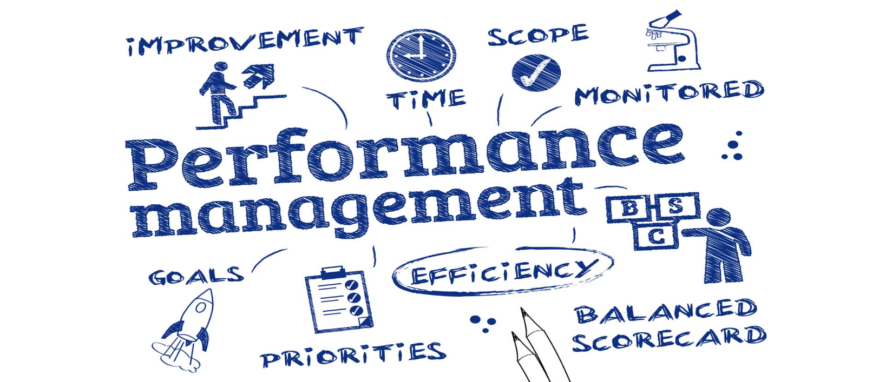
Contents Page
- Executive Summary………………………………………………………………..2
- Introduction…………………………………………………………………………3-7
  - Report Remit
  - What is Performance management?
  - Background and context
  - Rationale
  - Aim and objectives
- Literature Review ………………..……………………………………………….…7-9
- Conclusion……………………………………………………………………….……9-10
- Recommendations…………………………………………………………………….10

Table of Figures
Figure 2.3.1: Human Capital Trends in 2017………………………………………………5

- Executive Summary
This business case evaluates the contemporary issues in human resource management in organisations, making the reader aware that the traditional performance management process is not working anymore. This means organisations are now going to have to adapt and change their performance management process. Evidence will be shown throughout the report as to why the process is not working anymore and why a new one is more beneficial.
The purpose of this report is to explain to the reader and make them aware of how making a new change is good and why they should not be scared to do it. Within the report the reader will be able to see that a lot of organisations, some well known ones, have changed to a new performance management and have benefitted so much from it.
The reader will find how simple it is to improve their performance management. Throughout the report the reader will be able to see a lot of evidence showing how managers were getting increasingly irritated with traditional performance management systems as the terminology and purpose had changed a lot. Also, workforces are now made up of multiple generations with diverse cultural backgrounds, which means that there are a lot of millennials who want to work in an up to date environment. The report will also show the negative impact an organisation will have if they do not change from their traditional management process to a new one. There is a lot of evidence to back up why it is so beneficial and why organisations need to do it now before it is too late.
This report concludes by stating how change is occurring all the time and organisations need to adapt to the changes in order to stay up to date. This meant that the traditional performance management process was not working well enough anymore, meaning organisations needing to change to a new performance management process. Although, this can be hard as not everyone likes to change; however, change creates success. It was shown that a new process is very beneficial to an organisation, which meant it might cost the organisation their success and money if they were not going to change.

- Introduction
  - Report Remit
This business report thoroughly evaluates contemporary issues in human resource management in organisations. It will also explain how there is need to make a change from the current established process to a more contemporary approach to performance appraisal. This report will also offer recommendations to the organisation on how the head of CoE should approach the implementation of the new process with reference to change management techniques.

  - What is Performance management?
Performance management is a systematic process that is used to improve organisational, individual and team performance. However, strategic performance management focuses on what things need to be done to help the organisation achieve its business goals. For individuals, performance management helps to give better results by understanding and managing performance efficiently within an agreed framework of standards, planned goals, and competency requirements. This means developments must have a shared understanding about what needs to be achieved and how it should be achieved (Armstrong, 2012).
Brumbach (1988), states how “human performance is managed in order to achieve positive successes, avoid negative successes and failures and be open to positive failures”. This shows how managing performance is important as it helps people achieve successes, as well as being open to any failures as it can be used to help you adapt to continue to become successful.
If people are the greatest creators of the value in an organisation, then good performance management is vital for an organisation to become or to continue to become successful. It is important for employees to understand what is expected of them, and to achieve those goals they need to be managed efficiently. This means they must be motivated, have the essential skills, support, and resources. Performance management is the activities and processes that focus on these areas to continue to improve employee performance, in line with an organisation’s objectives (CIPD, 2019).
For an organisation to have a successful performance management process the Human Resources (HR) department must be motivated and dedicated to achieving it. Other stakeholders such as top managers, line managers and employees must be willing to work to the highest standards possible to create a successful performance management process.

  - Background and context
If organisations performance management change from the traditional management to a modern management, it means they are staying up to date with the external environmental factors.
The concept VUCA has become extremely popular as term to cover the numerous dimensions of the uncontrollable external environment. VUCA stands for Volatility, Uncertainty, Complexity and Ambiguity. The VUCA environment makes you look at things differently, forcing you to react to the changes that you face in your everyday lifestyle. VUCA is used to approach challenging conditions, in an uncontrollable environment. To succeed in challenging conditions, you must adapt to any changes that arise by learning new skills and strategic plans. This is very important for organisations, especially in competitive industries (Bennett & Lemoine, 2014).
Adaptive performance in the working environment refers to understanding and altering to new change in the work environment. This type of performance can alter behaviour to meet the new demands that are changing rapidly (Potsangbam, 2017).
The future of work is being shaped by unexpected changes in globalisation and technology. Employees who are mainly millennials, are now asking for a new management process and would rather have a coach instead of a boss as they would see them as a friend and probably get on with them better. Also, employees want accountability, clear expectations, a purpose, and ongoing coaching and feedback. This would benefit the organisation doing this, employees would be able to work better, making the organisation more successful (Harter, 2017).
Deloitte’s 2017 ‘Global Human Capital Trends’ report shows how organisations now need to adapt to change and stay up to date with modern times as a lot of things have changed.
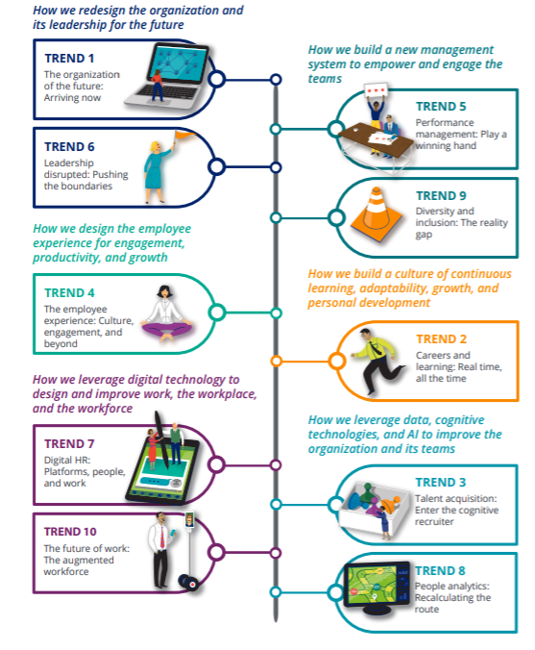
Figure 2.3.1: Human Capital Trends in 2017

In Figure 2.3.1. it shows all of the human capital trends since 2017. These trends have an impact on the way an organisation operates as they will need to change in order to meet the new trends (Deloitte, 2017). Due to trends changing, workforces are now made up of multiple generations with diverse cultural backgrounds, as well as being global. Organisations need to change as mostly all of the traditional management processes were developed over 20 years ago (Nina, 2016).

  - Rationale
Regulating performance management is a huge part of working in HR. With a good performance management strategy managers are able to create a space where themselves and their employees can produce a great work ethic and perform to the best of their abilities (Pollock, 2018). However, over time the traditional performance management has become a burden to organisations as it does not offer up to date strategies for opportunities or values for improving and developing their employees (CIPD, 2016).
Buckingham and Goodall who work for Deloitte undertook a survey and found out that more than half of the executives they had surveyed had stated how their current performance management approach did not increase employee engagement or result in a high performance (Buckingham & Goodall, 2015).
The traditional performance management process is not benefitting other organisations who were not included within that survey as well. For example, the leading global professional services company called Accenture got rid of their annual performance reviews and rankings. The CEO Pierre Naternme said how the organisation “are going to get rid of probably 90% of the performance management they had”. For a large organisation who has 330,000 employees it is a huge change for everyone. However, this shows how traditional strategies are not working as well as they used to if an organisation with that amount of employees are willing to change their performance management (Cunningham, 2015).
Managers are increasingly becoming irritated with traditional performance management systems as the terminology and purpose has changed a lot. In the past, managers used the traditional performance management process to develop employees as they used an annual performance review process to evaluate an employee’s past performance. However, employers want to develop their employees more and manage them efficiently, as well as shifting terminology from review to management advancements (Schaufenbuel, 2016). This shows if managers are getting irritated with the traditional performance management then it must mean it is not working well with the modern environment anymore. This could become very dangerous and managers will struggle to maintain an efficient performance management strategy for their employees, effecting the work ethic.
By changing to a new performance management process the organisation will notice that the approach will allow employers to set goals to be set and assessed more regularly than it was before. This is because a year is a very long time to set goals and objectives, modern day working people want to be up to date and know if they are doing well, or if they could improve on anything. This means that individual goals can be changed easily, benefiting the employee and organisation. Regular feedback also enables employees to know how they can improve their performance, which is more effective than giving feedback throughout an end of year appraisal, in which does not help to correct any performance defects or motivate the employee.
  - Aim and objectives

    - Aim
The aim of this business report is to explain how important it is to change from the traditional performance management team to a more contemporary approach.

    - Objectives
- To conduct secondary research to show the organisation how other organisations are now changing their traditional performance management processes to a new more modern process.
- Determine appropriate approaches to use for the new performance management process.
- To draw conclusions and make recommendations on how the CoE will approach the implementation of the new process with references to change management techniques.

- Literature Review
Performance management started in the 1950’s when formal systems were developed. This included formal performance appraisals which were more well-known for organisations when they were using personality-based systems for measuring their employee’s performance (Brooks, 2016).
The traditional performance management process includes establishing objectives at the start of the year and giving them to the employees who are responsible for achieving the goals set. The management has the role to monitor the performance of the employees, seeing if they have taken on board the objectives they had to undertake at the start of the year. They must also share their evaluations during the end of the year when it is time for the annual performance appraisals (CIPD, 2019).
However, in 2017 an HR consultancy called Mercer discovered that 89% of employers have employee performance ratings which were linked to the employee pay. The study also found 95% of the managers they did a study with were dissatisfied with their organisation’s performance management system. 48% of employers believed that their performance management process needed to be worked on to become more effective. Also, the study found that 10 to 15% of organisations said they were going to eliminate performance ratings as they can be replaced with checklists or written descriptions, which is what the organisations that have got rid of ratings have done (Sammer, 2017). Performance ratings effect organisations as they do not help employees to improve. This is because, although you give an employee a top rating and they may work harder, for every other employee who does not achieve the top rating they will feel angry, jealous and disappointed which demotivates them to work hard anymore creating a negative working environment (Latham, 2016).
Another issue the traditional performance management has is how the review process is every 12 months which is a very long time. However, today’s working environment requires the annual reviews to be as short as a week or a month, so employees are able to adapt and change if they need to straight away, so the organisation continues to stay successful. This means there is a need for organisations to start to adapt and change their performance management processes (Schaufenbuel, 2016).
According to Deloitte (2014), “8% of organisations report that their performance management process drives high levels of value, while 58% stated the process is not an effective use of time”. This shows how more than 50% of management say the traditional process is not working well, with only 8% stating how it does work well for them. However, that 8% might be older and used to the traditional management and do not want to change as they are comfortable. Although, a successful organisation must not be afraid to adapt to change or they will not be able to stay successful (Deloitte, 2014).
However, an organisation called Goldman Sachs which was founded in 1869 and has changed from their traditional performance management to a new more efficient one. This shows if this organisation can do it then anyone can. Goldman Sachs old performance management process focused heavily on annual reviews, ratings and stack rankings. All those processes stated have been proven that they are not working in the modern-day environment. However, the organisation undertook numerous surveys which showed how their employees wanted to have more continuous feedback. This led to the organisation creating their own web-based tool, so they are able to give and receive feedback. This will increase informal performance conversations, benefitting the organisation (Ashbaugh, 2019).
Also, in 2002 Brian Jensen enlightened his HR executives by explaining to them that Colorcon was not going to do annual reviews anymore and they were all horrified. This was back in 2002, 18 years ago which means it is definitely vital that every organisation who hasn’t changed to instant feedback and small weekly bonuses to employees, must do it immediately. In the U.S one third of organisations have changed to a new performance management process, replacing annual reviews with regular informal check-ups between the managers and employees (Cappelli & Tavis, 2016).
A tech consultancy called Cloudreach undertook research by trying and testing the weekly performance reviews for themselves and other organisations, to see if it does work well and is worth the change. Within the weekly catch ups the supervisor and employee were able to discuss any ongoing risks, opportunities or concerns and receive beneficial advice. The employee was also able to keep their manager up to date with any processes on their active workload. This change worked well, and the consultancy stated how they would “recommend weekly performance reviews as a great way to stay in the loop with what is going on, not only in my own role but in the rest of the organisation”. This shows how this method is working better than annual reviews (Hackland & Brunton, 2018).
Weekly or monthly reviews are not the only form of performance management within the process that works. An organisation will have to make a change in simple tools, compensation and reward and have continuous development in order to be successful. Organisations can save a lot of money from changing all of the old processes with new ones. In fact, organisations who undertake one-to-ones with their employees they usually see a 14.9% lower turnover rate. Adobe witnessed a 30% reduction in a voluntary turnover when the organisation changed their performance management process (Stuart, 2017). With the money the organisation saves they will be able to invest in rewarding their employees which would motivate them and make them feel valued, which would make them stay.
However, although the new performance management is good and works effectively, if there is no communication then the process will fail. For example, it is impossible for employees to achieve their job responsibilities to the highest standard possible, or even at all if they do not understand what they are. So, managers must make employees aware of what the new performance management they are going to use includes and what is expected of them (Tankersley, 2015).

- Conclusion
To conclude, you can see within this business case report that change is occurring all the time and organisations need to adapt to the changes in order to stay up to date. This meant that the traditional performance management process was not working well enough anymore, meaning organisations need to change to a new performance management process. This can be hard as not everyone likes to change; however, change creates success. It was shown that a new process is very beneficial to an organisation, which meant it might cost the organisation their success and money if they were not going to change.

- Recommendations
I would like to recommend the organisation some improvements to help them realise why they need the new performance management process.
Firstly, I would recommend the management team to be open to the idea of a new performance management and understand the differences between the new and old process.
I would also like to recommend the employees of the organisation to give their opinions and feedback about the new performance process, to see if they like it and if there is anything they would like to change. This would be very useful and could be used to improve the process even more. Also, this would make the employees feel included and valued in terms of changing the performance management process. If employees feel included, they might work harder, benefitting the organisation.
Another recommendation I would like to make is to evolve even though not everyone adjusts to change as well as others and some people will try and resist the new process. Being able to evolve is a huge skill to have and will benefit them for the future.
Lastly, I would recommend the organisation to see which change management process works well for them. Those models may include Kotter’s 8 Step Model, Crail, 2007, Lewin’s Model (1951), and many more.

References

Armstrong, M., 2012. Performance management. In: Armstrong's Handbook of Human Resource Management Practice. London: Kogan Page Limited, p. 322.
Ashbaugh, C., 2019. These Five Companies Are Trailblazing Performance Management. [Online]
Available at: https://www.reflektive.com/blog/companies-trailblazing-pm/
[Accessed 2 January 2020].
Bennett, N. & Lemoine, G. J., 2014. What VUCA Really Means for You. Harvard Business Review, p. 1.
Brooks, S., 2016. A Brief History of Performance Management. [Online]
Available at: https://www.peoplehr.com/blog/2015/03/25/a-brief-history-of-performance-management/
[Accessed 2 January 2020].
Brumbach, G. B., 1988. Some Ideas, Issues and Predictions about Performance Management. 387-402 ed. s.l.:Public Personnel Management.
Buckingham, M. & Goodall, A., 2015. Reinventing Performance Management. Harvard Business Review.
Cappelli, P. & Tavis, A., 2016. The Performance Management Revolution. Harvard Business Review, 1 October.pp. 58-67.
CIPD, 2016. Research report: Could do better? Assessing what works in performance management, London: Chartered Institute of Personnel and Development.
CIPD, 2019. Performance management: an introduction. [Online]
Available at: https://www.cipd.co.uk/knowledge/fundamentals/people/performance/factsheet
[Accessed 28 December 2019].
CIPD, 2019. Performance reviews. [Online]
Available at: https://www.cipd.co.uk/knowledge/fundamentals/people/performance/appraisals-factsheet
[Accessed 2 January 2020].
Cunningham, L., 2015. In big move, Accenture will get rid of annual performance reviews and rankings. [Online]
Available at: https://www.washingtonpost.com/news/on-leadership/wp/2015/07/21/in-big-move-accenture-will-get-rid-of-annual-performance-reviews-and-rankings/?arc404=true
[Accessed 1 January 2020].
Deloitte, 2014. Global Human Capital Trends, s.l.: Deloitte Consulting LLP.
Deloitte, 2017. Rewriting the rules for the digital age, s.l.: Deloitte Development LLC.
Hackland, J. & Brunton, N., 2018. Tried and tested: Weekly performance reviews. [Online]
Available at: https://www.managers.org.uk/insights/news/2018/january/tried-and-tested-weekly-performance-reviews
[Accessed 2 January 2020].
Harter, J., 2017. Failed Performance Management: The Fix. [Online]
Available at: https://www.gallup.com/workplace/236396/failed-performance-management-fix.aspx
[Accessed 1 January 2020].
Latham, A., 2016. Why Your Employee Performance Ratings Are Hurting Your Organization. [Online]
Available at: https://www.forbes.com/sites/annlatham/2016/02/07/why-your-employee-performance-ratings-are-hurting-your-organization/#79e749565410
[Accessed 2 January 2020].
Nina, M., 2016. Getting performance management right. [Online]
Available at: https://www.trainingjournal.com/articles/feature/getting-performance-management-right
[Accessed 2 January 2020].
Pollock, S., 2018. 6 Strategies for Effective Performance Management. [Online]
Available at: https://hrdailyadvisor.blr.com/2018/01/11/6-strategies-effective-performance-management/
[Accessed 29 December 2019].
Potsangbam, C., 2017. Abstract. Adaptive Performance in VUCA era: Where is research going?, 8(6), p. 9.
Sammer, J., 2017. Rethinking Stale Performance Management Practices. [Online]
Available at: https://www.shrm.org/resourcesandtools/hr-topics/compensation/pages/rethink-stale-performance-management.aspx
[Accessed 2 January 2020].
Schaufenbuel, K., 2016. Change Board. [Online]
Available at: https://www.changeboard.com/article-details/14539/time-to-transform-the-traditional-performance-review-process/
[Accessed 1 January 2020].
Stuart, H., 2017. The Business Benefits of Regular Performance Management Reviews. [Online]
Available at: https://www.clearreview.com/benefits-performance-management-reviews/
[Accessed 2 January 2020].
Tankersley, J., 2015. Poor Communication Is Killing Your Management Style. [Online]
Available at: https://www.vital-learning.com/blog/poor-communication-is-killing-your-management-style
[Accessed 3 January 2020].

