Project: A483 to Langdon Road New Link.
Project No: 001
Date: 01/03/2021
Prepared by: Richard Askham
Address:

Contents
Executive Summary. 7
Location and Desktop Survey. 7
Location. 7
Site Assessment. 8
Topography. 9
Constraints. 9
Policy Constraints. 9
Environmental Constraints. 9
Physical Constraints. 10
Desk Top Survey. 13
Site History. 13
Existing Infrastructure. 14
Ground Investigation. 15
Geology. 15
Ground Contamination. 15
Unexplode Ordnance (UXO). 18
Environmental Impact Assessment (EIA) 19
Transport. 19
Development Options. 20
Route Options. 21
Possible routes. 22
Preferred Route. 23
Discounted Routes. 23
Road Scheme Description. 27
Environment. 29
Pollution. 29
Construction Traffic Pollution Mitigation. 29
Construction Works Pollution Mitigation. 29
Green Infrastructure. 30
Socioecomonic Impact. 32
Road Construction 33
Programme overview. 33
Methodology overview. 33
Waste Disposal. 33
Rubble, concrete, and spoil. 33
Traffic Management Plan 35
Policy Guidance. 35
Sustainable Accessibility. 35
Public Transport. 35
Bus 35
Rail. 36
Cycling. 36
Private Vehicles. 36
Working Hours and Workforce. 36
Site Compound and Parking. 37
Construction Traffic. 37
Administration. 37
Operational Access and Egress Route. 37
Booking System. 37
Road Housekeeping. 38
Trip Generation. 38
Workforce. 38
HGV movements. 38
Plant movements. 39
Onsite Vehicle Movements. 41
Pedestrian Route Checklist. 42
Pedestrian Route Actions. 43
Vehicle Routes on Site. 44
Vehicle Routes on Site Actions. 45
Vehicle movements on Site. 46
Vehicle movements on Site Actions. 47
Deliveries to site. 48
Delivery to site Actions. 48
Access to site. 48
Control measure hierarchy for reversing operations. 49
Drivers’ checklist. 50
Banksman checklist. 51
References 52

Table 1: Summary of development options. 20
Table 2: Development stages.: 28
Table 3: programme overview. 33
Table 4 Construction Trip Analysis. 40

Figure 1:Location of the SA1 complex Swansea, taken from Google Maps. © 7
Figure 2 Land use register taken from Fabian Way Innovation Corridor Masterplan Framework. 8
Figure 3:Propsed route of Tennant Canal, taken from Fabian Way Innovation Corridor Masterplan Framework (2015) 10
Figure 4: Flood risk map of the area showing the types of risks, taken from Natural Resources Wales. © 11
Figure 5:Flood risk map of the area showing the alert areas, taken from Natural Resources Wales. © 11
Figure 6:Development Advice Map showing zone classifications, taken from Natural Resources Wales. ©: 11
Figure 7:Development Advice Map showing flood risk areas, taken from Natural Resources Wales. ©: 12
Figure 8: Exclusion zone around wind turbine and water treatment works, taken from Fabian Way Innovation Corridor Masterplan Framework Consultation (2015). 12
Figure 9 Historical map 1938-1951 taken from Old-Maps.co.uk. 13
Figure 10 historical map 1960-1962 taken from Old-Maps.co.uk. 13
Figure 11: Geology and location of borehole logs taken from BGS website, Crown Copyright. © 16
Figure 12:Aquifier designation taken from NRW website, Crown copyright. © 16
Figure 13:Borehole log reference ss69se19 taken from BGS website, Crown Copyright. © 17
Figure 14, UXO report of Swansea Docks taken from BACTEC report for Tidal Lagoon. 18
Figure 15, Roberts Road from SA1 to Baldwins Junction, taken from Google Maps © 21
Figure 16; Location of proposed new road under A483, taken from Google Maps © 21
Figure 17; Location of junction near Wern Fawr Road, taken from Google Maps © 21
Figure 18;Location of new spur from A483 to Roberts Road, taken from Google Maps © 21
Figure 19; Location of new spur from A483 to Langdon Road, taken from Google Maps © 21
Figure 20:Picture of Fabian Way A483 looking towards Swansea taken near the overbridge. 25
Figure 21:Picture of proposed link road route from the A483 25
Figure 22:Image of new canal culvert as part of new road construction, taken from https://www.lhcrt.org.uk/tunnel-vision.html. 26
Figure 23::Plan of new canal culvert as part of new road construction, taken from https://www.lhcrt.org.uk/tunnel-vision.html. 26
Figure 24, Draft CAD image of link road and new junction. 27
Figure 25: SSSI and NSA areas - image from Tidal Lagoon assessment 29
Figure 26 Map showing areas prone to flooding from surface water. Taken from NRW © 31
Figure 27 Location of Stenor Environmental, taken from Google Maps © 34
Figure 28 Location of Fabian Way Park and Ride in relation to the site, Taken from Google Maps © 36
Figure 29 :Route map showing access and egress from site. Taken from Google Maps © 38
Figure 30:Route map showing access and egress from site. Taken from Google Maps © 48

Executive Summary.
As the redevelopment of the SA1 complex begins its next phase GRAJ Civil Engineering Consultancy has been tasked with looking into the vehicular access into the complex for traffic from the east coming from the A483 Fabians way in the vicinity of Wern Terrace. The aim of this road is to relieve congestion at the Tawe Bridge junctions on the western side of the complex and improve conditions for pedestrians in the SA1 complex.

Location and Desktop Survey.

Location.
The SA1 complex is located to the southeast of the city centre and is broadly the area of land around the Prince of Wales Dock with the A483 to the north and the River Tawe on the western side, as shown in figure 1 below within the red line.
Figure 1:Location of the SA1 complex Swansea, taken from Google Maps. ©
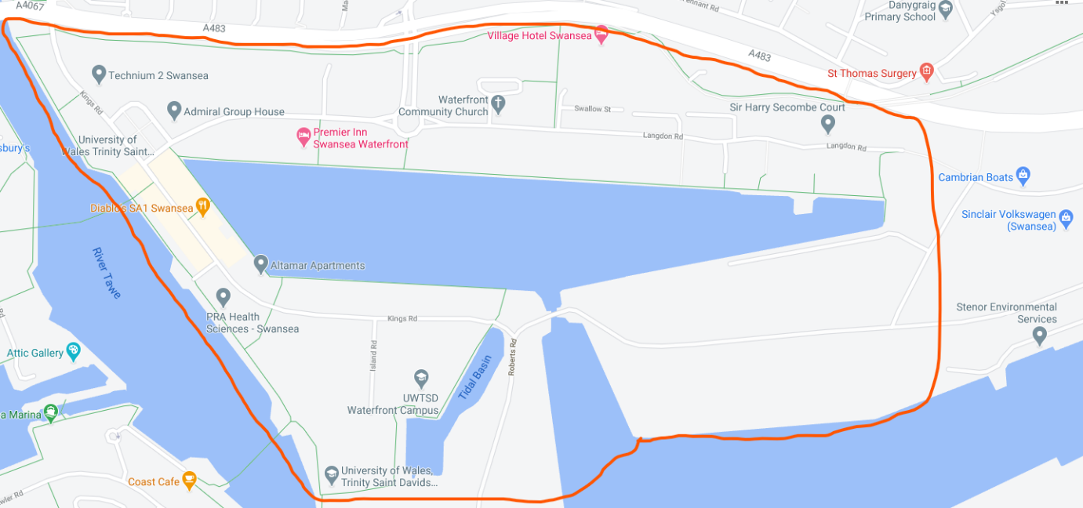

Site Assessment.
The area of the site most relevant to the project is an area of land known as Morrisey Land shown in figure 2 taken from the Fabian Way Innovation Corridor Masterplan. The land having previously used for railways which served the docks infrastructure and is earmarked for redevelopment by the City and County of Swansea Council (SCC) and Neath Port Talbot Borough Council (NPTC) as part of the Fabian Way Masterplan.
Figure 2 Land use register taken from Fabian Way Innovation Corridor Masterplan Framework.
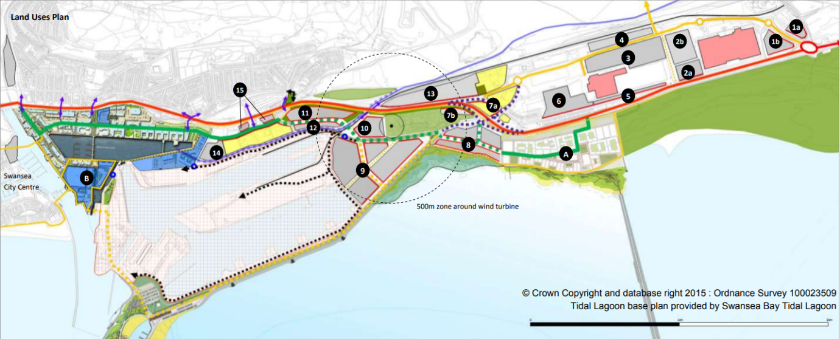
The reason for earmarking this section of the site for the location of the new link road is the location of the wind turbine in the Wastewater Treatment Plant which has a 500m buffer around it in which at the time of writing this report is taken as a typical separation distance for residential property for noise and shadow flicker impacts. (City and County of Swansea Council, Neath Port Talbot County Borough Council, 2015, p. 18)

Topography.
The area formally having mainly been used for the railway purposes is relatively flat with the A483 on an embankment to the north of the site.

Constraints.

Policy Constraints.
Welsh Assembly Government have legislated in the Planning Policy for Wales (PPW) to make sustainability a major aspect of a development, paragraph 3.59 states;

“Development should be located so that it can be well serviced by existing or planned infrastructure. In general, this will involve maximising the use of existing infrastructure or considering how the provision of infrastructure can be effectively co-ordinated to support development plans. Infrastructure choices should support decarbonisation, socially and economically connected places and the sustainable use of natural resources.” (Welsh Assembly Government, 2018)

Environmental Constraints.
In identifying a suitable location for the new access to the SA1 complex it is necessary to take note of the follow constraints listed in the City and Council of Swansea LDP ST006 (City and Council of Swansea, 2015) which designers must allow for, these are;
- The Natural Resources Wales (NRW) flood map shows the area to be at risk largely from surface water and small water courses flooding, however it is also in a flood alert area arising from its proximity to the sea and the adjoining docks. Consultation of Technical Advice Document 15 (TAN 15) (Welsh Assembly Government, 2004) indicates the area is in a C2 classification by Natural Resources Wales (NRW), so all proposed works are to allow for the possibility of flooding. See figures 4,5,6,7.
- As a result of the legacy from historic use of the land for industrial purposes Hazardous Installation Consultancy Zones (HIC) are present in the area, with one located at the east end of Kings’ Dock which is on the edge of the proposed road scheme. There will need to be a need to undertake ground investigations to determine both the location and severity of any pollution to allow mitigation strategies to be developed if needed.
- There is an existing hydrological link between the Prince of Wales Dock and the Tennant Canal which although not in the immediate vicinity of the proposed road scheme could present an environmental risk if the water course became polluted during works.
- There are two neighbouring sites of special scientific interest (SSSI) near the site, these are Crymlyn Bog to the north east and Crymlyn Burrows to the east.

Physical Constraints.
- The area is quite heavily built up with a combination of residential and commercial uses.
- The narrow corridor of land available between the existing A483 and the dock area
- Existing heavy rail infrastructure which whilst currently in a state of decline and disrepair might be needed in future and space should be left to allow this.
- The need to keep a corridor of land available to allow the future construction of a short section of waterway linking the Tennant Canal to the Prince of Wales dock through the SA1 complex, which is shown below in figure 3.
- The topple zone for the wind turbine located in the Welsh Water Treatment Works near Baldwins Bridge shown in figure 8.
Figure 3:Propsed route of Tennant Canal, taken from Fabian Way Innovation Corridor Masterplan Framework (2015)
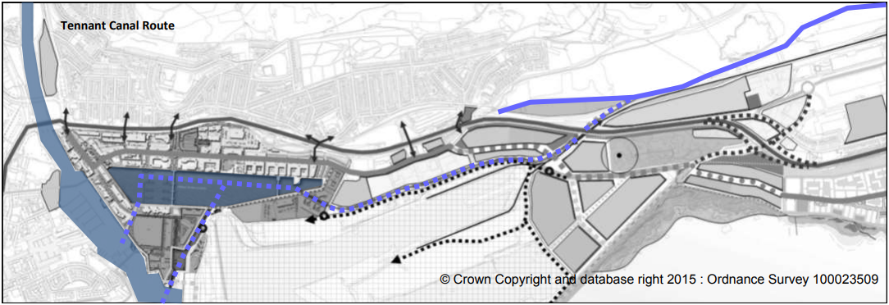
Figure 4: Flood risk map of the area showing the types of risks, taken from Natural Resources Wales. ©
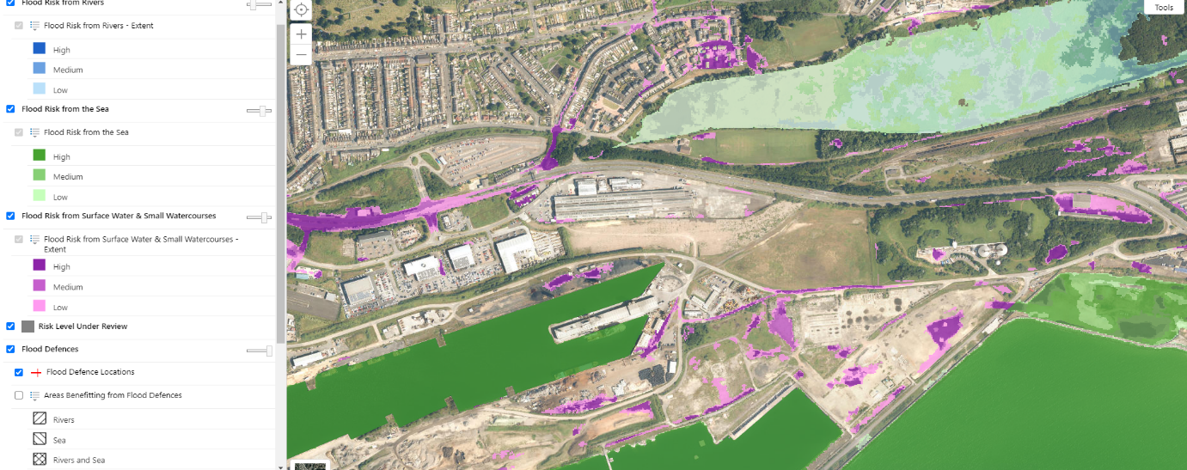
Figure 5:Flood risk map of the area showing the alert areas, taken from Natural Resources Wales. ©
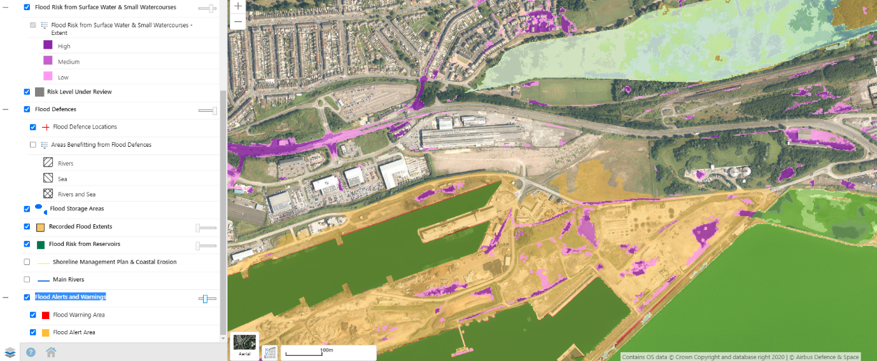
Figure 6:Development Advice Map showing zone classifications, taken from Natural Resources Wales. ©:
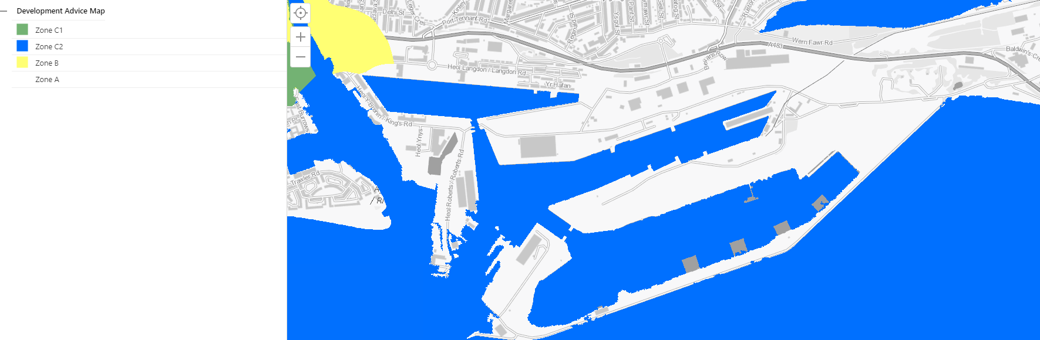
Figure 7:Development Advice Map showing flood risk areas, taken from Natural Resources Wales. ©:
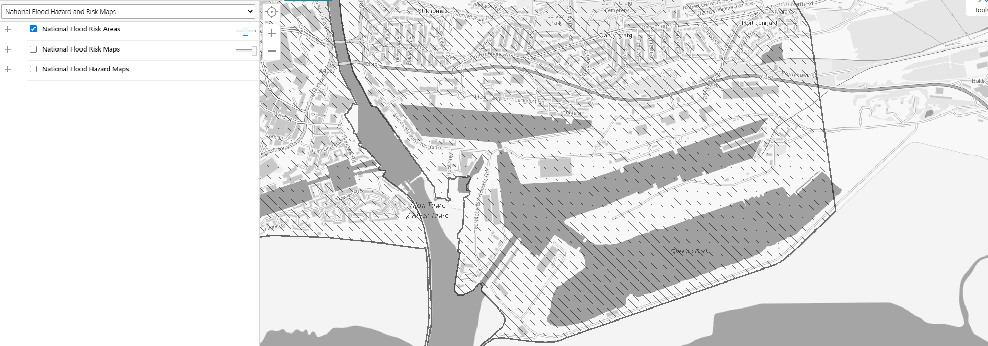
Figure 8: Exclusion zone around wind turbine and water treatment works, taken from Fabian Way Innovation Corridor Masterplan Framework Consultation (2015).
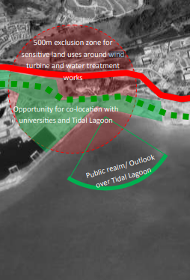

Desk Top Survey.

Site History.
The link road will be constructed on land primarily used for rail transport historically, however the site is also in the immediate vicinity of a former spelter (zinc) works which could present a contamination risk from residual pollution left in the area.
Figure 9 Historical map 1938-1951 taken from Old-Maps.co.uk.

The A483 was developed in the late 1950’s and early 1960’s when the existing road was upgraded to a dual carriage way and the bridge and embankment, which the new road will spur from, were also constructed at that time.
Figure 10 historical map 1960-1962 taken from Old-Maps.co.uk.
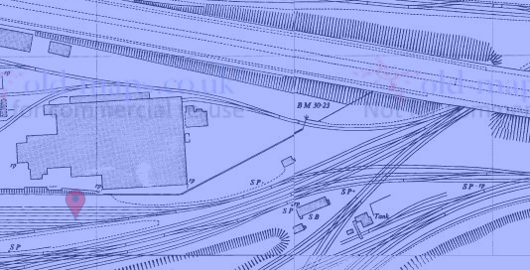
.

Existing Infrastructure.
The SA1 complex has predominantly been used for industrial purposes since its development in the late 19th century and benefits from having good existing transport infrastructure with Roberts Road being the most useful to our proposed development due to its connection with the A483 at Baldwin Bridge junction on the eastern edge of the complex.
Discussions with Associated British Ports (ABP), who control access into the complex from Roberts Road, have indicated that the possibility of using this land albeit with some alterations to facilitate the project is the preferred option from their view as landowner.
There are also some disused tunnels running under the area which linked the former Tir John Power Station with Queens Dock which were used for extracting and dispersing coolant water from the power station turbines back into the dock.
These tunnels were briefly discussed for use as a groundwater storage system which could with the use of pumps discharge into the Queens Dock again, however it was discounted because of the cost of excavating the infilled shaft at Queens Dock and locating and tapping into the tunnels buried 30m below the surface which might not be serviceable anymore.

Ground Investigation.

Geology.
The Geology of Britain Website published by the British Geological Survey (BGS) shows that the site is situated in the South Wales Middle Coal Measure formation with the bedrock being formed of mudstone, siltstone, and sandstone with alluvial fan deposits consisting of sand and gravel forming the superficial layer, see figure 11.
A borehole log number SS69SE19 taken from the BGS website shows the ground to made up of 3m (10’) of made ground, 2.4m (8’) of course brown sand and boulders with a further 2.4m of grey sand and boulders before we find a layer of peat at a depth of 7.9m, see figure 13.
The site is underlaid by bedrock which is classified by NRW as a secondary A aquifer which is described as a permeable layer capable of supporting water supplies at a local rather than strategic scale, and in some cases forming an important source of base flow to rivers. These are generally aquifers formerly classified as minor aquifers (Environment Agency, 2017). See figure 12.

Ground Contamination.
Like much of the former industrial land in and around Swansea there is likely to be contamination of the soils, these are most likely to be in the form of heavy metals and hydrocarbons.
The proposed spur from the A483 is not likely to present problems in this regard however the culvert for the Tennant Canal will require extensive excavation works and a detailed investigation will be needed to identify any potential problems in advance of works, with particular attention paid to the HIC adjacent to the site.
Figure 11: Geology and location of borehole logs taken from BGS website, Crown Copyright. ©
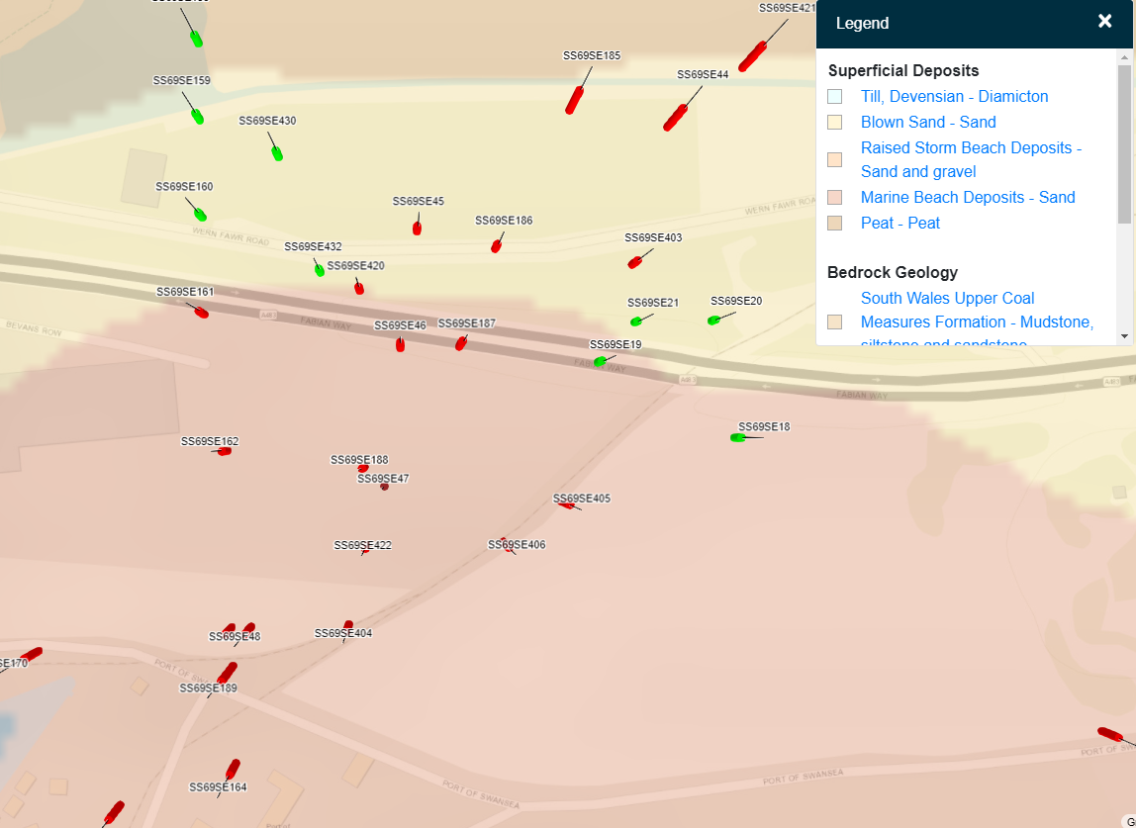

Figure 12:Aquifier designation taken from NRW website, Crown copyright. ©
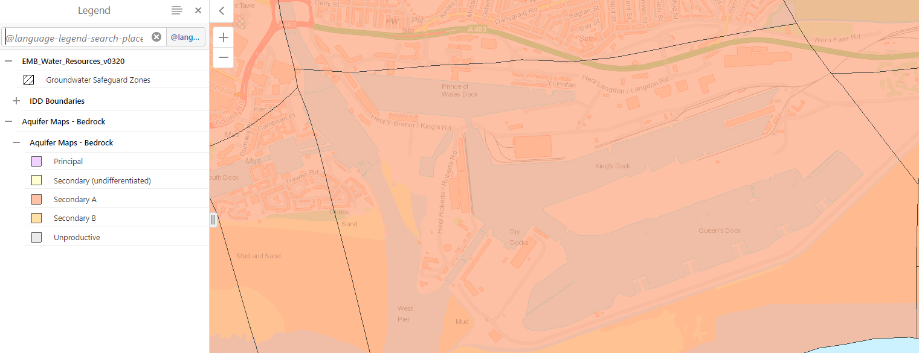
Figure 13:Borehole log reference ss69se19 taken from BGS website, Crown Copyright. ©
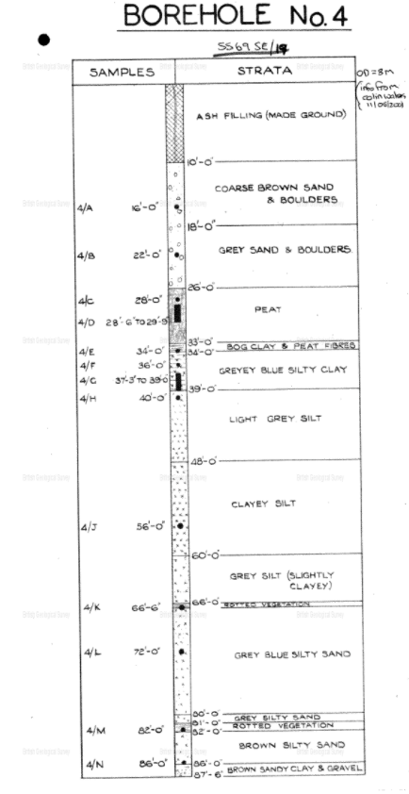

Unexplode Ordnance (UXO).
A 2014 report from BACTEC commissioned by Atkins Limited commissioned to inform the Tidal Lagoon project has flagged up the area of the road scheme to be at high risk from UXOs because of the Luftwaffe bombing campaign on Swansea during WW2. The report does state on page 21 that due to post war developments that risks from shallow buried ordnance will be partially mitigated following any excavations taken place during this time (BACTEC, 2016) but a watching brief from an Explosive Ordnance Disposal Engineer on all open excavations with further investigations is required upon the commencement of the project. See figure 14.
We do not envisage the need for any deep excavation or piling works but with the above information a full intrusive Magnetometer Survey of any pile/borehole locations and Target Investigation, will be undertaken if necessary. With investigation of Suspect Anomalies, if required.
Figure 14, UXO report of Swansea Docks taken from BACTEC report for Tidal Lagoon.
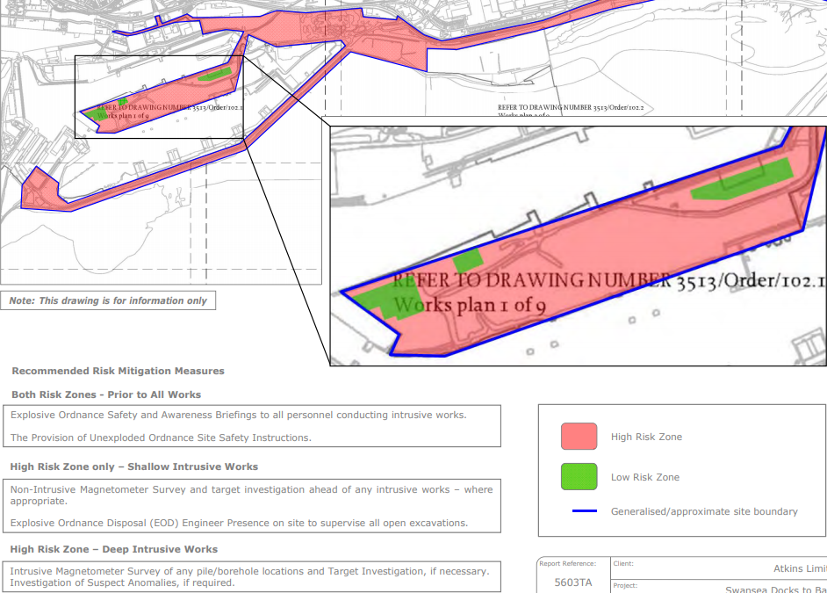

Environmental Impact Assessment (EIA)
A full Environmental Impact Assessment has been commission and is to be prepared separately from this. Conversation with the environmental officer at ABP Swansea has brought no information of protected flora or fauna in the proposed construction areas but it was noted that a detailed habitat survey would be needed.

Transport.
In 2015 The Fabian Way Innovation Corridor Masterplan stated that Fabian Way had 32,000 vehicle movements per day making it one of the busiest non-trunk roads in Wales (City and County of Swansea Council, Neath Port Talbot County Borough Council, 2015). The subsequent development of the UWTSD complex in the SA1 complex along with the building of many new dwellings and the construction of the new student accommodation block in King’s road has the potential to add significant numbers of vehicles to this number adding to the congestion at the Tawe bridge interchange and further along Fabians Way if the current infrastructure is not updated. An additional aspect of future traffic is the new waterfront arena development which has the potential to add to the amount of traffic coming into Swansea from the east.

Development Options.
A workshop for the scheme was held between GRAJ, The City and Council of Swansea and local stakeholders, to discuss the routes identified with a hypothetical sixth option of do nothing added to help with the comparisons.
Table 1: Summary of development options.
Development Option | Summary.
Do Nothing. | The option of doing nothing has been discounted based on the information in the Fabian Way Masterplan saying they will need significant investment in the next 25 years.
Route 4. | This is the preferred route for development.
Route 1. | This is the cheapest of the options, but we believe Baldwins Bridge interchange would prove to be a bottleneck without changes.
Route 2. | The need to protect both the heavy rail link along with the canal route means this is a nonstarter.
Route 3. | The existing residential and commercial interests would be seriously affected by the increase in traffic along the new route.
Route 5. | The existing commercial operations would be seriously affected by the increase in traffic along the new route.

Route Options.
Figure 15, Roberts Road from SA1 to Baldwins Junction, taken from Google Maps ©
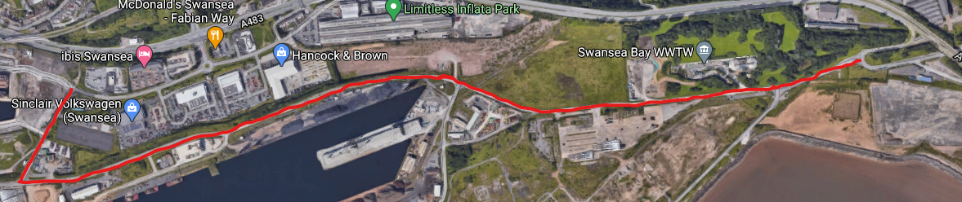
Figure 16; Location of proposed new road under A483, taken from Google Maps ©
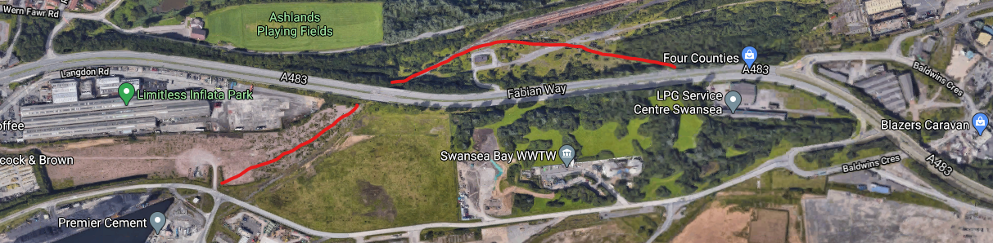
Figure 17; Location of junction near Wern Fawr Road, taken from Google Maps ©
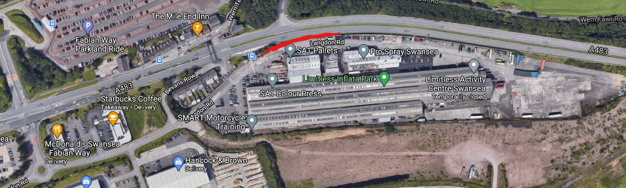
Figure 18;Location of new spur from A483 to Roberts Road, taken from Google Maps ©
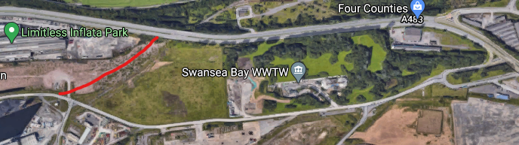
Figure 19; Location of new spur from A483 to Langdon Road, taken from Google Maps ©
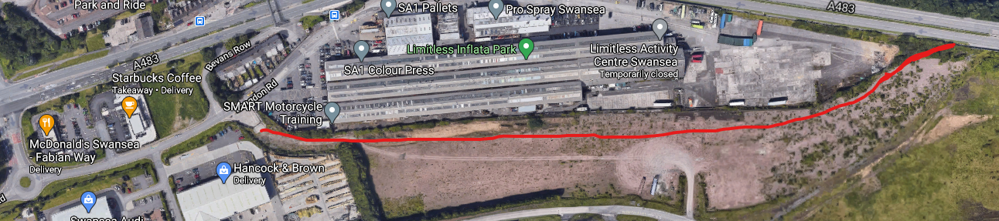

Possible routes.
With national policy preferring construction projects to be as sustainable as possible we have looked at the existing infrastructure and identified the following routes as possibilities;
- Using Roberts Road which runs from a junction with the A483 at Baldwins Bridge junction and runs through the dock area to a junction with Langdon road, shown in Figure 15.
- Using Roberts Road to allow access from the A483 into the SA1 complex but construct a new road which will use the alignment of the railway access under the A483 to link up with the road in the vicinity of the former access road into the Burrows Siding complex shown in Figure 16.
- Making a new junction for westbound traffic from the A483 to join Langdon Road in the vicinity of Wern Fawr Road shown in Figure 17.
- Create a new spur coming of the A483 on a junction past the Wastewater works and connecting with Roberts Road at a roundabout in the vicinity of the level crossing, blocking the access coming from the A483 at Baldwins Bridge into the complex and making Roberts Road on the eastern side of the junction one way only heading towards the A483 allowing access to both east and west directions shown in Figure 18.
- Create a spur as option 4 but construct a new road to meet up with Langdon Road near Handcock and Brown building merchants shown in Figure 19.

Preferred Route.
Route 4 is considered to be the best option as this allows the construction of a clear junction with the A483 whilst not impacting upon the existing business on Langdon Road and allowing traffic from the eastern side of the complex access to both directions of the A483 without going through a built up and busy area. The new spur from the A483 into the SA1 complex will divert left after the bridge shown in figure 20 and will run downhill alongside the railway and possible canal to a new junction with Langdon Road, which will become a one-way road heading eastbound towards the A483 at Baldwin Bridge interchange with the westbound junction from the A483 to Langdon Road been taken out of use. figure 19 shows the area to be used.
With this route it is necessary to consider the desire to reopen access to the docks from the canal, as such it is considered prudent to futureproof this by the installation of a culvert to carry the road over the canal alignment erasing the need to close the road should this plan be realised. There has been a similar construction works in the Birmingham area for the restoration of the abandoned Lichfield Canal (LHCRT, n.d.). shown if figures 22 and 23.
Another consideration in using this land is the location of the wastewater treatment works and wind turbine adjacent to the link road site. There is a need to allow for a buffer zone around the wastewater plant to minimise the potential nuisance from odours arising the works, further TAN 8: Renewable Energy 2008 suggests that to reduce unacceptable noise impact and shadow flicker from the turbine upon residential developments a separation distance of 500m is advised, this could potentially make the land cheaper to buy,

Discounted Routes.
We have discounted routes 2 and 3 because the rail link to the dock has been safeguarded for possible future use and in route 3 the businesses located on Langdon street could affected by the increase in traffic making it difficult to access them with the potential to cause traffic congestion backing on to the A483.
Route 1 has potential and would be the cheapest option but the junction at Baldwin Bridge is not designed for large volumes of traffic and there is potential for major traffic flow conflicts with traffic coming westbound from the A483 and traffic heading onto the A483 eastbound.
Route 5 is feasible but the junction with Langdon Road in between the various businesses could cause similar problems as routes 2 and 3.

Figure 20:Picture of Fabian Way A483 looking towards Swansea taken near the overbridge.
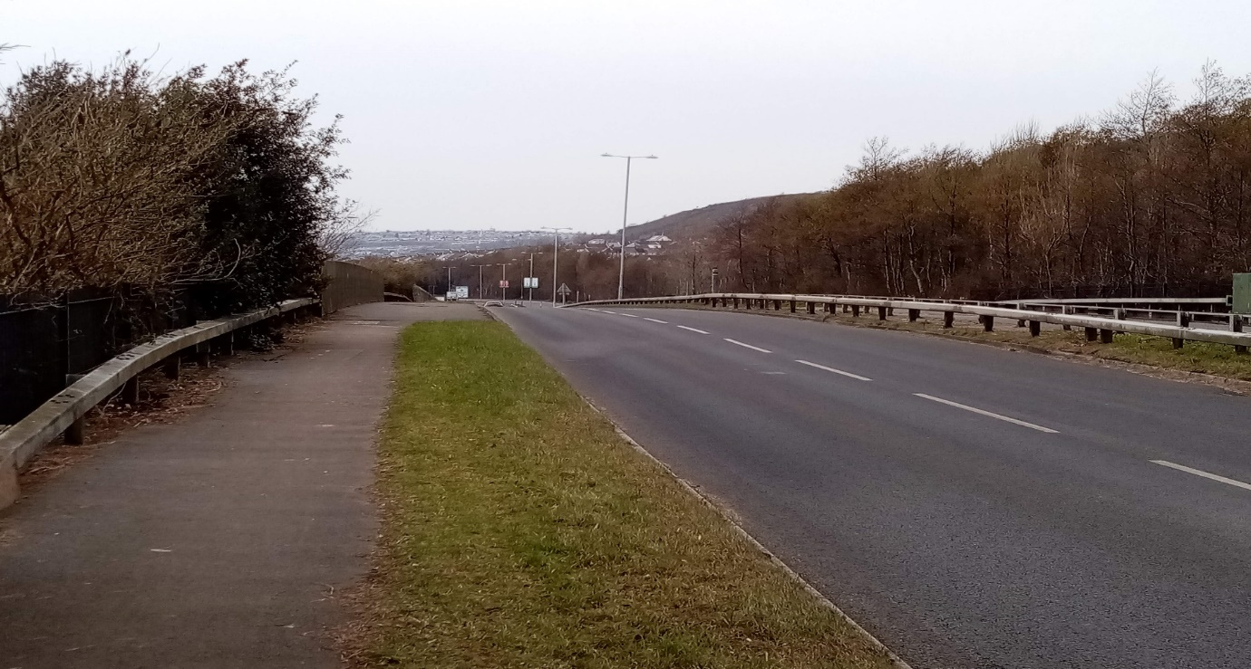
Figure 21:Picture of proposed link road route from the A483
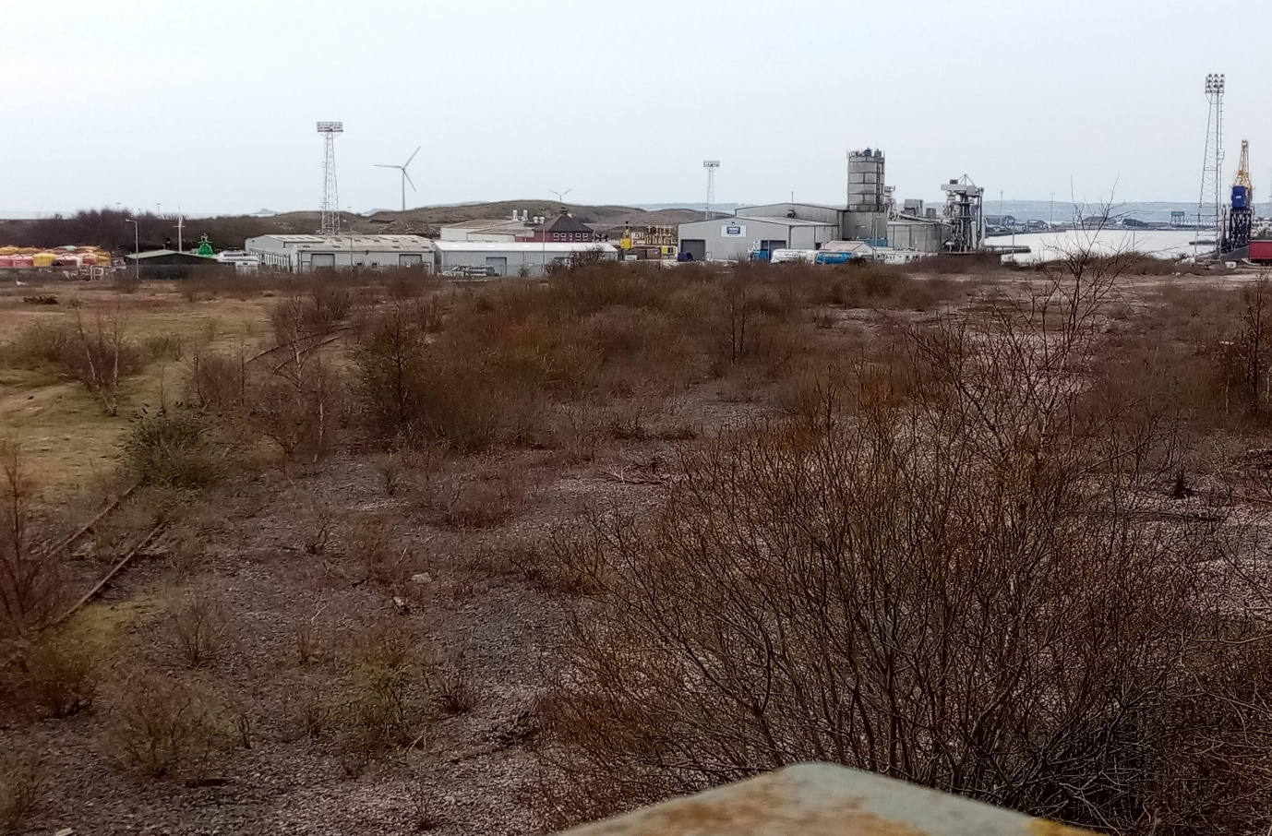
Figure 22:Image of new canal culvert as part of new road construction, taken from https://www.lhcrt.org.uk/tunnel-vision.html.
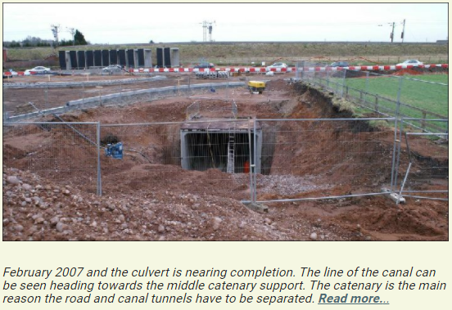
Figure 23::Plan of new canal culvert as part of new road construction, taken from https://www.lhcrt.org.uk/tunnel-vision.html.
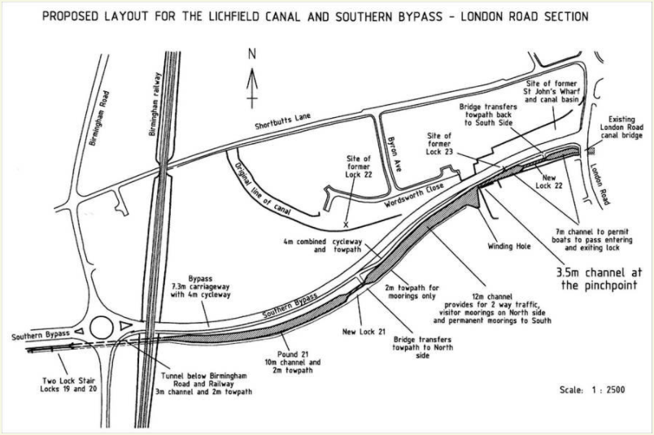

Road Scheme Description.
The proposed new link route will leave the A483 immediately after crossing the bridge which passes over the remains of the protected railway link between the docks and the Network Rail sidings on the north of the A483 and will head in a southerly direction towards Langdon Road. From here there will be an interchange in the form of a roundabout with a culvert for the future Tennant Canal link installed at the same time. Shown in figure 24.
At the eastern edge of Langdon Road at the Baldwins Bridge interchange the Road layout is to be altered to only allow traffic onto the A483 through the removal of one side of the junction.
The land which it will cross is previously developed land (PDL) which was mainly used for by the railway companies to access the dock.
To the east of the road is the Welsh Water Treatment Works which has a wind turbine, and the road will be in the topple zone of this.
To the south is more PDL with both the Kings and Queens Dock just beyond the Breedon Aggregates concrete plant which we will be using for the supply of any concrete needed.
To the west there are several small commercial units just outside of the site boundary.
Figure 24, Draft CAD image of link road and new junction.
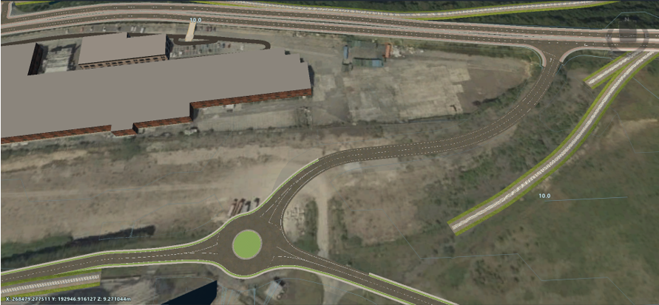

Table 2: Development stages.:
Scheme Area | Design Development.
New junction with A483 for link road. | An embankment will be formed from the A483 to allow graded access for construction traffic.
New road. | Construction of road with associated drainage and utility infrastructure.
New junction with Langdon Road. | The construction of a roundabout with a culvert installed to allow the future construction of the Tennnat Canal link.
Baldwins Bridge. | Junction to be altered to only allow access onto the A483.
Eastbound. | Upgrading of Langdon Road where necessary and the creation of a new bicycle path connecting to the Swansea University Campus.

Environment.

Pollution.
To the north of the proposed link road Crymlyn Bog which is a Special Area of Conservation (SAC), Site of Special Scientific Interest (SSSI) and a Nitrite Sensitive Area (NSA) (see figure 25).
Figure 25: SSSI and NSA areas - image from Tidal Lagoon assessment
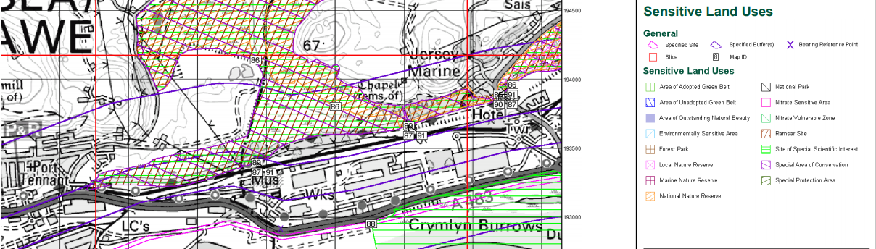
It is noted in an advice document written by DTA Ecology titled, Shadow Habitats Regulations Assessment to inform the Habitats Regulations Assessment of the Local Development Plan (DTA Ecology, 2021) in paragraph 3.73 page 29 that the possibility of air pollution from increased traffic and dust arising from construction works should not be ruled out, the construction of a road will add to the air borne contaminants and will need to be planned and mitigated for.

Construction Traffic Pollution Mitigation.
Pollution from traffic in conjunction of the works will be reduced as much as practicable in line with the recommendations in the CIRIA publication no C762 Environmental good practice on site (CIRIA, 2016) by encouraging vehicle sharing and the use of public transport, alongside scheduling deliveries to arrive outside peak traffic times to help alleviate traffic build up, all plant will be in good working order with exhausts pointed skywards to help disperse emissions and not blow dust up in the air.

Construction Works Pollution Mitigation.
If there is a prolonged period of dry weather, it might be necessary to control any possible dust pollution by dampening down any stockpiled loose materials with particular attention to be paid to any excavated materials which due to the nature of the land is likely to be contaminated with heavy metals and hydrocarbons.

Green Infrastructure.
As part of the Fabian Way Innovation Corridor Masterplan, there is a desire to improve the visual image of the city as people travel in from the western approaches. This offers an opportunity in line with policy ER2 of the councils Local Development Plan (LDP) which has the aim of protecting and enhancing green spaces and create interconnected areas of green infrastructure between proposed sites and existing areas. (City and Council of Swansea., 2020, p. 185)
The remains of the Tennant Canal and Crymlyn Bog in proximity offer a possible link up of the SA1 residential and commercial areas through a green corridor comprising of a new canal section and landscaped area of trees and shrubs which offer additional benefits of reducing air and noise pollution for residents on both sides of the A483. As well as helping to reduce the effects of air pollution upon Crymlyn Bog and Crymlyn Burrows which have been shown as being susceptible to airborne pollution.
With the development area being in the at-risk area of surface water and small watercourses see figure 26, the risk of additional run off water from the new road is to be mitigated using permeable asphalt for the road surface, bit is considered that additional measures should be undertaken to help meet requirements in TAN 15: Development and Flood Risk which in paragraph 8.2 states,
Built development, such as roads, pavements, and roofing, tends to increase the surface area of impermeable ground, thus reducing percolation and increasing rapid surface run-off. This has the effect of reducing the time it takes for precipitation to enter the watercourse and consequently increasing the peak discharge. SuDs can perform an important role in managing run-off from a site and should be implemented, wherever they will be effective, in all new development proposals, irrespective of the zone in which they are located. (Welsh Assembly Government, 2004)
Figure 26 Map showing areas prone to flooding from surface water. Taken from NRW ©
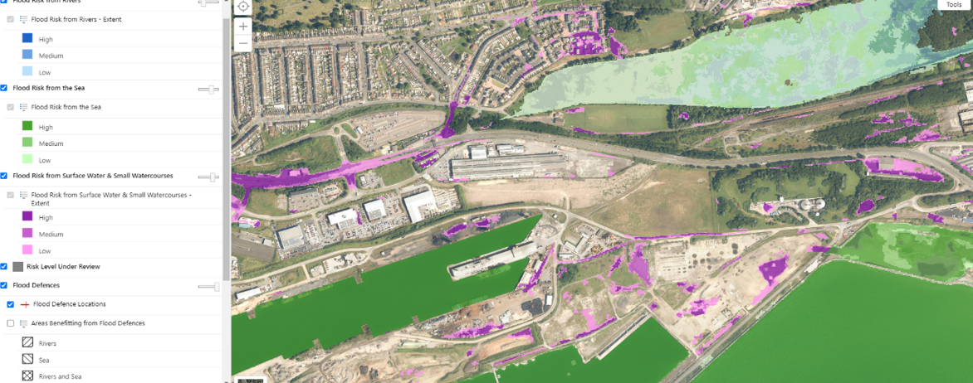
The desire of the City and Council of Swansea to redevelop the area immediately opposite for commercial purposes as shown in the Fabian Way Innovation Corridor Masterplan Framework will result in increased surface run off as land is developed and ground permeability reduced. Alongside the desire to increase access to social infrastructure for communities in the new developments south of the A483 stated in paragraph 3.1.57 of the Fabian Way Innovation Corridor Masterplan Framework (City and County of Swansea Council, Neath Port Talbot County Borough Council, 2015) it is proposed to use the protected Tennant Canal route for water catchment. This will be achieved by collection of water into attenuation ponds from which water can be dispersed into a new canal culvert to feed run off and excess ground water back into the canal system where it can drain into the dock infrastructure through the existing culvert under the A483 shown below.

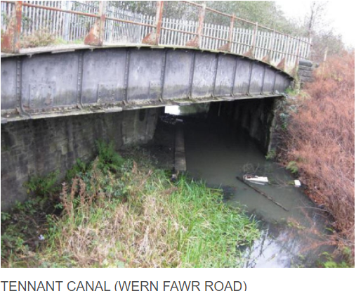

Socioecomonic Impact.
Incorporating green infrastructure such as the canal, towpath and planting into the finished project will increase the desirability of the area for regeneration increasing the employment possibilities in the area and allowing easy access for communities either side of the A483 to access leisure facilities such as the Marina, the LC2 leisure centre and Kilvey Hill Community Woodland. By creating a better physical environment through the incorporation of accessible greenspace for residents to make use of the scheme will be in line with objectives outlined in the Well-being of Future Generations (Wales) Act 2015 in creating a healthier nation. (Welsh Assembly Government, 2019).

A report looking at the gaps in labour for the construction industry prepared in support of the Swansea Bay Tidal Lagoon project outlined a lack of trained and experienced construction workers and managers locally (Lilley. S., 2016). This statistic corresponds with the Swansea Economic Profile published by Swansea Council which shows the area lagging behind the rest of Wales and the UK in employment statistics in the areas of associate professional and technical occupations alongside skilled trades occupations (City and Council of Swansea, 2020). The proximity of the UWTSD Campus affords an opportunity to collaborate with the university to help train future construction managers. A policy to employ local companies and to integrate the UWTSD as far as is practicable into the scheme will have positive socioeconomic impact.

Road Construction

Programme overview.
The main construction programme is yet to be fully finalised and will be presented elsewhere, however the current date for site mobilisation is scheduled for the 03/01/2022 and the road construction is planned to run for 48 working days with a projected completion date of 03/03/22.
Table 3: programme overview.
Activity | Programme dates and Duration.
Mobilisation | 03/01/2022 2 weeks.
Preliminary works. | 13/01/2022-31/01/2022. 3 weeks.
Construction Works. | 01/02/2022-04/03/2022. 4 weeks.
Finishing and commissioning. | 07/03/2022-09/03/2022. 1 week.

Methodology overview.
- Access and secure site.
- Construction of laydown area and site compound and services.
- Site preparation with environmental control measures e.g., dedicated fuelling areas.
- Preliminary works, such as setting out.
- Earthworks-creation of embankment and excavation for culvert.
- Construction of drainage and utility infrastructure.
- Road construction.
- Finishing works including landscaping.

Waste Disposal.

Rubble, concrete, and spoil.
Any solid waste that can be recycled providing it is not contaminated is to be taken away by Stenor who are based on Titanium Road which is 4.4 miles away from the site. See figure 27.
Figure 27 Location of Stenor Environmental, taken from Google Maps ©
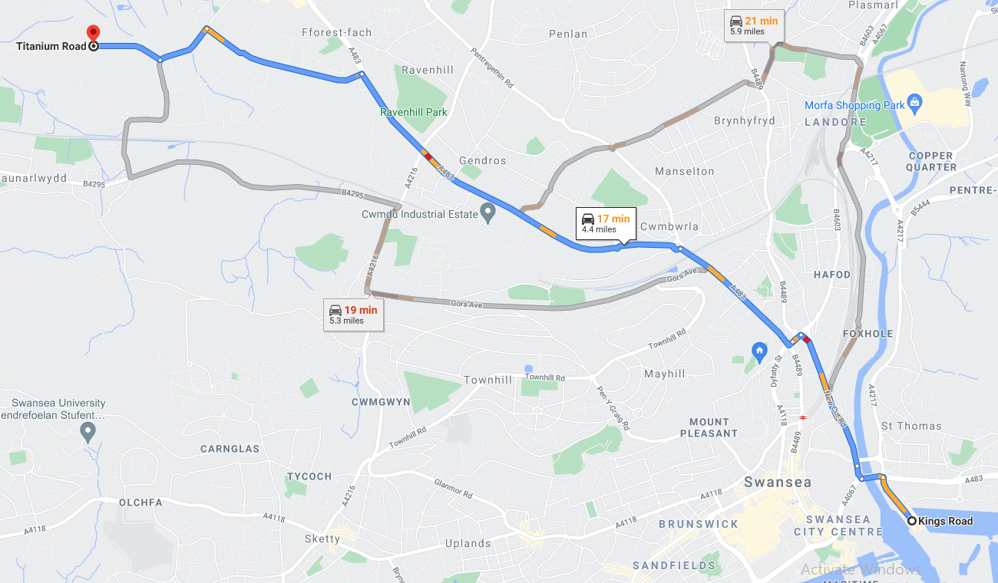

Traffic Management Plan
This traffic management document has been prepared to show the various policies GRAJ Construction will implement to do the following;
- Minimise the interface between Construction and Public traffic.
- Controlling vehicular and plant movements on site.
- Reduce the number of deliveries as much as practicable.

Policy Guidance.
A review of national and local transport policies shows the following documents to be relevant;
- Planning Policy for Wales (PPW), edition 11 February 2021
- City and Council of Swansea Local Development Plan (LDP).
Section5.3 of PPW outlines the assemblies’ ambitions on reducing the amount of private vehicle movements to help reduce climate change and improve air quality. (Welsh Assembly Government, 2021)
Section 2.12.4 of the LDP states that “The Council will require developments to meet high standards of accessibility. Urban developments should normally be within a walkable 400 metres from a public transport access point, on a route with a weekday 20 minute or better frequency.” (City and Council of Swansea., 2020)

Sustainable Accessibility.

Public Transport.

Bus
The site is ideally situated for local workers to use public transport with the Fabian Way Park and Ride a 14-minute walk from the site. See figure 28.
Figure 28 Location of Fabian Way Park and Ride in relation to the site, Taken from Google Maps ©
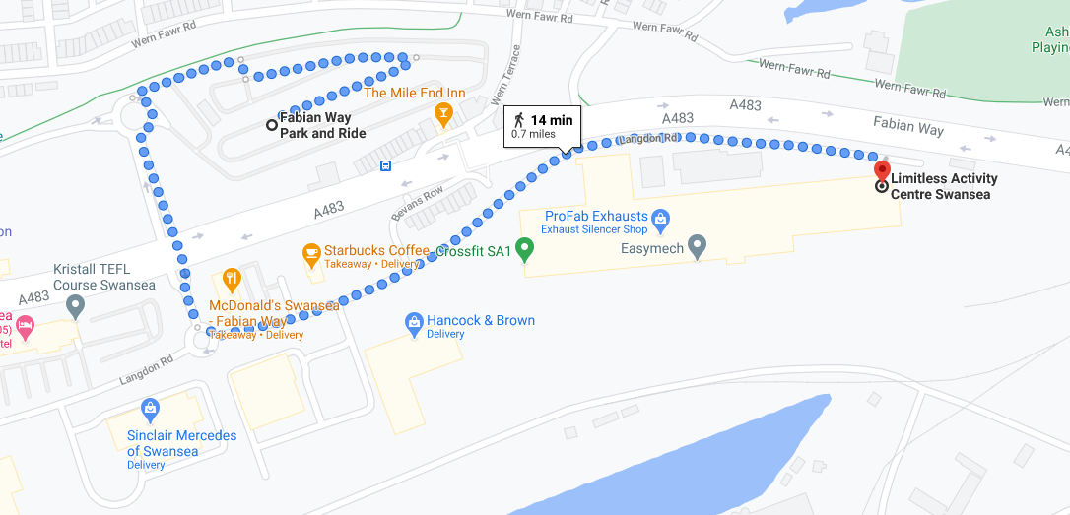

Rail.
There are no railway stations in the proximity but the main railway station for Swansea is situated 1.9 miles away and is approximately 38 mins away by foot.

Cycling.
The site is also convenient for cycling been easily accessed from both east and west directions.

Private Vehicles.
Staff will be encouraged to car share as much as possible and to arrive on site before the rush hour starts, however it is accepted that a 17.00pm leaving time will add additional traffic onto the A483, as such the traffic arising from the works will be monitored to assess whether there is a need to alter the working day to reduce traffic at peak times.

Working Hours and Workforce.
The site will have a standard working hour of 8.00 am to 17.00 pm Monday to Friday and 8.00 am to 13.00am on Saturdays, there might be a need for extra out of hours working if the project loses time due to unforeseen circumstances or the weather.
The anticipated workforce is estimated to be around 20-30 personnel with most arrivals expected in the 30 minutes before the working day starts with most departures in the 30 minutes at the end of the working day.

Site Compound and Parking.
A suitable location for the site compound has been identified on derelict land adjacent to the site with access from Roberts Road. The site offices, welfare and plant storage are to be located on the same land shown in figure 29. There will be ample parking for the expected workforce which will reduce the impact of vehicle parking on the surrounding roads.

Construction Traffic.

Administration.
The Traffic Manager is to be responsible for the control and management of the construction traffic both on site and deliveries, and will alongside the site foremen/women, security team and external contractors;
- Make sure that all subcontractors and supply deliveries, adhere to the prebooking requirements giving adequate notice to reduce the risk of congestion.
- Enforce the parking rules which will not allow parking outside authorised zones.
- Provide security checks at the entrances.
- Maintain clean access roads in and outside of the site.

Operational Access and Egress Route.
Figure 28 shows the access route in red, the egress route in blue with the site compound in green, the dark green line is the proposed link road route, and it will be able to be used for access of topping materials once at a suitable stage. The route shall be signposted with appropriate directional and warnings with a copy of the route will be sent to all contractors and delivery companies with no vehicles being accepted if they do not comply with the route without a valid reason.

Booking System.
There is to be a pre booking system for deliveries with any unscheduled deliveries not been accepted, therefore it is the duty of all contractors to notify GRAJ Construction Traffic Manager of all deliveries in advance to ensure the following does not happen;
- Deliveries taking place in peak traffic times.
- Queuing of vehicles causing a nuisance to residents.
- Unauthorised loading or unloading of vehicles.

Road Housekeeping.
The approved route shall be monitored daily, and all dust and debris will be cleaned up immediately and if it is necessary, a road sweeping vehicle will be used to maintain the highway.
At this stage the need for wheel washing facilities are deemed unnecessary due to the limited amount of off-road driving needed but provision will be made for one if necessary.
Figure 29 :Route map showing access and egress from site. Taken from Google Maps ©
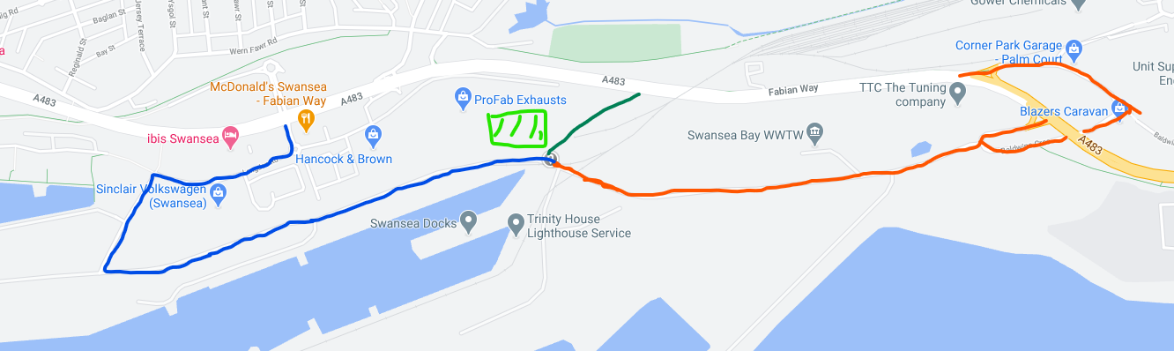

Trip Generation.

Workforce.
The estimated workforce for the project is expected to be no more than 30 personnel, with all traffic directed down towards Baldwins Junction to access Roberts Road. We will work on the basis that all staff will want to drive to site and that the peak time for worker movements will be 07.30am to 8.00 am and 17.00pm to 18.00pm.

HGV movements.
There will be no deliveries or collections between the hours of 08.00 and 9.00 am and 15.00 and 18.00pm, allowances will be made for concrete deliveries and muck away lorries with the acknowledgement that they are usually required at the beginning of the works where there is less chance of clashes with other deliveries, and courier deliveries for smaller items due to the unpredictability of their work.

Plant movements.
There is to the minimum amount of plant movement on the public roads with movements taking place outside of the busy times exceptions been made where plant or materials need to be moved between the second compound for the lock gate and plot F access project.
Table 4 shows that we anticipate 84 vehicle movements per day with the majority at 60 been the movement of workers, 8 been HGV and 28 plant movements. This is likely to fluctuate over the course of the job depending on the amount of spoil is removed from the canal culvert works and if any of it can be reused to help form the new embankment to the A483, and the extent of initial enabling works.

Table 4 Construction Trip Analysis.
Time. | Arrivals. |  |  | Departures. |  |  | Total.
 | HGV | Workers | Plant Movements. | HGV | Workers | Plant Movements.
07.00-08.00 | 0 | 30 | 0 | 0 | 0 | 0 | 30
08.00-09.00 | 0 | 0 | 0 | 0 | 0 | 0 | 0
09.00-10.00 | 1 | 0 | 0 | 1 | 0 | 0 | 2
10.00-11.00 | 0 | 0 | 2 | 0 | 0 | 2 | 4
11.00-12.00 | 1 | 0 | 1 | 1 | 0 | 1 | 4
12.00-13.00 | 0 | 0 | 0 | 0 | 0 | 0 | 0
13.00-14.00 | 1 | 0 | 2 | 1 | 0 | 2 | 6
14.00-15.00 | 1 | 0 | 2 | 1 | 0 | 2 | 6
15.00-16.00 | 0 | 0 | 1 | 0 | 0 | 1 | 2
16.00-17.00 | 0 | 0 | 0 | 0 | 0 | 0 | 0
17.00-18.00 | 0 | 0 | 0 | 0 | 30 | 0 | 30

Onsite Vehicle Movements.
A statistic on the Traffic management on site section of the HSE website states:
On average, each year, about 7 workers die as a result of accidents involving vehicles or mobile plant on construction sites. A further 93 are seriously injured. (Health and Safety Executive, 2021)
Section 27 of CDM Regulations (2015) states; (HM Government, 2021)
- A construction site must be organised in such a way that, so far as is reasonably practicable, pedestrians and vehicles can move without risks to health or safety.
- Traffic routes must be suitable for the persons or vehicles using them, sufficient in number, in suitable positions and of sufficient size.
- A traffic route does not satisfy paragraph (2) unless suitable and sufficient steps are taken to ensure that—
- pedestrians or vehicles may use it without causing danger to the health or safety of persons near it;
- any door or gate for pedestrians which leads onto a traffic route is sufficiently separated from that traffic route to enable pedestrians to see any approaching vehicle or plant from a place of safety;
- there is sufficient separation between vehicles and pedestrians to ensure safety or, where this is not reasonably practicable—
- (i)other means for the protection of pedestrians are provided; and
(ii)effective arrangements are used for warning any person liable to be crushed or trapped by any vehicle of its approach;
- any loading bay has at least one exit for the exclusive use of pedestrians; and
- where it is unsafe for pedestrians to use a gate intended primarily for vehicles, at least one door for pedestrians is provided in the immediate vicinity of the gate, is clearly marked, and is kept free from obstruction.
(4) Each traffic route must be—
- indicated by suitable signs where necessary for reasons of health or safety;
- regularly checked; and
- properly maintained.
(5) No vehicle is to be driven on a traffic route unless, so far as is reasonably practicable, that traffic route is free from obstruction and permits sufficient clearance.

Pedestrian Route Checklist.
 |  | Yes | No | N/A
1 | Are pedestrian routes separated in a clear manner from vehicle movements by a suitable barrier? If no see action 1. | Y
2 | Do pedestrian routes have sufficient space to accommodate the maximum amount of personal expected at peak time? If no see action 2. | Y
3 | Do pedestrian routes allow easy access to work areas? If no see action 3. | Y
4 | Are pedestrian routes free from obstructions? If no see action 4. | Y
5 | Are pedestrian routes clearly signed? If no see action 5. | Y
6 | Do pedestrians have a clear view of traffic routes and be able to cross safely? If no see action 6. | Y
7 | Do pedestrians have clearly marked designated separate access at site access gates? If no see action 7. | Y
8 | Do pedestrian routes allow safe access to welfare facilities? If no see action 8. | Y

Pedestrian Route Actions.
 | Actions to be taken | Actions Taken.
1 | Ensure routes are clearly marked with any alterations notified immediately. | Pedestrian routes to be identified in the induction and displayed throughout the site any alterations to be clearly instructed.
2 | Set the site up based on maximum amount of personal expected at any time.
3 | Plan routes and review regularly.
4 | Regular inspections and alter plans if needed. | To be checked and any obstructions logged.
5 | Ensure sufficient signage.
6 | Eradicate blind spots at the design stage.
7 | Ensure sufficient signage.
8 | Plan set up to avoid crossing points if possible. | Welfare to be kept away from vehicle routes.

Vehicle Routes on Site.
 |  | Yes | No | N/A
1 | Are vehicle routes separated in a clear manner from vehicle movements by a suitable barrier? If no see action 1. | Y
2 | Do vehicle routes have sufficient space to accommodate the maximum amount of personal expected at peak time? If no see action 2 | Y
3 | Do vehicle routes allow easy access to required areas? If no see action 3 | Y
4 | Are vehicle routes free from obstructions? If no see action 4. | Y
5 | Are vehicle routes clearly signed? If no see action 5. | Y
6 | Do pedestrians have a clear view of traffic routes and be able to cross safely? If no see action 6. | Y
7 | Do pedestrians have a clear view of vehicle movements at access gates? If no see action 7. | Y
8 | Is the need for reversing eliminated or reduced? If no see action 8. | Y
9 | Are excavations and temporary structures clearly marked and protected from impact? If no see action 9. | Y
10 | Will parking and/or wash off points be required? If yes see action 10. | Y

Vehicle Routes on Site Actions.
 | Actions to be taken | Actions Taken
1 | Ensure at the design stage that routes are clearly marked with pedestrians protected. | Routes to be easily identifiable and separated.
2 | Plan for maximum predicted vehicles on site, consider one way system if possible.
3 | Plan routes for safe access.
4 | Monitor routes regularly. | To be checked and any obstructions logged.
5 | Ensure sufficient signage.
6 | Design out any blind spots and make crossing points highly visible for drivers.
7 | Design out any blind spots and make access points highly visible for drivers.
8 | Consider one way system if not possible ensure all reversing movements have trained banksman.
9 | Install barriers near excavations and temporary structures and inform drivers of their location.
10 | Plan parking points at the design stage and make provision for wash off points.

Vehicle movements on Site.
 |  | Yes | No | N/A
1 | Have routes been designed to reduce excessive vehicle movements? If no see action 1. | Y
2 | Is plant machinery fitted with a reversing aid/warning? If no see action 2 | Y
3 | Will vehicles reverse without warning aids/warnings If yes see action 3 | Y
4 | Will vehicles reverse towards excavations and temporary structures? If yes see action 4. |  | N
5 | Are vehicle routes free from obstructions? If no see action 5. | Y
6 | Are vehicle routes clearly signed? If no see action 6. | Y
7 | Do pedestrians have a clear view of traffic routes and be able to cross safely? If no see action 7. | Y
8 | Do drivers have a clear view of pedestrians at crossing points and access gates? If no see action 8. | Y
9 | Is there a risk of mud been deposited? If yes see action 9. | Y

Vehicle movements on Site Actions.
 | Actions to be taken. | Actions taken.
1 | Design routes leaving plenty of space to turn without the need for three point turns etc. | Review daily and before delivery of large plant/materials.
2 | Do not allow on site if not fitted.
3 | All vehicles not fitted with reversing aids/warnings to be banked by trained banksman.
4 | Any reversing to have a banksman present and suitable stop blocks to be constructed.
5 | Monitor routes regularly. | To be checked and any obstructions logged.
6 | Ensure sufficient signage.
7 | Make all crossing points highly visible and make drivers are made aware of all crossing points
8 | Make all access points highly visible and make drivers are made aware of all access points
9 | Install wheel wash facilities.

Deliveries to site.
 |  | Yes | NO | N/A
1 | Will all deliveries be planned?  If no see action 1. | Y
2 | Will all drivers be made aware of access points with diversions notified? If no see action 2. | Y

Delivery to site Actions.
 | Actions to be taken. | Actions taken.
1 | All contractors and suppliers are to agree a delivery slot. | All deliveries are to be planned for outside peak traffic demands as far as is reasonably practicable.
2 | All contractors and suppliers are to be provided with route maps shown in figure 1 and any diversion as needed.

Access to site.
All traffic is to approach the site from the A483 at Baldwins Bridge Junction from the east shown in red, upon leaving the site it is to head west and join the A483 at the McDonalds junction
Figure 30:Route map showing access and egress from site. Taken from Google Maps ©
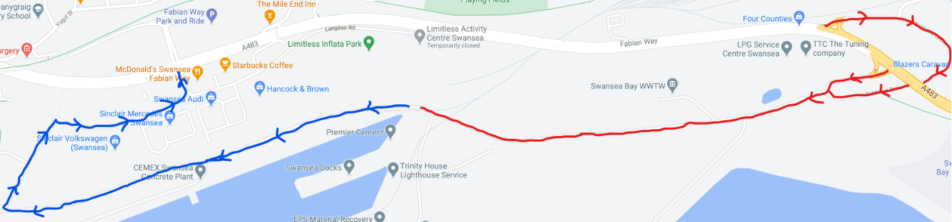

Control measure hierarchy for reversing operations.
1 | Eliminate reversing | Design one way system and designated turning areas.
2 | Reduce reversing. | Reduce vehicle movements to the minimum.  Instruct drivers no reversing is allowed without a banksman.
3 | Ensure adequate visibility for drivers. | Design out blind spots, do not stack material over an agreed height, fit convex mirrors.
4 | Enforce safe systems of work. | Remove pedestrians from vehicle routes.  Allow adequate space for turning.  Ensure banksman oversee reversing movements.  Ensure all plant is fitted with reversing aids/warnings.

Drivers’ checklist.
1 | Only operate vehicle you are trained and authorised to.
2 | Do not drive if unwell or under the influence of alcohol prescribed/illegal drugs.
3 | Make sure you understand all the functions of your vehicle including safe operating limits.
4 | Make sure you know the site routes and rules.
5 | Visiting/delivery drivers seek authority to enter site.
6 | Carry out daily checks and log them.
7 | Ensure windows and mirrors are clean
8 | Wear appropriate PPE when needed.
9 | Park vehicles on flat ground, if not possible use wheel chocks if necessary.
10 | Do no reverse without a banksman.
11 | Unless driver is protected, no driver is to stay on vehicle during loading operations.
12 | Ensure loads are safe to transport.
13 | Do not smoke during refuelling.
14 | Do not use a mobile whilst driving.

Banksman checklist.
1 | Use correct signalling and make sure the driver understands.
2 | Signal clearly.
3 | Ensure you are always visible to the driver and wear appropriate PPE.
4 | Always stand in a safe location and never behind in a crush zone.
5 | Make sure you can carry out your work safely and report any hazards immediately.
6 | Do not direct vehicles if unwell or under the influence of alcohol prescribed/illegal drugs.
7 | Do not use a mobile whilst signalling.

References
CIRIA, 2016. Environmental good practice on site pocket book. 4th ed. London: CIRIA.
City and Council of Swansea., 2020. Adopted Local Development Plan (LDP). [Online]
Available at: https://www.swansea.gov.uk/ldp
[Accessed 04 03 2021].
City and Council of Swansea, 2015. Candidate Site Assesment. [Online]
Available at: https://www.swansea.gov.uk/media/17709/ST006/pdf/ST006.pdf
[Accessed 20 02 2021].
City and Council of Swansea, 2020. Swansea Economic Profile. [Online]
Available at: https://www.swansea.gov.uk/economicprofile
[Accessed 02 03 2021].
City and County of Swansea Council, Neath Port Talbot County Borough Council, 2015. Fabian Way Innovation Corridor Masterplan Framework, Swansea: City and County of Swansea Council, Neath Port Talbot COunty Borough Council.
DTA Ecology, 2021. Swansea Council, Supplemmentary Planning Guidance. [Online]
Available at: https://www.swansea.gov.uk/spg
[Accessed 22 04 2021].
Health and Safety Executive, 2021. Traffic management on site. [Online]
Available at: https://www.hse.gov.uk/construction/safetytopics/vehiclestrafficmanagement.htm
[Accessed 28 02 2021].
HM Government, 2021. The Construction (Design and Management) Regulations 2015. [Online]
Available at: https://www.legislation.gov.uk/uksi/2015/51/regulation/27/made
[Accessed 28 02 2021].
LHCRT, n.d. Lichfield and Hatherton Canal Restoration Trust. [Online]
Available at: https://www.lhcrt.org.uk/tunnel-vision.html
[Accessed 28 01 2021].
Lilley. S., E. M. F. D., 2016. Tidal Lagoon Power. [Online]
Available at: http://www.tidallagoonpower.com/wp-content/uploads/2016/08/Final-SBTL-Construction-report.pdf
[Accessed 04 03 2021].
Welsh Assembly Government, 2004. Technical Advice Note 15:Development and Flood Risk, ardiff: Welsh Assembly Government.
Welsh Assembly Government, 2018. Planning Policy Wales, Cardiff: Welsh Assembly Government.
Welsh Assembly Government, 2019. Well-being of Future Generations (Wales) Act 2015: guidance. [Online]
Available at: https://gov.wales/well-being-future-generations-wales-act-2015-guidance
[Accessed 10 03 2021].
Welsh Assembly Government, 2021. Planning Policy Wales. [Online]
Available at: https://gov.wales/sites/default/files/publications/2021-02/planning-policy-wales-edition-11_0.pdf
[Accessed 20 03 2021].

