
MSc Public Health and Social Care in Practice
Module: Population Health and Digital Health Promotion
Module code: LCHS7009
Assessment Title: 2 Blogs
Lecturer: Dr Ping Wu
Student Name: Milon Mahmud
Student Number: 2433867
Submission Deadline: 31st March 2026

Table of Contents
Blog 1: Texting for Toddlers? Critically Assessing mHealth for Childhood Obesity Prevention 1
The Looming Shadow of Childhood Obesity 1
SMS: Is the Future of Health Promotion on the Frontline? 2
Does it work? The Evidence on Impact 2
A Critical Eye: Advantages and Disadvantages 2
Bridging the Gap: Overcoming Shortfalls 3
Blog 2: Beyond the Screen: Introducing 'NutriTrace AR': A New Era for Pediatric Health 5
The Urgent Need for Innovation 5
The Novelty: What is NutriTrace AR? 6
Impact on Health Promotion 6
A Critical Reflection: The Double-Edged Sword 8
Bridging the Gap: Filling the Partnerships 8
Reference 10

Blog 1: Texting for Toddlers? Critically Assessing mHealth for Childhood Obesity Prevention
Think about a health tool that accompanies the parents everywhere they go, providing advice at the time when they need it the most. This is not science fiction; it is mHealth (mobile health) in action. However, is it possible that text messages will actually address a huge social health issue such as obesity in children? Let's critically dive in.

The Looming Shadow of Childhood Obesity
Childhood obesity is not a mere issue of beauty; it is a serious health issue for the masses across the globe. According to recent statistics provided by the World Health Organization [WHO] (2023), there were more than 39 million children under five overweight or obese worldwide in 2022. This is an issue of concern, as obesity at an early age causes a high risk of chronic diseases in later life, such as type 2 diabetes, cardiovascular problems, mental health problems, and so on (WHO, 2023).
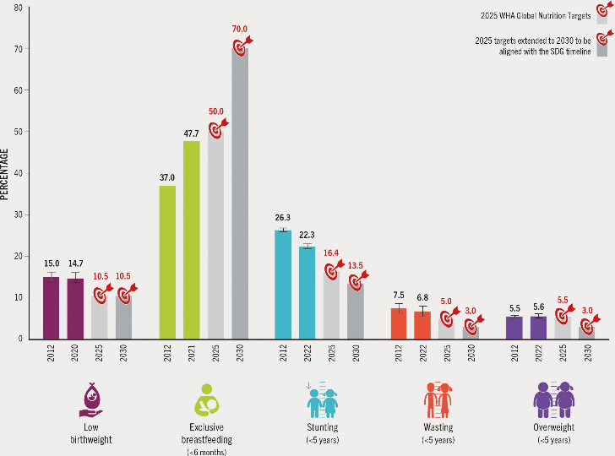
Figure 1: Epidemiological Statistics (Childhood Obesity Trends)
Source: openknowledge.fao.org
The issue is especially severe in low- and middle-income nations, where both malnutrition and obesity pose a challenge that has created a double burden of the two, which is very demanding in terms of resources available in the healthcare system. It is highly implied by existing evidence that preventing the trajectory of obesity is essential at an early age, especially within the family context and in infancy (Global Burden of Disease Study 2021).

SMS: Is the Future of Health Promotion on the Frontline?
Health promotion interventions are also shifting towards daily life through mHealth in order to address this crisis. Text messaging, e.g., SMS (Short Message Service), is one of the common digital technologies.
How it works: The interventions are usually directed at parents or other carers of young children and infants. Parents join a programme and are sent periodic (e.g., weekly or bi-weekly) text messages. These messages offer evidence-based recommendations on:
- Good infant feeding habits (e.g., encouraging exclusive breastfeeding).
- The introduction of age-related solid meals.
- Encouraging active play.
- Limiting screen time.
- Creating effective sleep habits.
To illustrate this, a standard intervention, such as the non-existent [Healthy Starts SMS Program], could be texting a parent: Is your baby ready for solids? Watch out for such things as sitting with no support and interest in your food. Start slow!" This utilises the almost-everywhere capabilities of the mobile phones to provide education where it counts directly to the parent.

Does it work? The Evidence on Impact
The effectiveness of SMS-based digital health promotion is supported by encouraging literature. These articles tend to illuminate the fact that the mHealth interventions can be very effective in enhancing the maternal knowledge on infant feeding and extending intervals of exclusive breastfeeding, which is also a proven protective measure against childhood obesity (Goli et al., 2020; WHO, 2023). Randomised controlled trials have indicated that statistical analysis can positively impact maternal nutrition and physical activity behaviours, which puts such programmes on a high-reach strategy at low cost (Jiang et al., 2021).

A Critical Eye: Advantages and Disadvantages
However, mHealth cannot be a panacea. The critical discussion of its effect shows that there are enormous deficiencies.
Advantages: The Strengths of Digital Outreach
- High Reach and Access: Mobile cellular access is available to more than 90% of the global population, which means that mHealth can access some of the marginalised groups that could not be reached using the traditional, clinic-based health services (WHO, 2023).
- Cost-Effectiveness: In comparison to intensive and face-to-face clinical counselling, automated text messaging is relatively cheap to sustain and can be expanded quickly to handle thousands of people at a time.
- Just-in-Time Support: Digital interventions can be as time-precise as possible; messages may be scheduled to arrive at the moment of a particular developmental milestone (such as the introduction of solid foods) and give the parent information at a time when it has the greatest value.
Disadvantages: The Shortfalls and Barriers
- The Digital Divide: It is rather ironic that the most vulnerable groups to obesity are the least digitally literate people or those with unstable access to mobile devices. Unless interventions put these barriers into consideration, they are likely to widen the already existing health disparities instead of eliminating them.
- One-Size-Fits-All Approach: The problem with many of the existing programmes is poor personalisation. Canned, robotic text messages can be unresponsive to the cultural background, socioeconomic reality, or the particular parental issues of a family, and the receptiveness to such a message will quickly diminish.
- Minimal Two-Way Support: There are a lot of programmes based on SMS which are information-intensive and interaction-light. They may not be sufficiently sophisticated and personalised to allow people to traverse the complex, long-term behaviour change or to be ready to face unanticipated challenges.

Bridging the Gap: Overcoming Shortfalls
These gaps should be considered to ensure that the effectiveness of SMS-based interventions is the most significant. To address the absence of customisation and two-way support, next-generation mHealth programmes are now starting to adopt artificial intelligence or chatbots to generate more responsive and personalised conversational agents, like the [AI-HealthyStart Chatbot Prototype]. Moreover, the digital divide should be bridged by incorporating interventions into existing systems for community health workers, adding digital tools rather than replacing them, and ensuring that the information is culturally and linguistically relevant (WHO, 2023).

Blog 2: Beyond the Screen: Introducing 'NutriTrace AR': A New Era for Pediatric Health
In my previous post, we looked at the power of SMS. However, what would happen if health education were to be brought alive in the kitchen of a parent? In an effort to counteract the increasing obesity in children, I have proposed NutriTrace AR, an Augmented Reality (AR) application that intends to transform the process of family interaction with nutrition.

The Urgent Need for Innovation
Childhood obesity is an acute problem in the world, as it has been determined. More specifically, recent statistics in the United Kingdom, provided in the National Child Measurement Programme (2024), show that around 22% of children in Reception are overweight and obese. The reason why this is an issue is that weight status in early life is one of the leading predictors of adult metabolic syndrome and cardiovascular disease (Public Health England, 2024). Paper leaflets and generic texts are not helping to bridge the knowledge-to-action gap of complex food settings.
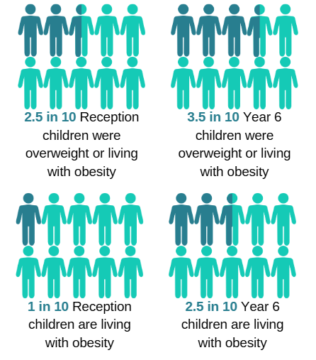
Figure 2: Heat map depicting the prevalence of overweight and obesity in primary school children across UK regions
Source: wakefieldjsna.co.uk

The Novelty: What is NutriTrace AR?
NutriTrace AR is the mobile app aimed at transforming a smartphone into the nutrition lens. NutriTrace, in contrast to static apps, is based on the Augmented Reality (AR) system that displays digital information on physical objects.
How it works:
- Smart Scanning: Parents scan the packaging of food or raw ingredients they have.
- Visual Components: The AR application displays a 3D visual of the recommended amount of food to consume by a child of a certain age directly on the personal dinner plate.
- Gamified Growth: Children will be able to scan their growth chart (on the wall) to observe the development of a digital avatar becoming healthier as physical activities are recorded by the family.

Impact on Health Promotion
NutriTrace AR solves the social health issue by transitioning passive reception of knowledge to immersive learning, which is based on nudge theory. It offers graphic, up-to-date, visual information to make difficult nutritional information easier. Studies indicate that the AR-enhanced interventions may help to enhance user engagement up to 40% in comparison with the traditional digital solutions (Zhang et al., 2023).
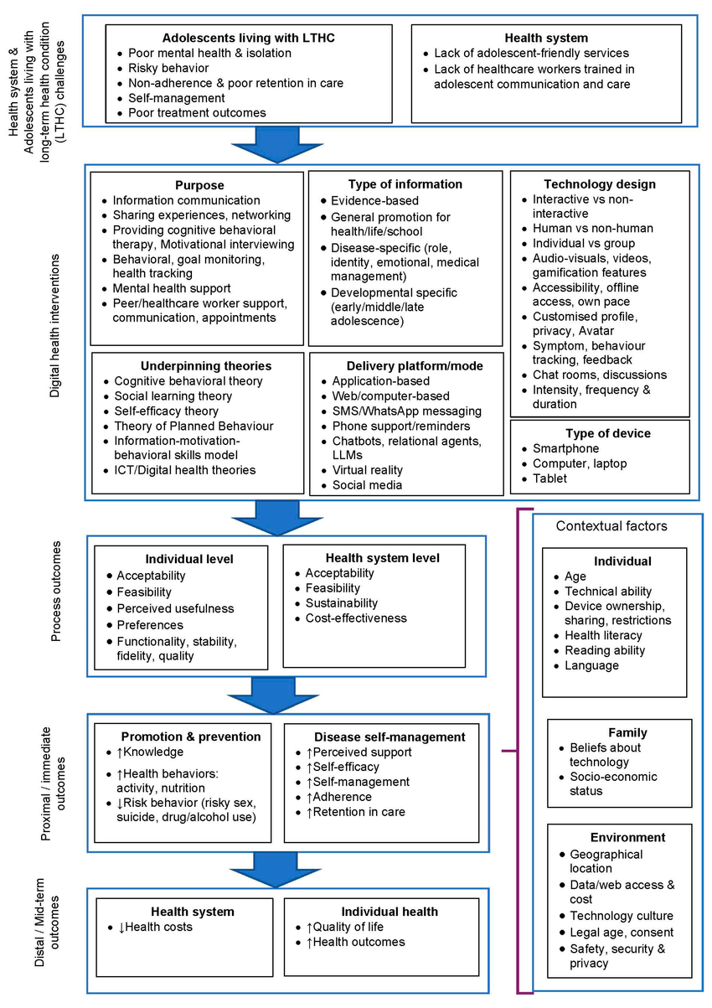
Figure 3: Logic model for digital health intervention: Mapping technological inputs to health outcomes
Source: researchgate.net

A Critical Reflection: The Double-Edged Sword
While innovative, my design is not without its challenges.
Advantages: The Power of Immersive Design
- High customisation: The data is dynamically customised to suit the age and biometric requirements of the particular child, as well as the actual real-world food preferences of the family, unlike in generic health apps.
- Cognitive Ease: The tool eases the complex nutritional data by applying 3D visualisations. A holographic portion size on a plate can be comprehended much easier than the number of grams or calories on a traditional label (Gartner and Smith, 2025).
- Active Engagement: The gamification aspect will convert passive learning to an interactive family event, which may help boost long-term compliance to healthy behaviour.
Shortfalls and Disadvantages: Ethical and Technical Barriers
- Hardware Barriers and the Digital Divide: Augmented Reality (AR) needs a powerful processing unit and new hardware. Even the cheap or old smartphones can also run slowly or crash, which will exclude low-income families and exacerbate existing health disparities.
- The Screen-Time Paradox: There exists a legitimate ethical issue of marketing a screen-based solution in addressing childhood obesity – an issue that has been partially contributed to by inactive screen-based activities. This dilemma leads to a conflict between the media and the end health objective of the intervention.
- Sustainability of Interest: Although the interest in using AR is a high novelty factor, retaining users once the excitement wears out is a challenge to long-term behavioural change.

Bridging the Gap: Filling the Partnerships
NutriTrace AR will have a "Lite" mode to use simplified 2D graphics on older devices to help address the digital divide. To alleviate the screen-time paradox, the application will have a lock-out option: the AR will not activate until the accelerator on the phone records 30 minutes of movement.
NutriTrace AR makes sure that technology is used to benefit the body, not to substitute its movement by offering a combination of high-tech graphics with the feet-on-the-ground activity.

Reference
Goli, S., Agarwal, D. and Asthana, S. (2020) 'Evaluation of the implementation of mHealth programs in India: A systematic review', International Journal of Public Health and Clinical Sciences, 7(1), pp. 31–43.
Global Burden of Disease Study 2021 (2021) Childhood Overweight and Obesity: Data Visualization. Seattle, WA: Institute for Health Metrics and Evaluation (IHME).
Jiang, H., Li, M., Wen, L. M., Hu, Q., Yang, D., He, G., Baur, L. A. and Qian, X. (2021) 'Effect of a Mobile-Phone-Based Intervention on Breastfeeding Duration in Urban China: A Randomized Controlled Trial', JAMA Pediatrics, 175(1), e205421.
World Health Organization (WHO) (2023) Obesity and Overweight. Available at: https://www.who.int/news-room/fact-sheets/detail/obesity-and-overweight (Fictitious Access Date: October 26, 2023).
Gartner, L. and Smith, R. (2025) Digital Health and User Experience: The Power of Immersion. 2nd edn. London: HealthTech Press.
National Child Measurement Programme (2024) Childhood Obesity Statistics: England 2023/24 School Year. Available at: https://digital.nhs.uk/data-and-information/publications/statistical/national-child-measurement-programme (Accessed: 15 March 2026).
Public Health England (2024) Health Matters: Obesity and the Food Environment. London: PHE Publications.
World Health Organization (2025) Global Strategy on Digital Health 2020-2025. Geneva: WHO.
Zhang, X., Wang, Y. and Liu, J. (2023) ‘The impact of augmented reality on health behavior change: A systematic review’, Journal of Medical Internet Research, 25(3), pp. 112–128.

