Blogging to communicate
Costa Coffee

Student name: Alina-Paula Manolache
Student ID: 2114609
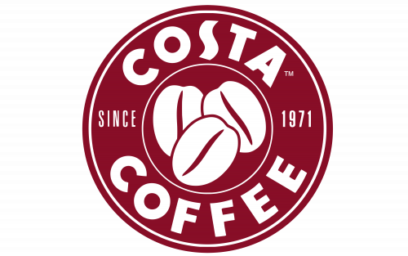
COSTA COFFEE COMPANY

Costa Coffee is a British coffee retail chain, owned by Whitbread from 1995 and in 2018 bought by Coca-Cola Company. Costa Coffee is an international brand, which is represented in over 40 countries with more than 3,800 coffee shops and voted the UK’s Favorite Coffee Shop. Costa Coffee has provided the service through its own stores, drive-thru, espresso bars and Costa at Home. Costa Coffee supports the communities, focus on social themes and as well established Costa Foundation, a charity for education.
Costa Coffee entry on the market started in 1971, when two Italian brothers Sergio and Bruno Costa came to London to share their passion and experience in coffee making. They started with a small roastery in Fenchurch Street, where they created the Signature blend, Mocha Italia. After few years, in 1978, the brothers moved in South London where they built a brand-new roastery, located on Old Paradise Street, Lambeth and remained there until 2017. Their first Costa Coffee shop was opened in Vauxhall Bridge Road in 1981, a strategic location for their start and the unique shape, crafted Cappuccino and Espresso served in porcelain cups brought them the success and customers could experience coffee at its best. In our case, the organization was concentrated on its limited resources on the greatest opportunities to increase sales and achieve a sustainable competitive advantage. Costa was focused on the key concept that customer satisfaction is the main purpose, as the customer constitutes the source of a company’s revenue.
That was the start of Costa Coffee expansion over UK and later on over the world. By 1995, Costa Coffee had 41 stores in the UK and it was acquired by Whitbread, the UK’s largest hotel and coffee shop operator for £19millions. Under Whitbread Company, Costa Coffee became more powerful because of the opportunities which Whitbread offered in their own hotels and restaurants .
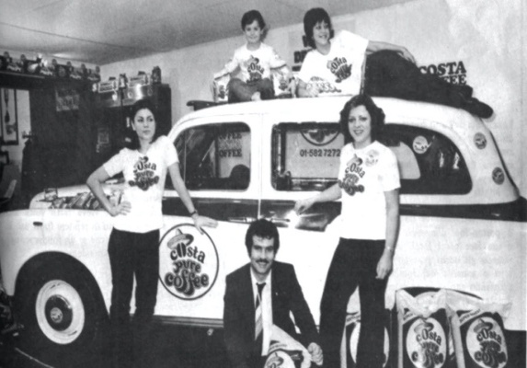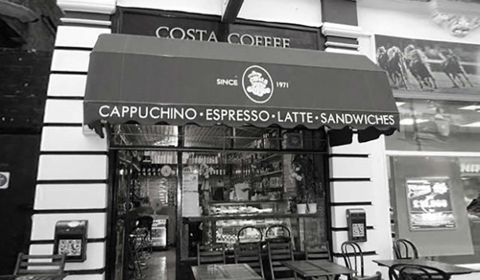

Coffee is one of the most profitable industry, so in 2018, Coca-Cola company purchased Costa Coffee from Whitbread for $4.9 billion, the takeover turn Coca-Cola into the biggest coffee shop player in UK.
UK customers have embraced coffee-shop culture since branded shops like Costa Coffee started to appear on the high street and coffee become an integral part of the day for many people. So Costa Coffee brand gained power because of its success, best fresh coffee, great location and customers obsession .
Costa collaborated with the big suppliers like Kuehne & Nagel, Freshways which have high quality and variety products and can satisfy customer wants.
Costa Coffee Expansion
Businesses with unique formats and strong brand position are increasingly moving into other places or countries. Many businesses are expanding internationally to escape saturated home markets. Thus, Costa Coffee grew quickly from being a wholesale operation supplying roasted coffee to caterers and specialist Italian coffee shops in 1971 to become the largest multinational coffee house company in the UK and the second in the world which plans to expand globally.
Costa Coffee’s main region of expansion outside the UK is Middle East, Dubai being the biggest and fastest growing market for Costa Coffee, therefore, here is the biggest branch, where can seat 320 people, but also in South West, Central and Eastern Europe . Firms like Costa want to tap into every country’s economic growth and to increase numbers of potential consumers.
By 2011, Costa Coffee operates 1175 outlets, making it the largest British chain in terms of stores. Those stores can be found in airports, motorway services, supermarkets, hotels and in some workplaces. In the same year, Costa purchased Coffee Nation, which is now Costa Express. Costa Coffee has been a leading player in the transport retail sector, in airports and railway station. Costa Coffee success come because they tried to satisfy customers needs and preferences, with a fresh roasted coffee combined with a velvety milk and a welcome atmosphere, helped Costa expansion all over the world.
The number of coffee shops in the UK has grown from 10,000 in 2007 to 24,000 in 2019, with 31,000 outlets forecast by 2022.

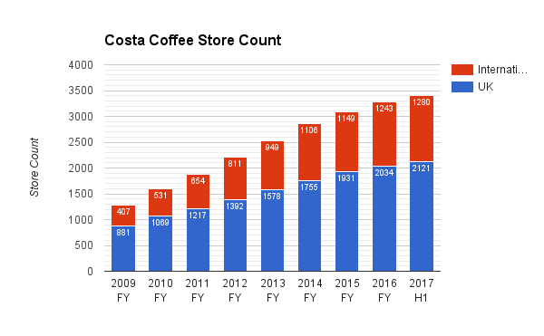
Competitors
The existence of competitors results in several strategic benefits and the competitors may share the costs of market and product development and help to create new technologies.
In our case, Costa Coffee is in competition with Starbucks, one of the biggest coffee shop chain around the world. Costa tried to understand the needs and wants of target markets and to deliver the desired satisfactions better than competitors do. Also, Costa Coffee is focused to win customers from competitors by delivering greater value. Both, Costa and Starbucks are coffee based, but each one have something different start from coffee beans roasting , flavors, pastries, cakes, savory lunchtime food and finish with the way of presentation and standards. The product differentiation is the method of distinguishing a product or offering from others, to make it more attractive to a particular target market. Thus, Costa Coffee demonstrate the unique aspects of firm’s product and create a sense of value.

Signature Blend
Costa Coffee is serving one of the best balanced coffee, their Signature blend, Mocha Italia, found in every store combined with fresh milk to create a delicious and warming cup of coffee, thus it’s making Costa Coffee The Nation’s Favorite Coffee Shop, being awarded "Best Branded Coffee Shop Chain in the UK and Ireland" by Allegra Strategies for 11 consecutive years (2010-2021).
The Signature blend is a perfect combination between Arabica and Robusta beans with a rich aroma and a smooth taste.
The products’ authenticity is because of the slow roasting method which roasts the beans slowly at reduced temperature, makes the coffee less bitter flavor and is on-trend with customer preferences.
Costa Coffee is always striving to deliver a great experience to their customers and give them a choice. Therefore Costa Coffee has a wide selection of hot and cold coffees , specialty teas and hot chocolates and large variety of cakes and sandwiches. The Flat White is the signature drink for Costa in the UK, they sell over 20m each year which equates to a whopping 10% of all drink sales.

Recycling Programme
Costa Coffee is one of the responsible businesses and it’s committed to reduce their impact on the environment, to reduce use of natural resources, to prevent pollution and promoting good environmental practice.
The company has a partnership with Veolia to recycle plastics and cardboard in the stores. Costa currently recycle 60% of the waste which generates it and send less than 0.5% of the waste to landfill. Withal, in 2018, Costa Coffee introduced new glassware for drink in iced drinks, which saved 8 million plastic cups in the first six month and replaced the plastic straws with a paper-based straws.
Costa Coffee is one of the businesses which is dedicated to increase recycling, but as well believes that encouraging reuse is the best way to forward for more sustainable future.
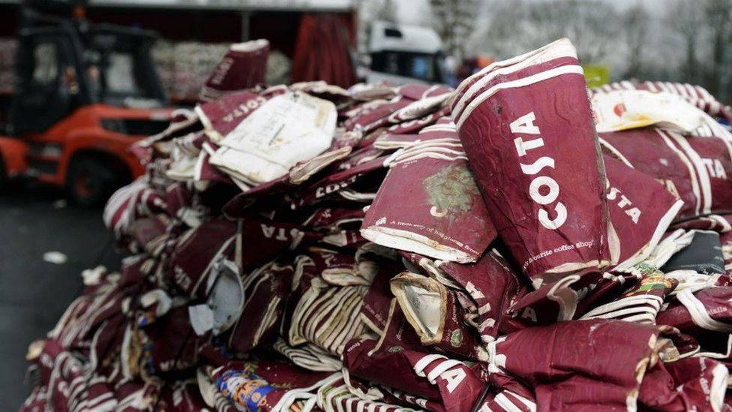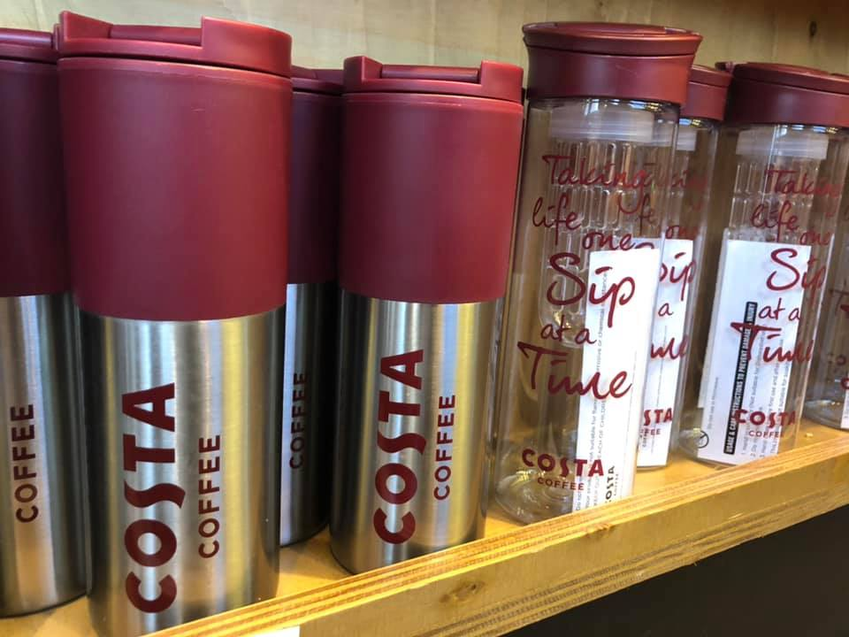

Basildon Roastery
Costa Coffee provide the high quality raw materials, so in 2017, with an investment of £38millions, Costa Coffee opened one of the biggest roasteries in Europe, in Basildon, Essex, where they can produce 45,000 tons of coffee a year, four times more than in the old roastery. Also, the roastery has an office area which accommodates employees and visitors to the new facility and a training academy which provides coaching to 3,000 baristas a year. Each barista has been trained in the art of making great coffee because the key ingredient to Costa Coffee is the expert way it’s served.
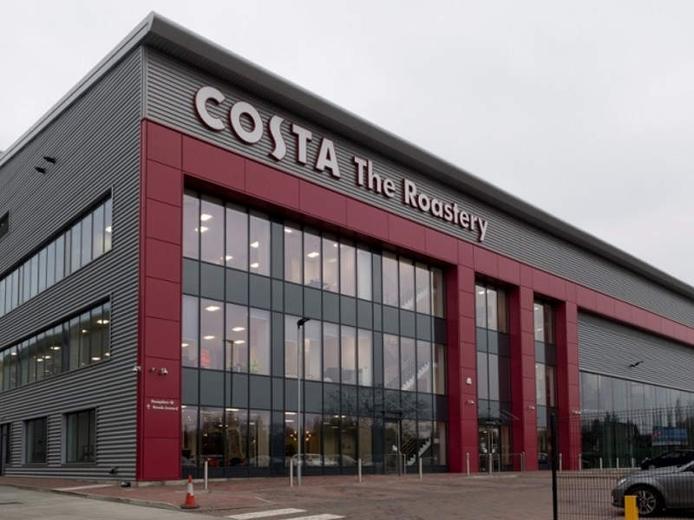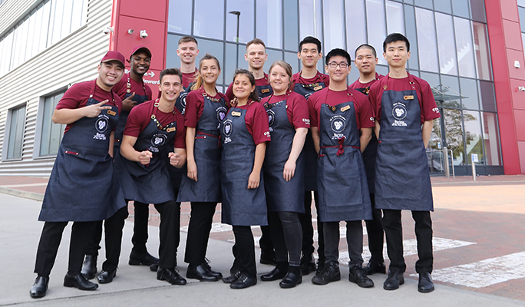

Basildon Roastery is one of the biggest roasteries, but is also one of the most sustainable buildings in the world where Costa experts source all raw coffee beans from 100% Rainforest Alliance Certified™ farms, from where they are than ready to be transported to Tilbury Dock, Essex, located 14 miles away from Costa Coffee Roastery, situated strategically for export.
Nutrition
Comparing with the competitors, like Starbucks, Pret A Manger, Nero, Costa Coffee is trying to provide a healthier choices and to improve the nutritional balance of their menu. Since 2015, they have supported Public Health England’s 20% by 2020 sugar reduction programme in food and 20% by 2021 sugar reduction programme in milk-based drinks. Costa introduced a healthier alternatives and reviewed the portion sizes. Customers can choose a dairy alternative milk, like almond, soya, coconut, oat milk, they can go for sugar-free syrups, order the drink in a smaller size and replace granulated sugar with plant-based, sugar-free stevia. Costa Coffee is one of the businesses which offer full range of menu to satisfy different customers’ needs and provides a comfortable environment and atmosphere with professional staff to serve their customers.

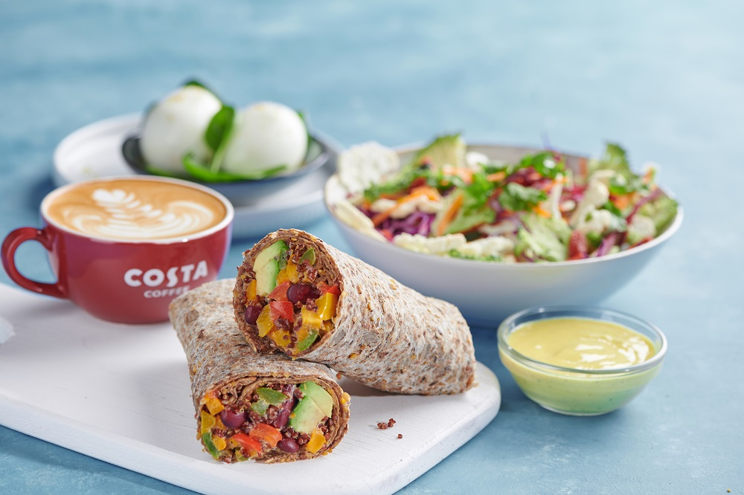

Costa Foundation and Communities
Costa Coffee like a business, cares not just about their customers and staff, but it focused on "helping communities grow", therefore they established Costa Foundation, a charity with a bold vision, to eradicate poverty in coffee-growing communities. The mission of Costa Foundation is to fund schools and schools projects in those communities which provide the opportunity to access a safe and quality education. The Costa team members are helping at this project every year, they had runs, cycles, swims, skating, snowboarding and skydiving. All Costa countries are working together to change a child’s life story. The idea was to make it personal and focus on the compelling stories of individual children who thrived at Foundation schools.



Costa Coffee has as well a Community Programme , to support the communities which they serve, focus on social themes like litter, loneliness and food waste. Every store has its own Community Noticeboard where customers and members of the public can put up news and information about activities that are happening in their local area. Involved in the community that’s helping the business to keep the loyalty customers in that area and to attract new ones.
Costa Coffee is the largest coffee chain in UK and the second in the world which operate for 50th years on the market. The company has a wide variety of products that vary based on cultures and the needs of the different countries in which it operates. Costa Coffee is developing quite rapidly because customers observed the quality of their products and the best customer service which provides.

References
- Costa Coffee, Our History Available at : https://www.costa.co.uk/behind-the-beans/our-story/history Accessed on 29.11.2021
- Costa Coffee, The Roastery Available at : https://www.costa.co.uk/behind-the-beans/our-story/roastery Accessed on 20.11.2021
- Davitt, Dermont(Nov/Dec 2005), Travel Retailer International, Stirring up the airport coffee market, pp 20-21 Available at : https://www.proquest.com/docview/194519732?OpenUrlRefId=info:xri/sid:primo&accountid=130472 Accessed on 8.12.2021
- Gulf News (April 2005) Dubai is biggest regional market for Costa Coffee Available at : https://gulfnews.com/business/markets/dubai-is-biggest-regional-market-for-costa-coffee-1.285491 Accessed on 03.12.2021
- Costa Coffee, Our coffees Available at : https://www.costa.co.uk/our-coffees Accessed on 29.11.2021
- Costa Coffee , At Home Available at : https://www.costa.co.uk/our-coffees/costa-at-home Accessed on 29.11.2021
- Alegra World Coffee Portal( February 2021), Costa Coffee crowned the Nation’s Favorite Coffee Shop for 11th years running Available at : https://www.worldcoffeeportal.com/Latest/News/2021/February/Costa-Coffee-crowned-the-Nation-s-Favourite-Coffee Accessed on 30.11.2021
- BBC News (October 2012) Costa Coffee helps Whitbread boost sales Available at : https://www.bbc.co.uk/news/business-20039070 Accessed on 29.11.2021
- Seeking Alpha (October 2016) Whitbread: Could Coffee Prices Cost Costa Its Growth? Available at : https://seekingalpha.com/article/4015949-whitbread-coffee-prices-cost-costa-growth Accessed on 30.11.2021
- INDEPENDENT ( April 2018) Costa’s recycling commitment is a vindication of The Independent’s campaign to cut cup waste Available at : https://www.independent.co.uk/voices/editorials/costa-coffee-recycling-cut-the-cup-waste-campaign-plastic-pollution-a8309306.html Accessed on 1.12.2021
- Costa Coffee, Press Releases( Feb. 2021) Costa Coffee crowned the Nation’s Favorite Coffee Shop for 11th years running Available at: https://costanewsroom.vuelio.co.uk/press/press-releases/48e6db8a-7920-4095-b263-21310d954cef/costa-coffee-crowned-the-nation-s-favourite-coffee-shop-for-the-11th-year-running Accessed on 30.11.2021
- Costa Coffee, Behind The Beans Available at : https://www.costa.co.uk/behind-the-beans Accessed on 29.11.2021
- Costa Coffee, Brand Excellence Manuel
- Coffee Blog, Kev( October 2020) Tag: Costa Coffee Available at : https://coffeeblog.co.uk/tag/costa-coffee/ Accessed on 29.11.2021
- Costa Coffee, Behind the beans, Managing waste Available at: https://www.costa.co.uk/behind-the-beans/planet/managing-waste Accessed on 08.12.2021
- Danny UK The Bearded Blogger(September 2019) Costa Coffee Available at : https://dannyuk.com/category/costa-coffee/ Accessed on 29.11.2021
- Caffe Society, Costa Coffee profits dip as independent coffee shops bite back Available at : https://www.caffesociety.co.uk/blog/costa-coffee-profits-dip-as-independent-coffee-shops-bite-back Accessed on 1.12.2021
- Costa Coffee, Behind The Beans, Cups and Packaging Available at : https://www.costa.co.uk/behind-the-beans/planet/cups-and-packaging Accessed on 29.11.2021
- Basildon Council, Basildon for business case study- Costa Coffee Available at : https://www.basildon.gov.uk/article/6446/Basildon-for-business-case-study-Costa-Coffee Accessed on 20.11.2021
- Costa Coffee, Behind the Beans, Nutrition and Wellbeing Available at: https://www.costa.co.uk/behind-the-beans/nutrition#allergens-advice Accessed on 29.11.2021
- Costa Foundation Available at : https://www.costafoundation.com/ Accessed on 30.11.2021
- Costa Foundation , Costa Foundation 50 Available at: https://www.costafoundation.com/costa-foundation-50/ Accessed on 30.11.2021
- Philip Kotler, Gary Armstrong, Lloyd C. Harris and Hongwei He,2020,Principles of marketing, Eighth European edition ,p. 1-637, Pearson Education Limited Available at: https://ebookcentral.proquest.com/lib/trinity/reader.action?docID=5978379 Accessed on 8.12.2021
- Costa Coffee, Behind The Beans, Local Community Available at: https://www.costa.co.uk/behind-the-beans/people/local-community Accessed on 1.12.2021

