Module Name: International Marketing: Principles and Practices
Module Code: LCMB7026

Student Name: Thelma Dhussey
Student ID: 2516910

Chosen Organisation: IKEA


Table of Contents
Introduction 2
Comparative Market Analysis Using PESTEL: IKEA in China and India 3
Comparative Analysis of STP and International Marketing Mix (7Ps): IKEA in China and India 5
IKEA’s Directional Development Strategy in India 8
Evaluation of Ethical Issues in the Marketing Mix of IKEA in China and India 11
Recommendations on Marketing Strategies of IKEA 12
Conclusion 14
Section 2: (Reflective Account) 15
References 18

Introduction
IKEA is a Swedish-based furniture and home decor retail company that was established in 1943 and is known for its low costs, ready-to-assemble furniture and stylish products. IKEA, which is based in more than 63 countries, is both cost-efficient and functional and modern, attracting diverse consumers. The company aims at sustainability, novel product design, and customer experience, and it is a firm belief in renewable resources and ethical business practices. In 2025, the group earned €44.5 billion as revenue (Statista, 2026).
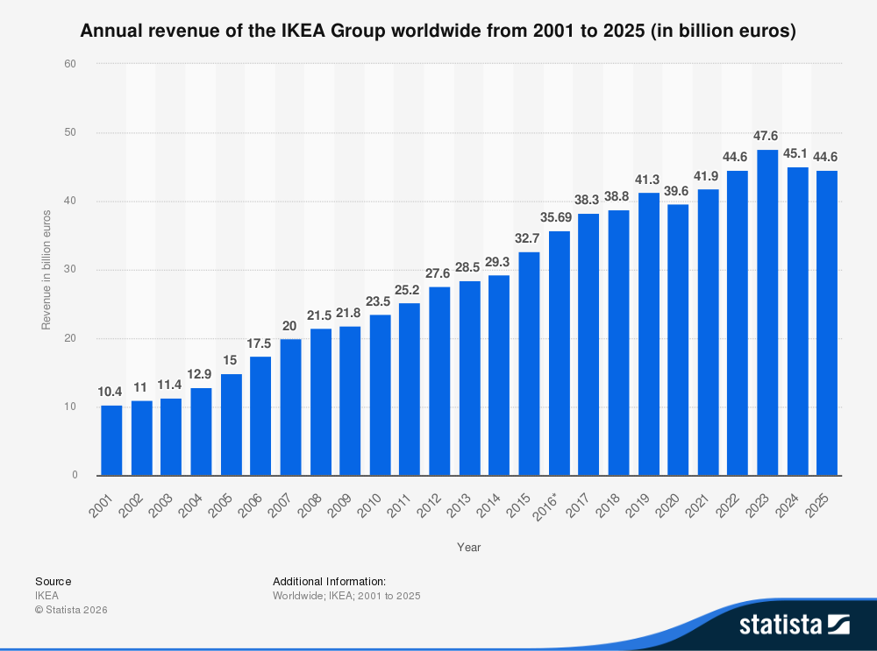
Figure: Annual Revenue (Statista, 2026).
This report is the analysis of international marketing strategies of IKEA in China and India, which are two of the largest emerging markets in the world. It offers a comparative analysis through PESTEL to analyse macro-environmental factors, consumer behaviour and culture. The report also analyses the STP (Segmentation, Targeting, and Positioning) and the 7P marketing mix of IKEA, its direction strategy of development in India and the possible ethical concern of the two countries. Lastly, the report will provide recommendations on the international marketing of IKEA to help the company realise sustainable growth and enhance its competitive advantage in these heterogeneous markets. A reflective account of the report will be provided using Gibbs Reflective Cycle.

Comparative Market Analysis Using PESTEL: IKEA in China and India
A PESTEL analysis assists in perceiving a business environment that is affected by the macro-environmental factors of a country where the business operates (Yusop, 2018). In the case of IKEA, China and India are major emerging markets with vast populations and expanding middle classes. However, differences exist between the two countries in terms of political systems, economic conditions and consumer behaviour. These factors can be used to understand the way IKEA works in these two markets.
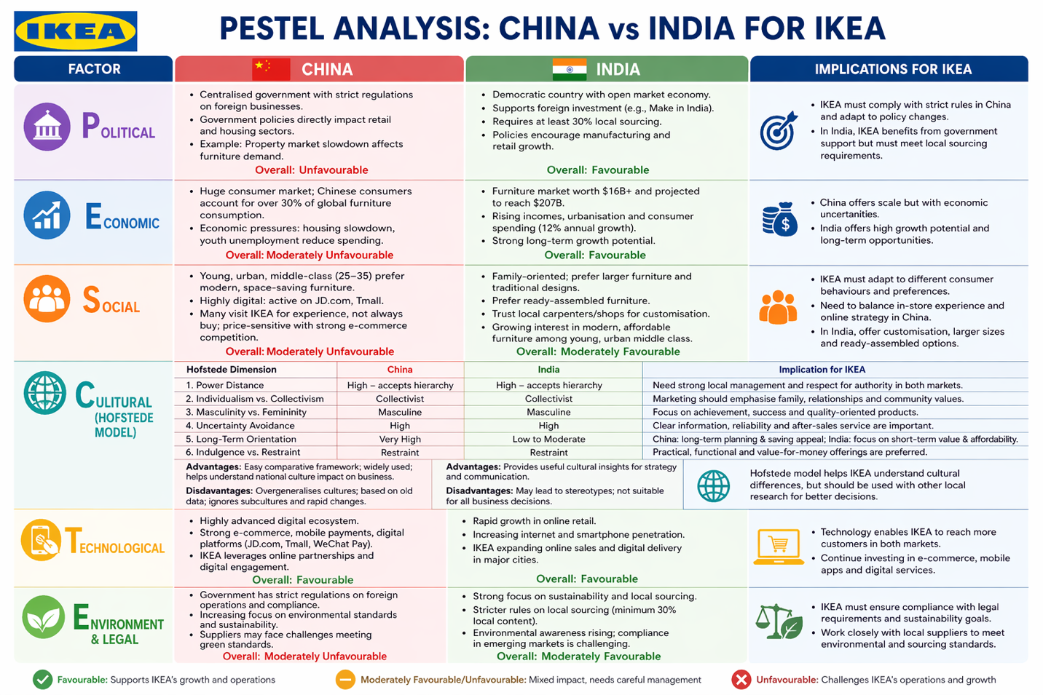
Source: (Self-made)

Political Factors: China is a centralised country in which the business regulations are highly governed by the government. Foreign corporations must operate within certain strict rules, and the governmental policy may have a direct impact on the housing business and retail industry (Groswald Ozery, 2023). As an illustration, the slowdown in the property market in China has decreased consumer spending on furniture, which impacts companies such as IKEA (Reuters, 2026). This has caused IKEA to recently shut down a few of its giant stores and turn to smaller stores and online sales to adjust to the change in economic conditions.
India, on the other hand, is a democratic nation with an open market economy. The government promotes foreign investment in retailing and manufacturing through initiatives like Make in India (Britannica, 2026). Nonetheless, the companies must address some requirements, including sourcing of at least 30% of their products domestically (The Economic Times, 2024). The policy has challenged IKEA to collaborate with the local suppliers and produce more locally in India.
Political factors are unfavourable for IKEA because of the rigid nature of the political environment due to regulations and government control. For India, Political factors are moderately favourable for IKEA because of supportive government initiatives towards investments by foreign companies.
Economic Factors: China is a huge consumer market in the world and a key consumer of furniture. The high demand for home products is reflected by the fact that Chinese consumers contribute over 30 % of the world's furniture consumption (McKinsey & Company, 2024). Nevertheless, in recent years, the economy has witnessed economic pressures like stagnation of housing and unemployment among the youth, limiting home products expenditure (Marketing to China, 2021).
The market of furniture in India is not large, but it grows very fast. It is a market worth over $16 billion, and it is projected to grow to $207 billion with the increasing level of income and urbanisation (afaqs! 2024). Moreover, India is expected to emerge as one of the biggest consumer markets in the world and consumer expenditure is projected at 12 % annually, which is high compared to the world average. This growth potential has made IKEA heavily invest in India and expand its stores and online presence.
Economic factors are moderately unfavourable for IKEA because of declining property market and low consumer expenditure on furniture in Chinese market and for Indian market the economic factors are favourable because of growth of furnishing market.
Social Factor: Consumer behaviour in the two countries is heavily impacted by social and cultural differences. Modern, stylish and space-saving furniture is mostly preferred by consumers in China, as most people live in small apartments in large cities. The primary target market of IKEA is young urban consumers, especially middle-class customers between 25 and 35 (The Brand Hopper, 2020). The consumers in China are also heavy users of digital platforms, and most of them use online shopping on websites like JD.com and Tmall (DataReportal, 2025).
Another notable behaviour in China is that most of them attend the IKEA stores solely for leisure or experience rather than for purchasing. Other consumers visit products in store but purchase other cheaper alternatives online (Burt et al., 2021). This behaviour demonstrates the effect of price sensitivity and intense competition in e-commerce on buying decisions.
On the contrary, culture and family lifestyle are strong factors affecting consumer behaviour in India. The Indian families usually choose big furniture that fits the joint families and traditional designs (Lingxiu, 2017). Ready-assembled furniture is also preferred by many customers as opposed to the do-it-yourself model applied by IKEA.
The highly unorganised market is also another distinct characteristic of the Indian market. Many customers purchase furniture from local carpenters or small shops because they have confidence in them and can easily customise their furniture (Yadav, 2020). But with the expanding middle-income and young urban generation, there is a rising trend of people showing interest in modern and affordable furniture, such as IKEA.
Social factors of Chinese market are unfavourable for IKEA because of the tendency among Chinese people to look for low-priced items online. On the contrary, social factors are moderately favourable for IKEA in Indian market because of cultural differences in furniture preferences, but a growing proportion of young people living in urban areas.
Cultural factor: Culturally, by the use of the Hofstede framework, China and India both have certain similarities as well as differences. Both China and India score highly on the dimension of power distance and are considered to be masculine societies. This means that there is need for a structured organization and a desire for achievement among consumers. China scores highly on collectivism and long term orientation, while India has a blend of collectivism and individualism with moderate long term orientation. India scores highly on flexibility on uncertainty avoidance while China scores higher on structure (The Culture Factor, 2023).
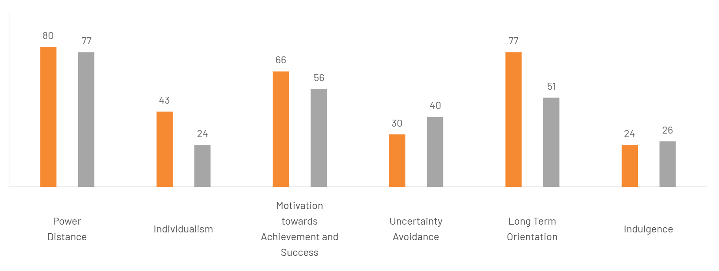
Figure: Hofstede cultural difference India vs China (The Culture Factor, 2023).
Technological Factors: The use of technology also influences the operation of IKEA in these markets. China possesses some of the most developed digital retailing environments in the world and has robust e-commerce and mobile payment systems (Yani et al., 2025). Consequently, IKEA has increased its online alliances and digital connections to access more customers.
Online retail in India is also rapidly increasing. IKEA has also established digital delivery platforms and online commerce in some of the cities to target those consumers who are not in proximity to its physical stores (The Economic Times, 2024).
Environment and Legal Factors: The two nations are becoming very concerned with environmental sustainability. IKEA markets green products and renewable resources on the international market. But this may not be easy when environmental standards are being implemented in emerging markets where the suppliers might not have sustainable technology.
In India, there are stringent regulations on local sourcing by companies and in China, the government is stricter with foreign business operations.

Comparative Analysis of STP and International Marketing Mix (7Ps): IKEA in China and India
Since IKEA is an international furniture retailer, its Segmentation, Targeting and Positioning (STP). approaches and the 7Ps marketing mix are different and aligned to the cultural, economic, and social characteristics of specific markets. China and India are the emerging economies with huge populations, which offer different consumer behaviour and market environments; in this case, IKEA needs to adopt a different approach.
Segmentation, Targeting, and Positioning (STP)
Segmentation: Segmentation means breaking down the market into groups of consumers with a similar character. IKEA has been segmenting its market in China, mainly based on demographics, lifestyle and urbanisation. The target market will be young city residents aged 25-35, residing in medium-size (and even smaller) apartments, often single or in nuclear families, and prone to modern, practical, and low-cost furniture. These are tech-savvy consumers who shop online a lot (Burt et al., 2021).
In India, there is wider segmentation of people because of different socio-economic status, culture and family set-up. IKEA targets the middle classes in the urban and semi-urban setting between the ages of 28-45 years who are purchasing larger homes to fit the joint family living. The lifestyle segmentation is also significant since the younger urban consumers are becoming more interested in modern modular furniture, whereas the older consumers tend to favour traditional designs. (IBEF, 2024).
Targeting: In China, the targeting revolves around concentrated targeting; the target market is young urban consumers in Tier 1 and Tier 2 cities, including Shanghai, Beijing and Shenzhen. There is a higher disposable income, a lower living space, and a great demand for contemporary design in these cities (Lingxiu, 2017). IKEA operates a differentiated targeting strategy in India, where the products are priced to attract the urban middle-class families who want their houses furnished in a modern way and young professionals who want IKEA products because of their affordability and utility (Arulsenthilkumar and Punitha, 2023).
Positioning: In China, positioning focuses on modernity, functionality, and global style. IKEA is positioned as a high-end but lower-end company that uses innovative and space-saving furniture solutions (Pham and Hongyu, 2012). In India, the positioning is somewhat different. According to Lawrence et al. (2021), IKEA is a foreign brand that introduces quality, modern design, and products of good value, focusing on low prices, customisation, and products that are also environmentally friendly to attract environmentally conscious consumers.
International Marketing Mix (7Ps)
IKEA has modified its 7Ps, namely Product, Price, Place, Promotion, People, Process and Physical Evidence, to meet the needs of the local consumer and economic situation in China and India.
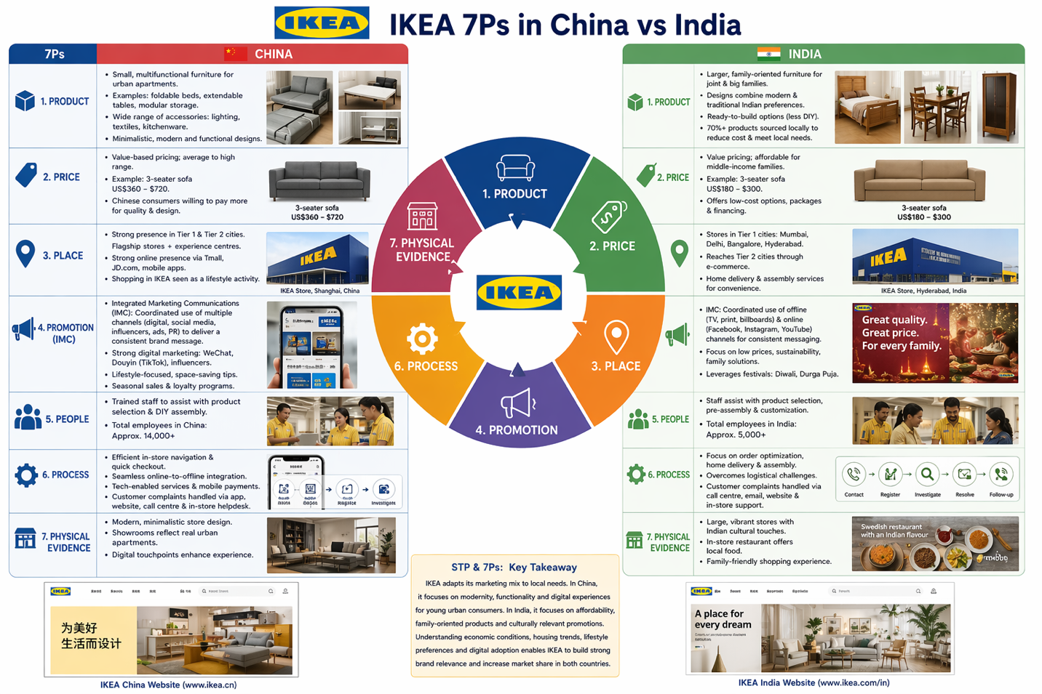
Figure: IKEA 7ps China vs India (Self-made)
Product: IKEA in China provides small and multifunctional furniture that fits in small apartments in cities. These are foldable beds, extendable dining tables and modular storage. IKEA is also known to offer a complete assortment of accessories to match the furniture, including lighting, textiles, and kitchenware (Lingxiu, 2017). Product adaptations can be affected by the consumer preferences for minimalistic, modern, and functional designs.
Indians have larger, family-based products, serving joint families and larger families. The furniture designs embrace modern and traditional Indian preferences. IKEA also offers ready-to-build alternatives to the Indian consumer who may not be as fond of the do-it-yourself (DIY) model prevalent in China. Moreover, IKEA has partnered with suppliers who are based locally to procure more than 70 %of its products locally, lowering its cost and responding to local preferences (Longani and Sharma, 2024).
Price: IKEA applies value-based pricing in both markets but comes to terms with the local purchasing power. The prices of furniture in China are average to high, considering the urban middle-income purchasing power and the increased real estate prices (Burt et al., 2021). A typical 3-seater sofa can be priced between $360 to $720, depending on the design and materials. The Chinese are ready to spend a little more on international brands offering modern design and quality.
In India, IKEA concentrates on low prices, as per capita income and price sensitivity among middle-income families are lower. The 3-seater sofa is costing $180-$300 on 3-seater (Yadav, 2020). IKEA can also provide less expensive options, packages and financing to appeal to more low-end buyers.
Place: The e-commerce and urban retail market in China is very developed. IKEA also has its flagship stores in large cities and has large online sale networks with such platforms as Tmall and JD.com that offer convenience and online payment. Physical stores are frequently planned as experience centres, where consumers perceive shopping in IKEA as an activity in life (Lawrence et al., 2021).
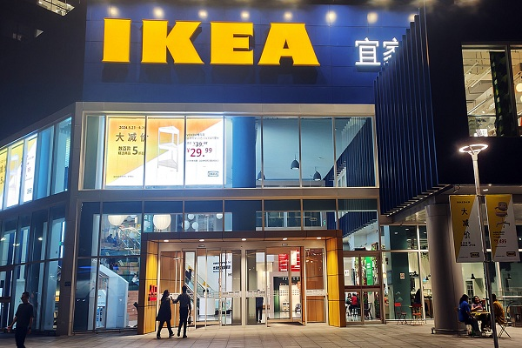
Figure: IKEA store in China (Shanghai Municipal Government, 2024)
IKEA uses a combination of physical and e-commerce in India, though, because urban density is lower, the location of stores is limited to Tier 1 cities, which include Mumbai, Delhi, and Bangalore. Consumers in Tier 2 cities are reached online (Lawrence et al., 2021). IKEA also adopts the use of home delivery and assembly as a strategy to satisfy the needs of the Indian consumers who would like ready-to-use furniture.
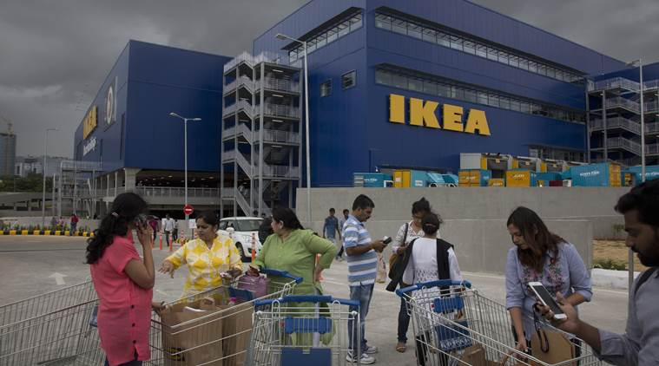
Figure: IKEA store in India (Bloomberg, 2018)

Promotion: A brief definition of IMC Integrated Marketing Communications could be included.
Integrated Marketing Communications (IMC) is regarded as the coordinated use of different promotional tools and channels to deliver a consistent and unified message to the target audience (Kitchen and Burgmann, 2010). The promotional strategies in both markets are culturally adjusted to the preferences and media consumption habits. IKEA is employing digital and social media marketing in China, such as WeChat campaigns, TikTok (Douyin) videos, and working with influencers. Promotions are lifestyle-focused, innovative and convenient, and they tend to include small space living tips. There are usual seasonal sales and loyalty programs (Burt et al., 2021).
IKEA in India is utilising both offline (TV, billboards) and online marketing (Facebook, Instagram, YouTube). Advertisements emphasise low prices, green products and solutions that are family-friendly (IKEA, 2021). Promotional opportunities are achieved by local festivals like Diwali and Durga Puja to reach the Indian culture.
People: IKEA focuses on the experience in the store and customer service in both countries. Workers are trained to be able to help customers to choose furniture and how DIY assembly works in China, and in India, employees also service pre-assembly and customisation.
Process: China focuses on effective in-store orientation, quick checkout, and online-to-offline smooth integration, which serve the tech-based consumers (Pham and Hongyu, 2012). India pays attention to the optimisation of the order, home delivery, and assembling services to overcome the logistical obstacles and introduce convenience.
Physical Evidence: The IKEA stores in China are built as modern, minimalistic ones, and the display rooms are in line with the real urban apartments. In India, the stores are large, vibrant, and culturally modified, such as in-store restaurants that sell local foods, which is more appealing to the shopping experience and makes the brand more accessible to the families (Yadav, 2020).
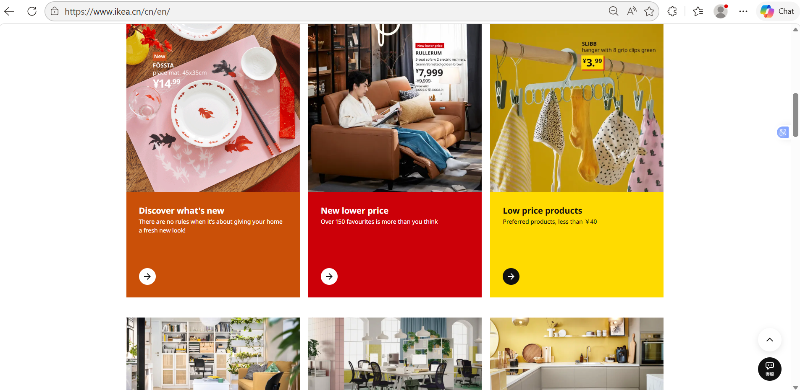
Figure: IKEA’s website for China (IKEA, n.d.)
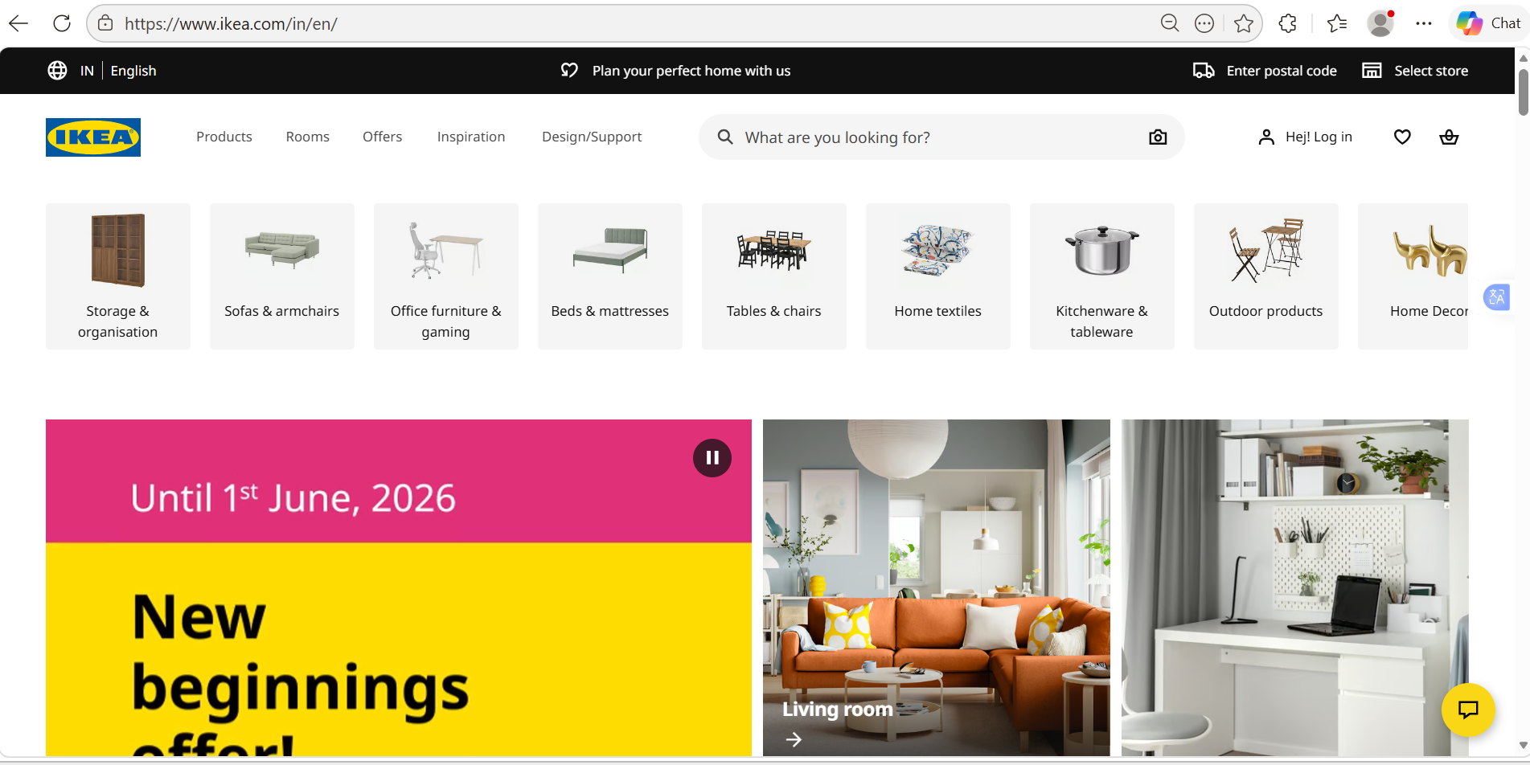
Figure: IKEA’s website for India (IKEA, n.d.)
The STP and 7Ps strategies that IKEA uses in China and India show that the local adaptation is significant. Whereas China focuses on modernity, functionality and digital experiences among young urban consumers, India needs to focus on affordability, family experience products and culturally targeted promotions. The success of IKEA in the two countries hinges on the knowledge of economic conditions, residential trends, lifestyle preferences and digital adoption, which inform its customised marketing mix and positioning approach (Lawrence et al., 2021). IKEA makes its brands more appealing to the local needs and increases its market share in these emerging markets.

IKEA’s Directional Development Strategy in India
The directional development plan of IKEA in India is based on market expansion, localisation, and sustainability over the long term. India is ranked as one of IKEA's most significant growth markets based on its high population, escalating middle-class and increased demand for contemporary home furniture (Ingka Group, 2025). The firm has embraced a market development and market penetration approach to bolster its market and grow its customer base.
Investment and Market Expansion Strategy: India IKEA was opened in 2018 in Hyderabad, and since that time, the company has opened additional stores in such cities as Mumbai and Bangalore. The firm has invested more than $1.6 billion in India in the form of stores, supply chain, and digital development (IKEA, 2021). This massive investment indicates that IKEA is committed to the Indian market in the long term.
The current furniture market in India is evolving at a high rate. In 2025, the size of the market is $60 billion, and it is estimated to reach a value of $89 billion in 2031 with a growth rate of approximately 7.2% annually (Grand View Research, 2024).
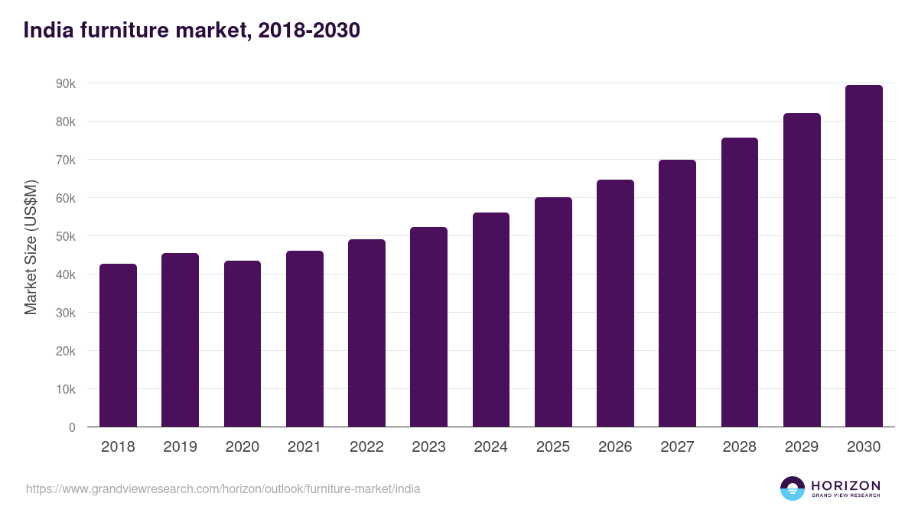
Figure: Indian Furniture Market (Grand View Research, 2024).
The urbanisation, escalating income, and housing demand contribute to this growth. IKEA plans to tap a good portion of this growing market by establishing additional stores in Tier 1 and Tier 2 cities.
Localisation Strategy: Local adaptation is one of the strategies of IKEA in India. The company has made changes in its product variety, price, and operations to suit the needs of the Indian consumers. As an example, IKEA has almost 70% of its products locally sourced, contributing to lower costs and governmental compliance (Lawrence et al., 2021).
Regarding product design, IKEA has products that can match the Indian lifestyle, including bigger beds, wardrobes, and kitchen storage units to accommodate joint families (IKEA, 2021). The company is also involved in selling pre-assembled furniture and assembly services, whereby many Indian consumers demand the ready-to-use products instead of assembling the furniture themselves.
Omnichannel and Digital Growth: IKEA is also working towards an omnichannel approach, whereby the company uses physical outlets and internet platforms. E-commerce is significant in India, where not everybody lives in proximity to major stores. According to The Economic Times (2026), IKEA has also expanded its online services to such cities as Delhi, Pune and Ahmedabad, where customers can easily browse and buy the products online.
The size of the current e-commerce market of India is $120-$140, and the size of the market is expected to reach more than $280-$300 billion by 2030. This presents a great opportunity to increase online sales by IKEA (The Economic Times, 2026). IKEA enhances the accessibility and convenience of customers by combining an online store with the physical outlets.
Low Cost and Market Penetration: IKEA employs a low-cost approach to capture middle-income consumers in India. The Indian consumers are more price-sensitive than those in developed markets. Thus, IKEA provides affordable products, offers and package deals (Arulsenthilkumar and Punitha, 2023). This strategy is aligned with Market Penetration strategy of the Ansoff Matrix by which an organisation can boost market share of existing products in the existing market capitalising on competitive pricing and promotions (Loredana, 2016).
As an example, simple furniture like chairs and tables is priced at a low price to appeal to first-time consumers (Löfstedt, 2018). This pricing approach assists IKEA in entering the market and competing with local furniture retailers, which occupy a huge percentage of the market.
Long-Term Growth and Sustainability: Another key aspect of the development strategy of IKEA is sustainability. The company encourages green products, renewable resources and energy-efficient outlets. IKEA collaborates with the local suppliers too to enhance sustainable production.
In India, IKEA is making an investment in renewable energy and striving to become climate-positive by 2030 (Longani and Sharma, 2024). This has not only aided the environmental objectives but also enhanced the brand image of the company to the consumers who are environmentally friendly.
In general, the IKEA directional development strategy in India is oriented towards expansion, localisation, affordability, and sustainability. With high investments, local culture adaptation, and digital platforms, IKEA is developing a good presence in the Indian market. The long-term strategy will enable the company to capitalise on the rising economy and rising demand of India towards modern home solutions, which will guarantee future sustainable growth.

Evaluation of Ethical Issues in the Marketing Mix of IKEA in China and India
IKEA has a reputation for being highly devoted to sustainability and ethical business conduct. However, like most international companies, it has encountered certain ethical issues concerning its marketing mix (product, price, place and promotion) in India.
Sustainability and Product Problems: The sourcing of raw materials, particularly wood, is one of the primary ethical issues. IKEA utilises so much wood in making its furniture, and there have been concerns that not all the materials are sourced in a sustainable manner. In the past, reports have raised concern about the transparency of the IKEA supply chain, especially in those countries whose environmental laws are less strict (IKEA, 2021).
IKEA has a goal of using 100 % sustainable or recycled materials by the year 2030, but difficulties still lie in tracking the suppliers in third-world countries such as India and China. An example is that a local supplier might not necessarily work under stringent environmental regulations, which can result in deforestation or destruction of the environment (Hu, 2023). This leads to the ethical issue of whether IKEA is truly sustainable in its practice.
Competitive Pricing and Fair Competition:
IKEA's low pricing policy is appealing to customers; however, it may cause some ethical issues in terms of competition. Small local businesses and carpenters dominate the furniture business in India (Löfstedt, 2018). The fact that IKEA can afford low prices because of the large-scale production and sourcing all over the world can be a burden to these small business enterprises, which might interfere with their livelihoods and their income.
Simultaneously, in China, not all consumers are convinced that the IKEA products are comparatively cheap in relation to the local ones (Rangan et al., 2014). This gives the perception problem where the profile of IKEA being affordable does not always align with local expectations, where the question of fairness and transparency on pricing arises.
Place and Labour Practices: The other ethical concern is associated with supply chain labour practices. In the past, IKEA has been criticised over working conditions in the supplier factories around the world. Although the company has enhanced its policies in its IWAY code of conduct, it is still difficult to hand out fair wages and a safe working environment to all the suppliers, particularly in big markets such as China and India (Laurin and Fantazy, 2017). As an example, compliance across hundreds of suppliers can be challenging, and any breach of labour standards can affect workers and damage the ethical reputation of IKEA.
Promotion and Cultural Sensitivity: Promotion may also attract ethical issues, especially on issues of cultural representation. IKEA usually aligns its advertising to the local cultures, but there is always the possibility of misinterpretation or misrepresentation of the local cultural values.
In China, IKEA has placed a lot of emphasis on online marketing and lifestyle advertisement. Nevertheless, critics claim that the brand encourages the Western lifestyle that does not entirely capture the local culture (Lingxiu, 2017). IKEA has tried to incorporate local culture in its promotions in India, like celebrating festivals like Diwali, but it should not make its campaigns offensive and culturally insensitive.
In general, IKEA has done a good job of being ethically sound, particularly regarding sustainability and responsible sourcing. Nevertheless, there are still problems in the areas of supply chain transparency, fair competition, labour practices, and cultural sensitivity. All these points point to the need to constantly keep an eye on these matters to be sure that the marketing mix adopted by IKEA is ethical and corresponds to its international values in China and India.

Recommendations on Marketing Strategies of IKEA
To be more competitive in such international markets as China and India, IKEA needs to emphasise localisation, sustainability, digitalisation, and responsible business practices. These suggestions are in line with the academic marketing theories.
Focus on Local Adaptation: According to Ghemawat (2004), international firms must strike a balance between standardisation and local adjustability. IKEA must keep its products, promotions, and services aligned with the needs of the local consumers. This, in the case of China, involves providing small-scale, multi-purpose furniture in small urban apartments. To appeal to cultural views of joint families in India, IKEA must focus on the furnishings that are family-sized and pre-assembled.
The process of promotion must be culture sensitive, where local festivals and traditions can be used to identify with the consumers (Barbu, 2011). As an example, in India, it is possible to promote pieces of furniture during the season of Diwali/weddings, which makes it more relevant and involved.
Improve Digital and Omnichannel Presence: As e-commerce is growing, particularly in China and India, IKEA needs to reinforce its online virtual frontiers and combine them with the physical stores. Under the customer-centric marketing strategy cited by ASLAN (2021), accessibility and convenience enhance customer satisfaction and loyalty.
In China, one can partner with such platforms as JD.com or Tmall to reach more people, whereas in India, collaboration with delivery, assembly services, and mobile applications will allow IKEA to reach Tier 2 and Tier 3 cities (Hu, 2023). Younger urban consumers can also be targeted through digital marketing campaigns using social media and influencers.
Ensuring Ethical and Sustainable practices: The IKEA brand all over the world is closely linked to sustainability. To handle ethical concerns, the company ought to increase the transparency of its supply chain, make all suppliers comply with labour and environmental regulations, and advocate for ecologically friendly products.
According to Hofstede's cultural dimensions theory, described by Żemojtel-Piotrowska and Piotrowski (2023), IKEA must pay attention to both long-term orientation and collectivism in the two markets. Chinese and Indian consumers care about sustainability and social responsibility, which can be able to boost brand loyalty provided that ethical practices are conveyed by being articulate in the marketing campaigns.
Adaptable Pricing policies: IKEA needs to keep on adjusting pricing to the local purchasing power. In India, the low-end packages and financing solutions can appeal to price-sensitive buyers, whereas in China, high-end product lines can be offered to urban professionals, who want to be stylish and functional (Mandal, 2020). IKEA will be competitive in the two markets through dynamic pricing strategies.
Experiential Marketing and Community Engagement: It is possible to enhance the perception of the brand by creating interactive experiences in the shop and advertising workshops, DIY training, or culture. Experience marketing fits with the Kotler et al. (2015) theory, where engaging the customers with meaningful experience leads to enhanced loyalty and word-of-mouth advertisement.
The international marketing strategy that IKEA should use should be a blend of local adaptation, ethical, digital integration, and customer-centric strategies. By taking into consideration cultural, economic, and social diversities, IKEA can reinforce its global brand and attain sustainable growth in China and India, as well as other developing markets.

Conclusion
Conclusively, the present report has revealed that the ability of IKEA in China and India to succeed is based on the ability to appreciate the differences in political, economic, social, technological, environmental, and legal aspects. China has a large tech-conscious urban market, which prefers modern, space-efficient furniture, yet there is a risk of high competition and price-sensitive customers. India, conversely, possesses a rapidly expanding furniture market due to the increase in income, urbanisation, and the need to purchase products for family size and cultural adaptability.
IKEA has properly exercised the STP and the 7Ps marketing mix in adapting to these markets. In China, modern, multi-purpose products, digital promotion and stores in cities are valued, whereas in India, affordability, sourcing locally, pre-assembled products and culturally relevant promotion are considered.
Sustainability and ethical issues are also tackled by the company, but the supply chain transparency and fair competition remain a challenge. With ongoing localisation, online growth, corporate responsibility, and customer relationship building, IKEA can attain sustainable growth and advance its presence in these new markets.

Section 2: (Reflective Account)
Reflective practice is a significant component of learning because it enables one to revise, synthesise, and better his work (Brockbank et al., 2017). To come up with this report on the international marketing strategies of IKEA in China and India, I relied on the Reflective Cycle of Gibbs (Adeani et al., 2020). This cycle entails six steps, which include description, feelings, evaluation, analysis, conclusion, and action plan. The application of this framework allowed me to consider the research, analysis, and writing process critically, identify my strengths and weaknesses, and create a plan on how to enhance my academic and professional abilities. The reflection also allowed me to learn that it is crucial to connect the theory with the practical world, and that the cultural, economic, and social factors should be considered when analysing the work of international business.
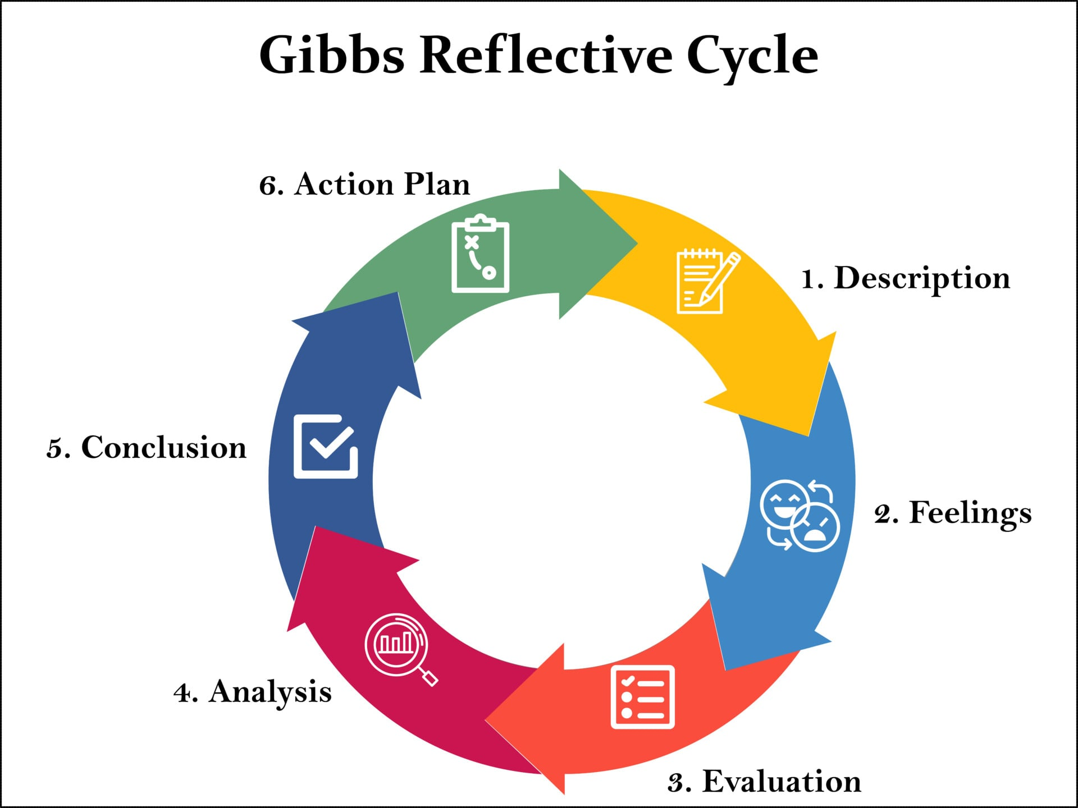
Figure: Gibbs Reflective Cycle (Adeani et al., 2020)
Description: The assignment involved a critical comparative study of the operation of IKEA in China and India, in terms of the PESTEL framework, STP (Segmentation, Targeting, and Positioning), the 7ps marketing mix, directional strategy, ethical concerns and strategic proposals. My start point was secondary data, which I gathered through diverse publications like scholarly journals, industry reports, government statistics and reputable news publications. This enabled me to comprehend the political, economic, social, technological, environmental, and legal environments in both countries.
After collecting the data, I put it into sections by the frameworks. I compared the targeting and segmentation strategies of IKEA and how the company is applying different positions in China and India. I also reviewed the 7Ps of marketing mix and how IKEA uses its product, price, place, promotion, people, process, and physical evidence market strategies to match the local markets. I also researched the IKEA direction strategy in India, the market expansion, the localisation strategy, and the digital integration strategy, and I discussed ethical concerns in its supply chain, pricing, and promotions. Finally, I have summarized all findings into a clear and structured report in a concise and simple language, retained a tone of academic report, and presented supporting arguments in terms of data and examples.
Feelings: I felt overwhelmed and anxious at the start of this task because the task required me to process a lot of information, and at the same time, it involved various frameworks and two different countries. I feared that I would fail to find up-to-date and real data to back up my comparisons and be able to present complicated concepts using simple language.
Nonetheless, when I organised my research and started sorting data, I became more confident. The task was not overwhelming because the report was broken down into sections, and each section dealt with one framework. Another aspect that I was pleased and inspired by was my ability to relate the strategies of IKEA with theories such as the Cultural Dimensions theory provided by Hofstede and the Global Standardisation vs Local Adaptation Theory as put forward by Levitt. The application of these theories rendered the report more analytical and provided me with a feeling of accomplishment because I was able to explain why the marketing of IKEA in China and India is different.
Evaluation: My approach had several positive sides. The systematisation of the research based on frameworks such as PESTEL and STP allowed me to compare the markets systematically. The credibility and accuracy of the analysis were contributed to by using credible sources such as McKinsey, The Economic Times, and DataReportal. The fact that statistics, actual examples, and information specific to the company have been included reinforced the report and made it more persuasive.
Conversely, there existed certain problems. At the beginning, I found it difficult to connect theory and practice, and certain portions were more descriptive as opposed to analytical. I also struggled to sustain the number of words used and have all the points covered in an appropriate manner. Another difficulty was to balance simple language and academic rigor as I did not want to make the report simple and dull but professional.
Analysis: It involved a learning process that taught me the significance of data interpretation in context, and not the collection of data. For example, the identification of the cultural dimensions through Hofstede in relation to IKEA marketing in China and India was useful in explaining why the store layouts, product sizes, and even promotions varied. The explanation in the globalisation versus localisation theory gave me to know why IKEA employs various strategies in these markets, striking a balance between the global brand image and the needs of the local consumers.
I also got to know the importance of time management and planning. The split into sections, which included PESTEL, STP, 7Ps, directional strategy, ethical evaluation and recommendations, enabled me to deal with one part at a time, and the research did not seem to be overwhelming. Furthermore, I understood that the visual illustrations, such as tables or charts, could have served better when comparing two markets, yet there is no way I could exceed the word count limit.
Conclusion: Considering this process, I have obtained enhanced insight into research, critical analysis, and academic writing. I got to know how to assess secondary data, connect it with the marketing theory, and make it coherent and structured. I also realised the significance of culture, economy and social aspects in international marketing. Also, I became more conscious of ethical concerns and the role of sustainability and responsible business practice in international operations. This has improved my analytical skills, research skills, and the skills of simplifying complex ideas.
Action Plan: To accomplish future assignments, I will focus on the following areas:
I will begin the research sooner, before feeling overwhelmed and have extra time to analyse data. Displaying comparisons using visual aids like charts, tables or diagrams is preferred. I will try to be more consistent in integrating theory and practice and connecting every point to an appropriate framework. I will try to make a balance between word count, depth and make the analysis concise and comprehensive. I will focus on rechecking to make the narrative more understandable, coherent, and analytical. Use various sources, industry reports, and scholarly articles to be more credible. With these strategies, I will improve my research abilities and academic writing and make tasks in the future more efficient and effective.

References
Adeani, I.S., Febriani, R.B. and Syafryadin, S., (2020). Using GIBBS reflective cycle in making reflections of literary analysis. Indonesian EFL Journal, 6(2), pp.139-148.
afaqs! (2024) AJIO taps Dhurandhar buzz with official Ranveer Singh-signed merch. Available at: https://www.afaqs.com/marketing/ajio-taps-dhurandhar-buzz-with-official-ranveer-singhsigned-merch-11216952 (Accessed: 16 March 2026).
Arulsenthilkumar, S. and Punitha, N., (2023). Ikea India: Building diversity and inclusion. JIMS, 8, p.59.
ASLAN, R., (2021). Customer-centric marketing. Contemporary business techniques, pp.55-73.
Barbu, C.M., (2011). Cultural adaptation of products. Management & Marketing-Craiova, (1), pp.105-110.
Bloomberg (2018) Ikea’s sofas and spoons in demand as first India store opens. The Indian Express. Available at: https://indianexpress.com/article/business/ikeas-sofas-and-spoons-in-demand-as-first-india-store-opens-5300356/ (Accessed: 24 April 2026).
Britannica (2026). Economy of India. Available at: https://www.britannica.com/money/economy-of-India (Accessed: 16 March 2026).
Brockbank, A., McGill, I. and Beech, N., (2017). Reflective learning in practice. In Reflective learning in practice (pp. 18-28). Routledge.
Burt, S., Dawson, J., Johansson, U. and Hultman, J., (2021). The changing marketing orientation within the business model of an international retailer–IKEA in China over 10 years. The International Review of Retail, Distribution and Consumer Research, 31(2), pp.229-255.
Burt, S., Dawson, J., Johansson, U. and Hultman, J., 2021. The changing marketing orientation within the business model of an international retailer–IKEA in China over 10 years. The International Review of Retail, Distribution and Consumer Research, 31(2), pp.229-255.
Chu, V., Girdhar, A. & Sood, R. (2013) ‘How IKEA adapted its strategies to expand in China’, Business Today, 6 July. Available at: https://www.businesstoday.in/magazine/lbs-case-study/story/how-ikea-adapted-its-strategies-to-expand-in-china-132642-2013-07-06 (Accessed: 16 March 2026).
DataReportal (2025) Digital 2025: China. Available at: https://datareportal.com/reports/digital-2025-china (Accessed: 16 March 2026).
Ghemawat, P., (2004). Global standardization versus localization. The global market: Developing a strategy to manage across borders, pp.115-145.
Grand View Research (2024) India furniture market size & outlook, 2021–2030. Available at: https://www.grandviewresearch.com/horizon/outlook/furniture-market/india (Accessed: 17 March 2026).
Groswald Ozery, T. (2023) Law and political economy in China: The role of law in corporate governance and market growth. Harvard Law School Forum on Corporate Governance. Available at: https://corpgov.law.harvard.edu/2023/11/28/law-and-political-economy-in-china-the-role-of-law-in-corporate-governance-and-market-growth/ (Accessed: 16 March 2026).
Hu, Q., (2023). The Observations of IKEA in Chinese Market. Academic Journal of Business & Management, 5(12), pp.56-60.
IKEA (2021) IKEA India launches its first city store in Mumbai. Available at: IKEA newsroom article (Accessed: 17 March 2026).
IKEA (n.d.) IKEA China – official website. Available at: https://www.ikea.cn/cn/en/ (Accessed: 24 April 2026).
IKEA (n.d.) IKEA India – official website. Available at: https://www.ikea.com/in/en/ (Accessed: 24 April 2026).
Ingka Group (2025) Ingka Group Annual Summary and Sustainability Report FY25. Available at: Access report (Accessed: 17 March 2026).
Kitchen, P.J. and Burgmann, I., 2010. Integrated marketing communication. Wiley international encyclopaedia of marketing.
Kotler, P., Burton, S., Deans, K., Brown, L. and Armstrong, G., (2015). Marketing. Pearson Higher Education AU.
Laurin, F. and Fantazy, K., (2017). Sustainable supply chain management: a case study at IKEA. Transnational Corporations Review, 9(4), pp.309-318.
Lawrence, G., Harvey, A., Hunter, J., Mohammed, A., Nolan, W., Stallings, L. and Jones, C., (2021). IKEA: GROWING THE MARKET IN INDIA–AN INTERNATIONAL CASE STUDY.
Lingxiu, J., (2017). IKEA marketing entry strategy in China.
Löfstedt, G., (2018). MOVING FORWARD IN INDIA An Analysis of IKEA’s Indian Distribution Network Development.
Löfstedt, G., (2018). MOVING FORWARD IN INDIA.
Longani, K.D. and Sharma, P., (2024). The green movement of sustainability: A case of IKEA in India. Perspektif Komunikasi: Jurnal Ilmu Komunikasi Politik Dan Komunikasi Bisnis, 8(2), pp.241-250.
Loredana, E.M., 2016. The use of Ansoff matrix in the field of business. In MATEC Web of Conferences (Vol. 44, p. 01006). Les Ulis, France: EDP Sciences.
Mandal, P.C., (2020). Pricing Strategies of Multinationals for Global Markets–Considerations and Initiatives: Pricing Strategies for Global Markets. International Journal of Business Strategy and Automation (IJBSA), 1(1), pp.24-36.
Marketing to China (2021) Furniture in China: The epic guide to sell to Chinese consumers. Available at: https://marketingtochina.com/furniture-in-china-the-epic-guide-to-sell-to-chinese-consumers/ (Accessed: 16 March 2026).
McKinsey & Company (2024) The truth about Chinese consumption. Available at: https://www.mckinsey.com/cn/our-insights/our-insights/the-truth-about-chinese-consumption (Accessed: 16 March 2026).
Pham, B. and Hongyu, X., (2012). Managing cultural differences in MNE: a case study on IKEA in China and their staffs.
Rangan, V.K., Toffel, M.W., Dessain, V. and Lenhardt, J., (2014). Sustainability at IKEA group. Harvard Business School Case, pp.515-1033.
Reuters (2026) China's new home prices extend decline in February as recovery remains elusive. Available at: https://www.reuters.com/world/asia-pacific/chinas-new-home-prices-extend-decline-february-2026-03-16/ (Accessed: 16 March 2026).
Shanghai Municipal Government (2024) Trendy stores in Shanghai. Available at: https://english.shanghai.gov.cn/en-TrendyStores/20240927/67115fcf32404e27bd460f323d72d752.html (Accessed: 24 April 2026).
Statista (2026) Annual sales of IKEA worldwide from FY 2009 to FY 2025. Available at: https://www.statista.com/statistics/264433/annual-sales-of-ikea-worldwide/ (Accessed: 17 March 2026).
The Brand Hopper (2020) Case study | IKEA “Glocal” marketing strategy in China. Available at: https://thebrandhopper.com/2020/11/14/case-study-ikea-glocal-marketing-strategy-in-china/ (Accessed: 16 March 2026).
The Culture Factor (2023) Country comparison tool: China vs India. Available at: Country comparison tool (Accessed: 24 April 2026).
The Economic Times (2024) IKEA looks at next round of investment in India after fulfilling Rs 10,500-cr promise. Available at: https://retail.economictimes.indiatimes.com/news/home-and-decor/furniture-and-decor/ikea-looks-at-next-round-of-investment-in-india-after-fulfilling-rs-10500-cr-promise/107413229 (Accessed: 16 March 2026).
The Economic Times (2026) IKEA aims to be profitable by FY28; to open 25 new small & medium size stores in next 4–5 years. Available at: https://economictimes.indiatimes.com/industry/services/retail/ikea-aims-to-be-profitable-by-fy28-to-open-25-new-small-medium-size-stores-in-next-4-5-years/articleshow/129103156.cms (Accessed: 17 March 2026).
The Economic Times (2026) India’s e-commerce market estimated to touch USD 300 billion by 2030: BCG report. Available at: https://economictimes.indiatimes.com/industry/services/retail/indias-e-commerce-market-estimated-to-touch-usd-300-billion-by-2030-bcg-report/articleshow/128744460.cms (Accessed: 17 March 2026).
Yadav, N., (2020). IKEA Inc.: the India way. Emerald Emerging Markets Case Studies, 10(1), pp.1-9.
Yani, M.F., Muhdiantini, C., Firdaus, F.A. and Muhammad, H.A., (2025). IKEA: Enhancing Customer Experience through Digital Transformation. JIPI (Jurnal Ilmiah Penelitian dan Pembelajaran Informatika), 10(2), pp.1771-1779 (Accessed: 16 March 2026).
Yusop, Z., (2018). PESTEL analysis. Paper presented at COMRAP, pp.34-39.
Żemojtel-Piotrowska, M. and Piotrowski, J., (2023). Hofstede’s cultural dimensions theory. In Encyclopaedia of sexual psychology and behaviour (pp. 1-4). Cham: Springer International Publishing.

