Critically reflect on your progress in planning, preparing and teaching lessons that incorporate 4 specific pedagogical principles. Identify one of these pedagogical principles as an area for development and justify the next steps in your development.

 | Targed/Target:  Targets given by marker CM from ECAD6007 essay | Yr hyn yr wyf wedi’i wneud yn yr aseiniad hwn….  What I have done in this assignment….
Targed/Target 1 | Ensure that you include information that is relevant to your essay but also that you include essential information that is required by the assignment brief | I followed the assignment brief to inform my essay.
Targed/Target 2 | Take every opportunity to use the literature to support your points | I have tried to support my writing through the use of appropriate literature.
Targed/Target 3 | Look for ways of comparing and contrasting specific ideas from the literature that you use, and use these to present a synthesis of some of the key ideas. Use this guide one developing critical approaches https://www.youtube.com/watch? v=DR9Zq7y9xt4 | I watched the suggested video and tried to implement these skills. I still feel like I need to work on this.

Part 1: Critically reflect on your progress in planning, preparing and teaching lessons that incorporate 4 specific pedagogical principles.
Professional Experience Template 1
Pedagogy Standard | Assessment for learning
What did you do and why? | I led a whole class guided reading session. In order to effectively prepare for the lesson, I decided to read the chapters of the book the class were going to read. Whilst reading the book, I planned questions I could ask the children. I realised my questions were all quite similar and I feared they were not challenging enough. I engaged in some research into effective questioning and found a useful resource (see below).  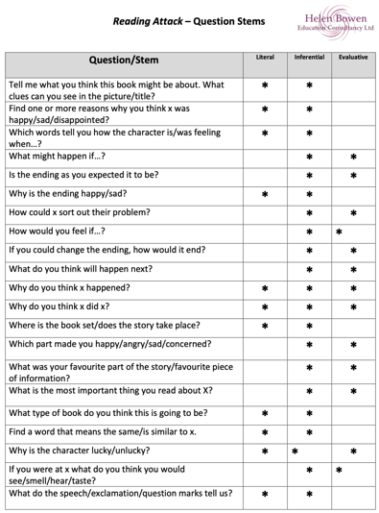  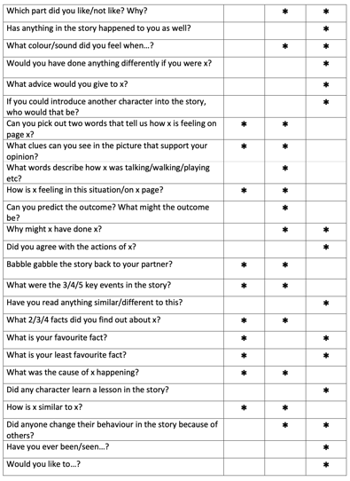  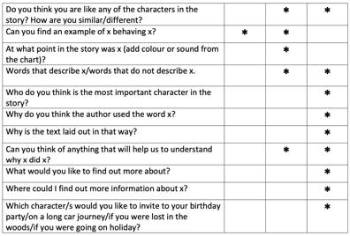  Reading these example questions gave me ideas on how I could expand upon my questions, which I them incorporated into my planning.  I also decided to print these out so I could refer to it in future lessons (see below)  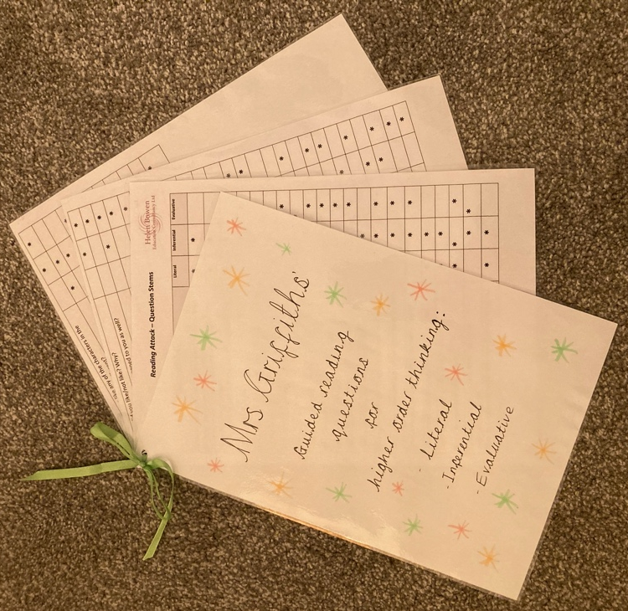  During the lesson, I was able to refer to my plan and ask the questions I had planned to ask. At first, I was asking the questions to the whole class and children put their hand up or called out their answers. I soon realised the same children were offering answers, so I began asking specific children. Doing this helped me to see how well the children were understanding the text, and highlighted to me which children were not. For example, I asked one child a question and they were unable to answer me. Another child offered an answer. I then asked the first child the same question and she was able to repeat what the other child had said. I told her I would ask her the same question at the end of the lesson and that I hoped she could give me a different answer. I did so and she was able to answer the question. Asking this child the questions alerted me to her lack of understanding, but it also made me think about how I could ensure she was provided with the opportunity to develop her understanding. Furthermore, on gaining a relationship with this child, I knew she often dislikes talking in front of her peers this giving her the opportunity to think of an answer was able to give her confidence.  The lesson was only planned to last 30 minutes, however, due to an incident, the class teacher was required to leave the class and asked me to continue the lesson until she returned. The lesson lasted over an hour. As I had not planned for the lesson to be so long, we began reading chapters of the book I had not yet read and therefore had not yet prepared questions for. This meant I had to think of questions on the spot. Fortunately, I had my questioning booklet I had made and was able to refer to it. After a little while of doing this, I noticed I was able to develop questions independently.
What have you learned? | I have learnt the difference between ineffective and effective questioning. Through practise, I have become more capable to understanding what an effective question is, however, I do so by basing this of a child’s response to my question. I notice I tended to ask a question thinking it was a high-quality question, but I was not met with the high-quality response I expected. I quickly realised this was not due to the child’s understanding, but rather due to my question. Using the questioning stems helped me to develop my ideas on this.  Although the questioning steps are useful, they are literacy based, so I began noticing my literacy questions were improving, but my questions in numeracy were not.
What next? | As I feel I can only tell if a question is effective or not by a child’s response, I feel I need to work on beginning to foresee their answers.  As my questions were not as effective in numeracy lessons, I need to research effective questions to check understanding and further children’s learning in numeracy and across other subjects.

Professional Experience Template 2
Pedagogy Standard | Blended learning experiences  “Teaching contexts and methods are blended to use experience from varied and appropriate environments to support each other. Learning areas such as the workshop, outdoors, laboratory, studio, gymnasium, library, theatre and classroom are integrated settings for learning, demonstrating discipline and structure appropriate to experience.”
What did you do and why? | In order to teach the topic of ‘countries and continents’ in a blended learning context, I provided the pupils with the opportunity to lead themselves in an example of self-directed learning. The children had three options to choose from; they could either create ‘Instagram’ posts, make a fact-file/brochure, or produce an advert (see below). To engage in investigatory work, the children were provided with methods to do so. These include the printing out of a range of Instagram posts and key landmarks from around the world. I also provided with the pupils with travel brochures and library books of different destinations and countries from around the world, laptops and iPads to conduct research. The children were not given a structure of how to produce the work and self directed learning was encouraged in order to show a variety of blended learning techniques. For example, some work the children produced included shadow art, the use of multimedia software and some implemented a performance arts piece. The children who chose to perform, did so by using the schools recording studio whilst others used the school grounds to showcase the natural beauty of Wales.      
What have you learned? | On reflection, I feel that providing such blended learning opportunities and encouraging self-direction in their learning can result in all of the children taking a different approach. This can make it difficult for the adults in the classroom to manage. When the pupils asked for support, it is difficult for the teacher and the teacher assistant to provide immediate assistance whilst the educator is discovering not only what the pupil is working on, but also what element of the blended learning task they are working within. However, all pupils decided to work on areas in which they had a particular interest in as part of groups with peers in which they may not usually be part of. This allowed for mixed ability work. The children were proud of the work and were confident in presenting it to the rest of the class. I have learnt that blended learning offers rich opportunities for deep understanding through pupil voice, however, practitioners must be organised yet flexible to ensure all pupils achieve success when doing so.
What next? | I need to personally improve my delivery of such sessions as I can see the benefits of implementing these methods. I need to be prepared in order for pupils to take my ideas further if they stumble across potential opportunities.

Professional Experience Template 3
Pedagogy Standard | Real life authentic contexts  “The teacher demonstrates an understanding of the use of real life, authentic contexts for learning being provided as a natural part of the learning experience. This extends the learner’s cultural, linguistic, religious and socio-economic experience and illustrates applications of concepts and abstracts in practice.”
What did you do and why? | During the topic of persuasion, I encouraged the pupils to persuade me to do a set of tasks to make the topic more engaging. This enabled the pupils to use a range of persuasion techniques in order for me to carry out a specific action which would be a result of the pupils using persuasive techniques effectively. I feel that this would be an effective way of teaching the subject of persuasion as pupils can immediately see the results, in the form of myself doing an action, by using a range of features. Another option would have been to teach the different techniques without demonstrating the practical examples which potentially would not have the same outcomes.  
What have you learned? | I have learned the importance of using real life authentic contexts as it allows pupils to contextualise their learning. Without practical examples, the pupils would not have been able to apply their learning to where it would be necessary to use in a real life context. Using practical examples, allows the pupils to see the purpose and benefits of the learning as well as facilitating an enjoyable learning experience.
What next? | Throughout my professional teaching experiences and for the duration of my career, I will ensure that there are opportunities to embed real life authentic contexts into my teaching to ensure that pupils have the best possible learning experiences. I will do this by considering a number of different contexts depending on what topic is being covered within my teaching. There are a number of options and opportunities to include any real-life contexts to any topic that can is taught within a classroom. I believe that the ability for pupils to apply their learning to a real life scenario is imperative for them to consolidate their understanding and learning.

Professional Experience Template 4
Pedagogy Standard | Cross-curricular themes  “The teacher knows, understands and engages with the principles of curriculum design and innovation, with development of cross-curricular themes relevant to areas of learning and justifies decisions.”
What did you do and why? | As part of the previously stated lessons where I had taught the topic of persuasion, I used this developed knowledge within a humanities lesson and more precisely, within a Geography lesson. The prior learning of ‘persuasion’ was utilised by the pupils having to convince others within the group to visit a specific country from around the world in which they were assigned with. Pupils used the skills and techniques of the persuasion lesson to persuade their peers of the positives and areas of interests of their designated countries, whilst presenting these specifics positively, in a way in which others may feel that they may want to visit the country having heard the argument for that nation. This is a clear link of cross-curricular themes, as an important literacy skill has been implemented in a Geography context.
What have you learned? | I have not only learned of the importance of implementing cross-curricular themes into my teaching, but I have also experienced the benefits of using such teaching methods. There has been extensive research that states the importance of cross-curricular themes within teaching and how it is every practitioner’s responsibility to implement, literacy and numeracy in particular, into all aspects of teaching. Having now had experience of teaching using cross-curricular themes, I can quickly observe the advantages of doing so. Not only did pupils create their own quick links to their prior learning and implemented their knowledge effectively, but I also had the advantage myself of teaching a Geography topic to a good standard using the skill of persuasion.
What next? | I will continue to embed cross-curricular themes into my planning and teaching to ensure that links can be made within a pupil’s learning and understanding of any given topic. I will consider other areas of the curricular and think how different themes can be added to other areas of and topics of future learning. This includes not limiting my planning to embedding literacy and Welsh themes, but further themes to create a whole learning experience for all of my pupils.

Part 2: Identify one of these pedagogical principles as an area for development and justify the next steps in your development.

In this essay, I will set out to engage in a critical reflection on my progress in planning, preparing, and teaching lessons which incorporated a pedagogical principle, and consider a personal area for development with an identification on steps I should take in order to develop my teaching.

In his review of the curriculum, Donaldson (2015) stated that the only way in which his radical proposals would become successful, would be dependent on the daily ongoings in every classroom throughout Wales. This message – effective learning is dependent on good teaching – is echoed throughout the powerful and ever-developing body of knowledge (Hargreaves and Fullan, 2012; Donaldson, 2011; Hattie, 2009; Payne, 2008; OECD, 2005; Elmore, 2004). Donaldson (2015) suggests that pedagogy is not just about teaching, but rather it is a combination of practical and theoretical knowledge with consideration and decisive selection of different teaching methods in response to individuals within the classroom in order to ensure all children learn effectively. The findings of these suggest that not only is effective pedagogy is essential, but that pedagogy and curriculum are intertwined, and when used in tandem they can propel learning within the classroom, moreover, it suggests that the teacher must be the core facilitator of effective learning.

Donaldson (2015) stated that the recommendations made within this review are not to be seen as placing an emphasis on particular teaching approaches, but rather it notions that any decisions made regarding teaching and learning should be based on contextual matters with specific purposes. He suggested the reflective process of identifying the pupils’ greatest needs, them matching the need with the most appropriate pedagogical approach, followed by assessing the impact of the teaching approach through pupil progress, and repeating as necessary. For these reasons, Donaldson (2015) argues pedagogical decisions are best made by the teacher.

It is for this reason that I feel, as a student teaching in my school, I have the means to decide upon which strategy I need to improve upon in order to have a greater impact on my placement school and the children I will have the privilege of teaching. Although I will be moving classes next term, I know that the school is in a deprived area and subsequently has low literacy standards which has been highlighted on the school’s action plan. Additionally, it was recommended within the school’s Estyn (2019) report that the school should strive to improve the quality of feedback. On discussion with the class teacher, she made me aware that the school are working on this recommendation by employing assessment for learning (AfL) strategies, and she told me that effective questioning was a part of the school’s aims. Due to a cumulation of these reasons, I will explore the pedagogical principle of AfL with the aim of developing this area of my practice in order to benefit the children in my placement school.

Aristotle (c. 338 B.C.), as referenced by Srivastava (2005) recognised that the curriculum is a syllabus of study based on theoretical knowledge, yet he believed that the approach of transmitting said syllabus in practical ways is how to best measure outcomes. In translation, this highlights that the curriculum is just the foundation of what pupils must cover during their time in school, but rather it is the how teachers choose to approach the curriculum that influence children’s attainment (Darling-Hammond et al, 2003). As there are no definite impeding insufficiencies highlighted in the curriculum in Wales itself, it can be surmised that the delivery of the curriculum is what has been causing the low outcomes in Wales (OECD, 2014). To support teachers in delivering the curriculum effectively, initiatives and approaches to teaching and learning are devised.

AfL is a combination of strategies which allows for a process in which both teachers and learners determine if an understanding is present and, if so, the learning can continue and progress. Information is collected to see if progression can take place in terms of the next steps of learning, within any given topic. The pupil, through AfL, can become aware of the progression that is needed in order to climb to the next step to ensure they are performing within lesson time. The process of AfL should not be compared with traditional methods of assessments in the form of testing pupils. Instead, AfL data can be gathered through use of feedback, observation and communication. William and Black (1998) stated that in order for pupils to observe and identify the learning in which they undertake, pupils must engage in AfL to progress. AfL is a statutory requirement which aims to provide pupils with the opportunity to assess their own learning and was initially piloted in Wales between 2005 and 2008 (Welsh Government, 2010). AfL can be defined as a formative assessment practice, where it not only benefits the pupils, but also informs the teacher on how to direct future learning (Welsh Government, 2013). In addition to pupils being aware of their own progression and achievements within lessons, early results of the pilots found there to be improvements in pupils’ performance. This then led to an improvement in pupil attainment levels, overall engagement during lessons and an improvement in overall skill development. As a result of this, this correlated with higher educational success and an enhanced employability chance per learner (Welsh Government, 2010).

There has been a substantial amount of research both nationally and internationally which supports the suggestion that AfL improves classroom experiences for both pupils and teachers in regard to progression. This has been supported by Black et al (2002) who found that AfL has a positive effect on the attainment levels at KS2 and KS3 by half a level as well as half a grade at GCSE (Welsh Government, 2010). More intrinsically, Black et al (2002) stated that the use of effective feedback has an important role in the development of a pupil, as pupils are immediately aware of the steps that they need to take in order to improve. This has been supported through a range of similar studies, where effective feedback has resulted in improved pupil performance (Welsh Government, 2010). Through extensive studies from William and Black, it has been found that practitioners can directly influence exam results by following routines of AfL strategies. This is vital in ensuring both teaching to a good standard is achieved through using the National Curriculum and endeavouring for attainment successful (Welsh Government, 2010).

AfL strategies permits pupils to understand how they work and progress, set attainable focuses for themselves dependent on this information and perceive, through the various techniques for evaluation and reflection, regardless of whether they have arrived at these objectives (Black et al., 2003). Evaluation is developmental when it illuminates future learning and accordingly, can be gainful to the pupils. For teachers, AfL practice must be carried out in a functioning and not unthinking manner; teachers must have time and freedom to foster a profound and mutual perspective of the hidden standards (Department for Children, Education, Lifelong Learning and Skills, 2010). Thus, improvement of viable AfL rehearses requires entire school social change which can require quite a while to become inserted. Therefore, AfL is not intended to be prescriptive, but rather to be used as direction materials which is intended to help schools and experts to draw in with the AfL ethos of learning how to learn.

The role of assessment is an imperative part of teaching and learning and formative assessment, in particular, has been a point of discussion for many years. William and Black (1998) claim that formative assessment is the cornerstone to successful teaching. Within education, there are a number of disputed methods to measure the success and effectiveness of teaching such as target setting, inspections and various other forms of initiatives and grading structures. All of these have been implemented with the aim of improving teaching. However, it can be argued that the necessary help to assist teacher in raising these standards has not been available until recently. Research has shown that formative assessment has positively impacted attainment levels (William and Black, 1998). In addition, it is suggested that all other methods of assessment are to distinguish if learning has taken place rather than commencing learning (Nutbrown, 2011).

William and Black (1998) suggest that it can be difficult to implement formative assessment through external assessments such as GCSE’s and through the National Curriculum, as they do not provide the opportunity to embed them into the teaching, therefore limiting the findings. Furthermore, Black et al (2003) argues that following these assessment structures rarely include time to incorporate testing or forms of AfL and deviates away from normal teaching practises. In addition, whilst formative assessment protocols can now be viewed as important aspects of teaching and learning, the financial backing for improvements does not align with the finances spent by schools on external assessments (Lambert and Lines, 2000).

Lambert and Lines (2000) contend that the burden and liability formed from external assessment has a detrimental impact on how practitioners perceive assessments. As a result, this can result in practitioners viewing informal formative assessment methods as less important whereas external assessment are viewed as crucial pillars. Lambert and Lines (2000) infer that in order to successfully implement formative assessment, there needs to be a ‘leap of faith’ in the beliefs of the teacher. AfL differs from external assessments in that it has an informal approach. It all allows the teacher to carry out the strategies based on their own teaching style and how they wish to carry out the strategy (Black et al, 2003). As there is not a single approach to implementing AfL within the classroom, William (2006) recommends that using AfL should allow the teacher to use their own strategies of choice but ensure that innovation is still taking place through the teaching.

Studies have shown that the use of formative assessment and standardised classroom teaching are linked together, with the aim of improving and developing teaching being the primary focus of any reform within education. Carless (2011) states that several important assessment methods are what is needed for teaching to be effective. This is supported by Rea-Dickins (2001) who claims that various forms of assessment are regularly seen within good standards of teaching. In spite of this, it is problematic in gathering evidence that it has a clear impact on everyday practice.

There is a high number of existing research into differing forms of AfL as foundations for formative assessment, yet there is, however, a limited number of studies on the impact of questioning when used as a form of assessment (Jiang, 2014). Many practitioners may feel as if they need to restructure their pre-existing teaching methods in order to incorporate effective questioning as an AfL strategy within their classrooms. In order to use questioning to its full potential, a move away from the existing ‘reward’ ethos across education may need to alter (Jiang, 2014). As a result of the ‘reward’ ethos, many pupils often feel hesitant in asking any questions in the fear that that they have posed something that is incorrect. This has a direct potential impact on the use of questioning within the classroom and, therefore, could lead to pupils avoiding potential future mishaps during any given question time (Wiliam and Black, 1998 and Sebatane, 1998). This has been cited as ‘learned helplessness’ (Gipps, 1994 cited in Lambert and Lines 2000:139) where a series of incorrect responses can have a detrimental impact of a pupil’ self-esteem. It can be suggested that formative assessment that is worthy in a classroom setting, must have pupils’ self-esteem as the cornerstone of its foundations (Wiliam and Black, 1998). This is further supported by Sadler (1989, citited in Wiliam and Black, 1998) who states that pupils should understand, through evidence, the gaps that exist in their learning and how to minimise these gaps. This proposes that although the teacher is ultimately responsible for delivering the content, the pupil must be able to control their own learning.

The use of questioning within the classroom can result in an investigatory dialogue with a pupil and teacher, which is a reason why it can be considered a useful method of AfL. Questioning a pupil in regard to their learning has the possibility to allow teachers to gather information on their current level of knowledge and understanding of the topic (Jiang, 2014). The Welsh Government (2010) believe that questioning can be considered as the ‘spearhead’ for the improvement on assessment within learning. They consider the use of questions, when to a high standard and open ended where possible, can result in meaningful discussions which explore the possibilities of further learning. In order for dialogue to be encouraged and frequently used, the Welsh Government (2010) encourages teachers to model and scaffold their expectations to pupils to build upon their skills over time. Furthermore, the discussions that take place between teachers and their pupils should be considered and have an element of reflection to discover their understanding whilst having the chance to contemplate and reveal their thought processes (Wiliam and Black, 1998).

Bloom’s (1956) taxonomy orders questions in view of the cognitive requirement of the respondent where lower demanding questions are focused on recall and higher demanding questions focusing on responses which are explained and detailed. Despite higher demanding questions requiring higher order thinking skills, it has been found that lower demanding questions are more prominent within classrooms (Black et al, 2003). However, it is important to note that lower demanding questions are a useful method of assessment which still have their use within education. It has also been found that lower demanding questions engage pupils to a higher degree in comparison with higher demanding questions (Jaing, 2014). Jaing (2014) stated that convergent and divergent questions can have a positive impact on pupils as an assessment method. Whilst convergent questions tend to be useful in pupils recalling their prior knowledge, divergent questioning can result in pupils accessing and deploying the higher order thinking skills required to answer the questions.

A particular technique of AfL is open questioning, which encourages pupils to discuss their responses in an extensive and detailed manner. The responses from the pupil are the result of what question is asked of them but aims to not receive one-word answers that would not result in a conversation (Black et al., 2003). Therefore, open questioning allows the teacher to analyse the responses from the pupils to determine their understanding of what they have previously learned or what they currently learning during lesson time. Contrasting to open questioning, closed questioning can also be used as an AfL technique. Closed questioning allows for a quick and definitive response from the learner to see if they have understood a particular learning point but does not require extensive thinking skills from the learner to build upon their answer. Closed questioning does not require the same necessary thinking skills of open questioning from the learner, as they do not need to develop their answer through any reasoning (Denton, 2015). Open questioning allows pupils to structure their perspectives and opinions of a topic, but this can be unhelpful for pupils who are naturally shy or less willing to share their viewpoints in a classroom environment.

Due to the nature of open questioning, it can be stated that they naturally encourage learning for pupils through discussion. Before the initial dialogue takes place between teacher and pupil for any open questions asked to them, pupils must consider their output and why they have this viewpoint of the matter. Therefore, pupils who are willing to think and provide a rationale for their perspective may be more willing to learn, have a higher extent of motivation and be engaged for a longer period (Denton, 2011).

Within my lesson I provided pupils with opportunities to develop their comprehension within literacy through the use of questioning as a form of assessment. Engaing in this type of formative assessment provided me with the opportunity to gain an understanding of the attainment of the whole class as well as the attainment of specific and targeted children. Welsh Government (2013) identified this type of formative assessment as a practice that benefits both children and the teacher alike due to its ability to inform the teacher on how to best direct future teaching and learning. It was apparent that this concept was taking place within my lesson as I was able use effective questioning to guide the learning experience in which I believed would benefit the children in their learning.

In preparation for this lesson, I recognised that I needed to develop my understanding of effective questioning in order to ensure high quality teaching would occur. To do so I read the book I would later read in class with the children. This process subsequently was time consuming. According to the Department for Children, Education, Lifelong Learning and Skills (2010) the practice of AfL, if to be successful, must be carried out in a thorough process during the planning stages in order to ensure successful skills are embedded within lessons. This notion validated my efforts and helped me understand that the process of AfL may not occur naturally within my teaching; in order to demonstrate successful AfL techniques, I must first spend time to acquire and refine them. This suggests to me the AfL that occurs in my lessons will be part of my own learning journey throughout my career as a teacher. This idea is supported by Black et al (2003) who expressed that using AfL approaches allows teachers to carry out strategies which are aligned with their own personal teaching styles. As a novice teacher, I will continue to build upon my strategies until I find myself with a variety of AfL techniques I can draw upon to use effectively.

From conducting the literature review I learned that for formative assessment to be successful within a classroom setting, pupils’ self-esteem must be central to all AfL practices (Wiliam and Black, 1998). I found this idea interesting as it is a theory that I have not previously considered. However, on engaging in reflection on my lesson I was able to recognise several incidents where I was able to ensure well-being and self-esteem when engaging in questioning (see above: professional experience template 1). Although I feel that this is something that I naturally do, now that I am aware of the importance of developing a safe ethos within my classroom I will strive to so when engaging in any form of formative or summative assessment.

Critical reflection is essential in developing teaching practice (Sprott, 2019). Teachers who engage in more reflective practice are more successful in improving their practice and tend to have a greater impact upon their pupils (Mizell, 2010; Darling-Hammond and Richardson, 2009). Self-directed and independent learning is essential when being reflective (Kyndt et al, 2016). This type of professional development must become a career long process of continued learning and skills development (Foord, 2009). Engaging in planning, preparing and teaching a lesson with a specific link to the pedagogical principle of AfL has allowed me to critically reflect upon my knowledge and understanding of this as well as my delivery and impact of my teaching. This is reiterated within the new professional standards for teaching and leadership introduced by the Welsh Government (2019). Within this document, it is proposed that teachers in Wales must continue their professional learning by displaying an active commitment implement new and revised teaching techniques. I feel that by engaging in this process of planning, implementing and reflecting, I have displayed my ability to work towards meeting this standard and is something I will strive to continue to do throughout my teaching career in order to provide quality teaching and learning opportunities for the children in my care.

Reference List:

Black, P., Harrison, C., Lee, C., Marshall, B. and Wiliam, D. (2003) Assessment for Learning – Putting it into Practice. Open University Press.

Black, P., Harrison, C., Lee, C., Marshall, B. and Wiliam, D. (2002) Working Inside the Black Box: Assessment for Learning in the Classroom. London: King’s College London, Department of Education and Professional Studies.

Bloom, B. S. (1956) (ed.) Taxonomy of Educational Objectives. New York: Longmans, Green.

Carless, D. (2011) From Testing to Productive Student Learning: Implementing Formative Assessment in Confucian-heritage Settings. New York: Routledge.

Darling-Hammond, L., Hightower, A. M., Husbands, J. L., LaFors, J. R., Young, V. M. and Christopher, C. (2003) Teaching Quality. Center for the Study of Teaching and Policy. 9(1), pp. 1-8.

Darling-Hammond, L. and Richardson, N. (2009) ‘Research review/teacher learning: What matters?’, Educational leadership, 66(5), pp. 46-54. Available at: https://outlier.uchicago.edu/computerscience/OS4CS/landscapestudy/resources/Darling-Hammond-and-Richardson-2009.pdf (Accessed: 3 January 2022).

Denton, P. (2011) Open-Ended Questions Stretch Academic and Social Learning. Available at: http://www.educationworld.com/a_curr/responsiveclassroom/responsiveclassroom014.shtml (Accessed: 2 January 2022).

Department for Children, Education, Lifelong Learning and Skills (2010) How to develop thinking and assessment for learning in the classroom. Available at: http://learning.gov.wales/docs/learningwales/publications/130429how-to-develop-thinking-en.pdf (Accessed: 2 January 2022).

Donaldson, G. (2015) Successful Futures. Welsh Government: Wales.

Donaldson, G. (2011) Teaching Scotland’s Future: Report of a review of teacher education in Scotland. Scottish Government.

Elmore, R. F. (2004) School Reform from the Inside Out: Policy, Practice and Performance. Harvard Education Press.

Estyn (2019) A report on Garnteg Primary School. Available at: https://www.estyn.gov.wales/system/files/2021-08/Inspection%20report%20Garnteg%20Primary%20School%202019.pdf (Accessed: 2 January 2022).

Foord, D. (2009) The developing teacher: practical activities for professional development. Peaslake: DELTA.

Hargreaves, A. and Fullan, M. (2012) Professional Capital: Transforming Teaching in Every School. Teachers’ College Columbia University.

Hattie, J. (2009) Visible Learning: A Synthesis of Over 800 Meta-analyses Relating to Achievement. Routledge.

Jiang, Y. (2014) ‘Exploring teacher questioning as a formative assessment strategy’, RELC Journal, 45(3), pp. 287-304.

Kyndt, E., Gijbels, D., Grosemans, I. and Donche, V. (2016) ‘Teachers’ everyday professional development: Mapping informal learning activities, antecedents, and learning outcomes’, Review of educational research, 86(4), pp. 1111-1150. Available at: https://journals.sagepub.com/doi/abs/10.3102/0034654315627864 (Accessed: 3 January 2022).

Lambert, D. and Lines, D. (2000) Understanding assessment: Purposes, perceptions, practice. New York: Routledge/Falmer.

Mizell, H. (2010) Why Professional Development Matters. Oxford: Learning Forwards Publishers.

Nutbrown, C. (2011) Threads of thinking: Young children and the role of early education. 3rd edn. London: SAGE Publications.

OECD (2014) Improving Schools in Wales: An OECD Perspective. Available at: http://www.oecd.org/unitedkingdom/FINAL%20Improving%20Schools%20in%20Wales%20-%20An%20OECD%20Perspective%20-%20with%20cover.pdf (Accessed: 2 January 2022).

OECD (2005) Teachers Matter: Attracting, Developing and Retaining Effective Teachers. OECD.

Payne, C. M. (2008) So Much Reform So Little Change: The Persistence of Failure in Urban Schools. Harvard Education Press.

Rea-Dickins, P. (2001) ‘Mirror, mirror on the wall: identifying processes of classroom assessment’, Language Testing, 18(4), pp. 429–462.

Sebatane, E.M. (1998) “Assessment and classroom learning: A response to Black & Wiliam”. Abingdon: Taylor and Francis Ltd.

Sprott, R. A. (2019) ‘Factors that foster and deter advanced teachers’ professional development’, Teaching and Teacher Education, 77(1), pp. 321-331. Available at: https://www.sciencedirect.com/science/article/abs/pii/S0742051X18302063 (Accessed: 3 January 2022).

Srivastava, D.S. (2005) ‘Concepts and Nature of Curriculum’ in Srivastava, D. S. and Kumari, S. (eds.) Curriculum and Instruction. Delhi: Isha Books.

Welsh Government (2013) Assessment for learning and the National Literacy and Numeracy Framework. Available at: http://learning.gov.wales/docs/learningwales/publications/131104-assessment-for-learning-and-the-nlnf-en.pdf (Accessed: 2 January 2022).

Welsh Government (2010) Why develop thinking and assessment for learning in the classroom? Available at: http://learning.gov.wales/docs/learningwales/publications/130426-why-develop-en.pdf

Welsh Government (2019) Professional standards for teaching and leadership. Available at: https://hwb.gov.wales/api/storage/19bc948b-8a3f-41e0-944a-7bf2cadf7d18/professional-standards-for-teaching-and-leadership-interactive-pdf-for-pc.pdf (Accessed: 2 January 2022).

Wiliam (2006) Assessment for Learning: Why, what and how? Orbit.

Wiliam, D. and Black, P. (1998) Inside the black box: Raising standards through classroom assessment. London: School of Education, King’s College London.

