Digital Skills and Research Methods
BMSW4003

Health& Social Care
Term 2/ Group 2
Student name: Stefania Juverdeanu
Student number: 1921014
Lecturer: Modak Koushik

Table of contents
Introduction 2
Rationale 2
Research Objectives 2
Literature Review/Review of the existing literature 2
Introduction 2
Concept of Virtual Learning Environment (VLE) 2
Advantages and disadvantages of Virtual Learning Environment (VLE) 3
Impact of Virtual Learning Environment (VLE) on the students 3
Ways to improve the Virtual Learning Environment 3
Literature gap 3
Conclusion 3
Research Methodology 3
Research method and the methodology 3
Qualitative, Quantitative and combined approach 4
Data, Primary and secondary data 4
Data collection process 4
Population, Sample and Sample size 4
Ethics in data collection 4
Results/Findings, analysis and discussion 5
Primary data analysis 5
Secondary data analysis 14
Summary of the findings 15
Conclusion and Recommendation 15
Recommendations 15
Reference list 17
Appendix 19

Introduction
According to the view of Phungsuk et al., (2017), Virtual learning environment in education consists of a wide range of benefits which is why most of the students prefer to achieve the learning experience from a virtual learning environment. In this medium, students have maintained the learning activity from their home and also as per their time flexibility during the pandemic situation of Covid-19.

Rationale
As stated by Phungsuk et al., (2017), virtual learning environment or VLE is actually a web based platform that is used by educational institutions to maintain the learning activities and interactions with the students digitally. Therefore, this following research paper has shed light on the impact of the Virtual Learning Environment (VLE) on the learning experience of the students at UWTSD London campus.

Research Objectives
The research study has been conducted by following some specific research objectives. They are as follows:
- To understand the concept of Virtual Learning Environment (VLE)
- To analyze the advantages and disadvantages of Virtual Learning Environment (VLE)
- To identify the impact of Virtual Learning Environment (VLE) on the learning experience of the students at UWTSD London campus
- To provide recommendations to the authority of UWTSD of London to improve the Virtual Learning Environment (VLE) in the campus

Literature Review/Review of the existing literature

Introduction
In this section of the research study, existing literature that is relevant with the current research topic has been reviewed to understand the issue in a coherent manner. For this purpose, the literature has been chosen by Google scholars from 2016 to 2020.

Concept of Virtual Learning Environment (VLE)
According to the view of Vaganova et al., (2017), a virtual learning environment can be defined as a design space for teaching and learning through digital medium. It is an artificial medium that has replaced real life education. In this medium, tutors provide learning resources, activities and interact with the students virtually within a specific course structure.

Advantages and disadvantages of Virtual Learning Environment (VLE)
Virtual learning environment consists of different advantages. As per the view of Khlaisang and Songkram, (2019), virtual learning environment allows a self spaced learning therefore, students can access their learning resources anytime and from any location. On the other hand, from the view of Martin and Bolliger, (2018), a virtual learning environment increases the learner's isolation massively which demotivates most of the learner to continue study.

Impact of Virtual Learning Environment (VLE) on the students
From the view of Kurbakova et al., (2020), it has been observed that virtual learning has improved the students' engagement in the study significantly during the time of Covid-19. It has removed the barrier of the location and time from the students and involved the students more in their study.

Ways to improve the Virtual Learning Environment
In modern days, technology has become highly advanced which can be used effectively in the area of online learning. As mentioned by Pererva et al., (2020), teachers can take the benefit of automated content in the virtual learning environment as it saves huge time for both teachers and students.

Literature gap
I have faced some issues to conduct the literature review of the study. There was difficulty to find out the relevant literature with the topic. Along with this, the methodology section was presented in a complex manner in some literature. Therefore, it was an issue to understand the literature properly.

Conclusion
There are some literature gaps in the study, although it has helped me massively to understand the research phenomenon significantly.

Research Methodology

Research method and the methodology
The following study has been conducted by using the interpretivism research philosophy. As this philosophy is associated with high levels of data validity, therefore it has been used in this study to achieve the accurate outcome.

Qualitative, Quantitative and combined approach
In order to conduct this study, a combined approach has been taken. Therefore, in the quantitative approach, the survey method was used to collect statistical data about the research study. On the other hand, in the qualitative approach secondary qualitative data has been gathered to conduct the study.

Data, Primary and secondary data
I adopted both primary and secondary data collection processes to collect required data for the study. Therefore, the survey approach of primary methods has been used in this study. On the other hand, the secondary qualitative data has been collected from different websites, journals, and articles and from other common resources.

Data collection process
In order to collect primary data, I selected 15 of my classmates studied in University of Wales Trinity Saint David in London campus. After that, a consent form has been sent to the respondents to seek their permission to be a part of the study. After collecting their permission, the prepared questionnaire with 10 questions related to this study has been distributed among the respondents by email. Also for collecting the secondary data, different websites related to the research topic have been used in this study.

Population, Sample and Sample size
The population of this research study is my classmates of UWTSD London campus who attend online classes of the University. Also for collecting both primary and secondary data, a non-probable data sampling method has been adopted. As per the view of Bin Abdul Lasi and bin Yunusi, (2020), in this method, researchers can choose the respondents randomly. The sample size of this research was 15.

Ethics in data collection
Ethics which are followed in this study are as follows:
- All the researchers have acknowledged properly whose work has been used in this study.
- No respondents were harmed during this entire study.
- Consent form was sent to the respondents to achieve their permission to be a part of this study.

Results/Findings, analysis and discussion

Primary data analysis
Question 1: How do you feel overall about Online Learning at University Trinity St David(London Campus)?
Options | Respondents | Percentage | Total respondents
Poor | 2 | 13.3 | 15
Below Average | 0 | 0 | 15
Average | 12 | 80 | 15
Good | 1 | 6.7 | 15
Excellent | 0 | 0 | 15
Table 1: Overall feelings about Online Learning at University Trinity St David(London Campus)

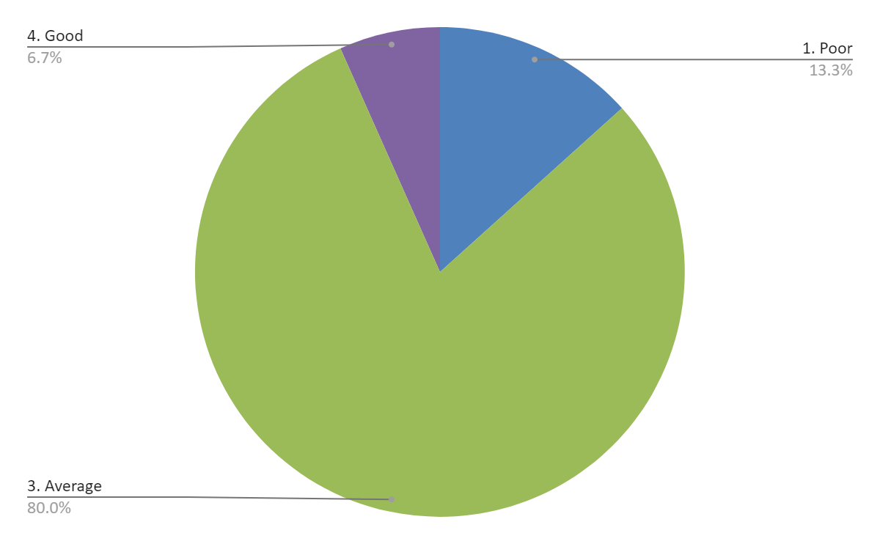
Graph 1: Overall feelings about Online Learning at University Trinity St David(London Campus)
In the first question, around 80% respondents have stated that they feel average in the online medium of learning.
Question 2: Do you have access to a device for learning online?
Options | Respondents | Percentage | Total respondents
Yes | 15 | 100 | 15
No | 0 | 0 | 15
Table 2: Respondents who have access to a device for learning online


Graph 2: Respondents who have access to a device for learning online
In this question, it is observed that all the respondents (100%) have access to devices in online learning.
Question 3: What device do you use for online learning?
Options | Respondents | Percentage | Total respondents
Laptop | 13 | 86.7 | 15
Desktop | 0 | 0 | 15
Tablet | 0 | 0 | 15
Smartphone | 2 | 13.3 | 15
Table 3: Devices that are used for online learning

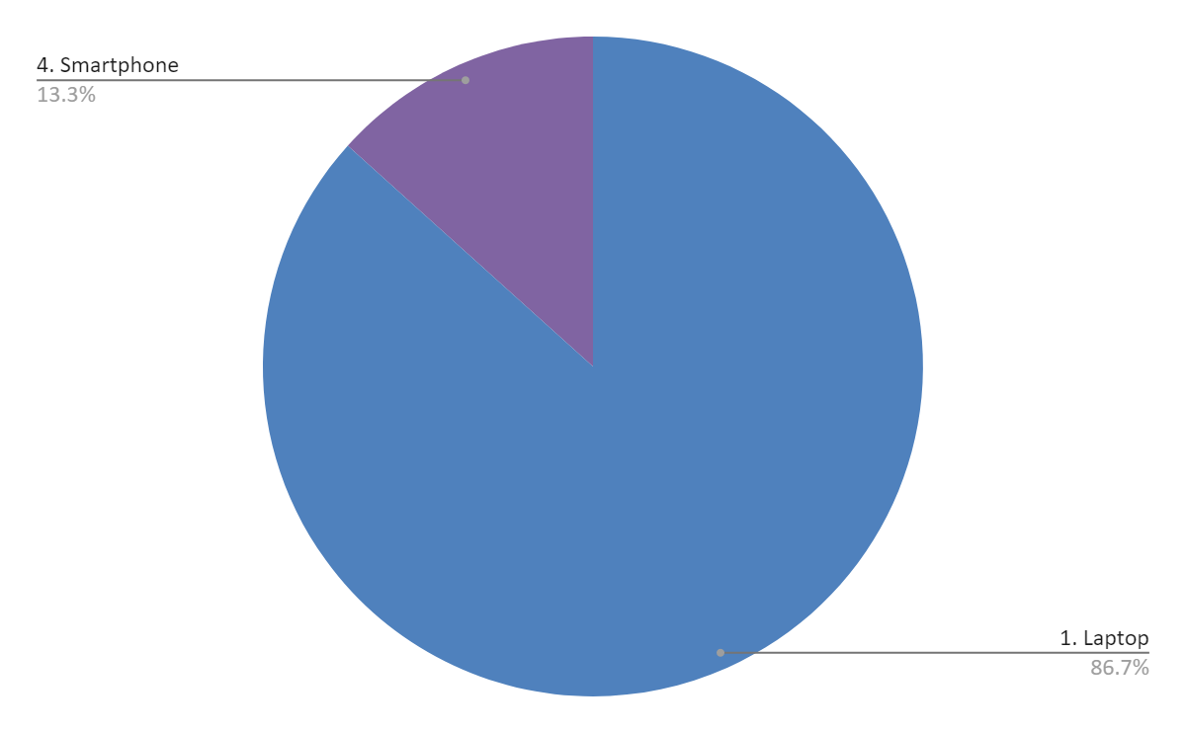
Graph 3: Devices that are used for online learning
It is noticed that 86.7% respondents use laptops for the purpose of online learning while 13.3% respondents use their Smartphones.
Question 4: How much time do you spend each day on an average online learning?
Options | Respondents | Percentage | Total respondents
1-3 hours | 1 | 6.7 | 15
3-5 hours | 12 | 80 | 15
5-7 hours | 1 | 6.7 | 15
7-10 hours | 0 | 0 | 15
10+ hours | 1 | 6.7 | 15
Table 4: Time that are spent by respondents each day on an average online learning

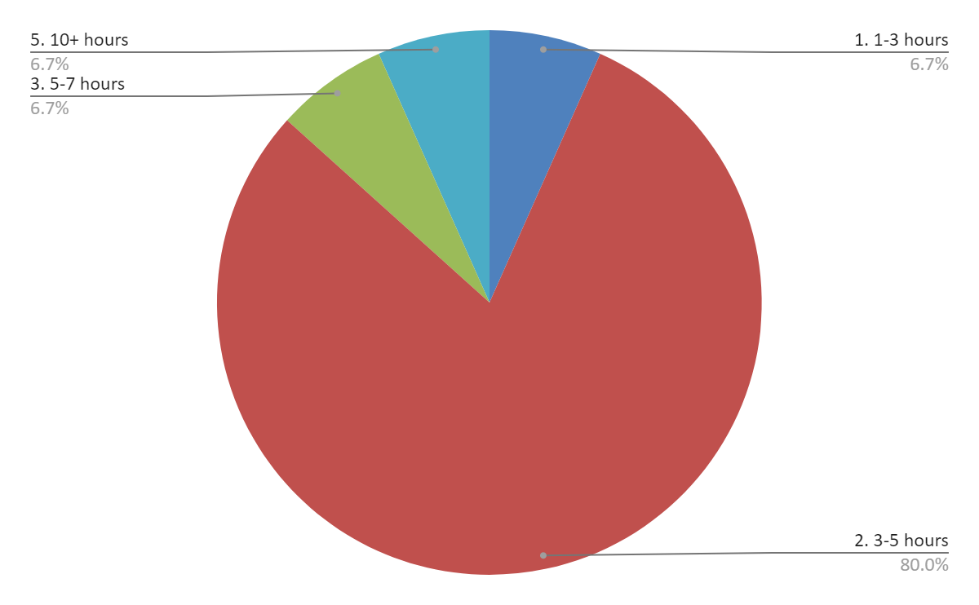
Graph 4: Time that are spent by respondents each day on an average online learning
In this question I found that, around 80% respondents stated that they spent around 3 to 5 hours every day in online learning. From the view of Tabatabai, (2020), during the pandemic situation of Covid-19, most of the students prefer online learning.
Question 5: On a scale from 1 to 10 how effective has online learning been for you? (1 is not effective at all and 10 is very effective)
Options | Respondents | Percentage | Total respondents
From 1 to 5 | 12 | 80 | 15
From 1 to 3 | 1 | 6.7 | 15
From 1 to 7 | 1 | 6.7 | 15
From 1 to 10 | 1 | 6.7 | 15
Table 5: Effectiveness of online learning

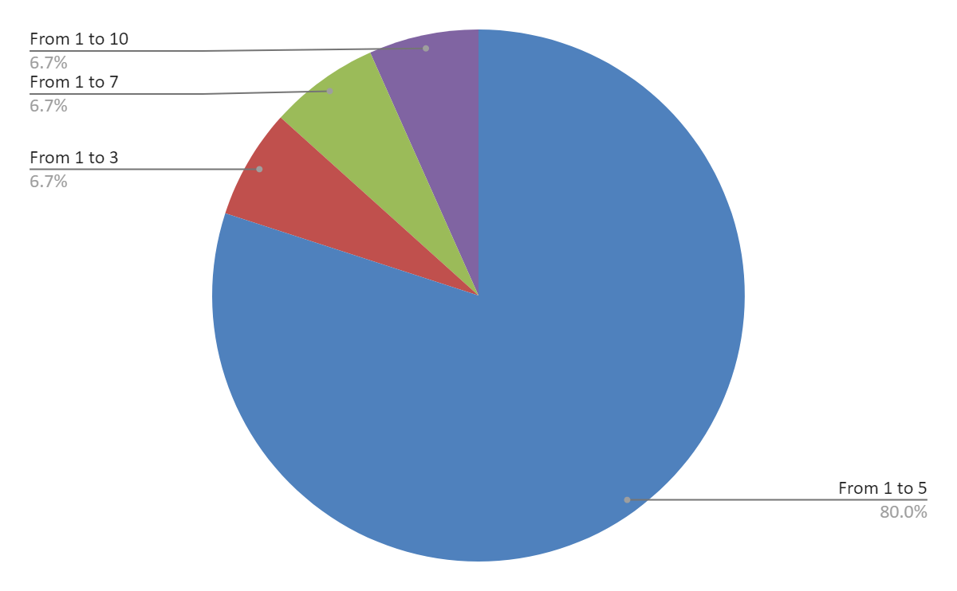
Graph 5: Effectiveness of online learning
On a scale from 1 to 10, around 80% respondents have selected 1 to 5 options. Therefore, through this, the effectiveness of online learning has been understood.
Question 6: How do you feel about learning online?
Options | Respondents | Percentage | Total respondents
Feel very stressed | 13 | 86.7 | 15
Feel comfortable | 2 | 13.3 | 15
Table 6: Respondents feelings about online learning

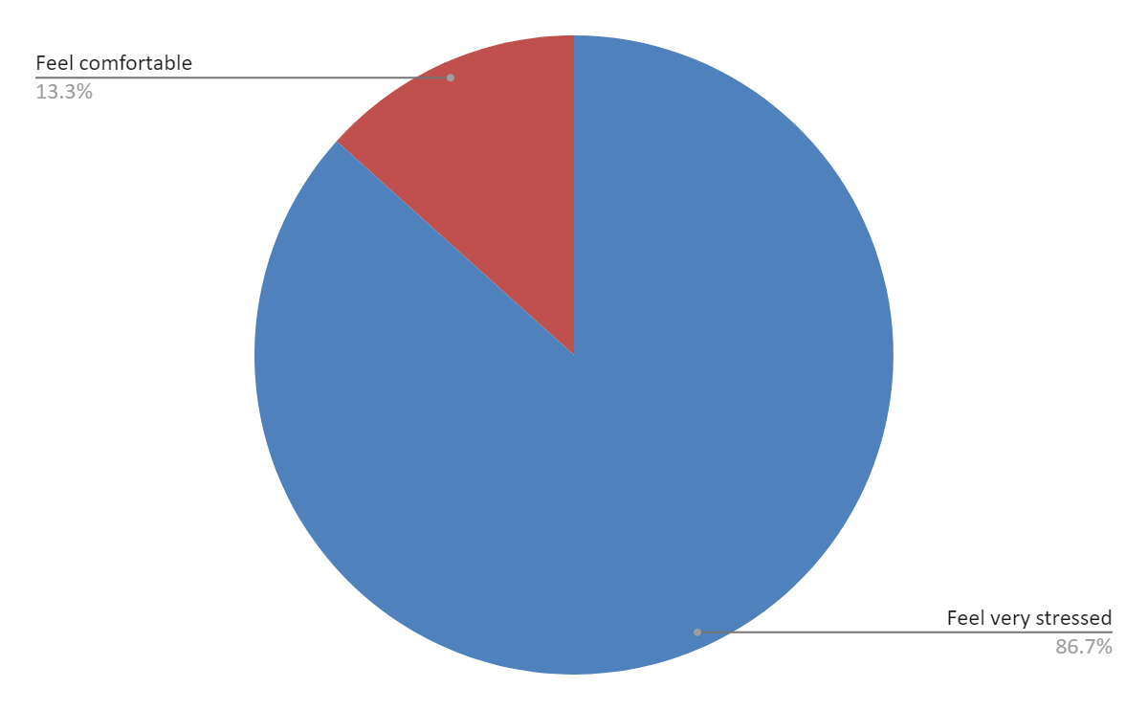
Graph 6: Respondents feelings about online learning
In the question of the feelings about online learning, 86.7% respondents have voted for a stressful medium while 13.3% have voted for a comfortable learning environment.
Question 7: How stressful is online learning for you during the COVID-19 pandemic?
Options | Respondents | Percentage | Total respondents
Not at all stressful | 2 | 13.3 | 15
Slightly stressful | 0 | 0 | 15
Moderately stressful | 1 | 6.7 | 15
Very stressful | 11 | 73.3 | 15
Extremely stressful | 1 | 6.7 | 15
Table 7: Online learning during the COVID-19 pandemic

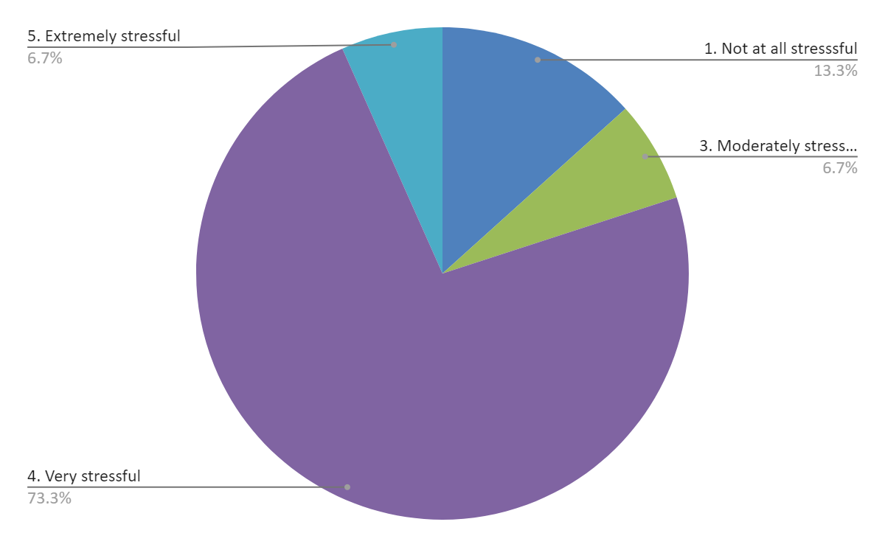
Graph 7: Online learning during the COVID-19 pandemic
Even in the seventh question, also 73.3% respondents defined online learning as a stressful medium during the Covid-19 pandemic. According to Moreira et al., (2017), disruption in the internet connection is a major issue in virtual learning. It generates stressful situations for the students.
Question 8: What do you think it should be done in order to get more help with your online learning? Please write below:
Options | Respondents | Percentage | Total respondents
Lecturers should offer more time for each student | 15 | 100 | 15
Table 8: Ways to improve online learning

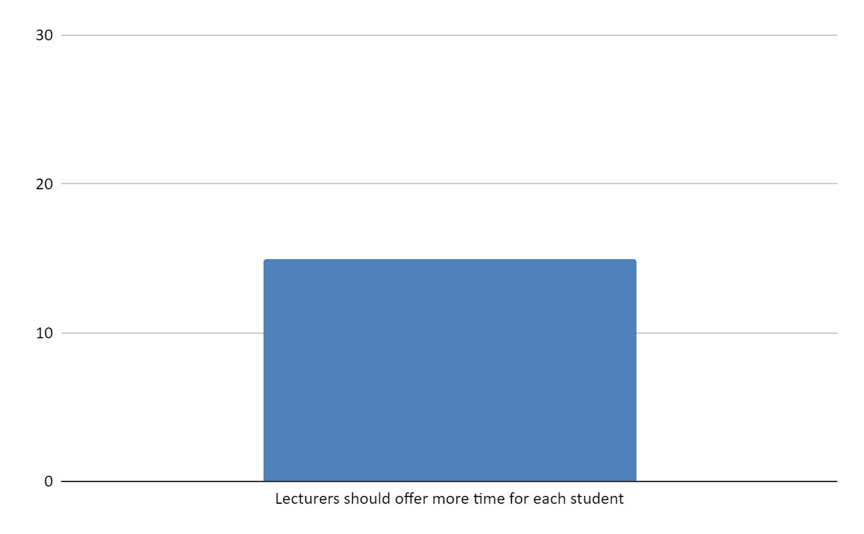
Graph 8: Ways to improve online learning
In order to suggest the way to improve online learning, all the respondents (100%) recommended that lectures should provide more time to the students.
Question 9: Do you enjoy learning remotely?
Options | Respondents | Percentage | Total respondents
Yes | 1 | 6.7 | 15
No | 14 | 93.3 | 15
Table 9: Respondents opinion about enjoying online learning

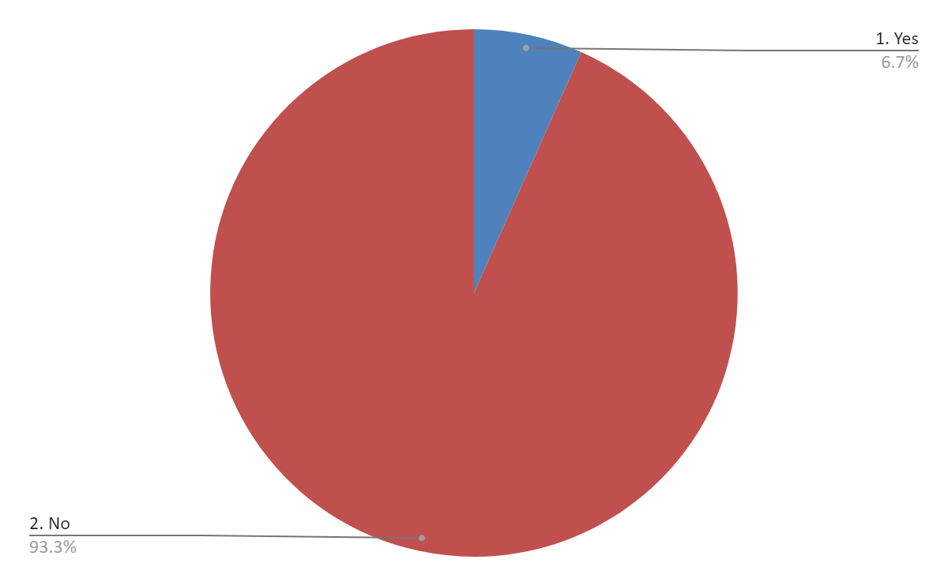
Graph 9: Respondents opinion about enjoying online learning
As per the 93.3% respondents, they enjoy online learning remotely.
Question 10: How helpful are your teachers while studying online?
Options | Respondents | Percentage | Total respondents
Not at all helpful | 1 | 6.7 | 15
Slightly helpful | 12 | 80 | 15
Moderately helpful | 1 | 6.7 | 15
Very helpful | 0 | 0 | 15
Extremely helpful | 1 | 6.7 | 15
Table 10: Effectiveness of the teachers in online study

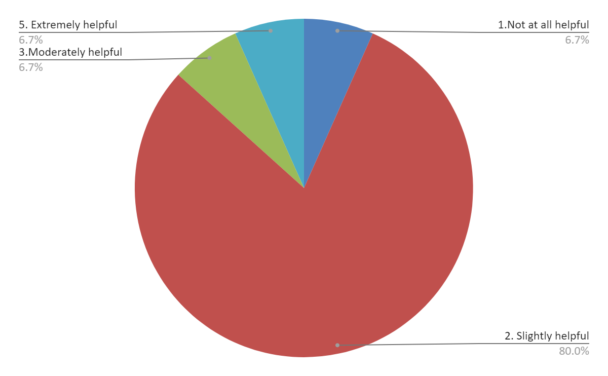
Graph 10: Effectiveness of the teachers in online study
In the last question, 80% respondents depicted that teachers are slightly helpful in the virtual learning environment.

Secondary data analysis
According to Firefly, (2020), a virtual learning environment is a component of educational technology to teach the students by using virtual learning mediums. The report of Statista, (2020), shows that in 2020, around 46% students who belong to the 16 to 24 age category, depend on online learning material.
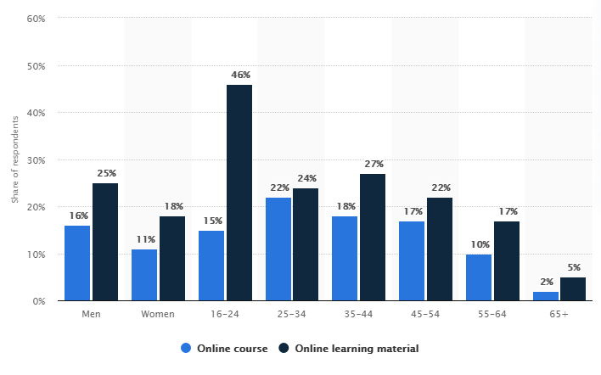
Figure 1: population who depends on online learning material

According to UT news, (2020), virtual learning environments have removed the gender inequality which exists in the in person classes. Therefore, in this way, it is highly effective to motivate the students towards the study and to develop their learning.

Summary of the findings
From the data findings, it has been observed that the virtual learning environment has great importance in recent days. There are many advantages of virtual learning which motivates the students to be involved in this medium.

Conclusion and Recommendation
In the conclusion of the study, it has been observed that a virtual learning environment has provided a positive impact on the students and in the educational sector. However, this research opens a number of ways of the future study on the same topic such as ways of improvement of online learning, negative impact on the students and others.

Recommendations
On the basis of the overall discussion, some recommendations are provided below:
- It is recommended that through using Technological advancements the UWTSD authority can develop their online learning process more in their London campus.
- Lectures need to provide more time to the students in online mode to help them more in the improvement of study.

Reference list
Bin Abdul Lasi, M. and bin Yunusi, E., 2020. Factors Influencing High Crime Rate in Kuala Lumpur Urban Community. International Journal of Publication and Social Studies, 5(2), pp.147-153.
Firefly, 2020. What Is A Virtual Learning Environment (VLE)?. [online] Available at: <https://fireflylearning.com/what-is-a-virtual-learning-environment-vle> [Accessed 28 December 2020].
Khlaisang, J. and Songkram, N., 2019. Designing a virtual learning environment system for teaching twenty-first century skills to higher education students in ASEAN. Technology, Knowledge and Learning, 24(1), pp.41-63.
Kurbakova, S., Volkova, Z. and Kurbakov, A., 2020, July. Virtual Learning and Educational Environment: New Opportunities and Challenges under the COVID-19 Pandemic. In 2020 The 4th International Conference on Education and Multimedia Technology (pp. 167-171).
Martin, F. and Bolliger, D.U., 2018. Engagement matters: Student perceptions on the importance of engagement strategies in the online learning environment. Online Learning, 22(1), pp.205-222.
Moreira, F., Ferreira, M.J. and Cardoso, A., 2017, July. Higher education disruption through IoT and Big Data: A conceptual approach. In International Conference on Learning and Collaboration Technologies (pp. 389-405). Springer, Cham.
Pererva, V., Lavrentieva, O., Lakomova, O., Zavalniuk, O. and Tolmachev, S., 2020. The technique of the use of Virtual Learning Environment in the process of organizing the future teachers' terminological work by specialty.
Phungsuk, R., Viriyavejakul, C. and Ratanaolarn, T., 2017. Development of a problem-based learning model via a virtual learning environment. Kasetsart Journal of Social Sciences, 38(3), pp.297-306.
Statista, 2020. Online Learning In Great Britain 2020 | Statista. [online] Available at: <https://www.statista.com/statistics/882117/online-learning-in-the-uk-by-demographic/> [Accessed 28 December 2020].
Tabatabai, S., 2020. Simulations and virtual learning supporting clinical education during the COVID 19 pandemic. Advances in Medical Education and Practice, 11, p.513.
UT News, 2020. The Positives Of Virtual Learning That Nobody Is Talking About - UT News. [online] Available at: <https://news.utexas.edu/2020/09/30/the-positives-of-virtual-learning-that-nobody-is-talking-about/> [Accessed 28 December 2020].
Vaganova, O.I., Smirnova, Z.V., Mukhina, M.V., Kutepov, M.M., Kutepova, L.I. and Chernysheva, T.L., 2017. THE ORGANIZATION OF THE TEST CONTROL OF STUDENTS KNOWLEDGE IN A VIRTUAL LEARNING ENVIRONMENT MOODLE. Journal of Entrepreneurship Education, 20(3), pp.1-4.

Appendix
Questionnaire
Question 1: How do you feel overall about Online Learning at University Trinity St David(London Campus)?
- Poor
- Below Average
- Average
- Good
- Excellent

Question 2: Do you have access to a device for learning online?
- Yes
- No

Question 3: What device do you use for online learning?
- Laptop
- Desktop
- Tablet
- Smartphone

Question 4: How much time do you spend each day on an average online learning?
- 1-3 hours
- 3-5 hours
- 5-7 hours
- 7-10 hours
- 10+ hours

Question 5: On a scale from 1 to 10 how effective has online learning been for you?
1 2 3 4 5 6 7 8 9 10

Question 6: How do you feel about learning online?
Question 7: How stressful is online learning for you during the COVID-19 pandemic?
- Not at all stressful
- Slightly stressful
- Moderately stressful
- Very stressful
- Extremely stressful

Question 8: What do you think it should be done in order to get more help with your online learning? Please wright bellow:

Question 9: Do you enjoy learning remotely?
- Yes
- No

Question 10: How helpful are your teachers while studying online?
- Not at all helpful
- Slightly helpful
- Moderately helpful
- Very helpful
- Extremely helpful

