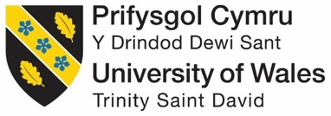

Consultancy Company: Elevate Hospitality Solutions - Holiday Inn Manchester
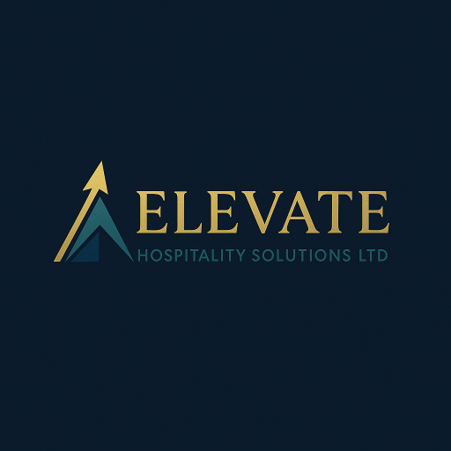
Logo of Elevate Hospitality Solutions

Module Code: BMIH6005
Module Title: Organisational Consultancy
Student Name: Roxana Pesu
Student ID: 2243649

AI Declaration
I used Chatgpt to check the grammatical errors in this presentation on 6 June 2025 with the following prompt-
-” Please check the file and let me know if there are any grammatical errors”.
-“Can you make me a logo for Elevate Hospitality Solutions Ltd.?”
However, I have not used any AI-generated content in this file.

Executive Summary
Elevate Hospitality Solutions Ltd has compiled this report, which thoroughly analyses Holiday Inn Manchester – City Centre, a luxury hotel in Manchester and a Holiday Inn branch under IHG company (IHG, 2023). The report is commissioned by hotel management to deal with urgent challenges concerning employee involvement, loyalty, and how the organisation is run. Despite how strongly the hotel is positioned, its positive reputation and its great location, it is seeing many employees leave, less enthusiasm among those who stay and few opportunities for them to rise within the company—all of which may lead to difficulty sustaining operations and damaging the brand's reputation in the competitive hospitality market (Himanchestercity.com, 2025). A consulting approach and several strategic frameworks help uncover the industry's main issues and find suitable solutions. An initial look at external elements uses the STEEPLED method to understand how pressure on the economy, new labour scenarios and changing social patterns affect what hospitality employees expect (Grzegorzek, 2024). Following internal evaluation, the SWOT and TOWS analyses pointed out the strength of the hotel’s brand, its position in the city, and opportunities for training, as well as discussed, the weaknesses, such as scheduling difficulties, poor employee support for their wellbeing and health, and a lack of personalised development programmes.
It was found through the consultancy process that because employer offerings do not match employee expectations, more people are leaving and becoming disengaged. In detail, employees stated that they were not content with their scheduled work hours, did not find their workplace wellbeing programmes personal, and did not have enough opportunities for career advancement. In addition, problems within the workforce increase when team members must deal with the city's higher living costs and intense efforts by other hospitality businesses to recruit them. If nothing is done about these factors, it could make it harder for Holiday Inn Manchester – City Centre to keep skilled people and maintain a high service level. As a result of spotting these various challenges, the report offers several valuable tips to boost employee engagement and wellbeing and ensure staff retention at Holiday Inn Manchester – City Centre. So, they have been created to include three critical areas: allowing greater flexibility at work, improving employee wellbeing and providing better training opportunities and rewards.

Adopting a flexible scheduling system could help with inflexible set schedules. It empowers staff, promotes a healthy work-life mix, makes them happier at work, and reduces absences and staff departures. Since many hospitality workers now want greater flexibility, this benefit helps the hotel meet the latest workforce standards and might make it more competitive to hire the best staff. In addition, a complete wellbeing programme is suggested to improve physical, mental and emotional wellbeing. Examples include setting up mindfulness activities, offering on-site ways to improve wellbeing and offering specialised mental health assistance because burnout and stress are common in hospitality. Wellbeing programmes help lower morale, raise performance and decrease the number of staff exits.
It also suggests developing employees by providing more training, making career paths more straightforward inside the organisation and ensuring regular acknowledgement and praise for successful performance. Through Holiday Inn Manchester – City Centre global learning platforms, the strategy plans to help employees acquire new skills, climb the ladder, and stay loyal to the company (Pujianto, 2024). When used with an organised reward and recognition programme, the approach helps employees understand what matters to the company and why they should stay. It is expected that these programmes will operate together with other efforts. They come together as an effective strategy that answers staff needs and strengthens Holiday Inn Manchester – City Centre’s daily work and image as an employer. The suggestions are built on industry facts, cost calculations, and a planned process for improving how things are done, so together, everyone can adjust well to the new changes.
The proposed strategies are effective because they provide a detailed monitoring and evaluation framework in the report. It is suggested that performance be reviewed every 12 months using quarterly cheques for employee retention, days off, how staff feel, and service ratings. Another type of loop for feedback will help the process keep improving and react to sudden obstacles promptly. The cost of each recommendation is foreseen using the hotel's dimensions and finances as references. The estimated yearly fees for the retail company are £5,000 for rota software, £7,000 for wellbeing support and £8,000 for training, development and rewards. Holiday Inn Manchester – City Centre can afford to spend £20,000 every year because of its position in the premium segment and large operations. In addition, expected savings in recruitment and onboarding because of better retention are expected to overcome the initial costs. Splitting up the implementation process is best, so costs are managed, and operations are minimally disturbed. These suggested changes solve problems within the hotel and help Holiday Inn Manchester – City Centre become a recognised and caring workplace (Gebbels, 2019). These efforts support Holiday Inn Manchester – City Centre's goals to sustain its workforce worldwide, which also helps distinguish the property in areas where creating a good workplace reputation is essential for hiring and retaining employees.
This report delivers a set of well-considered, hands-on suggestions for Holiday Inn Manchester – City Centre that keep their goals and way of working in Mind. Helping its team by offering benefits, flexibility, and career growth allows the hotel to keep its workforce motivated, strong, and committed (Preko and Anyigba, 2022). This change is necessary for better guest experiences, high service standards, and a continued reputation for the hotel.

Table of Contents
Executive Summary ii
Introduction 1
Analysis 3
Introduction to the Issue 3
In-Depth Issue Breakdown 4
STEEPLED Analysis 5
SWOT Analysis 7
TWOS Analysis 9
Recommendations and Change Management 11
Overview of Recommendations 11
Detailed Recommendations 11
Flexible Working Arrangements 11
Personalised Wellbeing & Support Programmes 12
Career Development & Recognition Schemes 13
Change Management Strategy 14
Monitoring & Measuring Success 16
Cost Estimates & Feasibility 17
Action Plan 18
Conclusion 20
References 22

Introduction
The four-star Holiday Inn Manchester – City Centre is in the middle of Manchester. The modern steel-and-glass building was welcomed by guests in 2016 as part of the InterContinental Hotels Group (IHG) brand. There are 193 guest rooms available, with a handful of spacious penthouse apartments and facilities such as a heated indoor pool, fitness centre, and ballroom (IHG, 2023). Being close to places like the Tate Modern, Shakespeare’s Globe, and Borough Market makes this neighbourhood attractive for travellers looking for business or leisure (Native Places, 2025). Because Holiday Inn Manchester – City Centre is part of IHG (InterContinental Hotels Group), it enjoys the parent brand’s good reputation, working policies, and customer loyalty system. Yet, due to the challenges of operating in a post-pandemic environment, it must deal with new issues related to its organisation and future success.
This consultancy report aims to help Holiday Inn Manchester – City Centre with a key operational question: why are employees less engaged, and what effect does this have on guests? During the past year, surveys, staff interviews, and online comments indicate increased employee unhappiness, more people quitting, and changing service levels. Though hotel guests are returning and bookings are improving after the pandemic, problems with staffing have made it hard for the hotel to maintain the best service level. If not dealt with, the hotel might see its brand damaged, customers choose others, and its earnings decrease as the city’s hospitality draws more competitors.
The report was written by Elevate Hospitality Solutions Ltd, a consulting group specialising in strategic development for hotels and resorts in the UK and Europe (Elevate Hospitality Solutions, 2024). After over a decade in the hospitality industry, our company gives custom-made recommendations based on observations in operations, new HR approaches, and ways to manage change. This study focused on working with hotels to make guests and team members happier by applying useful scientific findings.
The consultancy report will analyse what leads to low employee engagement among workers at Holiday Inn Manchester – City Centre and its effects. By reviewing the firm’s qualitative and quantitative information, this report will analyse the current environment, discover what is lacking and suggest ways to improve in the long run. Because employee engagement influences service quality, how much is produced and how happy customers are, addressing this is vital for the hotel.
Multiple common frameworks and tools will be applied to ensure comprehensive and organised analysis. The first stage in STEEPLED analysis is to assess the effects of sociocultural, technological, economic, environmental, political, legal, ethical, and demographic factors present in the external environment of the Manchester hospitality sector. This gives a broad context for understanding Holiday Inn Manchester City Centre.
Next, the SWOT analysis will assess the strengths, weaknesses, opportunities, and threats within the hotel and its surroundings. The study will show how the hotel compares to competitors and where it needs the most work.
Subsequently, a TOWS matrix will transform the findings from the SWOT analysis into strategic alternatives. This will allow Holiday Inn Manchester—City Centre to outline ways to combine its strengths with new possibilities, lessen its weaknesses, and cope with external threats. These strategic insights will form the basis for advising on what to do and how to manage changes.
In short, the report explains employee engagement at Holiday Inn Manchester—City Centre in a clear, structured, and well-researched way. The consultancy aims to analyse the hotel's needs and plan strategies to help it take suitable actions within its premium category and long-term business plans.

Analysis

Introduction to the Issue
Issue: Declining Employee Engagement at Holiday Inn Manchester – City Centre
The success of luxury hotels in competitive cities like Manchester now depends mainly on how engaged their staff are. Employee engagement at Holiday Inn Manchester – City Centre has decreased recently, as represented by higher staff resignations, a lower mood and less consistent service (Himanchestercity.com, 2025). The hotel continues to do well in terms of booking and location. Still, issues within the staff are starting to influence the service and experience provided to guests, which is essential to a five-star hotel.
According to exit interviews and regular staff surveys, more people are experiencing burnout, feeling unrecognised and unable to progress in their careers. This is also true according to reviews found on Glassdoor and TripAdvisor by guests who have seen their experience with service quality vary from poor check-in to simple housekeeping (Tripadvisor, 2024). Because engagement is down, companies must deal with understaffing, leading managers to become overworked and forced to train employees often.
The pandemic has worsened these challenges, and many people are now interested in looking for jobs in more flexible or stable industries. The hospitality sector in the UK is also having trouble finding enough staff, which allows skilled workers to negotiate better salaries (Baum et al., 2022). For this reason, encouraging and holding onto staff at Holiday Inn Manchester – City Centre is becoming much more difficult and expensive.
Handling the issue well requires an approach that includes several areas of consulting. Poor employee engagement negatively influences customer service, the brand's reputation, and the corporation's profitability (London Town Group, 2024). Holiday Inn Manchester—City Centre must address this problem to continue offering excellent service, stand by its brand, and ensure it grows over time.

In-Depth Issue Breakdown
Diminished employee engagement at Holiday Inn Manchester – City Centre results in several challenging effects, directly or indirectly, on the hotel's operations, the happiness of its guests, and its finances (Kewgreenhotels.com, 2022). Even with a respected brand and great location, the staff relations within the property have been placing extra strain on management during the past 18 months. This section examines how significant and serious the issue is by looking at operations, finances, guest experiences and the condition of the staff.
Impact on Operational Efficiency: Collaboration among departments is vital for the hospitality industry. If employees are not engaged, these connections are affected, and operations are less efficient. According to department supervisors, staff are taking time off more, arriving late, and learning new duties is becoming more time-consuming, all because the turnover rate is increasing (Burrage, 2025). For example, the housekeeping staff has frequently been understaffed, which has caused rooms to be ready late and higher pressure on the other group members. These gaps cause slow service and make errors more likely, negatively affecting service quality.
Impact on Financial Performance: Even if their lack of engagement isn't apparent, employees who care less about their work can increase operational expenses. Turnover leads to spending more on recruiting and training, while lower performance needs managers to check on employees more frequently and sometimes rely on temporary extra hands (Burrage, 2025). UK companies often lose an average of £4,000–£6,000 per employee due to their employees not being engaged, according to CIPD (2024). In a hotel with well over 200 team members, expenses can pile up swiftly. If services do not meet expectations, the company can suffer from people not wanting to return, hurting bookings and average daily rates and influencing revenue.
Guest Satisfaction: The guest’s experience in a five-star hotel is greatly influenced by how attentive, warm, and professional the staff are. Low-motivation employees do not usually go the extra mile to make guests happy (Hutton, Foley and Irvine, 2022). People’s reviews of Holiday Inn Manchester – City Centre on Google and TripAdvisor comment on inconsistent front desk service, slower than expected responses to requests, and different room cleanliness standards. Even though this is not an immediate challenge, these more frequent comments may ultimately strongly impact the hotel's market placement. Poor or inconsistent service decreases trust in a brand, mainly occurring in luxury because customers look for flawless service.
Staff Morale and Culture: Disengagement tends to be easily spread from one person to another. As staff notice other workers disengaging from their roles or leaving the company, they become less willing to help, affecting everyone else. Several Holiday Inn Manchester – City Centre employees who have stayed for years say they are unhappy with unclear ways to grow in their careers, little helpful feedback from managers, and not being valued enough (Holt, 2025). With a lot of movement within the staff, the busy atmosphere can put too much pressure on workers. In this situation, the less work is done, the higher the pressure will be for the workers who are left, which leads to even worse moods and higher stress levels.

STEEPLED Analysis
A STEEPLED analysis has been done to gain in-depth knowledge about what influences employee engagement at Holiday Inn Manchester—City Centre. This structure studies how Sociocultural, Technological, economic, Environmental, Political, Legal, Ethical, and Demographic factors might shape how employees behave and how the hotel handles staff recruitment and retention (MasterClass, 2022). Analysing these external forces allows us to discover general patterns that impact the company and guide the development of good strategies (Frue, 2020).

Image 1: STEEPLED Analysis (Author’s design)

Factor
  Relevance to Holiday Inn Manchester – City Centre and Employee Engagement
Sociocultural | After the pandemic, workers attach greater importance to a good work-life balance, flexibility and psychological support (Meetinmanchester.com, 2025). With new expectations affecting people’s needs, the hospitality sector’s inflexible shifts and high emotional demands are considered less desirable.
Technological | Because of automation and digital check-ins, employees do less routine work, but this could also cause some staff to feel less happy at work (Schwabe and Castellacci, 2020). At the same time, not having up-to-date technology (such as digital scheduling and mobile HR solutions) can disappoint staff, usually younger digital-native employees.
Economic | Wages for staff in hotels and restaurants in Manchester have not risen fast enough to keep up with the rising expenses due to inflation (Ashai, 2022). Because their salaries cannot cover daily living costs, many staff are getting into debt and seeking new opportunities in other well-paid industries.
Environmental | There is a growing push for hotels to follow sustainable practices. Employees may feel less connected if the company does not emphasise environmental concerns or offer them chances to get involved in green initiatives within the office (Angela, 2022).
Political | Because of new post-Brexit rules, there has been a shortage of workers in the hospitality industry. With a (progressive) shortage of EU national workers in frontline positions, it is harder to find new staff, making the jobs of those still working there more challenging and tiring (Team, 2022).
Legal | UK employment law requires wages to be fair, policies against discrimination to be in place, and workplaces to be safe (Harvey, 2023). However, it is sometimes unclear for staff what is owed due to zero-hour contracts and overtime, which can make them feel mistreated or overlooked.
Ethical | More attention is given to how hospitality brands treat their employees (Stewart, 2022). Understaffing, setting demanding KPIs, or excluding some workers can harm staff morale and blur the employer's brand reputation.
Demographic | Younger employees hold most entry-level positions and are primarily motivated by having a meaningful purpose, diversity and recognition (Hone, 2024). The hotel should change its culture and leadership approach to match these requirements or risk seeing employees leave.
Table 1: STEEPLED Analysis at Holiday Inn Manchester – City Centre
STEEPLED analysis reveals that outside social, economic, and political influences are behind employees' challenges at Holiday Inn Manchester—City Centre. The hotel must improve its services internally since it cannot always control the market or competition.

SWOT Analysis
A SWOT analysis analyses Strengths, Weaknesses, Opportunities, and Threats (Renault, 2025). It captures an overview of Holiday Inn Manchester—City Centre's current situation, considering its internal and external challenges and benefits. As engagement among hotel workers decreases, this model emphasises the upsides and downsides the business should consider. It also recognises external developments and points out possible future directions.
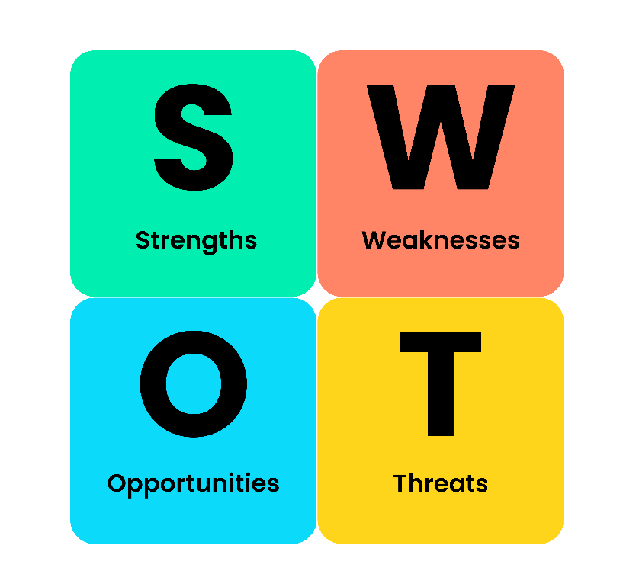
Image 2: SWOT Analysis (Renault, 2025)

Factors | Analysis
Strengths | The hotel is centrally located in Manchester and enjoys the excellent reputation of the IHG Brand. Comprehensive training and rewarding employees for their loyalty support each employee's growth (IHG, 2025). When guests write good reviews and processes work well, employers can build on those strengths to increase staff engagement.
Weaknesses | The hotel experiences internal difficulties such as many staff leaving, strict set working hours, and a lack of defined career routes. Support initiatives are not personalised for staff working in busy Manchester hospitality jobs (Vesty, 2024). These weaknesses lead to less employee motivation and increased stress on operations (Gebbels, 2019).
Opportunities | More employees now expect flexible work arrangements and support for wellbeing, which employers can provide (IHG, 2025). By using Holiday Inn Manchester—City Centre training programmes worldwide, associates can gain new skills and stay with the company longer. Recognising employees and participating in sustainability initiatives can help staff feel more involved and connected.
Threats | Outside challenges for the hotel include staff shortages in hospitality, Manchester's high living costs, and quality hotels that promote higher pay rates and flexible schedules (Vesty, 2024). If nothing is done, disengagement may continue and harm Holiday Inn Manchester—City Centre’s employer reputation, mainly among workers who value purpose.
Table 2: SWOT analysis at Holiday Inn Manchester – City Centre

TWOS Analysis
The TOWS matrix uses internal and external conditions to find potential strategies for responding to the SWOT (Bozac, 2018; University of Hertfordshire, 2022). By doing this, Holiday Inn Manchester—City Centre can focus on steps to improve their employees' morale and succeed in challenging situations.
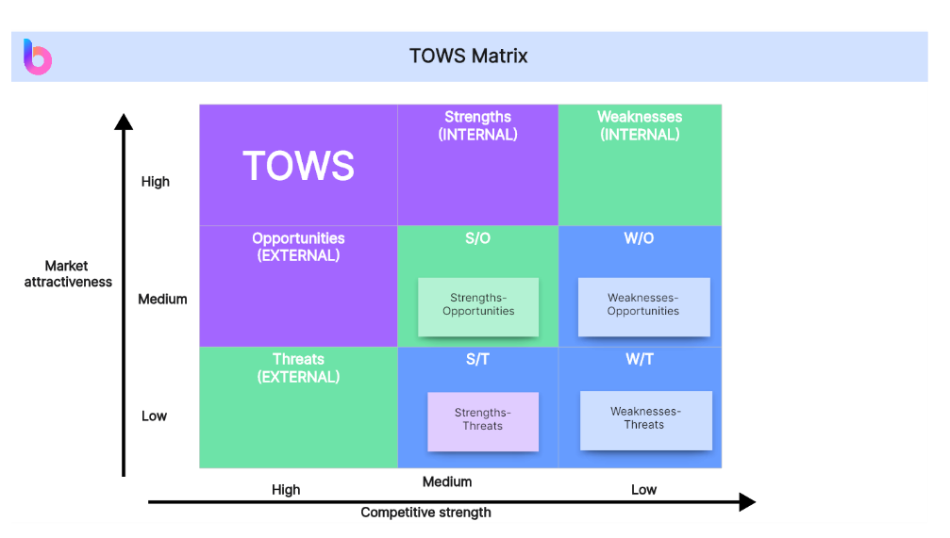
Image 3: TOWS matrix (boardmix.com, 2024)
Factors | Analysis
Strengths + Opportunities | Being a strong Holiday Inn Manchester hotel in a central area, Holiday Inn Manchester—City Centre can introduce flexible wellbeing initiatives that suit today's employees. Because of the set structure, employees can engage in sustainability projects and build related skills. Work in this area can encourage staff and let them know the hotel appreciates their skills and is up to date with new approaches in the workplace (Hanson, 2022).
Strengths + Threats | Since there are new challenges from increased living costs and more rivals, Holiday Inn Manchester – City Centre can leverage its strong focus on staff growth and high-value brand name. If the hotel promotes staff perks, rewards and growth opportunities, it can make itself seem like a fair and progressive workplace (Group, 2025). This measure may encourage staff to remain employed despite pay differences from other companies since it can create greater opportunities for staff who prefer steadiness (GOV.UK, 2019). Ensuring guests are happy and adopting good internal processes could help the hotel cope with low staff numbers.
Weaknesses + Opportunities | Flexible hours and customised support for staff members help overcome the issues with rigid scheduling and lack of personal aid. As many employees in the hospitality industry look for a better work-life balance, Holiday Inn Manchester—City Centre can offer different shift options to suit each person. Also, better ways for staff to grow and regular appreciation can be provided through Holiday Inn Manchester's training resources. As a result, people would feel less stressed and bored, and employees would be encouraged to stick with the company.
Weaknesses + Threats | Without changes, staff members could become even more unengaged because of external issues like inflation and attempts made by other hotels to steal them (HR editorial, 2022). Holiday Inn Manchester – City Centre should work on better communication, change its approach to leadership and emphasise career development to reach out to upcoming staff members. They can help retain staff and maintain the hotel’s position as a good employer for others to work at.
Table 3: TOWS matrix at Holiday Inn Manchester – City Centre

Recommendations and Change Management

Overview of Recommendations
Analysis of Holiday Inn Manchester – City Centre reveals that the hotel is encountering significant difficulties because staff are detached from work, have inflexible work hours and few chances to move forward. If no action is taken, these things may raise staff turnover, lead to operational problems and harm how the company is perceived (Leonard, 2025). To keep succeeding, the hotel needs targeted strategies that offer better employee experiences and, at the same time, meet both its day-to-day needs and Holiday Inn Manchester – City Centre's global values. The following three points are suggested: creating flexible work options, establishing custom wellbeing plans, and strengthening career advancement and appreciation systems. The programmes are intended to bring about positive cultural change, ensure staff members stay, and improve their morale (Sheppard, 2016). A well-structured change management plan helps carry out these solutions without much disturbance and ensures they stay successful long-term. Furthermore, management and cost systems will allow the hotel to check how it is doing, measure its achievements and prove the need for investment. They all help to stabilise the situation and encourage the team to strive for success.

Detailed Recommendations
This section proposes the following solutions to tackle staff disengagement and high turnover: flexible work options, support for wellbeing, and career advancement programmes. Every recommendation was designed to meet the specific needs of Holiday Inn Manchester—City Centre. It reflects what is expected in the hospitality industry today, so changes can help the hotel improve its staff retention, satisfaction, and work levels (Pujianto, 2024).

Flexible Working Arrangements
Holiday Inn Manchester – City Centre must adopt flexible working options to support employee satisfaction and keep staff longer. The demand for work-life balance has gone up in the Manchester hospitality industry. A 2023 survey from Caterer.com found that over two-thirds (68%) of staff in the UK hospitality care about flexible working hours to improve their work life, and 53% would prefer to stay with an employer that offers that flexibility (Caterer.com, 2023).
The hotel's set work schedules have made it stressful, fatiguing, and difficult for many frontline staff to maintain a work-life balance (Health Education England, 2019). A flexible rota system would help staff members choose their schedules, swap them when possible, and plan when they can take time off (Leonard, 2025). Digital scheduling software like Deputy or Rotageek can be integrated for about £5,000 a year, making shift management easier and helping everyone understand the schedule briefly.
Offering part-time positions, splitting shifts, or allowing job shares would help people in the housekeeping and reception departments (US EEOC, 2024). Also, there may be opportunities for back-office teams to work remotely one or two days a week as part of Holiday Inn Manchester—City Centre's expanded Work from Anywhere policy, which is used worldwide.
Doing these things can make employees happier, more committed and less likely to miss work. Employees who like their work schedule do well and stick around, making guest service more regular. Flexibility helps Holiday Inn Manchester – City Centre keep up with changing employee requirements and maintain consistent and successful operations in a busy competition.

Personalised Wellbeing & Support Programmes
Since staff stress, burnout and disengagement are increasing, Holiday Inn Manchester – City Centre needs to create custom employee wellbeing programmes. The fast-paced environment of central Manchester hospitality causes a lot of physical and emotional stress for employees (Wong, Kim and Xu, 2025). Compiled in 2023 by RSPH (2023), the research found that 74% of UK hospitality workers often feel stressed and blame it on a lack of support.
Currently, the hotel's wellbeing programme generically covers everyone and does not focus on the difficulties of different groups. Initiatives should match the needs of each department (MIND, 2019)—for instance, providing on-site mental health services and allowing regular breaks to front-of-house workers while at the same time supplying ergonomic devices and organising stress management sessions for those who work in the back of the house.
Organisations like Hospitality Health or Mind give employees cost-effective opportunities for confidential counselling, phone support, and building personal strength. Organising yoga sessions, workshops on mindfulness and bonding retreats every quarter may be beneficial (Yogacentral, 2020). Having one person in every department as the Wellbeing Champion helps promote proper resources and gather thoughts, making the organisation inclusive and adaptable.
The annual budget for such initiatives is estimated at around £7,000 to cover services, materials, and training. A small investment can result in team members feeling more positive at work, having less sick time, and having closer connections.
When wellbeing is personalised, Holiday Inn, Manchester, demonstrates that its team members are essential, which helps create a supportive workplace. In the end, such actions create an inspired team that is healthier and more ready to offer the best experiences for guests, which supports improved operations and brand recognition in the long term (Wilson, 2024).

Career Development & Recognition Schemes
Holiday Inn Manchester—City Centre should set up structured career development and regular recognition acts to improve employees' feelings about their jobs and encourage them to stay longer. A study reveals that around 42% of hospitality industry workers consider moving to other careers, pointing to the need for well-defined career pathways (Macha, 2023).
Strategies for Professional Advancement: Organised training sessions can significantly enhance how long employees remain with the company. According to the People 1st Hospitality Report, staff with development programmes are 40% likelier to stay at their jobs (Bergeron, 2022). Providing staff apprenticeships and Continuing Professional Development (CPD) gives them the ability and confidence for promotion (CPD UK, 2025). According to the Institute of Hospitality, employers believe that providing leadership training (95%) and supporting CPD (85%) is essential for both future employees and those currently working at their company (kleinhuis, 2025).
Recognition Schemes: It is critical to recognise employees often, so they remain motivated. According to Achievers, recognising employees once a month raises their productivity by 36%, making them 22% more committed to their work and 36% more engaged (Leung, 2024). Using peer-to-peer recognition platforms encourages everyone to feel included and valued. For example, using tools such as Rocket Alumni Solutions can see an employee engagement score increase by 30% in just three months (Rocket Alumni Solutions, 2024).
Implementation Strategy: Holiday Inn Manchester—City Centre might set up a step-by-step career development pathway with planned training sessions (Preko and Anyigba, 2022). Recognising employees can be part of daily work using electronic tools that give instant feedback for achievements (Dewar, 2023). By integrating these initiatives, employee satisfaction and the quality and smoothness of operations will increase.

Change Management Strategy
Recommended changes should be applied at Holiday Inn Manchester—City Centre using a structured plan to help staff accept them, lower resistance, and enjoy ongoing advantages (Naess, 2020). Kotter's 8-Step Change Model helps the hotel adapt its operations and culture reliably (Bell, 2022; Kotter, 2025).
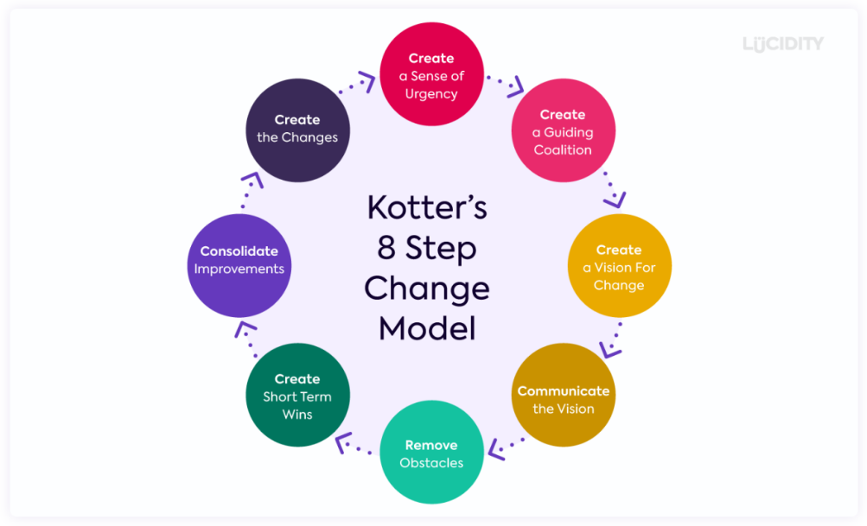
Image 4: Kotter’s 8-step change model (Bell, 2022)
Step 1: Create a sense of urgency
Emphasising why change is necessary is very important. Sharing details on increased staff resignations, higher levels of absenteeism, and lower levels of engagement will stress the importance of action (CIPD, 2024). Discussing what staff surveys and comparisons to competitors show can motivate everyone to participate in changes.

Step 2: Create a guiding coalition
The organisation should choose a team of HR, department managers and staff from the frontlines. This group will bring about change, share many perspectives and give all employee groups a chance to be heard.
Step 3: Create a vision for change
The change vision should focus on ensuring the workplace offers support, flexibility, and opportunities for growth. It should explain when and how flexible working, programmes for wellbeing, and career development will be applied, who is responsible, and set deadlines and resources.
Step 4: Communicate the vision
It is crucial to always be honest and direct. Use town halls, distribute newsletters, and post information on digital systems to explain all the updates, why they are happening, and how staff will gain from them. Concerns will be addressed, and trust will be built through forums and Q&A sessions.
Step 5: Empower Broad-Based Action
Money is needed to change policies that force staff members onto fixed schedules or properly train managers. Managers will learn about adaptable rostering and how to help teams through wellbeing. Enhancing employee participation in the company motivates them to take ownership.
Step 6: Generate Short-Term Wins
Recognise when you move forward on new ideas, such as introducing flexible schedules in one department or holding a wellbeing event. Early progress recognition helps keep things going and offers tangible results.
Step 7: Consolidate Gains and Produce More Change
The insights gained in the first months will guide the process for broader application. Using employee responses, the change team will alter their strategies and support people to avoid returning to old ways of doing things.

Step 8: Anchor New Approaches in the Culture
Making the changes a natural practice of Holiday Inn Manchester—City Centre culture is crucial for ensuring their sustainability. If revised policies are adopted, training is continued, and the ways of working are recorded in appraisals, they will become part of company operations.
Following this well-organised process will help reduce opposition, motivate workers and improve the work environment at Holiday Inn Manchester – City Centre, resulting in improved retention and excellent service.

Monitoring & Measuring Success
Holiday Inn Manchester—City Centre must have a reliable monitoring and evaluation system to check the Effectiveness of its strategies. Using key performance indicators linked to the recommendations allows for measuring how the work is advancing and its results.
To measure flexible working arrangements, KPIs may involve employees' views on work-life balance, the number of days missed, and the rate of workers leave. The quarterly survey will gather employee views about flexible schedules and related wellbeing.
Participation in well-being activities, employees' reported stress, and sites for counselling or mental health use are some ways to track the well-being of well-being. To keep the programmes up-to-date and meaningful, wellness champions should gather information from numbers and through interviews, surveys, and observation.
A company can judge its career and recognition programmes by tracking how many employees move up internally, how many finish required training, and how engaged the workforce is (Buttrick, 2018). The analytics system will also track the number and types of recognition an employee gets from peers and managers.
The change management team will examine the monthly data to find trends or issues that need fixing. Besides, it is essential to check annually through surveys how all implemented changes influence staff satisfaction in the long term (Kotter, 2012).

As Holiday Inn Manchester – City Centre regularly looks at these figures, it can make the right choices, provide evidence of good investments, and improve employee workplace culture. A formal review will occur at 12 months to evaluate overall success, as follows:
Area | KPI | Data Source | Frequency | Responsible
Flexible Working Arrangements | Employee satisfaction, turnover | Pulse surveys, HR reports | Quarterly | HR & Department Man
Wellbeinglbeing Pro | Wellbeingarticipation, stress levels | Wellness records, surveys | Quar | Wellbeinglbeing Cha
Wellbeingreer Development & Recognition | Training completion, promotion rates, engagement scores | LMS, recognition platform data | Monthly & Annual | HR & Line Managers
Table 4: A 12-month evaluation to evaluate overall success

Cost Estimates & Feasibility
We should spend £20,000 each year on the proposed changes: £5,000 for the flexible rota software, £7,000 for better empwellbeinglbeinwellbeinglbeing or additional training, licences and rewards for people. The costs are within most people's reach because of the large size of the Holiday Inn Manchester – City Centre and its central location. Because the investment should reduce staff turnover, there will be fewer recruitment and training costs, leading to better savings in the future. Starting with rota flexibility, suppowellbeing-being and career development will substantially smooth budgets and make it easier to see the programme's results (Noordzij, 2015). Paying for the upgrade in stages helps control costs and get the greatest return from the investment within the first year.

Action Plan
The table below outlines a detailed strategy for implementing the suggested changes, showing the problems, solutions, goals, planned timeline, deadlines, and estimated costs. The plan helps Holiday Inn Manchester—City Centre carry out changes in sequence, monitor progress, and keep its budget on track.
Problem | Solution | Desired Outcome | Time Scale | Completion Date | Planned Budget
Rigid working schedules cause burnout and high turnover | Introduce a flexible rota system with self-scheduling options and shift-swapping | Improved work-life balance, reduced absenteeism, lower staff turnover | 3 months | 1/10/2025 | £5,000/year
Low staff morale and well-being under pressure in a fast-paced city hotel | Launch strucwellbeing-being professional health support, wellness events, and stress management training) | Increased employee satisfaction, reduced stress levels, better staff retention | 4 months (overlapping) | 1/11/2025 | £7,000/year
Lack of clear career progression and limited recognition | Enhance training via Holiday Inn Manchester – City Centre LMS, launch peer and manager recognition platform | Improved staff engagement, higher internal promotion rates, increased motivation | 5 months (starts after rota changes) | 1/2/2026 | £8,000/year
Uncertainty in implementation and alignment across departments | Create a cross-functional change management team to lead, monitor, and review rollout | Smooth implementation, ongoing monitoring, and staff feedback integration | Ongoing throughout | Quarterly reviews, 12-month impact report due 01/06/2026 | Internal resources (no extra cost)
Table 5: Action Plan at Holiday Inn Manchester – City Centre
This step-by-step process guarantees clear execution, helps enjoy the best value and supports the daily running of a hectic Manchester hotel.

Conclusion
Holiday Inn Manchester – City Centre, a top city hotel operated by Holiday Inn, Manchester, has experienced the organisational challenges discussed in this report. Although the hotel is doing well because of its strong market position, convenient location and access to corporate training, it is now dealing with employee disengagement, high staff turnover and few opportunities for career growth within the company. The current problems within the sector are intensified by pressures from outside, like growing housing prices, the attractive pay packages at other hotels and shifts in what employees expect.
Careful exploration during the diagnostic process uncovered the real issues. Dissatisfied employees often feel that their schedules are inflexible, that their well-being is not conducive to the company, and that the company does not organise career development plans. A divergence between employer promise and employee hope may bring about a loss of employee loyalty, additional costly operations, and a bad image for the hotel regarding employment. Several tools, such as STEEPLED, SWOT, and TOWS, were used to evaluate the internal processes and external factors, giving a clear picture of how the hotel was organised.
After analysing the situation, three main strategies were suggested: (1) using flexible rota management software to protect autonomy and work-life balance, (2) introducing comwellbeinglbeing programs for workers in the hospitality industry, and (3) strengthening training, appreciation and career development plans to keep their team and support their progress. Such frameworks work together to promote better health, build a more attractive environment for employees, and align with Holiday Inn Manchester – City Centre values and today’s employees’ expectations.
The strategy's estimated annual cost of £20,000 is suitable because Holiday Inn Manchester—City Centre can cover the expenses. Besides, when the organisation invests, it should expect a better rate of return from lower turnover, less recruitment and training, and greater productivity. The roadmap for the rollout was determined, and internal teams were put in place to encourage adoption and explain the changes. A 12-month review of retention rates, how employees feel, and qualitative feedback will be used for monitoring.

Making these changes means Holiday Inn Manchester—City Centre can enhance its reputation as an employer and contribute to why hotels across Holiday Inn, Manchester prioritise their staff. Supporting people helps meet the company's ethical standards. It also supports its service quality and ability to perform reliably, which is essential for success in a harsh urban hotel industry (Whittington et al., 2020).
These efforts support Holiday Inn Manchester—City Centre's global principles for responsible hiring and compliance with what other hotels are doing to become more sustainable in their business. Fostering a friendly, safe, and encouraging work environment improves brand loyalty and lowers competition.
Elevate Hospitality Solutions Ltd. thanks Holiday Inn Manchester—City Centre for choosing them for the consultancy project. The firm is willing to partner again in implementing, reviewing, and enhancing organisational progress.

References
Angela (2022): What impact does inflation have on hospitality wages? Available at: https://gingerhospitality.co.uk/what-impact-is-inflation-having-on-hospitality-wages/ (Accessed: 3 June 2025).
Ashai, M. (2022) UK wages are rising – but not fast enough to keep up with soaring inflation – RGH Lathrop. Available at: https://rghlathro.com/uk-wages-are-rising-but-not-fast-enough-to-keep-up-with-soaring-inflation/ (Accessed: 1 June 2025).
Baum, T., Mooney, S.K., Richard, D. and Sanders, D. (2022) ‘COVID-19’s impact on the hospitality workforce – new crisis or amplification of the norm?’, ResearchGate. Available at: https://www.researchgate.net/publication/343291945_COVID-19 (Accessed: 3 June 2025).
Bell, S. (2022) Kotter’s 8-step change model. Available at: https://www.mindtools.com/a8nu5v5/kotters-8-step-change-model (Accessed: 3 June 2025).
Bergeron, P. (2022) Employees want additional career and skills development opportunities. Available at: https://www.shrm.org/topics-tools/news/organizational-employee-development/employees-want-additional-opportunities-career-skills-development (Accessed: 3 June 2025).
Boardmix (2024) Decoding the TOWS matrix: a thorough guide. Available at: https://boardmix.com/review/tows-matrix/ (Accessed: 3 June 2025).
Bozac, M.G. (2018) ‘SWOT analysis and TOWS matrix – similarities and differences’, Economic Research-Ekonomska Istraživanja, 21(1), pp. 19–34. Available at: https://www.researchgate.net/publication/298903599_SWOT_analysis_and_TOWS_matrix_-_Similarities_and_differences (Accessed: 3 June 2025).
Burleigh, E. (2024) Hilton credits their 93% engagement rate to a strong ERG culture and a ‘virtuous cycle’ of benefits. Fortune. Available at: https://fortune.com/2024/04/25/hilton-chro-says-these-benefits-let-to-high-engagement-low-turnover/?utm_source=chatgpt.com (Accessed: 1 June 2025).
Burnes, B. (2014) Managing change: a strategic approach to organisational dynamics. 4th ed. Harlow: Pearson Education. Available at: https://www.scirp.org/reference/referencespapers?referenceid=2936941 (Accessed: 3 June 2025).
Burrage, M. (2025) Analysing the UK job market and future trends towards 2025. Available at: https://www.linkedin.com/pulse/struggles-hospitality-professionals-magdalena-burrage-ye2rf/ (Accessed: 1 June 2025).
Buttrick, R. (2018) The project workout. 5th ed. New York: Routledge. Available at: https://doi.org/10.4324/9781315194424 (Accessed: 3 June 2025).
Caterer.com (2023) Flexible working options | Caterer.com. Available at: https://www.caterer.com/advice/flexible-working-options (Accessed: 3 June 2025).
CIPD (2024) Change management: a guide for people professionals. Available at: https://www.cipd.org/uk/knowledge/guides/change-management (Accessed: 3 June 2025).
CPD UK (2025) What is continuing professional development (CPD)? Available at: https://www.cpduk.co.uk/explained (Accessed: 3 June 2025).
Dewar, K. (2023) Employee rewards and recognition programs: a quick guide. Available at: https://www.achievers.com/blog/employee-reward-recognition-programs/ (Accessed: 3 June 2025).
Elevate Hospitality Solutions (2024) Elevate Hospitality Solutions. Available at: https://elevatehospitalitysolutionsllc.com/ (Accessed: 3 June 2025).
Frue, K. (2020) STEEPLED analysis: what is it with examples. Available at: https://pestleanalysis.com/steepled-analysis/ (Accessed: 3 June 2025).
Gebbels, M. (2019) ‘Career paths in hospitality’, in Human resource management in the hospitality industry, (2), pp. 459–476. Available at: https://doi.org/10.4324/9780429441400-29 (Accessed: 3 June 2025).
GOV.UK (2019) Hospitality and tourism workforce landscape: a research report mapping the sector workforce landscape for the Department for Digital, Culture, Media and Sport. Available at: https://assets.publishing.service.gov.uk/media/5d67a363ed915d53b4904899/Hospitality_and_Tourism_Workforce_Landscape.pdf (Accessed: 3 June 2025).
Splendid Hospitality Group (2025) Splendid Hospitality Group. Available at: https://www.linkedin.com/posts/splendid-hospitality-group_splendidfamily-bestplacestowork-splendidhospitality-activity-7331677492375601152-qApl?utm_source=chatgpt.com (Accessed: 1 June 2025).
Grzegorzek, J. (2024) The STEEPLE analysis — a business tool to assess the external environment. Available at: https://medium.com/@JerryGrzegorzek/the-steeple-analysis-a-business-tool-to-assess-the-external-environment-d5e5066585b4 (Accessed: 3 June 2025).
Hanson, S. (2022). Hotel employee engagement and retention continue to be a challenge. The Futurum Group. Available at: https://futurumgroup.com/news/hotel-employee-engagement-and-retention-continues-to-be-a-challenge/?utm_source=chatgpt.com (Accessed: 1 June 2025).
Harvey, D. (2023) ‘Hotels and bars need more EU workers, say bosses’, BBC News, 21 March. Available at: https://www.bbc.com/news/uk-england-bristol-65026562 (Accessed: 3 June 2025).
Health Education England (2019) NHS staff and learners' well-being is available at https://www.hee.nhs.uk/sites/default/files/documents/NHS%20%28HEE%29%20-%20Mental%20Wellbeing%20Commission%20Report.pdf (Accessed: 3 June 2025).
Himanchestercity.com (2025) Holiday Inn Manchester City Centre Hotel | Best price guaranteed. Available at: https://www.himanchestercity.com/ (Accessed: 3 June 2025).
Holt, J. (2025) ‘Emergency crews race to Holiday Inn hotel following serious incident’, Manchester Evening News. Available at: https://www.manchestereveningnews.co.uk/news/greater-manchester-news/emergency-crews-race-holiday-inn-30928042 (Accessed: 2 June 2025).
Hone, R. (2024) Addressing labour shortages in the hospitality sector. Available at: https://mooreks.co.uk/insights/addressing-labour-shortages-in-the-hospitality-sector/ (Accessed: 3 June 2025).
HR Editorial (2022) Future leader: Aimee Maltby, Access2Funding - HR Magazine. Available at: https://www.hrmagazine.co.uk/content/features/future-leader-aimee-maltby-access2funding/?utm_source=chatgpt.com (Accessed: 1 June 2025).
IHG (2023) Holiday Inn Manchester - City Centre. Available at: https://www.ihg.com/holidayinn/hotels/us/en/manchester/mchas/hoteldetail (Accessed: 2 June 2025).
IHG (2025) Holiday Inn Manchester - West. Available at: https://www.ihg.com/holidayinn/hotels/us/en/manchester/mchsa/hoteldetail/hotel-reviews?bvstate=pg:2/ct:r (Accessed: 2 June 2025).
Kewgreenhotels.com (2022) Holiday Inn Manchester - City Centre wins again. Available at: https://www.kewgreenhotels.com/news-stories/holiday-inn-manchester-city-centre-wins-again/ (Accessed: 2 June 2025).
Kleinhuis, A. (2025) Record your CPD. Institute of Hospitality. Available at: https://www.instituteofhospitality.org/professional-development/record-your-cpd/ (Accessed: 3 June 2025).
Kotter, J.P. (2012) Leading change. Boston, MA: Harvard Business Review Press. Available at: https://www.scirp.org/reference/referencespapers?referenceid=2233874 (Accessed: 3 June 2025).
Kotter, J.P. (2025) The eight steps for leading change. Available at: https://www.kotterinc.com/methodology/8-steps/ (Accessed: 3 June 2025).
Leonard, S. (2025) 187 best medium-sized places to work 2025. The Times. Available at: https://www.thetimes.co.uk/article/best-medium-companies-uk-2025-6h5mzgkwc?utm_source=chatgpt.com (Accessed: 1 June 2025).
Leung, I. (2024) Employee recognition statistics in 2024 | Achievers. Available at: https://www.achievers.com/blog/employee-recognition-statistics/ (Accessed: 3 June 2025).
London Town Group (2024) Recruitment challenges and strategies in the UK hospitality sector. Available at: https://www.londontowngroup.com/news/posts/2024/september/recruitment-challenges-and-strategies-in-the-uk-hospitality-sector/ (Accessed: 3 June 2025).
Macha, R. (2023) 42% of hospitality workers will likely consider a career change. CGA. Available at: https://cgastrategy.com/42-of-hospitality-workers-likely-to-consider-a-career-change/ (Accessed: 3 June 2025).
MasterClass (2022) STEEPLE analysis: how to conduct a STEEPLE analysis - 2024. Available at: https://www.masterclass.com/articles/steeple-analysis (Accessed: 3 June 2025).
Meetinmanchester.com (2025) Holiday Inn Manchester City Centre. Available at: https://www.meetinmanchester.com/listing/holiday-inn-manchester-city-centre/33406101/ (Accessed: 2 June 2025).
MIND (2019) Mental health at work | Mind, the mental health charity – help for mental health problems. Available at: https://www.mind.org.uk/workplace/mental-health-at-work/ (Accessed: 3 June 2025).
Naess, H.E. (2020) A history of organisational change. Available at: https://www.academia.edu/68040851/A_History_of_Organizational_Change (Accessed: 3 June 2025).
Native Places (2025) Native Manchester | Best aparthotel in Manchester. Available at: https://nativeplaces.com/property/native-manchester (Accessed: 2 June 2025).
Noordzij, G. (2015) Project management of hotel opening processes. Available at: http://www.maxwideman.com/papers/hotel/hotel.pdf (Accessed: 3 June 2025).
Preko, A. and Anyigba, H. (2022) ‘The tourism and hospitality career progression pathway’, International Hospitality Review, 38(1). Available at: https://doi.org/10.1108/ihr-02-2022-0005 (Accessed: 3 June 2025).
Pujianto, S. (2024) ‘Effectiveness of employee training and development in increasing productivity and innovation in multinational companies’, Global International Journal of Innovative Research, 2(9), pp. 2245–2256. Available at: https://doi.org/10.59613/global.v2i9.325 (Accessed: 3 June 2025).
Renault, V. (2025) SWOT analysis: strengths, weaknesses, opportunities, and threats. Community Tool Box. Available at: https://ctb.ku.edu/en/table-of-contents/assessment/assessing-community-needs-and-resources/swot-analysis/main (Accessed: 3 June 2025).
Rocket Alumni Solutions (2024) Employee recognition in hospitality: trends. Available at: https://www.rocketalumnisolutions.com/touchscreen/employee-recognition-hospitality-trends (Accessed: 1 June 2025).
RSPH (2023) One in five hospitality workers suffer from work-related severe mental health issues. Available at: https://www.rsph.org.uk/about-us/news/one-in-five-hospitality-workers-suffer-from-work-related-severe-mental-health-issues.html (Accessed: 3 June 2025).
Schwabe, H. and Castellacci, F. (2020) ‘Automation, workers’ skills and job satisfaction’, PLOS ONE, 15(11). Available at: https://doi.org/10.1371/journal.pone.0242929 (Accessed: 3 June 2025).
Sheppard, G. (2016) Work-life balance programs to improve employee performance. ScholarWorks. Available at: https://scholarworks.waldenu.edu/context/dissertations/article/3161/viewcontent/Sheppard_waldenu_0543D_17062.pdf (Accessed: 3 June 2025).
Stewart, H. (2022) ‘Pubs struggle to retain staff after Brexit and Covid “double whammy”’, The Guardian. Available at: https://www.theguardian.com/uk-news/2022/dec/28/pubs-struggle-to-retain-staff-after-brexit-and-covid-double-whammy (Accessed: 3 June 2025).
Team, I. (2022) Hospitality labour shortage explained – not just Covid and Brexit. Infraspeak Blog. Available at: https://blog.infraspeak.com/hospitality-labour-shortage/ (Accessed: 3 June 2025).
Tripadvisor (2024) Holiday Inn Manchester City Centre – an IHG hotel. Available at: https://www.tripadvisor.com/Hotel_Review-g187069-d8625691-Reviews-Holiday_Inn_Manchester_City_Centre_an_IHG_hotel-Manchester_Greater_Manchester_England.html (Accessed: 3 June 2025).
University of Hertfordshire (2022) An introduction to the TOWS analysis. Available at: https://www.herts.ac.uk/__data/assets/pdf_file/0007/290482/An-introduction-to-the-TOWS-analysis.pdf (Accessed: 3 June 2025).
US EEOC (2024) Proposed enforcement guidance on harassment in the workplace. Available at: https://www.eeoc.gov/proposed-enforcement-guidance-harassment-workplace (Accessed: 3 June 2025).
Vesty, H. (2024) ‘Hotel madness in Manchester following huge Oasis announcement as rooms disappear and prices soar’, Manchester Evening News. Available at: https://www.manchestereveningnews.co.uk/whats-on/hotel-madness-manchester-following-huge-29816701 (Accessed: 2 June 2025).
Whittington, R., Angwin, D., Regner, P., Scholes, K. and Johnson, G. (2020) Exploring strategy: text and cases. 12th ed. Harlow: Pearson.
Wilson, J. (2024) Campaign offers free mental health support to hospitality workers. HR Reporter. Available at: https://www.hrreporter.com/focus-areas/wellness-mental-health/campaign-offers-free-mental-health-support-to-hospitality-workers/386157 (Accessed: 1 June 2025).
Wong, A.K.F., Kim, S. and Xu, Y. (2025) 'Does hotel employees' mental health matter? Assessment of its antecedents and coping behaviour', International Journal of Hospitality Management, 126, p. 104084. Available at: https://doi.org/10.1016/j.ijhm.2025.104084 (Accessed: 3 June 2025).
Yogacentral (2020) Corporate yoga retreats for team-building – here’s why. Available at: https://yogacentral.in/2020/04/27/corporate-yoga-retreats-team-building/ (Accessed: 2 June 2025).

