BMSP 6015

The green economy
Leonard Betton
1910735

Executive Summary

The World Economic Forum’s Global Risks Report of 2025 presents a critical warning about the challenges facing the global community. Over the next two years the world is expected to face heightened levels of geopolitical instability, environmental threats and widespread public mistrust due to the rapid spread of misinformation.

This report will examine how these threats will affect the global efforts for sustainable development.

The main immediate global risks are misinformation, extreme weather events and state based armed conflict. These risks intertwine and cause extreme problems.

In response to these findings the report outlines strategies that could have a positive impact on the problems. These are to strengthen the cooperation between international institutions to promote peace. To combat the threat of misinformation through education, communication and digital accountability, and to accelerate the climate action efforts. Finally strategies could be used to enhance the efforts to gain back trust by promoting inclusivity and transparent governance.

The next two years will be critical, the risks highlighted by the WEF could also have a positive side and prove to be an opportunity for everyone to work together to reinforce the foundations of sustainable development .

Table of Contents
Executive Summary 1
Introduction 2
Misinformation and disinformation 4
Implications for sustainability 5
Strategic suggestions 5
Extreme Weather Events 7
Implications for sustainability 8
Strategic suggestions 8
State based armed Conflict 9
Implications for sustainability 9
Strategic suggestions 10
Conclusion 11
Recommendations 12
References 12

Introduction

This report will examine the findings of the ‘World Risk Forum’ (WRF) and explore the potential risk outlook for the planet within the next two years. The risks identified in the WEF Global Risks Report 2025 could make it difficult for the world to reach its Sustainable Development Goals (SDGs) this report will then explore the impact these risks will have on sustainable development.
The author will assess these risks and using the latest research will discuss a positive way forward to combat the problems.

The Global Risks Perception Survey (GRPS) brings together any global risks perceived by over 900 experts, policymakers and industry leaders (Matamis, 2025).
The WRF is informed of the findings of the GRPS and ranks the potential risks by severity. The risks are grouped into categories of economic, environmental, geopolitical, societal and technological threats.
They then explore the various strategies that can be implemented to address these problems (Elsner, Atkinson and Zahidi, 2025).

According to the World Economic Forum’s Global Risks Report 2025, misinformation and disinformation was shown to be the top risk, followed by extreme weather events and state-based armed conflict reflecting the surge in geopolitical instability and information warfare (Figure 1).

This chart shows how the risks have been grouped and ranked in their position of severity. This report will therefore examine the top three risks and explore any solutions that can be implemented to combat these problems, and suggest strategies that could be adopted by businesses, governments and society worldwide.

- Misinformation and disinformation
- Extreme weather events
- State-based armed conflict
- Societal polarization
- Cyber Espionage and warfare
Figure 1
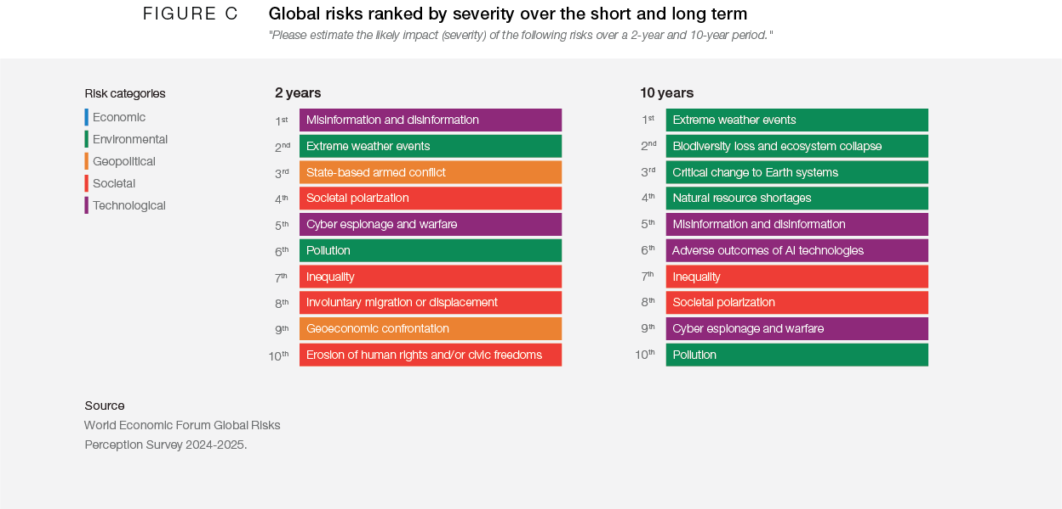

Misinformation and disinformation

The WEF have identified misinformation and disinformation as the most urgent problem in the short term, that is over the next two years (World Economic Forum, 2025).
Misinformation can be described as sharing false or inaccurate information without the intent to deceive anyone, research suggests that this is usually the case if the person genuinely believes the information to be correct (Broda and Strömbäck, 2024).
Disinformation is false information that is made up and shared purposely to mislead, or cause harm (Broda and Strömbäck, 2024).

Research suggests that the sharing of ‘fake news’ can have significant consequences for society. It can fuel misinformation and cause knowledge resistance which results in society distrusting any news, this undermines genuine news sources (Strömbäck et al., 2022).
This can have a knock-on effect and can change the way people vote or respond to public health warnings, and take away the importance of other global challenges such as climate change.
It can also result in social divides by reinforcing preconceptions which are fuelled by people who want the individuals to support their views (Dr et al., 2021).

This over time weakens democracy and makes it harder for society to unite on a common ground (Strömbäck et al., 2022).

Implications for sustainability

Misinformation is spreading very easily through platforms such as social media and other digital platforms. This not only causes confusion, but it also triggers mistrust in any facts, and this makes it harder to get support for rolling out new innovations such as renewable energy.
This distrust can escalate and cause rise to political tensions and mistrust between nations. The implications of this are that if countries stop working together or pull out of global agreements then any progress on Sustainable Development goals will slow down or even fail (Ognyanova et al., 2020).

In the context of health, climate change and governance, false information can delay urgent action, divide communities and weaken the democratic process essential for inclusive development. An example of this could be the need for the mass immunisation of a vaccine, and due to misinformation or scaremongering it could lead to a reduced number of people willing to have the vaccine. This process of posting misinformation on health or any other topic on social media is called an ‘infodemic’ and research suggests that it can be detrimental to a mass immunisation programme and could cause fatalities in some instances (Borges do Nascimento et al., 2022).

Strategic suggestions

Bateman and Jackson, 2024, suggest that there are strategies which governments can adopt to try and combat this problem. However, it is not an easy task, and the table ‘Figure 2’ shows an overview of case studies which describe how effective any intervention could be.

The results show that to be effective and to be able to scale the action easily the best solution would be ‘media literacy education’, which would involve teaching people how to critically evaluate information. It should also explain how to check facts and how to recognise bias (Lord and Vogt, 2021).

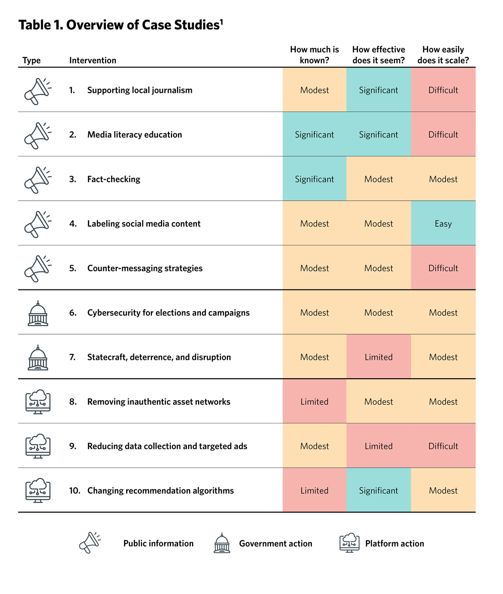
Figure 2.

(Bateman and Jackson, 2024).

Lord and Vogt, 2021, further suggest that although critics say that this will take too long and we need to act now, they reiterate that this is an ongoing problem which needs to be addressed properly. Research they have found demonstrates that a year and a half after taking part in media literacy training they continued to be 25% more likely to check multiple news sources and 13% were able to tell the difference between serious reporting and misinformation.

In the UK there is a ‘Local Climate Engagement ‘programme by UK100 which provides training, fact sheets, and public forums to address local climate misinformation. This promotes community involvement and trust in climate action (Uk100.org, 2025).

Research also suggests ‘Fact checking’ this could be done by organisations set up for that specific purpose. News outlets could use stricter rules on their editorial verification processes (Bateman and Jackson, 2024).

Showing support to local journalism would also send the message that the news reporting is true and not misinformation.
Research suggests that by amplifying credible climate experts will boost the reach of information to combat the misinformation (Sustainability Directory, 2025).

Another solution could be to report false information to the platform host; this could help the platforms eradicate people who do this on social media.
Research suggests that by fostering respectful conversations would empower local communities to build climate literacy and resilience (World Health Organization, n.d.).

Extreme Weather Events

The second urgent problem on the WRF’s report is the extreme weather events that are being experienced by society and intensified by climate change. These challenging extreme weather events include increased disasters, floods, drought, hurricanes, heatwaves and wildfires (McSweeney and Tandon , 2024).
Research suggests that between 2021 and 2023 the people experiencing natural disasters rose from 27% to 30%, and this was due to increased episodes of flooding (European Environment Agency, 2023).
These terrible events have caused substantial economic and human losses, highlighting the continued need for climate adaptation strategies.
The following Figure 3 shows the impact these disasters have had worldwide.

Figure 3 (McSweeney and Tandon , 2024)

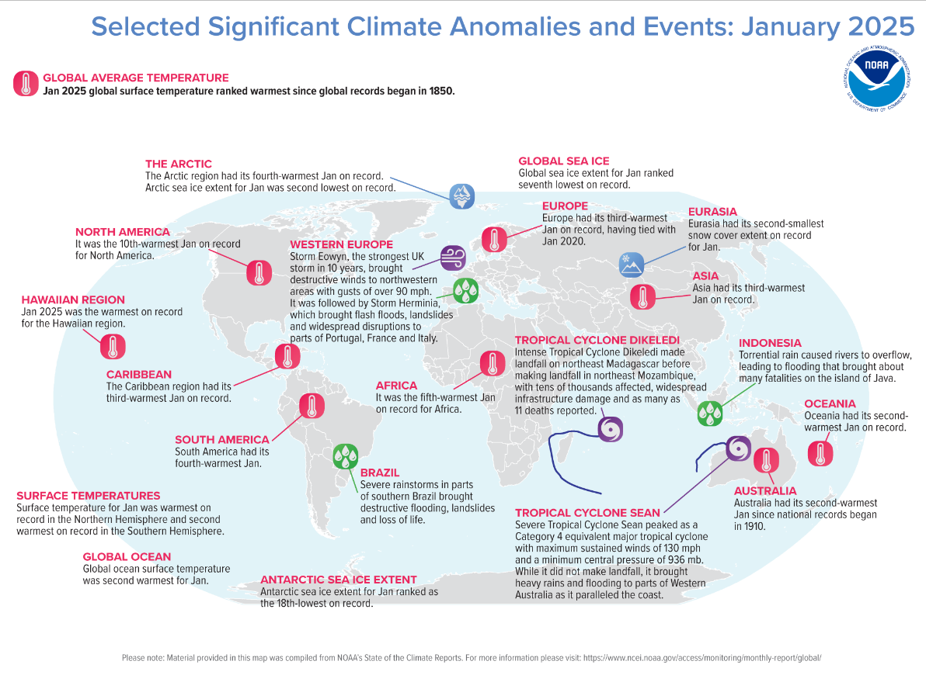

Implications for sustainability

The implications for sustainability on climate action is that due to the increase of severity of weather events the current climate action efforts are being impeded (UNDRR, 2020).
Research suggests that there is a delay in implementing renewable energy solutions and insufficient decarbonisation efforts are hindering the achievements of climate related targets and are causing untold damage to ecosystems and biodiversity (Saleh and Hassan, 2024).
This extreme weather like floods, wildfires, and heatwaves are becoming more frequent and are also more extreme due to climate change. These events are causing significant threats to sustainable development in low- and middle-income countries (Ebi et al., 2021).
They pose serious threats to sustainable development by disrupting critical systems that underpin economic stability, environmental health and social wellbeing.
These events cause huge problems to communities as they destroy buildings, destroy crops which causes more people to become hungry and costs the governments an enormous amount of money in recovery efforts which takes away finance for other long term development investments (World Food Programme, 2024).

They undermine the progress of the key Sustainable Development Goals, including zero hunger, clean water, clean sanitation and sustainable cities. If climate change continues at this rate and people do not act then the targets set for 2050 will never be achieved and this will widen inequality, threaten poverty and erode the resilience of human and natural systems (United Nations, 2023).

Strategic suggestions

Research suggests that one of the most concerning problems are that there is no early warning system that theses disasters are about to strike. Another problem is that these disasters often occur in remote areas, and areas where there are less educated and financially vulnerable people. (Climate Adapt, 2019).

Climate Adapt, 2019, further suggests that for an early warning system to be effective it must be able to alert all the people that are in danger.
Paul, Bee and Budimir, 2021, suggest that using a smartphone could be a way of alerting society and every person as to any imminent danger from weather systems. These targeted messages could be sent to everyone without users having to install a specific app to read them.
A scheme to train people in evacuation and disaster preparedness training could be beneficial, allowing the community to help themselves (Torani et al., 2019).

Research suggests that an investment in climate-resilient infrastructure could be an excellent strategic suggestion, it could include flood resistant housing, drought resilient irrigation systems and buildings that can withstand climate shocks.
Preserving natural ecosystems such as forests would provide critical protection against extreme weather.
Planting drought tolerant crops can help to secure food systems when faced with unstable weather conditions (Cho, 2024).

State based armed Conflict

One of the most severe concerns according to the WEF is state-based armed conflicts. This suggests that ongoing conflicts such as the war in Ukraine, Sudan and Gaza are amplifying the increasing geopolitical fragmentation and the breakdown of multilateral conflict resolution efforts (press.un.org, 2024).

State based armed conflict can be defined as organised violence between two governments which may include insurgent groups, rebel factions or other groups (UCDP, 2024).
These conflicts are characterised by their scale, how long they last and how much of disruption they cause to society. Recent years have seen an increase in such conflicts. For example, Sudan has been involved in a civil war since April 2023 which has resulted in an humanitarian crisis and caused millions of people to flee from their homes. This example demonstrates the severity of complex state-based conflicts and how they can affect the population living there (UNHCR, 2024).

Implications for sustainability

The ongoing and rising conflicts between countries such as Ukraine, Sudan and Gaza make it much harder to build peaceful societies. War destroys foundations, forces people to leave their homeland, and destroys the economy by using up money on arms that could have been used on education, healthcare or environmental needs (Jackson, 2024).
In the Republic of Congo, a large country in Central Africa, the M23’s (a rebel group) took control over the mineral rich area and this has led to heavy taxes on local population and businesses this has resulted in extreme poverty (Centre for Preventive Action, 2025).

In a similar situation Pakistan is facing significant risks due to an unrest with India. India and Pakistan have been fighting over Kashmir for over three years. India have recently been accused of attacking Pakistan, are they are debating whether to retaliate. Both countries have nuclear arms and so the situation is very serious (Mogul et al., 2025).
ET Online, 2025, suggest that if this situation did result in warfare, it could have dire effects on both countries and estimate125 million deaths. It also suggests that the rest of the world would see the effect by the collapse of global agriculture, and this would also signify a worldwide climate crisis.

Another problem with armed conflicts is that it results in people fleeing the area, leading to overcrowding in urban areas and a strain on the public services in that region. There can be a collapse of the healthcare system in these war-torn countries and the destruction of educational establishments can mean that children are losing out on educational opportunities (Tremblay, n.d.).

The environment is always affected by war, the destruction of eco-systems, pollution and exploitation of natural resources are common (Weir, 2020).

Columbia has seen illegal logging in conflict zones which has caused deforestation and exploitation of vulnerable communities which has undermined any efforts for conservation and biodiversity. These conflicts undermine Governments which promotes corruption (International Crisis Group, 2021).
An example of this can be seen again in the Congo where the government has lost control over the Eastern region and has allowed rebel groups to challenge the national sovereignty and government (Centre for Preventive Action, 2025).

Strategic suggestions

Research suggests that to combat the threat from state based armed conflict on sustainable development would require a multifaceted approach involving prevention, resolution and reconstruction strategies (press.un.org, 2000).

Implementation of a conflict prevention strategy could help identify and address potential triggers of violence. Research suggests that one of the main triggers is poverty and so it would be essential to address socio-economic grievances (Marks, 2016).

Post-conflict peacebuilding initiatives should be implemented and focus on reconciliation, trust and transparency. Strategies that involve healing past grievances and support social unity is essential. Rebuilding economies involves investment in infrastructure, creating employment opportunities and ensuring access to resources.
International investment can play an important role in revitalizing economies and reducing poverty (Seils, 2017).
The restoration of environments in war-torn areas are essential for long-term development. This can nurture cooperation among conflicting groups and contribute to ecological conservation.
Re-establishing governing structures and law is fundamental for stability. Anti-corruption laws and judicial reforms can nurture public trust in the system again (Jones et al., 2005).

Conclusion

This report has shown that the biggest problems facing the world over the next two years, highlighted by the WEF are misinformation and disinformation, extreme weather events and state based armed conflict.
These events do not happen in isolation; they interact with one another creating a highly volatile and unpredictable global environment.
The implications for sustainable development are intense. Armed conflict threatens peace, while misinformation undermines the trust needed for effective governance. Meanwhile climate related events continue to obstruct progress on climate action, food security and the infrastructure of our countries.
The destruction of global cooperation or trust could result in the stalling of the Sustainable Development Goals.
However, research suggests that there is an opportunity for meaningful action here. Research has shown that if global leaders work together to strengthen international institutions, promote digital literacy and accountability in information ecosystems, and accelerate the efforts for the use of sustainable energy then there may be a chance for the future.
The next two years will be decisive, and the vision of a just, green and inclusive world will depend on managing these existing challenges and anticipating the risks of the future.

Recommendations

The following actions are recommended to safeguard progress towards sustainable development in the future.
- Strengthen peacebuilding and conflict prevention by investing in early warning systems to identify potential conflict flashpoints. Promote inclusive peace negotiations when needed.
- Promote climate resilient development, and address climate risks as a security priority.
- Tackle misinformation through education, regulation and transparency, and encourage public trust, by working jointly with mechanisms such as the ‘EU Code of Practice on Disinformation.
- Regulate natural resources to prevent environmental harm.
- Support international cooperation by strengthening the authority of institutions such as the United Nations, the World Health Organisation and the International Monetary fund.
Words- 2556

References

Bateman, J. and Jackson, D. (2024). Countering Disinformation Effectively: An Evidence-Based Policy Guide. [online] Carnegie Endowment For International Peace. Available at: https://carnegieendowment.org/research/2024/01/countering-disinformation-effectively-an-evidence-based-policy-guide?lang=en.
Borges do Nascimento, I.J., Beatriz Pizarro, A., Almeida, J., Azzopardi-Muscat, N., André Gonçalves, M., Björklund, M. and Novillo-Ortiz, D. (2022). Infodemics and health misinformation: a systematic review of reviews. Bulletin of the World Health Organization, [online] 100(9), pp.544–561. doi:https://doi.org/10.2471/blt.21.287654.
Broda, E. and Strömbäck, J. (2024). Misinformation, disinformation, and fake news: lessons from an interdisciplinary, systematic literature review. Annals of the International Communication Association, 48(2), pp.139–166. doi:https://doi.org/10.1080/23808985.2024.2323736.
Center for Preventive Action (2025). Conflict in the Democratic Republic of Congo. [online] Global Conflict Tracker. Available at: https://www.cfr.org/global-conflict-tracker/conflict/violence-democratic-republic-congo.
Cho, R. (2024). The Case for Climate-Resilient Infrastructure. [online] State of the Planet. Available at: https://news.climate.columbia.edu/2024/07/22/the-case-for-climate-resilient-infrastructure/.
Climate Adapt (2019). Establishment of early warning systems — English. [online] climate-adapt.eea.europa.eu. Available at: https://climate adapt.eea.europa.eu/en/metadata/adaptation-options/establishment-of-early-warning-systems.
Dr, L., Stoilova, M., Anstead, N., Fry, A., El-Halaby, G. and Smith, M. (2021). Rapid Evidence Assessment on Online Misinformation and Media Literacy Final report. [online] Available at: https://www.ofcom.org.uk/siteassets/resources/documents/research-and-data/online-research/online-nation/2021/rea-online-misinformation.pdf?v=326529.
Ebi, K.L., Vanos, J., Baldwin, J.W., Bell, J.E., Hondula, D.M., Errett, N.A., Hayes, K., Reid, C.E., Saha, S., Spector, J. and Berry, P. (2021). Extreme weather and climate change: Population health and health system implications. Annual Review of Public Health, [online] 42(1), pp.293–315. doi:https://doi.org/10.1146/annurev-publhealth-012420-105026.
Elsner, M., Atkinson, G. and Zahidi, S. (2025). Global Risks Report 2025. [online] World Economic Forum. Available at: https://www.weforum.org/publications/global-risks-report-2025/.
ET Online (2025). India–Pakistan nuclear conflict won’t just be a border issue: 2019 ‘Nostradamus’ study warns it could star. [online] The Economic Times. Available at: https://economictimes.indiatimes.com/news/new-updates/indiapakistan-nuclear-conflict-wont-just-be-a-border-issue-2019-nostradamus-study-warns-it-could-starve-the-world/articleshow/120866536.cms?from=mdr [Accessed 9 May 2025].
European Environment Agency (2023). Economic Losses from weather- and climate-related Extremes in Europe - 8th EAP. [online] www.eea.europa.eu. Available at: https://www.eea.europa.eu/en/analysis/indicators/economic-losses-from-climate-related.
International Crisis Group (2021). A Broken Canopy: Deforestation and Conflict in Colombia. [online] Crisis Group. Available at: https://www.crisisgroup.org/latin-america-caribbean/andes/colombia/091-broken-canopy-deforestation-and-conflict-colombia.
Jackson, M. (2024). The Lost Generation: What Happens When War Kills Education | Education Above All Foundation. [online] Educationaboveall.org. Available at: https://www.educationaboveall.org/blog/our-advocacy/lost-generation-what-happens-when-war-kills-education.
Jones, S.G., Wilson, J.M., Rathmell, A. and K Jack Riley (2005). Establishing Law and Order After Conflict. United States.
Lord, K. and Vogt, K. (2021). Strengthen Media Literacy to Win the Fight Against Misinformation (SSIR). [online] Stanford Social Innovation Review. Available at: https://ssir.org/articles/entry/strengthen_media_literacy_to_win_the_fight_against_misinformation.
Matamis, J. (2025). Top Ten Global Risks for 2025 • Stimson Center. [online] Stimson Center. Available at: https://www.stimson.org/2025/top-ten-global-risks-for-2025/.
McSweeney, R. and Tandon , A. (2024). Mapped: How climate change affects extreme weather around the world - Carbon Brief. [online] Carbon Brief. Available at: https://interactive.carbonbrief.org/attribution-studies/index.html.
Mogul, R., Saifi, S., Iyer, A.S., Aditi Sangal, Hammond, E., Powell, T.B., Yeung, J. and Harvey, L. (2025). India strikes Pakistan in wake of Kashmir massacre. Pakistan says 5 Indian planes downed. [online] CNN. Available at: https://edition.cnn.com/world/live-news/india-pakistan-attack-kashmir-tourists-intl-hnk.
Ognyanova, K., Lazer, D., Robertson, R.E. and Wilson, C. (2020). Misinformation in action: Fake news exposure is linked to lower trust in media, higher trust in government when your side is in power. Harvard Kennedy School Misinformation Review, [online] 1(4), pp.1–19. doi:https://doi.org/10.37016/mr-2020-024.
Paul, J.D., Bee, E. and Budimir, M. (2021). Mobile phone technologies for disaster risk reduction. Climate Risk Management, 32, p.100296. doi:https://doi.org/10.1016/j.crm.2021.100296.
press.un.org. (2000). CONFLICT PREVENTION MUST BE ‘CORNERSTONE OF COLLECTIVE SECURITY IN 21ST CENTURY’, SECRETARY-GENERAL TELLS MEMBERS, AS COUNCIL DISCUSSES ARMED CONFLICT | UN Press. [online] Available at: https://press.un.org/en/2000/20000720.sc6892.doc.html.
press.un.org. (2024). Secretary-General Urges Statesmanship to End Geopolitical Deadlock, Warning Humanity ‘Ever Closer to a Great Fracture’, at Opening of Annual General Assembly Session | UN Press. [online] Available at: https://press.un.org/en/2024/ga12579.doc.htm.
Saleh, H.M. and Hassan, A.I. (2024). The challenges of sustainable energy transition: A focus on renewable energy. Applied chemical engineering, 7(2), pp.2084–2084. doi:https://doi.org/10.59429/ace.v7i2.2084.
Seils, P. (2017). The Place of Reconciliation in Transitional Justice. [online] International Center for Transitional Justice. Available at: https://www.ictj.org/publication/reconciliation-transitional-justice.
Strömbäck, J., Wikforss, Å., Glüer, K., Lindholm, T. and Oscarsson, H. (2022). KNOWLEDGE RESISTANCE IN HIGH-CHOICE INFORMATION ENVIRONMENTS. [online] Available at: https://library.oapen.org/bitstream/handle/20.500.12657/54482/9781000599121.pdf?sequence=1&utm_source=miragenews&utm_medium=miragenews&utm_campaign=news#page=88.
Torani, S., Majd, P.M., Maroufi, S.S., Dowlati, M. and Sheikhi, R.A. (2019). The importance of education on disasters and emergencies: A review article. Journal of Education and Health Promotion, [online] 8(85), p.85. doi:https://doi.org/10.4103/jehp.jehp_262_18.
Tremblay, S. (n.d.). Attacks on Schools and Hospitals. [online] United Nations Office of the Special Representative of the Secretary-General for Children and Armed Conflict | To promote and protect the rights of all children affected by armed conflict. Available at: https://childrenandarmedconflict.un.org/six-grave-violations/attacks-against-schools/.
UCDP (2024). UCDP Definitions - Uppsala University. [online] www.uu.se. Available at: https://www.uu.se/en/department/peace-and-conflict-research/research/ucdp/ucdp-definitions.
Uk100.org. (2025). UK100 | Projects | Local Climate Engagement | UK100. [online] Available at: https://www.uk100.org/projects/local-climate-engagement-lce [Accessed 9 May 2025].
UNHCR (2024). Sudan situation. [online] Global Focus. Available at: https://reporting.unhcr.org/operational/situations/sudan-situation.
United Nations (2023). Goal 6: Ensure access to water and sanitation for all. [online] United Nations Sustainable Development. Available at: https://www.un.org/sustainabledevelopment/water-and-sanitation/.
Weir, D. (2020). How does war damage the environment? [online] Conflict and Environment Observatory. Available at: https://ceobs.org/how-does-war-damage-the-environment/.
World Economic Forum (2025). Global Risks Report 2025: Conflict, Environment and Disinformation Top Threats. [online] World Economic Forum. Available at: https://www.weforum.org/press/2025/01/global-risks-report-2025-conflict-environment-and-disinformation-top-threats/.
World Food Programme (2024). A Global Food Crisis. [online] World Food Programme. Available at: https://www.wfp.org/global-hunger-crisis.
World Health Organization (n.d.). How to report misinformation online. [online] www.who.int. Available at: https://www.who.int/campaigns/connecting-the-world-to-combat-coronavirus/how-to-report-misinformation-online.

