
Designing an Integrated Human Capital Strategy to Foster Innovation and Hybrid Work at Aether Innovations

Student Name: Tirth G Patel
Student ID: 2522415

Module Name: Human Capital Management
Module Code: LCMB7023
Lecturer’s Name: Gladius Kulothungan Ejike Udeogu
Work Count: 2478

Term 1
Table of Contents
Part 1: Building a Culture of Innovation & Future Work Practices 3
1. Introduction 3
2. Innovation Culture in Technology Companies 4
3. Cultural Initiatives to Promote Innovation at Aether Innovations 5
3.1 Innovation Sprints 5
3.2 Intrapreneurship Programmes 6
3.3 Cross-functional Cooperation. 6
3.4 Innovation Reward Systems 7
4. Future of Work Model: Hybrid Work Strategy 9
5. Employee Motivation and Performance Outcomes 11
6. Conclusion 13
PART 2: Reflective Learning 14
7. Reflective Learning Using Gibbs’ Reflective Cycle 14
8. AI and Future Career Development 17
Reference list 18

Part 1: Building a Culture of Innovation & Future Work Practices

1. Introduction
Human Capital Management (HCM) has become a vital aspect of allowing contemporary organisations to recruit, nurture and keep talent that spurts innovation, agility and competitive advantage in the long run (Stratone & Vatamanescu, 2024). Effective HCM practices are directly related to employee engagement, productivity and customer outcomes in industries that are fast-paced and knowledge-intensive, like technology (Nastase, Andreea Adomnitei and Anisoara Apetri, 2025). Aether Innovations is a fast-developing 300-person technology firm with high staff turnover, stagnant growth and decreasing customer satisfaction, which means that its people practices do not align with its strategic goals. The challenges indicate that the organisational culture, work design and employee experience are weak, and are driving down its innovation and performance (Nhien & Nguyen, 2025). This report is aimed at formulating a cohesive Human capital strategy that would solve these problems by harmonising the people, culture and working practices with the strategic ambitions of the firm.
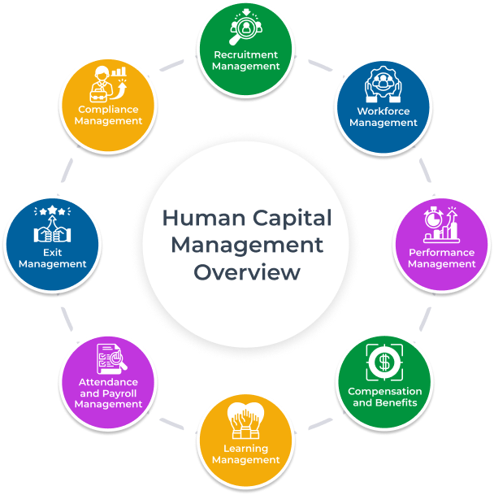
Figure 1 Human Capital Management Overview Framework
Image source: (Stratone & Vatamanescu, 2024)

2. Innovation Culture in Technology Companies

Human Capital Management (HCM) has become a vital aspect of allowing contemporary organisations to recruit, nurture and keep talent that spurts innovation, agility and competitive advantage in the long run (Donate, Peña and Sánchez de Pablo, 2015). Effective HCM practices are directly related to employee engagement, productivity and customer outcomes in industries that are fast-paced and knowledge-intensive, like technology (Donate, Peña and Sánchez de Pablo, 2015). Aether Innovations is a fast-developing 300-person technology firm with high staff turnover, stagnant growth and decreasing customer satisfaction, which means that its people practices do not align with its strategic goals. The challenges indicate that the organisational culture, work design and employee experience are weak, and are driving down its innovation and performance (Donate, Peña and Sánchez de Pablo, 2015). This report is aimed at formulating a cohesive Human capital strategy that would solve these problems by harmonising the people, culture and working practices with the strategic ambitions of the firm.

3. Cultural Initiatives to Promote Innovation at Aether Innovations
The targeted cultural initiatives that would help Aether Innovations respond to the high turnover and slow growth are as follows. Both of them use the existing HRM concepts to promote creativity, psychological security and ownership of employees (Magistretti et al., 2021).

3.1 Innovation Sprints
Innovation sprints are intensive, time-limited (usually 3-5 days) workshops in which cross-functional teams ideate intensively, prototype and test solutions to particular business problems, e.g. make customer onboarding faster or eliminate service delays (Krüger et al., 2023). Sprints reduce the innovation cycle and promote speedy experimentation and learning through failure, and thus, foster creative assurance and problem-solving flexibility (Krüger et al., 2023). To the engineers and product teams of Aether, quarterly sprints on customer pain points would be a direct improvement to the engagement because it offers a sense of autonomy, purpose, and visible effect, as well as generating actionable ideas that can improve the service quality and satisfaction (Krüger et al., 2023).

3.2 Intrapreneurship Programmes
Intrapreneurship programmes give employees specific time, budget and advice to innovate their internal business concepts, like new AI-powered features or process automation tools. It is organised as an Annual Venture Lab with successful proposals offered 20% of protected time and executive sponsorship, as in Google (Poleo, 2023).
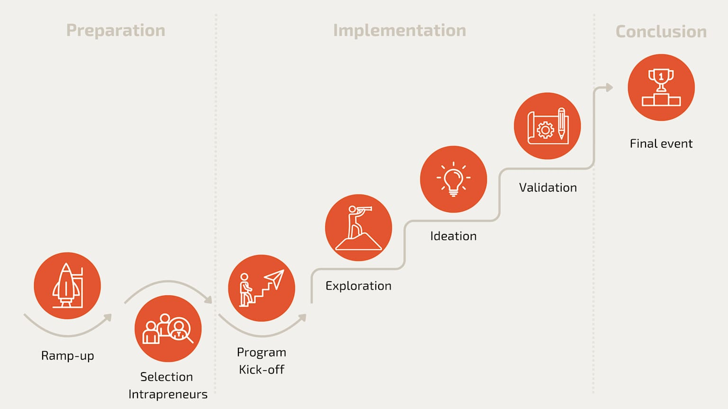
Figure 2 Stages of an intrapreneurship programme like Google’s model.
Image source: (Poleo, 2023)
This initiative enhances creativity since it enables individuals to be entrepreneurial and safe, and it adds to engagement by creating ownership and skill growth (Poleo, 2023). In Aether, it would keep high-potential talent that requires growth options, addressing the turnover directly and planting innovations that would generate revenues.

3.3 Cross-functional Cooperation.
Cross-functional teams (that are permanent and are composed of engineers and designers, along with sales and customer success) would address end-to-end priorities such as a product roadmap or client retention strategies (Bastian et al., 2018). Semi-formal syncs and hackathons would occur on a regular basis, eliminate silos, and incorporate various views (Bastian et al., 2018). This has been proven through research on team dynamics to increase creativity as a result of the recombination of knowledge and increase engagement as a result of collective accountability (Bastian et al., 2018). In the case of Aether, this partnership would help them make decisions faster, coordinate their efforts to meet customer expectations and create a sense of belonging, which would overcome the isolation that would lead to disengagement.

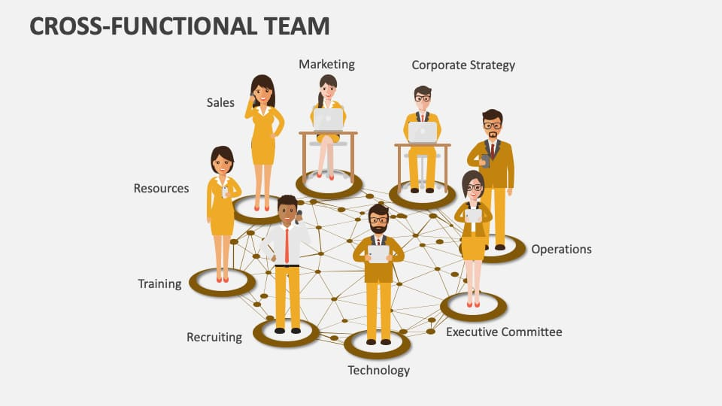
Figure 3 Structure of a cross-functional team breaking down silos.
Image source: (Bastian et al., 2018)

3.4 Innovation Reward Systems
The multi-layered rewards system would identify creative behaviours: peer-nominated Spark Awards of ideas generated, group bonuses on implemented sprints, and developmental rewards (training stipends, attending conferences) on intrapreneurial contributions (Darmaki, Omar and Ismail, 2020). This is based on the effort, collaboration and learning, unlike the output-only based incentives, which are in line with the theories of motivation that emphasise intrinsic recognition (Darmaki, Omar and Ismail, 2020). It would maintain interest and focus by psychologically satisfying innovation and making it visible, and strengthening organisational culture that rewards creativity over conformity, which will lead to increased retention and performance rates within Aether (Darmaki, Omar and Ismail, 2020).

4. Future of Work Model: Hybrid Work Strategy
A tailored hybrid work model can assist Aether Innovations to solve its challenges, including turnover, lack of growth and customer satisfaction that are stagnant through enhanced flexibility, teamwork and work experience (Amadeja Lamovšek et al., 2024). The offered plan is a hybrid model 3-2, in which employees will work three core days a week at the office in 2 days at home (Amadeja Lamovšek et al., 2024). Each office day would be used to prioritise high-value offline events, like innovation sprints, cross-functional workshops, client co-creation and solving complex problems, and remote days would be dedicated to focused, one-on-one work, documentation and asynchronous collaboration (Eng, Tjernberg and Champoux-Larsson, 2024). A solid digital ecosystem, such as integrated video conferencing, collaborative documentation, agile project management and instant messaging, should be the basis of this model, which would allow teams to sustain communication continuity despite geographic dispersion (Eng, Tjernberg and Champoux-Larsson, 2024). There must exist clear conventions on availability, response time and etiquette in responding to avoid getting overwhelmed by digital excess and ensure time is saved to engage in deep work (Eng, Tjernberg and Champoux-Larsson, 2024).
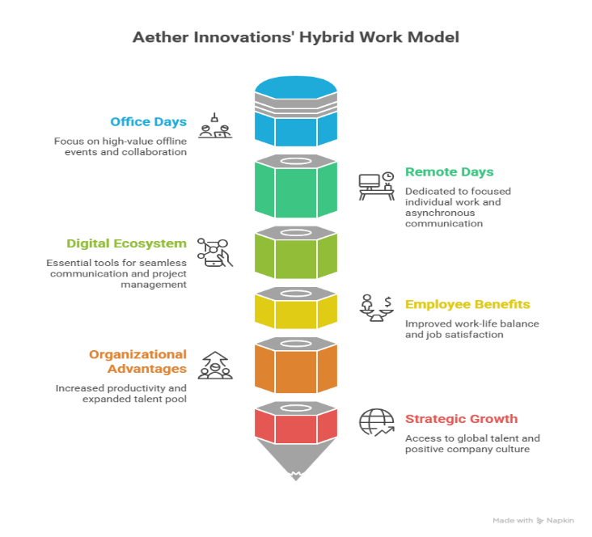
Figure 4 Aether Innovations' Hybrid Work Model
Image source: created by the author
To the employees, the hybrid model is meant to improve the union between work and personal life since they take less time to commute to work, have more control over the way and place of doing the work, and are able to combine their personal and professional lives (Aprilina & Martianty, 2023). Job satisfaction, engagement and perceived organisational support, which come with greater flexibility, will decrease voluntary turnover (Wang et al., 2025). To the organisation, a well-designed hybrid system has the ability to increase productivity because it enables staff to align the type of tasks to the best fit environment, which has the benefit of integrating both the creativity of the co-located session and the benefits of concentration that comes with working at a distance (Aprilina & Martianty, 2023). Strategically, hybrid work also allows Aether to expand the talent pool beyond its local geographical region, and more easily access scarce technical and innovation talent, and can be seen as a positive indicator of a progressive and people-centred culture, which is particularly appealing to younger and more digitally skilled employees (Wang et al., 2025). This hybrid future-of-work model, when combined with effective performance management, explicit objectives and an innovation-focused culture, could allow achieving greater engagement, more collaborative and consistent customer value generation at Aether Innovations (Aprilina & Martianty, 2023).

5. Employee Motivation and Performance Outcomes

The culture of innovation and the properly developed hybrid work model will contribute to the improvement of intrinsic and extrinsic motivation, which is converted into stronger performance (Zhang & Gandham, 2025). Two-Factor Theory by Herzberg opined that innovation efforts, autonomy and recognition are motivating factors that enhance the levels of satisfaction above the basic hygiene factors such as pay and job security (Zhou & Ma, 2024).

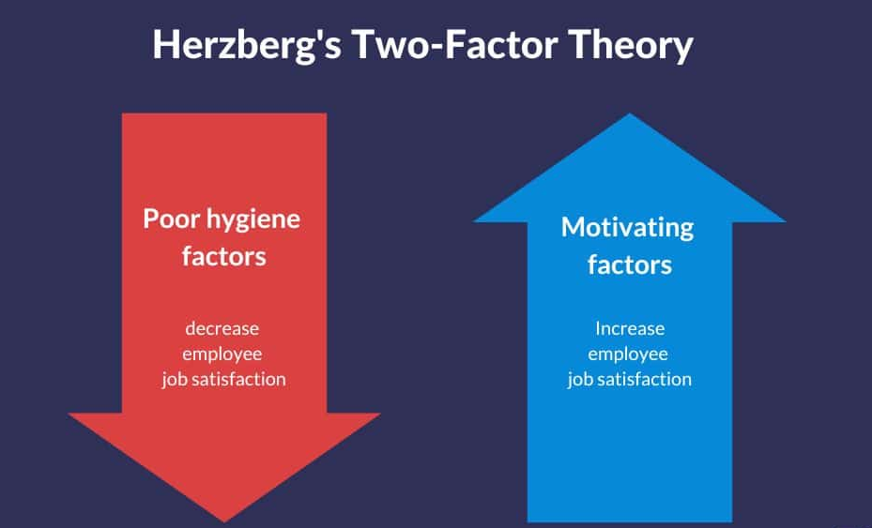
Figure 5 Herzberg's Two-Factor Theory
Image source: (Zhou & Ma, 2024)

Self-Determination Theory focuses on the aspects of autonomy, competence and relatedness: innovation sprints, intrapreneurship programmes and flexible hybrid work enhance each of the three by providing the employees with the option of choice of tasks, the possibility to acquire new skills and more enriched collaboration (Lyness et al., 2013). The essential dimensions identified by the Job Characteristics Model include skill variety, task significance and autonomy, cross-functional innovation projects, and work design to support a remote environment, enrich these factors and result in enhanced internal work motivation and effectiveness (Lucas, 2021). On the whole, employees who feel engaged through delivery of an innovation culture and conducive hybrid practices are more proactive in problem solving and creativity; the increased engagement in turn lead to eventual better individual and organisational performance outcome (Charles et al., 2025).

6. Conclusion
The report has suggested an overall Human Capital approach of Aether Innovations and the core focus based on the development of an innovation-oriented culture and the establishment of a formal hybrid work system (Magistretti et al., 2021). Among the most significant ones, there are innovation sprints, intrapreneurship programmes, cross-functional collaboration and innovation-oriented reward systems, a 3-2 hybrid structure with strong digital tools (Magistretti et al., 2021). All these practices will combine to reinforce intrinsic motivation, creativity and psychological safety, which will increase employee engagement (Lyness et al., 2013). Greater output of innovation in turn should be motivated by more engagement, enhanced collaboration and work-life balance, which will decrease staff turnover and eventually customer satisfaction and organisational performance (Kang et al., 2021).

PART 2: Reflective Learning

7. Reflective Learning Using Gibbs’ Reflective Cycle

Description
The Human Capital Management module was a good source of understanding on how organisations can strategically manage people to have sustainable performance and competitive advantage. During the module, a number of very critical issues were addressed, which included strategic human resource management, employee motivation, culture of innovation, talent management, and the future of work. The learning process was based on lectures, seminars, academic readings and discussion of actual organisational examples, and it enabled the demonstration of how human capital strategies determine the organisational outcomes. The main activity of this module has been to analyse the organisational issues and develop the HR plan of Aether Innovations, which is a rapidly expanding technology-focused company where employee turnover is high, and the customer satisfaction level drops.
Feelings
Early in the module, I was interested, but was at the same time a bit confused by the complexity of the concepts of Human Capital Management. Even though I possessed a little background knowledge regarding human resource management, the strategic approach in this module was more cutting-edge and demanded a greater insight into the organisational behaviour as well as leadership practices. First, I had a hard time trying to comprehend certain scholarly theories and models connected with motivation, organisational culture and strategic HRM.
Evaluation
All in all, I found my time in this module very positive, and it would be essential in my professional growth. Among the most useful things of the module was that human capital strategies could have a direct impact on the organisational performance. I also realised more about the way HR functions, including innovation programs, work-life balance and employee participation measures can enhance productivity and organisational performance.
Some challenges were experienced in the learning process. It took a great effort to read and understand the complicated academic texts and incorporate several theories into a single strategic recommendation.

Analysis
This module learning experience made me understand the strategic significance of human capital management to contemporary organisations. Employee motivation was one of the concepts that impacted my learning. As an illustration, the Two-Factor Theory by Herzberg proposes the idea that motivation factors like recognition, achievement and personal growth are not only important in employee satisfaction, but also based on some basic working conditions (Zhang & Gandham, 2025).
The other significant notion that was discussed in the module was the importance of organisational culture as an agent of innovation (Zhang & Gandham, 2025). In the case of technology firms, creative thinking, collaboration and continuous learning are often used to keep the firm competitive.
In addition, the idea of hybrid work emphasised the significance of the flexibility of current work environments. The hybrid work models also enable employees to have a combination of individual work-focused and collaboration activities, which could enhance productivity and job satisfaction (Zhang & Gandham, 2025). According to the leadership view, such a style demands managers to pay more attention to trust, communication and results instead of supervision in the traditional sense (Zhang & Gandham, 2025).

Conclusion
When looking back at my learning experience in this module, I have come to learn better how human capital management adds to organisational success. I have realised that people management effort should not be restricted to administrative HR functions but should be a design of systems and culture that help in motivating employees, encouraging innovation and teamwork. Besides, the module reinforced several of the crucial competencies, such as critical thinking, academic research and the capacity to transfer theoretical concepts into practice.

Action Plan
In order to continue working on my human capital management skills, I will take numerous steps in the future. I will also expand my understanding of HR strategies and leadership practices by reading more academic journals and industry reports on strategic HRM and organisational development in the short term. I will also keep on enhancing my analytical abilities by implementing theoretical concepts in real-world organisational case studies.
At the beginning of my career, I will use the knowledge acquired in this module to contribute to the effort of enhancing the engagement of the employees, innovation and organisational culture. I will maintain my professional growth in the long run by keeping abreast of new trends in human capital management, especially in such domains as digital transformation, artificial intelligence and people analytics.

8. AI and Future Career Development
The concept of Artificial Intelligence (AI) is currently changing the contemporary work environment faster, as it starts to automate the routine work, enhance data analysis and assist in quicker decision-making. Current activities that are now done through AI tools include screening of recruitments, performance analytics and analytics of customer behaviour in many organisations (Rathore, 2023). Consequently, there is a growing expectation that professionals will collaborate with AI technologies so that they become more efficient and productive (Rathore, 2023). Nevertheless, AI will be unable to substitute human judgment, creativity, and strategic thinking, since the technology is capable of working with large volumes of information and providing new insights (Rathore, 2023).

The unique human skills, including critical thinking, emotional intelligence, leadership, and creativity, will be of more essential concern to professionals in the future workplace (Dumitru & Halpern, 2023). Such skills enable the managers to make sense of complex organisational situations, inspire employees and develop effective organisational cultures (Dumitru & Halpern, 2023). As an example, creating an innovation culture or introducing a hybrid work strategy requires human knowledge of the needs of employees, teamwork and organisational values.

AI can thus be considered as a supplementary system and not a substitute for human professionals (Dima et al., 2024). It can help managers, as it can offer data-driven information that helps to make decisions, yet it will be up to human beings to ensure strategic direction and moral judgment (Dima et al., 2024). With the integration of technology and high-quality human leadership, professionals can adjust to the changing future of work.

Reference list
Amadeja Lamovšek, Radević, I., Shaima' Salem Mohammed and Matej Černe (2024). Beyond the office walls: Work design configurations for task performance across on‐site, hybrid and remote forms of work. ISJ. Information systems journal/Information systems journal, 35(1). doi:https://doi.org/10.1111/isj.12542.
Aprilina, R. and Martdianty, F. (2023). The Role of Hybrid-Working in Improving Employees’ Satisfaction, Perceived Productivity, and Organizations’ Capabilities. Journal of Theory and Applied Management, 16(2), pp.206–222. doi:https://doi.org/10.20473/jmtt.v16i2.45632.
Bastian, B., Jetten, J., Thai, H.A. and Steffens, N.K. (2018). Shared Adversity Increases Team Creativity Through Fostering Supportive Interaction. Frontiers in Psychology, 9(12). doi:https://doi.org/10.3389/fpsyg.2018.02309.
Charles, W.P., Aminah Mobara, Tendency Beretu and Mhembere, L.Y. (2025). How hybrid work and organisation support shape an IT company’s employee engagement. SA Journal of Human Resource Management, [online] 23(0), p.8. Available at: https://sajhrm.co.za/index.php/sajhrm/article/view/3161/5201.
Darmaki, S.J.A., Omar, R. and Ismail, W.K.W. (2020). Driving Innovation: Reviewing the Role of Rewards. Journal of Human Resource and Sustainability Studies, 07(03), pp.406–415. doi:https://doi.org/10.4236/jhrss.2019.73027.
Dima, J., Gilbert, M.-H., Dextras-Gauthier, J. and Giraud, L. (2024). The effects of artificial intelligence on human resource activities and the roles of the human resource triad: opportunities and challenges. Frontiers in Psychology, [online] 15(1360401), pp.1–15. doi:https://doi.org/10.3389/fpsyg.2024.1360401.
Donate, M.J., Peña, I. and Sánchez de Pablo, J.D. (2015). HRM practices for human and social capital development: effects on innovation capabilities. The International Journal of Human Resource Management, 27(9), pp.928–953. doi:https://doi.org/10.1080/09585192.2015.1047393.
Dumitru, D. and Halpern, D.F. (2023). Critical Thinking: Creating Job-Proof Skills for the Future of Work. Journal of Intelligence, 11(10), p.194.
Eng, I., Tjernberg, M. and Champoux-Larsson, M.-F. (2024). Hybrid workers describe aspects that promote effectiveness, work engagement, work-life balance, and health. Cogent psychology, 11(1), pp.1–13. doi:https://doi.org/10.1080/23311908.2024.2362535.
Kang, T.-W., Sinha, P.N., Park, C.-I. and Lee, Y.-K. (2021). Exploring the Intra Entrepreneurship-Employee Engagement-Creativity Linkage and the Diverse Effects of Gender and Marital Status. Frontiers in Psychology, 12. doi:https://doi.org/10.3389/fpsyg.2021.736914.
Krüger, J., Doloresco, F., Maerten-Rivera, J., Zafron, M., Borden, H. and Fusco, N.M. (2023). An Innovation Sprint to Promote Problem-solving and Interprofessional Skills Among Pharmacy and Public Health Students. The American Journal of Pharmaceutical Education, 87(1), pp.ajpe8852–ajpe8852. doi:https://doi.org/10.5688/ajpe8852.
Lowery, G. (2010). Worker turnover hurts customer service, study shows. [online] Cornell Chronicle. Available at: https://news.cornell.edu/stories/2010/01/study-shows-employee-turnover-damages-service.
Lucas, S. (2021). A Practical Guide to the Job Characteristics Model. [online] AIHR. Available at: https://www.aihr.com/blog/job-characteristics-model/.
Lyness, J.M., Lurie, S.J., Ward, D.S., Mooney, C.J. and Lambert, D.R. (2013). Engaging students and faculty: implications of self-determination theory for teachers and leaders in academic medicine. BMC Medical Education, 13(1). doi:https://doi.org/10.1186/1472-6920-13-151.
Magistretti, S., Allo, L., Verganti, R., Dell’Era, C. and Reutter, F. (2021). The microfoundations of design sprint: how Johnson & Johnson cultivates innovation in a highly regulated market. Journal of Knowledge Management, 25(11), pp.88–104. doi:https://doi.org/10.1108/jkm-09-2020-0687.
Nastase, C., Andreea Adomnitei and Anisoara Apetri (2025). Strategic Human Resource Management in the Digital Era: Technology, Transformation, and Sustainable Advantage. Merits, [online] 5(4), pp.23–23. doi:https://doi.org/10.3390/merits5040023.
Nhien, P.X. and Nguyen, L.H.D. (2025). Human Resource Practices and Employee Engagement in High-Tech Firms: Enhancing Job Satisfaction and Retention. Advances in Social Science, Education and Humanities Research, [online] 11(2), pp.199–210. doi:https://doi.org/10.2991/978-2-38476-470-9_15.
Poleo, F.A. (2023). Innovation Strategies: Unpacking Google’s 20% Time Policy. [online] Danaconnect. Available at: https://www.danaconnect.com/the-power-of-dedicated-innovation-time-unpacking-googles-20-time-policy/.
Rathore, S. (2023). The Impact of AI on Recruitment and Selection Processes: Analysing the role of AI in automating and enhancing recruitment and selection procedures. International Journal for Global Academic & Scientific Research, 2(2), pp.78–93. doi:https://doi.org/10.55938/ijgasr.v2i2.50.
Stratone, M.-E. and Vatamanescu, E.-M. (2024). Intellectual capital management as a catalyst for organizational agility and performance in post-COVID-19 Romanian SMEs. Kybernetes, 6(2). doi:https://doi.org/10.1108/k-11-2024-3008.
University of Cumbria (2020). Gibbs’ Reflective Cycle. [online] University of Cumbria, University of Cumbria, pp.1–4. Available at: https://my.cumbria.ac.uk/media/MyCumbria/Documents/ReflectiveCycleGibbs.pdf.
Wang, B., Saeed, S., Zhang, Y., Fang, X. and Yu, X. (2025). Does remote work adoption boost firm innovation? A cross-cultural study. The International Journal of Human Resource Management, 36(6), pp.1–30. doi:https://doi.org/10.1080/09585192.2025.2484382.
Zhang, M. and Gandham, G. (2025). Faculty Job Satisfaction in Higher Education: A Systematic Review of Empirical Studies through Herzberg’s Two-Factor Theory. Journal of Management World, 2025(6), pp.37–50. doi:https://doi.org/10.53935/jomw.v2024i4.1222.
Zhou, L. and Ma, Y. (2024). Research on Management Strategies for Generation Z Employees from the Perspective of Two-Factor Theory. Studies in Social Science Research, 5(4), pp.p12–p12. doi:https://doi.org/10.22158/sssr.v5n4p12.

