
By: Yordan Petrov (2120805)
  - Learning Experience of the Students at the University of Wales Trinity Saint David, London Campus
Digital Skills and Research Methods (BMSW4003_LON)
Lecturer: Koushik Modak
05.04.2022

The impact of Virtual Learning Environment: REASERCH REPORT

As we are witnessing fast paced changes in the way business and people operate with technology and increasingly the use of Virtual Learning Environment as an important tool for learning at universities. It is certain there is great potential in VLE for students and it will continue to impact their learning. The Report focuses on resources from the literature related and data provided by the students at the University if Wales Trinity Saint David by a survey. By using combined research approach, aiming to determine positive and negative trends and influences of Moodle on the student population at the university. In conclusion, recommendations are presented for enhancement of the VLE learning process.
Table of Contents
Introduction 2
Rationale 2
Research Objectives 3
Research Aim and Methodology 3
Statement of Authenticity and Integrity 4
Literature Review 4
Background of the use of VLEs in Education 5
Positive Impacts of VLEs 5
Negative Impacts of VLEs 6
Results 7
Analysis and Discussion 9
Secondary data Analysis: 9
Primary data Analysis: 9
Discussion 10
Recommendations in Conclusion 11
References 12
Appendices: 13
Appendix 1 – Questionnaire: 13
Appendix 2 – Questionnaire Results Tables: 15

Introduction
A Virtual Learning Environment or VLE is an online virtual system containing a variety of instruments in support of learning and administration of learning. It is hard to say when exactly universities began using Virtual Learning Environment to enhance teaching but, it increasingly influences business, life, and education. There is limited amount of data and research on how VLEs used in schools, suggesting that the use of VLEs have a profound influence on students. It promotes independent learning while boosting students’ motivation to study. This Report reviews and discusses existing literature to see how it is impacting students and their learning experience in Higher Education (HE). The report also contains research, based on the primary and secondary data collected through mixed research methodology. Looking for insights about the engagement of a population of students at UWTSD with “Moodle” – the university’s VLE. More specifically, it focuses on their experiences while learning and engaged in the Digital Skills and Research Methods module at the London Campus throughout the first term of their first year. Learners have been asked to fill a questionnaire regarding their experience with “Moodle”, its functionality, level of satisfaction and asking for any suggestions for enhancement. Recommendations based on the insights from the survey and covered existing literature related, are suggested towards the end of the report.

Rationale
Nowadays VLEs are widely used in many sectors of business, life and of education. We are looking at existing literature and primary data collected on the topic to see how they are impacting students’ learning. Going furthermore, specifically the Report discusses data collected from students at the UWTSD, London Campus about the universities’ VLE – Moodle and their experiences with it. After analysis, using scientific approach, recommendations are drawn for improvement based on the survey’s results and secondary data reviewed.

Research Objectives
To Identify and evaluate qualitive data and quantitative data related to Virtual Learning Environment and its impact on the students’ learning experience broadly, by looking at related published literature and primary data collected on the topic.

To collect sample data from a specific population at the UWTSD via a questionnaire (Appendix 1) – the students from Group 2 of the February’s intake, year 2022/2023, about their experience with the VLE at the university – Moodle.

And finally, summarize and analyze the results from the collected qualitive and quantitative data (Appendix 2), to suggest recommendations for improving the Virtual Learning Environment at the UWTSD.

Research Aim and Methodology

Using a combined approach, qualitative and quantitative data were collected through an electronic Questionnaire (Appendix 1). The questions were aiming provide insight about “Moodle” the Virtual Learning Platform used at the UWTSD London Campus and its impact on the students’ learning experience at the university.
The survey was distributed to all students from Higher Education Skills for the Workplace Term 1, Group 2 - February 2022 Intake Course (Level 4) by email, a total of 29 students.
The results represent their experience with the platform and are summarized graphically (Appendix 2) analyzed and discussed along with the secondary data reviewed, related to the topic.
The final objective of the research is to generate recommendations for actions to improve the VLE experience provided by Moodle.

Statement of Authenticity and Integrity

The Research was performed with the informed consent of participants, and it will safeguard the confidentiality of the respondents. Its findings are based on other Researchers Reports as well and their work only reviewed here, acknowledged accordingly, with integrity. If a statement is untrue, the student acknowledges that an assessment offence has been committed.
Attention is drawn to the plagiarism and unfair practices of both the University and of ILM.

Literature Review

The literature review begins with a look at existing literature on VLEs chronological background and development in support of learning and teaching, then positive and negative impacts on students. With some examples on how VLEs influences motivation and independence in learning, adding context to this research. The sections below are related to the questions the Report is looking to answer.

Background of the use of VLEs in Education
Historically It cannot be determined exactly when Virtual Learning Environment became an educational technology. Gossling (2002) explains - “Between 1979 and 1999 the proportion of 18-19-year-olds in higher education (known as the age participation index, or API) more than doubled from 12 per cent to 32 per cent (HEFCE, 2001). Growth has been slowing down since. Although since that time growth has slowed, expanding involvement has become a main goal of government policy targeting a 50 per cent participation ratio by 2010 (Gosling, 2002).
Going in the 21st Century we observe how the way people work and business operates is changing forever. There have been essential changes – supply and demand, a new way to generate knowledge and learn – all due to convergence of computing, communication, and document management technologies all around the world, most notably, because of the World Wide Web – The Internet (Jones, et al., 1998-07-01). Nothing so far has ever intrigued educators all together around the world more than the World Wide Web (Owston, 1997).
A recent key change has been the increase of student debt and increasing number of students being employed longer during their term. Simultaneously pressure and stress had increased in many academic areas. Those features combined had changed the nature of teaching in HE and demands more from the staff and students (Fry, et al., 2002).
Positive Impacts of VLEs
It has been established that the use of VLEs improves learning by increasing students’ motivation by making the learning processes more personal. “Research has been carried out into the benefits of Virtual Learning Environments for students and teachers: a 2012 study conducted by Michael Van Beek, director of education policy at the Mackinac Center for Public Policy in Michigan, US, found that a VLE helps students to engage in personalised education” (Virtual-College, 2012).
In the summer season of 1994, the Britain's Open University experimented with offering electronically an advanced psychology course aimed at kinds of students that were not able to reside at the campus, using Web and other Internet tools. “The following year two more courses were offered to students worldwide online at Open University (Owston, 1997).
The increasing use of technology in business and day-to-day tasks increasingly requires education to provide proper training to students. The results of the #VLEIreland student survey analyzed by (Raftery & Angelica Risquez, 2018) in their paper show that students value and relied on the use of VLE for their successful studies. As stated in the paper the relative analysis in the findings have lighted stability in students’ behavior and use of the VLE (Raftery & Angelica Risquez, 2018). When students were asked if the VLE was helpful and easy to use the surveyed students consider VLE is helpful, about 94%. In a UK university, students expressed that they feel VLE enhanced their performance, effectiveness, and experience. Individual students added comments, stating that “It’s really helpful” and “I could not survive academically without that (the VLE)” and commonly agreeing (about 80%) that the VLE was easy to use (Raftery & Angelica Risquez, 2018).

Negative Impacts of VLEs

As practical and useful a VLE can be, be a very important aspect of teachings always going to be missing – the social part. As more and more students increasingly use their devices to access VLE even in class there are some concerns about the emotional interaction between educators and learners. Researchers report that when students are not restricted to the typical class meeting schedule, it is likely they sense the class to be "in session" whenever they are connected (Piccoli, et al., 2001). Some students might feel isolated when using VLEs. For example, when compared, education through a VLE and in traditional classrooms, observations made show that for older and driven learners it is more beneficial, while less motivated and mature students tend to suffer” (Hiltz, 1993).
“Although the Web breaks down the long-standing physical and temporal barriers of access to education, it can create new kinds of barriers for students.” Owston (1997) wrote and continues - “These include computer hardware that malfunctions, difficulty in setting up software to access an educational institution or Internet service provider.” When students gain access, the problems are not ever yet. On-line traffic can burden common Web sites and they are slow to respond or basically don not. These technical problems are the cost of distance learning and using the internet to access the educational institutions (Owston, 1997).

Results

The collected answers from the survey are summarized and presented in the table below:
Questionnaire Results Summary Table:
Question 1: Are you using Moodle as a Virtual Learning Environment (VLE)?
Yes : 8 | No : 0
Question 2: How often do you use Moodle on a weekly basis?
15 to 30 minutes : 1 | 1 to 3 hours : 2
30 to 60 minutes : 1 | 3 to 6 hours : 2
6 hours or more : 2
Question 3: Please, rate how useful you find Moodle in you Virtual Learning Environment, on a scale of 1 to 5?
Scaled 1 : 0 | Scaled 3 : 0
Scaled 2 : 1 | Scaled 4 : 4
Scaled 5 : 3
Question 4: Was the Moodle platform easy to use?
Yes, very easy : 2 | Hard : 0
Easy enough : 6 | Very hard : 0
Impossible : 0
Question 5: What is best feature of the platform you used?
About half of students answered point at ease of use, other half the library as best feature of Moodle.
Question 6: What is the most difficult feature of the platform you used?
Almost all the students experienced issues related to the library, saying it was hard to download or find the material they were looking for.
Question 7: If you could improve any of the features in Moodle, which will it be? Please, describe briefly:
Most students consider the download feature needs improvement and stated Moodle can be made less confusing to use. A few had no issues.
Question 8: Will you continue to use Moodle in your future studies?
Yes : 8 | No : 0
Question 9: Please, how would you rate the platform overall on a scale of 1 to 10?
Scaled 1 : 0 | Scaled 6 : 0
Scaled 2 : 0 | Scaled 7 : 3
Scaled 3 : 0 | Scaled 8 : 4
Scaled 4 : 0 | Scaled 9 : 0
Scaled 5 : 0 | Scaled 10 : 1
Question 10: (Optional) What was the best or the worst experience you had on Moodle? Please describe shortly:
Only couple students answered here, sharing positive experiences, saying Moodle helped them with assignments and homework by letting them access material and recordings from previous classes.

Analysis and Discussion

Secondary data Analysis:

The reviewed literature highlights the necessity of VLEs for modern education and the great benefits for students and teachers offered by the tools of a VLE. Trought recent years the trends are towards increasing usage in life and business, the demands are growing, therefore the value of VLEs will likely continue to grow, as recognized by government bodies in UK and around the globe. The learning process is becoming easier to manage by both, learners, and teachers with trough VLE, increasing results and motivation of the students that use them. The number of users is growing rapidly, and satisfaction levels are high as well. More students rely on VLEs for their education and state its accessibility and ease of use make it unchangeable tool to achieve good results in higher education. There are concerns as well about the effect of VLEs on the learning processes, making some students, with less motivation to struggle, in comparison to a regular lesson in a classroom. Some students might prioritize a VLE over class and consider it a way to attend class whenever they like, by simply going online. As result of that there is no certainty about whether VLEs are beneficial to everyone, should they be more widely applied and established.

Primary data Analysis:

From the summarized result table, it is plainly obvious that the questioned students from the UWTSD’s, CertHE – Skills for the Workplace, 22/23 Intake – Group 2, have used the university’s VLE – Moodle, throughout their first term of their first year. All the above confirmed they regularly use the platform and will continue to do so. The time they spent using the VLE varies but, the data confirms regular use by most, if not all the population in question. When asked how useful they find it, almost all scaled it very high. That underlines the portent role Moodle has in their learning. Relatively easy to use but, with room for improvement as, many of the answers related to the ease-of-use are showing. Most people didn’t find it hard to use, according to Question 5 and gave the VLE high value but in Question 7, they point to ease of use as one of the features they would like to improve. In Question 6 some also stated they had a hard time to find the material they were looking for. Sati factionary levels are high overall with few negative, more positive comments and scaling the system high overeat, over 7 out of 10 scale, averagely.

Discussion
As technology is more and more applied into the learning processes of, HE and VLE’s are surely becoming a necessity, results remain questionable. Like the literature presented in the Report, the results are conflicting and uncertain in some areas of use of a VLE. For example, surveyed students from UWTSD pointed out it was easy to use but, recommendation is towards ease of use at the same time. One thing is certain, Moodle is a main part of the learning process of the students, and they rely strongly on it when it comes to their studies. Most stated they used the platform regularly and will keep using it in future.
The most mentioned features by them were the library and it’s downloading tool, as a negative experience for them and something they think will need to improve. Interesting as it is, most point to the library as the best the best feature also. In that case it is safe to assume that this feature is the reason for high satisfaction levels together with ease of access, bringing up the thought that the issues and negative experiences were minor and overall, they are happy with Moodle with only minor suggestions for improvement. Overall Moodle was helpful and useful to the students and technical issues specific to VLEs were in the center of the few negative examples. Recommendations are towards functionality and easier access. If those are improved Moodle will surely be the greatest tool in students’ higher education at the UWTSD.

Recommendations in Conclusion

Due to the conflicting results of previous research done is leading one to believe and the controversy of the results of the carried-out survey it is hard to conclude how Moodle and VLEs overall influenced students and their learnings. It has a great impact on them and certainly there are areas where it can be improved. Based on the data collected it can be concluded that most of the recommendations should be towards accessibility, ease of use and functionality – more specifically the library and downloading tool. They are the most used features of Moodle by the students and should be more reliable.

References
JISC (2009a) Effective Practice in a Digital Age (Bristol, HEFCE).
JISC (2009b) Effective Use of VLEs. Available online at: www.jiscinfonet.ac.uk
(Accessed 23 March 2010).
Fry, H., Ketteridge, S. & Marshall, S., 2002. A Handbook for Teaching and Learning in Higher Education. 2 ed. London: Kogan Page.
Gosling, D., 2002. Supporting Student Learning. In: A Handbook for Teaching and Learning in Higher Education. London: Routledge, p. 17.
Hiltz, S. R., 1993. The Virtual Classroom: Learning Without Limits Via Computer Networks, Norwood, NJ: Ablex Publishing Corporation.
Jones, B. L., Cramton, C. D., Gauvin, S. & Scott, D., 1998-07-01. Virtual Learning Enviroment: Prepairing for the knowledge Age Work in the 21st Century. The Journal of computer information systems, 38(4), p. 1.
Owston, R. D., 1997. The world wide web: A technology to enhance teaching and learning?. [Online]
Available at: https://www.yorku.ca/rowston/article.html
[Accessed 4 May 2022].
Piccoli, G., Ahmad, R. & and Ives, B., 2001. Web-Based Virtual Learning Environments: A Research Framework and a Preliminary Assessment of Effectiveness in Basic It Skills Training. MIS Quarterly, 25(4), p. 401–426.
Raftery, D. & Angelica Risquez, 2018. Engaging students through the VLE: comparing like with like using the #VLEIreland student survey. Special Issue on Virtual Learning Environments in Ireland, 3(2), p. 24–34.
Virtual-College, 2012. www.virtual-college.co.uk/. [Online]
Available at: https://www.virtual-college.co.uk/resources/virtual-learning-environments-benefit-students-and-teachers
[Accessed 30 April 2022].

Appendices:

Appendix 1 – Questionnaire:
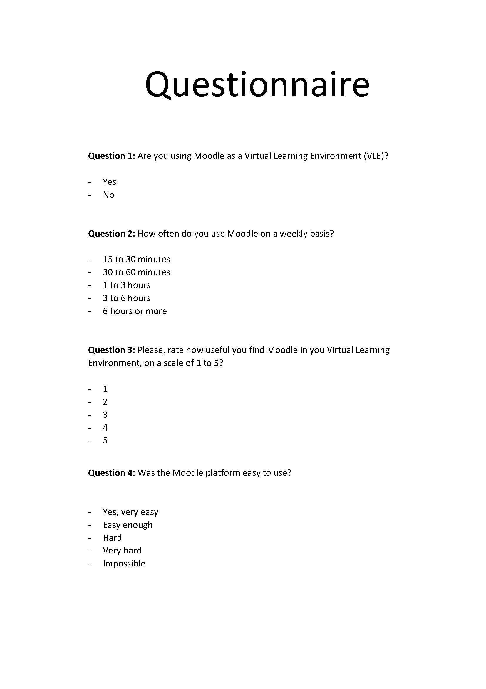
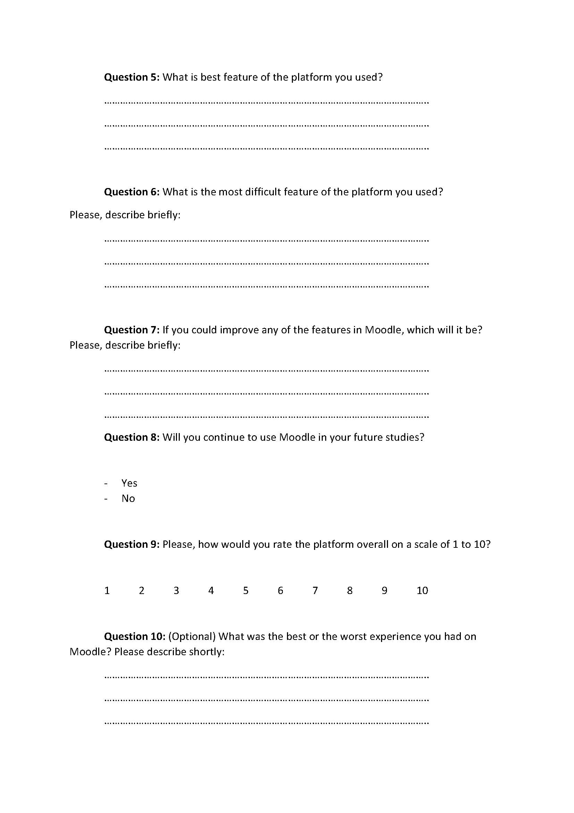

Appendix 2 – Questionnaire Results Tables:

Questionnaire Results Summary Table:
Question 1: Are you using Moodle as a Virtual Learning Environment (VLE)?
Yes : 8 | No : 0
Question 2: How often do you use Moodle on a weekly basis?
15 to 30 minutes : 1 | 1 to 3 hours : 2
30 to 60 minutes : 1 | 3 to 6 hours : 2
6 hours or more : 2
Question 3: Please, rate how useful you find Moodle in you Virtual Learning Environment, on a scale of 1 to 5?
Scaled 1 : 0 | Scaled 3 : 0
Scaled 2 : 1 | Scaled 4 : 4
Scaled 5 : 3
Question 4: Was the Moodle platform easy to use?
Yes, very easy : 2 | Hard : 0
Easy enough : 6 | Very hard : 0
Impossible : 0
Question 5: What is best feature of the platform you used?
About half of students answered pointed ease of use, other half the library as best features of Moodle.
Question 6: What is the most difficult feature of the platform you used?
Almost all of the stundets experienced issues related to the Library, saying it was hard to download or find the material they were looking for.
Question 7: If you could improve any of the features in Moodle, which will it be? Please, describe briefly:
Most students consider the download feature needs improvement and stated Moodle can be made less confusing to use. A few had no issues.
Question 8: Will you continue to use Moodle in your future studies?
Yes : 8 | No : 0
Question 9: Please, how would you rate the platform overall on a scale of 1 to 10?
Scaled 1 : 0 | Scaled 6 : 0
Scaled 2 : 0 | Scaled 7 : 3
Scaled 3 : 0 | Scaled 8 : 4
Scaled 4 : 0 | Scaled 9 : 0
Scaled 5 : 0 | Scaled 10 : 1
Question 10: (Optional) What was the best or the worst experience you had on Moodle? Please describe shortly:
Only couple students answered here, sharing positive experiences, saying Moodle helped them with assignments and homework by letting them access material and recordings from previous classes.

