

Student Name : Kuldip Bhuva
Student ID : 2517333

Module Name : Marketing Management
Module Code : LCMB7024

Lecturer’s Name : Dr Muhammad Tariq

Word Count : 2700

Submission Date: 01 May 2026

Term 1

Marketing Strategies Portfolio
Samsung AI Health Earbuds: A Brand Extension Strategy

Table of Contents
Element 1: Brand Extension Poster Presentation 3
Element 2: Segmentation, Targeting, Differentiation, and Positioning (STDP) Analysis 4
Segmentation 4
Targeting 5
Differentiation 5
Positioning 6
Element 3: Marketing Mix (7Ps) 8
Product 8
Price 9
Place 9
Promotion 9
People 10
Process 10
Physical Evidence 11
Element 4: Reflection 12
Reference List 14
Appendix A: Poster 16

Element 1: Brand Extension Poster Presentation
Samsung, which is the largest consumer electronics company in the world, offers to extend the brand into AI-powered health monitoring earbuds, the Galaxy Health Buds Pro. This extension transfers the existing brand name of Samsung to a new line of products which places it in the brand extension quadrant of the brand development screen of Kotler et al. (2024). The Galaxy Health Buds Pro are an upgrade of the Galaxy Health Buds with added real-time biometric features, heart rate, SpO 2, skin temperature, and an AI-generated stress index, all run on-board by the Samsung proprietary chipset, Exynos. It is an extension that takes advantage of the quickly developing wearable medical devices segment that is expected to continue growing to USD 168.29 billion by 2030 (Grand View Research, 2025) and the increased desire of customers to have multifunctional health wearables (Trinh, Skoll and Saxon, 2025). Consumer electronics and digital health integration have created a new type of health-monitoring earable, making in-ear wearables a clinically-acceptable substitute to standalone medical wearable (Clarke et al., 2025). The product is part of Samsung Galaxy for the planet program, with recycled plastics (bound to the oceans) and paper packaging made of 100 per cent recycled paper (Samsung Electronics, 2024). As shown in the poster that was introduced in the classroom and included as Appendix A, the brand extension rationale, market opportunity, and sustainability credentials are visually expressed.
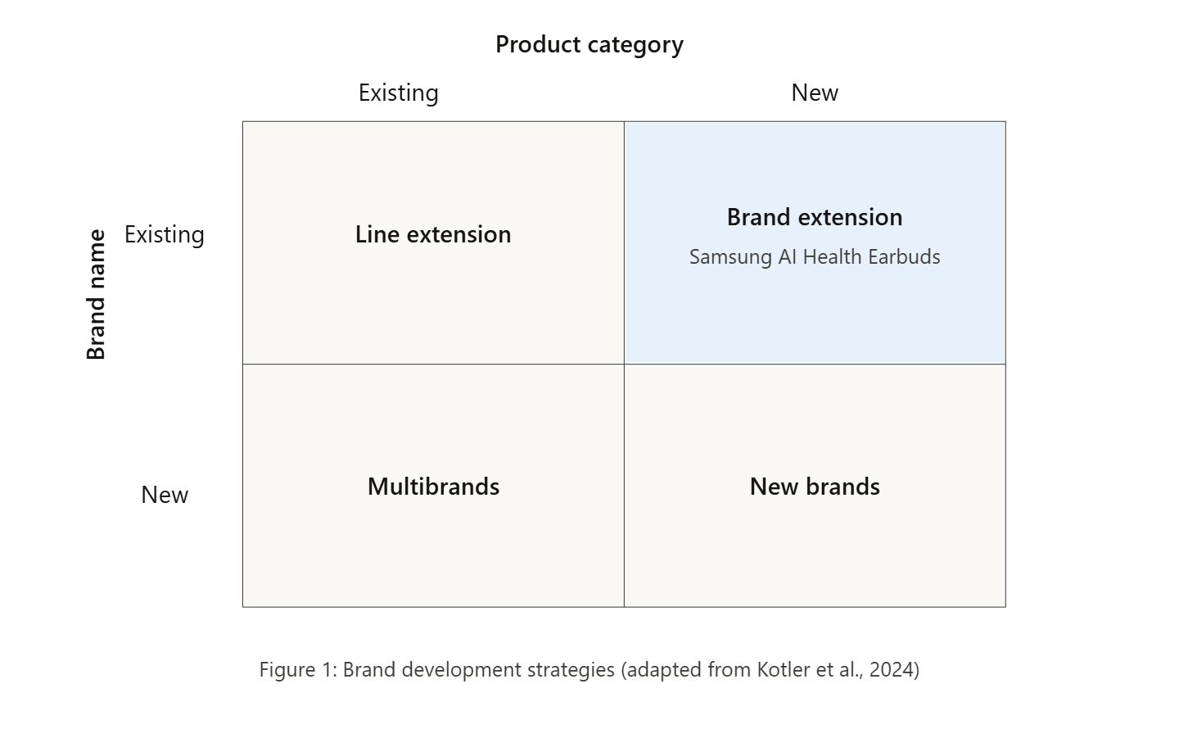

Element 2: Segmentation, Targeting, Differentiation, and Positioning (STDP) Analysis

Segmentation
Proper market segmentation is the key to a successful brand extension as it helps to determine consumer segments with unmet needs to which the new product can be relevant (Kotler et al., 2024). Samsung AI Health Earbuds is going after a consumer market based in the convergence of the consumer audio, health wearable technology, and preventative well-being. Segmentation will be carried out on four well-defined basis to accommodate a complete coverage of the market.
Geographic segmentation first focuses on areas that have developed digital health infrastructure and with great penetration of smartphones: North America, Western Europe, South Korea, Japan and city centres in Australia and Southeast Asia. According to the Grand View Research (2025), North America is the highest revenue share within the global wearable medical devices market which is USD 42.74 billion by 2024, and Asia-Pacific is already showing the steepest growth trend. The gradual launch utilizes the current Samsung Galaxy retail and e-commerce presence in the geographies followed by the expansion to the emerging economies with health-monitoring awareness gaining acceleration (Huhn et al., 2022).
The demographic will be targeted at adults between 22 and 40 years old, including late Generation Z and Millennials, and middle-to-upper disposable income. According to Trinh, Skoll and Saxon (2025), this age group of consumers is one of the first to embrace wearable vital-sign technology and they actively want digitally mediated health management systems. They target both genders, but the approach to promotion changes depending on the context: stress tracking in the workplace among city workers, and biometrics in fitness among the customer with an active lifestyle.
The willingness to share data with the Healthcare provider is low (26.5%), but sharing behaviour between wearable users is high (78.4%), which indicates a behavioural gap that can be successfully addressed by the automated image of data-forwarding capabilities of Samsung Health (Chandrasekaran et al., 2025).
Psychographic segmentation can find health-conscious people that are technologically progressive and believe in self-quantification and proactive wellness. Kang and Exworthy (2022) establish that wearable users who feel empowered by personal health data have much sustained engagement. More importantly, this group also puts importance on sustainability credential, a fact that provides strategic alignment of Samsung Galaxy to the Planet that aims at removing single-use plastic by 2030 (Samsung Electronics, 2024).
Behavioural segmentation targets those who are benefit-seekers and focus on multifunctionality in one device premium audio with around-the-clock health monitoring instead of carrying two or more earbuds and a standalone fitness tracker. According to Clement (2025), health feedback loops that are kept real time create habits of use, and reinforce the brand loyalty on the long term, benefit-based positioning will then maintain repeat buying with benefit accessory add-ons and benefit upselling in the Samsung health ecosystem.

Targeting
The strategy of differentiated targeting is implemented and focuses the resources on two segments. The main target audience includes health-conscious Millennial and Gen Z professionals aged between 25-38 who already are already part of the Samsung Galaxy ecosystem - have a Galaxy smartphone, watch, or tablet. This segment presents the lowest customer acquisition cost as integration of Samsung Health apps will provide out of box value with no need of behavioural change. The second segment is the group of fitness and wellness users who might be using other rival smartphone applications but are lured by the clinical-grade biometric features found in competing earbuds. According to Canali, Schiaffonati and Aliverti (2022), interoperability of data to cross-platform wearables remains a challenge to wearable uptake; Samsung counteracts this by means of a companion iOS application in addition to native Galaxy integration, thus expanding the market that can be targeted and the ability to maintain ecosystem stickiness.

Differentiation
Samsung contrasts the competition like Apple AirPods Pro and Jabra Elite on three strategic scales, which are AI Health Earbuds. To begin with, the clinical-grade biometric depth: real-time measurements of the heart rate, SpO 2, skin temperature, and a cortisol-proxy stress index are superior compared to the one-measure health capabilities of a mainstream earbud. Second, local AI processing through Samsung-built Exynos chipset provides individual wellness data without relying on the cloud, which Canali, Schiaffonati and Aliverti (2022) cite as the main adoption impediment. Third, verifiable sustainability: the earbuds use recycled cobalt and ocean-bound recycled plastics which scales Samsung material-circularity programme (Samsung Electronics, 2025) to the hearable industry and appeals to the environmentally aware psychographic segment. As evidenced by Hesse et al. (2022), green brand extensions are rated in a more positive manner where parent-brand environmental claims are seen to be genuine rather than act-based; which the Samsung brand has a 10-year track record of recycled-materials offers to the letter. With AI algorithms installed on wearable sensors, real-time signal processing and noise reduction are provided, which is much more accurate to read the biometrics such as heart rate, SpO₂, and skin temperature than cloud-dependent methods (Shajari et al., 2023).
It is proven by scoping review evidence that AI-powered platforms with wearable sensors depict clinical validity in real-time cardiovascular monitoring, which allows supporting the premium positioning of the Galaxy Health Buds Pro in comparison to the mainstream earbuds (Abedi et al., 2025).

Positioning
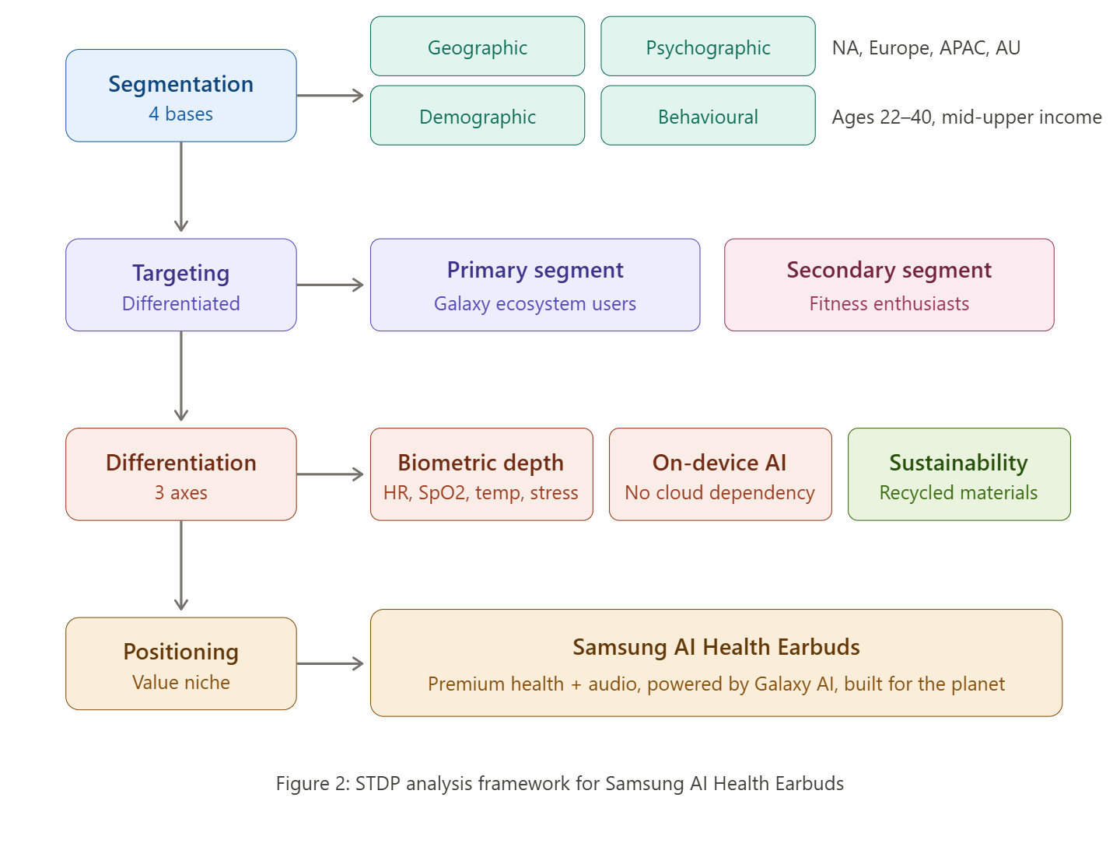
The positioning statement is the following: To tech-savvy, health-aware customers who can get both high-quality audio and proactive health management without sacrificing their overall personal wellness, Samsung AI Health Earbuds is the intelligent hearable that turns daily listening into daily health management driven by Galaxy AI but engineered to be planet-neutral. This puts the product in the intersection of premium and health between commodity-level audio earbuds but more affordable than dedicated medical devices, a position that Kotler et al. (2024) refer to as a value proposition niche. The positioning by pinning the extension on the preexisting brand design of the Galaxy brand carries to the preventive healthcare space the already existing brand associations regarding technological dominance of Samsung, but carries with it brand meaning to the preventive healthcare sub-realm, a trend, according to Kotler, Huan and Setiawan (2024), that Kotler describes as typical of an immersive, technology-driven brand evolution.
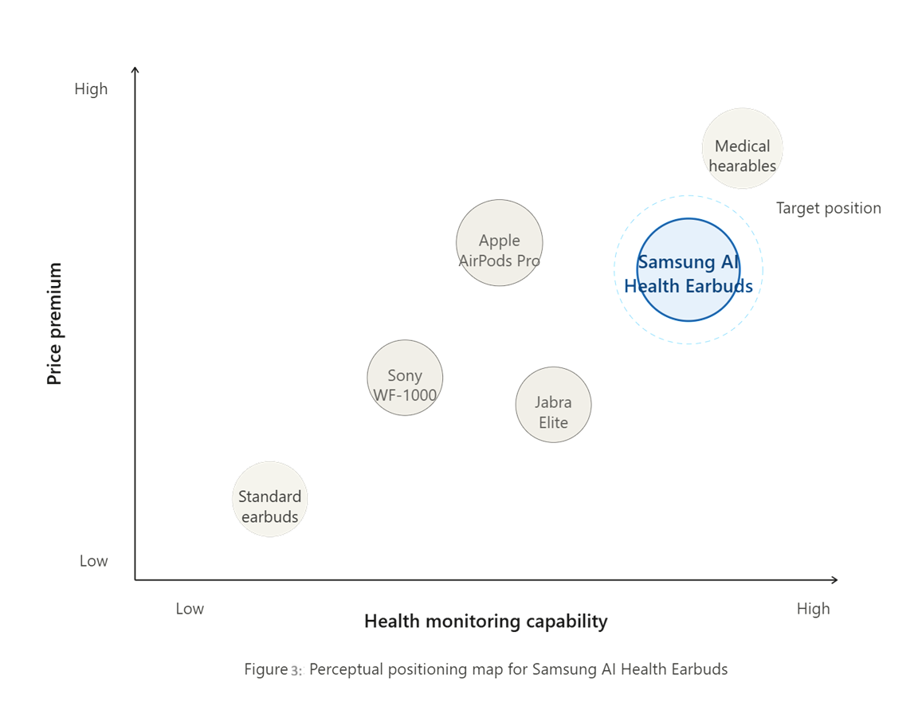

Element 3: Marketing Mix (7Ps)
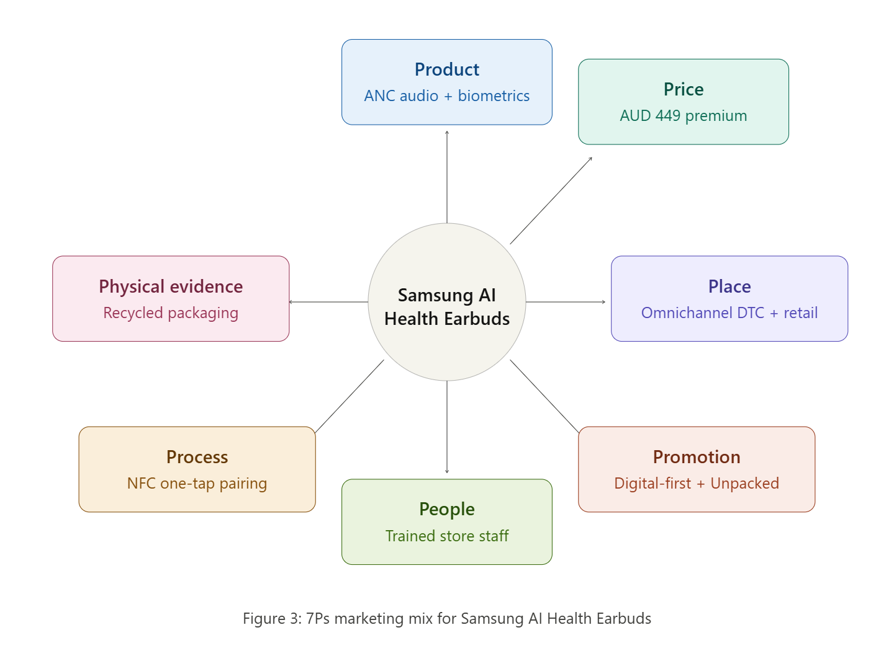

Product
The Samsung AI Health Earbuds are a brand extension, which implies the use of an existing brand name when launching a new product line (Kotler et al., 2024). The main product proposes high quality active-noise-cancelling audio and 24/7 biometric feedback: optical heart rate, SpO 2, skin temperature and AI-derived stress index. The real product consists of an ergonomic in-ear offering and three colourways, an IP68 charge case that has UV-C sanitisation and easy connectivity to the Samsung Health platform to analyse the long-term health trends. The augmented product includes a 90-day customized wellness onboarding experience, over-the-air software upgrades that unlock new health metrics data like blood-pressure estimation and voluntary data-sharing channel with medical professionals. According to Trinh, Skoll and Saxon (2025), consumer-facing devices are becoming more and more blurry on the distinction between wellness accessory and clinical instrument; the tier product architecture places the earbuds in a state where it develops along the continuum, not by replacing hardware but via software iterations, extending the product lifecycle and engaging the consumer. The strategy is in line with Kotler, Huan and Setiawan (2024) who argue that product experiences based on immersion should focus on constant value creation as opposed to fixed functions.

Price
Premium pricing approach is followed with a recommended retail price of AUD 449 (around USD 299) placing the earbud just higher than the mainstream earbuds (AUD 250-350), but lower than the dedicated medical earbuds (AUD 600+). It is also in line with value-based pricing reasoning: the consumer is paying a high price not just because of sound quality but because of the built-in health-tracking feature, which Clement (2025) puts into perspective as a long-term expense savings compared to the cost of preventive health care. Purchase At purchase, a penetration-support strategy will be available, whereby a 12-month Samsung Health+ subscription (which would cost AUD 7.99 per month normally) is included free of charge, which reduces the perceived total cost of ownership and speeds up adoption of the ecosystem. Promotional pricing will be conducted on a seasonal basis on major retail events like the Black Friday and Galaxy Week by Samsung, giving a 10-15-day discount to the secondary target market of price-conscious buyers. The practice of price skimming is not sought since it is essential to build volume within a short duration before other competitors launch similar multi-sensor hearables.

Place
The distribution approach of an omnichannel is guaranteed to reach most of the customer channels. The key platform is the Samsung-specific direct-to-consumer ecosystem: Samsung.com, Samsung Shop application and Samsung Experience Stores where consumers have access to sampling of the biometric features via live demonstration. Secondary will involve large electronics stores like JB Hi-Fi, Harvey Norman and Amazon as well as mobile phone deals with Telstra and Optus involving the earbuds with Galaxy smartphone upgrade packages. Kang and Exworthy (2022) note that provider approval can drive wearables much faster; in that regard, placation within pharmacy chains and wellness retail stores like Chemist Warehouse can expand into health-based purchasing environments currently inaccessible to competitors. The segments of Launch markets are geographically reflected: Australia, the United States, the United Kingdom, South Korea, and major urban centres in ASEAN with the further expansion to continental Europe and India in twelve months after the first launch.

Promotion
The unified promotional model is the combination of digital-first communication and the brand activation through experience. The heart of the campaign will be content marketing: a short-form demonstration video to show how real-time health alerts work in real-life situations, the cooperation with the influencers who are recognized in the target psychographic and has the credibility to offer the content, and a branded podcast series on the theme of AI-driven preventative health in partnership with health professionals. Samsung uses the infrastructure of Galaxy Unpacked events as part of creating substantial earned media during launch by adding hands-on journalist preview meetings. Paid media focuses on programmatic digital advertising on YouTube, Instagram, and Tik Tok, but it narrows in on psychographic and behavioural groups that were selected in Element 2. Hesse et al. (2022) warn that the perceived category fit is low when consumers consider brand extension: thus, all messages should explicitly place the earbuds in the context of the already established Galaxy wearables ecosystem to enhance technological fit and brand fit. There is a sustainability story running through all the touchpoints, and mentioning construction with recycled materials, and circularity roadmap of Samsung (Samsung Electronics, 2025), which Clement (2025) states becoming an even more definitive part of health-technology marketing.

People
The employees in the Samsung Experience Store frontline are subject to specialised training about biometric demonstration protocols in communicating credibly about the value of health monitoring; which is a critical investment as Canali, Schiaffonati and Aliverti (2022) determine accuracy perception as the key obstacle to health wearables adoptions. The personnel have their own demonstration devices which are already loaded with sample health data to help them have a feel of how the unit works without the need to have customers enter their own biometrics in the store. Specially designed Samsung Health coaching team offers onboarding post-purchase through an in-app live chat that translates uncooked biometric information into practical wellness information and maintains user engagement over time, not just within the initial fresh phase.

Process
The customer experience is designed to achieve a frictionless activation process and permanence. Near field communication allows one-tap pairing to all Galaxy devices and a guided set-up wizard in Samsung Health sets baseline health metrics in two minutes. The deployment of firmware updates is done automatically through Wi-Fi, with the features gradually added to the device without involving consumers. The returns policy also provides a 30-day satisfaction guarantee, which makes purchase-risk perception a lesser concern to first-time users of health-wearables (a driver that Trinh, Skoll and Saxon (2025) claim is more visible among biometric wearables non-users). Weekly notifications of wellness summaries after purchase are automated and keep people engaged and make them see the value of further usage.

Physical Evidence
The initial tangible sustainability proof-point is a recycled-paper box with soy-based inks, 100 percent no single-use plastics, and it is in line with the packaging promises of Samsung (Samsung Electronics, 2024). The earbuds themselves have a visible mark of certification with Galaxy for the Planet that gives real material support of environmental claims instantly. In-app health dashboards give biometric information in a clinically informed but consumer-friendly visual information display, which adds to the product credibility as a valid health tool, instead of a new-fangled device. Grand View Research (2025) has observed that consumer confidence in wearable health data is a condition that needs to be fulfilled before an industry can be sustained in the market; integration of Samsung Health with big electronic health records is a proof of institutional level data reliability, which current competitors in the hearable market cannot demonstrate.

Element 4: Reflection
Developing the Samsung AI Health Earbuds brand extension portfolio was a career development exercise involving reconciling real conflicts between premium and volume objectives, ecosystem exclusivity and cross-platform ubiquity, and green-wash rhetoric versus real physical investment. This dilemma is commonplace for the type of marketing managers who work in the tech industry.
Strengths
One strength was my capacity to perform a cross-functional STDP analysis across consumer electronics, digital health and wellness, and lifestyle. The Kang and Exworthy (2022) study helped me to view wearable adoption not as a technology-acceptance problem but as a consumer empowerment offer, shifting my focus from demographics to psychographics and behaviours informed by health-behaviour theory. A second strength was to utilise the extended 7Ps with strategic rigour, remembering that People, Process and Physical Evidence can be the most important factors in services-enhanced product categories. The inclusion of issues of data quality and interoperability from Canali, Schiaffonati and Aliverti (2022) in these sections resulted in a commercially viable plan. My poster presentation also showed my capability to condense key messages in a visual and compelling format (with time constraints) through multiple drafts, with a focus on the most critical points.
Weaknesses
An obvious weakness is the segmentation primarily based on secondary data. The analysis is solely based on industry reports and peer-reviewed literature, which reflect the general industry trends, but not the specific perceptions and willingness to pay of my exact target market. Without primary data collection (e.g. surveys, focus groups) the targeting logic, while sound, is untested. The second area for improvement was the shallowness of the competitor analysis in the differentiation section. The competitors mentioned were Apple AirPods Pro and Jabra Elite, but the analysis was done at a macro level without benchmarking on price points, distribution channels, and consumer awareness.
Action Plan for Improvement
To overcome these limitations, I will do three things in future. First, I will include primary market research in the form of structured surveys alongside secondary desk research from the beginning of the project, to include primary data on consumer intentions to adopt and share data. Second, I will create a perceptual map and weighted competitive matrix prior to finalising the positioning statement, to substantiate differentiation claims with comparative data. Third, I will include a high-level financial analysis in pricing strategy to stress test the recommended selling price across various scenarios of demand to make the portfolio more marketable.

Reference List
- Abedi, A., Verma, A., Jain, D., Kaetheeswaran, J., Chui, C., Lankarany, M. and Khan, S.S. (2025) 'AI-driven real-time monitoring of cardiovascular conditions with wearable devices: scoping review', JMIR mHealth and uHealth, 13, e73846. Available at: https://doi.org/10.2196/73846 (Accessed: 1 April 2026).
- Canali, S., Schiaffonati, V. and Aliverti, A. (2022) 'Challenges and recommendations for wearable devices in digital health: data quality, interoperability, health equity, fairness', PLOS Digital Health, 1(10), e0000104. Available at: https://pmc.ncbi.nlm.nih.gov/articles/PMC9931360/ (Accessed: 1 April 2026).
- Chandrasekaran, R., Sadiq T, M. and Moustakas, E. (2025) 'Usage trends and data sharing practices of healthcare wearable devices among US adults: cross-sectional study', Journal of Medical Internet Research, 27, e63879. Available at: https://doi.org/10.2196/63879 (Accessed: 1 April 2026).
- Clarke, L., Liau, C., Wei, V.W. and Liao, C. (2025) 'Healthcare monitoring with earables: a paradigm shift towards digital health', Biomedical Analysis, 2(4), pp. 207–222. Available at: https://doi.org/10.1016/j.bioana.2025.12.002 (Accessed: 1 April 2026).
- Clement, S. (2025) 'Wearable tech for sustainability: how real-time health data is redefining preventive healthcare marketing', Academy of Marketing Studies Journal, 29(S6), pp. 1–9. Available at: https://www.abacademies.org/articles/wearable-tech-for-sustainability-how-realtime-health-data-is-redefining-preventive-healthcare-marketing-17662.html (Accessed: 1 April 2026).
- Grand View Research (2025) Wearable medical devices market size, share and trends analysis report, 2025–2030. Available at: https://www.grandviewresearch.com/industry-analysis/wearable-medical-devices-market (Accessed: 1 April 2026).
- Hesse, A., Bündgen, K., Claren, S. and Frank, S. (2022) 'Practices of brand extensions and how consumers respond to FMCG giants' greening attempts', Journal of Brand Management, 29(6), pp. 520–537. Available at: https://doi.org/10.1057/s41262-022-00274-w (Accessed: 1 April 2026).
- Huhn, S., Axt, M., Gunga, H.-C., Maggioni, M.A., Munga, S., Obor, D., Sié, A., Boudo, V., Bunker, A., Sauerborn, R., Bärnighausen, T. and Barteit, S. (2022) 'The impact of wearable technologies in health research: scoping review', JMIR mHealth and uHealth, 10(1), e34384. Available at: https://doi.org/10.2196/34384 (Accessed: 1 April 2026).
- Kang, H.S. and Exworthy, M. (2022) 'Wearing the future — wearables to empower users to take greater responsibility for their health and care: scoping review', JMIR mHealth and uHealth, 10(7), e35684. Available at: https://mhealth.jmir.org/2022/7/e35684 (Accessed: 1 April 2026).
- Kotler, P., Armstrong, G., Harris, L.C. and He, H. (2024) Principles of marketing. 7th European edn. Harlow: Pearson Education. Available at: https://commecsinstitute.edu.pk/wp-content/uploads/2024/08/Kotler-and-Armstrong-Principles-of-Marketing.pdf (Accessed: 1 April 2026).
- Kotler, P., Huan, H.D. and Setiawan, I. (2024) Marketing 6.0: the future is immersive. Hoboken: Wiley. Available at: https://www.wiley.com/en-gb/Marketing+6.0%3A+The+Future+Is+Immersive-p-9781119835219 (Accessed: 1 April 2026).
- Samsung Electronics (2024) Samsung Electronics sustainability report 2024. Available at: https://news.samsung.com/global/samsung-electronics-releases-2024-sustainability-report (Accessed: 1 April 2026).
- Samsung Electronics (2025) Samsung Electronics sustainability report 2025. Available at: https://news.samsung.com/global/samsung-electronics-releases-2025-sustainability-report (Accessed: 1 April 2026).
- Shajari, S., Kuruvinashetti, K., Komeili, A. and Sundararaj, U. (2023) 'The emergence of AI-based wearable sensors for digital health technology: a review', Sensors, 23(23), pp. 9498–9498. Available at: https://doi.org/10.3390/s23239498 (Accessed: 1 April 2026).
- Trinh, S., Skoll, D. and Saxon, L.A. (2025) 'Health care 2025: how consumer-facing devices change health management and delivery', Journal of Medical Internet Research, 27, e60766. Available at: https://pmc.ncbi.nlm.nih.gov/articles/PMC12059502/ (Accessed: 1 April 2026).

Appendix A: Poster
S A M S U N G  AI Health Earbuds  A Brand Extension for the Future of Preventive Healthcare | $168B+  Wearable Medical Devices  Market by 2030

The Brand Extension  Samsung, the world's leading consumer electronics company, extends its trusted Galaxy brand into AI-powered health monitoring earbuds. The Galaxy Health Buds Pro combine premium audio with real-time biometric tracking — heart rate, SpO₂, body temperature, and stress levels — powered by Samsung's on-device AI engine (Kotler et al., 2024). |  | Market Appeal & Emerging Trends  ▌ Wearable Health Market Boom  The global wearable medical devices market was valued at $42.74B in 2024 and is projected to reach $168.29B by 2030 at a 25.53% CAGR (Grand View Research, 2025).  ▌ AI-Powered Personalisation  The wearable AI market reached $35.6B in 2024 and is growing at a 34% CAGR, driven by demand for personalised health insights on-device (Market.us, 2025).  ▌ Post-Pandemic Health Awareness  92% of smartwatch users now track health and fitness metrics, reflecting a permanent shift towards personal health monitoring (IMARC Group, 2025).  ▌ Audio & Health Convergence  The hearables market is projected to reach $107.1B by 2031 at 11.47% CAGR, with healthcare monitoring as the fastest-growing segment (Mordor Intelligence, 2026). |  | Sustainability Alignment  ▌ Recycled Materials  Earbuds casing utilises ocean-bound recycled plastics, aligning with Samsung's Galaxy for the Planet initiative to eliminate single-use plastics by 2030 (Samsung, 2024).  ▌ Eco-Friendly Packaging  100% recycled paper packaging with soy-based inks, eliminating all plastic from the unboxing experience, consistent with Samsung's sustainability framework (Samsung, 2024).  ▌ Carbon Neutral Operations  Manufacturing powered by renewable energy, contributing to Samsung's commitment to achieve net-zero carbon emissions across all operations by 2050 (Samsung, 2024).
  ●  Real-Time  Health Tracking | ●  On-Device  AI Engine | ●  Premium  Audio Quality

Why Invest in Samsung AI Health Earbuds?
1B+  Active Samsung Galaxy  Smartphones Worldwide | 25%+  CAGR Wearable Medical  Devices Market | 92%  Smartwatch Users  Track Health & Fitness | #1  Android Smartphone  Vendor Globally

Unique Value Proposition  Samsung AI Health Earbuds seamlessly integrate clinical-grade biometric monitoring with premium audio — transforming an everyday accessory into a personal health companion. Unlike competitors, Samsung leverages its unmatched Galaxy ecosystem of over 1 billion active devices (Counterpoint Research, 2026), the Samsung Health platform, and proprietary Exynos AI chipset to deliver proactive, personalised wellness insights to existing Galaxy users worldwide. |  | Target Audience  ● Health-conscious millennials & Gen Z (aged 22–40)  ● Fitness enthusiasts and wellness-focused professionals  ● Existing Samsung Galaxy ecosystem users seeking integrated health tools  ● Tech-savvy consumers who value AI-driven personalisati
LCMB7024 Marketing Management | Brand Extension Portfolio | Samsung AI Health Earbuds References: Kotler et al. (2024); Grand View Research (2025); Market.us (2025); IMARC Group (2025); Mordor Intelligence (2026); Counterpoint Research (2026); Samsung (2024)

