

MBA – Master of Business Administration
STRATEGIC MANAGEMENT
LCMB7003
Assessment 1

STUDENT ID: 2128680
STUDENT NAME: SHANAVAS PARAMBAN
LECTURER: CHARLES OHAM

Executive summary
The development of a strategy for marketing is crucial to get an advantage in the competitive market. The organizations in this case need to analyze the environment of the business, competitiveness in the market, and the internal capabilities that can help in implementing strategies effectively. The case study of Nike is used regarding the development of sustainable products in the market of UK for illustrating several aspects of marketing. Different tools of analysis such as PESTEL, Five Forces, Four Links, and others are used in this case to evaluate the situation of the company properly. The development strategies of the Nike organisations have been identified in the report. The models and theories linked with the corporate strategies have been adequately evaluated. The promotional and marketing strategies of the organisations are also evaluated to gain a further competitive edge and expansion worldwide. Nike has different challenges in implementing their sustainable product strategy which includes developing better products with the use of sustainable materials. Further, Nike faced challenges in developing positive work culture for the laborer’s. For instance, forced overtime, chemical exposure, illegal pay and physical abuse obstruct Nike from achieving a sustainable strategy. Mintzberg’s theory has been considered to be important in implementing the sustainability strategy of Nike. The theories reflect that setting objectives, allocating resources and monitoring can help in the sustainable strategy of Nike. The KISS model suggests developing a simple strategy instead of becoming complex for the successful implementation of the strategy. The balanced scorecard helps in identifying the KPI that describes the success of project implementation. The KPI discusses in terms of financial, customer, future and internal perspectives. The contribution organisational culture of Nike to keep its employee base active has been represented and that their approaches in generating competitive advantages also have been noted in the study. These include the development of objectives, resource allocation, monitoring and controlling and a Balance of the scorecard for the project implementation.

Table of contents
1. Introduction 4
2. Analysis of the strategy of Nike 4
2.1 Discussion on the case study of Nike 4
2.2 Description of the market 5
2.3 Measurement of the turbulence of the market 5
2.4 Analyzing the external environment of Nike 6
2.5 Analyzing growth as well as lifecycle 7
2.6 Key success factors 7
2.7 Assessment of competitiveness in the market 8
2.8 Evaluating the factors linked with cooperation by four links 9
2.9 Factors associated with immediate competitors 9
2.10 Analyzing customers with segmentation and positioning 10
3. Development of strategy 10
3.1 Cost Leadership strategy of Nike 10
3.2 Application of Value chain for carving the production approaches of Nike 11
3.3 Assessing the organisational culture of Nike using the Johnson and Scholes model 12
3.4 Evaluating the endorsement and sponsorship strategy of Nike 13
3.5 Strategic approaches of Nike in competitive advantage generation using Game theory 14
3.6 Innovation and learning-based model as a foundation of technology strategies of Nike 15
3.7 Product diversification strategies using the perspective process model 16
3.8 Marketing growth strategies of Nike by using the emergent model 17
3.9 Sustainable design ethos and corporate strategy model 18
4. Implementation of strategy 19
4.1 Mintberg’s theory in the planning process 20
4.2 KISS model in strategy implementation 21
5. Conclusion 25
Reference 27

1. Introduction
Strategic management is linked with setting objectives for the companies, developing strategies, and implementing the strategies effectively that can help in achieving targets effectively. Analysis of the environment of the business is important in this case and can help the company to assess the situation of the organization and to develop strategies effectively. This study emphasizes the case study of Nike regarding the use of sustainable business processes that can benefit the environment effectively. The initiatives linked with sustainability can also provide benefits to the organization in achieving its target in the long run. The competitiveness of the organization in the market is analysed along with the factors that need to be considered during the development of strategies for the organization effectively. The aim of this research is to analyze the situation or position of the company in the market, and to develop a sustainable strategy of business that can help this organization to achieve its goals. It also focuses on developing policies of implementing business strategies effectively to achieve the targets.

2. Analysis of the strategy of Nike

2.1 Discussion on the case study of Nike
According to the case study of Nike the company launched a shoe “Air Jordan Basketball Shoe” in 2008 that was developed with the use of recycled materials which is important for achieving the goal of sustainability. This organization used the materials of used shoes for the development of the shoe, and also focuses on reducing the number of harmful chemicals that are used in the manufacturing of the shoes. The company focuses on more production of this type of shoe in the future which can help the company to reduce its dependence on the raw materials, and also helps in managing waste materials effectively. The governments of the countries develop strategies to reduce the use of fossil fuels. The raw materials of the shoes are also derived from the oil or petroleum products (nike.com, 2022). Therefore, it is important for the company to align its strategy with the strategy of the government to achieve success in the future.
The enhancement in the prices of fossil fuel in the market, and the dynamic nature of the prices create problems for the company to maintain a sustainable cost price of the shoes. This approach can also help the company to reduce the expenses of the organization required for the purchase of raw materials which can enhance the profit of the company (Eyada, 2020). However, the organization faced several challenges in implementing the strategy of developing all of its shoes from recycled products. Therefore, the company focuses on developing a strategy to achieve the goal of sustainability effectively that can help the organization in achieving all its targets prominently.

2.2 Description of the market
Nike has a reputation in the market of the UK, and this company, and 8.59 million customers or people in the UK purchased the products of Nike. According to the data for 2022 the total size of the sneakers market of this company is $3.66 billion (statista.com, 2022).
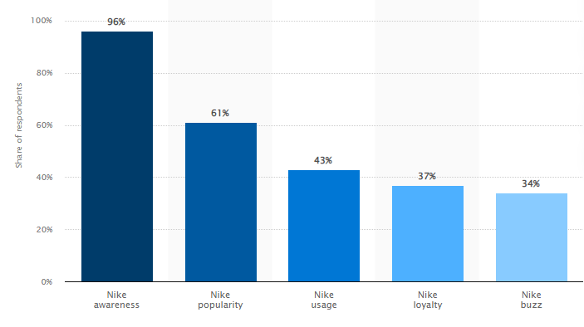
Figure: Brand profile of Nike in the UK
(Source: statista.com, 2022)
The above diagram reflects that 96% of the people are aware of Nike in the UK, and this brand is popular among 61% of the people. 43% of people used the products of Nike, and 37% of people are loyal to the brand which reduces the chances of alteration of products.

2.3 Measurement of the turbulence of the market
In the present day the turbulence level of the market is too high because of the instability in the politics of the UK, and the war between Russia, and Ukraine that enhances the prices of fossil fuels and also induces an inflation rate in the market. Enhancement in the rare COVID-19 pandemic in China, and some countries of East Asia also increases the changeability of the market (Dalton et al. 2020). The data on the enhancement of COVID cases can help in predicting the trend of enhancement, and its impact on the market. The trend of the growth rate can also be predicted effectively which can influence the business.

2.4 Analyzing the external environment of Nike
The external environmental analysis of the company focuses on evaluating the impact of the external environment of the company on its development, and implementation of the strategy. A PESTLE analytical tool is used in this case to evaluate the factors that can make an impact on the organization.
Political
Instability in the government of the UK, and failure of the government to develop a proper policy for business organizations have a negative impact on the business. Tensions between the different countries and wars enhance the pressure on the government. However, the liberal policies of different countries and the good relationship of the UK with other countries can make a positive impact on business.
Economic
The country cannot recover fully from the impact of COVID-19, and the associated lockdown. A higher rate of inflation such as 10.7% at the present day also affects the economy of the country and reduces the GDP growth rate to 0.5% (ons.gov.uk, 2022). Unemployment also reduces the purchasing ability of customers in a market which can negatively impact the organization.
Social
The multicultural society of the UK enhances the dependence on diverse products, and the educated population also has a better opportunity for income which has a positive effect on business.
Technological
The government and private institutions make huge investments in R&D, and the tech-savvy mindset of people helps the company to use technologies for influencing customers. It makes a good impact on the business.
Legal
“Equality Act 2010, “Employment Act 1996”, and different other acts enforced by the government to secure the liberty, and rights of workers (Schoppe‐Sullivan and Fagan, 2020). These acts help in maintaining the business in ethical ways and avoid unethical actions.
Environmental
The government of the UK, like most governments of the world, focuses on reducing the emission of carbon by reducing the use of fossil fuels, and also focuses on sustainability (Lambin and Thorlakson, 2018). Therefore, the initiatives Nike linked with sustainability can get the support of the government.

2.5 Analyzing growth as well as lifecycle
Growth and life cycle analysis can be used by the organization to understand the position of the company or an industry in the stage of its life cycle. There are different stages in this growth and lifecycle model such as "start-up, growth. Shakeout, maturity, and deadline".
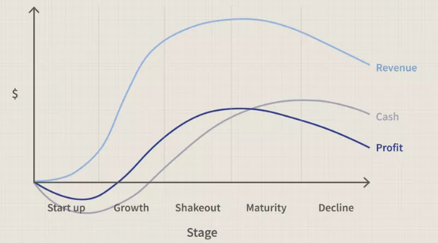
Figure: Growth and lifecycle
(Source: Balboni et al. 2019)
The above diagram shows that the revenue and profit of the companies maximize between the shakeout and maturity stages (Balboni et al. 2019). Analysis of the revenue generation and profit of Nike also reflects that the company is situated in this stage. However, the company plans to prevent decline and rejuvenate the company by applying the strategy of sustainability.

2.6 Key success factors
The main success factors associated with the organization are an effective strategy and a clear vision of the organization. Availability of resources in this case, and a proper understanding of the requirement of resources are important for achieving success. A huge capital of Nike can help the company to use its resources for the success of a business (Moeuf et al. 2020). The agility of an organization is also important to face the dynamic changes of the market. The motivation of workers, skills, and the collaboration between teams also act as a success factor of the organization. Effective business operations and the use of technology also help in getting the success of this company.

2.7 Assessment of competitiveness in the market
The competitiveness in the market of the organization can be analyzed by using Porter's five forces model which helps in understanding the impact of competitiveness on the business of the company. The impact of these five forces is described below:
Power of the suppliers
The strength of suppliers depends on the uniqueness of the products that the suppliers supplied in the market, and also it is influenced by the number of suppliers in a market. The chances of alteration of suppliers by the company also influence the power of these suppliers (Baxter, 2019). In the case of Nike, the company has the availability of suppliers in the market which reduces the power of suppliers.
Customer’s power
Options for the alteration of the product or the number of companies in a market influence the power of customers. In the UK market, the presence of several rival brands of Nike enhances the power of customers. Therefore, innovation is in this case to get an advantage in a competitive market.
Chances of new entrants
The incorporation of technologies and the utilization of different innovative ways to enter the market enhance the chances of new entrants. It can induce the pressure of new entrants in the market which affects Nike's business.
Competitiveness
Puma, Adidas, Under Armour, and other competitor brands enhance the competition for Nike in the market of UK (Bruijl and Gerard, 2018). This competition forced the company to set prices as per the average price of products which reduces the profit of this company in the market.
Substitution threat
Competitor brands of Nike and the new companies developed the same products in the market which induces the chance of product alteration. However, the manufacturing of innovative products can help this company to decrease the possibilities of alteration of products.

2.8 Evaluating the factors linked with cooperation by four links
The four links model is an effective model that helps the company to analyze the collaboration of a grand in a particular market which is important for the sustainability of a business, and to expand business properly. The four links of this model are "government links, informal links, formal links, and complementors. Government links are essential for organizations to get support from the government in business. Nike has a reputation in the market and also has good links with the government that help the company in getting support.
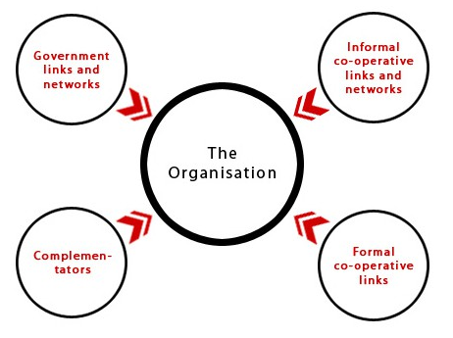
Figure: The model of four links
(Source: Rahil and Dumitru, 2019)
Informa links are related to the chamber of commerce and associations of industry. Formal links are associated with strategic alliances, joint ventures, affiliate marketing, and others. Nike also has strategic alliances and joint ventures such as the joint venture of Nike and Apple help the company to develop innovative products as well as to expand the market. Compliments are associated with businesses that want to join the business of a company such as Nike (Jerrim and Moss, 2019). Reputation and market value if the organization helps in attracting other brands to join with Nike that is important for the expansion of the market.

2.9 Factors associated with immediate competitors
Different factors associated with the immediate competitors such as Puma, Adidas, and Under Armour need to be analyzed by the organization effectively such as “objectives of competitor brands, resources, performances, current products, and present strategies of business”. Therefore, it is essential for Nike to gather data or information about the visions of competitor brands, the resources of the companies, and the data regarding the past performances of the companies (Burke et al. 2018). This information can help Nike to develop strategies effectively that can help the company to get an advantage in a competitive market. Data regarding the products of competitors are useful for this brand to make innovations in products to reduce the chances of alteration of products, and the assessment of strategies helps in understanding the processes the competitors can use in operating business efficiently.

2.10 Analyzing customers with segmentation and positioning
In the case of the profiling of customers, the company focuses on gathering data regarding their age, goal, income, location, hobbies, purchase habits, jobs, and challenges in their life of the customers. These data are used by the organization to develop strategies of segmentation as well as positioning. In the case of segmentation, the company segments the customers according to their age of the customers and gender. Different age groups of people have different choices (Iyer et al. 2019). Therefore, it can help the company to target customers effectively. The organization used functional and price positioning for the marketing of the product that emphasizes quality as well as the price of the products that can help this company to beat competitors.

3. Development of strategy

3.1 Cost Leadership strategy of Nike
Nike is one of the premium brands in the athletic footwear and apparel market in the current context that is known for its product prices. Based on the principle of cost leadership strategy, a brand tried to obtain competitive advantages by maintaining the lowest cost of operation in comparison to the other major players in the market (Yuan et al, 2020). This approach has also been taken care of by Nike for generating competitive advantages. Nike focuses on managing their waste generation factors for reducing the cost of production. Keeping this waste management approach in view Nike uses recycled Nylon in its production process (nike.com, 2022). This factor keeps the company ahead in the compilation from the other players in the market.
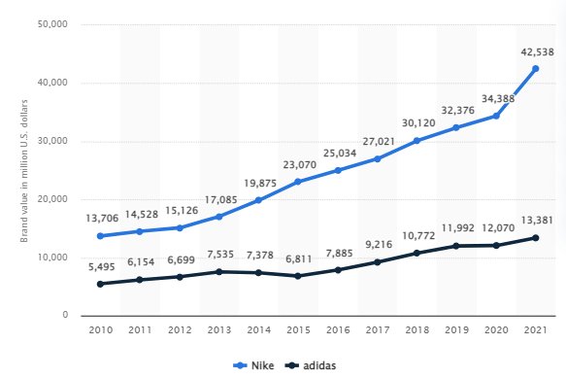
Figure 1: Brand value comparison of Nike and Adidas
(Source: statista.com, 2022)
Using the recycling methods Nike not only practices the Cost leadership approach but retains the attention of the consumer base that supports competing with other major players in the market. The reports reveal that the brand value of Nike reached a figure of 42.5 billion U.S. dollars in 2021 while Adidas has 13.4 billion U.S. dollars of brand value in 2021 (statista.com, 2022). The contribution of the cost leadership approach of Nike in reaching this position cannot be avoided.

3.2 Application of Value chain for carving the production approaches of Nike
Value chain analysis specifies the activities which contribute to developing a competitive advantage for Nike in the market. The value chain approaches of Nike are dependable on the two specific segments which are primary and supportive activities (Stangl, 2021). From the activities of the inbound logistics, Nike focuses on managing their supply-related attribution like receiving, storing of materials, and warehousing. Other crucial primary activities of Nike are service, operations, and outbound logistics which are supported by the firm's infrastructure, technology development and procurement.
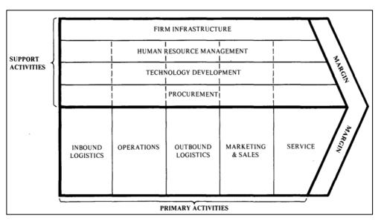
Figure 2 Value chain analysis of Nike
(Source: Stangl, 2021)
The marketing approaches of value chain strategy also need to be considered to get a better position in the market. Nike focuses on marketing approaches as the selling and administrative expenses of Nike have increased significantly (investors.nike.com, 2022). Most of the Nike products are sourced from China, Vietnam and Thailand which signifies its large supplier base. The marketing investment of Nike is one of the main reasons that support the company to hold a strong competitive position in the market. In addition to that supporting activities like human management needs to be considered as it supports the company to maintain their production fluency effectively.

3.3 Assessing the organisational culture of Nike using the Johnson and Scholes model
The cultural approaches of an organisation play a vital role in creating the competitive advantages of the company as it influences the workforce of the organisation to work effectively. The culture of a company can be analysed by segmenting them into stories, rituals and routines, symbols, organisational structure, power structure, and control system dynamics (leadershipcentre.org.uk, 2022). Nike promotes the approaches and aspects of innovation and creativity among its employee base that keep them motivated. Nike adheres to inclusivity and maintains an environment of empowerment and respect.
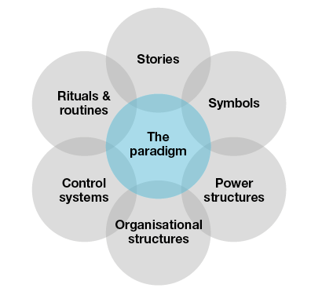
Figure 3: Cultural Web
(Source: leadershipcentre.org.uk, 2022)
The symbolic approaches of Nike also represent its culture effectively for instance, athletic traits can be traced from the logo of Nike which signifies its culture. Nike’s organisational culture is centralised on creativity (Skinner et al., 2018). The authority of Nike involves its employee base in the decision-making approaches that gave evidence about the creative and collaborative cultural practice of Nike. The decentralisation of power and its equal distribution can be seen in Nike which represents its power structure. Despite power decentralisation, the board of directors of the company controls and measures the process of working and production-related approaches.

3.4 Evaluating the endorsement and sponsorship strategy of Nike
Nike has not represented itself as a particular product but as a sporty mindset. Nike intended to create the future of the sport as it sees the inner athlete of individuals (nike.com, 2022). Using the products Nike is intended to trigger the inner athletes of individuals. Nike provokes its consumer base using brand endorsement by showcasing the sports persons in the products of Nike. From the reports, Nike has paid $1.3 billion to Michael Jordan and the Jordan Brand makes $10 billion from the endorsement (forbes.com, 2020). Using the brand endorsement process Nike not only provokes the consumer to lead a healthy life but also an active purchaser of the brand.
The positive impact of brand endorsement on the sales value of Nike can be seen which gave a competitive advantage in the market. Statistics reveal that Nike might witness an annual growth rate of 14.81% by the end of 2027 (statista.com, 2022). The brand endorsement of Jordan supported the company to boost its sales and revenue generation. On the other hand, using the brand endorsement process Nike also gets the opportunity of fulfilling its objective of providing sporty life to individuals.

3.5 Strategic approaches of Nike in competitive advantage generation using Game theory
Comparative advantages can be considered as the consequences of justified decision-making of strategic management. The application game theory supports an organisation in over viewing the drivers of business and based on their deliverables creating competitive advantages (Choi et al., 2020). This factor needs to be taken into consideration by Nike for evaluating its strategic approaches to develop competitive advantages in the market. Using the Game theory Nike can focus on the numerical values for developing strategies aiming to get a better position in the market.
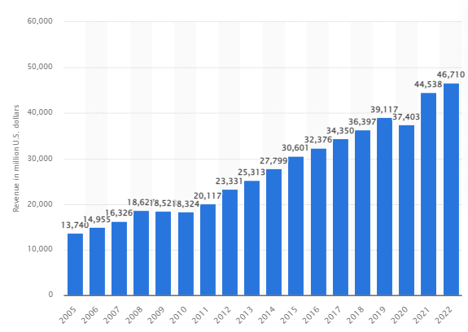
Figure 4: Sales revenue of Nike
(Source: statista.com, 2022)
Strategic decisions regarding the marketing of the products can be practised by Nike using the game theory. For instance, Nike Air Force 1 ‘07 is one of the best-selling products of Nike (nike.com, 2022). This factor signifies the market demand for the product and Game theory supports the company to understand the market priorities of this particular product. Using the Game theory Nike increases the production rate of this particular product. This particular product contributes a high value to the revenue-making process of the company.

3.6 Innovation and learning-based model as a foundation of technology strategies of Nike
Technology is considered a foundation base for Nike's business growth strategy. The firm has adequately invested in R&D and indicated the lowest environmental impact. The product footprint using recycled and reused content within their production line is also considered an important factor. Specifying the pattern-intensive target and efficient midsole processes for guiding the product teams is also an important factor in this context. Implementing clear logical plans has additional resources devoted to new ideas with the guarantee of success within the framework (Nike Considered, IC, pp.7). The innovation flow process has shown competition and a resource base for experimenting and developing competitive advantages over time. However, the strategic directions of the Nike organisation have focused on a steadily growing environment to manage the expenses of the firm and expand outside their dynamic pressure.
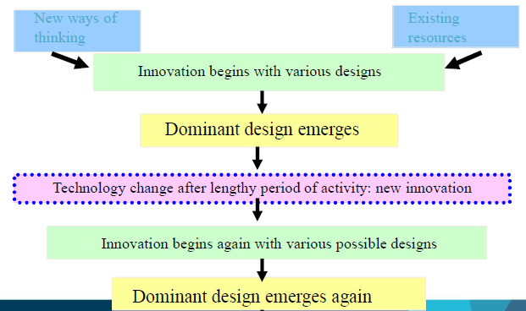
Figure 5: Innovation flow process and dynamics for Nike’s organisation
(Source: Strategy dynamics C5, pp 7)
The innovation and learning-based model has concentrated on the resource base to achieve the existing market opportunities and provide new offerings to potential customers. The Nike organisation has faced maintaining the baseline sustainability for the assessment of energy footprints within the framework (Nike.com, 2022). Hence, it is rightly proved that Nike’s success factor is dependent on the business strategy model to remain ahead of the curve with their new products.

3.7 Product diversification strategies using the perspective process model
Tackling the strategy dynamics by developing new products and effective long-term planning to reach out to the market is considered an important factor. The combined effect of some of the important indicators for finding marketing opportunities and developing competitive advantages over time is also a crucial factor (Antoniet et al., 2020). The prospective process model has provided a purpose with an insistence on the quality products is also considered an important aspect in terms of the business process of Nike. The synthesis of the key drivers for change and the strategic planning process has shown new ventures for the organisation for further growth and sustainability within the framework. Product diversification strategies of the organisations have used a formal approach with additional resources devoted to new ideas and developing their products over time (Nike Considered, IC, pp.8). Reducing the costs over the production process and the organisation has decentralised their planning and approach for the mass production of quality products is also considered an essential factor.
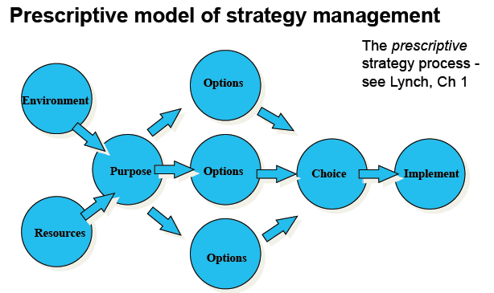
Figure 6: A perspective model strategy for product diversification of Nike
(Source: Review of Theory and Practice_1, pp.4)
The lowest cost of their production to give the firm the edge against their competitors is also considered an important factor. Moreover, remaining competitive with the promotional techniques to relocate their operations over various locations to drive the marginal cost down is also considered an essential factor (Altenburg et al., 2020). Product differentiation in terms of the function design and packaging to improve the efficacy and brand name is also a crucial factor in terms of product diversification strategies. Therefore, the identification and capture of new market spaces to act against the short time horizons of their production lines are also considered important factors.

3.8 Marketing growth strategies of Nike by using the emergent model
Marketing is considered one of the core pillars of Nike’s business growth strategies. The economy has adequately focused on its marketing practices by executing effective marketing campaigns. Moreover, the company has maintained a distinct image with the right tone in the terms of marketing. The company connects with their followers all over the world with their seasonal marketing techniques by creating stronger emotional bonds with the audience. However, another key driver to sales growth related to effective promotional strategies is product innovation to create a highly differentiated service which is also a crucial factor. Experiencing intense competition by adequately involving in new sets of standards within the industry is also a crucial factor for the company’s worldwide expansion (Jeng, 2020). Furthermore, maintaining a leadership position and maintaining the position in terms of product innovation is also a compelling factor for the company to gain a competitive edge. Sustainable chain management within their production allows organisations to save costs and grow business faster as core strength for the company’s business strategies. Hence, the emergent model has helped organisations to substantially focus on innovation within their business practices.
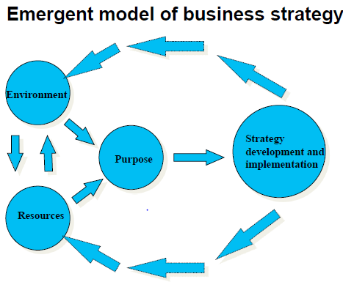
Figure 7: Emergent business model for marketing growth opportunities
(Source: Review of Theory and Practice_1, pp.5)

3.9 Sustainable design ethos and corporate strategy model
Exploring the Corporate strategy model to identify the strategic position of the firm in terms of the business environment, capability, purpose and culture is considered an essential factor. The strategic choices and the strategy in action for business evaluation and innovation are important for maintaining a sustainability factor in business (Li et al., 2021). Furthermore, the process of resourcing, organising the processes and changing practices are also considered important factors. The idea of strategic fit for identifying the capabilities, resources and competencies in terms of the environmental context as a basis of competitive advantages is also considered an essential factor. The corporate strategy model is a unique plan designed to gain competitive advantages over the market participants as well the various stakeholders as an expansion and combination strategy within the organisational framework.
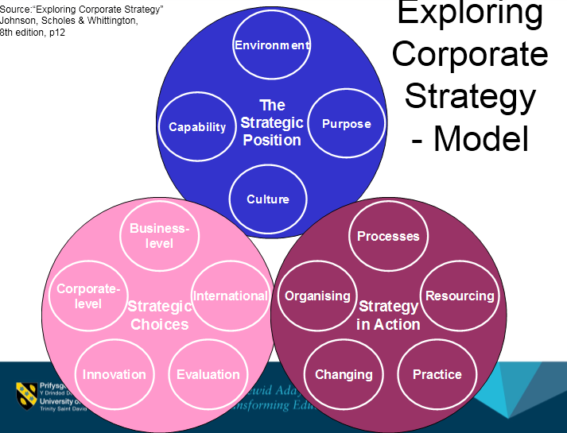
Figure 8: Using Corporate Strategy Model for Nike’s organisation
(Source: Lecture 2 STM, ppt slide 3)
Nike has adequately focused on the investment in technology and production for developing unique products for their customers. High-quality and market-leading technology can be considered as a business strategy to expand to the market for further growth (Review of Theory and Practice_1, pp.5). Thereby, involvement in greater use of science and technology through effective structuring and manufacturing through mass production of their quality products is also considered an essential factor. The organisation has focused on low-footprint-reducing products through formal assessment is also a crucial factor. Thus, the sustainable design ethos and corporate strategy of the organisation are helpful in gaining competitive advantages over their competitors.

4. Implementation of strategy
Implementation challenges
Nike has made different strategies for achieving sustainability and designing eco-friendly products. This includes using raw material which contains less carbon content. Further, collaborating with material suppliers and independent industry help in better production as well as energy sourcing is challenging. On the other hand, according to the case study, Nike had made a strategy related to labour, environment and the design of the product (Lyddy et al., 2019). It had been observed that Nike had a strategy of global sourcing which allowed Nike to low cost products. However, the effort leads to creating some public relations issues. Activists have criticised Nike for its labour practices of Nike including forced overtime, illegal pay, sexual harassment, physical abuse and exposure to chemicals (Lyddy et al., 2019). Nike, therefore, starts making strategies in consideration of labour practice.
Nike under a new VP starts exploring the reason leading to suppliers' non-compliance with the code of conduct. There were many implementation challenges with the implementation of the sustainability strategy which need to be considered by Nike. Some of the implementation challenges include performance and aesthetics, time, design, supply chain partners, profit margin, and consumers. One of the challenges to Nike's sustainability strategy is the complex design process (nike.com, 2022). It is, therefore, that designers need to find the right design for sustainable products. It requires considerable time and planning that looked cool as well as efficient. Further, it is important to consider the price as well as constraints to performance improvement. It is important, that the product help in the performance improvement of athletics.
The other challenge that needs to be considered by Nike is considering the time in the development of greener products. From the case study, it was observed that due to fast pace development of products according to the consumer trend as well as organisational effort requires more time (Nike Considered.IC_ (1) Page No 13). Moreover, it was observed that employees were facing difficulty in focusing from dance-oriented consumers towards sports-oriented. It was also observed that Nike faced some performance as well as an aesthetic risk with the use of EPMs. For instance, one of the widely used EPM products is synthetic leather. However, the use of recycled materials results from the use of solvents can result in an efficient product.

4.1 Mintberg’s theory in the planning process
The strategic implementation of sustainability can be done efficiently by setting the objective, allocating resources, monitoring and issue while implementing. First, it is important to understand the limitation of the implementation process (Sönnichsen and Clement, 2019). There needs to be the development of objectives, required time in implementing the plan and monitoring of the progress. For instance, the use of Mintzberg's theory can help in the better implementation of a sustainable strategy.
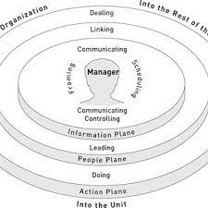
Figure 9: Mintzberg theory
(Source: researchgate.net, 2022)
According to Mintzberg's theory, there are five things that need to be considered while making the project implementation (Serrat, 2021). The first thing is making the proper plan of delivering the strategy. The next important thing is doing better than the competitors. The use of different strategies and tools such as impact analysis, scenario analysis and future wheel can help in understanding future competition (Foss et al., 2022). The next important thing is the positioning of Nike in the market. This can be done by reflecting on Nike's efforts towards achieving sustainability. Further, the implementation of strategy depends upon the culture of the organisation. There are different tools such as the cultural web, and the congruence model can be used by Nike in its effort to sustainability.

4.2 KISS model in strategy implementation
Further, the theory KISS (Keep it simple stupid) model can be used in the implementation of sustainability strategy. The use of this model ensures that the process of implementation needs to be kept simple including better communication in the team. The KISS model can be used in the sustainable product development of Nike (Ekhad and Zeilberger, 2020). The model focuses that product design and development need to be simple that can help in achieving the business objectives.
Different stages in project implementation are discussed below:
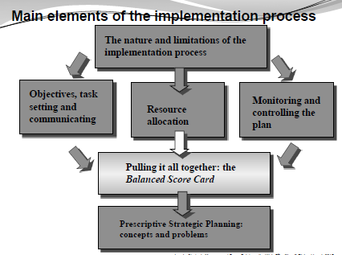
Figure 10: Implementation of strategy
(Source: Strategic implementation Page No 9)
Setting of objectives
It is important that while implementing the Nike sustainable strategy it is important to the development of the strategy. The sustainable strategy can be made by Nike managers or superiors. The next important thing is communicating the roles to the employees for effective implementation of strategy (Strategic implementation Page No 5). The most important is to clarify the objective that the organization needs to achieve. For instance, in this case, the objective is achieving sustainability by Nike.
Resource allocation
This is the next important thing for the implementation of the strategy. Resource allocation requires the finance manager in the organisation to suggest a budget for the project realisation. Nike's decision to launch sustainable footwear is better decisions as these are not expensive as designer shoes (Strategic implementation Page No 6). For instance, some of the natural resources that will be required by Nike in producing greener shoes are leather, rubber, and plant fibres such as hemp, coconut, bamboo, linen and others (weebly.com, 2022). The use of recycled plastic and polyesters can be used in product development.
Monitoring and controlling of plan
This is an essential step during the strategy implementation. For instance, it is important that employees in the organisation are clear about their roles and responsibility (Implementation Guidelines Page No 1). Further, it is important that there is no miscommunication in the team. Moreover, it requires strategy-making for product implementation in a fast-changing environment. The manager of Nike can monitor and control the implementation of the strategy.
Balance Scorecard
The use of a balanced scorecard can help in controlling and monitoring the strategy implementation. It is used for checking the entire process in the implementation of the strategy (Betto et al., 2022). There are four perspectives of the balanced scorecard including financial perspective, customer perspective, internal perspective and future perspective.
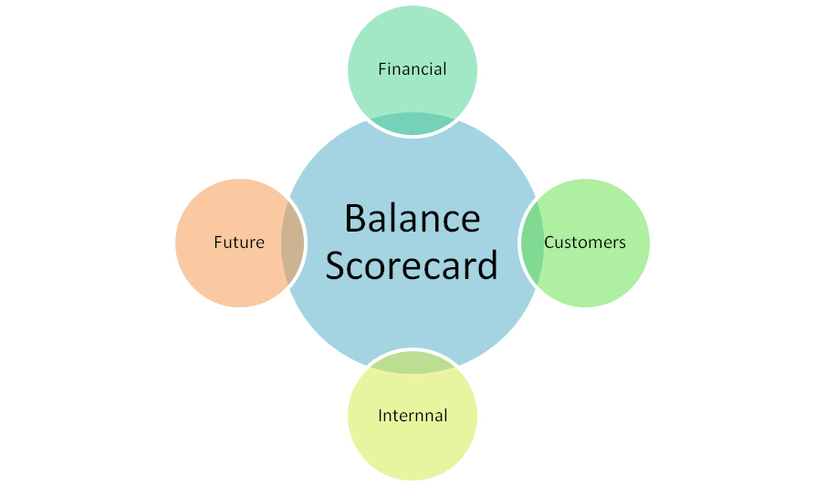
Figure 11: Balance Scorecard
(Source: Created by author)
Strategy perspective | Description | KPI
Financial perspective | - Ensuring return on investment  - Key risk involved with the business  - Satisfying needs of all involved in business customers, suppliers and customers | - Increased revenue  - Sales growth  - Return on capital
Customer perspective | - Understanding customer satisfaction with the new product  - Customer perspective to competitors | - Customer retention  - Customer satisfaction  - Procuring of new market and customers
Internal perspective | - Ensuring the objective of the business is met  - Confirming the quality of product  - Making new strategies that improved customer experience. | - Sustainability of product  - Quality of product  - Manufacturing cost  - Inventor management
Future perspective | - Making a future goal for the organisation  - Integrating new technologies such as AI and Automation | - Employee retention  - Employee profitability  - R&D competencies  - New development of product
Table 1: Balance scorecard
(Source: Created by author)
Perspective strategic planning
A perspective strategic management approach defines that the business objectives are defined earlier as well as a plan of achieving them. This approach is based on a top-down structure which helps in the efficient implementation of the strategy. In this approach, there are meetings and debates every year which help in the sustainable strategy implementation of Nike. Further, the allocation of funds for the strategy implementation is planned before. Moreover, this approach helps in resource allocation and in controlling outcomes (George et al., 2019). The emergent approach in the project implementation can be used for the strategy implementation. In this approach, managers of Nike make operational decisions and make strategy time to time that results in certain patterns (Strategic implementation Page No 12). Therefore, the strategy made through certain patterns can be documented and presented in the annual report.
Linking strategy implementation with organisational activities
The activities within the organisation play an important role in strategy implementation. Some of the important organisational activities that affect the implementation of the strategy include human resources, project reviews, rewards and budget (Chaffey and Ellis-Chadwick, 2019). It is important for the HR at Nike to make a plan and define the roles and responsibilities of the employees clearly. Further, it is important that HR regularly provide feedback to employees at regular intervals. It is also important for managers at Nike to consider the view of other stakeholders and shareholders on their new strategy for making eco-friendly products.

5. Conclusion
It can be concluded from the above discussions that Nike's decision for traceability sustainability is a good step. This will promote sustainability and increase the corporate social responsibility of Nike. However, the realisation of Nike's sustainability plan requires making a different strategy. For instance, it is important to understand the market of Nike's operation. The political environment of the UK is observed to be a positive impact on Nike. However, the economic environment of the UK is not supportive of Nike. On the other hand, the factors social, environmental and legal support the sustainable plan Nike.
The key success factor for the implementation sustainability strategy of Nike requires the allocation of resources and the budget. Further, the factor of motivation among workers and collaboration is important for the realisation of the project. The theories such as cost leadership, value chain, KISS, and Mintzberg theory show that lower cost of operation will give a competitive advantage to Nike. On the other hand, value chain theory reflects that Nike needs to focus on primary and supportive activities to gain a competitive advantage. These include infrastructure, technology, and outbound logistics. The model Jhonson and Scholes show that the culture of the organisation plays an important role in gaining an advantage in the market. Further, the KISS model shows that strategy-making need to be simple to increase the efficiency of project implementation.

Reference
Altenburg, T., Chen, X., Lütkenhorst, W., Staritz, C. and Whitfield, L., (2020). Exporting out of China or out of Africa? Automation versus relocation in the global clothing industry (No. 1/2020). Discussion Paper.
Antoni, D., Jie, F. and Abareshi, A., (2020). Critical factors in information technology capability for enhancing firm's environmental performance: case of Indonesian ICT sector. International Journal of Agile Systems and Management, 13(2), pp.159-181.
Balboni, B., Bortoluzzi, G., Pugliese, R. and Tracogna, A., (2019). Business model evolution, contextual ambidexterity and the growth performance of high-tech start-ups. Journal of Business Research, 99, pp.115-124.
Baxter, G., (2019). A strategic analysis of Cargolux Airlines International position in the global air cargo supply chain using Porter’s Five Forces Model. Infrastructures, 4(1), p.6.
Betto, F., Sardi, A., Garengo, P. and Sorano, E., (2022). The Evolution of Balanced Scorecard in Healthcare: A Systematic Review of Its Design, Implementation, Use, and Review. International Journal of Environmental Research and Public Health, 19(16), p.10291.
Bruijl, D. and Gerard, H.T., (2018). The relevance of Porter's five forces in today's innovative and changing business environment. Available at SSRN 3192207.
Burke, L.M., Hawley, J.A., Jeukendrup, A., Morton, J.P., Stellingwerff, T. and Maughan, R.J., (2018). Toward a common understanding of diet–exercise strategies to manipulate fuel availability for training and competition preparation in endurance sport. International journal of sport nutrition and exercise metabolism, 28(5), pp.451-463.
Chaffey, D. and Ellis-Chadwick, F., (2019). Digital marketing: strategy, implementation & practice. Pearson uk.
Choi, T.M., Taleizadeh, A.A. and Yue, X., (2020). Game theory applications in production research in the sharing and circular economy era. International Journal of Production Research, 58(1), pp.118-127.
Dalton, C., Corbett, S. and Katelaris, A., (2020). Pre-emptive low cost social distancing and enhanced hygiene implemented before local COVID-19 transmission could decrease the number and severity of cases. The Medical Journal of Australia, 212(10), p.1.
Ekhad, S.B. and Zeilberger, D., (2020). Automatic counting of restricted Dyck paths via (numeric and symbolic) dynamic programming. arXiv preprint arXiv:2006.01961.
Eyada, B., (2020). Brand activism, the relation and impact on consumer perception: A case study on nike advertising. International Journal of Marketing Studies, 12(4), pp.30-42.
forbes.com, (2020). “Michael Jordan Has Made Over $1 Billion From Nike — The Biggest Endorsement Bargain In Sports”. Available at: https://www.forbes.com/sites/kurtbadenhausen/2020/05/03/michael-jordans-1-billion-nike-endorsement-is-the-biggest-bargain-in-sports/?sh=26a36b786136, [Accessed on: 28th December, 2022]
Foss, N.J., McCaffrey, M.C. and Dorobat, C.E., (2022). “When Henry Met Fritz”: Rules As Organizational Frameworks For Emergent Strategy Process. Journal of Management Inquiry, 31(2), pp.135-149.
George, B., Walker, R.M. and Monster, J., (2019). Does strategic planning improve organizational performance? A meta‐analysis. Public Administration Review, 79(6), pp.810-819.
Implementation Guidelines Page No 1
investors.nike.com, (2022). “INVESTOR NEWS DETAILS”. Available at: https://investors.nike.com/investors/news-events-and-reports/investor-news/investor-news-details/2021/NIKE-Inc.-Reports-Fiscal-2021-Fourth-Quarter-and-Full-Year-Results/default.aspx, [Accessed on: 28th December, 2022]
Iyer, P., Davari, A., Zolfagharian, M. and Paswan, A., (2019). Market orientation, positioning strategy and brand performance. Industrial Marketing Management, 81, pp.16-29.
Jerrim, J. and Moss, G., (2019). The link between fiction and teenagers’ reading skills: International evidence from the OECD PISA study. British Educational Research Journal, 45(1), pp.181-200.
Lambin, E.F. and Thorlakson, T., (2018). Sustainability standards: Interactions between private actors, civil society, and governments. Annual Review of Environment and Resources, 43(1), pp.369-393.
leadershipcentre.org.uk, (2022). “Creating the Web”. Available at: https://www.leadershipcentre.org.uk/artofchangemaking/theory/cultural-web/, [Accessed on: 28th December, 2022]
Lecture 2 STM, ppt slide 3
Li, R., Cui, Y. and Zheng, Y., (2021). The impact of corporate strategy on enterprise innovation based on the mediating effect of corporate risk-taking. Sustainability, 13(3), p.1023.
Lyddy, C., Henderson, R., Locke, R.M. and Reavis, C., (2009). Nike Considered: Getting Traction on Sustainability.
Moeuf, A., Lamouri, S., Pellerin, R., Tamayo-Giraldo, S., Tobon-Valencia, E. and Eburdy, R., (2020). Identification of critical success factors, risks and opportunities of Industry 4.0 in SMEs. International Journal of Production Research, 58(5), pp.1384-1400.
Nike Considered, IC, pp.7
Nike Considered, IC, pp.8
Nike Considered.IC_ (1) Page No 13
nike.com (2022) Sustainability, Available at: https://www.nike.com/in/sustainability (Accessed on: 30th December, 2022)
nike.com, (2022). “Bestsellers(98)”. Available at: https://www.nike.com/in/w/best-76m50, [Accessed on: 28th December, 2022]
nike.com, (2022). “NIKE FORWARD”. Available at: https://www.nike.com/in/sustainability/materials, [Accessed on: 28th December, 2022]
nike.com, (2022). “Nike sustainability strategy”. Available at: https://about.nike.com/en/impact/focus-areas/protecting-the-planet, [Accessed on: 31st December, 2022]
Nike.com, (2022). “NIKE”. Available at: https://www.nike.com/in/, [Accessed on: 26th December, 2022]
nike.com, (2022). “PASSION. POTENTIAL. AND OUR PURSUIT.”. Available at: https://jobs.nike.com/brands, [Accessed on: 28th December, 2022]
ons.gov.uk (2022) GDP Growth Rate, Available at: https://www.ons.gov.uk/economy/grossdomesticproductgdp#:~:text=Monthly%20real%20gross%20domestic%20product,of%20HM%20Queen%20Elizabeth%20II. (Accessed on: 30th December, 2022)
Rahil, A. and Dumitru, S., (2019). The sustainable links of development between leadership and organizational cultures. Journal of Economic Development, Environment and People, 8(2), pp.45-55.
researchgate.net, (2022). “Mintberz theory”. Available at: https://www.google.com/url?sa=i&url=https%3A%2F%2Fwww.researchgate.net%2Ffigure%2FThe-Model-of-Managing-Mintzberg-2009a-p-48_fig2_320267823&psig=AOvVaw1JFzIsODogpQtVEbSn-aQG&ust=1672561755723000&source=images&cd=vfe&ved=2ahUKEwiG6OSbuKP8AhVMi9gFHTwpBukQr4kDegUIARCBAg, [Accessed on: 31st December, 2022]
Review of Theory and Practice_1, pp.4
Review of Theory and Practice_1, pp.5
Schoppe‐Sullivan, S.J. and Fagan, J., (2020). The evolution of fathering research in the 21st century: Persistent challenges, new directions. Journal of Marriage and Family, 82(1), pp.175-197.
Serrat, O., (2021). Mintzberg’s model of managing: Random thoughts from an observation. In Leading Solutions (pp. 157-169). Springer, Singapore.
Skinner, J., Smith, A.C. and Swanson, S., (2018). Conclusion: Leadership, Culture and Invention. In Fostering Innovative Cultures in Sport (pp. 241-270). Palgrave Macmillan, Cham.
Sönnichsen, S.D. and Clement, J., (2020). Review of green and sustainable public procurement: Towards circular public procurement. Journal of cleaner production, 245, p.118901.
Stangl, L.J.M., (2021). Digital Transformation in the Sports Apparel Industry. The Case of Nike, Inc. GRIN Verlag.
statista.com (2022) Brand Profile, Available at: https://www.statista.com/forecasts/1252337/nike-sports-and-outdoor-online-shops-brand-profile-in-the-uk (Accessed on: 30th December, 2022)
statista.com (2022) Footwear Market of Nike in the UK, Available at: https://www.statista.com/outlook/cmo/footwear/sneakers/united-kingdom (Accessed on: 30th December, 2022)
statista.com, (2022). “Brand value comparison of Nike and adidas worldwide from 2010 to 2021”. Available at: https://www.statista.com/statistics/985227/brand-value-comparison-of-nike-and-adidas-worldwide/, [Accessed on: 28th December, 2022]
statista.com, (2022). “Footwear - Jordan”. Available at: https://www.statista.com/outlook/dmo/ecommerce/fashion/footwear/jordan, [Accessed on: 28th December, 2022]
statista.com, (2022). “Nike's revenue worldwide from the fiscal years of 2005 to 2022”. Available at: https://www.statista.com/statistics/241683/nikes-sales-worldwide-since-2004/, [Accessed on: 28th December, 2022]
Strategic implementation Page No 12
Strategic implementation Page No 5
Strategic implementation Page No 6
Strategic implementation Page No 9
Strtaegiy dynamics C5, pp 7
Teng, J., (2020), December. Analysis of Female Marketing—Taking Nike as an Example. In 2020 3rd International Conference on Humanities Education and Social Sciences (ICHESS 2020) (pp. 286-291). Atlantis Press.
weebly.com, (2022). “Natural resources for shoes”. Available at: https://theproductionofnikeshoes.weebly.com/natural-resources.html, [Accessed on: 31st December, 2022]
Yuan, Y., Lu, L.Y., Tian, G. and Yu, Y., (2020). Business strategy and corporate social responsibility. Journal of Business Ethics, 162(2), pp.359-377.

