TRANSITION IN DIGITAL MARKETING AND PROMOTION APPROACHES IN THE POST COVID SCENARIO HOSPITALITY INDUSTRY
Name: Mohit Bhatt
Student Id: 2132840
Course: Master of Business Administration
Supervisor name: DR. REXON NTING

Table of Contents
Introduction 2
Aims and objectives 2
Literature review 2
Methodology 5
Limitations 6
Ethical considerations 7
Timeframe 7
Conclusion 8
References 9

Introduction
The proposed research aims to investigate the transition in digital marketing and promotion approaches in the post-COVID scenario in AccorHotels that operates in the UK and global hospitality industry. The study will conduct a comprehensive literature review to understand the current digital marketing trends in the hospitality industry, and analyse how COVID-19 has affected the digital marketing approach of AccorHotels. The research methodology will involve a mixed-methods approach, including both quantitative and qualitative data analysis techniques. The study's limitations will include a focus on AccorHotels in a specific geographic location and the availability of data. Ethical considerations will be taken into account throughout the research process.

Aims and objectives
Aim
The aim of this research proposal is to analyse the transition in digital marketing and promotion approaches in the post-COVID scenario hospitality industry.
Objectives
- To contribute to the existing body of knowledge on digital marketing and promotion in AccorHotels in the post-COVID scenario.
- To identify the changes in consumer behaviour and preferences related to the AccorHotels’s digital marketing and promotion in the post-COVID scenario.
- To explore the emerging digital marketing and promotional trends in AccorHotels after the COVID-19 pandemic.
- To evaluate the effectiveness of digital marketing and promotion strategies of AccorHotels in the post-COVID scenario.
Questions
- What are digital marketing and promotion strategies adopted in AccorHotels in the post-COVID scenario?
- What are the changes in consumer behaviour and preferences related to the digital marketing and promotion strategies of AccorHotels in the post-COVID scenario?
- What are the emerging digital marketing and promotional trends in the hospitality industry specially in AccorHotels after the COVID-19 pandemic?

Literature review
Digital marketing in AccorHotels: A critical analysis of the pre-covid scenario
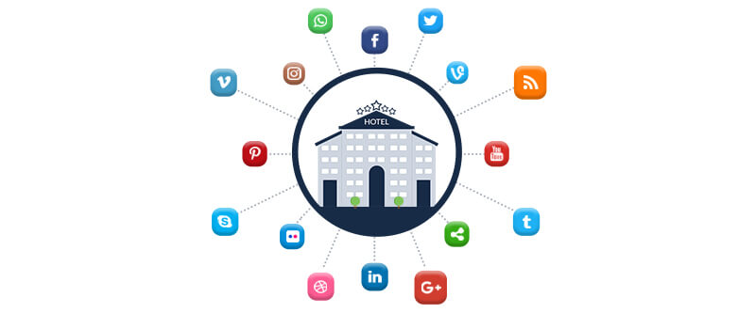
Figure 1: Digital marketing strategies
(Source:Ezeeabsolute.com, 2023)
Digital marketing has become an essential aspect of the hospitality industry. The hospitality industry is highly competitive, and digital marketing strategies can be used to differentiate brands and create loyal customers (Pandey,2021). AccorHotels is known for its high customer service standards, and digital marketing plays a crucial role in providing personalised and tailored services to customers. Research shows that digital marketing channels, such as social media, search engines, and email marketing, are the most popular channels used by AccorHotels to reach their target audience. Studies also suggest that digital marketing strategies such as personalization and customer engagement can help increase customer loyalty and retention rates. According to Kumaret al. (2022), by using data analytics, hospitality companies can collect and analyse customer data to tailor their marketing messages to specific customer groups, enhancing customer experience and satisfaction. However, despite the advantages of digital marketing, there are also challenges. One of the main challenges for AccorHotels is managing online reviews and reputation. Negative reviews can damage a brand's reputation, and managing online reviews can be time-consuming and resource-intensive.
Transition in digital marketing approaches in the post-Covid scenario
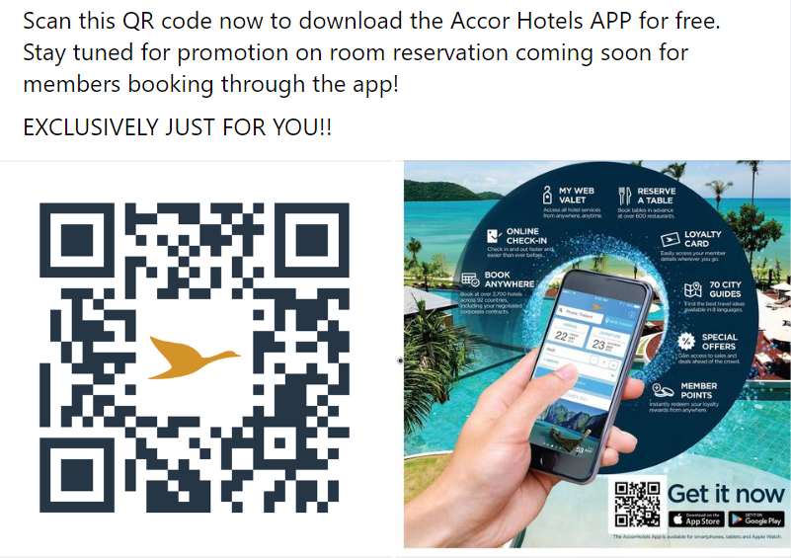
Figure 2: Online presence of AccorHotels
(Source: All.accor.com, 2023)
The Covid-19 pandemic has had a significant impact on digital marketing approaches. Companies have had to adjust their marketing strategies to cater to the changing consumer behaviour and adapt to the new digital landscape. According to Statista, the global e-commerce market is projected to grow to $6.54 trillion by 2022, a significant increase from $3.53 trillion in 2019 (MISHRA,2021). This indicates that more consumers are shopping online, and based on that AccorHotels must adjust their digital marketing strategies to cater to this trend. Another significant change is the increased use of social media platforms for marketing. The pandemic has led to a surge in social media usage, and AccorHotels are now leveraging these platforms to reach their target audience. According to Hootsuite, 53.6% of the global population uses social media, with Facebook being the most popular platform. Thus, AccorHotels managing an effective presence on social media platforms. Personalization is another key aspect of digital marketing that has gained significance in the post-Covid scenario. As stated by Sakaset al. (2022), with more people shopping online, AccorHotels are leveraging data to provide personalised experiences for their customers. According to Accenture, 91% of consumers are more likely to shop with brands that provide personalised offers and recommendations. The Covid-19 pandemic has accelerated the shift towards digital marketing, with AccorHotels adapting to the changing consumer behaviour and leveraging data to provide personalised experiences.
Strategies for implementing digital marketing in the hospitality industry
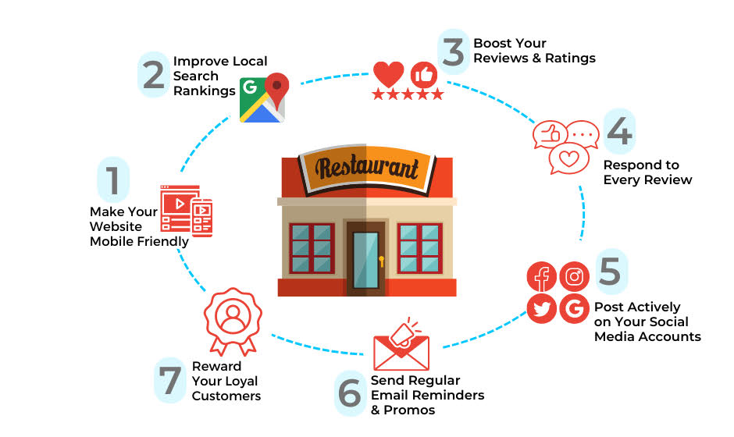
Figure 3: Digital marketing strategies
(Source: Platr.co, 2022)
The Covid-19 pandemic has brought about a paradigm shift in the way the hospitality industry operates, with digital marketing strategies becoming increasingly important. In a survey conducted by McKinsey, 75% of hotel owners including the owners of AccorHotels reported that digital marketing played a crucial role in their recovery from the pandemic (Toubeset al. 2021). To effectively implement digital marketing in the hospitality industry, it is crucial to adopt a data-driven approach. Utilising tools such as Google Analytics can help AccorHotels in understanding customer behaviour and identifying target audiences. Social media platforms like Facebook and Instagram is being also leveraging to reach a wider audience and increase brand visibility. Another key strategy of AccorHotels is to implement an omnichannel approach, which involves integrating all channels of communication and delivering a consistent customer experience across all touchpoints (Alkasasbeh, 2020). This includes social media, email marketing, search engine optimization, and website optimization. Additionally, personalization is becoming increasingly important in digital marketing for AccorHotels. The company can use customer data to offer personalised experiences, such as customised packages, promotions, and rewards programs.
Literature gap
The COVID-19 pandemic has significantly impacted the world's economic and social landscape, with businesses forced to rethink their marketing strategies in the face of reduced physical interactions and shifting consumer behaviour. While there have been studies on digital marketing approaches pre-COVID, there is a literature gap on the transition in digital marketing approaches post-COVID. Specifically, little research has been conducted on how AccorHotels are adapting their digital marketing approaches to cope with the post-COVID scenario, which may involve permanent changes in consumer behaviour and preferences for the company. Understanding this transition is crucial for AccorHotels seeking to remain competitive and relevant in the digital marketplace.

Methodology
The proposed research aims to investigate the transition in digital marketing approaches of AccorHotels in the post-Covid scenario. The study will employ a positivism philosophy, descriptive design, quantitative data collection, and thematic data analysis to answer the research questions. As opined by Baryshnikovaet al. (2021), positivism is a philosophical approach that asserts that knowledge should be based on empirical evidence and scientific methods. This philosophy is suitable for this research because it aims to study the transition in digital marketing approaches in the post-Covid scenario. A descriptive design will be used for this research. This design is appropriate because it aims to describe the current state of digital marketing approaches in the post-Covid scenario. The descriptive design will involve the collection of data through surveys and questionnaires.
The data collection will be done using a quantitative approach. This approach is appropriate because it aims to measure the frequency and quantity of certain variables. The data collected will be numerical and will be analysed using statistical methods. The use of statistical methods will enable the researcher to make generalisations about the responses of employees and managers of AccorHotels. Thematic data analysis will be used to analyse the data collected through statistical analysis. Thematic data analysis involves the identification and analysis of themes within the data. The themes will be identified based on the research questions and objectives. The data will be coded and categorised into different themes, and the themes will be analysed to identify patterns and trends. The data collection process will involve the distribution of online surveys and questionnaires to digital marketers in various industries. The surveys and questionnaires will be designed to gather information on the current state of digital marketing approaches in the post-Covid scenario. The results will be discussed and analysed based on the research questions and objectives. The conclusions drawn from the analysis will be used to make recommendations for future research and digital marketing practices in the post-Covid scenario.

Limitations
The transition in digital marketing approaches in the post-Covid scenario is an interesting and timely topic. However, data collection in this field is not without limitations. One limitation is the availability and quality of data. In words of Tiwariet al. (2021), due to the pandemic, many businesses have shifted their marketing strategies online, resulting in a wealth of data related to digital marketing. However, the quality and accuracy of this data may be questionable, as the management of AccorHotels are experimenting with new approaches and strategies, resulting in data that is inconsistent or incomplete. Furthermore, some population from the selected employees and managers of AccorHotels may not be willing to share their data due to privacy concerns, which may limit the amount of data that can be collected. Another limitation is the potential for bias in data collection. Researchers may be tempted to rely on readily available data sources such as online surveys or social media analytics, which may not accurately represent the entire population or may be subject to biases such as response bias or sampling bias. Researchers should consider using multiple sources of data and using a variety of methods to collect data to reduce the risk of bias.

Ethical considerations
When conducting research on the transition in digital marketing and promotion approaches in the post-COVID scenario in AccorHotels, it is essential to consider several ethical factors. According to Gauret al. (2021), it is crucial to ensure that the employees and managers who will participate in data collection process are fully informed about the research objectives, procedures, and potential risks and benefits before they provide their consent to participate. Secondly, the researchers should ensure that the data collected is kept confidential and only used for the research purposes stated because it can be personal properties of AccorHotels. Thirdly, it is essential to obtain ethical clearance from the authorities of AccorHotels and comply with the ethical guidelines and standards set by the academic and professional bodies. Finally, the researcher should be aware of the potential impact of the research findings on the stakeholders of AccorHotels and ensure that the research is conducted in an unbiased and responsible manner.

Timeframe
Activities | Week 1-2 | Week 2-4 | Week 4-5 | Week 5-6 | Week 6-7 | Week 7-8
Background study
Research objectives and questions
Literature review
Research methodology
Survey
Secondary data collection
Findings and analysis
Conclusion and recommendations
Final draft submission

Conclusion
In conclusion, this research proposal aimed to explore the transition in digital marketing and promotion approaches of AccorHotels in the post-COVID scenario. Through an extensive literature review and a mixed-methods approach, the study hopes to provide valuable insights into the changes that occurred in the industry and identify effective digital marketing strategies for a sustainable growth and development for AccorHotels. However, the study also acknowledges its limitations, ethical considerations such as the small sample size and the potential biases.

References
Alkasasbeh, F., 2020. The effects Of COVID-19 on restaurant industry: A perspective article. Journal of Innovations in Digital Marketing, 1(1), pp.22-31.
All.accor.com, 2023, About us, Available at: https://all.accor.com/india/index.en.shtml?utm_term=mar&gclid=Cj0KCQjwuLShBhC_ARIsAFod4fLJV1iAdviMvEsLK2Sq3u2LUSCRI7ja6BAWUAulUTOSpbKcE8-k1PUaAvpqEALw_wcB&utm_campaign=ppc-ach-mar-goo-in-en-pure-mix-sear-&utm_medium=cpc&utm_source=google&utm_content=in-en-ALL-ALL [Accessed on 5th April 2023]
Baryshnikova, N., Kiriliuk, O. and Klimecka-Tatar, D., 2021. Enterprises’ strategies transformation in the real sector of the economy in the context of the COVID-19 pandemic. Production Engineering Archives, 27(1), pp.8-15.
Ezeeabsolute.com, 2023, Hoteliers are Going Gaga Over These 11 Hotel Digital Marketing Strategies,Available at: https://www.ezeeabsolute.com/blog/hotel-digital-marketing-strategies/ [Accessed on 30th March 2023]
Gaur, L., Afaq, A., Singh, G. and Dwivedi, Y.K., 2021. Role of artificial intelligence and robotics to foster the touchless travel during a pandemic: a review and research agenda. International Journal of Contemporary Hospitality Management, 33(11), pp.4079-4098.
Kumar, A., Syed, A.A. and Singh, A., 2022. Future Aspects of Digital Sustainability in Hotels: A Study on Digital Marketing Challenges with Proposed Solutions (Opportunities) during and Post COVID Era. International Management Review, 18, pp.79-94.
MISHRA, A., 2021. Online Marketing: A Burgeoning Covid Free Marketing Strategy and Some Reviving Post-Covid Marketing Measures.
Pandey, N., 2021. Digital marketing strategies for firms in post covid-19 era: insights and future directions. The new normal challenges of managerial business, social and ecological systems in the post covid-19 era.
Platr.co, 2022, 7 Digital Marketing Strategies Most Likely to Boost Your Restaurant’s Revenue, Available at: https://www.platr.co/digital-marketing-strategies-to-boost-restaurants-revenue/[Accessed on 30th March 2023]
Sakas, D.P., Reklitis, D.P., Terzi, M.C. and Vassilakis, C., 2022. Multichannel Digital Marketing Optimizations through Big Data Analytics in the Tourism and Hospitality Industry. Journal of Theoretical and Applied Electronic Commerce Research, 17(4), pp.1383-1408.
Tiwari, P., Séraphin, H. and Chowdhary, N.R., 2021. Impacts of COVID-19 on tourism education: Analysis and perspectives. Journal of Teaching in Travel & Tourism, 21(4), pp.313-338.
Toubes, D.R., Araújo Vila, N. and Fraiz Brea, J.A., 2021. Changes in consumption patterns and tourist promotion after the COVID-19 pandemic. Journal of Theoretical and Applied Electronic Commerce Research, 16(5), pp.1332-1352.

