

Name: Keval Hansraj Mange
Student ID: 2240155
Subject: Strategic Management
Submitted to: Dr Jayalakshmi Goaplkrishnan

INTRODUCTION
The strategic analysis of Ameya involves thoroughly examining the critical elements impacting the current and future standing of the upscale restaurant in the ever-evolving culinary industry. With a particular emphasis on its expansion efforts within the United Kingdom, the well-known London-based establishment acknowledges the necessity of effectively thriving through the challenges presented by the competitive fine dining sector to achieve strategic growth and long-term sustainability. Today's competitive scenario is constantly fluctuating, to stay ahead of their rivals, companies have to make specific strategic alterations and corrections in their strategies and implement them in such a manner that helps the company to achieve its long-term and short-term goals.
When expansion is the goal, several aspects, such as internal and external factors, need to be considered. External factors will be assessed with the help of PESTLE, in which Political, Economic, Social, Technological, Legal, and Environmental forces will be analyzed. Microanalyses will also be used in this strategic report.

BACKGROUND INFORMATION
Restaurant Market in the UK
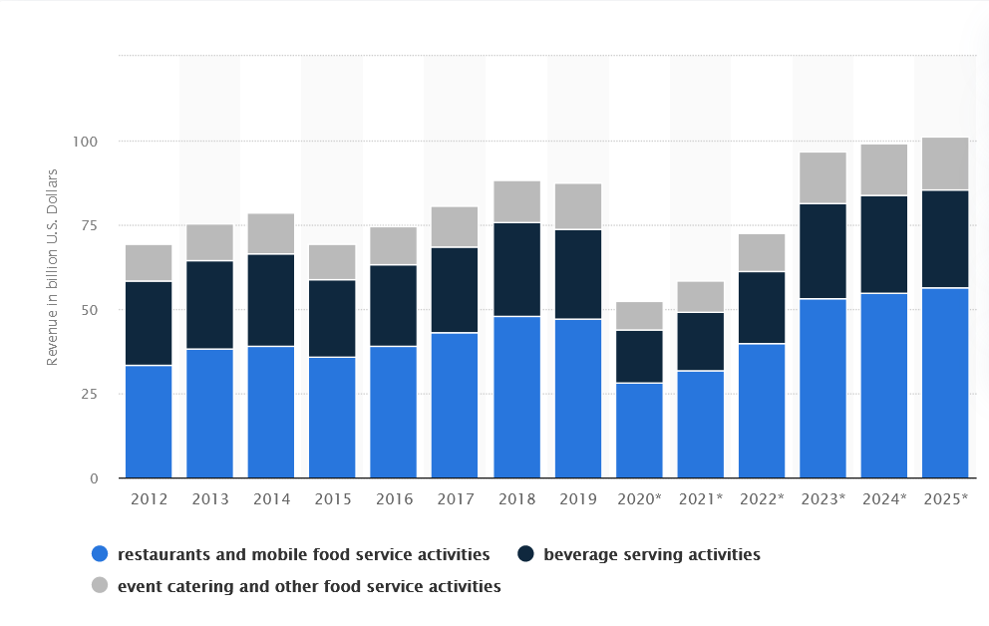
Source: Statista

The restaurant market is booming and expected to grow even more in upcoming years and it is one of the reasons for Ameya to expand across the UK. Ameya boldly ventured into uncharted territory by sourcing top-quality ingredients, blending Western culinary techniques, and innovatively presenting Indian flavours. It paved the way for others to follow, as numerous restaurants later embraced a similar approach.
Remaining a leader in modern Indian cuisine within the UK, Ameya, under the guidance of its founder and executive chef Vivek Singh, has been a constant presence since its inception. Vivek Singh's enduring presence positions him as an authority on the evolving preferences of the British public for Indian flavors over the last two decades. Despite the enduring popularity of dishes like chicken tikka masala and baltis, there has been a significant change in customer preferences at his restaurants.

- AMEYA’S VISION, MISSION AND OBJECTIVES
Vision Statement
"Our vision is to redefine food excellence by flawlessly blending the rich tapestry of Indian flavours with an unparalleled and innovative dining experience. Through our commitment to impeccable service, authenticity, and a welcoming ambiance, we aim to create lasting memories and set new standards for indulgence in Indian gastronomy."

Mission Statement
"At Ameya, our mission is to elevate the dining experience by presenting a contemporary interpretation of authentic Indian cuisine, infusing timeless classic Indian spices with a modern flair. We aspire to captivate your palate with the harmonious blend of tradition and innovation, bringing the essence of modern Indian gastronomy to every corner of London. Our commitment is to delight patrons with a symphony of flavors, creating memorable moments that transcend the ordinary and redefine the culinary landscape."

Goals and Objectives:
Expansion:
The primary objective of Ameya is to establish a pervasive presence throughout the entirety of the UK, consistently upholding the exceptional standards and distinctive flavors for which we are renowned. Our ambition extends beyond familiar territories as we venture into unexplored markets, connecting with new patrons, and unlocking novel locations. Through this expansion, we aspire to introduce our culinary excellence to diverse communities, ensuring that the unparalleled taste and quality synonymous with Ameya transcend boundaries and captivate new audiences across the United Kingdom.
Customer Satisfaction:
The objective of Ameya is to deliver an impeccable service experience to every guest, ensuring that each patron departs with a contented smile. We aspire to guarantee absolute satisfaction by meticulously attending to every facet of the fine dining journey, encompassing exquisite cuisine, a premium and immersive atmosphere, and genuine hospitality. Our commitment is to create not just meals, but lasting memories, leaving our patrons with a sense of fulfilment and delight in every dimension of their dining encounter.
Innovation with Tradition
Innovation is a key component of entrepreneurship (Hébert and Link, 2006). Entrepreneurs bring change in industries and consumer expectations by introducing innovative products, services, and processes. This innovation not only changes the landscape of the industry but also raises barriers against imitation, providing a competitive advantage (Home, 2011; Lee et al., 2016a; Ottenbacher and Harrington, 2007). Ameya aspires to seamlessly blend tradition and innovation, crafting an unparalleled and uniquely memorable experience for our discerning customers. We put efforts into marrying the timeless allure of tradition with the dynamic energy of innovation, creating a dining atmosphere that is both classic and cutting-edge. Our commitment is to provide a singular and extraordinary journey for our patrons, where the fusion of heritage and creativity results in an unmatched culinary adventure.
Brand Awareness and Loyalty
Research suggests that there is a significant correlation between performance and brand name. In the pursuit of culinary excellence, Ameya endeavors to establish itself as a distinguished purveyor of high-end Indian cuisines, renowned for both exceptional service and delectable gastronomy. Furthermore, we prioritize cultivating a devoted clientele, recognizing that building a loyal customer base is fundamental to our mission. Through a commitment to delivering unparalleled dining experiences, we aim to not only elevate the perception of Indian cuisine but also foster enduring relationships with our valued patrons.
Personalized Experience
At Ameya, our mission is to curate a bespoke and uniquely tailored experience, infused with our distinctive essence to bring unparalleled delight to our clientele. We are dedicated to delivering personalized service beyond expectations, ensuring each guest enjoys a memorable encounter that reflects the individuality and charm that define Ameya.

- ENVIRONMENTAL AUDIT OF THE COMPANY
Macro Environmental Analysis
Political | Economic | Social | Technological | Legal | Environmental
-Political Stability  -Flexibility  -Health & Safety Policy | -Disposable Income  -Industry Growth  Economic Stability | -Preference  -Food Awareness | -Usage of Technology | -Food Quality Laws | -Sustainability  -Measures

Political:
These forces encompass political strategies and procedures, which involve the degree to which a government gets involved in economic affairs. They comprise aspects like tax regulations, financial strategies, trade barriers, the political atmosphere, and the effectiveness of institutions like the national banking system. For Ameya, the political environment includes the political stability of the country, Ameya’s flexibility to adapt rules, and the health and safety policy of the UK. (Aziri, B. and Ismaili, R., 2020)
Economic:
Economic conditions involve the overall state of the economy and particular aspects like interest rates, exchange rates, inflation, unemployment, economic growth, trade imbalances, savings rates, and per-person domestic income. Additionally, economic factors involve the state of stock and bond markets, influencing consumer confidence and available spending money. Here from Ameya’s perspective, the major economic factor is the disposable income of the target market. (Aziri, B. and Ismaili, R., 2020)
Social:
The social environment is about the current trends, consumer behavior, population growth rate, and local population. Currently, vegan and vegetarian diet preferences are trending globally and, in the UK, as well, Ameya serves Indian food that has a lot of variety that can benefit the restaurant.
Technological:
Technological forces include establishments creating information and directing the use of technology, such as R&D consortia, university-sponsored technology incubators, patent and copyright laws, and government control over the Internet. (Aziri, B. and Ismaili, R., 2020)
Legal:
Laws like minimum wage, consumer laws, etc. can directly make an impact on the business. Especially, Ameya faces challenges with health and safety laws and food quality laws as a restaurant chain.
Environmental:
The environmental forces can directly impact industries such as insurance, farming, energy production, and tourism. They may have an indirect but substantial effect on other industries such as transportation and utilities. Apart from this, in businesses like restaurants, the efforts put into saving the environment also affect; therefore, Ameya focuses on taking measures for waste management and green energy. (Aziri, B. and Ismaili, R., 2020)

Micro Environmental Analysis
Ameya is a well-established name in the fine dining industry. Several factors need to be assessed for the company's micro-environmental analysis, such as the company itself, suppliers, competition, suppliers, and, customers. Analyzing these factors will give the company an edge over its competition, and help build an expansion strategy.
Company:
In the company analysis, internal aspects like marketing, Human resources, structure, and R&D are to be examined.
Marketing:
In the United Kingdom, there is a clear inclination among restaurant visitors to prioritize the overall dining experience when selecting where to eat, overshadowing other factors. Additionally, British restaurants are grappling with the task of establishing a distinctive brand identity to foster customer loyalty and encourage repeated visits. Given the saturation of competitors in the restaurant industry, cultivating customer loyalty has emerged as a crucial element for gaining a competitive edge. These dual emphases—on expanding reach to showcase the offered experience and the necessity to construct a brand for fostering loyalty—are compelling restaurants to allocate substantial resources to their digital marketing efforts. (Strategic Direction, 2021)
As it is difficult to make an impactful brand identity, to successfully expand across the UK, Ameya will have to create a distinguish image in the mind of the customers with their marketing and branding strategy. Moreover, Ameya can also use digital marketing to target specific areas with potential customers. Digital marketing strategies are becoming more relevant than ever if any are going to survive the significant disruption already faced by the market. Those who have been able to adapt and utilize their online presence have so far gained a significant competitive advantage. (Strategic Direction, 2021)
Human Resource:
In the realm of the restaurant industry, the workforce plays a pivotal role across various sectors, particularly in fine dining establishments where the essence lies in delivering a remarkable experience and committed culinary flavors. However, should the staff falter in achieving the predetermined objectives, establishing a brand reputation and enduring in the competitive market becomes a formidable challenge.
Ameya is dedicated to incorporating a Human Resources practice that involves comprehensive training for its employees, emphasizing the delivery of services with a primary focus on ensuring safety for both customers and staff. Additionally, the establishment is committed to fostering a culture where employees are not only well-versed in their roles but are also equipped with the necessary skills and knowledge to prioritize and maintain a secure environment. This commitment underscores the restaurant's dedication to excellence in customer service while upholding the highest standards of safety for everyone involved.
R&D:
- Developing new ingredients or formulas
Ameya is constantly inclined toward developing new ways to deliver authenticity of Indian food, for that, a good amount of R&D investment should be done.
- Creating healthier product lines
The sustainable way to improve as a restaurant company is to take care of healthy types of food that can benefit consumers in some way. Health consciousness is increasing nowadays, especially after the Covid-19 pandemic. Ameya promises to take care of customers’ health while providing them with tasty food.

Porter’s 5 Forces
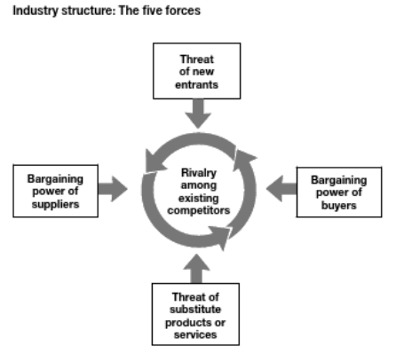
Source: Micheal Porter

- Competitive Rivalry.
If industry rivalry is high organizations may throw the profit and value they create away; buyers are the ultimate gainers in such rivalry. Indian fine dining has a moderate competitive rivalry, overall industry has a high level of industry competition as there are many types of fine dining restaurants such as Italian, Mexican, Thai, Chinese, Japanese, and British fine dining restaurants that bring a lot of competition on the table for Ameya. (Margretta,2020)
- Supplier Power.
Suppliers' bargaining power is high in Ameya as it has to rely on suppliers for high-quality raw materials. Powerful suppliers will charge higher prices or insist on more favorable terms, lowering industry proﬁtability. However, the company constantly makes efforts to divide the power by finding different reliable suppliers, this is how the company maintains harmony in dependency on single suppliers. (Margretta,2020)
- Buyer Power.
Customers with high bargaining power ask for more value in the product or service. The bargaining power of buyers still can be rated as high to medium, because of intense rivalry in the market as stated before there are many types of fine dining places in London; but, not each of those has the brand positioning as Ameya. Especially in the area of Indian Fine Dining. (Margretta,2020)
- Threat of Substitution.
The threat of substitutes is also high. A Substitute means anything that provides the company's basic product. In terms of Ameya basic product is food, so, all the food-providing hubs will be substitutes for Ameya. (Margretta,2020)
- Threat of New Entry.
Obstacles for new entrants act as protection for the existing companies. The threat of new entrants is low for the fine dining industry. As the barriers to entry are huge and more in number. First of all, it takes a lot of investment to enter the fine dining market: in the form of R&D, ambiance, hiring of professional chefs, property costs, and managerial costs. Another barrier for the industry is the strong brand name and winning the trust of local people. It takes a lot of time and marketing efforts to make a good brand name. Which makes the industry a little safer place for current players to survive and thrive. (Margretta,2020)

- STRATEGIC OPTIONS FOR AMEYA TO EXPAND
BCG Matrix
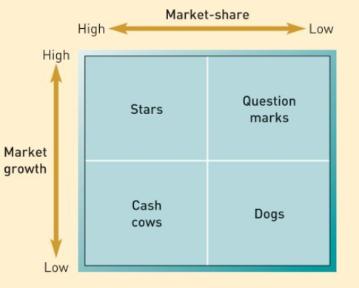
Source: Fundamentals of Strategy

As stated above the restaurant and fast-food industry is growing and future growth is also expected as per the prediction shown by Statista, Ameya will be classified as either a STAR or QUESTION MARK business unit as per the four categories given by the BCG matrix. The categories stated above (Stars and Question marks) have high market or industry growth.

Ansoff Matrix
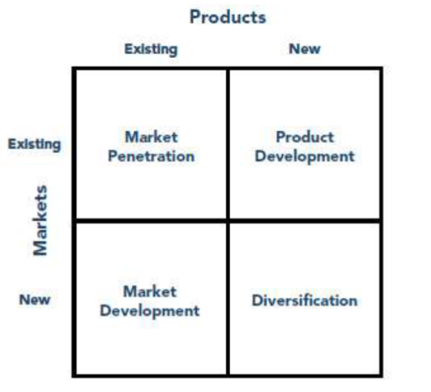
Source: Ansoff Matrix. Strategy Skills
As Ameya here is to expand its territory by exploring new place market development is the strategy that fits best for the company. It is a strategic approach in which a company identifies or establishes new market segments to accommodate its existing range of products and/or services. Nevertheless, this strategy involves potential risks associated with factors such as the unique characteristics of new markets, local competition dynamics, and uncertainties surrounding the profitability of the targeted market segment. (Yin, 2019)

VRIO Framework of Ameya

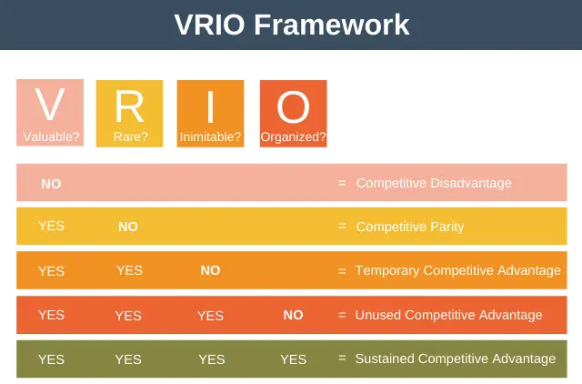
Source: BizNews

Valuable:
Ameya’s resources and capabilities can exploit external opportunities and neutralize external threats. For example, intense competition is a major threat; however, Ameya’s unique style of food presentation can help overcome the threat. Similarly, opportunities are well explored by its opportunistic location. Therefore, it can be said that Ameya’s resources and capabilities are valuable. (Aziri, B. and Ismaili, R., 2020)
Rare:
In the context of Ameya, it cannot be said that Ameya’s resources and capabilities are rare. However, some of its capabilities of serving Indian cuisine in Tapas style can somewhat be called rare. (Aziri, B. and Ismaili, R., 2020)
Imitable:
Imitability means can competitors or rivals copy the capabilities of Ameya. If yes, how costly it is to copy Ameya’s resources and capabilities? Ameya’s capabilities are not easy to copy, and neither its resources are. Ameya’s skilled employees have mastered the Tapas style of cooking. It takes a lot of effort and experience to become an expert of those skills. (Aziri, B. and Ismaili, R., 2020)
Organize:
To fully realize this potential, a firm must be organized to exploit its resources and capabilities. Furthermore, to increase sustainability in the competitive environment Ameya has to organize its operations and align them in certain ways, for example, all the departments should work for one goal (here) hospitality and food service. (Aziri, B. and Ismaili, R., 2020)

SWOT Analysis
STRENGTHS  -Strong Brand Name  -Location  -Skilled and Experienced Staff  -Unique Selling Proposition | WEAKNESS  -Limited Cuisine Options  -High pay rate for Staff  -Lack of Creative Freedom
OPPORTUNITIES  -Growing Market  -Food Trends  -Nearby Residing Areas | THREATS  -Competition  -Change in Customers Preference  -Government Policy & Rules  -Recession

Strengths:
-Strong Brand Name
In the competitive landscape of the UK market, a strong brand name is crucial for a restaurant's success. Ameya, as a Michelin-rated Indian culinary haven, establishes trust and confidence in its customers. The brand serves as a symbol of quality and reliability, influencing customer choices. In the challenging journey of building a new brand, Ameya's Michelin recognition becomes a significant asset, facilitating the development of a positive reputation and fostering customer loyalty in the dynamic and demanding UK culinary scene.
-Location
Ameya's strategic advantage lies in its established location at Halkin Arcade, Off Lowndes St, London SW1X 8JT, providing a competitive edge over rivals. The choice of this new location is a critical decision, influencing market reach and customer accessibility. The expansion emphasizes Ameya's commitment to reaching a broader audience and solidifying its presence in diverse areas, ensuring sustained growth and relevance in the dynamic restaurant industry.
-Skilled and Experienced Staff
Ameya recognizes that a well-trained and experienced staff is necessary for its success, as they serve as the face of the company. The commitment to excellence is maintained through training and motivational initiatives, ensuring that every staff member embodies the brand's promise of an exclusively premium service. By nurturing a dedicated and skilled team, Ameya aims to deliver on its commitment to excellence, providing customers with a consistently exceptional and memorable dining experience.
-Unique Selling Point
Ameya, a distinguished Indian fine-dining establishment, has a unique selling point (USP) centered around its exceptional Indian cuisine. Renowned for its tapas-style approach, offering a delectable array of grilled and tandoor-baked dishes, Ameya sets itself apart in the culinary landscape. The restaurant's charm is further enhanced by its elegant and airy ambiance, featuring an open kitchen that adds a touch of transparency to the culinary artistry. This distinctive blend of culinary innovation and sophisticated atmosphere positions Ameya as a standout destination for those seeking an elevated and culturally rich dining experience.

Weakness
-Limited Cuisine Options
Ameya, while excelling in Indian cuisine with a tapas-style twist, encounters a limitation inherent in fine-dining establishments – a niche focus. Specializing in a specific culinary style restricts the diversity of offerings. To broaden their menu, Ameya faces the challenge of innovating within their tapas presentation, requiring extensive research and development. Striking a balance between expanding options and preserving authenticity demands particular efforts. Maintaining the distinctive tone of their current range while venturing into new culinary territories necessitates a thoughtful approach. Despite this weakness, Ameya's commitment to culinary excellence and creativity becomes the driving force behind overcoming these challenges, promising a unique and evolving dining experience.
-High pay rate for Staff
Ensuring its staff aligns with the unique style of service, Ameya invests significantly in tailored training programs, reflecting a commitment to excellence. This investment not only cultivates a high-quality service team but also demands competitive remuneration. Recognizing that a well-compensated staff is pivotal to sustaining excellence, Ameya values its employees, acknowledging that their skills and dedication contribute significantly to the restaurant's reputation and success in the competitive fine-dining industry.
-Lack of Creative Freedom
Ameya has limited flexibility to adapt to evolving customer preferences in the dynamic food market. The volatile nature of contemporary culinary trends poses a challenge, as the restaurant's focused approach narrows its capacity to pivot swiftly. Unlike more versatile establishments, Ameya must maximize its offerings within the bounds of its existing customer base, potentially missing out on capturing those swayed by transient trends. Despite this constraint, Ameya strategically capitalizes on its dedicated market, emphasizing the need for innovation within its defined style to maintain relevance and allure to its existing clientele.
Opportunities
-Growing Market
As per stats suggested by Statista the UK’s food industry is going to grow even more in upcoming years. It is a great opportunity for Ameya to grow as it is known that the restaurant is planning to expand itself across the UK to grab the growing opportunity along with the market.
-Food Trends
Consumer behaviour is changing every minute nowadays, it can be an opportunity for Ameya to market in such a way that it can grab the attention of the customer base that was unexplored before. In other words, Ameya can increase its brand awareness for the people who are willing to try Indian food in the future, which means potential customers. Once, new customer visits the restaurant, it can be easy to make an impact in their minds with service and quality food.
-Nearby Areas
Strategic placement near bustling commercial hubs presents a valuable opportunity for Ameya to expand its customer outreach. Within these thriving business districts, a notable trend involves the frequent occurrence of high-stakes business meetings, often hosted in upscale dining establishments. By positioning itself in such a locale, Ameya stands to capitalize on the dynamic environment, attracting a sophisticated clientele seeking fine dining experiences. This strategic move not only enhances visibility but also aligns Ameya with the discerning tastes of professionals engaging in important corporate discussions within the nearby commercial sphere.
Threats
-Competition
Ameya faces formidable competition from renowned fine dining establishments specializing in Indian cuisine, including Benares, Gymkhana, Jamavar, Quilon, Trishna, and Veeraswamy. These high-end players operate in the same market, posing a significant threat to Ameya's market share.
-Change in Customers Preference
Customers nowadays are constantly changing their preferences. People nowadays do not like to stay with one type of food, they keep experimenting with eating habits. For instance, people are moving towards a vegan and vegetarian diet as they think it is more sustainable.
-Government Policy & Rules
After COVID-19, the UK government has tightened its laws on health and safety. All the laws such as food safety, hygiene, food quality, and transparency are implemented, those laws are for safety; however, rules and regulations is something that businesses always have been dealing with. Sudden changes in laws disrupt the harmony of business operations.

-Recession
The UK along with other European regions is facing a recession after the COVID-19 pandemic. Although, some recovery can be observed in the current year full economic expansion is yet to be seen. With the other businesses, Ameya is also one of the affected businesses.

Value Chain Analysis
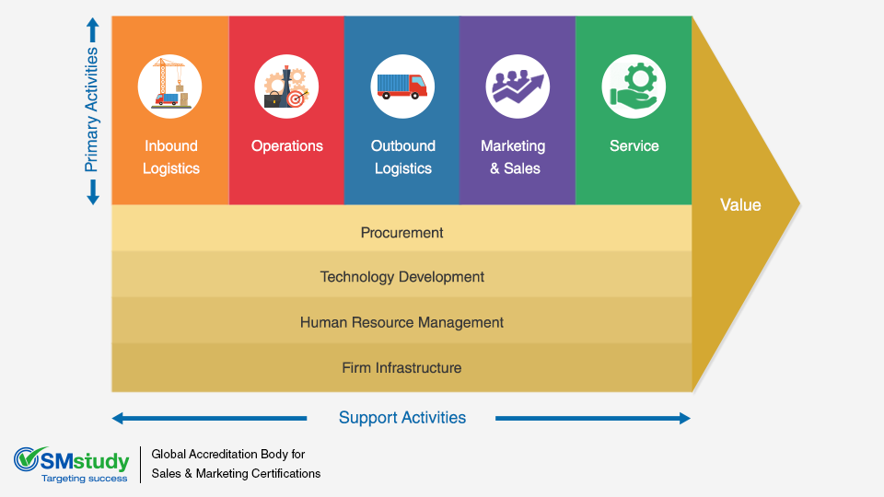
Source: SMstudy
The primary activities
Inbound Logistics.
Activities related to receiving, storing, and disseminating inputs to the product, such as material handling, warehousing, inventory control, vehicle scheduling, and returns to suppliers. Ameya as a fine dining restaurant, has to be very punctual with inbounds because the raw material it requires, does not have a very long shelf life.
Operations/ Productions
Transforming inputs into the final product form. Cooking and preparing Indian cuisine with raw materials like vegetables, oil, spices.
Marketing and Sales.
Buyers can purchase the product and induce them to do so, such as advertising, promotion, sales force, quoting, channel selection, channel relations, and pricing.
Service.
Activities associated with providing service to enhance or maintain the value of the product. For example, a great hospitality experience with the specific style of cuisine.
The Support Activities
Procurement.
Procurement refers to the function of purchasing inputs used in the firm’s value chain, not to the purchased inputs themselves. Here in Ameya’s case, it will be cooking equipment.
Technology Development.
Technology development consists of a range of activities that can be broadly grouped into efforts to improve the product and the process. A flawless payment system can be the one and also a website or an app for booking a table or hall.
Human Resource Management.
Human resource management involves tasks related to hiring, training, developing, and compensating various personnel. It plays a crucial role in supporting both individual activities like hiring engineers and the overall value chain, such as labor negotiations. The impact of human resource management on a company's competitive advantage is significant, influencing employee skills, motivation, and the costs associated with hiring and training. In certain industries, it is a crucial factor in determining competitive advantage.
Firm Infrastructure.
The company's infrastructure involves various functions like overall management, planning, finance, accounting, legal matters, government affairs, and quality management. Unlike other support activities, infrastructure typically aids the entire chain rather than specific tasks.

- IMPLEMENTATION
Porter’s 3 Generic Strategies
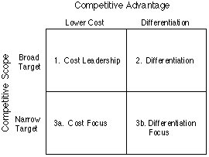
Source: University of Cambridge
In the pursuit of an expansion strategy, Ameya has strategically aligned itself with Porter's "differentiation focus" approach. This strategic choice entails positioning Ameya as a fine dining establishment specializing in Indian cuisine. Essentially, the targeted demographic for Ameya comprises individuals with a distinct preference for Indian culinary offerings, seeking a refined and elevated dining experience.
Ameya distinguishes itself by offering an exquisite culinary journey coupled with a premium ambiance, thereby justifying a higher price point. This differentiation, however, inherently places a constraint on the broad market potential of Ameya, as it tailors its services to a more specific customer base.
The strategic focus revolves around the premise that Ameya is not aiming to appeal to a mass market; rather, it seeks to attract a niche audience appreciative of the sophistication inherent in fine dining, particularly within the realm of Indian cuisine. This intentional exclusivity is designed to resonate with individuals who prioritize both the cultural richness of Indian flavors and the luxury associated with fine dining establishments.
In the process of market expansion, when a firm tries to broaden its market for an existing service, it inevitably enters into competition with alternative service categories that fulfill similar consumer needs. Within this competitive landscape, various customer needs vie for attention and allocation of resources. Addressing this complexity requires companies to extend their efforts beyond the confines of product categories. This insight, as articulated by Bang and Joshi (2010), underscores the multifaceted nature of market expansion, necessitating a nuanced approach that transcends traditional boundaries.

For Ameya, a fine dining restaurant planning market expansion within the premium service segment, the challenge lies in navigating the diverse range of consumer preferences and competing service offerings. The restaurant, known for its distinctive Indian cuisine presented in a refined dining environment, faces the task of not only meeting but exceeding customer expectations. This involves not only delivering exceptional culinary experiences but also justifying the premium prices associated with its offerings. As Ameya seeks to carve a niche within the upscale dining market, its success hinges on the ability to create a value proposition that resonates with customers, compelling them to allocate their resources for an unparalleled and worthwhile dining experience. This strategic imperative underscores the importance of understanding and effectively addressing the dynamic interplay of customer needs and market competition within the realm of premium service offerings.

- MONITORING TOOL, SUSTAINABILITY & CSR
Establishing Key Performance Indicators (KPIs)
Key Performing Indicators- KPIs are evaluating measures for monitoring the performance of an entire organization or any particular department. (Alnajar, 2023) KPIs can detect any aspect of an organization; however, effective KPIs should be:
Relevant: Should be linked with the organization’s vision.
Quantifiable: Should have some quantifiable measures to evaluate the success.
Agreed Upon: Every key decision maker should agree upon the KPIs.
Implementing KPIs
Ameya can implement KPIs through an app or software system. These implementations should be according to the nature of KPIs, organizational demands, and resources available. (Alnajar, 2023)
Conducting Regular Reviews:
- Assess Performance:
Monitoring tools collect data from the customers, suppliers, and other stakeholders;that data performance should be measured. (Alnajar, 2023)
- Address Issues:
No planning or strategy is perfect but needs to be addressed or reevaluated constantly. This approach helps fix the issues. (Alnajar, 2023)
- Adjust Strategies:
If issues are constantly rising despite being fixed several times, the organization should redevelop or modify the existing strategies. (Alnajar, 2023)

Sustainability
Sustainability, focusing on economic, environmental, and social aspects, is now a crucial concern for businesses globally, both in developing and developed markets. The "triple bottom line" concept emphasizes corporate reporting that considers these three dimensions as pillars of sustainability. With growing awareness, many organizations worldwide are finding creative approaches to enhance their sustainability practices and performance in the market. (Hussain et al., 2020)
A competitive advantage is like a superpower for a company. It's when a company is good at smartly using its resources, making it better than its competitors. Imagine it's like having a special skill that sets the company apart. So, if a company can create more value (meaning, it's more successful and makes more money) than another company, it's said to have a competitive edge. It's being better at business than the competition. To achieve market performance, businesses must generate a sustainable competitive advantage. Competitive advantage and market performance are significantly associated. Many studies in the strategic management, international business, and marketing literature believe a direct positive correlation between competitive advantage and market performance.
At fine-dining restaurants, here Ameya chefs often get their ingredients from local sources, like nearby farms or producers. This helps them check the quality of the products, ensure timely delivery, and make sure they can get enough of what they need. It also helps maintain a consistent level of quality and keeps prices reasonable. Some restaurants go beyond just buying from local suppliers – they build direct connections with farmers. This is called the farm-to-table model. It's not just about buying; it's about influencing how the food is grown. (Huang and Hall, 2023)
Some restaurants not only use foraged foods but also offer classes to customers on how to forage. This has led to the rise of foraging tourism, where people travel to experience this unique way of sourcing food. It's all part of a broader movement towards sustainable tourism, supporting local foods, and taking things slow to create more meaningful connections with the places we visit. (Huang and Hall, 2023)
Corporate Social Responsibility
CSR, or Corporate Social Responsibility, is a broad concept that encompasses a company's socially responsible activities, its responsiveness to social issues, and its efforts to contribute positively to society (Carroll, 1991; Han et al., 2020). Companies performing CSR not only benefit themselves but also create a strong relationship with the communities in which they operate (Han et al., 2019; Lee et al., 2018; McWilliams & Siegel, 2001; Su et al., 2017).
In the fast-growing hospitality industry, stakeholders must minimize negative impacts and maximize positive contributions to society (Chen, Chang, & Lin, 2012; Lee et al., 2018; McWilliams & Siegel, 2001). CSR plays a crucial role in shaping a company's image and reputation (Park, 2019) and influencing positive customer attitudes (Han et al., 2019). Furthermore, CSR is fundamental to corporate management activities (Baumgartner, 2014). It is not surprising that many companies in the hospitality sector are actively involved in practicing and promoting various socially responsible activities, covering economic, legal, ethical, and philanthropic dimensions (Han et al., 2020; Park, 2019).
CSR & other Associated Managerial Factors
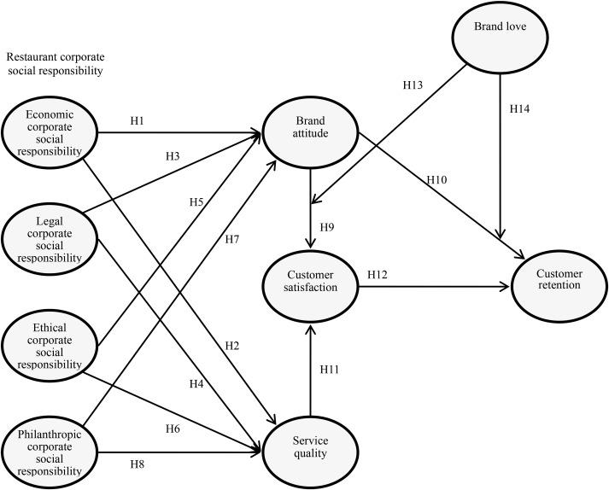
Source: ScienceDirect.com
For chain restaurants aiming for sustained success, integrating Corporate Social Responsibility (CSR) into their operations is crucial. CSR activities, such as community support and environmentally conscious practices, can significantly impact patrons' perception of the brand, creating what we call "brand love." This emotional connection translates into a positive brand attitude and customer loyalty, ultimately driving retention.
To enhance brand love effectively, Ameya considers innovative strategies. One approach is leveraging social marketing and live broadcasts to showcase CSR initiatives. Engaging customers through various social media channels allows the restaurant to create compelling content, fostering a sense of community participation and active communication.
Moreover, aligning CSR activities with the overall marketing strategy is strategic. Incorporating these initiatives into marketing campaigns highlights the company's commitment to social responsibility and builds a positive image among customers. Ameya can implement the same strategy when it opens one branch in London. This external promotion should be coupled with internal transparency measures, instilling trust and accountability. (Lee et al., 2020)

CONCLUSION
Ameya, a top-notch Indian fine-dining restaurant in London, is eyeing a strategic expansion across the UK. With a clear vision, mission, and objectives, Ameya aims to redefine Indian gastronomy with innovation and authenticity.
The plan involves a thorough analysis of external factors (PESTLE), a peek into the UK restaurant market, and a focus on customer satisfaction, innovation, and brand loyalty.
For expansion, Ameya considers market development and places itself as a star or question mark in the BCG matrix. The restaurant plans to maintain its unique tapas-style approach to Indian cuisine, emphasizing a strong brand, skilled staff, and a prime location.
However, challenges like limited cuisine options, high staff pay rates, and potential shifts in customer preferences loom. The game plan includes staying competitive, adapting to trends, and carefully navigating government regulations.
By strategically aligning resources, embracing opportunities, and delivering a memorable dining experience, Ameya aims to carve a niche in the evolving culinary landscape across the UK.

References:
Alnajar, H. (2023). Measuring Success in Strategic Partnerships: KPIs, Monitoring, and Reviews. [online] www.linkedin.com. Available at: https://www.linkedin.com/pulse/measuring-success-strategic-partnerships-kpis-reviews [Accessed 3 Jan. 2024].
Bang, V.V. and Joshi, S.L. (2010). Market expansion strategy–performance relationship. Journal of Strategic Marketing, 18(1), pp.57–75.
Digital food focus: The benefits of digital marketing tools for restaurant competitive advantage. (2021). Strategic Direction, 37(8), pp. 9-10.
Magretta, J. and Porter, M. (2020). Understanding Michael Porter: The essential guide to competition and strategy. Boston: Harvard Business Review Press.
Hussain, I., Mu, S., Mohiuddin, M., Danish, R.Q. and Sair, S.A., 2020. Effects of sustainable brand equity and marketing innovation on market performance in hospitality industry: Mediating effects of sustainable competitive advantage. Sustainability, 12(7), p.2939.
Johnson, G. (2018). Fundamentals of strategy. 4th ed. Harlow, England: New York.
Hallak, R., Assaker, G., O’Connor, P. and Lee, C. (2018). Firm performance in the upscale restaurant sector: The effects of resilience, creative self-efficacy, innovation and industry experience. Journal of Retailing and Consumer Services, 40, pp.229–240. doi https://doi.org/10.1016/j.jretconser.2017.10.014.
Yin, N. (2019). Application of AHP-Ansoff Matrix Analysis in Business Diversification: The case of Evergrande Group. MATEC Web of Conferences, [online] 44, p.01006. Available at: https://www.researchgate.net/publication/297898861_Application_of_AHP-Ansoff_Matrix_Analysis_in_Business_Diversification_The_case_of_Evergrande_Group.
Beuchelt, T. D. and Zeller, M. (2013) “The role of cooperative business models for the success of smallholder coffee certification in Nicaragua: A comparison of conventional, organic and Organic-Fairtrade certified cooperatives,” Renewable Agriculture and Food Systems. Cambridge University Press, 28(3), pp. 195–211. doi: 10.1017/S1742170512000087.
Huang, Y. and Hall, C.M. (2023). Locality in the Promoted Sustainability Practices of Michelin-Starred Restaurants. Sustainability, [online] 15(4), p.3672. doi: https://doi.org/10.3390/su15043672.
Carroll, A. B. (1991). The concept of corporate social responsibility: Towards the moral management of organizational stakeholders. Business Horizons, 34(4), 39-48.
Han, H., Kim, W., Lee, S., & Al-Ansi, A. (2019). Tourists’ attitude–behavioral intention link in a destination: The moderating role of destination image. Journal of Destination Marketing & Management, 12, 16-26.
Han, H., Hsu, L. T. J., Lee, J. S., & Sheu, C. (2020). Corporate social responsibility and the formation of exploratory and exploitative innovations: The moderating role of environmental dynamism. Journal of Business Research, 113, 1-11.
Lee, J. S., Han, H., & Lee, C. K. (2018). The impact of non-pharmaceutical interventions for 2009 H1N1 influenza on travel intentions: A model of goal-directed behavior. Tourism Management, 66, 191-201.
McWilliams, A., & Siegel, D. (2001). Corporate social responsibility: A theory of the firm perspective. Academy of Management Review, 26(1), 117-127.
Park, J. (2019). Examining the influence of corporate social responsibility (CSR) on customer behavior: A conceptual model for understanding CSR in the hotel industry. *International Journal of Hospitality Management, 81, 169-179.
Aziri, B. and Ismaili, R., (2020). Business environment analysis as a key stage in the process of strategic management. ECONOMIC VISION-International Scientific Journal in Economics, Finance, Business, Marketing, Management and Tourism, 7(13-14), pp.99-110.

