Student Name: Abigail Davies
Student Number: 2114472
Course: BSC2-PT Computing (Software Engineering)
Module Name: L4 - Introduction to Web and Database Concepts
Assignment Title: HTML & CSS Web Development
Due Date: 3rd May 2022

Contents
Introduction 3
Requirements 4
Implementation 4
Screenshots of Webpage 5
Page 1 (Home Page) 5
Page 2 (Cakes) 6
Page 3 (Cupcakes) 7
Page 4 (Brownies) 8
Page 5 (Blondies) 9
Page 6 (Treat Boxes) 10
Page 7 (Contact Page) 11
Validation 11
Evaluation 12
Usefulness 12
Search Engine Optimisation 12
Accessibility 13
Conclusion 13
References 14
Appendices 17
index.html 17
cakes.html 18
cupcakes.html 21
brownies.html 23
blondies.html 25
treatboxes.html 27
contact.html 29
stylesheet.css 31

Figure 1 5
Figure 2 6
Figure 3 7
Figure 4 8
Figure 5 9
Figure 6 10
Figure 7 11

Introduction

This report reflects the knowledge and skills that I have learnt on HTML and CSS during the web development module. I have created my website based on a hobby of mine. I discovered this when I had a lot of spare time to bake over the pandemic months. The document contains information on each process that I have studied to create this website. This includes the purpose and target audience of my website, screenshots of each page, the validation process, and finally, the evaluation.

Requirements

According to the article from the Administrative Assistant's Update, blog stands for web log, and they are effectively online journals [1]. This would be the reason I chose to create a blog as I would be able to make it more personal. The purpose of this website is to provide ideas to people of the recent bakes I’ve made. Furthermore, I hope that it inspires people to start baking in their spare time. I was inspired by many other websites and hope that my website would have the same impact on someone else.
Baking has become my most enjoyed hobby and I’ve noticed that many others have also started baking on social media. In my opinion, baking requires a variety of skills that can also be applied to other aspects of life.
I believe the target audience for my baking blog would be for teenagers who have chosen cookery for their options in secondary school. When I was completing my course in school, we were required to do research for our final product. My final product was a three-tier cake so researching baking blogs was key when I was experimenting different decoration ideas. In addition, I also believe that the target audience will be for all ages of people who also have the same baking interest as me or who are looking to start baking in their spare time. That being said, from personal experience, some people, especially the elderly, do not like viewing online content so this will not be specially targeted to them.

Implementation

Screenshots of Webpage

Page 1 (Home Page)
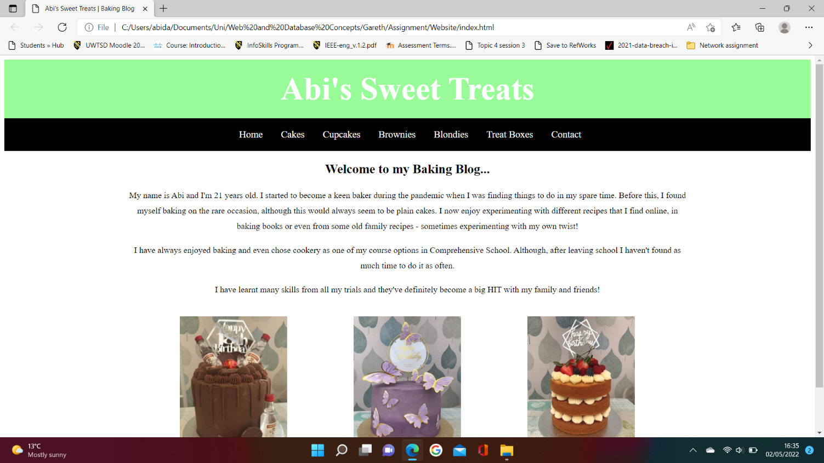

Figure 1

Figure 1 is a screenshot of my home page. This is also known as the index page. I have included a brief summary of who I am and what this website is about. I’ve also included images that I believe would be appealing to the user as this would be the initial page the user views.
I have used w3schools website [2], to assist me in the formatting of the three images.
I have chosen to have a plain background as I have included a number of images throughout the website. I believe that having a pattern or coloured background would have made the website less clear to view.
I have used Times New Roman as the font on each page so that the same format is kept. Times New Roman is a serif typeface font. Canva quotes Robyn Young stating books and newspapers generally have serif typeface fonts [3]. In addition, I also decided to align the text to the centre of each page. As this blog has an even distribution of text to images, the paragraphs appeared to be too short to be aligned in a justified format.
In addition, I have also used a contrast of colours for the navigation bar. I decided to have the navigation bar horizontally on the page to maintain a straightforward format. When the user hovers over a specific button, the word changes to a pale green. Initially, I considered using a different colour so that it was more obvious to the user that they were hovering over a button. That being said, I believe it is equally as important to continue the colour scheme throughout all aspects of the website.
Furthermore, I referred to the Umbrella Code and multiple PowerPoints which was created by my lecturer, Gareth, to assist with the format of my code in both the HTML and CSS documents [4].

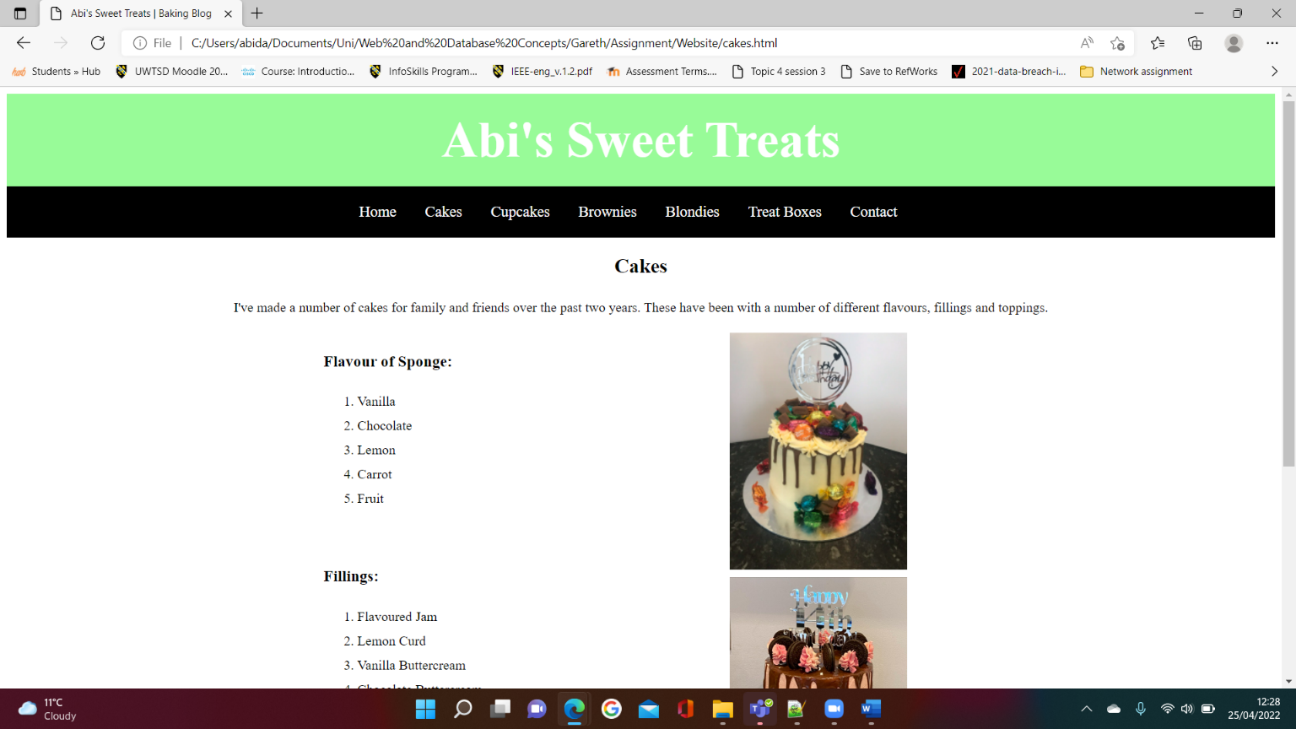
Page 2 (Cakes)
Figure 2

Figure 2 is screenshot of my second page which I’ve used to display the types of cakes I’ve made. I considered using a description list for the flavour of sponge, fillings, and toppings, however, I preferred the format of the items being numbered with an ordered list.

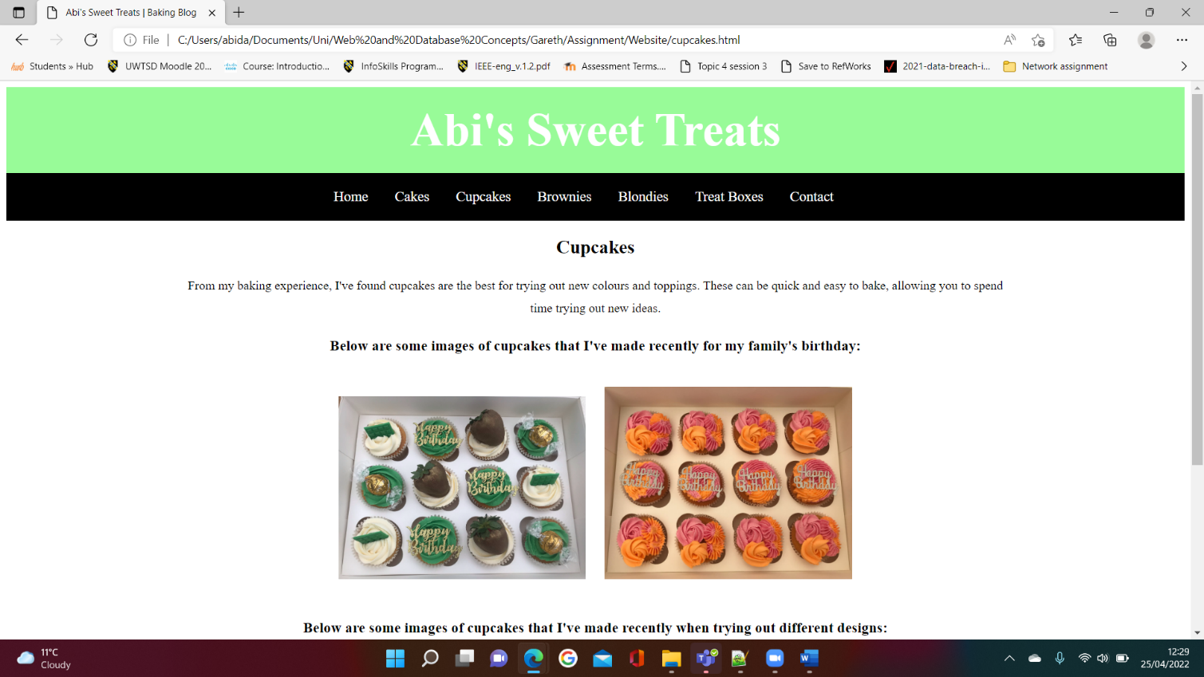
Page 3 (Cupcakes)
Figure 3

Figure 3 is a screenshot of my cupcakes page. This page includes five images which are all bright in colour and have a variety of different designs on them. I have used these images to catch the user’s eye and entice them into looking at other pages on my website. Moreover, I have also ensured that all images were landscape to ensure the format of the page looks neat and organised.

Page 4 (Brownies)
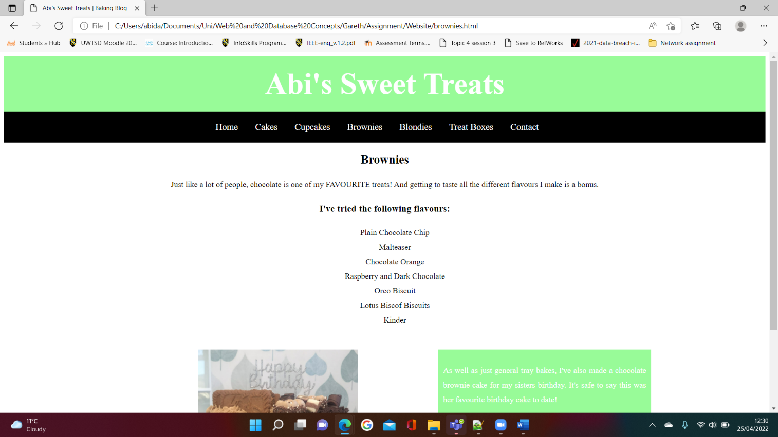
Figure 4

Figure 4 is a screenshot of my brownies page. I have used an un-ordered list to display the different flavours and removed the bullet points. At first, I was unsure how to remove these, although I found a website called Computer Hope which allowed me to implement this [5].
Furthermore, I also added a side bar to this page and ensured that it had the same background colour as the main header. Corpuz states that colour in a website can improve the user’s experience [6]. In addition, he further explains that adding colour can also help users understand the order of the page and have an impact on what the user reads.
Additionally, to add more text to the side bar I have used Lorem ipsum text [7]. This is text that is used to fill a space in a file when content is not the biggest concern [8]. Therefore, it allows web developers to understand and visualise how the web page would look before the genuine content is confirmed.

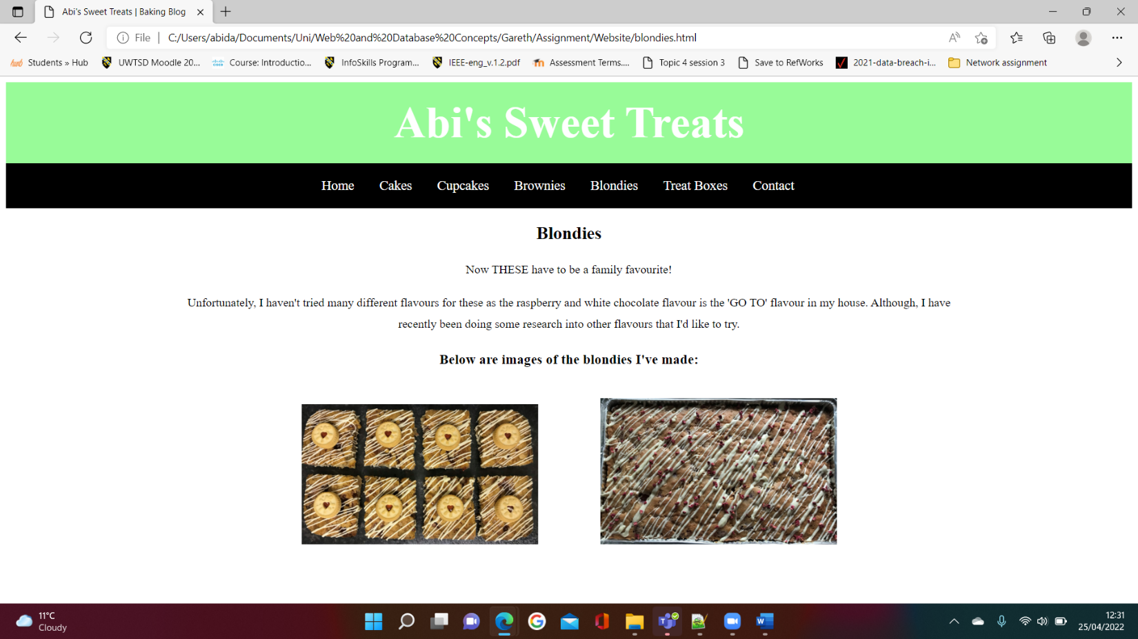
Page 5 (Blondies)
Figure 5

Figure 5 is a screenshot of my fifth page which is one of my simpler pages. I have used this page to display information about the blondies I have made. Both images used had a lot of unwanted background in them before I implemented them in my web page. To rectify this, I used a photo editor on my laptop to amend the size of the images. In my opinion, these now look much more appealing to the eye.

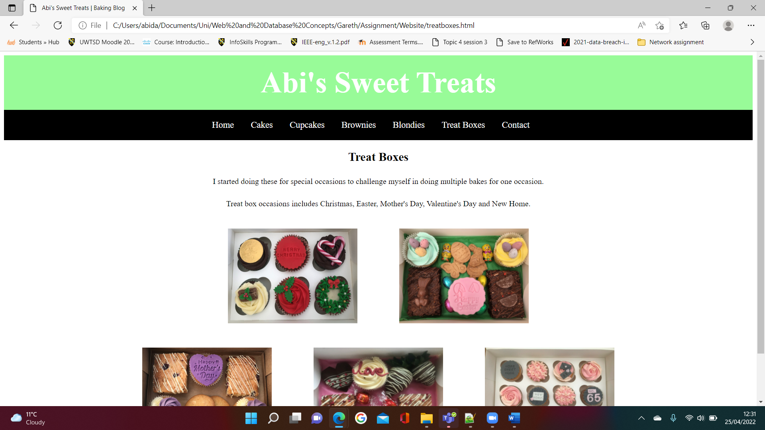
Page 6 (Treat Boxes)
Figure 6

Figure 6 is a screenshot of my treat box page. Similarly to page five, this page also has a simple layout compared to the others and like page three I have inserted a number of colourful images. I have also ensured each row of images are the same height for precision.

Page 7 (Contact Page)
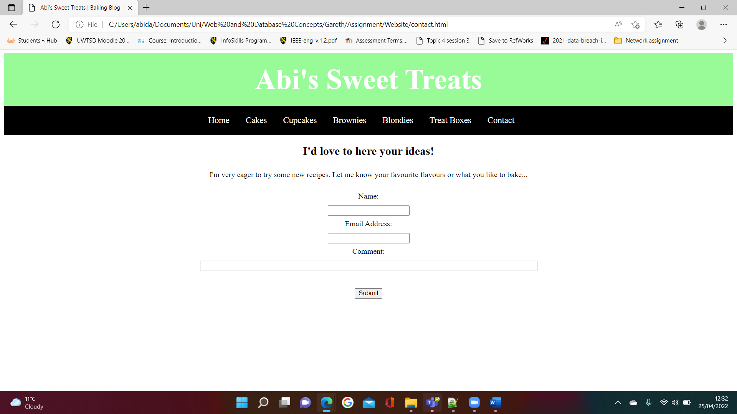
Figure 7

Figure 7 is a screenshot of my contact page. This allows my website to become interactive with the user. The user must enter their name, email address, that they wish for a response from and any comments they have. I have created this form with support from a number of different pages on w3schools website [9], [10]. Additionally, I wanted the form to send me an email once the user had clicked the submit button. I found out how to format this with the help of another w3schools page [11].

Validation

To validate my HTML and CSS code I used a validator website [12]. The same error that appeared throughout all my HTML pages was related to the images, were a backslash was used as part of the pathway. I researched this error and found that someone had recommended replacing this with a forward-slash [13]. This made no visual changes to my website; however, I have now amended all HTML files to implement this.
The validator website also informs you of any warnings within your code. The warning that appeared on every HTML page of my website was that I should consider declaring the language of the file by inserting a language attribute to the html start tag. The website also provides a link on how to do this [14]. I have also now implemented this across all seven HTML pages. Although, similarly to the previous error, it did not make any visual changes to my website.
In addition, I also used the same website to validate my CSS code. However, no errors or warnings were found for this.

Evaluation

Usefulness

The usefulness of a website can be established through careful consideration of specific elements [15]. Belanche, Casaló, Guinalíu, refer to Flavián et al, claiming that this involves examining the complexity of the format, as well as analysing the ease of use of the website, primarily. In addition, they further explain this also includes how quickly the user can navigate around the website, what expected actions are necessary for the user to obtain their chosen outcome and finally, whether the user has full control and understanding of their actions and location within the entire website. Additionally, they clarify that usability has a significant impact on how a website performs and for that reason, when a website has usability issues, it is likely that it will influence the user’s behaviour. The researchers conducted many experiments to find that the usefulness of a website has a major impact on user satisfaction. However, it is not always the primary standpoint when there are other aspects involved. That being said, it is still extremely relevant when it comes to web development.
When comparing my website to the study mentioned above, I believe the structure of my website is straightforward, implying it is easy to use. The format of my website is consistent throughout, creating a clear navigation system between the pages. This also indicates that there should be minimum time spent between each action of the user when attempting to reach their desired outcome. The user should also have full understanding of where they are when on each page as I have ensured each page has a heading that stands out from the rest of the text on the page. Nevertheless, I think that more text would improve my website. If this website was something I decided to take on and update on a regular basis, more information would be essential in keeping the user interested.

Search Engine Optimisation

Lui and Au state that Search Engine Optimisation (SEO) is the ease of how a search engine scans and understands a website [16]. They further explain that on-page optimisation describes the measures taken to simplify the search engine’s understanding of the website. This could involve improving links, content of the website and meta descriptions. Further research suggests that other on-page optimisation strategies include using header tags and image alt tags, as well as configuring an optimised URL structure [17]. In addition, the research also indicates that using a number of good quality but a variety of content types, such as images/ videos, text and lists, will improve the on-page optimisation of the website.
To reiterate what I’ve mentioned previously, I believe implementing more content to my website would be a great development. By following the strategies advised by Team LINCHPIN [17], introducing more text such as recipes or including links to videos that helped me in my baking knowledge would improve my website’s SEO. Moreover, when referring to the techniques researched by Lui and Au, I have not included meta descriptions. However, as my website is only being run locally to my machine, I do not believe this is quite as important in this case. Although, generally, it is very important in web development so I will look at applying this to any future websites that I create. Similarly, the URL of my website is the location of my website on my machine. Therefore, for any websites that I create in the future, that are not local to my machine, I will ensure that I configure an optimised URL.

Accessibility

Accessibility in web development refers to the ease of which any given person can access a website [18]. The Web Content Accessibility Guidelines have provided a number of ways for developers to ensure a website is accessible to wider range of people with disabilities that affect a person’s eyesight, hearing, speech, and movement. In addition, the guidelines can also assist in making a website more accessible to people who are sensitive to images and/ or have learning disabilities. The guidelines expand on this to state that these guidelines can be implemented via a number of different devices such as laptops and tablets.
There are many aspects of a website that a web developer should consider when researching the accessibility of it [19]. These include using text, images, and sounds within the website, as well as using code to justify the structure. Furthermore, the web developer should take into account the different types of web browsers, the user’s knowledge and experience, and authoring /validation tools.
I believe my website follows most of the recommendations suggested in the above research. For example, I have included text and images throughout my website, and completed checks to ensure my website is accessible via multiple web browsers. However, when using an online contrast checker to compare the colours used in my main header, there is not a big enough contrast so it would not be accessible to someone who is colourblind [20]. On the other hand, the colour of the background and text in the main section of my website is fully colour compliant and readable to people who are colourblind [20]. A future improvement will be to ensure that all of my website is accessible, rather than just the main sections. I will do this by checking the colour contrast prior to completion.

Conclusion

To conclude, I am very pleased the outcome of my website. I think it is well structured and has clear navigation. I have ensured the colour scheme is consistent throughout to assist with simplifying the user’s experience on the website. However, future improvements would include adding more text and possibly other media content such as videos, as well as ensuring all sections are accessible.

References

[1] Anonymous, “What is a blog?”, Administrative Assistant's Update, pp1-5, Sep. 2004. [Online]. Available: https://www-proquest-com.ezproxy.uwtsd.ac.uk/docview/225226180/fulltext/801AC36A65304D03PQ/1?accountid=130472 [Accessed April 24, 2022].

[2] W3Schools, “Tags”, W3Schools. [Online]. Available: https://www.w3schools.com/tags/tryit.asp?filename=tryhtml_img_vspace_css. [Accessed April 24, 2022].

[3] Canva, “Serif vs. Sans Serif fonts”, Canva. [Online]. Available: https://www.canva.com/learn/serif-vs-sans-serif-fonts/. [Accessed April 23, 2022].

[4] Gareth Jones, “L4 - Introduction to Web and Database Concepts (ACCA4023) (Gareth)”, Moodle. [Online]. Available: https://moodle.uwtsd.ac.uk/course/view.php?id=7476. [Accessed April 4, 2022].

[5] Computer Hope, “How to create a bullet list with no bullets in HTML”, Computer Hope, Aug. 31, 2020. [Online]. Available: https://www.computerhope.com/issues/ch001704.htm#:~:text=Adding%20the%20%22list%2Dstyle%3A,removes%20any%20bullet%20or%20number. [Accessed April 25, 2022].

[6] A. Corpuz, “3 REASONS WHY COLORS ARE SIGNIFICANT IN WEB DESIGN”, Medium, Aug. 23, 2020. [Online]. Available: https://medium.com/@angelitocorpuz.ph/3-reasons-why-colors-are-significant-in-web-design-5a95e07037a5. [Accessed April 25, 2022].

[7] Lipsum, “Lorem Ipsum”, Lipsum. [Online]. Available: https://www.lipsum.com/feed/html. [Accessed April 25, 2022].

[8] C. Bryant, “Lorem Ipsum”, Techopedia, Aug. 14, 2020. [Online]. Available: https://www.techopedia.com/definition/12898/lorem-ipsum. [Accessed April 25, 2022].

[9] W3Schools, “HTML Forms”, W3Schools. [Online]. Available: https://www.w3schools.com/html/html_forms.asp. [Accessed April 25, 2022].

[10] W3Schools, “HTML Input Types”, W3Schools. [Online]. Available: https://www.w3schools.com/html/html_form_input_types.asp. [Accessed April 25, 2022].

[11] W3Schools, “HTML”, W3Schools. [Online]. Available: https://www.w3schools.com/html/tryit.asp?filename=tryhtml_form_mail. [Accessed April 25, 2022].

[12] Validator, “Nu Html Checker”, Validator. [Online]. Available: https://validator.w3.org/nu/#textarea. [Accessed April 25, 2022].

[13] Filburt, “Validation Error on img tag: Bad value for attribute src on element img: Backslash ("\") used as path segment delimiter”, Stackoverflow, Aug. 23, 2017. [Online]. Available: https://stackoverflow.com/questions/45837855/validation-error-on-img-tag-bad-value-for-attribute-src-on-element-img-backsla. [Accessed April 25, 2022].

[14] R. Ishida, “Declaring language in HTML”, W3C, Jun. 23, 2021. [Online]. Available: https://www.w3.org/International/questions/qa-html-language-declarations. [Accessed April 25, 2022].

[15] D. Belanche, L. Casaló and M. Guinalíu, “Website usability, consumer satisfaction and the intention to use a website: The moderating effect of perceived risk”, Journal of retailing and consumer services, vol.19, 2012. [Online]. Available: https://www-sciencedirect-com.ezproxy.uwtsd.ac.uk/science/article/pii/S0969698911001160. [Accessed April 25, 2022].

[16] R. Lui and C.H. Au, “I.S. educational game: Adoption in teaching search engine optimization (SEO)”, The Journal of computer information systems, vol.60, May. 03, 2020. [Online]. Available: https://www-tandfonline-com.ezproxy.uwtsd.ac.uk/doi/full/10.1080/08874417.2018.1461034. [Accessed April 26, 2022].

[17] TEAM LINCHPIN, “How To Design An SEO Friendly Website That Ranks Well In Google”, Linchpinseo, Jan. 13, 2022. [Online]. Available: https://linchpinseo.com/how-to-design-an-seo-friendly-website/#on-page-optimization-strategies. [Accessed April 26, 2022].

[18] W3C, “Web Content Accessibility Guidelines (WCAG) 2.1”, W3C, Jun. 5, 2018. [Online]. Available: https://www.w3.org/TR/WCAG21/. [Accessed April 26, 2022].
[19] S.L Henry, “Essential Components of Web Accessibility”, W3C, Feb. 27, 2018. [Online]. Available: https://www.w3.org/WAI/fundamentals/components/. [Accessed April 26, 2022].

[20] Acart Communications, “CONTRAST CHECKER COLOR SELECTION”, contrastchecker. [Online]. Available: https://contrastchecker.com/. [Accessed April 28, 2022].

Appendices

index.html

<!DOCTYPE html>

<html lang="en">
<head>
<meta charset="utf-8" />
<title>Abi's Sweet Treats | Baking Blog</title>
<link rel="stylesheet" type="text/css" href="styleSheet.css">
</head>

<body>
<header id="main-header">
<div class="container">
<h1>Abi's Sweet Treats</h1>
</div>
</header>

<nav id="navbar">
<div class="container">
<ul>
<li><a href="index.html">Home</a></li>
<li><a href="cakes.html">Cakes</a></li>
<li><a href="cupcakes.html">Cupcakes</a></li>
<li><a href="brownies.html">Brownies</a></li>
<li><a href="blondies.html">Blondies</a></li>
<li><a href="treatboxes.html">Treat Boxes</a></li>
<li><a href="contact.html">Contact</a></li>
</ul>
</div>
</nav>

<section id="main">
<div class="container">
<h2>Welcome to my Baking Blog...</h2>
<p>My name is Abi and I'm 21 years old. I started to become a keen baker during the pandemic when I was finding things to do in my spare time. Before this, I found myself baking on the rare occasion, although this would always seem to be plain cakes. I now enjoy experimenting with different recipes that I find online, in baking books or even from some old family recipes - sometimes experimenting with my own twist!</p>
<p>I have always enjoyed baking and even chose cookery as one of my course options in Comprehensive School. Although, after leaving school I haven't found as much time to do it as often.</p>
<p>I have learnt many skills from all my trials and they've definitely become a big HIT with my family and friends!</p>
<img src="CakeImages/Cakes/ChocolateVodkaCake.jpeg" alt="Choc Cake" style="width:200px;height:280px;align:center;margin:20px 60px"/>
<img src="CakeImages/Cakes/ButterflyCake.jpeg" alt="Butterfly Cake" style="width:200px;height:280px;align:center;margin:20px 60px"/>
<img src="CakeImages/Cakes/VictoriaSpongeCake.jpeg" alt="Victoria Sponge Cake" style="width:200px;height:280px;align:center;margin:20px 60px"/>

</div>
</section>

</body>
</html>

cakes.html

<!DOCTYPE html>

<html lang="en">
<head>
<meta charset="utf-8" />
<title>Abi's Sweet Treats | Baking Blog</title>
<link rel="stylesheet" type="text/css" href="styleSheet.css">
</head>

<body>
<header id="main-header">
<div class="container">
<h1>Abi's Sweet Treats</h1>
</div>
</header>

<nav id="navbar">
<div class="container">
<ul>
<li><a href="index.html">Home</a></li>
<li><a href="cakes.html">Cakes</a></li>
<li><a href="cupcakes.html">Cupcakes</a></li>
<li><a href="brownies.html">Brownies</a></li>
<li><a href="blondies.html">Blondies</a></li>
<li><a href="treatboxes.html">Treat Boxes</a></li>
<li><a href="contact.html">Contact</a></li>
</ul>
</div>
</nav>

<div class="container">
<section id="main">

<h2>Cakes</h2>
<p>I've made a number of cakes for family and friends over the past two years. These have been with a number of different flavours, fillings and toppings.</p>

<div class="bulletPoints">
<h3>Flavour of Sponge:</h3>
<ol>
<li>Vanilla</li>
<li>Chocolate</li>
<li>Lemon</li>
<li>Carrot</li>
<li>Fruit</li>
</ol>

<br>

<h3>Fillings:</h3>
<ol>
<li>Flavoured Jam</li>
<li>Lemon Curd</li>
<li>Vanilla Buttercream</li>
<li>Chocolate Buttercream</li>
<li>Biscof Spread</li>
</ol>

<br>

<h3>Toppings:</h3>
<ol>
<li>Favourite Chocolate</li>
<li>Favourite Sweets</li>
<li>Favourite Biscuits</li>
<li>Fruit</li>
<li>Alcohol</li>
</ol>
</div>

<img src="CakeImages/Cakes/QualityStreetCake.jpeg" alt="Quality Street Cake" style="width:20%;height:20%;"/>
<br>
<img src="CakeImages/Cakes/OreoDripCake.jpg" alt="Oreo Drip Cake" style="width:20%;height:20%;"/>
<br>
<img src="CakeImages/Cakes/StrongbowCake.jpeg" alt="Strongbow Cake" style="width:20%;height:20%;"/>

</section>

</div>

</body>
</html>

cupcakes.html

<!DOCTYPE html>

<html lang="en">
<head>
<meta charset="utf-8" />
<title>Abi's Sweet Treats | Baking Blog</title>
<link rel="stylesheet" type="text/css" href="styleSheet.css">
</head>

<body>
<header id="main-header">
<div class="container">
<h1>Abi's Sweet Treats</h1>
</div>
</header>

<nav id="navbar">
<div class="container">
<ul>
<li><a href="index.html">Home</a></li>
<li><a href="cakes.html">Cakes</a></li>
<li><a href="cupcakes.html">Cupcakes</a></li>
<li><a href="brownies.html">Brownies</a></li>
<li><a href="blondies.html">Blondies</a></li>
<li><a href="treatboxes.html">Treat Boxes</a></li>
<li><a href="contact.html">Contact</a></li>
</ul>
</div>
</nav>

<section id="main">
<div class="container">
<h2>Cupcakes</h2>
<p>From my baking experience, I've found cupcakes are the best for trying out new colours and toppings. These can be quick and easy to bake, allowing you to spend time trying out new ideas.</p>

<h3>Below are some images of cupcakes that I've made recently for my family's birthday:</h3>
<img src="CakeImages/Cupcakes/GreenBirthdayCupcakes.jpeg" alt="Green Birthday Cupcakes" style="width:30%;height:30%;align:center;margin:20px 10px"/>
<img src="CakeImages/Cupcakes/BrightBirthdayCupcakes.jpg" alt="Bright Birthday Cupcakes" style="width:30%;height:30%;align:center;margin:20px 10px"/>

<h3>Below are some images of cupcakes that I've made recently when trying out different designs:</h3>
<img src="CakeImages/Cupcakes/SunflowerCupcakes.jpeg" alt="Sunflower Cupcakes" style="width:30%;height:30%;align:center;margin:20px 10px"/>
<img src="CakeImages/Cupcakes/LemonCupcakes.jpeg" alt="Lemon Cupcakes" style="width:30%;height:30%;align:center;margin:20px 10px"/>
<img src="CakeImages/Cupcakes/ChocolateOrangeCupcakes.jpeg" alt="Chocolate Orange Cupcakes" style="width:30%;height:30%;align:center;margin:20px 10px"/>

</div>
</section>

</body>
</html>

brownies.html

<!DOCTYPE html>

<html lang="en">
<head>
<meta charset="utf-8" />
<title>Abi's Sweet Treats | Baking Blog</title>
<link rel="stylesheet" type="text/css" href="styleSheet.css">
</head>

<body>
<header id="main-header">
<div class="container">
<h1>Abi's Sweet Treats</h1>
</div>
</header>

<nav id="navbar">
<div class="container">
<ul>
<li><a href="index.html">Home</a></li>
<li><a href="cakes.html">Cakes</a></li>
<li><a href="cupcakes.html">Cupcakes</a></li>
<li><a href="brownies.html">Brownies</a></li>
<li><a href="blondies.html">Blondies</a></li>
<li><a href="treatboxes.html">Treat Boxes</a></li>
<li><a href="contact.html">Contact</a></li>
</ul>
</div>
</nav>

<div class="container">
<section id="main">
<h2>Brownies</h2>
<p>Just like a lot of people, chocolate is one of my FAVOURITE treats! And getting to taste all the different flavours I make is a bonus.</p>
<h3>I've tried the following flavours:</h3>
<ul style="list-style: none;">
<li>Plain Chocolate Chip</li>
<li>Malteaser</li>
<li>Chocolate Orange</li>
<li>Raspberry and Dark Chocolate</li>
<li>Oreo Biscuit</li>
<li>Lotus Biscof Biscuits</li>
<li>Kinder</li>
</ul>
<br>

</section>

<img src="CakeImages/Brownies/BrownieCake2.jpeg" alt="Brownie Cake" style="width:30%;height:30%;align:left;"/>

<aside id="sidebar">
<p>As well as just general tray bakes, I've also made a chocolate brownie cake for my sisters birthday. It's safe to say this was her favourite birthday cake to date!</p>
<p>Lorem ipsum dolor sit amet, consectetur adipiscing elit. Integer ante sapien, tempor vitae malesuada sit amet, scelerisque eu purus. Duis lorem ligula, laoreet sit amet eleifend vitae, faucibus id lacus. Nullam ipsum neque, egestas non justo vel, convallis congue diam.</p>
</aside>

</div>

</body>
</html>

blondies.html

<!DOCTYPE html>

<html lang="en">
<head>
<meta charset="utf-8" />
<title>Abi's Sweet Treats | Baking Blog</title>
<link rel="stylesheet" type="text/css" href="styleSheet.css">
</head>

<body>
<header id="main-header">
<div class="container">
<h1>Abi's Sweet Treats</h1>
</div>
</header>

<nav id="navbar">
<div class="container">
<ul>
<li><a href="index.html">Home</a></li>
<li><a href="cakes.html">Cakes</a></li>
<li><a href="cupcakes.html">Cupcakes</a></li>
<li><a href="brownies.html">Brownies</a></li>
<li><a href="blondies.html">Blondies</a></li>
<li><a href="treatboxes.html">Treat Boxes</a></li>
<li><a href="contact.html">Contact</a></li>
</ul>
</div>
</nav>

<section id="main">
<div class="container">
<h2>Blondies</h2>
<p>Now THESE have to be a family favourite!</p>
<p>Unfortunately, I haven't tried many different flavours for these as the raspberry and white chocolate flavour is the 'GO TO' flavour in my house. Although, I have recently been doing some research into other flavours that I'd like to try.</p>
<h3>Below are images of the blondies I've made:</h3>
<img src="CakeImages/Blondies/JammyDodgerBlondie.jpeg" alt="Jammy Dodger Blondie" style="width:30%;height:30%;align:center;margin:20px 40px"/>
<img src="CakeImages/Blondies/RaspberryWhiteChocBlondie.jpeg" alt="Raspberry White Choc Blondie" style="width:30%;height:30%;align:center;margin:20px 40px"/>
</div>
</section>

</body>
</html>

treatboxes.html

<!DOCTYPE html>

<html lang="en">
<head>
<meta charset="utf-8" />
<title>Abi's Sweet Treats | Baking Blog</title>
<link rel="stylesheet" type="text/css" href="styleSheet.css">
</head>

<body>
<header id="main-header">
<div class="container">
<h1>Abi's Sweet Treats</h1>
</div>
</header>

<nav id="navbar">
<div class="container">
<ul>
<li><a href="index.html">Home</a></li>
<li><a href="cakes.html">Cakes</a></li>
<li><a href="cupcakes.html">Cupcakes</a></li>
<li><a href="brownies.html">Brownies</a></li>
<li><a href="blondies.html">Blondies</a></li>
<li><a href="treatboxes.html">Treat Boxes</a></li>
<li><a href="contact.html">Contact</a></li>
</ul>
</div>
</nav>

<section id="main">
<div class="container">
<h2>Treat Boxes</h2>
<p>I started doing these for special occasions to challenge myself in doing multiple bakes for one occasion.</p>
<p>Treat box occasions includes Christmas, Easter, Mother's Day, Valentine's Day and New Home.</p>

<img src="CakeImages/TreatBoxes/ChristmasCupcakes.jpeg" alt="Christmas Cupcakes" style="width:260px;height:190px;align:center;margin:20px 40px"/>
<img src="CakeImages/TreatBoxes/EasterTreatBox.jpeg" alt="Easter Treat Box" style="width:260px;height:190px;align:center;margin:20px 40px"/>
<br>
<img src="CakeImages/TreatBoxes/MothersDayTreatBox.jpeg" alt="Mothers Day Treat Box" style="width:260px;height:190px;align:center;margin:20px 40px"/>
<img src="CakeImages/TreatBoxes/ValentinesTreatBox.jpeg" alt="Valentines Treat Box" style="width:260px;height:190px;align:center;margin:20px 40px"/>
<img src="CakeImages/TreatBoxes/NewHomeCupcakes.jpeg" alt="New Home Cupcakes" style="width:260px;height:190px;align:center;margin:20px 40px"/>

</div>
</section>

</body>
</html>

contact.html

<!DOCTYPE html>

<html lang="en">
<head>
<meta charset="utf-8" />
<title>Abi's Sweet Treats | Baking Blog</title>
<link rel="stylesheet" type="text/css" href="styleSheet.css">
</head>

<body>
<header id="main-header">
<div class="container">
<h1>Abi's Sweet Treats</h1>
</div>
</header>

<nav id="navbar">
<div class="container">
<ul>
<li><a href="index.html">Home</a></li>
<li><a href="cakes.html">Cakes</a></li>
<li><a href="cupcakes.html">Cupcakes</a></li>
<li><a href="brownies.html">Brownies</a></li>
<li><a href="blondies.html">Blondies</a></li>
<li><a href="treatboxes.html">Treat Boxes</a></li>
<li><a href="contact.html">Contact</a></li>
</ul>
</div>
</nav>

<section id="main">
<div class="container">
<h2>I'd love to here your ideas!</h2>
<p>I'm very eager to try some new recipes. Let me know your favourite flavours or what you like to bake...</p>

<form action="mailto:2114472@student.uwtsd.ac.uk" method="post" enctype="text/plain">
<label for="name">Name:</label><br>
<input type="text" id="name" name="name">
<br>
<label for="emailAddress">Email Address:</label>
<br>
<input type="email" id="emailAddress" name="emailAddress">
<br>
<label for="comment">Comment:</label><br>
<input type="text" id="comment" name="comment" size=100px>
<br>
<br>
<input type="submit" value="Submit">
</form>
</div>
</section>

</body>
</html>

stylesheet.css

body{
font-family:Times New Roman, serif;
font-size:16px;
text-align:justify;
line-height:1.8em;
}

.container{
width:70%;
margin:auto;
overflow:hidden;
text-align: center;
}

#main-header{
background-color:#98FB98;
color:white;
font-size:30px;
text-align:center;
}

#navbar{
background-color:black;
color:#fff;
}

#navbar li{
display:inline;
}

#navbar a{
font-size:18px;
padding-right:30px;
}

a{
color:white;
text-decoration:none;
}

a:hover{
color:#40E0D0;
}

#sidebar{
float: right;
width:40%;
background-color:#98FB98;
color:#fff;
padding:10px;
box-sizing:border-box;
text-align:justify;
}

#main ol{
text-align: left;

}

#main sidebar{
float:right;
}

.bulletPoints {
float: left;
width:40%;
padding-left:150px;
box-sizing:border-box;
text-align:justify;
}

