

Certificate of Higher Education in Skills for the Workplace

Task 2
Professional career development report

Student name: Jagpreet Kaur
Student ID: 2112515
Module name: Professional Career Development
Module code: (BMSW4005_LON)
Lecturer name: Bianca Sanfilippo
Word count: to be written
Submission date: 14/08/2022
WORD COUNT 2987 (Including Job Description Form)

Contents

- Personal reflection on the role play: Recruitment and Selection – 3
- Applying Gibbs’s (1984) learning cycle – 3
- Skills and knowledge which contribute toward working effectively – 5
- My personal strengths and areas for further development – 10
- SWOT ANALYSIS - 10
- My employment goals and my personal career action plan/development plan –11
- My short - medium – long term targets for the development of my own professional career plan –12
- Conclusion -13
- References - 13
- Appendix A - The questions asked as interviewer in the role play (A1) -14
- Appendix B - Application Form completed as applicant for the role play -14

Personal reflection on the role play: Recruitment and Selection - Applying Gibbs’s (1984) learning cycle
Here I write a reflection on my recent interview. In this interview, I played two roles. At first, I pretended as an interviewer and my fellow Gabrieela played her role as an assistant manager applicant. Then we swapped and she pretended to be the interviewer and I played the role of an applicant for a teaching assistant. Each role lasts for 10 minutes. I want to get higher education to meet my needs properly so I can get a better job from today after studies. Before describing it in detail, I will briefly explain why role play is important.

Personal reflection is a kind of ability to think and know where we stand. To meditate or evaluate our skills and goals is known as a personal reflection (Keogh et al., 2013). We can pour our thoughts, desires, motivations and behaviour in this. Also, it is stated that there are some stages of reflection like self-awareness, description, critical analysis, synthesis and evaluation. With self-reflection, we know that in which niche we are good and questioning in a positive way can polish our personality nicely (Porter 2017). I believe that self-reflection is a more efficient way to enhance our skills and knowledge. That is why I have mentioned above my role play as an interviewer as well as an applicant too.
Gibb’s reflective cycle:
Here is the application of Gibbs cycle on my role play.
- Introduction:
I am Jagpreet Kaur who lives in London. I have experience of working in various private schools. But currently I am providing my services to a school academy from the past 5 years.
- Skills:
I think I am good at providing my services to nonverbal autistic children as well as experience too. I can manage when there are difficult situations by using my problem-solving skills.
- Job priorities:
I always look for a friendly environment. I believe I am suitable for this job because of my communication and problem-solving skills.
- Teacher Assistant:
For me, a teacher assistant is the one who guides all the teachers with educational responsibilities.
Commitment:
I will stay at your institute as long as I get opportunities for growth and advancement.
Gibbs Cycle:
Description:
Interviews last for 10 minutes each. During role play first I acted as candidate and partner took my interview and then we did vice versa.
Feelings:
At the start I was so nervous yet I was prepared and I was hoping to answer all the questions. Due to nervousness, I answered all the questions so briefly.
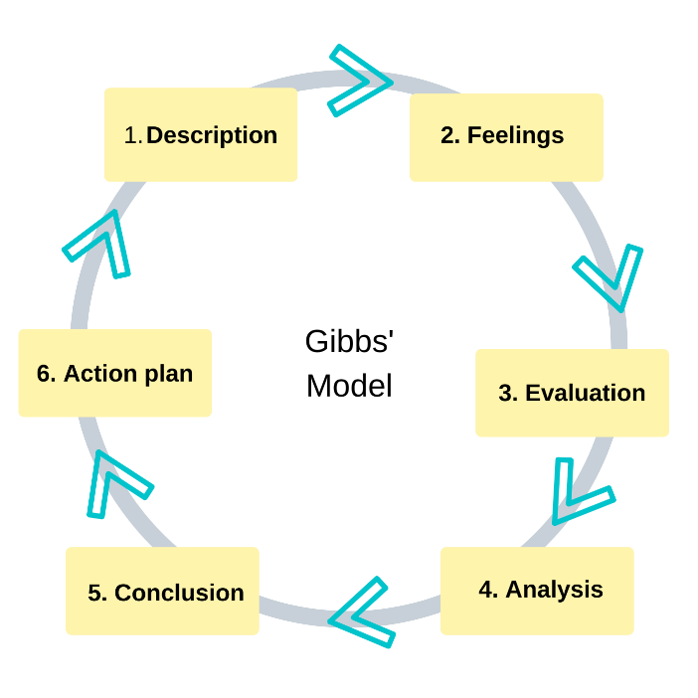

Evaluation:
At the start I greeted my partner with a smile and shook my hand. I maintained my smile during the whole interview. However, I believe I rushed to answer all the questions instead of taking some time to understand the questions. Due to this I answered so briefly whereas I believe I could do much better.
Analysis:
Overall, my experience was good. The whole interview was a mix of feelings. On one hand I enjoyed it a lot, on the other hand I was nervous and a bit confused. However, all of this gave me experience of doing better next time.
Conclusion
I believe I could stay calmer. If I stay calmer, I think I could answer all the questions in more detail. Whereas, I learned a lot after this interview.
Action Plan:
Next time when I will get this opportunity, I will practice more either with my friend or Infront of my mirror with myself so I can do much better than before.

Skills and knowledge which contribute toward working effectively
As I want to be SENCO (Special Educational Needs Coordinator), I need to focus on some skills that are required to be an expert in my field.
When we learn skills required to a particular field, we become masters in our tasks because learning helps in our professional life to achieve goals. It also gives us confidence and motivates us to become more passionate towards our field (Davidovitch 2013).
I am going to mention some important skills that are required for this position.
Willingness and ability:
This skill is required to develop knowledge and become a specialist, to stay up-to-date with local and national policies.
Leadership skills:
Leadership skills encourage and motivate other teachers to model good practice and develop a whole school commitment to support students of SENCO.
Interpersonal skills:
Also, it is necessary to have excellent interpersonal skills to make a good relation with parents, teachers and other professionals. Similarly, written communication skills are important to make reports on student’s progress and for the training of staff.
Communication skills:
The way we communicate to our colleagues and boss matters a lot. In listening skills, we should interpret the verbal and non-verbal messages sent by others (Khan et al., 2017).
Organisation and time management skills:
Organisation and time management skills are required to do tasks on time with maximum accuracy to lessen workload and balance a busy schedule.
Presentation skills:
A teacher should be well dressed and speak clearly. Teacher has to use gestures and show facial expressions to make the lesson more interesting.
Problem solving skills:
Problem solving skill is required to know the pros and cons of every problem so that it could be solved timely. It means one should be a critical thinker.
Critical thinking:
Critical thinking helps us to be a better version of ourselves so that we can understand things nicely. It helps us to avoid negative thinking.
Other skills:
- Honesty
- Teamwork and collaboration
- Decision making
- Critical thinking
- Patience
- Creativity
- Work ethics
We stay active instead of being lazy and creepy and it also boosts our confidence (Schulz 2008).
Knowledge of Legislation (Laws):
It is very important to know basic knowledge of laws. So, we can know the rules and regulations of the place where we are working. When we don’t know our rights, we can’t stand by ourselves. The most important laws were merged into a single equality act in 2010. According to this act, no one is allowed to talk about someone’s religion, sex, age, colour and creed.
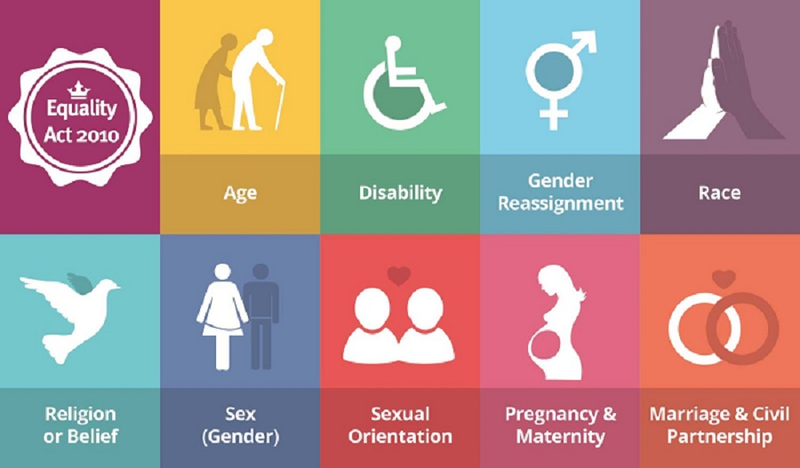

According to equality act 2010, it is against the law to differentiate between genders. Men and women have equal rights. Both are eligible to work at the same place with the same salary.
There should be no religion discrimination when time to hire an employee. According to this act, it is against the law to harass or bully a person in public functions, work, education and transport (Fell et al., 2017).

Legislation on DATA PROTECTION:
This law educates us how to protect our data and how necessary it is. It is stated that under the data protection act 2018, this is your right to know what kind of information is used by the government and other organisations. It is your right to have access to your personal information so that you can change things accordingly (Custers et al., 2018).


Health and safety at work:
The health and safety at work act was introduced in 1974 and abbreviated as HASAWA. According to this act, a company or an organisation should protect the mental and physical health of employees or workers. The purpose of this act is to secure a working and healthy environment. Also, this act educates to minimise the accidents, injuries and deaths on job. The main purpose is to protect the workers and to reduce the dangerous explosion.
Companies should train their employees well and reward them for being safe at the workplace. Ensure them to keep the place clean. First aid training should be done. Try to educate the workers that they should use workplace tools, machines and equipment safely (Ridley and Channing 2008).
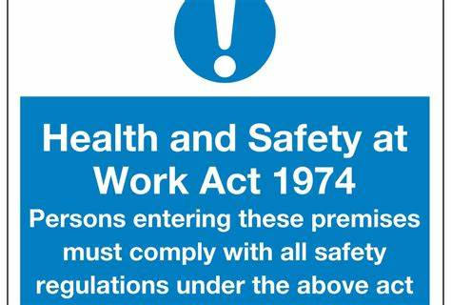

Knowledge of Rights and Contract:
It is very important to know the rights like break time during working hours. There should be no unfair dismissal. One should protect wage insolvency and discrimination.
HUMAN RIGHTS 1998:
The Human Rights act is a UK law which was passed in 1998. According to this act, everyone should be treated equally with dignity, grace and respect. This is basically a freedom from discrimination that all humans are equal no matter what religion, sex they have. It gives right to live freely without any slavery and torture. Some basic rights are included in this act like values, dignity, complexion, equality, respect and freedom (Vick 2002). These are all values defined and protected by law.


Knowledge of rules:
As we all know, knowledge is power. So if someone has knowledge about rules he could be more accurate to the workplace. Because we all know that each workplace has some rules and regulations to strictly follow and act upon. So, it is also important to know them.

My personal strengths and areas for further development

SWOT ANALYSIS
SWOT ANALYSIS

STRENGHTS  During Covid, I have supported many kids and cared about their health without being frustrated. | WEAKNESSES  I am working on my public speaking as I get nervous when talk to an unknown person.
OPPORTUNITIES  I want to complete my education to work more efficiently and get a better job. | THREATS  Threat, I have a threat to face verbal abuse and discrimination and cultural differences.

My employment goals and my personal career action plan

My professional career pathway is:
I want to get higher education to have success in SENCO career.

What are my current strengths?
I am studying in level four and improved my skills.

What are my achievements and areas of success since the beginning of the module/programme?
I have read four modules and passed them.

In what areas do I need to develop?
I want to manage my stress and public speaking and accepting feedback.

Why is it important to improve in these areas?
With stress, I can’t focus on work so I need to work on stress management. As I have mentioned above about fear of public speaking so it is my developing area.

Who will help me? What resources will I need?
I will read some motivational books and hang out with friends to release stress. I will talk everyone nicely and will practise to speak in front of mirror in order to come up with my fear of public speaking.

What are the constraints/ barriers to achieving this key are and how I will manage these– e.g., time, resources,
I have never talked to anyone more often so now I will make time to set up my routine to manage things timely. I will follow some productive tips to achieve this key.

What further action do I need to take now?
Actions to be taken – things to do, people to see.
Furthermore, I may take help from my mentors, seniors and friends. Most importantly I will take help of motivational speakers and will make mind to achieve more.

Time scale – by when
It will end in October.

My short - medium – long term targets for the development of my own professional career plan (using Specific, Measurable, Agreed, Realistic, Time-bound –SMART targets)

Short-term plan (3 -6months)
Specific | Enrol and do level 5 BA.
Measurable | When I submit my first assignment.
Agreed | Could be agreed with friends or colleagues.
Realistic | Yes.
Time-Bound | 15/10/2022
Medium-term plan (1-2 years)
Specific | Complete level 5. (BA Hons Graduate)
Measurable | When I will submit my last assignment.
Agreed | Family dissertation supervisor.
Realistic | Yes.
Time-Bound | 01/09/2024
Long-term plan (2-5 years)

Specific | Start new job role.
Measurable | Pass my provision period.
Agreed | Agreed with supervisor or line manager.
Realistic | Yes.
Time-Bound | 10/10/2025

Conclusion:
I have well played my role and explained in Gibb’s cycle completely. I have elaborated my skills and knowledge. Also, i have mentioned why they are important and what are my future plans and expectations after getting higher education.
References :
- Keogh, R., Boud, D. & Walker, D. (2013). Introduction: What is Reflection in Learning? Turning experience into learning, 7-17.
- Porter, J. (2017). Why You Should Make Time for Self-Reflection (Even If You Hate Doing It). Harvard Business Review.
- Markkanen, P., Anttila, M., Valimaki, M. & Kuuskorpi, M. (2020). A reflective cycle: Understanding challenging situations in a school setting. Educational Research, 62(1), 46-62.
- Davis, T. M. & Murrell, P. H. (1993). Turning Teaching into Learning. The Role of Student Responsibility in the Collegiate Experience. ASHE-ERIC Higher Education Report No. 8. ASHE-ERIC Higher Education Reports.
- Davidovitch, N. (2013). Learning-centered teaching and backward course design from transferring knowledge to teaching skills. Journal of International Education Research, 9(4), 329-338.
- Khan, A., Khan, S., Zia-Ul-Islam, S. & Khan, M. (2017). Communication Skills of a Teacher and Its Role in the Development of the Students' Academic Success. Journal of Education and Practice, 8(1), 18-21.
- Schulz, B. (2008). The importance of soft skills: Education beyond academic knowledge.
- Fell, E. V. & Dyban, M. (2017). Against discrimination: equality act 2010 (UK). The European Proceedings of Social & Behavioural Sciences, 188-194.
- Custers, B., Dechesne, F., Sears, A. M., Tani, T. & van der Hof, S. (2018). A comparison of data protection legislation and policies across the EU. Computer Law & Security Review, 34(2), 234-243.
- Ridley, J., & Channing, J. (Eds.). (2008). Safety at work. Routledge.
- Vick, D. W. (2002). The human rights act and the British constitution. Tex. Int'l LJ, 37, 329.

Appendix A: The questions asked as interviewer in the role play (A1)
- Tell me about yourself?
- What do you know about our company?
- What do you look for in a job?
- Why do you want to work for us.
- How long would you stay with us.
The question/s asked as interviewee in the role play (A1)
- Tell me about yourself.
- Why should we hire you?
- What do you look for in a job?
- Please give me your definition of teacher assistant.
- How long would you stay with us?
Appendix B: Application Form completed as applicant for the role play (A1).
Job application form

Application for Teaching Assistant –
Your details
Name: Jagpreet Kaur
Education and training
Please give details:
1. 2021-2022- University of Wales Trinity Saint David, London Campus.
2. 2021- Pro-trainings London
3. 2021- Newham College
Qualifications
Please give details:
Level 4- Higher Education Skills for Workplace
Level 3- Learning Teaching Assistant
Level 3- Paediatric Infant and Child First Aid (VTQ)
Level 2- Safeguarding Children
Level 2- Common care skills for the Professional Childcare
Employment history
Your current or most recent employer
Name of employer: Winster Way Academy
Job title: Teaching Assistant
Length of time with employer: From 2011
Reason for leaving: Ongoing
Duties:

- Getting the classroom ready for lessons.
- Helping children with special needs.
- Supporting teachers in managing classroom behaviour.
- Supporting group of children with their learning who needs extra support.

Previous employers
Please tell us about other jobs you have done and about the skills you used or learned in those jobs.

- Midday Assistant: Responsibility of children during their lunch times.
- Making sure they are safe and happy.
- Midday Supervisor: supporting midday assistants during lunch times.
- Making sure they supervise children properly with their meals and in playground.
Supporting statement
Please tell us why you applied for this job and why you think you are the best person for the job.
I am interested in becoming a teacher assistant because I believe that children should be given equal opportunities in learning. Being a teaching assistant, I have unique abilities to see where students need support, so I can make sure that support is provided in time. I believe I have all the abilities to assist teachers and students wherever is needed. I am best at arranging classrooms according to the requirements. Moreover, based on my past experience, I believe I have all the abilities which a good teaching assistant requires. I am very creative person, who is always ready to find solutions of the problems according to situation. I am a person who is keen to learn new things and enjoys the process of learning.

During my studies I have learned about the different styles of teaching, which makes me enthusiastic for becoming a teaching assistant. Now I want to turn my enthusiasm into work. I am so grateful to you for reviewing my application and I hope you will give me a chance to utilise my dedication towards work.
Right to work in the UK
Do you need a work permit to work in the UK? No
References
Please give the names and contact details of 2 people who we can ask to give you a reference.
We may ask them before an employment offer is made. We will not ask your current employer until we get your permission.
Reference 1: Helen Penner
Designation: Head Teacher Winston Way Academy
Relation: Employer
Contact: 02084785626
Reference 2: Rida Zahra
Relation: Friend
Contact: 07737218184
Designation: Community Associate at IWG
Declaration
I confirm that to the best of my knowledge the information I have provided on this form is correct and I accept that providing deliberately false information could result in my dismissal.
Name: Jagpreet Kaur
Signature: Jagpreet Kaur
Date: 14/07/2022

